THỨ 2- TIẾT 3 BUỔI SÁNG NGÀY 17/2/2025- LỚP 7A6- TIẾT 67 THEO PPCT
Date of preparing: February 02nd, 2025
TOPIC 8: FILMS
Total numbers of periods: 7 periods; from period 62 to period 68
LESSON 6: SKILLS 2
Period: 67 Class: 7A6
I.OBJECTIVES:
1. Knowledge:
* Vocabulary: adjectives to describe films, aspects of a film
* Grammar: the connectors: although/ though and however
By the end of the lesson, students will be able to use the way to listen for special information about a comedy and write a short paragraph about your favorite film.
2. Competence:
-General competence:
+Self-controlled and self-learning competence .
+Communicative and cooperative competence .
-Distinctive competence;
+Linguistic competence (sts know how to use their native language and foreign language to indicate the evidence for their answers)
3. Values:
+ Responsibility (sts are aware of the task their group gave)
+ Diligence (sts work better to get English better)
II. TEACHING AIDS AND MATERIALS:
1. Materials: Grade 7 textbook, lesson plan, workbook, the teacher’s book, reference books
2. Equipment: TV, cassettes, pictures, cards, handouts, extraboards, sachmem.vn.
III. TEACHING PROCEDURE:
- WARM UP (5ms)
a. Aims:
To wake up students’ interest.
- To lead into the lesson
b. Content: To play a game to create a friendly and relaxed atmostphere to inspire Ss to warm up to the subject and new lesson.
c. Expected answers: Remembering the names of films.
d. Organization of activities: Teacher’s instructions …
Game: Name the comedy
- Teacher divides the class into 2 groups and shows them a video of some comedies.
- After the video, teacher asks students to pass the chalk and take turns to run to the board and write down the name of the films that appeared in the video.
- Students take turns to run to the board and write down the name of the films appeared in the video.
- Teacher allows students to cross check first.
-Teacher confirms the answers and gives feedback.
2. KNOWLEDGE FORMATION ACTIVITIES (8MS)
a. Aims:
- To help Ss predict the topic of the listening text
- To introduce how to talk about the films
b. Content: work in pair and discuss
c. Expected answers: Know more new words. Understanding the conversation
d. Organization of activities: Teacher’s instructions..
- Teacher asks students what type of films are in the video in the previous activity.
- Students quickly discuss with a partner.
- Teacher asks what they like/ dislike comedies and why/ why not.
- Teacher gives feedback
3. PRACTICE ACTIVITIES ( 24’)
Task 1: ( 5’) ( Ex 2, p89)
a.Aims: To draw students attention to listening skills: predicting, identifying keywords and listening for specific details
b.Content: Listen and predict who stars in naughty twins.
c. Expected answers: Know more new words. Understand the passages
Key: Linda Brown and Susan Smith
d. Organization of activities: Teacher’s instructions.…..
- Teacher plays the recording.
- Students listen and focus on the predicted keywords to find out the answer.
- Teacher allows students to peer check first.
- Teacher confirms the answers and gives feedback.
Task 2: (10’) ( Ex 3, p89)
a.Aims:
To help students develop listening skills for specific information.
b.Content: Listen and read the conversation. Choose the correct answer.
c. Expected answers: Know more new words. Understand the conversation
key: 1. A, 2. C, 3. A, 4. A
d. Organization of activities: Teacher’s instructions.…..
- Teacher asks students to read the conversation and to focus on the key information and underline the keywords.
- Teacher plays the recording again. Ask students to listen and choose the correct answer.
- Teacher lets students peer-check with a partner.
- Teacher calls some students to give the answers to the class and correct the mistakes where necessary, encourages students to explain their answers, and shares some tips on finding the information
Task 3: (11’) ( Ex 4, p89)
a.Aims:
To help students prepare ideas for their writing
b.Content: make note about one of your favourite fimls
c. Expected answers: students' answer
d. Organization of activities: Teacher’s instructions.…..
- Teacher asks students to make notes about one of their favourite films. Remind them they do not have to write full senences and they can you abbreviations
- Then asks ss to share their notes with their partners. Teacher may read out the note from some more able ss to the whole class.
4. APPLICATION ACTIVITIES ( 8’)
a.Aims: to help ss practise writing a paragraph about their favourite films
b. Content: write a paragraph about their favourite films
c. Expected answers: Ss can write a paragraph about the favourite films
d. Organization of activities: Teacher’s instructions
- Teacher shows a model of a short paragraph about a favourite films. Then recalls students’ knowledge on the structure of a paragraph.
- Teacher tells students to make a favourite films about their agreed favorite movie in Task 4. Teacher gives students some time to arrange the work within the groups and give each group an A2 plain card with some colors.
- Teacher allows students time to write a paragraph (about 80 words) about their favorite film, using the suggested ideas/ information in Task 4.
- Teacher asks some students to decorate the card with the colors and stickers.
- Teacher allows students to cross check first.
- Teacher gives feedback.

 |  | 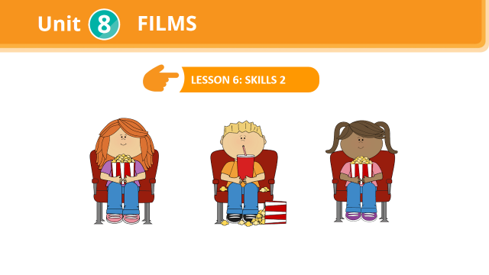
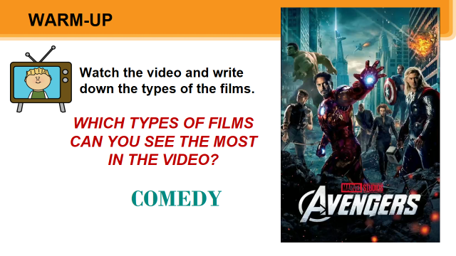 |  | 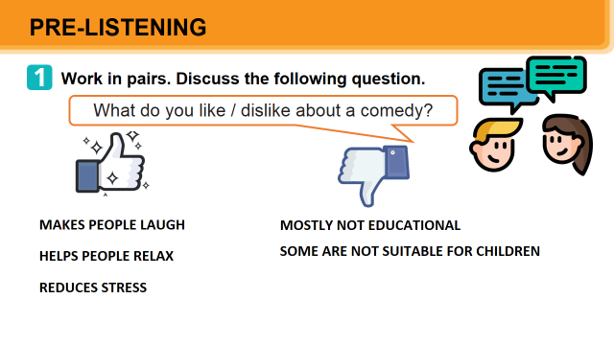
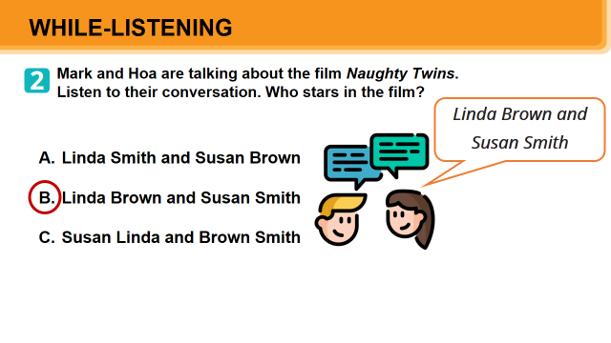 |  | 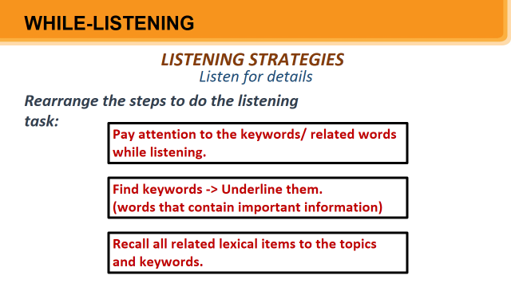
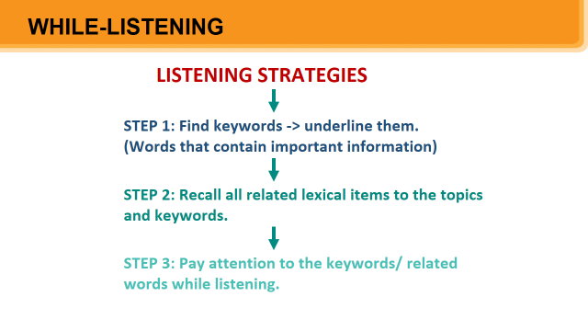 |  | 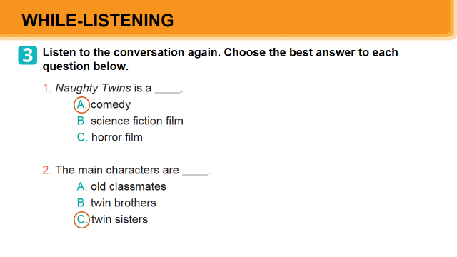
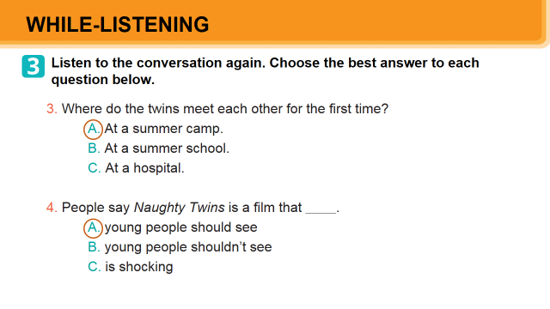 |  | 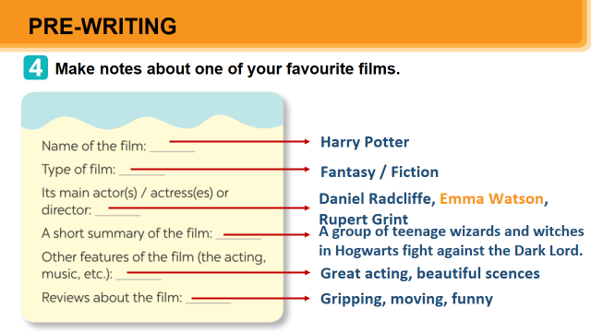
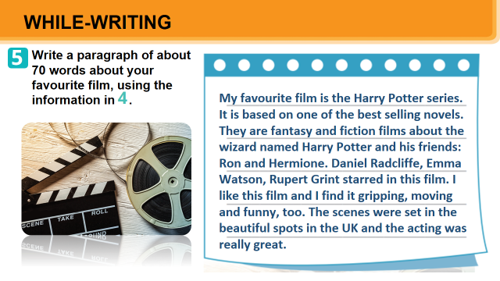 |  | 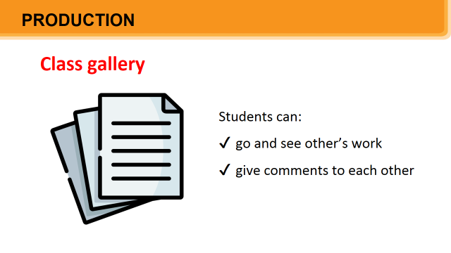
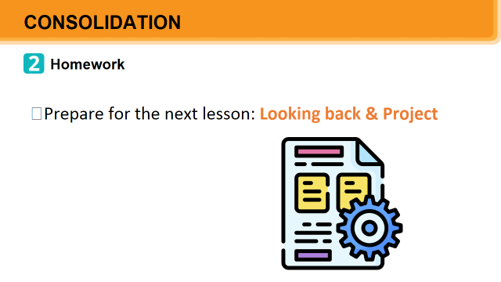 |  | 