**THỜI GIAN DẠY: THỨ 2- 01/3/2024 – TIẾT 04 BUỔI CHIỀU- LỚP 8A2- TIẾT 74 THEP PHÂN PHỐI CHƯƠNG TRÌNH**

*Date of preparing: February 12, 2024*

**UNIT 9: NATURAL DISASTERS**

***Total numbers of periods: 7 periods; from period 69 to period 75***

**LESSON 4: COMMUNICATION**

***Period: 72 Class: 8A2***

**I. OBJECTIVES**

**1. Knowledge:**

By the end of this lesson, Ss will be able to:

- Use the lexical items related to natural disasters.

- Practise giving and responding to bad news.

**2. Competences**

***- General competence:***

- Develop communication skills and creativity

- Be collaborative and supportive in pair work and teamwork.

- Actively join in class activities

***- Distinctive competence:***

+ Linguistic competence (Ss know how to acquire vocabulary, empathy, and cultural sensitivity to effectively convey and respond to bad news and natural disasters, employing appropriate language structures, tones, and communication strategies)

**3. Values:**

+ Responsibility (Ss understand their duty to convey information accurately)

+ Diligence (Ss show consistent effort in communicating effectively and assisting those affected)

**II. TEACHING AIDS AND MATERIALS**

**1. Materials**

- Grade 8 textbook, lesson plan, workbook, the teacher’s book, reference books, pictures and flashcards

**2. Equipment:**- Computer connected to the internet, - TV, hoclieu.vn

**III. TEACHING PROCEDUCES**

**1. WARM-UP (5ms)**

**a. Aims:**

**-** To create an active atmosphere in the class before the lesson.

- To lead into the new lesson.

**b. Content:** Answering the questions

**c. Expected products:** Ss can answer the questions about the picture.

**d. Organization of activities:**

- Teacher shows a picture about one disaster and asks the two questions:

1*. What do you see in the picture?*

*2. How do you feel?.*

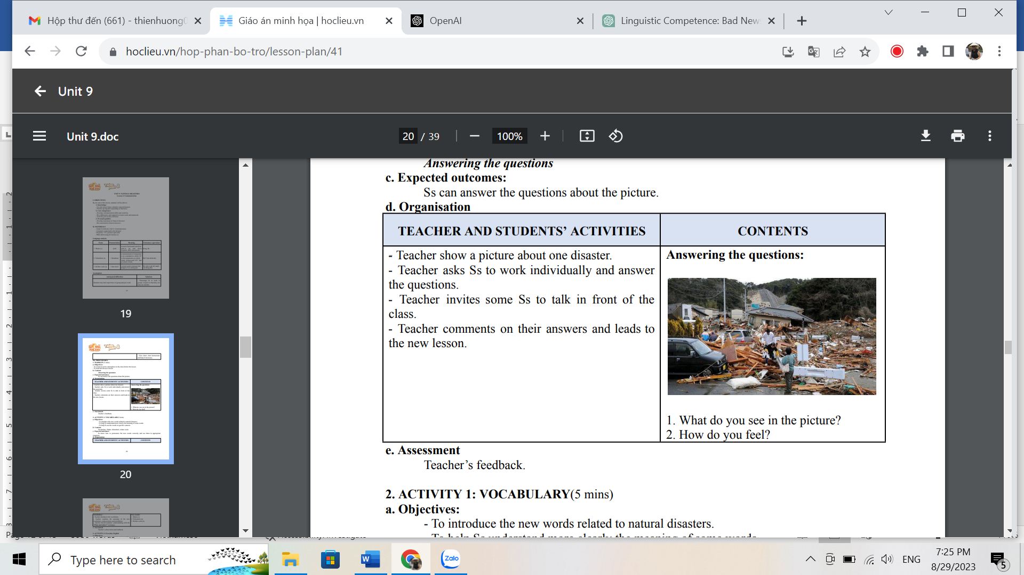

- Teacher asks Ss to work individually and answer the questions.

- Teacher invites some Ss to talk in front of the class.

- Teacher comments on their answers and leads to the new lesson.

**2. KNOWLEDGE FORMATION ACTIVITIES (7 ms)**

**a. Aims:**

- To introduce the new words related to natural disasters.

- To help Ss understand more clearly the meaning of some words.

- To help Ss use the words in specific contexts.

**b. Content:** Vocabulary: Shake, fahrenheit, richter scale

**c. Expected products:** Ss know how to pronounce the new words correctly and use them in appropriate situations.

**d. Organization of activities**

- Teacher introduces the vocabulary.

- Teacher explains the meaning of the new vocabulary, using pictures and translation. - Teacher checks students’ understanding with the “What and where?” technique.

**New words: 1. Shake (v) 2. Fahrenheit (n) 3. Richter scale (n)**

- Teacher observe and give feedback.

**3. PRACTICE ACTIVITIES (28 ms)**

**ACTIVITY 1: EVERYDAY ENGLISH**

**Task 1: (6 ms)**

**a. Aims**

- To introduce ways of giving and responding to bad news.

**b. Content:**

- Listen and read the dialogue below. Pay attention to the highlighted sentences.

**c. Expected products:** Ss know how to give and respond to bad news

**d. Organization of activities:**

- Teacher plays the recording for Ss to listen and read the dialogue between Mark and Phong.

- Teacher asks Ss to pay attention to the highlighted sentences and tells them that these are two ways to give and respond to bad news.

- Teacher has Ss practise the dialogue in pairs.

- Teacher calls on some Ss to practise the dialogue in front of the class.

­

**Task 2: (7 ms)**

**a. Aims:** - To help Ss practise giving and responding to bad news.

**b. Content:** - Work in pairs. Practise giving and responding to bad news in the following situations.

**c. Expected products:** Ss can give and respond to bad news

**d. Organization of activities:**

- Teacher asks Ss to work in pairs to read the given situations

*Situations: – You have a friend in a mountainous area. A landslide destroyed his family’s garden yesterday. You share this news with your classmate.*

*– You hear that a big earthquake hit a city. You share this news with your classmate.*

- Teacher asks Ss to make similar dialogues, using the language they have learnt.

- Ss use the language and make similar dialogues.

- Teacher moves around to observe and provides help.

- Teacher calls on some pairs to practise in front of the class.

- Teacher comments on their performance.

**ACTIVITY 2: KNOWLEDGE OF NATURAL DISASTERS.**

**Task 3: (7 ms)**

**a. Aims:** - To help Ss identify the natural disasters described in the short texts.

- To check Ss’ knowledge of different natural disasters via a questionnaire.

- To provide Ss with a chance to communicate with each other and confirm their knowledge of natural disasters.

**b. Content:** - Read the short passages below. Decide which natural disaster each person below is talking about.

- Work in pairs. Compare your answers. Then check your answers with the key on page 101. How many points did each of you get?

**c. Expected products:** Ss know more about natural disasters.

**d. Organization of activities:**

- Teacher asks Ss to work in pairs to read the three short texts and decide what natural disaster each person is talking about.

- Teacher asks Ss to prepare an explanation for their answers.

- Teacher elicits answers from Ss.

- Teacher confirms the correct answers.

**Task 4: (8 ms)**

**a. Aims:** - To check Ss’ knowledge of different natural disasters via a questionnaire.

**b. Content:** . Choose the correct answer to each question to see how much you know about natural disasters.

**c. Expected products:** appropriate choice.

**d. Organization of activities:**

- Teacher tells Ss that they are going to answer a questionnaire to see how much they know about natural disasters.

- Teacher has Ss read through the questionnaire quickly and explain any new words.

- Teacher asks Ss to answer the questions individually.

Answers: A 2. B 3. C 4. B 5. C 6. A

**4. APPLICATION ACTIVITIES (5 ms)**

**Task 5: (5ms)**

**a. Aims:** - To provide Ss with a chance to communicate with each other and confirm their knowledge of natural disasters.

**b. Content:** Work in pairs. Compare answers. Then check your answers with the key on page 101. How many points did each of you get?

**c. Expected products:** Ss can earn the highest points

**d. Organization of activities:**

- Teacher asks Ss to work in pairs to compare their answers.

- Teacher asks Ss to note down the answers and then check them with the key on page 101.

- Teacher has Ss calculate the points each of them earns.

- Teacher asks some Ss to report their answers and points to the class.

|  |
| --- |
| **HANDOUT** |