Date of preparation: October 25th, 2025 Teacher: Tran Thi My
Group: EL – PE – ARTS
UNIT 3: FRIENDS
Period 27: LESSON 2.2- GRAMMAR
Subject: English Classes: 6A2

Time expected to complete the topic: 9 periods
I. OBJECTIVES
1. Knowledge
- use the Present Continuous for future use.
2. Competences:
- General competence:
+ Self-controlled and self-learning competence (students know how to use the Present Continuous).
+ Communicative and cooperative competence (collaboration, creativity, communication)
- Distinctive competence:
+ improve speaking skill, writing skill.
+ improve the use of English.
3. Values
- have positive attitude in English language learning so that they actively participate in all classroom activities.
- make a plan for their near future activities.
II. TEACHING AIDS AND MATERIALS
- Material: Lesson plan, PPT slides, student’s book, workbook, notebook, personal computer (if any),
- Equipment: projector/TV, speakers, DCR & DHA on Eduhome, handouts…
III. TEACHING PROCEDURES
I. WARM UP: (5ms)
a. Aims: Introduce the new lesson and set the scene for Ss to acquire new language; get students' attention at the beginning of the class by means of enjoyable and short activities as well as to engage them in the steps that follow.
b. Content: Revision of Present Continuous
c. Product: Ss have general ideas about Present Continuous for future plans
d. Organization of the activities:
- Have Ss rearrange the words / phrases to make a meaningful sentence (format: ioe.vn) (T can use about 4-6 sentences)
- Call Ss to give answers
- Check, correct Ss’ answers if necessary
Lead to the new lesson.

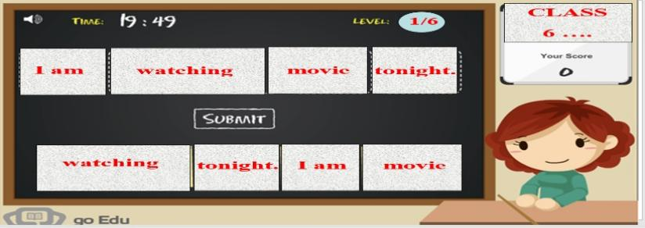
2. KNOWLEDGE FORMATION ACTIVITIES (5MS)
a. Aims: Ss can use the present continuous tense for fixed future plans. Ss usually use future time expressions such as this weekend, on Saturday, tomorrow, tonight, etc.
b. Content: Revision of Present Continuous
c. Product: Ss have general ideas about Present Continuous for future plans
d. Organization of the activities:
- Give a small exercise. Have Ss use the words given to fill in the blanks
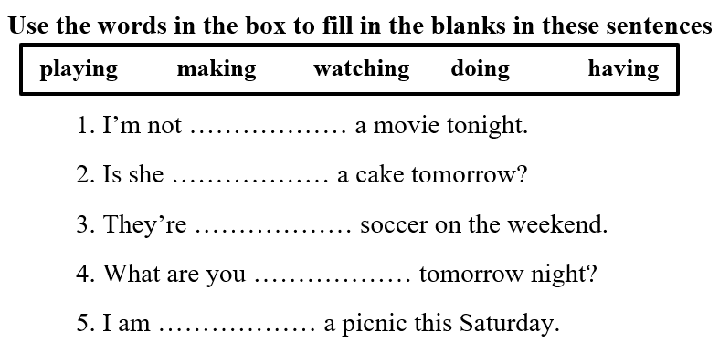
- Have Ss read their answers
- Check, ask Ss to focus on the tense used in these sentences
Answer keys
1. watching 2. making 3. playing 4. doing 5. having
- Lead to the new lesson
3. PRACTICE ACTIVITIES (28MS)
Tast 1: (10 ms)
a. Aims: Ss know how to use the Present Continuous for future plans.
b. Content:
- Listen and repeat
- Grammar explanation
c. Products: Ss can use the Present Continuous to talk about their plan for future activities.
d. Organization of the activities:
- Have Ss look at the picture
- Play the audio (CD1 – Track 35), ask Ss to listen and read the speech bubbles
- Play the audio again and have Ss listen and repeat
*Grammar box:
- Ask Ss to make comments on the black bold verb form in the examples
- Have Ss retell the form and usage of the Present Continuous tense.
- Lead to the grammar table and explain the usage of the Present Continuous for future action
- Ask Ss to pay attention to the future time expressions
- Have some Ss read the sentences aloud
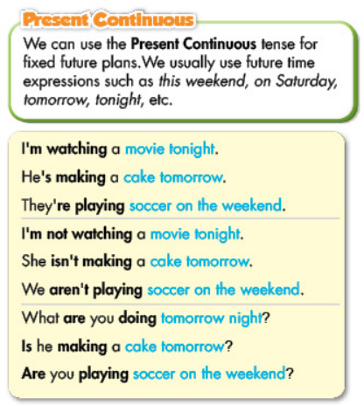

- Have Ss make more sentences, using the Present Continuous for future action
- Give feedback
- Work in pairs to make sentences
Suggested answers
1. I’m doing exercises tonight.
2. I’m having a cooking class this Saturday.
Tast 2: (8ms)
a. Aims: Ss can get used to using the Present Continuous for future activities
b. Content:
- Filling in the blanks, using the Present Continuous
c. Products: Ss can apply the use the Present Continuous in communication.
d. Organization of the activities:
- Use the example to demonstrate this activity
- Have Ss use the Present Continuous to fill in the blanks, draw attention to the negative and question form
- Have pairs check each other’s work
- Have Ss share their answers with the class by writing down on the board.
- Check Ss’ answers, correct if necessary

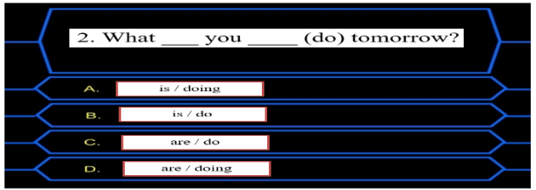

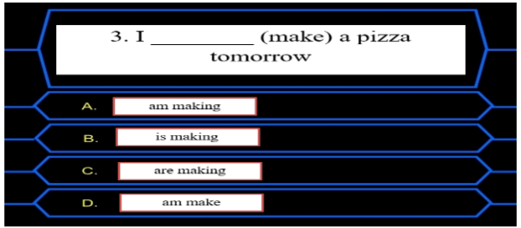

Answer keys
2. are / doing 3. am making
4. Are / having 5. is going
6. are playing 7. Is / watching
Tast 3 (10ms)
a. Aims: Ss can get used to using the Present Continuous for future activities in negative and yes / No question
b. Content:
- Writing full sentences, using the given words and the Present Continuous.
c. Products: Ss can apply the use the Present Continuous in communication.
d. Organization of the activities:
- Demonstrate the activity, using the example
- Let Ss write full sentences, using the prompts
- Go round and give help if necessary
- Have Ss work in pairs to check each other’s work
- Call Ss to write answers on the board
- Check and correct Ss’ answers
Answer keys
2. I am having a barbecue today.
3. Emma and Jane are not watching a movie on Sunday.
4. We are making a pizza this weekend.
5. Is David playing badminton this evening?
6. Is Maria watching TV with her sister tonight?
4. APPLICATION ACTIVITIES (7MS)
a. Aims: Ss can get used to using the Present Continuous for future activities to ask and answer
b. Content: Write true sentences about yourself, then ask your partner
c. Products: Ss can apply the use the Present Continuous in communication.
d. Organization of the activities:
- Have Ss work in pairs to write true sentences about themselves and ask their partner.
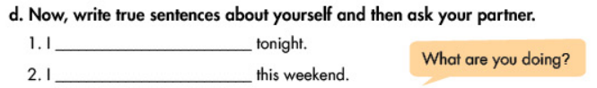
- Have some Ss demonstrate the activity in front of the class
- Give feedback and evaluation

HANDOUT

