Date of preparation: September 26, 2025 Teacher: Tran Thi My
Group: EL – PE – ARTS
UNIT 2: LIFE IN THE COUNTRY
Period 13 - Lesson 1.2: Grammar, pages 15 & 16

Subject: English Classes: 8A1

Time expected to complete the topic: 10 periods
I. Objectives
By the end of this lesson, students will be able to…
1. Language knowledge/ skills
- practice and use quantifiers with countable and uncountable nouns correctly
2.Competences
- General competence:
+ Self-controlled and self-learning competence (Sts know how life in the country is and find out the good things of life in the countryside)
+Communicative and cooperative competence (students know how to persuade their friends about the good thigs of countryside)
- Distinctive competence:
+Linguistic competence (students know how to use their native language and foreign language to indicate the evidence for their answers)
3. Values:
- Patriotism: love their hometown as well as be proud of the beauty of the countryside
II. Teaching aids and materials
- Teacher’s aids: Student’s book and Teacher’s book, class CDs, DCR– Phần mềm tương tác trực quan, DHA – Ứng dụng trò chơi tương tác, projector / interactive whiteboard /TV (if any), PowerPoint slides.
- Students’ aids: Student’s book, Workbook, Notebook.
III. Procedures
1. WARM UP: 5’
a. Objectives: to review lesson 1.1 and introduce the grammar point in the new lesson.
b. Content: categorizing activity.
c. Expected outcomes: Ss can put the words they learnt in lesson 1 into two groups: countable and uncountable.
d. Organization
Put the words below in the correct column: countable and uncountable nouns.
Air, noise, facility, vehicle, pollution, entertainment, transportation, people, nature, peace, thing, car.
Countable | Uncountable
- Ask students to work in pairs to put the words in the box into the correct column: countable and uncountable nouns.
- Pick some Ss to give their answers.
- Give feedback.
Answer Keys
Countable | Uncountable
air, noise, pollution, entertainment, peace, nature, transportation | facility, vehicle, people, thing, car

2. KNOWLEDGE INFORMATION: 15’
a. Objective: to help Ss know how to use lots of/a lot of, too many, too much, not enough correctly.
b. Content:. lots of/a lot of, too many, too much, not enough
c. Expected outcomes: Ss can talk life in the country and life in the city using lots of/a lot of, too many, too much, not enough.
d. Organization
Presentation:
-Introduce the usage of quantifiers with countable and uncountable nouns
- Ask Ss to underline quantifiers and circle the nouns after them:
1. There are lots of people.
2. There is too much work to do.
3. There are too many cars on the road.
4. There isn't enough time to play.
- Pick some Ss to underline quantifiers and circle the nouns on the board.
- Give feedback.
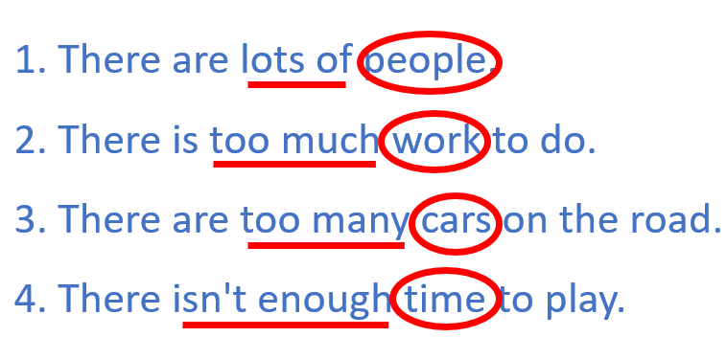
- Ask Ss to work in pairs to complete the rules with lots of/a lot of, too many, too much, not enough.
……………………means a large amount of something.
…………………….means the amount of something countable is more than you want.
……………………means the amount of something uncountable is more than you want.
…………………………means the amount is less than you want.
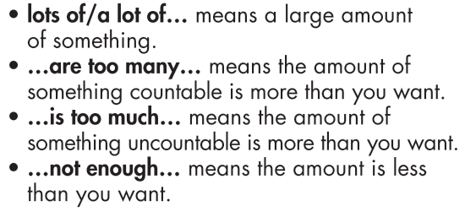
- Pick some Ss to fill in the blanks on the board.
- Give feedback.
- Remind Ss that too many, too much, not enough have a negative meaning
Task a-b page 15
a. Objective: to check sts’ knowledge about some quantifiers they have learnt by reading and listening to fill in the blnks
b. Content: Read, listen and fill in the blanks with suitable quantifiers
c. Expected outcomes: Ss can talk life in the country and life in the city using lots of/a lot of, too many, too much, not enough.
d. Organization

: Read about quantifiers with countable and uncountable nouns
- Ask Ss to work in pairs to fill in the blanks to complete the conversation (using the DCR/PPT slides).
Task b: Listen and check your answers. Listen again and repeat.
- Play the CD and ask Ss to listen and check.
- Play the CD again and ask Ss to repeat.
3. PRACTICE: 20’
Task a:
a. Objective: to help Ss practice using the correct quantifiers with countable and uncountable nouns.
b. Content: Read the examples on the left and circle the correct words.
c. Expected outcomes: Ss can use quantifiers correctly.
d. Organization:
1. There are too much/many vehicles on the road.
2. There aren't/isn't enough facilities in this village.
3. There is/are too much noise in my town.
4. This city doesn't have enough/many fresh air.
5. There isn't enough things to do/entertainment here.
6. There is lots of nature/vehicles here in the country.
- Ask Ss to read the sentences carefully and choose the correct words.
- Get Ss to check the answers with their partner and explain for their choices.
- Pick some Ss to give the answer and explain.
- Check Ss’ answers.
Answer Keys:
1. many 2. aren't 3. is
4. enough 5. Entertainment 6. nature
Task b:
a. Objective: to help Ss practice using the correct quantifiers with countable and uncountable nouns.
b. Content: Write sentences using the prompts.
c. Expected outcomes: Ss can use quantifiers correctly.
d. Organization:
- Get Ss to pay attention to the type of sentences (affirmative, negative or interrogative) to use the correct structure.
- Set the time and monitor the class.
1. There/lots/peace and quiet/my village
2. My town/not/have/enough/entertainment
3. This city/have/much/pollution
4. There/many/vehicles/my street
5. There/lot/room/people/play/my city
6. There/not/many/things/do/my village
- Ask Ss to write sentences using gerunds and the prompts.
- Let Ss check with their partner.
- Pick seven students to write seven sentences on the board.
- Check Ss’ answers (using the DCR/PPT slides).
- Write sentences using gerunds and the prompts.
Answer Keys
1. There is lots of peace and quiet in my village.
2. My town doesn't have enough entertainment.
3. This city has too much pollution.
4. There are too many vehicles in/on my street.
5. There is a lot of room for people to play in my city.
6. There aren't many things to do in my village.
4. APPLICATION:5’
a. Objectives: to help Ss to use the language in the real situation.
b. Content: Talk about your town using lots of/a lot of, not enough, too many, and too much.
c. Expected outcomes: Ss can talk about their hobbies, using verbs expressing preferences correctly.
d. Organization
Task c: In pairs:
- Ask Ss to work in pairs to talk about your town using lots of/a lot of, not enough, too many, and too much.
- Monitor the class and help them if necessary.
- Ask some Ss to talk about their town.
- Give feedback.
- Share their ideas.
Sample answer:
There are lots of vehicles in my hometown.
My city has too much noise.

HAND OUT

