Date of preparation: September 16th , 2025 Teacher: Pham Ngoc Trai
Group: EL- PE- ARTS
UNIT 2: LIFE IN THE COUNTRY
Period 15 - Lesson 2.1: Vocab & Reading, pages 18 & 19

Subject: English Classes: 8A4,5

Time expected to complete the topic: 10 periods
I. Objectives
By the end of this lesson, students will be able to…
1. Language knowledge/ skills
- learn and use vocab. related to life in the country and life in the city
- practice reading for gist and for detail
2.Competences
- General competence:
+ Self-controlled and self-learning competence (Sts know how life in the country is and find out the good things of lifein the countryside)
+Communicative and cooperative competence (students know how to persuade their friends about the good thigs of countryside)
- Distinctive competence:
+Linguistic competence (students know how to use their native language and foreign language to indicate the evidence for their answers)
3. Values:
- Patriotism: love their hometown as well as be proud of the beauty of the countryside
II. Teaching aids and materials
- Teacher’s aids: Student’s book and Teacher’s book, class CDs, DCR– Phần mềm tương tác trực quan, DHA – Ứng dụng trò chơi tương tác, projector / interactive whiteboard /TV (if any), PowerPoint slides.
- Students’ aids: Student’s book, Workbook, Notebook.
III. Procedures
1. WARM UP: 5’
a. Objective: to introduce the topic of the new lesson.
b. Content: Let’s talk!
c. Expected outcomes: Ss can talk leisure activities in the country.
d. Organization
In pairs: Look at the picture. What are the children doing? What else can children do for fun in the country?
- Ask Ss to work in pairs, to talk about what the children in the picture are doing and some more leisure activities in the country.
- Pick some Ss to share their ideas.
- Give feedback.
Sample answers:
Read books, play hide and seek, fly a kite
2. KNOWLEDGE INFORMATION: 15’
Task a:
a. Objective: to help Ss know more vocabulary about leisure activities in the country.
b. Content:. Read the sentences, then match the words with the definitions. Listen and repeat.
c. Expected outcome: Ss can match the words with the definitions
talk about their favorite leisure activities.
d. Organization
- Ask Ss to read the sentences and the definitions, then underline key words to help guess the meaning of new words.
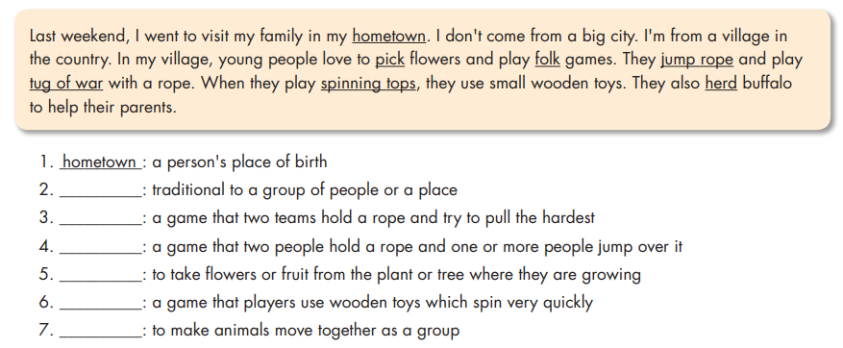
- Pick some Ss to share their ideas.
- Give feedback.

Answer Keys:
1. __________: a person's place of birth
2. __________: traditional to a group of people or a place
3. __________: a game that two teams hold a rope and try to pull the hardest
4. __________: a game that two people hold a rope and one or more people jump over it
5. __________: to take flowers or fruit from the plant or tree where they are growing
6. __________: a game that players use wooden toys which spin very quickly
7. __________: to make animals move together as a group

- Ask Ss to match the words with their definitions.
- Let Ss check with their partners.
- Pick some Ss to give their answers.
- Check their answers.
Answer Keys:
1. hometown 2. Folk
3. tug of war 4. jump rope
5. Pick 6. spinning tops 7. herd

- Ask Ss to listen and repeat chorally.
- Pick some Ss to say the words and correct their pronunciation if necessary.
- Check their memory by playing a game in pairs: Student A say the definition, Student B say the word (with books closed).
Task b.
a. Objective: to help Ss know more vocabulary about leisure activities in the country.
b. Content:. Talk about what you like to do when you visit places in your country.
c. Expected outcome: Ss can talk about their favorite leisure activities.
d. Organization
- Ask Ss to read the sentences and the definitions, then underline key words to help guess the meaning of new words.
-Ask Ss to work in pairs to talk about what they like to do when they visit places in the country and say the reasons.
- Pick some Ss to share their ideas.
- Give feedback.

Sample answers:
A: When I go to my hometown, I like to play soccer with my friends.
B: I prefer to play folk games with my family.

3. PRACTICE: 20’

Reading:
- Objective: to help Ss Read through the blog post and choose the main idea
practice reading for gist and for specific information.
b. Content: tasks a, b, and c.
c. Expected outcomes: Ss can figure the main idea and answers the questions about details.
d. Organization:
Task a: Read Vy's blog post. What does she mostly talk about?
1. popular activities in her hometown
2. her family's favorite folk games
- Introduce the task.
- Ask Ss to read through the blog post and choose the main idea.
- Give Ss some time to read.
- Pick some students to give their answers and justify their choice.
- Give feedback.
Answer Keys:
- popular activities in her hometown
(They prefer to play outdoors. They play
sports and folk games. The girls love to jump rope and pick flowers. The boys love to play tug of war and soccer.)

Task b .
a.Objective: to help Ss practice reading for gist and for specific information.
b. Content: read and circle the correct answers
c. Expected outcomes: Ss can figure the main idea and answers the questions about details.
d. Organization:
- Ask Ss to read the questions and underline the key words.
- Pick some Ss to share their ideas.
- Give feedback.
1. Where was Vy last week?
A. in Ho Chi Minh City B. in her hometown C. in another country
2. What don't kids do in Vy's hometown?
A. play computer games B. pick flowers C. play soccer
3. What do girls like to do in Vy's hometown?
A. play spinning tops B. play tug of war C. pick flowers
4. What do boys like to do in Vy's hometown?
A. jump rope B. play tug of war C. herd buffalo
5. What does the word it in paragraph 4 refer to? A. a game B. a song C. a place

Answer keys:
1. Where was Vy last week?
2. What don't kids do in Vy's hometown?
3. What do girls like to do in Vy's hometown?
4. What do boys like to do in Vy's hometown?
5. What does the word it in paragraph 4 refer to?

- Ask Ss to read the blog post and choose the best answer for each question.
- Let Ss check with their partner.
- Pick some students to give their answers and give evidence for their choices.
- Confirm the answers.
- Give their answers.
Answer keys:
1. B – hometown (Sorry I didn't post anything last week! I couldn't use my computer because I wasn't at home. I visited my family in my hometown.)
2. A - play computer games (Here, the kids never play computer games, and they rarely watch TV.)
3. C - pick flowers (The girls love to jump rope and pick flowers.)
4. B - play tug of war (The boys love to play tug of war and soccer.)
5. A- a game (I prefer to play chess because it's more relaxing than some folk games. My uncle and I sometimes sit down and play it under a tree.)
4. APPLICATION: 5’
Task d: In pairs
a. Objective: to give Ss opportunities to talk about their favorite folk games.
b. Content: Which folk games do you like? Why?
c. Expected outcomes: Ss can talk about the folk game they like and say why.
d. Organization:
- Ask Ss to work with their partner to talk about the folk game they like and state the reasons.
- Pick some Ss to share their ideas.
- Give feedback.
Sample answers:
I really like tug of war because it's exciting,
and many people can play it together.

HAND OUT

