*Date of preparation: September 6th, 2025 Teacher: Tran Nguyen Huu*

*Group: EL – PE – ARTS*

**UNIT 1: HOME**

**Period 3: LESSON 1.2 - GRAMMAR**

Subject: English Classes: 6A1

Time expected to complete the topic: 9 periods

**I. OBJECTIVES:**

**1. Knowledge:**

* Grammar: The present simple with Yes/ No questions.

*By the end of the lesson, students will be able to:*

- improve speaking skills, writing skills.

- improve the use of English.

**2. Competences:**

- General competence:

+ Self-controlled and self-learning competence (students know how to use the present simple)

+ Communicative and cooperative competence (students know how to get someone’s attention)

- Distinctive competence:

+Linguistic competence (students know how to use their native language and foreign language to ask about people’s homes)

**3. Values:**

+ Responsibility (students are aware of loving their homes)

+ Diligence (students work better to talk about people’s home)

**II. TEACHING AIDS AND MATERIALS:**

**1. Materials:** Grade 6 textbook, lesson plan, workbook, the teacher’s book, reference books

**2. Equipment:** TV, cassettes, pictures, cards, handouts, extraboards, sachmem.vn, On-line websites …

III. PROCEDURES:

**1. WARM-UP (5MS)**

**a. Aims:** -To create an active atmosphere in the class before the lesson

- To lead into the lesson

**b. Content:** Playing the game “Jumbled word” to get Ss to make a meaningful words.

**c. Expected Products:** Ss can review the words about the topic “Home”.

**d. Organization of activities:**

- Lets Ss play the game “Jumble word”

- Gives Ss some letters.

1. dary 2. areagg 3. calnoby

4. oolp 5. dargne 6. tikench

- Has Ss rearrange letters to make a meaningful word.

- Call. Ss to give answers.

- Check Ss’ answers, gives feedback and lead to the new lesson

- Leads to the new lesson.

**\*Answers keys**

1. yard 2. garage 3. balcony 4. pool 5. garden 6. kitchen

**2. KNOWLEDGE FORMATION ACTIVITIES (5MS)**

**a. Aims:** To help Ss know how to use the Present Simple.

**b. Content:** The usage of the Present Simple

**c. Expected products:** Ss can use the Present Simple in everyday communication.

**d. Organization of activities:**

**\* Task a: Listen and repeat**

- Has Ss look at the picture

- Plays audio (CD1 – Track 05) and have Ss listen and read the speech bubbles

- Plays audio again and have Ss listen and repeat

- Has Ss look at the grammar explanation

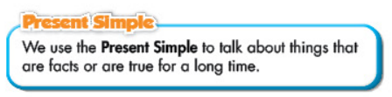

- Has Ss look at the box with the different forms

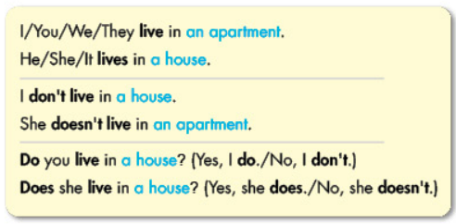

- Explains more about the form and the usage of the Present Simple, has Ss pay attention to the negative and the question form

***Form:***

*Be: (+) S + am / is / are + …*

*(-) S + am / is / are + not + …*

*(?) Am / Is / Are + S + …*

*Normal verb: (+) S + V s/es*

*(-) S + don’t / doesn’t + V bare infinitive*

*(?)Do / Does + S + V bare infinitive*

***Usage:*** *to talk about things that are facts or are true for a long time*

- Has some Ss read the sentences in the Grammar Box aloud

- Asks Ss to give more examples using the Present Simple

**3. PRACTICE ACTIVITIES (28MS)**

**a. Aims:** To help Ss know how to use the Present Simple.

**b. Content:** The usage of the Present Simple with exercise.

**c. Expected products:** Ss know how to use them in appropriate situations.

**d. Organization of activities:**

**\* Task b: Fill in the blanks with the correct form of the verbs.**

- Demonstrates the activity, using the example.

- Has Ss fill in the blanks with the correct form of the verbs.

- Has Ss work in pairs to check each other’s work.

- Lets some Ss share their answers with the whole class.

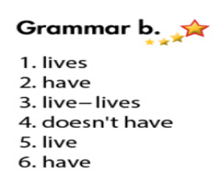- Gives feedback, correct Ss’ answers if necessary.

**\* Task c: Look at the table and write Alex’s answers.**

- Demonstrates the activity, using the table.

- Asks Ss to write Alex’s answers.

- Has Ss work in pairs to check each other’s work .

- Has some Ss share their answers with the whole class (Write on the board).

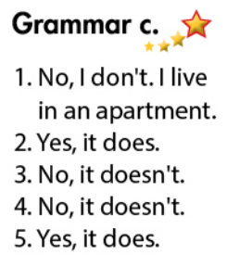- Checks, corrects Ss’ answers.

**4. APPLICATION ACTIVITIES ( 7’)**

**a. Aims:** - To help Ss use the Present Simple.

**b. Content:** Practice the conversation with your partner

**c. Products:** Ss produce the new language successfully, and they can apply the Present Simple in everyday speaking and writing.

**d. Organization of activities:**

- Has Ss do the task in pairs, then swap the roles.

- Lets Ss do the task in pairs to ask and answer about their house.

- Encourages Ss to use their own ideas to make up a dialogue-using the Present Simple.

- Calls Ss to demonstrate the activity in front of the class.

- Gives feedback and evaluation.

|  |
| --- |
| **HANDOUT** |