Date of preparation: 6/9/2025 Teacher: Pham Ngoc Trai
Group: EL- PE- ARTS
UNIT 1: FREE TIME
Period 4 -Lesson 1.3: PRONUNCIATION + SPEAKING

Subject: English Classes: 7A1

Time expected to complete the topic: 9 periods
I. OBJECTIVES:
1. Knowledge:
* Pronunciation: the sound /eɪ/
* Vocabulary: the words relating to hobbies
* Grammar: time expressions of the Simple Present
By the end of the lesson, students will be able to:
- pronounce the sound /eɪ/ correctly
- ask and answer about free time activities, using time expressions of the Simple Present
- conduct a survey about hobbies
2. Competences:
- General competence:
+ Self-controlled and self-learning competence (students know how to adapt themselves to ask and answer about free time activities)
+ Communicative and collaborative competence (students can talk to their classmates about hobbies)
- Distinctive competence:
+Linguistic competence (sts know how to pronounce the sound /eɪ/)
3. Values:
+ Diligence (sts practice the sound /eɪ/ regularly to pronounce it better)
II. TEACHING AIDS AND MATERIALS:
1. Materials: Grade 7 textbook, workbook, lesson plan, the teacher’s book, reference books, …
2. Equipment: TV, cassettes, pictures, cards, handouts, extra-boards, Digital Book (DCR phần mềm tương tác SB, DHA (từ vựng/ cấu trúc) phần mềm trò chơi tương tác), …
III. TEACHING PROCEDURES:
1. WARM-UP (5MS)
a. Aims:
- To revise the words relating to hobbies
- To introduce the new lesson and set the scene for sts to acquire new language
- To get students' attention at the beginning of the class by enjoyable and short activities as well as to engage them in the follow-up steps
b. Content: Match the words in A with those in B to make a meaningful phrase about hobby
c. Expected products: Students match the words about hobbies
d. Organization of activities:
- Divides the class into 4 groups
- Gives them a clear paper and asks them to write down their answers
- Shows the table having 2 columns: A and B with the words related to hobbies
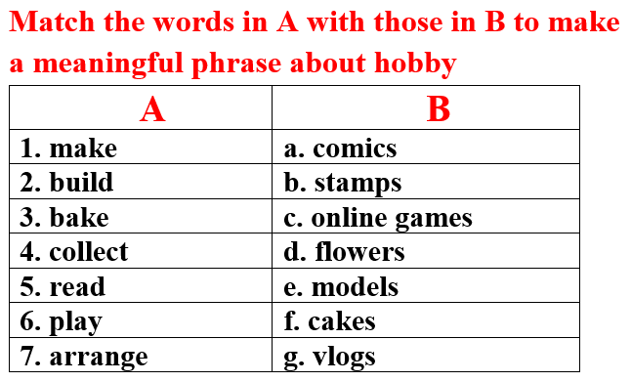
- Decides the winner who has the correct answers with the least running time
*Answer keys:
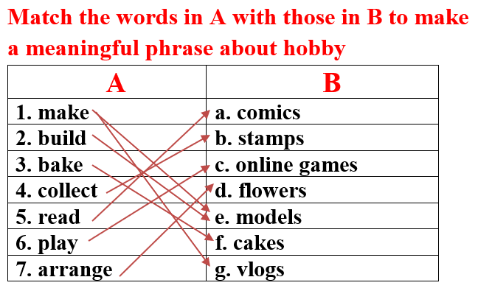
- Leads to the lesson
2. KNOWLEDGE FORMATION ACTIVITIES (7MS)
a. Aims: To know how to pronounce the sound /eɪ/
b. Content: The words have the sound /eɪ/
c. Expected products: Students know and pronounce the sound /eɪ/ correctly
d. Organization of activities:
- Briefly explains the sound /eɪ/
- Introduces some words which have this sound: make, bake, game, play
- Plays the recording and gets sts to repeat the words chorally, then individually
- Nominates individuals to read the words aloud
- Checks students’ pronunciation and corrects
- Gives feedbacks
3. PRACTICE ACTIVITIES (26MS)
Task 1: (6’)
a. Aims: To pronounce the sound /eɪ/ correctly
b. Content: Listen and cross the word that doesn’t have /eɪ/ sound
c. Expected products: Students read and cross the word that doesn’t have /eɪ/ sound, then read the words with the sound /eɪ/
- Answer key: car
d. Organization of activities:
-Tells sts about what they are going to learn in task 1
- Plays the recording twice for sts to listen and cross out the option that doesn’t use /eɪ/ sound
- Calls sts to give their answers
- Plays the recording again and check answers as a whole class
- Has sts practice reading the words with a partner, using the noted sound
- Calls some sts to read in front of the class
- Asks sts to find more words containing the /eɪ/ sound: car
- Gives feedbacks
Task 2: (6’)
a. Aims: To help sts to know how to ask and answer about free time activities
b. Content: Ask and answer about free time activities, using time expressions of the Simple Present
c. Expected products: Sts can use the pictures and make the role-play about free time activities
- Answer keys: What do you do in your free time? – I bake cakes.
How often do you bake cakes? – I bake cakes few times a month.
…
d. Organization of activities:
- Uses DCR to show the task
- Asks sts to retell about the hobby in each picture to review
- Retells about expressions of the Simple Present: once a week, every day, a few times a month, on the weekends, …
- Asks sts to make some sentences that have time expressions of the Simple Present
- Demonstrates the activity by asking and answering with a student:
+ What do you do in your free time? – I make vlogs.
+ How often do you make vlogs? – I make vlogs once a week.
- Has sts work in pairs to ask and answer, using the pictures.
- Reminds Ss to use the time expressions of the Present Simple
- Gives feedbacks
Task 3: (7’)
a. Aims: To help sts to share about your own free time activities
b. Content: Practice with students’ own ideas
c. Expected products: Sts can make the role-play about their free time activities
- Answer keys: What do you do in your free time? - I play online games.
How often do you play online games? – I play online games on the weekends.
…
d. Organization of activities:
- Has sts work in pairs and practice the conversation with their own ideas, then swap roles
- Invites some pairs to do the activity
- Gives feedbacks and evaluation
Task 4: (7’)
a. Aims: To help sts to conduct a survey about hobbies
b. Content: Complete the survey for yourself, then ask three more friends, and fill in the table
c. Expected products: The survey about students’ hobbies
- Answer keys: (It’s up to sts)
 | Hobby | How often | What else do you like doing?
Me
d. Organization of activities:
- Uses DCR to show the task
- Demonstrates the activity by practicing a role-play with a student
- Asks sts to fill in the table with their own information about hobbies first
- Then has sts work in groups of four, take turns to ask and answer about hobbies
- Asks sts to complete the table
- Moves around to observe and offer help if necessary
4. APPLICATION ACTIVITIES (7MS)
Task 5: (7’)
a. Aims: To report to the class about the survey results of group
b. Content: Answer the question: What is the most popular hobby in your group?
c. Expected products: The most popular hobby in each group
d. Organization of activities:
- Has some sts share their findings with the class
-Ask sts some more questions:
+ What’s your hobby? How often do you …?
+ What is the most popular hobby in your group?
+ Can you list other hobbies in your group?
+ In your group, is there any easy/difficult hobby?
- Gives feedbacks and evaluation

HANDOUT

