Date of preparation: 15/2/2025 Teacher: Pham Ngoc Trai
Group: EL – PE – ARTS

UNIT 8: FESTIVALS AROUND THE WORLD

Total numbers of periods: from 73 – 84
Period 73: Lesson 1.1. New words + Listening
Subject: English Classes: 7A_{4,5}

I. OBJECTIVES
1. Knowledge:
- know some new words about festivals around the world. (bonfire, race, lantern, competition, sculpture, water fight, hot-air balloon).
- talk about festivals around the world and their activities.
- read an article about 2 festivals in Japan and Australia to understand
1.2. Competences
- improve communication, collaboration, analytical and critical thinking skills.
1.3. Values
- be active to take part in outdoor activities.
- respect cultures of other countries in the world.
II. TEACHING AIDS AND MATERIALS
1.Materials : Student’s book and Teacher’s book, notebook, reference books…
2.Equipment: Lesson plan, PPT slides, student’s book, workbook, notebook, computer, projector/TV, speakers, DCR & DHA on EDUHOME, handouts…
III. PROCEDUCES:
1.WARM –UP (5MS)
a) Aim: Introduce the new lesson and set the scene for Ss to acquire new language; get students' attention at the beginning of the class by enjoyable and short activities as well as to engage them in the follow-up steps.
b) Content: Introduce words about festivals.
c) Expected Products: Ss have general ideas about the topic of the new lesson: Festivals around the world.
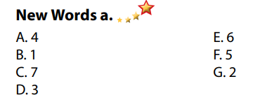
d) Organization of activities:
- Number the pictures. Listen and repeat.
- Uses the “New words” part a– page 60 for the warm-up activity.
- Shows words and pictures using DCR, has Ss look and number the pictures (in pairs).

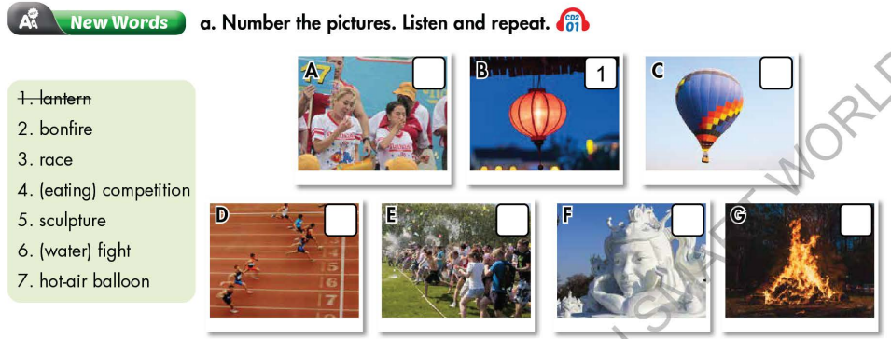
- Calls Ss to give answers.
- Gives feedback and shows correct answers using DCR.
- Lead to the new lesson.
- Plays the audio (CD2 – Track 01), has Ss listen and repeat
- Corrects Ss’ pronunciation if necessary.
2. KNOWLEDGE FORMATION ACTIVITIES (8MS)
- Pre-Reading (Vocabulary) (8’)
a) Aim: Ss know some words about festivals around the world.
b) Content:
- Vocabulary study: bonfire, race, lantern, competition, sculpture, water fight, hot-air balloon, …
- Number the pictures. Listen and repeat.
- Speaking: Say which of these you'd like to see or try.
c) Expected products: Ss know how to pronounce the new words correctly and use them in appropriate situations.
d) Organization of activities:
- Has Ss review the words in they have known in the warmup activity by giving a matching exercise. (T uses different pictures from those in the text book.)
- Has Ss do the matching in pairs and gives the meaning of the words.
- Calls Ss to give answers (read or write).
- Checks answers as a whole class.
- Calls some Ss to read the words again.
- Plays audio (CD2 – Track 01). Has Ss listen and repeat.
- Corrects Ss’ pronunciation.
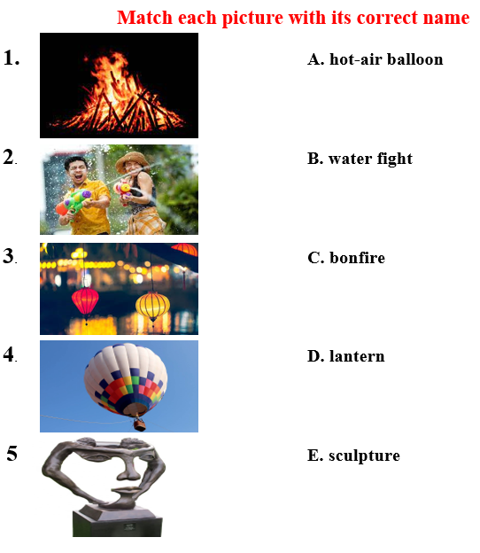
Task b. Say which of these you'd like to see or try.
- Has pairs discuss and say which of these they'd like to see or try.
- Reminds Ss to use the phrase: I’d like to …
- Has Ss share their answers in front of the class.
- Gives feedback and evaluation
3. PRACTICE ACTIVITIES (12MS)
a) Aim: Students can develop their reading skill.
b) Content:
- Read the article and choose the best title.
- Read and answer the questions.
c) Expected outcomes: Students can read an article and understand more about 2 famous festivals in the world.
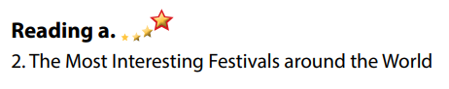
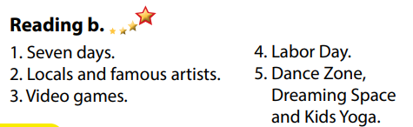
d) Organization of the activity:
Task a. Read the article and choose the best title.
- Asks Ss to scan the article, then choose the best title.
- Reminds Ss to underline or highlight the keywords or supporting ideas for their answers.
- Has some Ss share their answers with the class (read), explain for their answers.
- Gives feedback.
- Gives feedback and correct Ss’ answers if necessary.
4. APPLICATION ACTIVITIES ( 5 ms)
a) Aim: Students can use the vocabulary and ideas from the reading text to develop their speaking skill.
b) Content: Speaking: Would you like to visit the Sapporo Snow Festival or the Melbourne Moomba Waterfest? Why?
c) Expected products: Students can talk about a festival they would like to visit.
d) Organization of activities:
Task c. In pairs: Would you like to visit the Sapporo Snow Festival or the Melbourne Moomba Waterfest? Why?
- Has Ss work in pairs to answer the questions.
- Goes round and give help if necessary.
- Calls some Ss to share their ideas with the whole class.
- Gives feedback and evaluation.

