KẾ HOẠCH BÀI DẠY | Class: 8A3,4,5 (ILSW)
Teacher: Tran Nguyen Huu

UNIT 4: DISASTERS
Period: 38 Lesson 1: Vocab & Reading, pages 34 & 35

I. Objectives
By the end of this lesson, students will be able to…
1. Language knowledge/ skills
- learn and use vocab. related to disasters
- practice reading for gist, reading to recognize correct/incorrect/not given information
2.Competences
- General competence:
+ Self-controlled and self-learning competence (Sts know how the effects of natural disasters)
+Communicative and cooperative competence (students know how to persuade their friends to protect the environment and reduce natural disasters)
- Distinctive competence:
+Linguistic competence (students know how to use their native language and foreign language to indicate the evidence for their answers)
3. Values:
-Responsibility:
Be aware of the effects of natural disaters and their responsibility of reducing these effects
II. Teaching aids and materials
- Teacher’s aids: Student’s book and Teacher’s book, class CDs, DCR– Phần mềm tương tác trực quan, DHA – Ứng dụng trò chơi tương tác, projector / interactive whiteboard /TV (if any), PowerPoint slides.
- Students’ aids: Student’s book, Workbook, Notebook.
III. Procedures
1. WARM UP: 5’
a. Objectives: to introduce the topic.
b. Content: Let’s talk.
c. Expected outcomes: Ss can talk about the disasters they see in the picture and some more disasters happening in Vietnam.
d. Organization
In pairs: Look at the picture. What do you think happened? What types of disasters happen in your country?
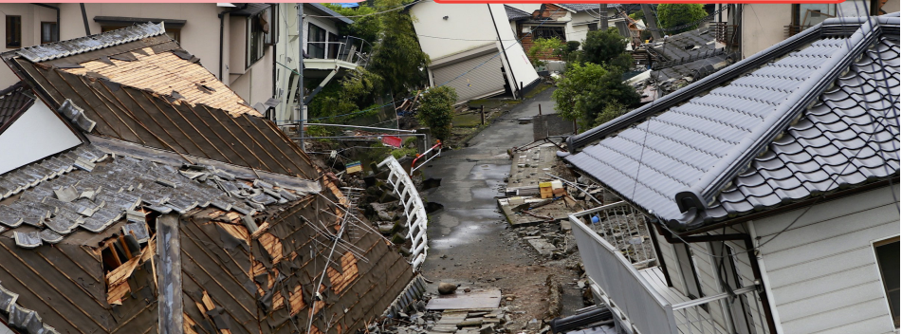
- Ask Ss to work in pairs, look at the picture and answer the questions (using the DCR/ PPTs slides).
- Call some pairs to give their answers.
- Give feedback.

2.KNOWLEDGE FORMATION ACTIVITIES:15’

Task a:
a. Objectives: to help Ss improve their vocabulary about disasters.
b. Content: . Match the words with the pictures. Listen and repeat
c. Expected outcomes: Ss can name correct natural disasters.
d. Organization
- Ask Ss to work in pairs and match the words with the pictures (using the DCR).
- Check Ss’ answers around the class.
- Ask Ss to listen and repeat.
Answer Keys:
1. typhoon 2. earthquake
3. tsunami 4. flood
5. wildfire 6. blizzard
7. heat wave 8. drought
9. landslide 10. avalanche

Task b: Use the new words to talk about disasters you read or heard about
a. Objectives: to help Ss improve their vocabulary about disasters.
b. Content: . Match the words with the pictures. Listen and repeat
c. Expected outcomes: Ss can name some natural disasters.
d. Organization
- Ask Ss to work with their partner to talk about disasters they read or heard about, using the new words.
- Go around the class to help if necessary.
- Pick some Ss to talk about their partner.
- Give feedback.
Sample answer:
I read about a tsunami in Thailand.

3.PRACTICE ACTIVITITES: 20’

Task a:
a. Objectives: to help Ss practice reading for main idea and details.
b. Content: Read the quick facts on a website about a famous disaster. Which of the following topics is NOT mentioned?
A. Where it happened
B. The damage it caused
C. How people stayed safe
c. Expected outcomes: Ss can read for main idea and specific information about a famous disaster named Typhoon Tip.
d. Organization:
- Ask Ss to read the facts about the disaster and choose the topic that is not mentioned.
- Pick some Ss to give the answer and show where the other topics are mentioned.
- Check Ss’ answers.
Answer Keys: Jess
C. How people stayed safe
(A can be found in “Where was Typhoon Tip?”, and B can be found in “How much damage did Typhoon Tip cause?”)

Task b:
a. Objectives: to help Ss practice reading for main idea and details.
b. Content: read and write True, False, or Doesn't say.
c. Expected outcomes: Ss can read for main idea and specific information about a famous disaster named Typhoon Tip.
d. Organization:
- Ask Ss to read carefully and decide True, False, or Doesn’t say.
- Set the time and monitor the class.
- Pick some Ss to give their answers and evidence for their choices.
According to the website,
1. Typhoon Tip was the biggest tsunami ever. ______
2. the typhoon affected Japan, South Korea, and Vietnam. _______
3. Typhoon Tip lasted longer than any other storm. ______
4. the storm damaged more than twenty thousand homes. ______
- Ask Ss to read the phrases and underline the key words.
- Get Ss to scan the text to find the key words.

Answer keys:
According to the website,
1. Typhoon Tip was the biggest tsunami ever.
2. the typhoon affected Japan, South Korea, and Vietnam.
3. Typhoon Tip lasted longer than any other storm.
4. the storm damaged more than twenty thousand homes.

- Check Ss’ answers (using the DCR).

Answer Keys
1. False (The biggest typhoon was Typhoon Tip.)
2. False (It affected parts of many countries including Japan, the Philippines, North and South Korea, and China.)
3. Doesn't say (Typhoon Tip lasted from October 4 to October 24, 1979.)
4. True (In Japan, floods damaged twenty-two thousand homes.)

Task c:
a. Objectives: to help Ss practice reading for main idea and details.
b. Content: Ss listen and read again
c. Expected outcomes: Ss can read for main idea and specific information about a famous disaster named Typhoon Tip.
d. Organization:

Listen and read.
- Play the CD and ask Ss to listen and read aloud.
- Pick three Ss to read the three passages aloud and correct their pronunciation if necessary.

4.APPLICATION ACTIVITIES: 5’
a. Objectives: to help Ss to use the language and information in the real situation.
b. Content: What is the most surprising about
Typhoon Tip?
c. Expected outcomes: Ss can compare and contrast their hobbies with those of the people in the passages.
d. Organization
In pairs: What is the most surprising about
Typhoon Tip?
- Ask Ss to work in pairs to say the most surprising about Typhoon Tip.
- Monitor the class and help them if necessary.
- Ask some Ss to share their ideas.
Sample answer:
I think the amount of damage is the most surprising.
- Give feedback.

HAND OUT

