Date of preparation: Sep,20th , 2024 Teacher: Pham Ngoc Trai
Group: EL- PE- ARTS

UNIT 2: LIFE IN THE PAST
Total numbers of periods: 10 periods; from period 12 to 21
Period 13: Lesson 1.2: Grammar (Pages 15 & 16)

Subject: English Class:9A2,3
I. Objectives
1. Language knowledge/ skills
- learn and use “would” for repeated past actions
- produce sentences using “would”
- improve Grammar and Speaking.
2. Competences:
- General competence:
+ Self-controlled and self-learning competence (students are aware of the tradition of family)
+Communicative and cooperative competence (students know how to share ideas with friends the roles of the man and woman in the past and now)
- Distinctive competence:
Learning about the nature and society: sudents know some traditions of extended family in the past and nuclear family nowadays
3. Values:
Patriotism: students love the tradition of family and proud of being Vietnamese.
II. Teaching aids and materials
- Teacher’s aids: Student’s book and Teacher’s book, class CDs, DCR– Phần mềm tương tác trực quan, DHA – Ứng dụng trò chơi tương tác, projector / interactive whiteboard /TV (if any), PowerPoint slides.
- Students’ aids: Student’s book, Workbook, Notebook.
III. Procedures
1. WARM UP : (5’ )
a. Aims To introduce the grammar point: “would”.
b. Content: Share the ideas with the class.
c. Expected products: Ss can talk about repeated past actions
d. Organization of activities:
Warm-up activities: Work in pairs and answer these questions.
- Divide Ss into pairs.
- Give Ss instructions and one example.
- Show questions for Ss to discuss.
- Call some pairs to give their answers.
- Give feedback.
Questions:
1. What activities would you regularly do with your friends when you were younger?
2. What special routines would you have before going to bed as a child?
3. What sports or games would you play with friends in your neighborhood?
4. What foods or snacks would you always eat when you were a child?

Suggested answers
1. When I was younger, I would regularly play jump rope with my friends.
2. Before going to bed, I would brush my teeth and put on my pyjamas.
3. In my neighborhood, we would often play soccer.
4. When I was a child, I would always eat ice cream.
2.KNOWLEDGE FORMATION ACTIVITIES. (15’)
a. Aims: To help Ss understand how to use “would” for repeated past actions
b. Content: Tasks a and b.
c. Expected products: Ss can make sentences using “would” for repeated past actions
d. Organization of activities:
Task a: Read about would, then fill in the blanks.
- Ask Ss to work individually and complete the task (using the DCR/ PPTs slides).
- Ask Ss to compare the answers with a partner.
- Check Ss’ answers around the class.
- Explain the use of “would” (using the DCR/ PPTs slides)
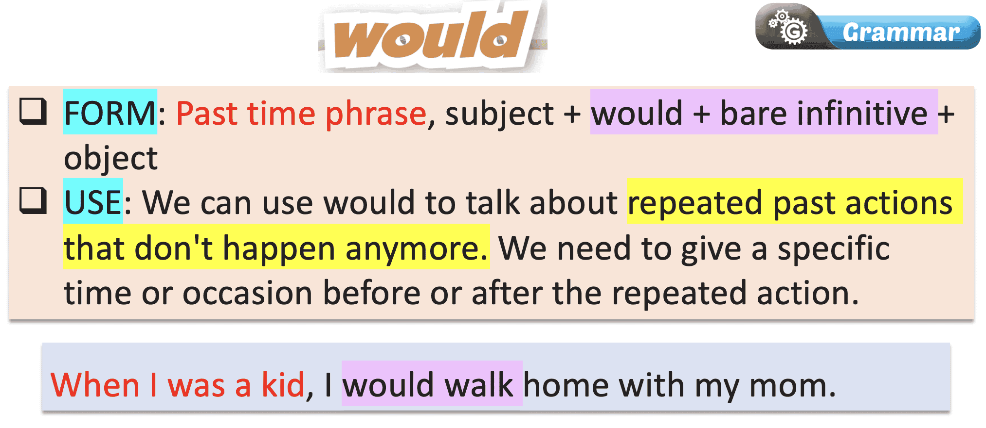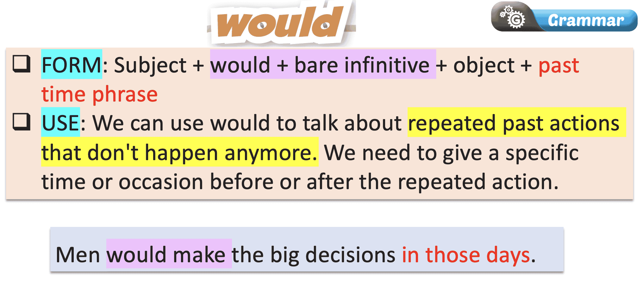
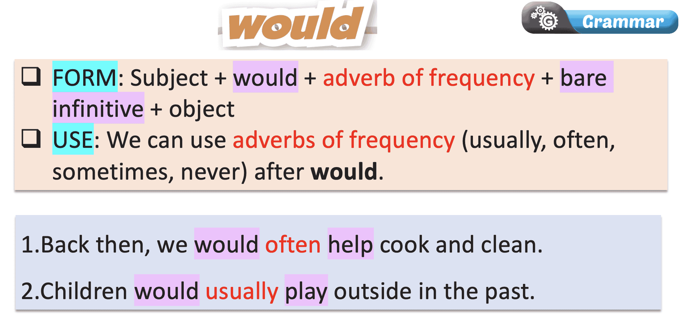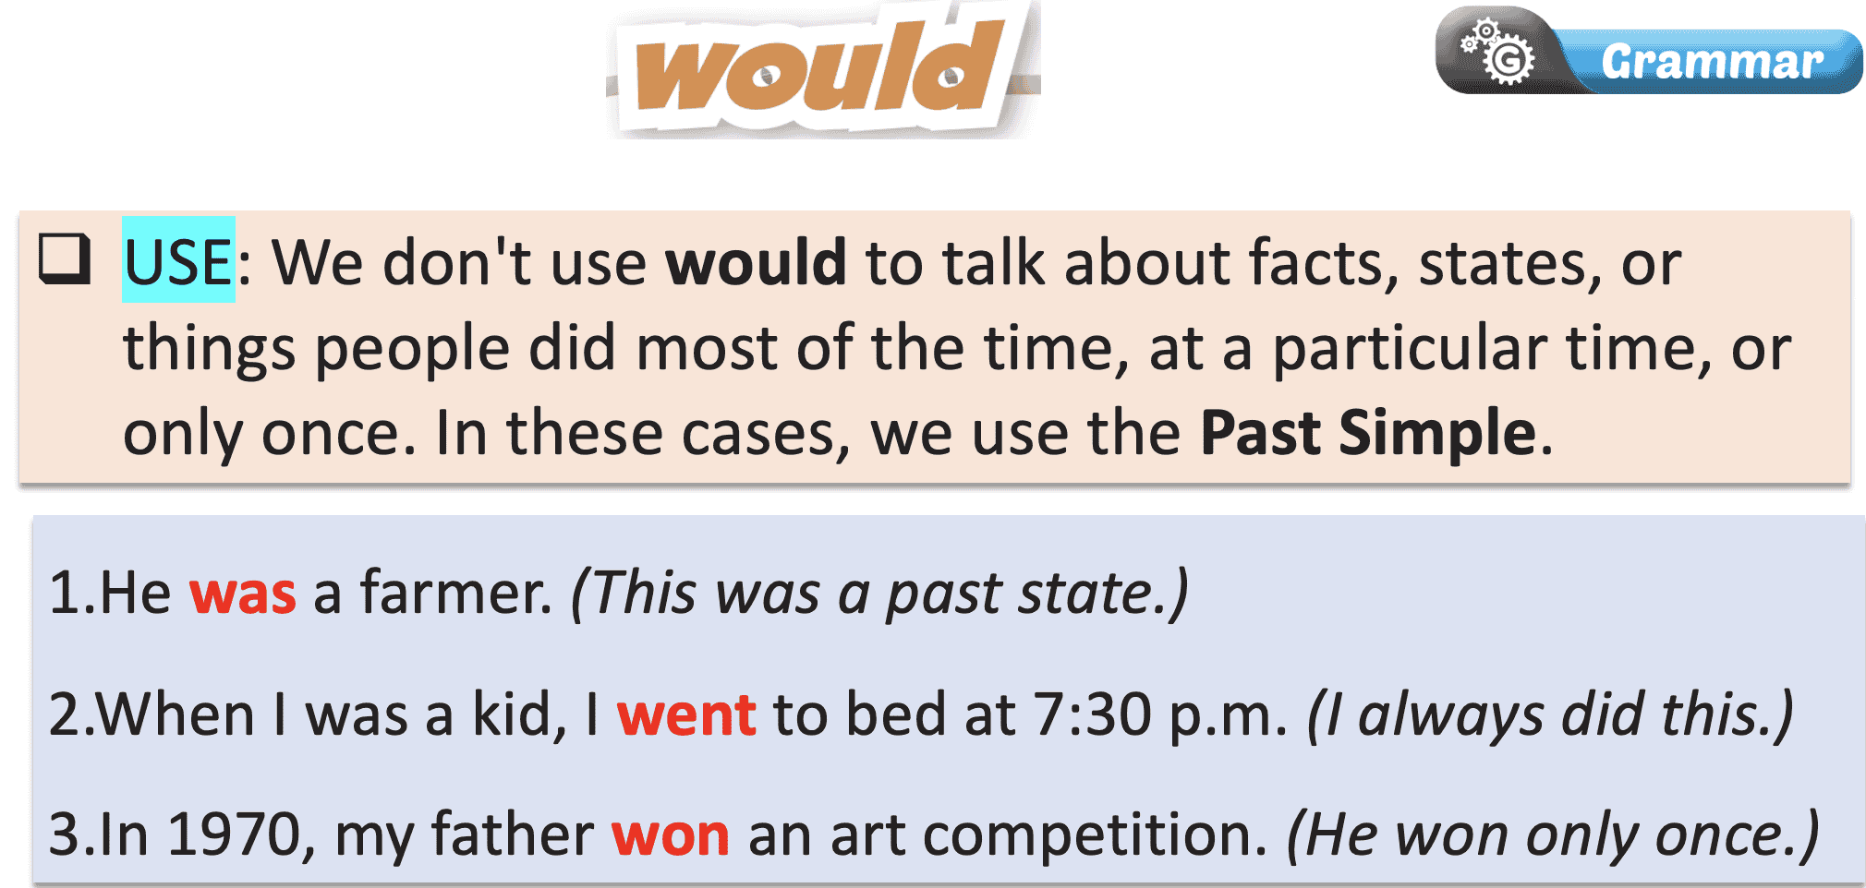
Task b: Listen and check. Listen again and repeat.
- Check Ss’ answers around the class.
Answer Keys:
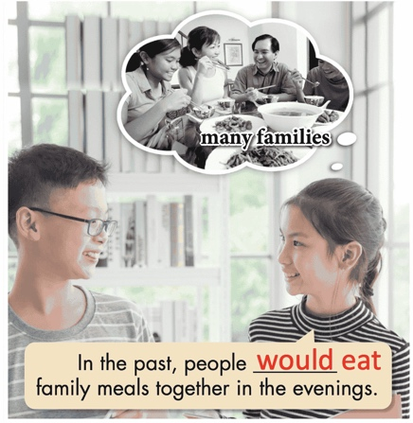
3. PRACTICE ACTIVITIES (15’)
a. Objectives: To help Ss practice the use of “would”.
b. Content: Tasks c and d.
c. Expected outcomes: Ss can practice the use of “would” and when to use them.
d. Organization:

- Listen to the instructions
- Complete the task.
- Compare the answers with a partner.
- Read the sentences out loud.

- Correct the answers
Answer Keys:
1. In the past, people would usually be home for family meals.
2. Back then, people would usually have five to ten children.
3. Fifty years ago, people would often live in extended
families.
4. A hundred years ago, the husband would often be the breadwinner.
5. Back then, women would become housewives after
getting married.
6. In the past, the mother would cook for the whole family.
Task d: Read the statements about life in the past and complete the sentences below using would or the Past Simple.
- Demonstrate the activity using the example.
- Ask students to complete the sentences using the statements and would or Past Simple.
- Have pairs check each other's work.
- Ask some students to share their answers with the class.
- Check Ss’ answers (using the DCR).

Answer Keys:
1. In the past, people often didn't live in nuclear families.
2. In the past, women would live with their families their whole lives.
3. Parents would make their children do a lot of chores back then.
4. People would only meet their husband or wife a few
times before getting married in the past.
5. Back then, my wife had a small bakery and was busy, so I became a househusband.
6. Back then, children would often skip school if they
had to do chores at home.
4. APPLICATION ACTIVITIES (10’)
a.Aims: To help Ss produce sentences using “would”.
b. Content: Different methods to study English.
c. Expected products: Ss can compare and contrast their study methods with other students, using “would” for repeated past actions.
d. Organization of activities:
Task e. In pairs: Use the topics below to talk about things that happened regularly when you were a kid.
- Divide the class into pairs.
- Have students take turns talking about things that happened regularly when they were kids.
- Have some students demonstrate the activity in front of the class.
- Monitor the class and help them if necessary.
- Ask some Ss to share their ideas.
Suggested answers:
1. My mom would walk me to school every morning when I was a kid.
2. Back then, I would play with my sisters after school. 3. In the past, my family would sometimes go to Vũng Tàu on holidays.
4. When I was little, my classmates and I would often play jump rope during break time at school.
5. I would stay at my grandmother's house on the weekends when I was younger.
6. My parents would sometimes take me to the country in the summer back then.

Hand out

