*Date of preparation: August 27th, 2024 Teacher: Tran Thi My*

*Group: EL – PE – ARTS*

**UNIT 1: HOME**

**Period 9: LESSON 3.2 – SPEAKING & WRITING**

Subject: English Classes: 6A4,5

Time expected to complete the topic: 9 periods

**I. OBJECTIVES:**

**1. Knowledge:**

*By the end of the lesson, students will be able to:*

- talk about some famous places in Europe.

- write a paragraph about their hometown.

**2. Competences:**

- General competence:

+ Self-controlled and self-learning competence (students know how more about their hometown)

+ Communicative and cooperative competence (students know how to ask about their villages, towns, cities)

- Distinctive competence:

+Linguistic competence (students know how to use their native language and foreign language to ask about people’s homes)

**3. Values:**

+ Responsibility (students are aware of loving hometown)

+ Diligence (students can improve reading, speaking and writing skills)

**II. TEACHING AIDS AND MATERIALS:**

**1. Materials:** Grade 6 textbook, lesson plan, workbook, the teacher’s book, reference books

**2. Equipment:** TV, cassettes, pictures, cards, handouts, extraboards, sachmem.vn, On-line websites …

III. PROCEDURES:

**1. WARM-UP (5MS)**

**a. Aims:** -To create an active atmosphere in the class before the lesson.

- To lead into the lesson.

**b. Content:**  Introduction of Cần Thơ City /Colmar (France), Clovelly (England).

**c. Expected Products:** Ss have general idea about the places that are mentioned in the lesson.

**d. Organization of activities:**

- Has Ss guess: Which city is it?

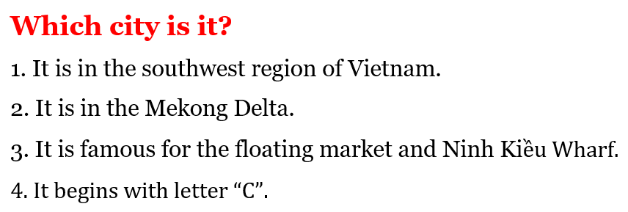

- Calls Ss to give answers.

- Gives a small gift to the first Ss who can give the right answers.

- Shows the map and have Ss find Cần Thơ on the map.

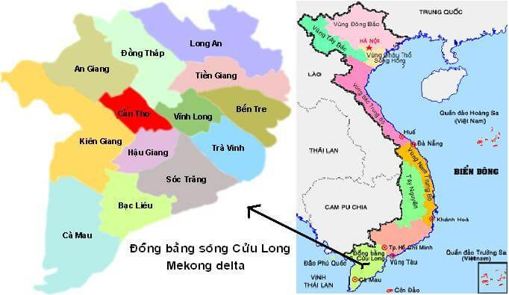

🡪 Leads to the new lesson.

**2. KNOWLEDGE FORMATION ACTIVITIES (15MS)**

**\* ACTIVITY: Speaking**

**a. Aims:** Ss can talk about some famous places in Europe.

**b. Content:** Asking and answering about Colmar and Clovelly.

**c. Expected products:** Ss practice and produce the target language successfully to talk about the places they know.

**d. Organization of activities:**

**Task a. You’re planning a geography presentation. Work in pairs. Student A, answer Student B’s questions about Colmar. Swap roles and repeat with Clovelly**

- Demonstrates the activity by asking and answering with a student.

- Has Ss practice the conversation in pairs: Student B asks about Colmar and Student A answers the questions-using the information in the textbook.

- Has Ss swap the roles for Clovelly.

- Observes and gives help if necessary.

- Has some pairs act out the conversation in front of the class.

- Gives feedback and evaluation.

**Task b. Ask and answer about other places you know**

- Has Ss work in pairs to talk about other places they know.

- Goes round and give help if necessary.

- Calls some pairs to demonstrate the activity.

- Gives feedback and evaluation.

**3. PRACTICE ACTIVITIES (15MS)**

**\* ACTIVITY: Writing**

**a. Aims:** T help Ss get the main information about their hometown.

**b. Content:** Asking and answering about the places Ss live, then write.

**c. Expected products:** Ss can use what they have learnt to produce the language successfully.

**d. Organization of the activity:**

- Demonstrates the activity by asking and answering with a student.

- Has pairs ask and answer about where they live and complete the notes.

- Has some pairs demonstrate the conversation in front of the class.

- Checks answers as a whole class.

**4. APPLICATION ACTIVITIES (10’)**

**a. Aims:** To help write about their hometown.

**b. Content:** Writing a paragraph about their hometown.

**c. Products:** Ss can apply the target language to producing the language successfully.

**d. Organization of activities:**

- Has Ss use their notes and the Reading to write a paragraph about your hometown.

- Has Ss write their paragraph on the board.

- Checks, corrects Ss’ mistakes.

- Has Ss finish their writing part in their notebooks.

|  |
| --- |
| **HANDOUT** |