|  |  |
| --- | --- |
| *Ngày 26 tháng 08 năm 2025* | *Họ và tên giáo viên:* Trần Thanh Sơn  *Tổ chuyên môn: Khoa học xã hội* |

**UNIT 2: MY HOUSE**

***Total numbers of periods: 7 periods; from period 9 to period 15***

**LESSON 1: GETTING STARTED**

***Period: 9 - Class: 6A2, 6A3.***

**I. OBJECTIVES:**

**1. Knowledge:**

* Vocabulary: town house (n), country house (n), flat (n)

* Grammar: -Prepositions of places

By the end of the lesson, students will be able to:

- have an overview about the topic “*My house*”

- know types of house and use the words for types of houses to talk about where they live

- understand the conversation between Mi and Nick to do the multiple choice and the gap-filling task

**2. Competences:**

- General competence:

+ Self-controlled and self-learning competence (students know how to adapt themselves to their places of living)

+ Communicative and cooperative competence ( students know how to persuade their friends to love their places of living)

- Distinctive competence: Linguistic competence (sts know how to use their native language and foreign language to indicate the evidence for their answers)

**3. Values:**

+ Responsibility (sts are aware of protecting their places of living)

+ Diligence (sts work better to get well-paid future jobs and support their families to make the houses better)

**II. TEACHING AIDS AND MATERIALS:**

**1. Materials:** Grade 6 textbook, lesson plan, workbook, the teacher’s book, reference books

**2. Equipment:** TV, cassettes, pictures, cards, handouts, extraboards, sachmem.vn, On-line websites ( Kahoot)…

III. PROCEDURES :

**1. WARM-UP (5MS)**

**a. Aims:**

- To create an active atmosphere in the class before the lesson

- To lead into the new unit

**b. Content:** Matching game on Kahoot about the words related to rooms in a house

**c. Expected Products: :** Students match the words about rooms in a house with the correct pictures

**d. Organization of activities:**

- Divides the class into 4 groups and chooses a group leader for each group

- Introduces the app KAHOOT and guides sts how to play matching game with KAHOOT

- Shows the pictures of the rooms and 5 words related to 5 types of rooms

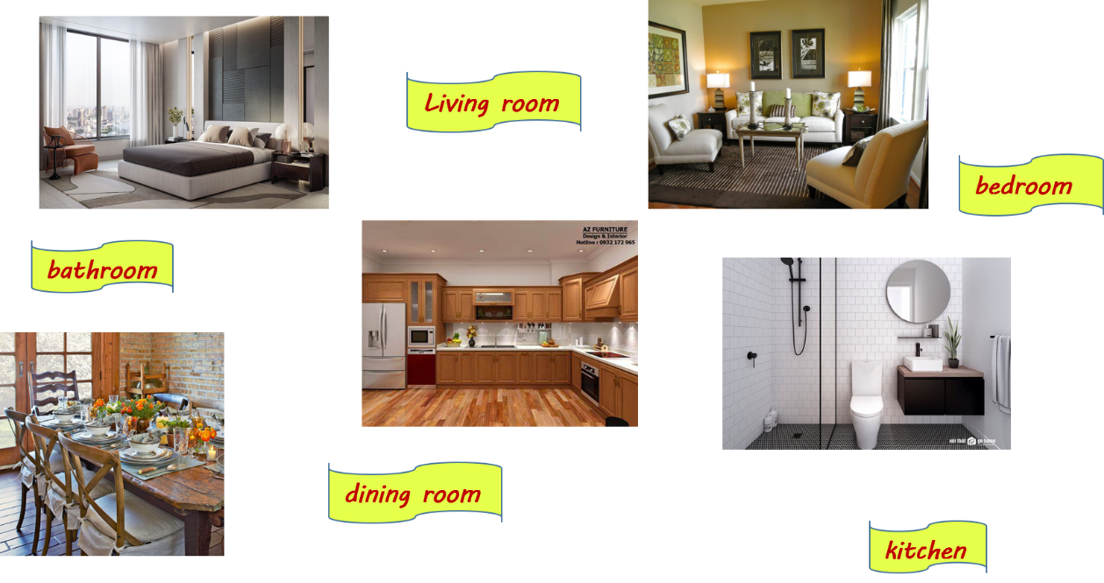

- Nominates a representative from each group to join the game

- Decides the winner who has the correct answers with the least running time

- Leads to Unit 2 and writes the unit title “MY HOUSE” on the board

- Asks sts to have a guess about what they are going to learn about in unit 2

**2. KNOWLEDGE FORMATION ACTIVITIES (5MS)**

**a. Aims:**

-To draw sts’ attention to the context

- To supply sts with the main knowledge of new words about types of houses

**b. Content:** New words about types of houses and the examples of prepositions of place that are mentioned in the text

**c. Expected products:** Students know and pronounce the words about the types of houses correctly

**d. Organization of activities:**

**-** Pre-teaches some new words using suitable techniques

√. town house (n) (picture +explanation)

√. country house (n) (picture +explanation)

√. flat (n) ( picture +explanation)

- Gets sts to repeat the words chorally, then individually

- Nominates individuals to read the words aloud and asks sts to copy down the words

- Checks the understanding of the new words by conducting the game “SLAP THE BOARD”

**3. PRACTICE ACTIVITIES (28MS)**

**Task 1**: **(7’)**

**a. Aims:**

- To set the context for the introductory text

- To introduce the topic of the unit and some main points that will be learnt more in A CLOSER LOOK 1 and 2

**b. Content:** Listen and read the conversation

**c. Expected products:**

**-** Students read and understand the meaning of the text.

- Students know how to role play

- Sts get an overview about prepositions of places through the examples extracted from the text

**d. Organization of activities:**

**-**Shows the picture in the textbook and introduces Mi and Nick: *They are pen friends*



**-** Has sts look at the picture and have a guess :

+ What are Nick and Mi doing?

+ What might they talk about?

**-** Tells sts about what they are going to learn in task 1

- Plays the recording twice for sts to listen and read along

- Has sts underline the words that are related to the topic MY HOUSE while they are listening and reading

* Assigns sts to practice the conversation in pairs
* Nominates two pairs to read the conversation aloud.

- Checks students’ guess and asks sts what exactly Mi and Nick talked about

* Confirms the correct answers (*They talked about their houses. Mi said that her family was moving to a new flat and she briefly described her new flat*)

**Task 2:** **(7’)**

**a. Aims:** To help sts understand the text

**b. Content:** Tick (✔) the family members that Mi talks about

**c. Products:** Sts can indicate the members in Mi’s family

**\*Suggested answers:**

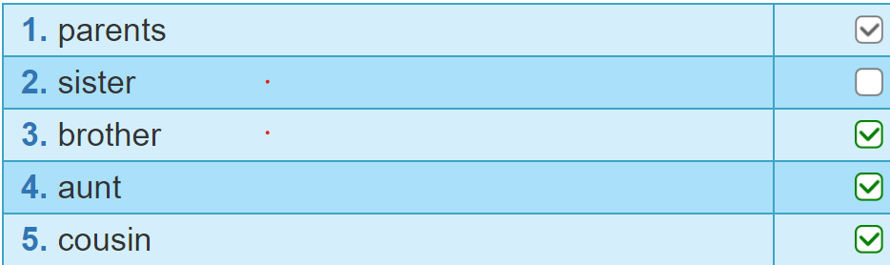

**d. Organization of activities:**

- Firstly, asks sts to give the answers without reading the conversation again

- Then,tells students to read the conversation again and work independently to find the answers. Remind students to hightlight the sentences that have the answers

- Invites some students to give their answers and the evidence

- Confirms the correct answers.

**Task 3:(7’)**

**a. Aims:** To have students get specific information of the text and further understand the text

**b. Content:** Complete each sentence with one word

**c. Products:** Sts know to choose the words in the text to fill in the gap

*Suggested answers:

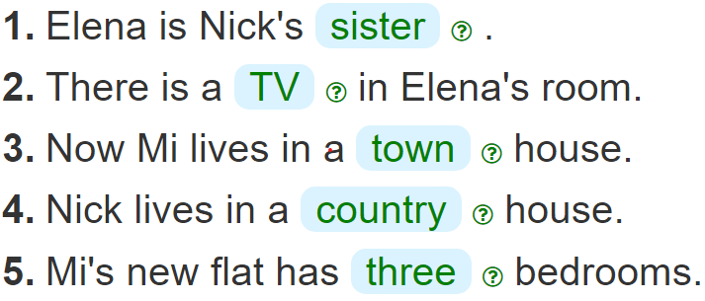

**\* d. Organization of activities:**

**-** Instructs sts how to do the exercise : *First, read the sentence and identify the kind of information to fill in the gap. Next, read the conversation and locate the place to find the word to fill the blank*

- Does the first sentence as an example

* Asks sts to works individually to fill in the gaps with the words from the text
* Allows sts to share answers before discussing as a class
* Invites sts to read the words
* Checks sts’ answers and writes them on the board.

**Task 4:(7’)**

**a. Aims:** To develop sts’ knowledge of the vocabulary about types of house

**b. Content:** Complete the wordweb

**c. Products:** The words about the types of house including the ones in the text and the ones sts know

*\*Suggested answers;*

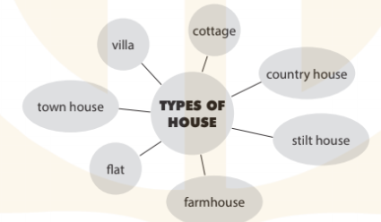

**d. Organization of activities:**

- Divides the class into 6 groups and asks sts to work in groups to complete the word web about types of house. Reminds sts to read the text again to get the words and use the words the know.

- Asks the representatives of the groups to write down their word webs on the boards. Decides the best group which has the most words.

- Has the other give their comments on the word webs and add some more if they know.

- Gives feedbacks.

**4. APPLICATION ACTIVITIES ( 7’)**

**Task 5:(7’)**

**a. Aims:**

- To help sts practice asking and answering about where they live

- To develop sts’ self-controlled and self-learning competence,communicative and cooperative competence

- To train sts as responsible and diligent people

**b. Content:** Ask friends where they live

**c. Products:**

- Sts know their friends’ place of living and their friends’ types of house

- Sts know to protect their place of living

- Sts gain self-controlled and self-learning competence, communicative and cooperative competence, responsibility and diligence

**d. Organization of activities:**

- Models with one good student to make sure that sts know how to aks and answer

*-* Asks one st in each group to be the secretary and to take notes of other sts’ answers so that by the end of the activity, the group secretary will report the findings to the class

- Asks sts to work in groups to take turns to ask and answer about where they live

- Moves around to observe and offer help when needed

- Invites some sts to aks and answer in front of the whole class. Has the group secretaries to report their findings. Gives them a sample (*In my group, A and B live in flats . C lives in the country house*.)

- Gives feedbacks and educates sts to protect their place of living and persuade their friends to do so

- Advises sts to learn better to support their families in the future to make their houses better