*Date of preparation: April 10th, 2025*

**UNIT 9: ENGLISH IN THE WORLD**

Time expected to complete the topic: 9 periods from 85 to 93

**Lesson 2.2. Grammar**

**Period 89 Class: 7A3**

**I. OBJECTIVES**

**1. Knowledge:**

- use *Past Simple with regular verbs* correctly.

- talk about their last holiday.

**2. Competences**

- improve speaking, listening and writing skills.

- improve the use of English.

**3. values**

- love studying English, love travelling.

- have good preparation for any trip.

**II. TEACHING AIDS AND MATERIALS**

**1.Materials :** Student’s book and Teacher’s book, notebook, reference books…

**2.Equipment:** Lesson plan, PPT slides, student’s book, workbook, notebook, computer, projector/TV, speakers, DCR & DHA on EDUHOME, handouts…

**III. PROCEDUCES:**

**1.WARM –UP (5MS)**

**a) Aim:** Introduce the new lesson and set the scene for Ss to acquire new language; get students' attention at the beginning of the class by enjoyable and short activities as well as to engage them in the follow-up steps.

**b) Content:** Review words / Introduce: Past simple with irregular verbs.

**c) Expected products:** Ss review old knowledge and have general ideas about the grammar points they are going to study in the new lesson.

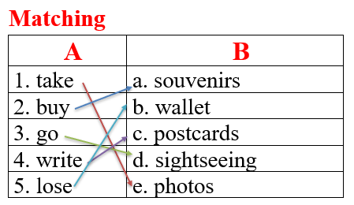

* **d) Organization of activities: Option 1: Matching**

- Has Ss close all books.

- Has Ss work in pairs to match verbs in A with words / phrases in B.

- Calls Ss to give answers, have Ss read the verb phrases again, tell the meaning.

- Leads to the new lesson.

**\*Illustration:**

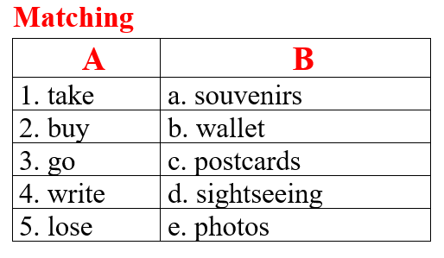

**2. KNOWLEDGE FORMATION ACTIVITIES (12MS)**

* **Activity 1: Presentation (12ms)**

**a) Objective:** Introduce: Past Simple with regular verbs.

**b) Content:**

**-** Listen and repeat.

**-** Introduce the grammar point: *Past Simple with regular verbs.*

**c) Expected products:** Ss know how to use *Past Simple with regular verbs* to do some following exercises.

**d) Organization of the activity:**

**Task a. Listen and repeat**

- Has Ss look at the picture using DCR.

- Plays audio (CD2 – Track 19) and have Ss listen and read the speech bubbles.

- Plays the audio again and have Ss listen and repeat.

**Grammar box**

- Has Ss look at the grammar explanation, examples and read: *Past Simple with regular verbs.*

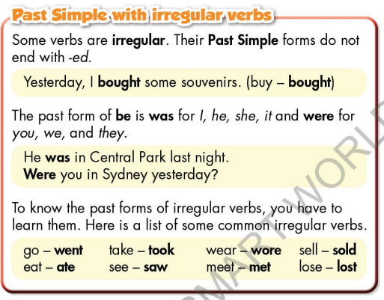

- Briefly explains the grammar point.

- Asks Ss to make sentences with *Past Simple with regular verbs.*

- Gives feedback and evaluation.

**3. PRACTICE ACTIVITIES (18MS)**

* **Activity 2: Practice (18ms)**

**a) Aim:** Students can use Past Simple with regular verbs correctly.

**b) Content:**

- Fill in the blanks with the correct form of the verbs in the box.

- Fill in the blanks with the correct Past Simple form of the verbs.

**c) Expected products:** Students can use Past Simple with regular verbs to talk about holidays in their speaking.

|  |  |
| --- | --- |
|  |  |

**d) Organization of activities:**

**Task b. Fill in the blanks with the correct form of the verbs in the box.**

- Demonstrates the activity using DCR.

- Has students fill in the blanks.

- Has pairs check each other's work.

- Havs some students share their answers with the class.

- Checks Ss’ answers, give feedback.

**Task c. Fill in the blanks with the correct Past Simple form of the verbs**.

- Demonstrates the activity using the example.

- Havsstudents read the message and the fill in the blanks with the correct Past Simple form of the verbs.

- Has students check their answers with a partner.

- Checks answers as a whole class using DCR.

**4. APPLICATION ACTIVITIES ( 10 ms)**

* **Activity 3: Production (10ms)**

**a) Aim:** Students master the grammar point they study in the lesson.

**b) Content:**  Speaking: Ask your partner about their last holiday. Use the prompts to ask the questions

**c) Expected products:** Ss produce the new language successfully, and they can apply the grammar point they have learnt in speaking and writing.

**d) Organization of activities:**

**Task d. Ask your partner about their last holiday. Use the prompts to ask the questions**.

- Divides class into pairs.

- Has Ss ask each other questions using the prompts.

- Hassome pairs demonstrate the activity in front of the class.

- Gives feedback and evaluation.

|  |
| --- |
| HANDOUT |