*Date of preparing: 23/3/2025*

*Date of teaching:15/04/2025*

**UNIT 9: HOUSES IN THE FURTURE**

***Total numbers of periods: 9 periods; from period 85 to period 93***

***Period: 89 -* LESSON 2.2 :Grammar**

***Class:* 6A3**

**I. OBJECTIVES:**

**1. Knowledge:**

*By the end of the lesson, students will be able to:*

- know how to use **Modal verb Might** to say that something is possible in the future

**2. Competences:**

- General competence:

+ Self-controlled and self-learning competence (students can describe the differences and similarities between homes now and in the future)

+ Communicative and collaborative competence (students know how to talk about what we will have in smart homes in the future).

- Distinctive competence:

+Linguistic competence (students know how to use language to talk about homes in the future)

**3. Values:**

+ Diligence (Students study harder when they have ideas of homes in the future)

+ Responsibility (students are aware of the place where they will live)

**II. TEACHING AIDS AND MATERIALS:**

**1. Materials:** student’s book, lesson plan, **the teacher’s book**, reference books

**2. Equipment:TV,laptop**,cassettes, pictures, cards, handouts, extraboards.

III. TEACHING PROCEDURES :

**1. WARM-UP (5ms)**

**a. Aims:**Introduce the new lesson and set the scene for Ss to acquire new language; get students' attention at the beginning of the class by means of enjoyable and short activities as well as to engage them in the steps that follow.

**b. Content:** A game

**c. Expected Products:** Ss can review the language learnt in the previous lesson

**d. Organization of activities:**

- Books closed, show the questions on the board

- Have Ss work in pairs, read and find the missing words

1. *A _______, like a TV or a mobile phone, is a machine with a computer in it.*
2. *A _______ is a flying machine. It can carry things.*
3. *I use my phones by touching the _______.*
4. *A _______ can make all kinds of objects.*
5. *An _______ will make anything you want to eat.*
6. *Get a _______ to do your washing and cleaning at home.*

- Give time for Ss to find the answers

- Check the answers with the whole class

-Lead to the new lesson

**2. KNOWLEDGE FORMATION ACTIVITIES (10ms)**

**a. Aims:**To have Ss learn the new grammar point – Might for future possibilities

**b. Content:** Might for future possibilities

**c. Expected products:** Students can understand, practice and use the mentioned grammar point correctly in communication.

**d. Organization of activities:**

**a. Listen and repeat**

- Ask students to look at the grammar explanation.

- Have Ss look at the table with the forms of Might.

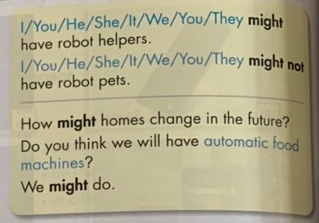

- Have some Ss read the sentences aloud.

- Have Ss give the rule of using Might.

-Ask Ss to write the new language in their notebooks.

**3. PRACTICE ACTIVITIES (23MS)**

**Task 1 (8ms)**

**a. Aims:**Sscan use the new grammar point – Might for future possibilities

**b. Content:** Fill in the blanks using “might” and a verb from the box

**c. Expected products:**

**Answer key:**

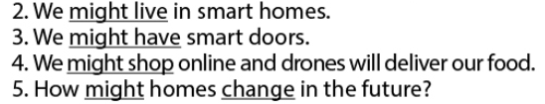

**d. Organization of activities:**

- Have Ss study the task.

- Demonstrates the activity using the example.

*1. Automatic food machine* ***might make*** *all our food.*

- Have Ss fill in the blanks using “might” and a verb from the box.

- Have Ss check their works in pairs.

- Have some Ss share their answers with the class.

- Give feedback

**Task 2: (15ms)**

**a. Aims:**Ss can use the new grammar point – Might for future possibilities

**b. Content:** Unscramble the sentences.

**c. Expected products:**

**Answer keys**

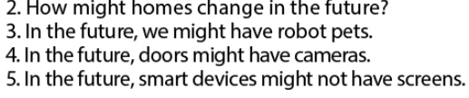

**d. Organization of activities:**

- Have Ss explore the task

- Demonstrate the activity using the example.

*1. In the future, we* ***might have*** *robot helpers.*

- Have Ss unscramble the sentences.

- Have Ss check their works in pairs.

- Have some Ss share their answers with the class.

- Give feedback

**4. APPLICATION ACTIVITIES (7’)**

**a. Aims:**To get Ss another step in grasping the grammar point

**b.Content:**Game: Lucky numbers

**c. Expected products:**Students can have a free-talk about smart homes

**d. Organization of activities:**

- Ask Ss to play the game in teams.

- Divide the class into two team: Team A and B.

- Ask Ss to choose a number which is attached a word/ phrase and then say out loud a sentence with the structure they have learned. If any number showing the word Lucky, Ss can choose a word from the lesson and T has to make a sentence for it.

# 1: Smart phones

# 2: Cameras

# 3: Lucky number

# 4: Robot helpers

# 5: Lucky number

# 6: Lucky number

# 7: Smart homes

# 8: Drones

- Announce the winner of the game.

*Consolidation:

S +MIGHT+ V-inf +O