SỞ GIÁO DỤC VÀ ĐÀO TẠO GIA LAI

**TRƯỜNG THPT SỐ 1 NGUYỄN DU**

bs00554_

**KẾ HOẠCH BÀI DẠY**

**Môn Tiếng Anh Lớp 11**

**Global Success**

**(TIẾT DẠY HỌC TẠI THƯ VIỆN)**

***Giáo viên:* Đỗ Thị Ngọc Thạch**

**TỔ TIẾNG ANH**

**Date of preparation: 02nd September, 2025** **Name: Do Thi Ngoc Thach**

**Date of teaching: 17th September, 2025 Group: English**

**LESSON IN THE LIBRARY**

**UNIT 1: A LONG AND HEALTHY LIFE**

***Subject: English; Classes: 11A2, 11A12***

*The total number of periods: 8 (from 2 to 9); (Month: September)*

**Period 09 – Lesson 8: LOOKING BACK & PROJECT**

**I. OBJECTIVES**

By the end of this lesson, students will be able to:

**1. Knowledge:**

- Review the vocabulary and grammar of Unit 1.

- Apply what they have learnt (vocabulary and grammar) into practice through a project.

**2. Competences:**

Self-learning ability, communicate competency:

+ Interpersonal competences (effective work, team work).

+ Learning competencies (self-motivation towards of their problem solving, active participation in learning progress.)

+ Cognitive competencies (evaluation, self-assessment, critical thinking).

+Develop presentation skills and creativity.

**3. Personal qualities:**

- Attract and encourage students to engage in reading books.

- Foster a reading habit among students.

- Inspire students to develop a passion for reading.

- Be more creative when doing the project.

- Develop self-study skills.

**II. TEACHING AIDS AND MATERIALS**

- Grade 11 textbook, Unit 1, looking back and project

- A power point lesson plan

- A laptop, smartphone connected with the internet, a bluetooth speaker

- TV connected to the Internet

- A printer and papers

- Tables and chairs for students

- The internet-connected desktop computer

- hoclieu.vn

**III. PROCEDURES**

**1. ACTIVITY 1: WARM-UP (5 ms)**

**a. Aims:**

- To let students stablise in the right seat position in the library room.

- To ensure that students are aware of the library rules.

- To stir up the atmosphere and activate students’ knowledge on the topic of healthy life.

- To enhance students’ skills of cooperating with teammates.

**b. Content:**

**- Game:** Quizizz <https://quizizz.com/admin/quiz/66ea08c7267496701dd3bf77?at=66ea0abf62678d8dc65d0d3a>

**c. Expected outcomes:**

**-** Students can review vocabulary and grammar points related to the previous lesson.

- Students join the game enthusiastically and gain knowledge on the topic.

**Suggested words:**

*1. antibiotic 2. bacteria 3. has just examined*

*4. suffered 5. fitness 6. food poisoning*

**d. Organisation:**

**Game: Quizizz**

- Teacher and the librarian help students to sit in the right position in the library room.

- Divide the class into three groups.

- There are 6 questions, each question has 4 choices.

- Teacher shows the question. Students raise their hands to answer.

- The fastest group which the correct answer will get 1 point for each question.

- Confirms the correct answers and congratulates the winner.

- Lead in the lesson.

- Observe and give feedback.

**2. ACTIVITY 2: PRESENTATION (5 ms)**

**a. Aims:**

- To help students review strong and weak forms of auxiliary verbs.

- To help students revise words and phrases they have learnt in this unit.

- To help students review the past simple and present perfect.

**b. Content:**

- Review strong and weak forms of auxiliary verbs.

- Revise words and phrases they have learnt in this unit.

- Review the past simple and present perfect.

**c. Expected outcomes:**

- Students can review the knowledge they have learnt in this unit to complete the tasks successfully.

**d. Organisation:**

- Help students review strong and weak forms of auxiliary verbs, words and phrases they have learnt in this unit and the past simple and present perfect.

- Ask students what they remember.

- Call some students to give the answers.

- Give feedback.

**3. ACTIVITY 3: PRACTICE: LOOKING BACK (15 ms)**

**a. Aims:**

- To help students review strong and weak forms of auxiliary verbs.

- To help students revise words and phrases they have learnt in this unit.

- To help students review the past simple and present perfect.

**b. Content:**

**-** Task 1: Circle the common pronunciation of the underlined auxiliary verbs. Then listen and check. Practice saying the conversations in pairs (p.16)

- Task 2: Fill in each gap with one word. (p.16)

- Task 3: Circle the underlined part that is incorrect in each of the following sentences. Then correct it. (p.17)

**c. Expected outcomes:**

- Students can use the knowledge they have learnt in this unit to complete the tasks successfully.

**Task 1:** *1. B – A 2. B – A*

**Task 2:** *1. cut 2. suffer 3. Working 4. balanced 5. treatment*

**Task 3:** *1. A (=> went) 2. A (=> was) 3. C (=> when) 4. B (=> haven’t done)*

**d. Organisation:**

**Task 1: Circle the common pronunciation of the underlined auxiliary verbs. Then listen and check. Practice saying the conversations in pairs.**

- Puts students in pairs and has them read the conversations paying attention to the underlined auxiliary verbs.

- In weaker classes, check if students can read the phonetic transcriptions of the two forms.

- Ask students to circle the correct pronunciation of the auxiliary verbs.

- Check answers as a class by playing the recording.

- Ask students to role-play the conversations in pairs. Encourage them to use the correct forms of the auxiliary verbs.

- Praise for good pronunciation and fluent delivery.

**Task 2:** **Fill in each gap with one word.**

- Select some words from the unit to write on the board, one letter at a time (also known as slow reveal game, in which one letter of a word is given at a time from left to right until a student can guess the whole word).

- Have individual students call out their guesses.

- Focus attention on the sentences and have students skim through them.

- Check if they know all the words.

- Have students complete the activity.

- Checks answers as a class.

**Task 3: Circle the underlined part that is incorrect in each of the following sentences. Then correct it.**

- Teacher explains to students that they are going to review the use of the past simple and present perfect. In weaker classes, give students some time to revise the grammar rules in the Language lesson before doing the activity.

- Check answers as a class by asking individual students to read the correct sentences and give reasons for their corrections.

**4. ACTIVITY 4: PRODUCTION: PROJECT (20 ms)**

**a. Aims:**

- To provide an opportunity for students to develop their research and collaboration skills, and to practice giving a poster presentation.

**b. Content:**

- Presentation of posters about healthy habits by groups in class.

**c. Expected outcomes:**

- Students practice giving a poster presentation.

**d. Organisation:**

- Assign the project after finishing Lesson 1 – Getting Started.

- Divide class into 3 groups.

- Ask students to work in groups and prepare for the project by discussing

to choose ideas. Students design by poster/ slide (Canva/ PowerPoint or paper) with picture, slogan and main idea.

- Students use library space: consult health books/newspapers on the internet, discuss in groups, divide work (writer, artist, online designer, presenter).

- Give students a checklist for self-assessment and peer assessment. Explain that they will have to tick the appropriate items while listening to their classmates present and write comments if any. The presenter should complete the self-assessment checklist after completing the presentation.

- If necessary, review the presentation assessment criteria to ensure students are familiar with them.

- Invite two or three groups to present. Encourage the rest of the class to ask questions at the end.

- Give praise and feedback after each presentation. Teachers can also grade students' presentations as part of ongoing assessment.

**Suggested checklist for peer assessment:**

|  |  |  |
| --- | --- | --- |
|  | *Tick where appropriate* | *Comments (in English or Vietnamese)* |
| ***DELIVERY*** |  |  |
| *- The presenters greeted the audience.* |  |  |
| *- The presenters spoke clearly and naturally.* |  |  |
| *- The presenters cooperated when delivering their talk.* |  |  |
| *- The presenters interacted with the audience.* |  |  |
| *- The presenters used appropriate photos / pictures to illustrate their ideas.* |  |  |
| *- The presenters concluded their talk appropriately.* |  |  |
| ***CONTENT:*** *The presentation includes the following information:* |  |  |
| *- What is a health habit?* |  |  |
| *- What are the benefits of this habit?* |  |  |
| *- How can we develop this habit?* |  |  |
| *- What we can do to develop this habit?* |  |  |
| ***VISUAL AIDS:*** |  |  |
| *The poster is well-organized and visually attractive.* |  |  |
| *There are no spelling or grammar mistakes.* |  |  |

**Suggested checklist for self-assessment:**

|  |  |  |
| --- | --- | --- |
|  | *Tick where appropriate* | *Comments (in English or Vietnamese)* |
| ***DELIVERY*** |  |  |
| *- I greeted the audience.* |  |  |
| *- I spoke clearly and naturally.* |  |  |
| *- I cooperated with my group members when delivering the talk.* |  |  |
| *- I interacted with the audience.* |  |  |
| *- I used some photos/ pictures to illustrate my ideas.* |  |  |
| *- I concluded my part of the talk appropriately.* |  |  |
| ***CONTENT:*** *Our presentation includes the following information:* |  |  |
| *- What is a health habit?* |  |  |
| *- What are the benefits of this habit?* |  |  |
| *- How can we develop this habit?* |  |  |
| *- What we can do to develop this habit?* |  |  |
| ***VISUAL AIDS:*** |  |  |
| *The poster is well-organized and visually attractive.* |  |  |
| *There are no spelling or grammar mistakes.* |  |  |

**SOME IMAGES IN THE LIBRARY**

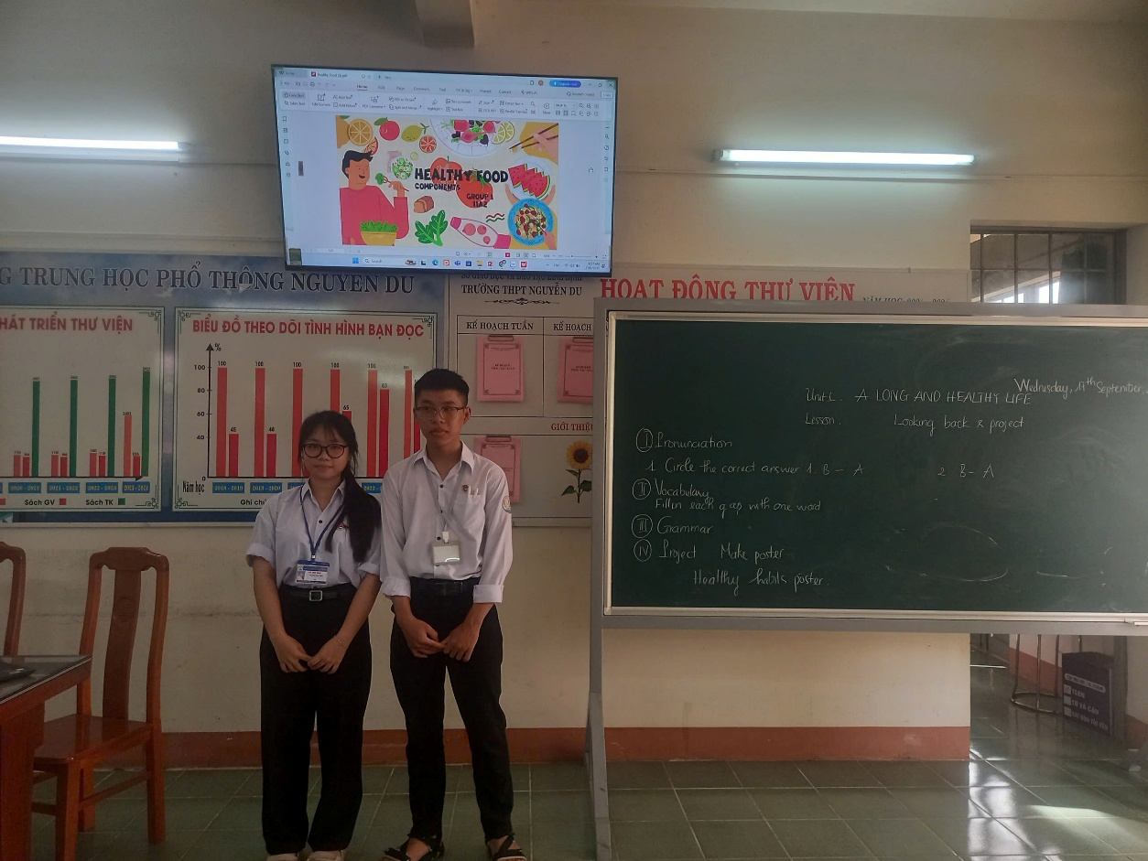

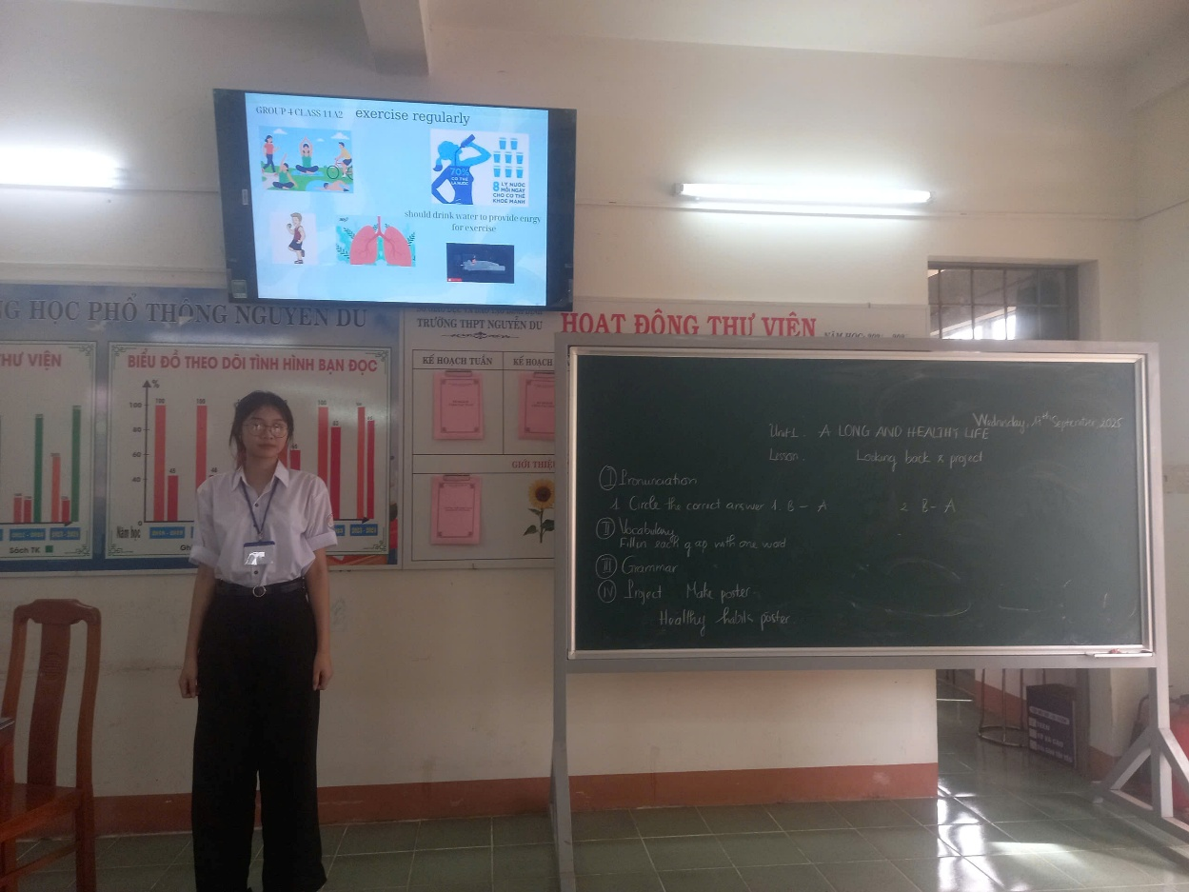

**PRODUCTS OF GROUPS**

**GROUP I:**



**GROUP II:**





**GROUP III:**

**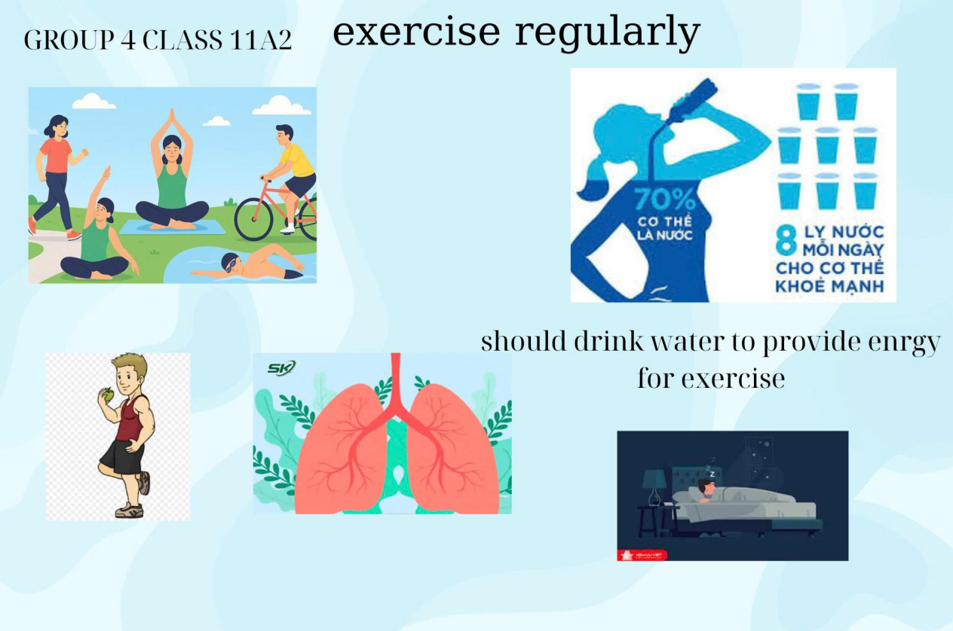**

*Hoài Nhơn, ngày 17 tháng 09 năm 2025*

**GV thực hiện**

**Đỗ Thị Ngọc Thạch**