Date of planning :
Date of teaching :
Period 69
UNIT 9 : NATURAL DISASTERS
Lesson 1: Getting Started - We Are All Safe!
I. Objectives:
By the end of this lesson, Ss will be able to:
1. Knowledge:
- Introduce an overview about the topic Natural disasters.
- Learn how to use vocabulary to talk about Natural disasters.
- Practice listening and reading skills .
+ Vocabulary:The lexical items related to Natural disasters.
- Pronunciation: Stress in words ending in -al and - ous
- Giving and responding to bad new.
+ Grammar: Past continuous tense.
2. Competence:
- Develop communication skills and creativity.
- Be co-operative and supportive in pair work and teamwork.
- Actively join in class activities.
3. Qualities:
- Develop awareness of Natural disasters.
- Be concerned to Natural disasters.
II. Teaching Aids:
- Teacher: Grade 8 text book,computer, projector / TV, hoclieu.vn/ sachmem.vn.....
- Students : Text books, workbook…
III. Procedure:

1. Warm - up ( 5’)
Aims: - To create an active atmosphere in the class before the lesson;
- To lead into the new unit.
Teacher’s Student’s activities | Content
+ Greeting  - T asks Sts to work in 2 groups and think of some natural disasters they know.  - T writes the name of one natural disaster as a modeling activity.  - Sts (one by one) go to the board and write the names of natural disasters that they know.  - T checks Ss’ results.  - The group with more correct names of natural disasters becomes the winner.  OR** Before Sts open their books, show pictures of common natural disasters in Viet Nam. Elicit the phrase natural disasters. Tell them that natural disasters are sudden and violent events in nature (such as an earthquake, a hurricane, or a flood) that kill or injure a lot of people and / or cause a lot of damage.  + Ask them what they know about natural disasters.  + Write the unit title on the board Natural Disasters. Share with Ss the objectives of the lesson (it is a good idea to write the objectives in a corner of the board and leave them there or put them on a slide to show Ss).  - Have Ss open their Student's Book and start the lesson | + Greeting ; T_Ss.  +  Students (Ss) listen and learn how to do  the tasks.  Earthquake  * Suggested answers:  Earthquake, snow storm, acid rain, typhoon, tidal wave, flood, drought, …  - Open the book and write the tittle of the lesson.
2. Presentation ( 10’)
Aims: - To set the context for the introductory conversation;
- To introduce the topic of the unit and the vocabulary to be learnt.
Teacher’s Student’s activities | Content
Activity 1: Listen and read  *Teach vocabulary:  + T uses different techniques to teach vocab (situation, realia, translation.)  + T do the “Rub out and remember” checking technique.  - T reveals that these seven words will appear in the reading text and asks students to open their textbooks to discover further.  - Ask Sts to look at the picture on pages 92 - 93 and answer the questions below:  + Elicit answers from Ss.  - Introduce the two characters: Tom and Mi.  - Explain that they are friends, and they are talking about natural disasters.  - Play the recording twice for Ss to listen and read along. Have Ss underline the words or phrases that are related to the topic of the unit while they are listening and reading.  - Sts practise the conversation in pairs, then invite some pairs to read the conversation aloud. Sts say the words or phrases in the text that they think are related to the topic of the unit.  - Quickly write the words or phrases on one part of the board or show the conversation on a slide and highlight the words or phrases. Comment on Ss' answers. | 1. Listen and read:  *Vocabulary:  1. damage (n,v) Thiệt hại, gây tổn hại  2. funnel (n) Cái phễu  3. tornado (n) Lốc xoáy  4. eruption (n) Sự phun trào  5. pull up (v) Kéo lên, nhổ lên, lôi lên  6. landslide (n) Vụ sạt lở  * Answer:  - What can you see in the picture?  - What natural disaster is it?
3. Practice ( 17’)
Aims: To help Ss understand the conversation; To introduce the names of some natural disasters; To help Ss understand the meaning of the words and phrase indicating natural disasters in 3.
Teacher’s Student’s activities | Content
Activity 2: Read the conversation again. Complete each sentence with no more than TWO words from it .  - Sts read the sentences and fill in the blanks without reading the conversation again.  - Elicit the answers from Ss. Quickly write these answers on the board.  - Have them read the conversation again to check their answers.  - Allow them to share the answers with a partner before discussing as a class.  - Ask Ss for their answers again, referring to the answers that have been previously written on the board.Confirm the correct answers. | 2- Read the conversation again. Complete each sentence with no more than TWO words from it .  * Answer key:  1. flood  2. second floor  3. natural disaster  4. was having  5. pulled
Activity 3: Write the natural disasters from the box under the pictures. Then listen, check, and repeat.  + Ask Ss to look at the pictures and say if they can name the natural disaster shown in each picture.  - Have Ss work individually to write the natural disasters from the box under the pictures.  - Have them compare their answers with a partner.  Invite some Ss to go to the board and write their answers. | 3- Write the natural disasters from the box under the pictures. Then listen, check, and repeat.  * Answer key:  1. flood  2. tornado  3. volcanic eruption  4. storm  5. landslide  6. earthquake
Activity 4: Choose the correct answer to complete each sentence.  - Have Ss work in pairs, read the sentences, and choose the correct answers.  - Ask for Ss' answers and confirm the correct ones.  - For a more able class, have Ss work in pairs to do the activity and explain why the other word is not the correct answer. | 4- Choose the correct answer to complete each sentence.  * Answer key:  1. volcanic eruption  2. earthquake  3. landslide  4. storms  5. tornado
4. Production ( 10’)
Aims: To help Ss revise the words and phrases indicating natural disasters.
Teacher’s Student’s activities | Content
Activity 5: Word web  + Set a time limit (3 - 5 minutes) for Ss to do this activity.  - Have Ss work in groups to complete the word web with all the words and phrases related to natural disasters they know. Tell Ss that they can include the words and phrases learnt in this lesson or other words and phrases. Invite some Ss to share their group's answers with the class.  + For a more able class, after Ss have finished the word web, ask them to make some sentences with the words and phrases they have written. | 5- Word web  * Key  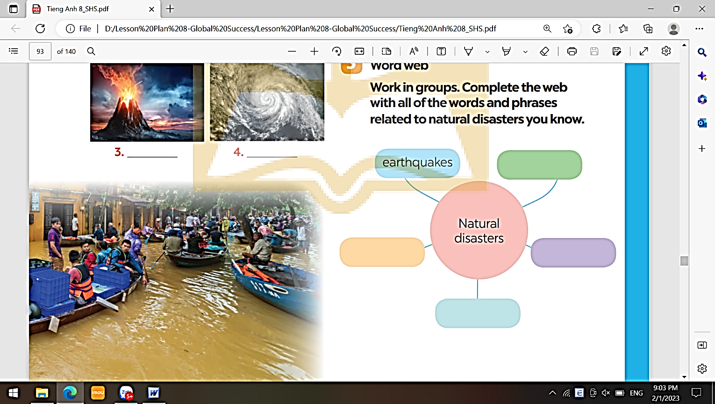
5. Wrap-up & Home work (3’)
+ Ask one or two Ss to tell the class what they have learnt. Draw Ss' attention to the objectives on the board or show them the slide with the objectives. Tick the objectives that have been learnt.
+ Ask Ss to say aloud some words and phrases they remember from the lesson.
+ If there is a projector in the classroom, show the the conversation in 1 and highlight the keywords related to the topic. It would be helpful to also highlight the past continuous and the words ending in -at and -ous. Tell Ss that they will learn these language points in the upcoming lessons
* HOME WORK:
- Do more exercises in workbook.
- Prepare new lesson: Lesson 2: A CLOSER LOOK 1 .
- Prepare for the Project of the unit:
Teacher randomly puts Ss in groups of 4 or 5 and asks them to brainstorm about a serious pollution problem in their areas and solutions to the problem, then make a poster about it. Students will show and present their posters in Lesson 7 – Looking back and Project. (Teacher should check the progress of students’ preparation after each lesson.)

Date of planning :
Date of teaching :
Period 70
UNIT 9 : NATURAL DISASTERS
Lesson 2 : A Closer Look 1
I. Objectives:
By the end of this lesson, Sts will be able to:
1. Knowledge:
- Introduce the lexical items related to natura disasters.
- Identify the stress in words ending in -al and -ous
+ Vocabulary: The vocabulary related to Natural disasters.
- Pronunciation: Stress in words ending in -al and - ous
- Giving and responding to bad new.
+ Grammar: Past continuous tense.
2. Competence:
- Develop communication skills and creativity. Actively join in class activities.
- Be co-operative and supportive in pair work and teamwork.
3. Qualities:
- Develop awareness of Natural disasters.
- Be concerned to Natural disasters.
II. Teaching Aids:
- Teacher: Grade 8 text book,computer, projector / TV, hoclieu.vn/ sachmem.vn.....
- Students : Text books, workbook…
III. Procedure:

1. Warm - up ( 5’)
Aims: - To create an active atmosphere in the class before the lesson;
Teacher’s Student’s activities | Content
+ Greeting * Kim’s game:  - T asks Sts to work in 2 groups.  - T shows some pictures related to Natural disasters in 2 minutes.Sts look at the pictures and remember (no writing)  - As soon as T stops showing the pictures, Ss work in groups and write the words for the pictures they have seen.  - The group with more correct words becomes the winner.  OR.+ Show some pictures of the natural disasters Ss learnt in the previous lesson.  - Have some Ss say the disasters aloud.  - Lead into this lesson which focuses on words and phrases related to natural disasters and stress in words ending in -al and -ous.  + Share with Ss the objectives of the lesson and have Sts open their books and start the lesson. | + Greeting ; + Kim’s game:  * Suggested answers:  Earthquake, tornado, volcano, tidal wave/ tsunami, flood, drought.
2. Presentation ( 10’)
Aims: To present some verbs and nouns related to natural disasters.
Teacher’s Student’s activities | Content
Activity 1: In column B, write the noun forms of the verbs in column A.  + T uses different techniques to teach vocab (situation, realia, translation.)  + T introduces the vocabulary by:  - providing the pictures  - eliciting the definition of the words  - T checks the students' understanding by the Rub out and Remember technique.  - Sts read the verbs in column A and try to give the noun forms of these verbs in column B.  - Let Sts work in pairs to compare their answers before giving T the answers. Some Ss write their answers on the board.  - For a more able class, give Ss some sentences with a blank in each. Ask Sts to fill in each blank with a verb or noun learnt in this activity.  - Check and confirm the correct answers. | 1. In column B, write the noun forms of the verbs in column A.  *Vocabulary  1. destroy (v) Phá hủy  2. erupt (v) Phun trào  3. predict (v) Dự đoán  4. emergency kit Bộ dụng cụ dùng trong trường hợp khẩn cấp  5. property (n) Của cải, nhà cửa  6. rescue worker Nhân viên cứu hộ  7. victim (n) Nạn nhân  Key:  1. destruction  2. eruption  3. warning  4. prediction  5. damage
3. Practice ( 15’)
Aims: - To present some words and phrases related to natural disasters
- To give Ss further practice with words and phrases related to natural disasters.
Teacher’s Student’s activities | Content
Activity 2: Write a word or phrase from the box under the correct picture.  - Sts do this activity individually. Let them share their answers in pairs. Invite some Sts to give the answers and confirm the correct ones.  - Sts make sentences with some of the expressions they have learnt. Invite Sts to share their sentences. This activity can be carried out as a competitive game.  - Sts to work in groups and make as many sentences as possible with the words and phrases. | 2. Write a word or phrase from the box under the correct picture.  *Answer key:  1. whistle  2. property  3. emergency kit  4. victim  5. rescue worker
Activity 3: Fill in each blank with a word or phrase from the box.  - Sts do this activity individually. Have Sts read all the sentences carefully to make sure they understand the sentences and fill in the blanks with the words and phrase in the box.  - Let them share their answers in pairs.  - Invite some Sts to give the answers and confirm the correct ones. | 3. Fill in each blank with a word or phrase from the box.  * Answer key:  1. damage  2. warning  3. emergency kit  4. predict  5. property
4. Pronunciation (12’)

Stress in words ending in -al and - ous
Aims: - To help Ss identify the stress in words ending in -aland -ous;To help Ss practise pronouncing these words with correct stress;To help Ss stress the words ending in -al and -ous correctly and read the sentences including these words with correct stress.
Teacher’s Student’s activities | Content
Activity 4: Listen and repeat the words. Pay attention to the word stress.  - Some Sts read out the words first. Then play the recording for them to listen to and repeat the words they hear.  - Play the recording as many times as necessary.  - Explain to Ss that these words have stress on the first syllable. Tell Ss that the endings -al and -ous do not change the stress pattern of the original words. For example, the word music has the stress on the first syllable, and when we add -al to it, the stress is still on the first syllable.  + Ask Ss to work in pairs to practise saying the words.  - Invite some Sts to say the words aloud  -T gives corrections and feedbacks to students’ pronunciation | 4. Listen and repeat the words. Pay attention to the word stress.  * Key:  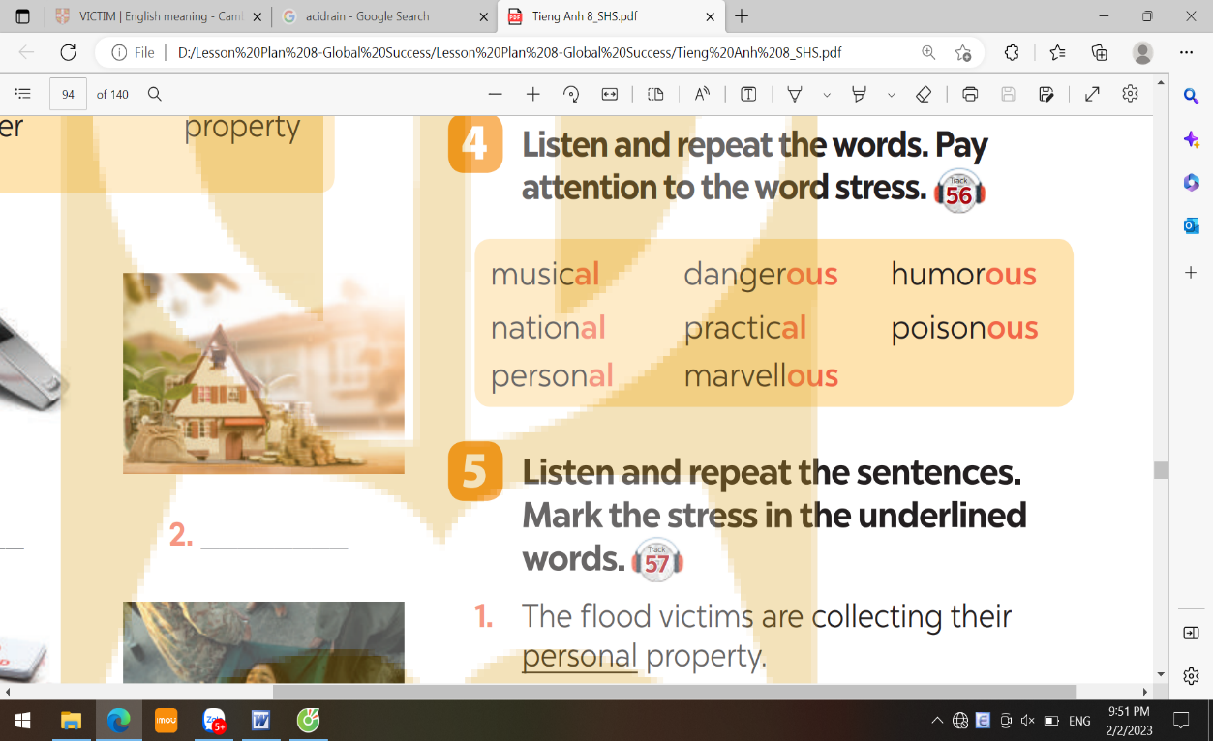
Activity 5: Listen and repeat the sentences. Mark the stress in the underlined  -Sts quickly read the sentences. Play the recording for Ss to listen to the sentences. Ask them to pay attention to the underlined words and put stress on the correct syllable in each word  + Invite some Ss to share their answers. Confirm the correct ones.  + Play the recording again for Ss to repeat the sentences. Have Ss practise the sentences in pairs. Invite some pairs to read the sentences aloud.  - T checks students’ answers and their pronunciation and gives feedback. | 5. Listen and repeat the sentences. Mark the stress in the underlined words.  * Answer key:  1. The flood victims are collecting their ‘personal property.  2. Avoid ‘dangerous places, such as windows or bookcases, during an earthquake.  3. There are ‘numerous ‘tropical storms in this area every year.  4. Some ‘natural disasters, such as landslides, usually happen in ‘mountainous areas.  5. She gave us ‘practical tips about treating ‘poisonous wastes.
5. Wrap-Up & Home Work (3’)
- Ask one or two Ss to tell the class what they have learnt. Draw Ss' attention to the objectives on the board or show them the slide with the objectives.
- Tick the objectives that have been learnt.
- Ask Ss to summarise what they have learned in the lesson.
* Home Work:
- Do more exercises in workbook.
- Prepare new lesson: Lesson 2: A CLOSER LOOK 2 .

**********************************
Date of planning :
Date of teaching :
Period 71
UNIT 9 : NATURAL DISASTERS
Lesson 3 : A Closer Look 2
I. Objectives:
By the end of this lesson, Ss will be able to :
1. Knowledge:
- Teach the past continuous tense.
+ Vocabulary:The lexical items related to Natural disasters.
- Pronunciation: Stress in words ending in -al and - ous
+ Grammar: How to use “The past continuous tense”
2. Competence:
- Be co-operative and supportive in pair work and teamwork.
- Actively join in class activities.
3. Qualities:
- Develop awareness of Natural disasters.
- Be concerned to Natural disasters.
II. Teaching Aids:
- Teacher: Grade 8 text book,computer, projector / TV, hoclieu.vn/ sachmem.vn.....
- Students : Text books, workbook…
III. Procedure:

1. Warm -up ( 5’)
Aims: - To create an active atmosphere in the class before the lesson;
- To lead into the new lesson.
Teacher’s Student’s activities | Content
+ Greeting  + Say one sentence about yourself, using the past continuous, for example, At 8 p.m. yesterday, I was watching TV. What were you doing at that time?  + Invite some Sts to answer the question.  - Quickly write the sentence about yourself and some Ss'answers on the board. If Ss do not use the past continuous, still accept their answers.  + Underline the form of the past continuous in your sentence, then correct Ss' answers if they do not include the past continuous in their sentences.  + Tell them that today they are going to learn the past continuous. Lead into the lesson.  + Introduce the objectives of the lesson. Write the objectives in the top-left corner of the board | + Greeting  - T_Ss.  + Sts listen and learn how to do the tasks.  Eg : I was watching TV at 8 pm yesterday. What were you doing?  * The past continuous tense  A. Form of the past continuous:  (+) Affirmative sentences:  S + was/ were + V_ing.  (-) Negative sentences:  S + was/ were not + V_ing.  (?) Questions:  Was/ were + S + V_ing?  B.The use of the past continuous:  ……………………………………
2. Presentation ( 12’)
Aims: To help Ss practise the form of the past continuous.

REMEMBER: The past continuous tense
A. Form of the past continuous:
(+) Affirmative sentences:
S + was/ were + V_ing.
(-) Negative sentences:
S + was/ were not + V_ing.
(?) Questions:
Was/ were + S + V_ing?

B. Use:

+ We use the past continuous to describe:
- an action that was happening at a particular time in the past.
- một hành động đang xảy ra tại một thời điểm cụ thể trong quá khứ.

Ex: - I was having dinner at 6 p.m. yesterday.
- Were you having dinner at 6 p.m. yesterday? - Yes, I was.
- a past action that was happening when another action interrupted it.

( Một hành động trong quá khứ đang xảy ra thì một hành động khác xen vào nó)
+ We use the past simple for the action that interrupted it.
(Chúng ta dùng thì quá khứ đơn cho hành động làm gián đoạn nó.)

Ex: - When / While we were watching TV, we felt the earthquake.
- What were they doing when they felt the earthquake?

- They were watching TV.
Notes: + We can use when or while before the past continuous.
( Chúng ta có thể sử dụng when hoặc while trước thì quá khứ tiếp diễn.)

+ We can only use when before the past simple.
( Chúng ta chỉ có thể sử dụng when trước thì quá khứ đơn.)
Teacher’s Student’s activities | Content
Activity 1: Complete the sentences by putting the verbs in brackets into the past continuous.  Introduce the grammar point of the lesson “ The past continuous tense”.  - Ask Ss to do the exercise in pairs and then check their answers with another pair.  - Invite some Ss to share their answers. Confirm the correct answers. | 1. Complete the sentences by putting the verbs in brackets into the past continuous.  * Answer key:  1. were helping 2. was snowing  3. was working  4. were … doing, was watching  5. Were … crying
3. Practice ( 17’)
Aims: - To help Ss distinguish the past simple and the past continuous.
- To give Ss further practice with the past continuous.
- To help Ss ask and answer the questions using the past continuous.
Teacher’s Student’s activities | Content
Activity 2: Circle the correct answer to complete each sentence.  + Have Ss do this exercise individually and then compare their answers with a partner.  + Ask some Ss to share their answers. Confirm the correct answers. | 2. Circle the correct answer to complete each sentence.  * Answer key:  1. donated  2. were you doing, was sleeping  3. were camping, came  4. ran, moved  5. wasn’t reading, was watching.
Activity 3: Look at the picture and write what each person in Lan’s family was doing when the earthquake happened. Use the given word and phrases from the box.  + Ask Sts who they can see in the picture and what they are doing.  - Describe the situation to Ss and ask them to describe the actions of the people in the picture, using the past continuous and the words and phrases given in the box.  - Sts do this exercise individually and then compare their answers with another classmate's.  - Invite some Ss to write their answers on the board.Check the answers with the whole class. Confirm the correct answers. | 3. Look at the picture and write what each person in Lan’s family was doing when the earthquake happened. Use the given word and phrases from the box.  * Answer key:  1. Lan’s grandparents were watching TV.  2. Lan’s/ Her mother was reading a book.  3. Lan’s/ Her father was drinking tea.  4. Lan was talking on the phone.  5. Lan’s/ Her brother was drawing.
Activity 4: Form questions using the past continuous. Then in pairs, ask and answer the questions.  - Sts read the example carefully. Explain what they have to do.  - Sts work in pairs to do this activity. Have them make the questions and then practise asking and answering.  - Invite some pairs to ask and answer the questions in front of the class.  - Comment on their answers. Accept different answers provided that they are correct and logical. | 4. Form questions using the past continuous. Then in pairs, ask and answer the questions.  * Answer key:  1. Were you having dinner at 7 o’clock yesterday evening?  2. Were you doing your homework at 8 o’clock yesterday evening?  3. Were you watching a film at 9 o’clock yesterday evening?
4. Production ( 8’)
Aims: To help Ss practice the past continuous with game.
Teacher’s Student’s activities | Content
Activity 5: Work in groups. Take turns to say a sentence that describes what each person in the picture was doing.  + Divide Ss into groups. Assign a group leader to keep watch of the game  - Explain the rules of the game:The picture shows a class at break time. Now work in groups. Look at the picture for one minute.  - Take turns to say a sentence that describes what each person in the picture is doing.  - You score one point for every correct sentence.The student with the highest score in each group wins.  - T gives corrections and feedbacks. | 5. GAME. Memory challenge  Work in groups. Take turns to say a sentence that describes what each person in the picture was doing.  * Suggested answers:  + Mai was reading.  + Phong and Nick were playing chess.  + Lan and Ann were singing.  + Nam was cleaning the board.  + Mi and Ha were talking.
5. Wrap-up & Home Work (3’)
- Ask Ss to summarise what they have learnt in the lesson. Have Ss look at the objectives written on the board at the beginning of the lesson and tick the objectives they have learnt.
* Home Work:
- Remember the form and use of the past continuous.
- Do more exercises in workbook.
- Prepare new lesson: Lesson 4 : COMMUNICATION.

THE PAST CONTINUOUS TENSE
A. Cấu trúc (Form)
1) Thể khẳng định (Possitive):

I/ she/ he/ + was + V+ing
We/ you/ they + were + V+ing

Ex: We were working on the computer at 3 p.m yesterday.
(Lúc 3 giờ chiều hôm qua chúng tôi đang làm việc trên máy tính.)
2) Thể phủ định (Negative)

I/ she/ he/ + wasnot/ wasn’t + V+ing
We/ you/ they + werenot/ weren’t + V+ing

Ex: He wasn’t studying at that time. (Vào lúc đó anh ấy không học bài.)
c. Thể nghi vấn (Interrogative)
Was I/ she/ he/ + V+ing ?
Were we/ you/ they + V+ing ?

Ex: Were you listening to music last night? (Có phải tối hôm qua bạn nghe nhạc không?)
B. Cách dùng (Usage): Thì Quá khứ tiếp diễn được dùng để diễn đạt:
a . Sự việc đang diễn ra tại một thời điểm cụ thể trong quá khứ.
Ex: What were you doing at 7 o’clock last night? ~ I was watching TV.
(Lúc 7 giờ tối qua bạn làm gì? ~ Tôi đang xem TV.)
b. Sự việc xảy ra và kéo dài một thời gian ở quá khứ.
Ex: Yesterday, he was working in the laboratory all the afternoon.
(Suốt cả chiều hôm qua ông ấy đã làm việc trong phòng thí nghiệm.)
c. Sự việc đang diễn ra trong quá khứ thì có một sự việc khác xảy đến (dùng past continuous cho hành động kéo dài, dùng past simple cho hành động xảy đến).
Ex: When I came yesterday, they were having dinner.
(Hôm qua khi tôi đến, họ đang ăn tối.)
d. Hai hành động xảy ra đồng thời tại một thời điểm xác định trong quá khứ.
Ex: Yesterday, he was reading a newspaper while his wife was cooking in the kitchen.
(Hôm qua, anh ấy đọc báo trong khi vợ anh ấy nấu ăn trong bếp.)
C. Dấu hiệu nhận biết thì quá khứ tiếp diễn
- Trạng từ quá khứ tiếp diễn thường gặp là:
- At + giờ + thời gian trong quá khứ. (at 5 o’clock yesterday,…)
- At this time + thời gian trong quá khứ. (at this time last year,…)
- In + năm (in 2001, in 1992) ; In the past
Ex:
+ In 1998, he was staying with his parents.
+ At this time last week, we were playing soccer on the beach.
+ I was working at 10pm last night.
- They were not playing football at 9am this morning.
- What were you doing at 10pm last night?
- What were you doing when he arrived?
- She was cooking when I telephoned her.
- We were having dinner when it started to rain.
- Ram went home early because it was snowing.

*********************************

Date of planning :
Date of teaching :
Week 24- Period 72
UNIT 9 : NATURAL DISASTERS
Lesson 4 : Communication
I. Objectives:
By the end of this lesson, Ss will be able to :
1. Knowledge:
- Give and respond to bad new.
- Apply the lexical items related to natural disasters.
- Practise giving and responding to bad news.
+ Vocabulary:The lexical items related to Natural disasters.
- Pronunciation: Stress in words ending in -al and - ous
+ Grammar: Past continuous tense.
2. Competence:
- Develop communication skills and creativity.
- Be co-operative and supportive in pair work and teamwork.
- Actively join in class activities.
3. Qualities:
- Develop awareness of Natural disasters.
- Be concerned to Natural disasters.
II. Teaching Aids:
- Teacher: Grade 8 text book,computer, projector / TV, hoclieu.vn/ sachmem.vn.....
- Students : Text books, workbook…
III. Procedure:

1. Warm - up ( 5’)
Aims: - To create an active atmosphere in the class before the lesson;
- To lead into the new lesson.
Teacher’s Student’s activities |  | Content
+ Greeting  * Ask and answer  - Teacher show a picture about one disaster.  - Teacher asks Ss to work individually and answer the questions.  - Teacher invites some Ss to talk in front of the class.  - Teacher comments on their answers and leads to the new lesson.  - Ask Ss to look at COMMUNICATION on page 86. |  | + Greeting  + Answering the questions:  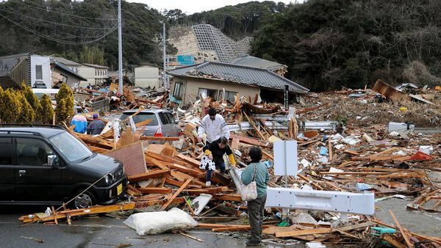  1. What do you see in the picture?  2. How do you feel?  - Open the book and write the tittle of the lesson.
2. Presentation ( 10’)
EVERYDAY ENGLISH
Giving and responding to bad new
Aims : To introduce ways of giving and responding to bad news;To help Ss practise giving and responding to bad news.
Teacher’s Student’s activities |  | Content
Activity 1: Listen and read the dialogue below. Pay attention to the highlighted sentences.  - Teacher introduces the vocabulary.  - Teacher explains the meaning of the new vocabulary, using pictures and translation.  - Teacher checks students’ understanding with the “What and where?” technique.  - Play the recording for Ss to listen to and read the conversation between Mark and Phong.  - Ask Ss to pay attention to the highlighted sentences.  - Tell them that these are two ways to give and respond to bad news.  - Have Ss practise the conversation in pairs.  - Call on some pairs to practise the conversation in front of the class |  | 1. Listen and read the dialogue below. Pay attention to the highlighted sentences.  * Vocabulary  1. shake (v) Rung, lắc  2. fahrenheit (n) Độ F (đo nhiệt độ)  3. richter scale (n) Độ rích te (đo độ mạnh của động đất)  Mark: Phong, why are you so sad?  Phong: My grandparents called this morning. A flood destroyed their house.  Mark: I’m sorry to hear that.  Phong: It also damaged all of their crops.  Mark: That’s awful. I hope your grandparents are safe.
EXTRA ACTIVITY
- Have Sts close their books; Write on the board the four highlighted statements in 1 in the mixed order; Put Sts into pairs and have them order the sentences correctly. Note that different answer possibilities are possible.
- Read them over and discuss the meaning of the sentences.
- Explain to the class that the four sentences can be grouped into two categories. Ask the class to try grouping the four sentences into two categories.
- Explain that "A flood destroyed their house." and "It's also damaged all of their crops" are sentences giving bad news. But the sentences "I'm sorry to hear that." and "That's awful." are used to respond to bad news.
- Ask Ss to think about how they respond to bad news in their own language and make any comparisons that are possible with similar expressions in English.
Activity 2: Work in pairs. Practise giving and responding to bad news in the following situations.  - Ask Ss to work in pairs to read the given situations and make similar conversations, using the language they have learnt.  - Move around to observe and provide help. Call on some pairs to practise in front of the class.  - Comment on their performance.  * Teacher listens to students’ pronunciation and gives feedback. |  | 2. Work in pairs. Practise giving and responding to bad news in the following situations.  * Situations:  You have a friend in a mountainous area. A landslide destroyed his family’s garden yesterday. You share this news with your classmate.  -You hear that a big earthquake hit a city. You share this news with your classmate.
3. Practice ( 17’)
Aims: - To help Ss identify the natural disasters described in the short texts.
- To check Ss' knowledge of different natural disasters with a questionnaire.
Activity 3: Read the short passages below. Decide which natural disaster each person below is talking about.  - Ask Ss to work in pairs to read the three short texts and decide what natural disaster each person is talking about. Have them prepare explanations for their answers.  - Elicit answers from Ss.  - Confirm the correct answers. |  | 3. Read the short passages below. Decide which natural disaster each person below is talking about.  * Answer key:  Nam: landslide  Ann: tornado  Tom: earthquake
Activity 4: Choose the correct answer to each question to see how much you know about natural disasters.  - Tell Ss that they are going to answer a questionnaire to see how much they know about natural disasters.  - Have Ss read though the questionnaire quickly and explain any new words.  - Ask Ss to answer the questions individually. |  | 4. Choose the correct answer to each question to see how much you know about natural disasters.  * Answer key:  1. A 2. B  3. C 4. B  5. C 6. A
4. Production ( 10’)
Aims: To provide Sts with a chance to communicate with each other and confirm their knowledge of natural disasters.
Teacher’s Student’s activities |  | Content
Activity 5: Work in pairs. Compare your answers. Then check your answers with the key on page 101. How many points did each of you get?  - Have Ss work in pairs to compare their answers. Ask them to note down the answers and then check them with the key on page 101, Student's Book.  - Sts calculate the points each of them earns.  - Ask some Sts to report their answers and points to the class.  - If time allows, ask Sts what they know about the disasters in the questionnaire.  -T corrects any grammar and pronunciation mistakes if necessary. |  | 5. Work in pairs. Compare your answers. Then check your answers with the key on page 101. How many points did each of you get?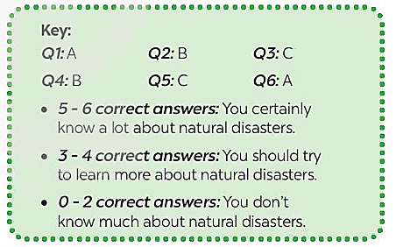
5. Wrap-up & Home Work (3’)
- Ask Ss to summarise what they have learnt in the lesson. Have Ss look at the objectives written on the board at the beginning of the lesson and tick the objectives they have learnt.
* Home Work:
- Do more exercises in workbook.
- Prepare new lesson: Lesson 5 : SKILLS 1.

Date of planning :
Date of teaching :
Period 73
UNIT 9 : NATURAL DISASTERS
Lesson 5 : Skills 1/ Reading and speaking
I. Objectives:
By the end of this lesson, Ss will be able to :
1. Knowledge:
- Apply the lexical items related to natural disasters.
- Further practice reading and speaking about natural disasters through the two articles.
- Prepare a short piece of news about natural disasters.
+ Vocabulary:The lexical items related to Natural disasters.
- Pronunciation: Stress in words ending in -al and - ous
- Giving and responding to bad new.
+ Grammar: Past continuous tense.
2. Competence:
- Develop communication skills and creativity.
- Be co-operative and supportive in pair work and teamwork.
- Actively join in class activities.
3. Qualities:
- Develop awareness of Natural disasters.
- Be concerned to Natural disasters.
II. Teaching Aids:
- Teacher: Grade 8 text book,computer, projector / TV, hoclieu.vn/ sachmem.vn.....
- Students : Text books, workbook…
III. Procedure:

1. Warm - up ( 5’)
Aims: - To create an active atmosphere in the class before the lesson;
- To lead into the new lesson.
Teacher’s Student’s activities | Content
+ Greeting * BRAINSTORMING  - T divides Sts into groups.  - T gives each group a piece of paper.  - T asks them to list all the words about natural disasters they have learnt.  - Sts work in their group and list all the words about natural disasters in 2 minutes.  - T asks 4 groups to ticks their posters on the board.  - T checks and gives comments.  - The group with most correct words is the winner.  - Share with Sts the lesson objectives.  - Write the objectives in a corner of the board and leave them there till the end of the lesson, or put them on a slide to show Sts. | + Greeting ; T_Ss , Ss – Ss  * BRAINSTORMING  + Words about natural diasters.  Typhoon, landslide, tornado, earthquake, storm, volcanic eruption, flood, drought ….  - Open the book and write the tittle of the lesson.
2. Presentation ( 10’)
A. READING
Aims: To activate Ss' knowledge of the topic of the reading text.
Teacher’s Student’s activities | Content
Activity 1: Match the headlines (1 – 2) with the natural disasters (A – B).  *Teach vocabulary:  + T uses different techniques to teach vocab (situation, realia, translation.)  + T do the checking “Matching”  + Sts read the headlines and match them with the disasters. Elicit and confirm the correct answers.  - Tell Sts something about Tonga, which is a country in the southwestern Pacific Ocean. It consists of about 170 islands.  Tell Sts that they are going to read two news articles about two natural disasters, i.e. a volcanic eruption and an earthquake. | 1- Match the headlines (1 – 2) with the natural disasters (A – B).  * Vocabulary:  - ash (n) Tro  - Tsunami (n) Trận sóng thần  - tremble (v) Rung lắc  *Answer key:  1. B  2. A
3. While Reading ( 17’)
Aims: - To help Ss develop the skill of guessing the meaning of new words in context.
- To help Ss develop the skill of reading for specific information (scanning).
Teacher’s Student’s activities | Content
Activity 2: Read the two news articles. Match the highlighted words with their meanings.  - Tell Sts what they are going to do.  - Ask Sts how to do the exercise. Elicit answers from Sts.If needed, tell them to follow these steps:  - Read the words in column 1.  - Locate each word in the text.  - Read around the word to get the general meaning.  - Read the meanings in column 2, find the suitable meaning to match with each word.  - Ask Sts to repeat the steps.  - Ask Sts to do the exercise individually and then check their answers in pairs.  - Invite some Sts to share their answers. Confirm the correct answers. | 2- Read the two news articles. Match the highlighted words with their meanings.  * Answer key:  1. d  2. e  3. a  4. b  5. c
Activity 3: Read the articles again and answer the questions.  + Ask Sts what they are going to do.  - Sts share how to do this exercise.  - Briefly tell them the steps: read the questions, underline the keywords in each question, locate the keywords in the text, and find the information to answer the questions.  - Ask Sts to repeat the steps if necessary.  - Ask Sts to do the exercise individually and then check their answers in pairs.  - Invite some Ss to share their answers. Have them explain their answers. Confirm the correct answers.  - Teacher’s observation and feedback. | 3- Read the articles again and answer the questions.  * Answer key:  1. In the South Pacific last Saturday.  2. A tsunami.  3. It destroyed hundreds of homes on some small islands, and more than twenty people on these islands are missing.  4. For about 30 seconds.  5. A strong earthquake in China.
EXTRA ACTIVITY
Have Ss summarise the first natural disaster by answering these questions:
1. What kind of natural disaster was it?
2. When and where did it happen?
3. What caused it? What were its effects? How did people help the victims?
+ This activity helps lead Ss tothe speaking part.

4 . SPEAKING
Aims: To help Ss generate ideas for talking about a natural disaster;To help Ss practise asking and answering about a natural disaster; To give Ss a chance to share a short piece of news about a natural disaster.
Teacher’s Student’s activities | Content
Activity 4: Work in pairs. Match the questions with the answers.  - Tell Ss that they are going to work in pairs to match the questions with the answers and then practise asking and answering the questions.  - Set a time limit of 3 - 5 minutes for Ss to do the exercise.  - Move around to observe and offer help if needed.  - Invite some Ss to share their answers and confirm the correct answers.  - Invite some pairs to practise in front of the class. | 4- Work in pairs. Match the questions with the answers.  * Answer key:  1. c  2. e  3. a  4. b  5. d
Activity 5: Work in groups. Prepare a short piece of news about the natural disaster in 4 or one you know of. Report the news to the class.  - Ask Ss to work in groups to prepare a short piece of news about the natural disaster in 4.  - Have Ss read the news in the reading part again to imitate the way it is written. Then ask them to read the example. Tell them that they only need to organise the answers to the questions in 4 in a logical order to create a piece of news.  - For a more able class, encourage Ss to think about a natural disaster they know and prepare a piece of news about it.  - Move around to give support if needed.  - Invite some groups to report the news to the class.  - Ask other groups to listen and give comments.  - Comment on Ss' answers.  - T asks the class to give feedback on their questions and answers, and pronunciation. | 5- Work in groups. Prepare a short piece of news about the natural disaster in 4 or one you know of. Report the news to the class.  * Suggested speaking:  Example:  Five days of heavy rain caused a serious flood in a village in Phu Yen. The flood happened last week. …
EXTRA ACTIVITY
- Lead a class discussion about which Ss think is worse, an earthquake or a volcanic eruption.
- Accept any logical explanations and try to get the class to agree upon one of the two types of natural disasters.
5. Wrap-Up & Home Work (3’)
+ Ask Ss to summarise what they have learnt in the lesson. Have them look at the objectives written on the board at the beginning of the lesson and tick the objectives they have learnt.
* HOME WORK:
- Learn by heart all the words that they have just learnt.
- Do more exercises in workbook.
- Make a speech introducing a new shopping centre in your city.
- Prepare new lesson: Lesson 6 : A SKILLS _2.

**************************************

Date of planning :
Date of teaching :
Period 74
UNIT 9 : NATURAL DISASTERS
Lesson 6 : SKILLS 2/ Listening and writing
I. Objectives:
By the end of this lesson, Ss will be able to :
1. Knowledge:
- Use the lexical items related to the topic of the listening text.
- Develop the skills of listening for specific information.
- Write instructions about things to do before, during, and after a flood.
+ Vocabulary:The lexical items related to Natural disasters.
- Pronunciation: Stress in words ending in -al and - ous
- Giving and responding to bad new.
+ Grammar: Past continuous tense.
2. Competence:
- Develop communication skills and creativity; Actively join in class activities.
- Be co-operative and supportive in pair work and teamwork.
3. Qualities:
- Develop awareness of Natural disasters.
- Be concerned to Natural disasters.
II. Teaching Aids:
- Teacher: Grade 8 text book,computer, projector / TV, hoclieu.vn/ sachmem.vn.....
- Students : Text books, workbook…
III. Procedure:

1. Warm - up ( 5’)
Aims: - To create an active atmosphere in the class before the lesson;
- To lead into the new lesson.
Teacher’s Student’s activities | Content
+ Greeting + Ask and answer  - Show the picture of a storm, ask Ss what people should do before, during, and after a storm.  - Elicit answers from Ss.  - Lead into the new lesson: Listening and Writing about what people should do before, during, and after a natural disaster.  - Introduce the objectives of the lesson. Write the objectives in the top-left corner of the board. | + Greeting ; T_Ss.  + Ask and answer  + Sts listen and learn how to do the tasks.  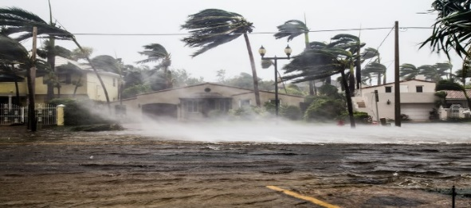
2. Presentation ( 10’)
A. LISTENING
Aims : To prepare Ss for the listening text.
Teacher’s Student’s activities | Content
Activity 1: Work in pairs. Look at the picture and answer the questions.  *Vocabulary pre-teaching  + T uses different techniques to teach vocab (situation, realia, translation.)  + T do the “Rub out and remember” checking technique.  + Show the picture of a storm , ask Sts what people should do before, during, and after storm . Elicit answers from Ss.  + Sts answer the questions in the Student's Book.  Elicit answers from Sts. This is an open activity, so accept all answers provided that they make sense.  Introduce some new words from the listening text if necessary. | 1- Work in pairs. Look at the picture and answer the questions.  * Vocabulary  - authority (n) Chính quyền  - warn (v) Cảnh báo  - avoid (v) Tránh, tránh xa  * Suggested answer:  A torch, a mask, a lamp, a whistle, a bottle of water, some medicine, matches, a radio, some plasters, a candle, a multi-purpose knife, some batteries, a blanket
3. While Listening ( 17’)
Aims :- To help Ss develop the skill of listening for specific information.

- To help Ss develop the skill of listening for specific information.
Teacher’s Student’s activities | Content
Activity 2: Listen to a broadcast. Put the activities (1 – 6) in the correct column.  - Tell Sts that they are going to listen to a broadcast in which instructions to prepare for a natural disaster are given.  - Have them read the activities (1 - 6) and try to guess which activities go into which column.  - Some Sts to share their answers and write them on the board.  - Sts read the activities again and underline the keywords.  - Play the recording and ask Ss to listen and put the activities in the correct column. Ss work in pairs to compare their answers.  - Ask for Sts' answers and compare them with the ones on the board.  - Confirm whether they are right or wrong, playing the recording again if necessary. | 2- Listen to a broadcast. Put the activities (1 – 6) in the correct column.  * Answer key:  +) Before a storm: 2, 6  +) During a storm: 3, 5  +) After a storm: 1,4
Activity 3: Listen again and tick (√) T (True) or F (False) for each sentence.  + Tell Ss that they are going to listen to the broadcast again and decide if the statements are true or false.Without playing the recording again, have Ss read the statements and decide if they are true or false.  - Play the recording and ask Ss to listen again to check their answers. Ask Ss to work in pairs to compare their answers.  - Ask for Ss' answers. Confirm the correct ones.  - T checks the answers and gives feedback. | 3- Listen again and tick (√) T (True) or F (False) for each sentence.  * Answer key:  1. F  2. T  3. F  4. T
4 . WRITING
Aims : To help Sts brainstorm ideas and make an outline for their writing; To help Sts practise writing instructions about things to do before, during, and after a flood.
Teacher’s Student’s activities | Content
Activity 4: Work in pairs. Discuss what you should do before, during, and after a flood. Write your ideas in the columns.  - Sts work in pairs to discuss what they should do before, during, and after a flood and write their ideas in the columns.  - Have some Sts present their answers or write their answers on the board.  - Comment on their answers | 4- Work in pairs. Discuss what you should do before, during, and after a flood. Write your ideas in the columns.  * Suggested answers:  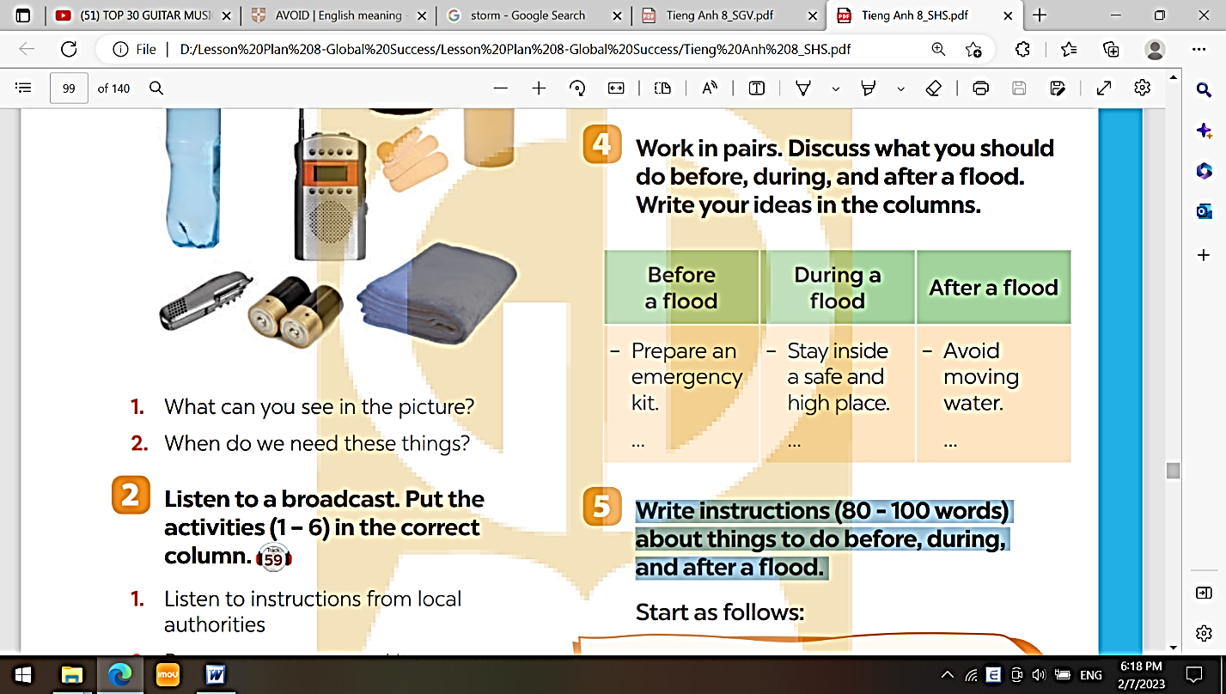
Activity 5: Write instructions (80 - 100 words) about things to do before, during, and after a flood.  - Have Ss write their instructions individually based on their answers in 4.  - Ask one student to write his or her answer on the board. Other Ss and T comment on the writing.  - Collect some writing to correct at home. Otherwise, ask Ss to revise and rewrite at home based on the T's comments on their friends'writing.  - Have them bring their new text to class in the next lesson. Collect some for marking. Comment on their writing  Sample:  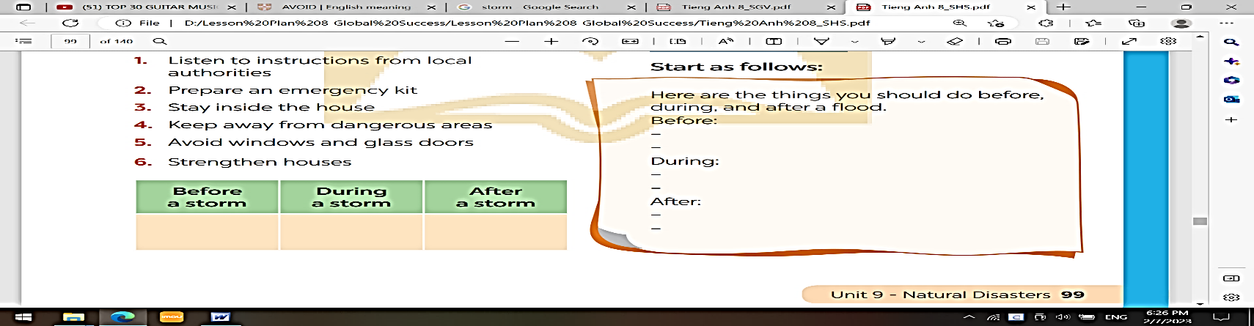  - T gives feedback on their writing in terms of spelling, grammatical mistakes, cohesion, and content. | 5- Write instructions (80 - 100 words) about things to do before, during, and after a flood.  * Suggested answer:  Here are the things you should do before, during, and after a flood.  Before:  - Prepare an emergency kit with necessary things.  - Build barriers to stop floodwater from entering the house.  - Move to a higher place if necessary.  During:  - Listen to the radio or television for warnings and information.  - Be careful with flash flooding.  After: - Avoid moving water.  - Stay away from damaged areas unless the local authority needs your help.  - Listen for local warnings of flash floods.
5. Wrap-Up & Home Work (3’)
- Ask Ss to say what skills they have developed in this lesson. Ask them about their progress and what they want to improve.
* HOME WORK:
- Do more exercises in workbook.
- Prepare new lesson: Lesson 7 : LOOKING BACK.

**********************************

Date of planning :
Date of teaching :
UNIT 9 : NATURAL DISASTERS
Lesson 7 : Looking Back & Project
I. Objectives:
By the end of this lesson, Ss will be able to :
1. Knowledge:
- Revise more vocabulary items they have learnt in the unit.
- Revise the differences between the past simple and past continuous.
- Revise the past continuous.
- Have an opportunity to research more deeply into a natural disaster.
- Apply what they have learnt (vocabulary and grammar) into practice through a project.
+ Vocabulary:The lexical items related to Natural disasters.
- Pronunciation: Stress in words ending in -al and - ous
- Giving and responding to bad new.
+ Grammar: Past continuous tense.
2. Competence:
- Develop communication skills and creativity.
- Be co-operative and supportive in pair work and teamwork.
- Actively join in class activities.
3. Qualities:
- Develop awareness of Natural disasters.
- Be concerned to Natural disasters.
II. Teaching Aids:
- Teacher: Grade 8 text book,computer, projector / TV, hoclieu.vn/ sachmem.vn.....
- Students : Text books, workbook…
III. Procedure:

1. Warm - up ( 5’)
Aims: - To create an active atmosphere in the class before the lesson;
- To lead into the new lesson.
Teacher’s Student’s activities | Content
+ Greeting:  - T writes on the board “Unit 9” and asks students to think of what they have already learnt in this unit.  - Sts work in groups to do the task.  - T calls some students to retell.  - T confirms and leads them to do all the exercises in books.  -T leads in the lesson. | + Greeting T_Ss. Ss - Ss  Answers:  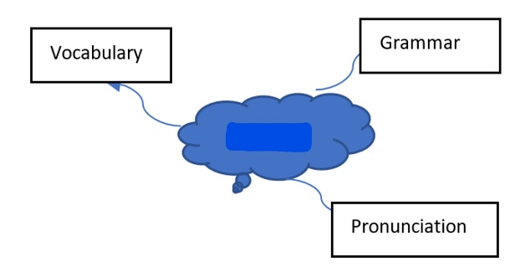
2. Presentation ( 10’)
Aims : - To help Ss revise the vocabulary items they have learnt in the unit.
- To help Ss revise the vocabulary items they have learnt in the unit.
Teacher’s Student’s activities | Content
Activity 1: Write the name of a natural disaster in each blank.  + Have Ss do this activity individually, then compare their answers with their partners.  - Ask for Ss' answers or ask one student to write his / her answer on the board.  - Confirm the correct answers. | 1- Write the name of a natural disaster in each blank.  *Answer key:  1. flood 2. storm  3. earthquake 4. volcanic eruption  5. landslide
Activity 2: Fill in each blank with the correct form of the word in brackets.  + Have Ss complete the sentences using the correct form of the words given.  - Ask them to share their answers with a classmate.  - Invite some Ss to write their answers on the board.  - Confirm the correct answers. | 2- Fill in each blank with the correct form of the word in brackets.  * Answer key:  - 1. destruction  - 2. predictions  - 3. victims  - 4. warned  - 5. workers
3. Practice (17’)
Aims: - To help Ss revise the differences between the past simple and past continuous.

- To help Ss revise the past continuous by completing the sentences about them and their family members
Teacher’s Students’ activities | Content
Activity 3: Put the verbs into the correct tense:the past simple or past continuous.  + Have Ss do this exercise individually, then compare their answers with a partner.  + Call on some Ss to give the answers. Confirm the correct answers and write them on the board.  - Confirm the correct answers as a class. | 3- Put the verbs into the correct tense:the past simple or past continuous.  * Answer key:  1. were … doing  2. destroyed  3. was watering; came  4. were calling; appeared  5. Were … listening
Activity 4: Complete the sentences about you and your family members.  - Have Ss do this exercise individually, then compare their sentences with a partner.  - Invite some Ss to write their sentences on the board.  - Comment on their answers. | 4- Complete the sentences about you and your family members.  * Suggested answers:  At 7 p.m. yesterday, …  1. I was _________________.  2. my grandmother / grandfather __________________________.  3. my mother ________________.  4. my father _________________.  5. my sister / brother __________.
4. Production/ Project (10’)
YOUR DREAM SHOPPING PLACE
Aims: To help Ss do a project on a natural disaster they want to learn more about.
Teacher’s Student’s activities | Content
Activity 5: Project  + Ask Sts to read the instructions. Make sure they understand what to do. Ask Ss to work in groups to do the project.  - Instruct Ss how to carry out this project. Ask them to try to search for information to answer the questions given and create a poster about the natural disaster they have chosen.  - If time is limited, assign the project in earlier lessons such as in GETTING STARTED lesson.  - Make sure you guide them carefully and check their progress after each lesson. In the last lesson (LOOKING BACK), ask Ss to present their poster to the class.  - T checks ss’ grammatical and spelling mistakes on their poster, listens to their presentation, and gives feedback. | *Project  - T should assign the project in earlier lessons such as in GETTING STARTED lesson. Make sure you guide them carefully and check their progress after each lesson. In the last lesson (LOOKING BACK), Ss to present their report to the class.  + Ss display all the posters on the wall or bulletin board ; Each group presents the poster they prepare to the whole class.  ** Students’ posters & presentations
5. Wrap-Up & Home Work (3’)
- Ask Sts to complete the self-assessment table.
- Identify any difficulties, weak areas, and provide further practice
* HOME WORK:
- Do more exercises in workbook.
- Prepare new lesson: Unit REVIEW 3 (7,8,9).

Date of planning :
Date of teaching :

REVIEW 3 (UNIT 7- 8- 9)- LANGUAGE FOCUS
Pronunciation- Vocabulary-Grammar
I. Objectives:
By the end of this review, Ss will be able to:
1. Knowledge:
- Revise the language and skills they have learnt in Unit 7-8-9.
- Revise the words related to environment protection; words about shopping ; and words related to types of natural disasters.
- Pronounce the sounds /bl/ and /kl/; /sp/ and /st/; stress in words ending-al and -ous in isolation and in context;
- Revise how to asking for clarification ; making complaints; Giving and responding to bad news.
a) Vocabulary: Ss revise the words related to the environment protection ; words about shopping;
b) Grammar : Revise complex sentences with adverb clause of time ; adverb of frequency, present simple for future events; Past contiuous tense.
c) Writing : - Writing a note ; Writing a paragraph about the advantages and disadvantages of a type of shopping ; Writing instructions about things to do before, during, and after a natural disaster.
2. Competence:
- Develop communication skills and creativity.
- Be cooperative and supportive in pair work and teamwork.
- Actively join in class activities
3. Qualities :
- Raise the students’ awareness about enviromental protection; Show respect and interest in different type of shopping places; develop awareness of Natural disasters.
- Have the good attitude to working in groups, individual work, pair work, co-operative learning.
- Develop self-study skills.
II. Teaching Aids:
- Teacher: Grade 8 text book,computer, projector / TV, hoclieu.vn/ sachmem.vn.....
- Students : Text books, workbook…
III. Procedure:

1. Warm - up (5’)
Aims: By the end of this review, students will have revised the language they have learnt and the skills they have practised in Units 7 – 9.
+ Ask Sts what they have learnt so far in terms of language and skills.
+ Summarise their answers and add more information if necessary. Encourage Ss to recall and name as many words as possible.
- T may use this language review section as a self-test. Ss do the exercises in 30 minutes then check their answers. Provide further practice if necessary. Otherwise, conduct each activity separately.
Teacher’s & Student’s activities | Content
+ Greeting  + Revision on the old lessons/ Chatting  - T asks Sts some questions about them and class.  - Ask Sts to open their book and introduce what they are going to study…. | + Greeting ; T_Ss  + Chatting  - Open their book and write .
PRONUNCIATION (7’)
Aims: To help Ss review the pronunciation of the sounds /bl/, /kl/, /sp/, /st/ learnt in Units 7-8 and word stress ending in -al and -ous learnt in Unit 9.
Teacher’s & Student’s activities | Content
Activity 1: Listen and repeat, paying attention to the underlined words.  1.a  + Play the recording. Have Ss listen to and repeat the sentences aloud in chorus, paying attention to the underlined words.  - Call on some Ss to read the sentences.  - Correct their pronunciation as a class.  1.b  - Sts work individually to choose the word in each line with a different stress pattern.  - T checks as a class. | 1a. Listen and repeat, paying attention to the underlined words.  * Audio script - Track 60:  1. The sky today is clear and blue.  2. The speaker talked a lot about honesty.  3. The store on that corner sells local specialties.  1 b. Choose A, B, C, or D to show the word in each group with a different stress pattern.  * Key : 1. B 2. C 3.D
VOCABULARY ( 12’)
Aims: To help Ss review using the words and phrase they have learnt in Units 7-9; To help Sts revise the form and use of some words they have learnt in Units 7-9 in sentences
Activity 2: Choose A, B, C, or D to show the word in each group with a different stress pattern.  + Ask Sts to read the sentences and find the words / phrase to fill in the blanks. Have them read the sentences carefully and look for clues so that they can choose the right words / phrase to complete the sentences.  + Then have Ss share their answers with a partner. Check Ss' answers as a class. | 2- Complete the sentences with the words and phrase from the box.  * Key:  1. single-use 2. customers  3. habitats 4. natural disasters  5. bargain
Activity 3: Use the correct forms of the words in brackets to complete the sentences.  - Have Ss do this exercise individually.  - Have Ss read the sentences for 2 - 3 minutes.  - Ask them what part of speech (noun, adjective, adverb, antonym with prefix, etc.) can be used to fill in each blank.  - Elicit their answers.  - Ask some Ss to write their answers on the board. Correct as a class. | 3- Use the correct forms of the words in brackets to complete the sentences.  * Suggested answer:  1. destructive  2. disadvantage  3. extinction  4. Addictive  5. instructions
GRAMMAR (8’)
Aims: To help Ss revise the forms and uses of the tenses they have learnt in Units 7-9 (the past continuous, past simple, present simple for future) in context; To help Ss apply the use of the grammar points they have learnt in Units 7-9 in real context by completing sentences about themselves.
Teacher’s & Student’s activities | Content
Activity 4: Use the correct tense of the verbs in brackets to complete the sentences  + Have Ss do the task individually or in pairs.  -Tell them to study the meaning and context of each sentence carefully and use the correct tense of the verbs given.  - Check Ss' answers as a class. | 4- Use the correct tense of the verbs in brackets to complete the sentences.  * Key:  1. was cleaning 2. has  3. starts 4. Were … waiting  5. was just falling; heard
4. Pronunciation (10’)
Activity 5: Complete the sentences, so that they are true for you.  - Give them some time to work independently and write down their sentences.  - Then have them work in pairs to exchange their sentences.  - Call on some Ss to write their answers on the board. Other Ss comment.  - T corrects as a class.  + Do more exercises if have time. | 5- Complete the sentences, so that they are true for you.  * Key: (Students answers)  1. When I finished my lessons yesterday, I went to bed early.  2. Before I go to bed at night, I will brush my teeth.  3. I will wait until the teacher shows up to the class.  4. As soon as we have our summer holiday, we will go to the beach.  5. I usually listen to music while I study.
5. Wrap-Up & Home Work (3’)
- Summarise the main points.
- Ask Ss what they have learnt so far. Have them recall the important grammar points.
+ Words / phrases . Vocabulary; The grammar points.
* HOME WORK
- Read again the conversation
- Do more exercises in workbook.
- Make more sentences using adverbs of frequency.

******************************

Date of planning :
Date of teaching :
Period 77
REVIEW 3 (UNIT 7- 8- 9)
SKILLS : Reading- Speaking- Listening - Writing
I. Objectives:
By the end of this review, Ss will be able to:
1. Knowledge:
- Revise the language and skills they have learnt in Unit 7-8-9.
- Revise the words related to Environment protection; words about shopping ; and words related to types of natural disasters.
- Pronounce the sounds /bl/ and /kl/; /sp/ and /st/; stress in words ending-al and -ous in isolation and in context;
- Revise how to asking for clarification ; making complaints; Giving and responding to bad news.
a) Vocabulary: Ss revise the words related to Environment protection ; words about shopping;
b) Grammar : Revise complex sentences with adverb clause of time ; adverb of frequency, present simple for future events; Past contiuous tense.
c) Writing : - Writing a note ; Writing a paragraph about the advantages and disadvantages of a type of shopping ; Writing instructions about things to do before, during, and after a natural disaster.
2. Competence:
- Develop communication skills and creativity.
- Be cooperative and supportive in pair work and teamwork.
- Actively join in class activities
3. Qualities :
- Raise the students’ awareness about enviromental protection; Show respect and interest in different type of shopping places; develop awareness of Natural disasters.
- Have the good attitude to working in groups, individual work, pair work, co-operative learning.
- Develop self-study skills.
II. Teaching Aids:
- Teacher: Grade 8 text book,computer, projector / TV, hoclieu.vn/ sachmem.vn.....
- Students : Text books, workbook…
III. Procedure:

1. Warm - up (5’)
Aims: By the end of this review, students will have revised the language they have learnt and the skills they have practised in Units 7 - 9; Ss revise what they have learnt so far in terms of language and skills. Summarise their answers and add some more information if necessary.
Teacher’s & Student’s activities | Content
+ Greeting + Revision / Chatting  - T asks Sts some questions about old lessons and class.  - Ask Ss to open their book and introduce what they are going to study…. | + Greeting  - T_ Ss / Chatting  - Sts listen and learn how to do.  - Open their book and write .
Reading
Aims:To develop Ss' skill of reading for specific information.
Teacher’s & Student’s activities | Content
Activity 1: Read the passage and tick (✓) T (True) or F (False) for each sentence.  - Sts do the task individually. Tell them to read the passage two or three times, then read each statement, identify where it appears in the text, and decide if it is true (T) or false (F).  - Sts work with a partner to discuss the answers.  - Explain the new words and clarify anything difficult. Ask more questions to see if they understand the passage fully.  - Call on some Ss to read the passage aloud before the class.  - Check their pronunciation and intonation.  - Check the answers as a class. | 1- Read the passage and tick (✓) T (True) or F (False) for each sentence.  * Key:  1. F  2. T  3. F  4. T  5. T
Speaking
Aims: To provide Ss with an opportunity to revise the vocabulary they have learnt; To give Ss practice in asking and answering about disaster(s) that sometimes occur(s) in their areas.
Activity 2: Work in pairs. Take turns to ask your classmate the following question.  + Tell Ss that they are going to listen to a passage about air pollution in big cities. Tell them that their task is to write no more than two words in each blank while listening.  + First, ask Ss to think of disaster(s) that sometimes happen in their areas.  - Ss work in pairs, asking and answering questions about that / those disaster(s).T tells them to use Wh- questions.Ss talk about the damage that the disaster(s) may cause.  - Go round to monitor and give help when necessary.  - Call on some pairs to perform the task in front of the class.T and other Ss listen and comment. | 2- Work in pairs. Take turns to ask your classmate the following question.  * Students’ answer  * The damage that FLOODS may cause:  - Floods wreaked havoc on infrastructure, including highways, schools, health institutions, and community centres.  - Over 360 schools were flooded or destroyed, over two million cattle lives were lost, and 30,000 hectares of agricultural productivity were devastated, according to reports.  - The distribution of aid in the aftermath of the floods was hampered by substantial damage to public transit systems.
Listening
Aims: To help Ss practise listening for specific information.
Teacher’s & Student’s activities | Content
Activity 3: Listen to the passage and fill in each blank with no more than TWO words.  - Tell Ss that they are going to listen to a passage about air pollution in big cities.  - Tell them that their task is to write no more than two words in each blank while listening.  -Sts read the sentences carefully and predict what word(s) should be filled in each blank.  - Play the recording. Tell Ss to listen carefully and pay attention to keywords that help them understand the main ideas of the recording.  - Sts write their answers as they listen.  - Check their answers. | 3- Listen to the passage and fill in each blank with no more than TWO words.  * Key:  1. pollution 2. Dangerous  3. air pollution 4. coal  5. other sources
Writing
Aims: To help Ss practise writing a paragraph about where their family shops and giving reasons for their choice.
Teacher’s & Student’s activities | Content
Activity 4: Write a paragraph ( 80- 100 words) about where your family shops and give reasons for your choice.  + Before writing, brainstorm Ss' ideas about the reasons why they go shopping at a particular place: convenience, price, freshness of food, friendliness of sellers, etc. Also brainstorm words and phrases they may need for their writing.  - Give them time to do the writing task.  - Collect their papers to check at home. T may have them swap their writing with their partner to learn more experience. | 4- Write a paragraph ( 80- 100 words) about where your family shops and give reasons for your choice.  * Suggested answer:  My family usually shops at the open-air market in my neighbourhood. My mum goes shopping there once every two days, it is only about five minutes' walk from my home, so it is very convenient. There is a wide variety of goods, from groceries to vegetables, from clothes to kitchen utensils, etc. And their price is reasonable. Moreover, the food there is good and fresh as farmers bring their products to sell there every day. We are lucky to have a good shopping place nearby .
5. Wrap-Up & Home Work (3’)
- T asks sts to talk about what they have learnt in the lesson .
- Summarise the main points.
- Ask Ss what they have learnt so far. Have them recall the important elements:
* HOME WORK
- Finish the writing. Copy into the notebooks.
- Do more exercises in workbook.

**************************************

