Week | Period | Date of preparation | Date of teaching | Class/ Number | Absent
5 | 14 | 01/10/2024 |  | 7A:38
 |  |  |  | 7B:38
 |  |  |  | 7C:39
 |  |  |  | 7D:37
 |  |  |  | 7E:39

UNIT 2: HEALTH
Lesson 2.2 - Grammar (Page 16)
I. OBJECTIVES
By the end of the lesson, Ss will be able to:
1.1. Language knowledge and skills
- listen to 2 people asking and answering about a health problem and advice.
- use “should” and “shouldn’t” to ask for and give advice.
1.2. Competences
- improve speaking, listening and writing skills.
- improve the use of English.
1.3. Attributes
- know how to ask for advice and give advice.
- lead a healthy life.
II. TEACHING AIDS AND LEARNING MATERIALS
1. Teacher’s aids: Student book and Teacher’s book, class CDs, Digital Book (DCR phần mềm tương tác SB, DHA (từ vựng/ cấu trúc) phần mềm trò chơi tương tác), projector/interactive whiteboard / TV (if any), PowerPoint slides, handouts.
2. Students’ aids: Student’s book, workbook, notebook.
III. PROCEDURES
A. Warm up: (5’)
a) Objective: Introduce the new lesson and set the scene for Ss to acquire new language; get students' attention at the beginning of the class by enjoyable and short activities as well as to engage them in the follow-up steps.
b) Content: Review vocabulary about health problems / Introduce “should”.
c) Expected outcomes: Ss review words about health problems and Ss have general ideas about the grammar point they are going to study in the new lesson.
d) Organization of the activity:
TEACHER’S ACTIVITIES | STUDENTS’ ACTIVITIES
- Option 1: Health problems  - Have Ss look at the pictures and give names of health problems.  - Call Ss to give answers.  - Check Ss’ answers, give feedback and lead to the new lesson.  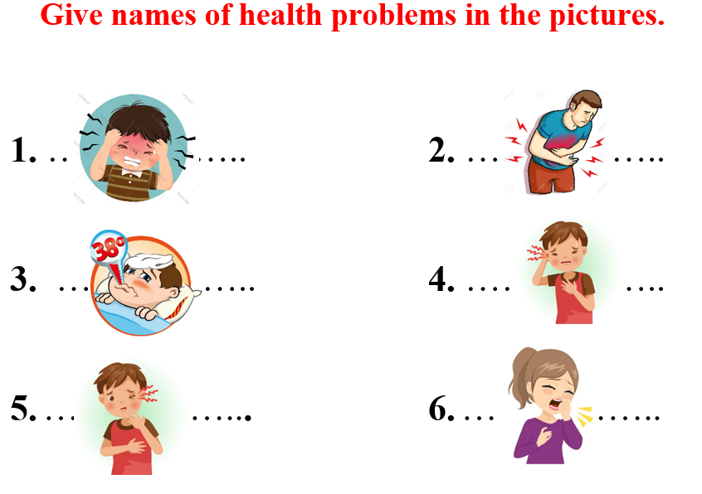  - Have Ss make sentences, using the vocabularies above.  - Lead to the new lesson.  - Option 2: Game: Letter Lingo  - Have Ss close all books and notebooks.  - Show some pictures, have Ss choose number at random and then give names of the pictures.  - Have Ss use the red letter of their answers (the red letter is shown on the screen) to form a new word.  - The first student to give the correct key word in the shortest time will be the winner.  - Give praise or a small present to the winner.  *Illustration:  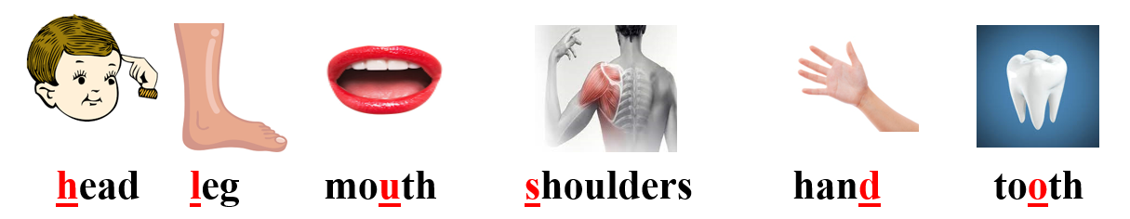  - Tell Ss about the grammar point they are going to study in the new lesson: “should” and “shouldn’t”.  - Lead to the new lesson. | - Work in pairs.  - Give answers.  Answers keys  1. headache  2. stomachache  3. fever  4. sore eye  5. earache  6. cough  - Read sentences.  - Close books and notebooks.  - Choose number and answer.  Answers keys  Keyword: SHOULD  - Listen.
B. New lesson (35’)
- Activity 1: Presentation (10’)
a) Objective: Introduce “should” and “shouldn’t”.
b) Content:
- Listen and repeat.
- Introduce “should” and “shouldn’t” (affirmative, negative and interrogative form).
c) Expected outcomes: Ss know how to use “should” and “shouldn’t” to do some following exercises.
d) Organization of the activity:

TEACHER’S ACTIVITIES | STUDENTS’ ACTIVITIES
Task a. Listen and repeat  - Have Ss look at the picture (using DCR).  - Play audio (CD1 – Track 20) and have Ss listen and read the speech bubbles.  - Play the audio again and have Ss listen and repeat.  Grammar box  - Option 1:  - Have Ss look at the grammar explanation (using DCR).  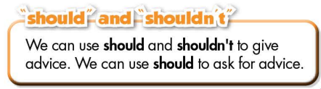  - Have Ss look at the box and read examples of different forms.  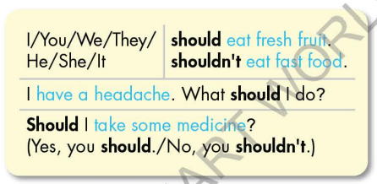  - Explain more about the form and the usage of “should” and “shouldn’t”, have Ss pay attention to the negative and the question form.  Form:  (+) S + should + V_{B.I} …  (-)S + shouldn’t + V_{B.I} …  (?)Should + S+ V_{B.I} …  Usage: to ask for and to give advice.  *Note: V_{B.I} = verb in bare infinitive form  - Have some Ss read aloud the sentences in the Grammar Box.  - Ask Ss to give more examples using “should” and “shouldn’t”.  - Option 2:  - Have Ss close books.  - Show sample sentences in the grammar box (using DCR).  - Have Ss read the sentences aloud  - Have Ss make comment on the way they use “should” and “shouldn’t” by asking Ss some questions:  *Suggested questions:  1.What type of verb is used after “should” and “shouldn’t”?  2.In each sentence, what so they use “should” and “shouldn’t” for?  3. How do we answer question with “should”?  - Call Ss to give answers, comment on Ss’ answers  - Then have Ss open the books and read the grammar box  - Have Ss give more examples of “should” and “shouldn’t”, encourage them to make sentences with their own ideas.  - Give feedback and evaluation | - Look.  - Listen, then read.  - Listen and repeat.  - Look and read.  - Look and read.  - Listen and take notes.  - Read.  - Give examples.  - Close all books.  - Look and answer.  - Read.  - Answer the questions.  - Open the books and read the grammar box.  - Give examples.
- Activity 2: Practice (19’)
a) Objective: Students can use “should” and “shouldn’t” to ask for and give advice.
b) Content:
- Use the prompts to give advice for each problem.
- Fill in the blanks using “should” and “shouldn’t”.
c) Expected outcomes: Students can apply “should” and “shouldn’t” to ask for and give advice in their speaking.
d) Organization of the activity:
TEACHER’S ACTIVITIES | STUDENTS’ ACTIVITIES
Task b. Use the prompts to give advice for each problem.  - Demonstrate the activity, using the example (using DCR).  - Have Ss use the prompts to give advice for each problem (in individual).  - Have Ss work in pairs to check each other’s work.  - Have some Ss share their answers with the whole class.  - Give feedback, correct Ss’ answers if necessary.  Task c. Fill in the blanks using “should” and “shouldn’t”  - Demonstrate the activity, using the example (using DCR).  - Have Ss fill in the blanks using “should” and “shouldn’t”.  - Have Ss check answers with their partners.  - Call Ss to read answers.  - Check Ss’ answers, give feedback. | - Look and listen.  - Work individually.  - Work in pairs.  - Write answers on the board.  Answer keys  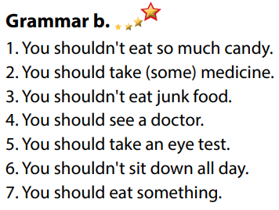  - Look and listen.  - Work individually.  - Work in pairs.  - Read answers.  Answer keys  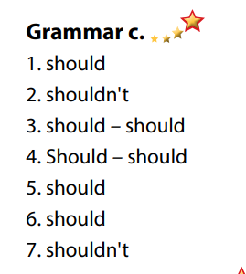
- Activity 3: Production (6’)
a) Objective: Students master the grammar point they study in the lesson.
b) Content: Speaking: Ask for and give your partner advice using the prompts.
c) Expected outcomes: Ss produce the new language successfully, and they can apply “should” and “shouldn’t” in speaking and writing.
d) Organization of the activity:
TEACHER’S ACTIVITIES | STUDENTS’ ACTIVITIES
Task d. In pairs: Ask for and give your partner advice using the prompts.  - Use DCR to show the task.  - Divide class into pairs.  - Have Ss ask for and give their partner advice using the prompts.  - Encourage Ss to use more words about health problems and give advice with their own ideas.  - Have some pairs demonstrate the activity in front of the class.  - Give feedback and evaluation. | - Listen and take notes.  - Have conversation in pairs.  - Present.  - Listen.

C. Consolidation and homework assignments (5’)
*Consolidation
- “should” and “shouldn’t”
Form:
Form:
(+) S + should + V_{B.I} …
(-)S + shouldn’t + V_{B.I} …
(?)Should + S+ V_{B.I} …
Usage: to ask for / give advice
* Homework:
- Make 2 sentences, use “should” and “shouldn’t to ask for / give advice.
- Do the exercises in WB: Grammar (page 11).
- Complete the grammar notes in Tiếng Anh 7 i-Learn Smart World Notebook (page 13).
- Play consolation games in Tiếng Anh 7 i-Learn Smart World DHA App on www.eduhome.com.vn
- Prepare: Lesson 2 – Pronunciation and Speaking (page 17 – SB).

