Week | Period | Date of preparation | Date of teaching | Class/ Number | Absent
4 | 10 | 23/09/2024 |  | 7A:38
 |  |  |  | 7B:38
 |  |  |  | 7C:39
 |  |  |  | 7D:37
 |  |  |  | 7E:39

UNIT 2: HEALTH
Lesson 1.1 - Vocabulary and Reading (Page 12)

I. OBJECTIVES
By the end of the lesson, Ss will be able to:
1.1. Language knowledge and skills
- talk about a healthy and unhealthy lifestyle, using phrases: get some sleep, eat fruits and vegetables, eat fast food, drink soda, healthy, unhealthy.
- practice reading and understanding general and specific information about Toby and Lisa’s healthy living class survey.
- use indefinite quantifiers.
1.2. Competences
- improve communication, collaboration, analytical and critical thinking skills.
1.3. Attributes
- lead a healthy lifestyle and ditch bad ones.
II. TEACHING AIDS AND LEARNING MATERIALS
1. Teacher’s aids: Student book and Teacher’s book, class CDs, Digital Book (DCR phần mềm tương tác SB, DHA (từ vựng/ cấu trúc) phần mềm trò chơi tương tác), projector/interactive whiteboard / TV (if any), PowerPoint slides.
2. Students’ aids: Student’s book, workbook, notebook.
III. PROCEDURES
A. Warm up: (5’)
a) Objective: Introduce the new lesson and set the scene for Ss to acquire new language; get students' attention at the beginning of the class by enjoyable and short activities as well as to engage them in the follow-up steps.
b) Content: Introducing some verb phrases and adjectives about life style.
c) Expected outcomes: Ss have general ideas about the topic of the new lesson: “health”.
d) Organization of the activity:
TEACHER’S ACTIVITIES | STUDENTS’ ACTIVITIES
- Option 1: Matching  - Use the “New words” part a.– page 12 for the warm-up activity.  - Show pictures and words (using DCR), have Ss match the words and phrases with the pictures (in pairs).  - Call Ss to give answers.  - Give feedback and show correct answers (using DCR).  - Lead to the new lesson.  - Play the audio (CD1 – Track 13), have Ss listen and repeat.  - Correct Ss’ pronunciation if necessary.  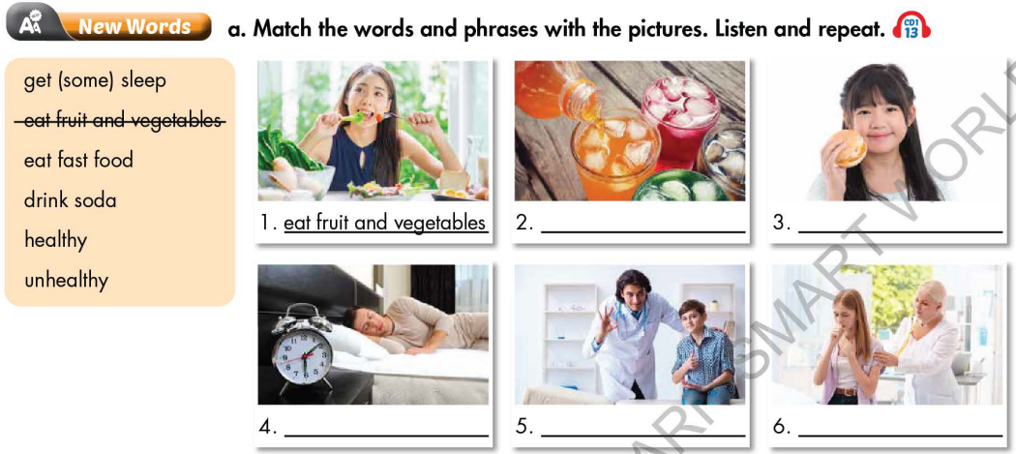  - Option 2: Game: CROSSWORD  - Explain the rules of the game.  - Design the game “Crossword Puzzle” with words and pictures about food and drink.  - Let Ss play the game, encourage Ss to guess the key word.  - If any S can give the correct key word, T hasn’t confirmed yet, the game will be continued until the keyword is opened (to check whether his/her answer is correct or not and to let other Ss take part in the game eagerly).  - Give a small gift to the Ss who is the fastest to give the correct key word.  - Ask Ss an extra question: Which food / drink is good / not good for your health?  - Give feedback and lead to the new lesson. | - Work in pairs to match the words and phrases with the pictures.  - Give answers.  - Listen.  Answer keys  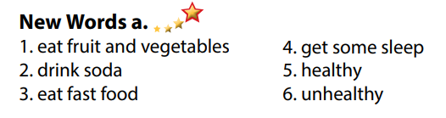  - Listen.  - Take part in the game by answering the questions in horizontal line (not in order) and try to guess keyword in the vertical column.  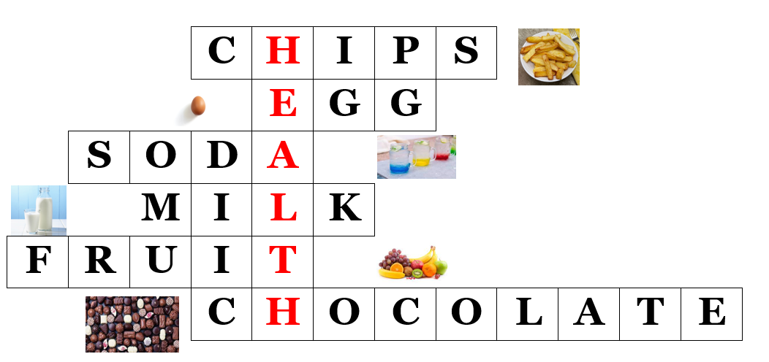  Keyword: HEALTH
B. New lesson (35’)
- Activity 1: Pre-Reading (Vocabulary) (12’)
a) Objective: Ss know some verb phrases about life style.
b) Content:
- Vocabulary study (get some sleep, eat fruits and vegetables, eat fast food, drink soda, healthy, unhealthy).
- Speaking: Discuss which things are healthy and unhealthy.
c) Expected outcomes: Ss know how to pronounce the new words correctly and use them in appropriate situations.
d) Organization of the activity:
TEACHER’S ACTIVITIES | STUDENTS’ ACTIVITIES
Task a. Match the words and phrases with the pictures. Listen and repeat.  - Option 1 (If the teacher hasn’t used this part for the Warm-up activity)  - Demonstrate the activity, using the example (using DCR).  - Have Ss match the words and phrases with the pictures.  - Divide class into pairs and have them check their answers with their partners.  - Call Ss to give answers (read or write).  - Check answers as a whole class (using DCR).  - Play audio (CD1 – Track 13). Have Ss listen and repeat.  - Correct Ss’ pronunciation.  - Option 2: Matching (If the teacher has used part a. for the Warm-up activity)  - Have Ss review the words they have known in the warm-up activity by looking at the pictures and filling in the blanks, (T uses different pictures from those in the textbook).  - Call Ss to give answers (read or write).  - Check answers as a whole class.  - Call some Ss to read the words again.  - Correct Ss’ pronunciation if necessary.  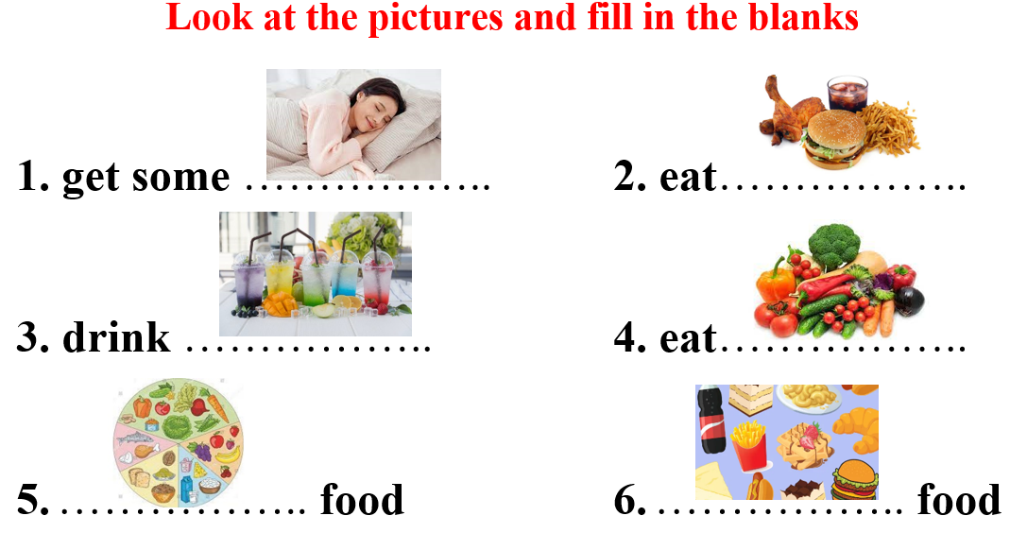  Task b. Discuss which things are healthy and unhealthy.  - Have Ss discuss in pairs which things are healthy and unhealthy.  - Have Ss share their ideas in front of the class.  - Give feedback and evaluation.  - Have Ss give more activities related to lifestyle which are divided into 2 groups: healthy and unhealthy.  - Give feedback and evaluation. | - Look and listen.  - Work individually.  - Work in pairs.  - Give answers.  - Listen and repeat.  Answer keys  - Work in pairs.  - Give answers.  - Read.  Answer keys  1. get some sleep  2. eat fast food  3. drink soda  4. eat vegetables  5. healthy food  6. unhealthy food  - Work in pairs.  - Present.  Suggested answers  Healthy: get some sleep, east fruit and vegetables  Unhealthy: eat fast food, drink soda
- Activity 2: While - Reading (17’)
a) Objective: Students can develop their reading skill.
b) Content: Reading Toby and Lisa’s class report and choosing the correct answer, then reading Toby and Lisa’s Healthy Living Class Survey and circling the correct answer.
c) Expected outcomes: Students can read and understand general and specific information about a healthy living class survey.
d) Organization of the activity:
TEACHER’S ACTIVITIES | STUDENTS’ ACTIVITIES
Task a. Read Toby and Lisa’s class report and circle the correct answer  - Use DCR to show the task. Ask Ss to read two options and find out key words.  - Have Ss read the class report individually.  - Have Ss circle the correct answers.  - Have some Ss share their answers with the class (read), explain for their answers.  - Give feedback.  - Give feedback and correct Ss’ answers if necessary.  Task b. Now, read and circle the correct answers.  - Use DCR to show the task. Have Ss read the questions, underline key words and guess the answers.  - Have Ss read the text again and circle the correct answers – underline or highlight the supporting ideas.  - Have Ss check answers with their partners.  - Call Ss to give answers, explain.  - Give feedback and evaluation. | -Work individually.  - Circle the correct answers.  - Read answers, explain.  - Check answers.  Answer keys  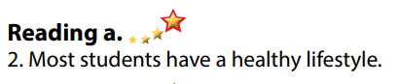  - Read and underline.  - Do the task.  - Check answers.  Answer keys  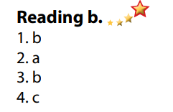
- Activity 3: Post - Reading (6’)
a) Objective: Students can use the vocabulary and ideas from the reading text to develop their speaking skill.
b) Content: Speaking: Do you have a healthy lifestyle? Why / Why not?
c) Expected outcomes: Students can talk about their own lifestyle and try to lead a healthy lifestyle.
d) Organization of the activity:
TEACHER’S ACTIVITIES | STUDENTS’ ACTIVITIES
Task c. In pairs: Do you have a healthy lifestyle? Why / Why not?  - Have Students work in pairs to talk about their lifestyle and decide whether it is healthy or not.  - Call some Ss to share their ideas with the whole class.  - Give feedback and evaluation.  - For more practice, have Ss play a game with DHA. | - Discuss in pairs.  - Listen.
C. Consolidation and homework assignments (5’)
* Consolidation:
- Verb phrases about lifestyle: get some sleep, eat fruits and vegetables, eat fast food, drink soda.
- Adjectives: healthy and unhealthy.
* Homework:
- Learn the new words by heart.
- Practice talking about lifestyle.
- Do the exercises in WB: Unit 2 - Lesson 1 - New words + Reading (pages 8,9).
- Do the vocabulary exercise in Tiếng Anh 7 i-Learn Smart World Notebook (page 10).
- Play consolation games in Tiếng Anh 7 i-Learn Smart World DHA App on www.eduhome.com.vn
- Prepare: Lesson 1.2 – Grammar (page 13 – SB).

