Week | Period | Date of preparation | Date of teaching | Class/ Number | Absent
1 | 2 | 31/08/2024 |  | 7A:37
 |  |  |  | 7B:38
 |  |  |  | 7C:39
 |  |  |  | 7D:38
 |  |  |  | 7E:39

UNIT 1: FREE TIME
Lesson 1.2 - Grammar
I. OBJECTIVES
By the end of the lesson, Ss will be able to:
1.1. Language knowledge and skills
- listen to 2 people asking and answering about a free time activity.
- talk about habits or things that happen regularly.
- use the Present Simple correctly.
- write simple sentences about habits.
1.2. Competences
- improve speaking, listening and writing skills.
- improve the use of English.
1.3. Attributes
- take up a useful hobby and spend a suitable amount of time on this hobby.
- build good habits for themselves and kick bad ones.
II. TEACHING AIDS AND LEARNING MATERIALS
1. Teacher’s aids: Student book and Teacher’s book, class CDs, Digital Book (DCR phần mềm tương tác SB, DHA (từ vựng/ cấu trúc) phần mềm trò chơi tương tác), TV, PowerPoint slides, handouts.
2. Students’ aids: Student’s book, Workbook, Notebook.
III. PROCEDURES
A. Warm up: (5’)
a) Objective: Introduce the new lesson and set the scene for Ss to acquire new language; get students' attention at the beginning of the class by enjoyable and short activities as well as to engage them in the follow-up steps.
b) Content: Jumbled word or rearranging words to make a meaningful sentence.
c) Expected outcomes: Ss review words about hobbies or Ss have general ideas about the grammar point they are going to study in the new lesson.
d) Organization of the activity:
TEACHER’S ACTIVITIES | STUDENTS’ ACTIVITIES
- Give greetings.  - Check attendance.  - Option 1: Game “JUMBLED WORD”  - Have Ss rearrange letters to make a meaningful word.  - Call Ss to give answers.  - Check Ss’ answers, give feedback and lead to the new lesson.  1. bbohy 2. deloms 3. moiccs  4. lonnie 5. bouYutre  - Have Ss make sentences, using the words they have just made.  - For more vocabulary games, use DHA.  - Lead to the new lesson.  - Option 2: REARRANGING  - Have Ss rearrange the words to make a meaningful English sentence.  1. do / do / free time / What / you / your / in?  2. play / you / Do / soccer?  3. reading / like / comics / I  4. online / He / on / plays / games / Sundays  5. We / on / like / movies / the / watching / weekends.  - Have Ss read their answers.  - Tell Ss about the grammar point they are going to study in the new lesson.  - Lead to the new lesson. | - Greet T.  - Take part in the game.  - Give answers (write on the board).  Answers keys  1. hobby 2. models 3. comics  4. online 5. Youtuber  - Read sentences.  - Work in pairs.  Answers keys  1. What do you do in your free time?  2. Do you play soccer?  3. I like reading comics.  4. He plays online games on Sundays.  5. We like watching movies on the weekends.  - Give answers.  - Listen.
B. New lesson (35’)
- Activity 1: Presentation (10’)
a) Objective: Help Ss review Present Simple (form, usage).
b) Content:
- Listen and repeat.
- Review the form and usage of the Present Simple.
c) Expected outcomes: Ss remember the Present Simple and use it in some exercises that follow.
d) Organization of the activity:
TEACHER’S ACTIVITIES | STUDENTS’ ACTIVITIES
Task a. Listen and repeat.  - Have Ss look at the picture (using DCR).  - Play audio (CD1 – Track 03) and have Ss listen and read the speech bubbles.  - Play the audio again and have Ss listen and repeat.  Grammar box  - Option 1:  - Have Ss look at the grammar explanation (using DCR).  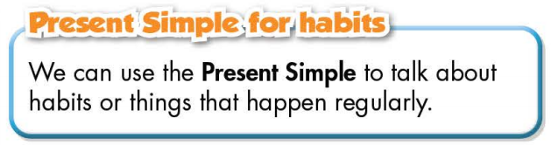  - Have Ss look at the box and read examples of different forms.  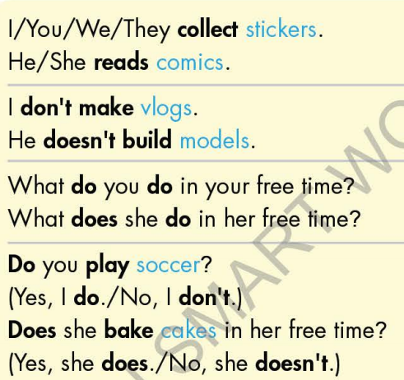  - Explain more about the form and the usage of the Present Simple, have Ss pay attention to the negative and the question form.  Form:  Be: (+) S + am / is / are + …  (-) S + am / is / are + not + …  (?) Am / Is / Are + S + …  Normal verb:  (+) S + V _{s/es}  (-) S + don’t / doesn’t + V _{bare infinitive}  (?)Do / Does + S + V _{bare infinitive}  Usage: to talk about habits or things that happen regularly.  - Have some Ss read aloud the sentences in the Grammar Box aloud.  - Ask Ss to give more examples using the Present Simple.  - Option 2:  - Have Ss close books.  - Give some model sentences, ask Ss to indicate which tense is being used, then have Ss retell form of the Present Simple.  *Suggested model sentences:  1.I always watch TV after I finish my exercises.  2.We go to the library every Saturday.  3.My father often has a cup of coffee every morning.  - Call Ss to give answers, comment on Ss’ answers  - Ask Ss: What are these sentences about?  - Then have Ss open the books and read the grammar box.  - Have Ss give more examples of the Present Simple,  encourage them to make sentences with their own ideas.  - Give feedback and evaluation. | - Look.  - Listen, then read.  - Listen and repeat.  - Look and read.  - Read.  - Listen and take notes.  - Read.  - Give examples.  - Close all books.  - Look and answer.  Expected answer: The sentences are about habits or activities that happen regularly.  - Read.  - Give examples.  - Listen.
- Activity 2: Practice (19’)
a) Objective: Students can use the “Present Simple for habits” to do the given exercises.
b) Content:
- Filling in the blanks.
- Writing sentences about habits, using the pictures and prompts.
c) Expected outcomes: Students can get used to the use of Present Simple and use it correctly.
d) Organization of the activity:
TEACHER’S ACTIVITIES | STUDENTS’ ACTIVITIES
Task b. Fill in the blanks with the correct form of the verbs.  - Demonstrate the activity, using the example (using DCR).  - Have Ss fill in the blanks with the correct form of the verbs.  - Have Ss work in pairs to check each other’s work.  - Have some Ss share their answers with the whole class.  - Give feedback, correct Ss’ answers if necessary.  Task c. Write sentences about habits, using the pictures and prompts.  - Option 1:  - Demonstrate the activity, using the example (using DCR).  - Have Ss write sentences about habits, using the pictures and prompts, remind Ss to pay attention to the form (negative, affirmative, or interrogative)  - Have Ss check answers with their partners.  - Call Ss to write answers.  - Check Ss’ answers, give feedback.  - Option 2:  - Help Ss remember the activities in the pictures given in the exercise first (using DCR).  - Have Ss work in pairs to give names of activities in the pictures.  Eg: Picture 1: collect soccer stickers  - Have Ss write sentences about habits, using the pictures and prompts, remind Ss to use the verb phrases they have reviewed and pay attention to the form (negative, affirmative, or interrogative).  - Have Ss check answers with their partners.  - Call Ss to give answers by reading them aloud.  - Give feedback and show correct answers (using DCR). | - Look and listen.  - Work individually.  - Work in pairs.  - Read answers.  Answer keys  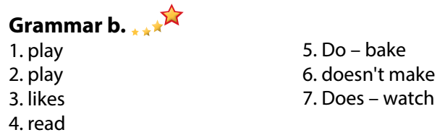  - Look and listen.  - Work individually.  - Work in pairs.  - Write answers.  Answer keys (use DCR)  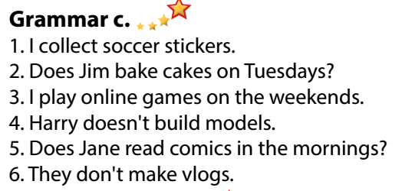  - Listen and memorize.  - Work in pairs.  Expected answers:  Picture 2: bake cakes / bake a cake  Picture 3: play online games  Picture 4: build models  Picture 5: read comics  Picture 6: make vlogs  - Work individually.  - Work in pairs.  - Give answers.  Answer keys

- Activity 3: Production (6’)
a) Objective: Students master the grammar point they study in the lesson.
b) Content: Speaking: Asking and answering about what they do and don’t do in their free time.
c) Expected outcomes: Ss produce the new language successfully, and they can apply the Present Simple in everyday speaking and writing.
d) Organization of the activity:
TEACHER’S ACTIVITIES | STUDENTS’ ACTIVITIES
Task d. Ask your partner about what they do and don’t do in their free time.  - Divide class into pairs.  - Have Ss ask their partner about what they do and don’t do in their free time.  - Have some pairs demonstrate the activity in front of the class.  - Give feedback and evaluation.  - For more practice, have Ss play grammar games with DHA. | - Have conversation in pairs.  - Present.  - Listen.
C. Consolidation and homework assignments (5’)
* Consolidation:
Form and usage of the Present Simple:
Form:
Be: (+) S + am / is / are + …
(-) S + am / is / are + not + …
(?) Am / Is / Are + S + …
Normal verb: (+) S + V _{s/es}
(-) S + don’t / doesn’t + V _{bare infinitive}
(?)Do / Does + S + V _{bare infinitive}
Usage: to talk about habits or things that happen regularly.
* Homework:
- Make 3 sentences, use the Present Simple to talk about your habits.
- Do the exercises in WB: Lesson 1 - Grammar (page 5).
- Prepare: Lesson 1 – Pronunciation and Speaking (page 6 – SB).
- Complete the grammar notes in Tiếng Anh 7 i-Learn Smart World Notebook (page 5).
- Play consolation games in Tiếng Anh 7 i-Learn Smart World DHA App on www.eduhome.com.vn

