Week | Period | Date of preparation | Date of teaching | Class/ Number | Absent
1 | 1 | 30/08/2024 |  | 7A:37
 |  |  |  | 7B:38
 |  |  |  | 7C:39
 |  |  |  | 7D:38
 |  |  |  | 7E:39

UNIT 1: FREE TIME
Lesson 1.1 - Vocabulary and Reading
I. OBJECTIVES
By the end of the lesson, Ss will be able to:
1.1. Language knowledge and skills
- talk about their hobbies, using words: build models, bake cakes, make vlogs, read comics, play online games, collect soccer stickers.
- practice reading and understanding general and specific information about a teen’s hobby.
- use the Present Simple for talking about habits.
1.2. Competences
- improve communication, collaboration, analytical and critical thinking skills.
1.3. Attributes
- take up a useful hobby and spend a suitable amount of time on this hobby.
- build good habits for themselves and ditch bad ones.
II. TEACHING AIDS AND LEARNING MATERIALS
1. Teacher’s aids: Student book and Teacher’s book, class CDs, Digital Book (DCR phần mềm tương tác SB, DHA (từ vựng/ cấu trúc) phần mềm trò chơi tương tác), TV, PowerPoint slides.
2. Students’ aids: Student’s book, Workbook, Notebook.
III. PROCEDURES
A. Warm up: (5’)
a) Objective: Introduce the new lesson and set the scene for Ss to acquire new language; get students' attention at the beginning of the class by enjoyable and short activities as well as to engage them in the follow-up steps.
b) Content: Introduce words about hobbies.
c) Expected outcomes: Ss have general ideas about the topic “free time activities”.
d) Organization of the activity:
TEACHER’S ACTIVITIES | STUDENTS’ ACTIVITIES
- Give greetings.  - Check attendance.  - Option 1: Number the pictures.  - Use the “New words” part a.– page 4 for the warm-up activity.  - Show pictures and words (using DCR), have Ss number the pictures (in pairs).  - Call Ss to give answers.  - Give feedback and show correct answers (using DCR).  - Lead to the new lesson.  - Play the audio (CD1 – Track 02), have Ss listen and repeat.  - Correct Ss’ pronunciation if necessary.  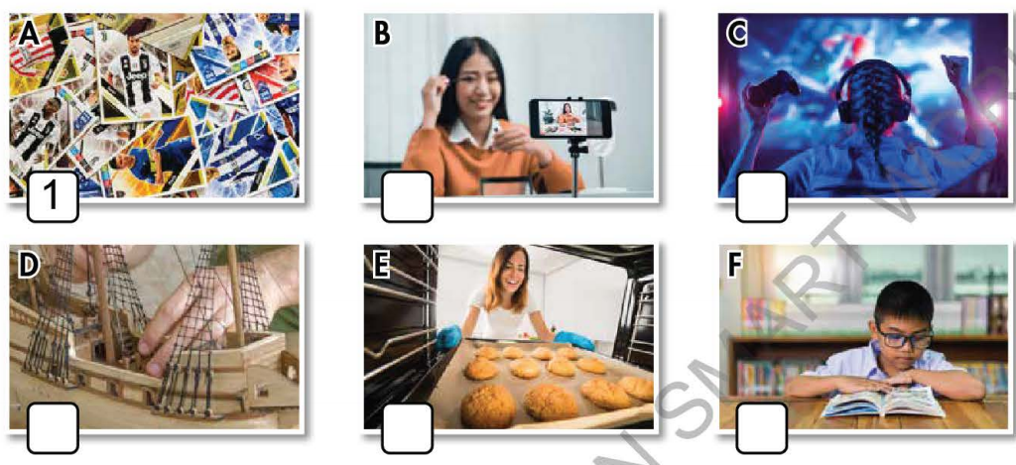  - Option 2: Chatting.  - Ask Ss some questions about their free time activities:  Eg: - What do you often do in your free time?  - How much time do you spend doing it?  - Do you find it useful?  - …  - Lead to the new lesson: Free time. | - Greet T.  - Work in pairs to number the pictures.  - Give answers.  - Listen.  Answer keys  A1 B4 C6 D2 E3 F5  - Answer the questions.  - Listen.
B. New lesson (35’)
- Activity 1: Pre-Reading (Vocabulary) (12’)
a) Objective: Ss know words about free time activities.
b) Content:
- Vocabulary study (build models, bake cakes, make vlogs, read comics, play online games, collect soccer stickers).
- Speaking: Note more than 3 hobbies you know and discuss if you like them.
c) Expected outcomes: Ss know how to pronounce the new words correctly and use them in appropriate situations.
d) Organization of the activity:
TEACHER’S ACTIVITIES | STUDENTS’ ACTIVITIES
Task a. Number the pictures. Listen and repeat.  - Option 1 (If the teacher hasn’t used this part for the Warm-up activity)  - Demonstrate the activity, using the example (using DCR).  - Have Ss number the pictures.  - Divide class into pairs and have them check their answers with their partners.  - Call Ss to give answers (read or write).  - Check answers as a whole class.  - Play audio (CD1 – Track 02) (using DCR). Have Ss listen and repeat.  - Correct Ss’ pronunciation.  - Option 2: Matching. (If the teacher has used part a. for the Warm-up activity)  - Have Ss review the words they have known in the warm-up activity by matching words with pictures (T uses different pictures from those in the textbook).  - Call Ss to give answers (read or write).  - Check answers as a whole class.  - Call some Ss to read the words again.  - Correct Ss’ pronunciation if necessary.  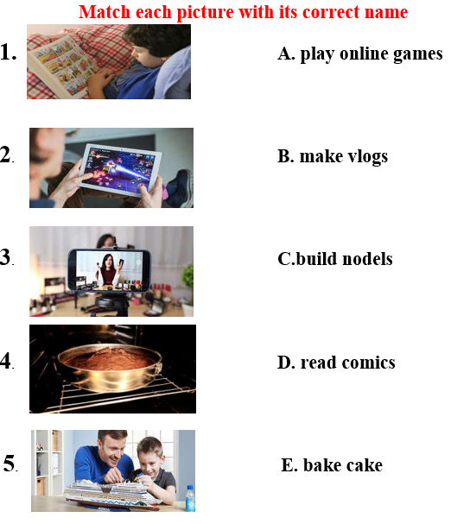  - For more practice and options, have Ss play a vocabulary game using DHA.  Task b. Note three more hobbies you know. Discuss if you like them.  - Option 1:  - Have Ss talk in pairs about their hobbies using the new words and three other hobbies they know.  - Remind Ss to use the structure:  Do you like +V.ing …?  - Have Ss share their ideas in front of the class.  - Give feedback and evaluation.  - Option 2: (for class with better students)  - Give Ss an extra activity: Have Ss work in groups to have a free talk about their hobbies. Encourage students to use their own ideas. Remind students to state whether they like these hobbies and whether these hobbies are useful or not.  - Call some groups to present their conversation with the class.  - Give feedback and evaluation. | - Look and listen.  - Work individually.  - Work in pairs.  - Give answers.  Answer keys  A1 B4 C6 D2 E3 F5  - Listen and repeat.  - Work in pairs.  - Give answers.  - Read.  Answer keys  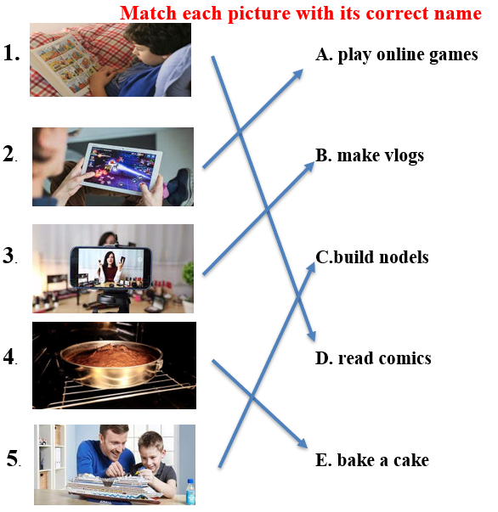  - Watch and play.  - Work in pairs.  - Present.  Suggested three more hobbies: playing sports, arranging flowers, making origami, …  - Work in groups.  - Present.  Suggested conversation  A: My hobby is playing online games. Do you like it?  B: Yes, I like it too  C: I think playing online games is relaxing, but it’s rather time-consuming.  A: Oh really? So what do you often do in your free time?  C: I collect old correction pen. I find this hobby not really challenging but relaxing  …
- Activity 2: While - Reading (17’)
a) Objective: Students can develop their reading skills.
b) Content: Reading a teen blogger and choosing the best title, then circling the correct answer.
c) Expected outcomes: Students can read and understand general and specific information about a teen’s hobby.
d) Organization of the activity:
TEACHER’S ACTIVITIES | STUDENTS’ ACTIVITIES
Task a. Read Kate’s blog post and choose the best title.  - Option 1:  - Ask Ss to read two options and find out key words.  - Show the task using DCR. Have Ss read the blog individually.  - Have Ss work in pairs to read the blog again.  - Have Ss circle the correct answers.  - Have some Ss share their answers with the class (read), explain for their answers.  - Give feedback.  - Give feedback and correct Ss’ answers if necessary.  - Option 2:  - Have students look at the picture in part Reading a (using DCR) and ask them some questions about Kate:  What is her name?  What is her hobby?  What is the title of the blog?  - Retell students what a blog is ? Lead to the reading text.  - Have Ss read the questions and guess the answers.  - Have Ss read the blog and circle the correct answers – underline the supporting ideas.  - Have Ss check answers with their partners.  - Call Ss to give answers, explain.  - Give feedback and evaluation.  Task b. Now, read and circle the correct answers.  - Use DCR to show the task. Have Ss read the questions, underline key words and guess the answers.  - Have Ss read the blog again and circle the correct answers – underline or highlight the supporting ideas.  - Have Ss check answers with their partners.  - Call Ss to give answers, explain.  - Give feedback and evaluation. | -Work individually.  - Work in pairs.  - Circle the correct answers.  - Read answers, explain.  - Check answers.  Answer keys  1.My Model Collection  - Look and give answers.  - Listen.  - Read and do the task.  - Work in pairs.  - Give answers, explain.  Answer key: No  1.My Model Collection  - Read and underline.  - Do the task.  - Check answers.  - Give answers, explain.  Answer keys  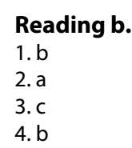
- Activity 3: Post - Reading (6’)
a) Objective: Students can use the vocabulary and the sample text to develop their speaking skills.
b) Content: Speaking: What cool things can you make?
c) Expected outcomes: Students can have a free-talk about a cool thing they can make (What is it? How do you make it? What is it used for? Who helped you to make it…)
d) Organization of the activity:
TEACHER’S ACTIVITIES | STUDENTS’ ACTIVITIES
Task c. What cool things can you make?  - Have Students work in groups to talk about what cool things they can make.  - If there is enough time, ask Students to choose a cool thing to draw it (each group draws a picture).  - Have students hang the pictures on the board, ask the whole class to vote for the best picture.  - Make comments and announce the best picture. | - Work in groups to discuss and then draw.  - Take part in the class activities.
C. Consolidation and homework assignments (4’)
* Words about free time activities: build models, bake cakes, make vlogs, read comics, play online games, collect soccer stickers.

* Homework:
- Learn the new words by heart.
- Practice talking about your hobby.
- Do the exercises in Workbook: Lesson 1 - New words (page 2).
- Prepare: Lesson 1 – Grammar (page 5 – SB).
- Do the vocabulary exercise in Tiếng Anh 7 i-Learn Smart World Notebook (page 4).
- Play consolation games in Tiếng Anh 7 i-Learn Smart World DHA App on www.eduhome.com.vn

