Period 27: UNIT 4: MUSIC AND ARTS
Lesson 1: GETTING STARTED
A talk at the school gate

I. OBJECTIVES: * By the end of this lesson, Ss will be able to gain:
- use the words related to the topic Music and Arts;
- pronounce the sounds /ʃ/ and /ʒ/ correctly;
- use like, different from, (not) as... as to compare people and things;
- express preferences;
- read for specific information about a traditional art form;
- talk about a musical performance at their school;
- listen for specific information about street painting;
- write an informal letter of invitation
1. Knowledge:
- To introduce the topic “ Music and arts ”. To practice listening and reading.
- Have an overview about the topic Music and arts.
- Use the vocabulary to talk about Music and arts.
+ Vocabulary: + use the lexical items related to the topic Music and arts;
concert hall (n), actress (n), artist (n), composer (n), puppet (n), portrait (n), photography , perform
- pronounce and recognize the sounds /ʃ/ and /ʒ/.
+ Grammar: - Comparisons: like, different from, (not) as … as .
2. Competence: Students will be able to practice listening and reading the conversation between Trang and Nick. (They are talking about music and arts, what they often do in their free time, and then they agree on what to do next weekend.)
- Develop communication skills.
- Be cooperative and supportive in pair work and teamwork.
- Actively join in class activities.
3. Qualities: - To educate the love of music and art.
- Be ready to know the words about music and arts.
- Develop self-study skills.
II. TEACHING AIDS:
- Teacher: Grade 7 text book, laptop, projector / TV/ pictures and cards.....
- Students : Text books, studying equipment….
- Computer connected to the Internet.
- Sach mem.vn
III. PROCEDURE:
Notes: In each activity, each step will be represented as following:
* Deliver the task.
* Implement the task.
* Discuss.
* Give comments or feedback.

 | - WARM UP & INTRODUCTION ( 5’)
Aims:
- To create an active atmosphere in the class before the lesson;
- To lead into the new unit
* Content: To have some warm-up activities to create a friendly and relaxed atmosphere to inspire Ss to warm up to the subject and new lesson.
* Outcome: Having a chance to speak English.
* Organisation : Teacher’s instructions …

 | Teacher’s Student’s activities |  | Content
 | + Greeting  + Guessing game: Kinds of music  * Teacher divides students into 2 groups and has them listen to some songs to guess what kinds of music they are.  * Students work in 2 groups, try to listen, and guess.  * The member in each group which has the answer can raise hand. If student has the correct answer, he/ she will get 1 point for his/ her group.  * Teacher confirms the winner.  * Teacher leads students into the lesson by telling them that “ In today lesson, we are going to learn more words to talk about Music and arts and two sounds /ʃ/ and /ʒ/.”  - Ask Ss to guess what they are going to learn about in this unit. Then write Music and Arts and ask Ss to give any words or phrases they know related to these activities.  - Ask Ss to open their book and introduce what they are going to study…. |  | + Greeting  + Guessing game: Kinds of music  - T_Ss.  + Students (Ss) listen and learn how to do the tasks.  Suggested answers:  1. Classical music:  https://www.youtube.com/watch?v=zHvBPwNUBS8&ab_channel=JervyHou  2. Rock:  https://www.youtube.com/watch?v=AW8AFTBbetI&ab_channel=Infraction-NoCopyrightMusic  3. Jazz:  https://www.youtube.com/watch?v=jUCxIbI9cak&ab_channel=bojunc  5. Pop:  https://www.youtube.com/watch?v=8xg3vE8Ie_E&ab_channel=TaylorSwiftVEVO  6. Country music:  https://www.youtube.com/watch?v=rCIXjYo9qs4&ab_channel=MusicTravelLove
 | - PRESENTATION/ NEW LESSON ( 15’)
ACTIVITY 1:
Aims: To set the context for the introductory conversation;
- To introduce the topic of the unit.
* Content: Learn some new words . Read the conversation and find out new words.
* Outcome: Knowing more new words. Understanding the conversation; topic of the lesson, grammar points…
* Organisation : Teacher’s instructions..
 | Teacher’s Student’s activities |  | Content
 | 1. Listen and read: (Ex 1, p. 40)  *Teach vocabulary:  + Teacher uses different techniques to teach vocab (situation, realia, translation.)  + Teacher introduces the vocabulary by:  - providing the pictures  - eliciting the definition of the words  + Teacher do the “Rub out and remember” checking technique.  + Teacher checks students’ pronunciation and gives feedback. Teacher reveals that these words will appear in the reading text and asks students to open their textbook to discover further.  - Call on some groups of Ss to read the conversation aloud.  ** Set the context for the listening and reading. Introduce Trang and Nick: they are friends.  - Have Ss look at the title and the picture and guess what the conversation between Chau and Nick might be about. Have Ss answer some questions.  - Encourage Ss to answer, but do not confirm whether their answers are right or wrong.  - Play the recording twice for Ss to listen and read along. (They may read silently or aloud.)  - Have some pairs of Ss read the conversation aloud..... |  | 1. Listen and read: - T_Ss  * Vocabulary  1. classical (adj): cổ điển  2. spare time (n): thời gian rảnh rỗi  3. musical instruments (n): nhạc cụ  4. landscape (n): cảnh quan  5. art gallery (n): phòng trưng bày nghệ thuật  ...  - Listen carefully and read aloud.  ** ... Ask Ss what exactly Trang and Nick are talking about. Now confirm the correct answer. (They are talking about music and arts, what they often do in their free time, and then they agree on what to do next weekend.)  - Have Ss say the words in the text that they think are related to the topic of the unit. Have them pronounce the words containing the sounds /ʃ/ and /ʒ/ . Quickly write the words on the board.
  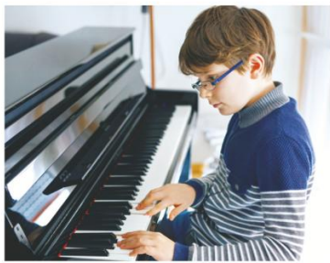
 | - PRACTICE ( 15’)
ACTIVITY 2:
Aim: To help Ss understand the main idea of the text.
* Content: Listen and read the conversation. Answer the question.
* Outcome: Understanding more the content of the conversation.
* Organisation :
 | Teacher’s Student’s activities |  | Content
 | 2. What are Trang and Nick talking about?  - First, ask Ss to give the answers without reading the conversation again.  - Then have Ss underline the words / phrases in the conversation that are related to the topic Music and Arts and check their answers. Confirm the correct answers.  - Check the answers as a class. |  | 2. What are Trang and Nick talking about?  - T_Ss  - Work individually.  - Give the answers  * Key: C
ACTIVITY 3:
Aims:
- To help Ss further understand the text;
- To acquaint Ss with the grammar points and new vocabulary of the unit.
* Content: Complete the sentences with suitable word or phrases.
* Outcome: Ss know more the use of words and phrases in context.
* Organisation :
 | 3. Complete the phrases under the pictures with the verbs below.  - Ask Ss to work independently to fill each blank with a word / phrase from the box.  - T may instruct them how to do the exercise: (1) read the sentences and identify the kind of information needed to fill the blanks, (2) read the conversation again and locate the place to find the words / phrases to fill the blanks.  - Allow Ss to share answers before discussing as a class.  - Write the correct answers on the board.  - If there's time, call on some Ss to read the sentences.  - Check the answers as a class. |  | 3. Complete the phrases under the pictures with the verbs below.  - T_ Ss  - Listen to the instructions clearly  - Ss to work independently  - Copy them  Key:  1. art gallery 2. photos  3. different from 4. like  5. musical instruments
ACTIVITY 4:
Aim: To develop Ss' knowledge of the vocabulary about music and arts.
* Content: Write the correct word od phrases under each picture.
* Outcome: Ss know more some words about music and arts
* Organisation :
 | 4. Write the correct word or phrase under each picture. Then listen and repeat.  - Ask Ss to work in pairs or in groups to do the task. Tell them that some words / phrases appear in the text and some do not.  - Play the recording for Ss to check and repeat. - Check and correct their pronunciation.  - Give them the meaning of the words / phrases if necessary.  - Check the answers as a class. |  | 4. Write the correct word or phrase under each picture. Then listen and repeat.  - T_ Ss. Work in pairs  - Ss do it.  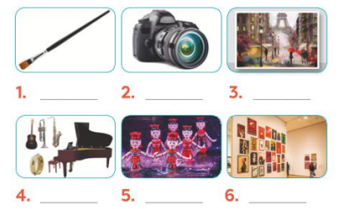  * Key:  1. paintbrush 2. Camera  3. painting 4. musical instruments  5. water puppet show 6. art gallery
 | - PRODUCTION/ FURTHER PRACTICE ( 8’)
ACTIVITY 5:
Aim: To help Ss revise some vocabulary related to the field of music and arts and to evaluate how artistic they are.
* Content: Doing the Quiz
* Outcome: Ss can remember the words. Revise and learn more new words.
* Organisation :

 | Teacher’s Student’s activities |  | Content
 | 5. QUIZ : How artistic are you?  - Have Ss work individually. Tell them to write down their answers to all the questions.  - Let them add up their points and report to their group how artistic they are.  Example:  A: I think I'm very artistic. I have 4 As out of 5.  B: I'm not artistic at all. I've got only 1 A and 4 Bs.  (If a student's answer is 4 or 5 As, he / she is very artistic, if his / her answer is 3 As, he / she is somewhat artistic, if his / her answer is 0 / 1 / 2 As, he / she is not artistic (at all).)  - T may call on some Ss to report to the whole class. |  | 5. QUIZ : How artistic are you?  + Listen to the instructions carefully and do the tasks.  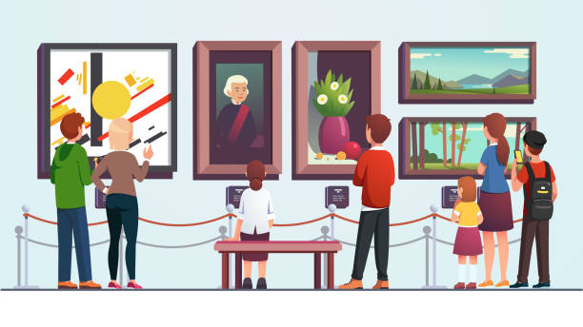
- WRAP-UP & HOME WORK (2’)

1. Ask one or two Ss to tell the class what they have learnt. Ask Ss to say aloud some words/ phrases they remember from the lesson. If there is a projector in the classroom, show the conversation, highlight the key words related to the topic. It would be helpful if T also highlights in the conversation the words with the sounds /ʃ/ and /ʒ/. the structures with like, (not) as... as, different from.
- Tell Ss that they will learn these language points in the following lessons.
- Bring to class some posters / pictures, or show on the screen some images of musical instruments, places or things related to the topic Music and Arts, or some famous actors and actresses.
- Ask Ss to name them.
2. Teacher informs student of the final project of the Unit’s project.
+ Explain the requirements of the project: Imagine that you are going to organise a music show and then design an invitation for that show. Students will show their posters and present their ideas in Lesson 7 – Looking back and Project.
+ Teacher explains to students how they can get the information.
+ Put students into groups and ask them to discuss to assign tasks for each member. Help them set a deadline for each task.
(Teacher should check the progress of students’ preparation after each lesson.)
* HOME WORK
- Read again the conversation on page 40
- Do more exercises in workbook.
- Prepare new lesson: Lesson 2: A CLOSER LOOK _1

Period 28: UNIT 4: MUSIC AND ARTS
Lesson 2 : A CLOSER LOOK - 1

I. OBJECTIVE: By the end of this lesson, students will be able to gain the following things :
1. Knowledge:
- To introduce the topic “ Music and arts ”. To teach some new words
+ Use the lexical items related to the topic Music and arts;
+ Pronounce and recognize the sounds /ʃ/ and /ʒ/.
+ Vocabulary: + use the lexical items related to the topic Music and arts;
concert hall (n), actress (n), artist (n), composer (n), puppet (n), portrait (n), photography , perform
- pronounce and recognize the sounds /ʃ/ and /ʒ/.
+ Grammar: - Comparisons: like, different from, (not) as … as .
2. Competence: Students will be able to know more new words related to the field of music and arts.
- Develop communication skills.
- Be cooperative and supportive in pair work and teamwork.
- Actively join in class activities.
3. Qualities: - To educate the love of music and art.
- Be ready to know the words about music and arts.
- Develop self-study skills.
II. TEACHING AIDS:
- Teacher: Grade 7 text book, laptop, projector / TV/ pictures and cards.....
- Students : Text books, studying equipment….
- Computer connected to the Internet.
- Sach mem.vn
III. PROCEDURE:
Notes: In each activity, each step will be represented as following:
* Deliver the task.
* Implement the task.
* Discuss.
* Give comments or feedback.

1. WARM UP & INTRODUCTION (5’)
Vocabulary
Aim: - To create an active atmosphere in the class before the lesson;
- To lead into the new unit
- Bring to class some posters / pictures, or show on the screen some images of musical instruments, places or things related to the topic Music and Arts, or some famous actors and actresses.
- Ask Ss to name them.
- Brainstorming: Have Ss find all the words / phrases they know related to music and arts. - Encourage them to say out as many words / phrases as possible.
* Content: To have some warm-up activities to create a friendly and relaxed atmosphere to inspire Ss to warm up to the subject and new lesson.
* Outcome: Having a chance to speak English.
* Organisation : Teacher’s instructions …

Teacher’s & Student’s activities | Content
+ Greeting  + Revision .  - Ask Ss to guess what they are going to learn about in this unit. Then write Music and Arts and ask Ss to give any words or phrases they know related to these activities.  - Ask Ss to open their book and introduce what they are going to study…. | + Greeting  + Revision  - T_ Ss  - Students (Ss) listen and learn how to do.  - Open their book and write .
2. PRESENTATION/ NEW LESSON (12’)
ACTIVITY 1:
Aim: To revise / teach nouns indicating people and places related to the field of music and arts.
* Content: Teach some new words . Listen and repeat. Write them in the correct columns.
* Outcome: Ss know more new words. Learn how to use them . Do the tasks correctly.
* Organisation :
Teacher’s & Student’s activities | Content
1. Listen and repeat these words and phrases  *) Pre- teach vocabulary:  - Teacher uses different techniques to teach vocabulary (situation, realia, translation .....)  + Teacher may introduce the vocabulary by:  - providing explanations of the words;  - showing picture illustrating the word.  + Follow the steps to teach vocabulary  - Repeat in chorus and individually  + Check vocabulary.  - Play the recording and let Ss listen. Play it again with pause for them to repeat each word / phrase.  - Correct their pronunciation.  - Explain the meaning of these words / phrases if necessary.  - Have Ss work in pairs and put these words / phrases in the correct columns | 1. Listen and repeat the words and phrases  - T_ Ss  + Students (Ss) listen to the instructions carefully and learn how to do the tasks.  * Vocabulary:  I. Vocabulary  1. concert hall (n) phòng hòa nhạc  2. actress (n) nữ diễn viên  3. artist (n) nghệ sĩ  4. composer (n) nhà soạn nhạc  5. puppet (n) con rối  6. portrait (n) chân dung  7. photography (n) nhiếp ảnh  8. perform (v) thực hiện/ trình diễn  .......  * Audio script - Track 24:  art gallery composer  concert hall musician  actress artist  painter puppet theatre
3. PRACTICE (15’)
ACTIVITY 2:
Aim: To teach Ss how to combine a verb and a noun to form a collocation about music and arts.
* Content: Do the matching.
* Outcome: Ss can match a word in A with a word or phrase in B correctly.
* Organisation :
Teacher’s Student’s activities | Content
2. Match a word in A with a word or phrase in B.  - Explain to Ss that in English some verbs and nouns go together, and some don't.  - Have Ss work in pairs. Tell them to match the verbs in column A with nouns in column B to form collocations. Then check their answers as a class. Explain to them which noun goes with each verb.  - T may allow Ss some time to extend their vocabulary by adding more words to combine with each verb.  Example: perform a play, magic...  - Check the answers as a class.  - Correct Ss' pronunciation if necessary. | 2. Match a word in A with a word or phrase in B.  - Listen carefully and learn how to do.  - Give the answer  * Key:  1.e 2.d 3.a 4.c/e 5. b
ACTIVITY 3:
Aim: To give Ss practice in how to use words / phrases related to music and arts in context.
* Content: Complete the sentences.
* Outcome: Ss can complete sentences correctly.
* Organisation :
3. Underline the correct word to complete each sentence.  - Have them read the sentences carefully and look for clues so that they can choose the correct words to complete the sentences.  - Have one student write the words on the board. Confirm the correct answers.  - T may call on some Ss to read the sentences. | 3. Underline the correct word to complete each sentence.  - Ss to work individually.  * Key:  1. drawing 2. composer  3. museum 4. concert  5. photography
II. PRONUNCIATION: (10’)
Sounds /ʃ/ and /ʒ/.
ACTIVITY 4
Aim: To teach Ss how to pronounce the sounds /ʃ/ and /ʒ/ and practise pronouncing these sounds in words correctly.
* Content: Listen and repeat the word to pay attention to the sounds: /ʃ/ and /ʒ/
* Outcome: Ss can learn how to pronounce the sounds: /ʃ/ and /ʒ/
* Organisation :
Teacher’s Student’s activities | Content
4. Listen and repeat. Pay attention to the sounds /ʃ/ and /ʒ/  - Let Ss practise the sounds /ʃ/ and /ʒ/ together. - Ask Ss to observe T's mouth when pronouncing the two sounds.  - Play the recording and ask Ss to listen to these words and repeat.  - Correct their pronunciation. Play the recording as many times as necessary.  - Call on some Ss to read the words aloud. | 4. Listen and repeat. Pay attention to the sounds /ʃ/ and /ʒ/  - Listen carefully  - Listen and repeat  * Audio script- track 25:  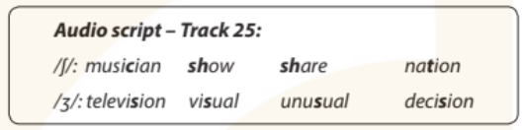
4. FURTHER PRACTICE (8’)
ACTIVITY 5:
Aim: To help Ss practise pronouncing the sounds /t/, /id/, and /id/ in sentences.
* Content: Listen and pay attention to the underlined parts
* Outcome: Ss will be able to pronounce the sounds correctly.
* Organisation :
5. Listen and repeat. Listen again and single-underline the words with the sound /ʃ/ and double-underline the words with the sound /ʒ/  - Have Ss quickly read the sentences and single-underline the words with the sound /ʃ/ and double underline the words with the sound /ʒ/ . Then play the recording for Ss to listen and check the words that they have underlined.  - Have them work in pairs to compare their answers. Check Ss' answers.  - Play the recording again. Let Ss listen and repeat sentence by sentence, paying attention to the underlined words.  - Comment on their pronunciation .  Notes:  For more able Ss,T may refer to the following:  Sound /ʃ/ can be represented by sh (she, wash,...)  by ch (machine,...)  by t (station, initial...)  by s (sugar, sure ...)  or by c (special, physician ...)  Sound /ʒ/ can be represented by s (television, usually ...) | 5. Listen and repeat. Listen again and single-underline the words with the sound /ʃ/ and double-underline the words with the sound /ʒ/  - T_ Ss  - S do the tasks    * Audio script-Track 26  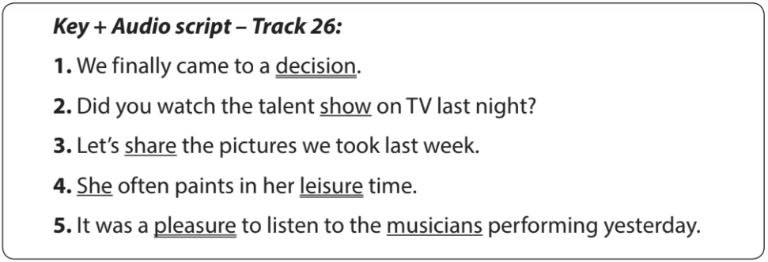
5. WRAP-UP & HOME WORK (2’)

- Ask Ss to summarise what they have learnt in this lesson. Ask some Ss to recall some vocabulary and collocations.
* HOME WORK
- remember some verbs in the past simple
- Do more exercises in workbook.
- Prepare new lesson. A CLOSER LOOK_ 2

Period 29: UNIT 4: MUSIC AND ARTS
Lesson 3 : A CLOSER LOOK - 2

I. OBJECTIVE: By the end of this lesson, students will be able to gain the following things :
1. Knowledge:
- Know how to recognize and write comparisons with like, different from, (not) as … as:
- To introduce the topic “ Music and arts ”. To teach some new words
+ Use the lexical items related to the topic Music and arts;
Types of comparisons | How to use | Examples
1. like | to show that sth is similar to sth else. | This picture is like the one I saw at the art museum.
2. different from | to show that two or more things are not similar. | Painting portraits is different from painting landscapes.
3. as + adj + as | to show that two things are similar. | My brother is as tall as my father.
4. not as + adj + as | to show that sth is “more” or “less” than sth else. | Classical music is not as exciting as rock.
+ Vocabulary: + use the lexical items related to the topic Music and arts;
concert hall (n), actress (n), artist (n), composer (n), puppet (n), portrait (n), photography , perform
- pronounce and recognize the sounds /ʃ/ and /ʒ/.
+ Grammar: - Comparisons: like, different from, (not) as … as .
2. Competence: Students will be able to know how to recognize and write comparisons with like, different from, (not) as … as:
- Develop communication skills.
- Be cooperative and supportive in pair work and teamwork.
- Actively join in class activities.
3. Qualities: - To educate the love of music and art.
- Be ready to know the words about music and arts.
- Develop self-study skills.
II. TEACHING AIDS:
- Teacher: Grade 7 text book, laptop, projector / TV/ pictures and cards.....
- Students : Text books, studying equipment….
- Computer connected to the Internet.
- Sach mem.vn
III. PROCEDURE:
Notes: In each activity, each step will be represented as following:
* Deliver the task.
* Implement the task.
* Discuss.
* Give comments or feedback.
1. WARM UP & INTRODUCTION (5’)
Aims:
- To create an active atmosphere in the class before the lesson;
- To lead into the new lesson.
Comparisons: like, different from, (not) as ... as
- Different types of comparisons and the vocabulary related to them were already studied in Tieng Anh 5 and Tieng Anh 6, so T may ask Ss to recall them and give examples.
Focus Ss' attention on the Remember! box. Explain the uses of the three structures to them and give some examples. (Always remember that examples should be directed to the topic of the unit.)
T may also bring to class some pictures of different musical instruments (or show on the screen) and ask Ss to make comparison.
* Content: Review the previous lesson or have some warm-up activities to create a friendly and relaxed atmosphere to inspire Ss to warm up to the new lesson.
* Outcome: Having a chance to speak English and focus on the topic of the lesson..
* Organisation :Teacher’s instructions…

Teacher’s & Student’s activities | Content
+ Greeting  GAME: BRAINSTORMING  * Teacher asks students to work in 2 teams to think of as many adjectives to describe as possible.  - Students work in 2 teams.  - In 1 minute, students from each team, turn by turn, run to the board and write down one adjective.  - Teacher comments and counts how many correct answers for each team.  - The team which has more correct answers will be the winner.  - Teacher shows the picture and asks students to use one adjective they have found to make comparisons.  - Teacher confirms the answers and gives feedback.  - Teacher gives feedback, then lead to the new lesson.  - Ask Ss to open their book and introduce what they are going to study…. | + Greeting  GAME: BRAINSTORMING  - T_Ss  - Students play games  - Team work  Adjectives  * Suggested answers:  big, small, heavy, light, cheap, expensive, boring, interesting, special, fun, thin, fat, tall, short, handsome, ugly, etc.  Eg:  - Tom is taller than Mary.  - Mary isn’t as tall as Tom
2. PRESENTATION/ NEW LESSON (12’)
ACTIVITY 1:
Aim: To help Ss identify the correct comparison, using like, (not) as... as, different from.
* Content: Complete the sentences using like, as, different from..
* Outcome: Ss can learn how to use the comparison.
* Organisation : Teacher’s instructions…
Grammar: Comparisons: like, different from, (not) as … as.
Remember!
We use:
– like to show that something is similar to something else.
Example: This picture is like the one I saw at the art museum.
– different from to show that two or more things are not similar.
Example: Painting portraits is different from painting landscapes.
– as + adjective + as to show that two things are similar.
– not as + adjective + as to show that something is “more” or “less” than something else.
Example: Classical music is not as exciting as rock.

Teacher’s & Student’s activities | Content
1. Write like, as, or different in the blanks.  - Ask Ss to do the exercise individually and then compare their answers with a partner. Check the answers as a class. Confirm the correct answers.  - Teacher confirms the answers and gives feedback.  - Students find out the form and the usage of comparisons using “like, different from, (not) as … as”  * Concept checking:  + Form:  1. (not) as + adj + as  2. as + adj + as  3. to be different from  4. like  + Use: ask students to read “Remember box”, then teacher asks students some questions to check understanding. | 1. Write like, as, or different in the blanks.  - T_ Ss  + Students (Ss) listen to the instructions carefully and learn how to do the tasks.  * Key:  1. as 2. like 3. different  4. as 5. different
3. PRACTICE (18’)
ACTIVITY 2:
Aim: To help Ss use the correct comparison, using like, (not) as... as, different from in situations.
* Content: Complete the sentences by using like , as.... as, or different from
* Outcome: Ss understand more using comparison. Complete the sentences correctly.
* Organisation :
Teacher’s Student’s activities | Content
2. Finish the second sentence in each pair , using like, as.... as, or different from.  Tell Ss to do the task independently first. Tell them to write in their notebooks, then check their answers as a class.  T may call on some Ss to call out their answers and / or write their answers on the board. Explain if necessary.  - Check the answers as a class  Notes:  Hoàng Long & Phạm Tuyên: famous composers from Viet Nam. They have composed a lot of good songs for children.  The Vatican Museum: art museum in the Vatican City.  The Louvre Museum (or the Louvre): the world's largest art museum in Paris, France. | 2. Finish the second sentence in each pair , using like, as.... as, or different from.  - T_ Ss  - Listen carefully and learn how to do.  - Ss work individually  - Give the answers  * Key:  Key:  1. different from 2. like  3. as... as 4. different from  5. as... as
ACTIVITY 3:
Aim: To help Ss practise using like, (not) as... as, different from in context.
* Content: Compare The two museums using like , as ....as , different from.
* Outcome: Ss can compare the two museums correctly.
* Organisation :
3. Work in pair. Compare the two museums: History and Science, using like, as.... as, or different from.  - Have Ss work in pairs. Help them interpret the table first.  - Give them instructions how to do the task.  {Note: A museum is "friendly" when its staff are friendly.)  - This is a speaking activity so encourage Ss to talk as much as possible.  Example: History is not as modern as Science.  - While Ss do their task, T goes round to monitor the whole class.  - Check the answers as a class.  - Comment on their performance. | 3. Work in pair. Compare the two museums: History and Science, using like, as.... as, or different from.  - Ss to work in pairs  - Ss do themselves.  - Speaking tasks  Key:  Example: History is not as modern as Science.  1. The History Museum is not as modern as the Science Museum.  2. The staff in History Museum is as friendly as ones in Science Museum.  3. Things in History Museum are more interesting than things in Science Museum.  4. The price in History Museum is like in Science Museum.
ACTIVITY 4:
Aim: To help Ss revise like, (not) as... as, different from in sentence writing.
* Content: Write complete sentences using the words given at the beginning.
* Outcome: Ss can write complete sentences from the words given correctly.
* Organisation :

Teacher’s Student’s activities | Content
4. Rewrite sentences, using the words given at the beginning.  - Have Ss do the exercise individually and then exchange their answers with a classmate. Ask them to write down the sentences in their notebooks.  - Call on some Ss to write their answers on the board. Other Ss comment.  Confirm the correct answers. Some Ss read the sentences aloud.  - Check the answers as a class. | 4. Rewrite sentences, using the words given at the beginning.  - T_ Ss  - Do the tasks and share the answers.  Key:  1. I think comedies are not as interesting as action films.  2. Our history homework is not as difficult as our maths homework.  3. This year's music contest is not like last year's.  4. The characters in the film are different from the ones in the play.  5. That picture is not as bright as this one.
4. FURTHER PRACTICE ( 8’)
ACTIVITY 5:
Aim: To help Ss practise speaking, using comparison with like, (not) as... as, different from through pictures.
* Content: Ask and answer about Tom’s project in 2016 and 2018.
* Outcome: Further practice using past simple tense. Answer the questions.
* Organisation :
5. Work in groups. Look at the two pictures below. Compare them , using like, as ....as, or different from.  - Have Ss work in groups. Tell them to look at the two pictures and compare them, using like, (not) as ... as, or different from.  - Elicit the similarities and differences between the two pictures and the things in them.  Examples:  Picture A is not as big as Picture B.  The cat in Picture A is different from the cat in Picture B.  .................  - Encourage Ss to give as many sentences as possible. Don't stop Ss while they are speaking in order to correct their errors. Correct only common errors after Ss finish speaking.  Suggested answers:  - Picture A is not as big as picture B.  - The cat in picture A is different from the cat in picture B.  - The cat in the house in picture A is like the cat in the house in picture B.  - The fish in picture A is not as big as the fish in picture B.  - The flower in picture A is not as small as the flower in picture B.  * Further practice:  - If time allows, T may ask some Ss to make comparisons between their classmates, or things in the classroom.  Examples:  - Trung is as tall as Nam.  - Nam's backpack is quite different from Duy's.  ....... | 5. Work in groups. Look at the two pictures below. Compare them , using like, as ....as, or different from.  - T_ Ss  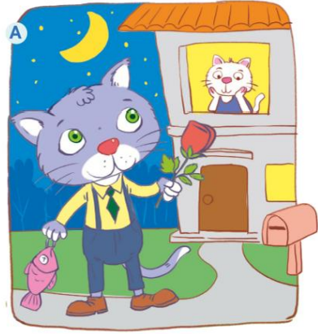  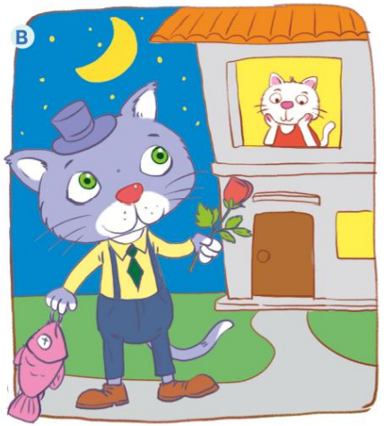  * Suggested answers:  - Picture A is not as big as picture B.  - The cat in picture A is different from the cat in picture B.  - The cat in the house in picture A is like the cat in the house in picture B.  - The fish in picture A is not as big as the fish in picture B.  - The flower in picture A is not as small as the flower in picture B.
5. WRAP-UP & HOME WORK (2’)
- Ask Ss to summarise what they have learnt in the lesson.
- Reactivate the knowledge that students have gained
- Have them say out loud the past forms of the verbs they learnt in the lesson.
*HOME WORK
- Remember the form and use the past simple tense.
- Do more exercises in workbook.
- Prepare new lesson: COMMUNICATION.

