**Period 129**

**UNIT 8 – MY FRIENDS AND I**

**Review and Practice (page 118)**

**1. Objectives**

By the end of this lesson, students will be able to ask if people were at a place.

**1.1. Language knowledge and skills**

**Vocabulary:** *movie theater, playground, museum, mall, supermarket, amusement park*

**Sentence patterns:** *Where were you last night? I was at the movie theater.*

*Where was Nick last Saturday? He was at the mall.*

*Where were Alfie and Mai yesterday? They were at the park.*

**Skills:** Listening, Reading, Writing, and Speaking.

**1.2. Competences**

**Self-control and independent learning:** review asking if people were at a place.

**Communication and collaboration:** work in pairs or groups to ask if people were at a place.

**Critical thinking and creativity:** learn how to ask if people were at a place.

**1.3. Attributes**

**Kindness:** support their friends to complete the learning tasks or play the games.

**Diligence:** focus on the lesson and work hard to complete all the tasks.

**Honesty:** play fair.

**Accountability:** appreciate kindness, diligence, and honesty.

**2. Teaching aids and materials**

**- Teacher’s aids:** Tiếng Anh 4 i-Learn Smart Start Student’s Book and Teacher’s book, Class CDs, Flashcards, DCR & DHA on Eduhome, Projector/Interactive Whiteboard /TV (if any), PowerPoint slides.

**- Students’ aids:** Tiếng Anh 4 i-Learn Smart Start Student’s Book, Workbook, Notebook.

**3. Procedures**

**A. Warm up** (5 minutes)

**a. Objectives:** To help the students review the previous lessons, generate the students’ interests, and lead in the Review and Practice lesson.

**b. Content:** Playing the game: “Roll the dice” or “Bingo”.

**c. Expected outcomes and assessment**

- Task completed with excellence:Students can remember the words in each category or identify the vocabulary items on the flashcards quickly and correctly.

- Task completed: Students can remember the words in each category or identify the vocabulary items on the flashcards.

- Task uncompleted: Students are unable to remember the words in each category or identify the vocabulary items on the flashcards.

**d. Organization**

|  |  |
| --- | --- |
| **Teacher’s activities** | **Students’ activities** |
| **“Memory” game**   * Divide the class into four teams. * Invite 2 students from 2 groups to come to the board. * Place some flashcards or writes some words on the board (about 15 – 20 flashcards or words). * Give the students time to memorize as much words as possible. When the time is up, the students write down what they have memorized. The student who has the most correct words gets points for his/her team. * Repeat with different students. | - Follow and do as T’s guides.  - Join the game, try to say the correct word. |

**B. Main lesson** *(30 mins)*

**a. Objective:** review vocabulary related to common places and ask about where people were.

**b. Content:** Listen and draw lines, read and answer, and write about where you were.

**c. Expected outcomes and assessment**

- Task completed with excellence: Students can finish the given tasks quickly and correctly.

- Task completed: Students can finish the given tasks.

- Task uncompleted: Students are unable to finish the given tasks.

**d. Organization**

|  |  |
| --- | --- |
| **Teacher’s activities** | **Students’ activities** |
| **A. Listen and draw lines.**   * Have students look at the pictures and call out what they can see. * Demonstrate the activity using the example. * Use DCR to play the audio. * Have students listen and match the names with places. * Use DCR to check answers as a whole class.   **B. Look and read. Answer the questions.**   * Ask Ss to look at the timetable and read the days and places individually. * Divide the class into pairs. * Have Student A read the questions and Student B answer the questions. * Check answers as a whole class.   **C. Write about where you were.**   * Demonstrate the activity using the example. * Have Ss look at the timetable. Read each question and answer the questions. * Check answers as a whole class. * Afterwards, have Ss answer the questions with their own ideas. | * Follow T’s guides. * Look and match. * Look at the timetable, read the days and places individually. * Ask and answer. * Listen and take notes. * Listen and follow T’s guides. * Look at the timetable. Read the questions and answer. * Complete the writing task with own ideas. |

**C. Consolidation** (5 minutes)

|  |  |
| --- | --- |
| **Teacher’s activities** | **Students’ activities** |
| **Consolidation** (5 minutes)  **“Conversation line”**   * Have students make two lines and stand face to face. * Give each student a picture/flashcard about places. Student 1 of the first line asks a question. E. g. “Were you at the museum yesterday?” Then student 1 of the second line answers. E.g., “Yes, I was/ No, I wasn’t.”. * Swap roles and continue to the end of the lines. | * Do as T’s guides * Work in groups. Try to join the conversations. |
| **Homework Assignment**   * Ask Ss to do exercise A on page 80 in the workbook. * Have Ss review the vocabulary in Unit 8 and prepare for page 119 in the Student’s Book. | * Do homework and review Unit 8. * Prepare the new lesson. |

**----------------------------------------------------------------**

**Period 130**

**UNIT 8 – MY FRIENDS AND I**

**Review and Practice (page 118)**

**1. Objectives**

By the end of this lesson, students will be able to review asking where people were and how people felt.

**1.1. Language knowledge and skills**

**Vocabulary:** *movie theater, playground, museum, mall, supermarket, amusement park*

**Sentence patterns:** *Where were you last night? I was at the movie theater.*

*Where was Nick last Saturday? He was at the mall.*

*Where were Alfie and Mai yesterday? They were at the park.*

**Skills:** Listening, Reading, Writing, and Speaking.

**1.2. Competences**

**Self-control and independent learning:** review asking where people were and how people felt.

**Communication and collaboration:** work in pairs or groups to ask where people were and how people felt.

**Critical thinking and creativity:** learn how to ask review asking where people were and how people felt.

**1.3. Attributes**

**Kindness:** support their friends to complete the learning tasks or play the games.

**Diligence:** focus on the lesson and work hard to complete all the tasks.

**Honesty:** play fair.

**Accountability:** appreciate kindness, diligence, and honesty.

**2. Teaching aids and materials**

**- Teacher’s aids:** Tiếng Anh 4 i-Learn Smart Start Student’s Book and Teacher’s book, Class CDs, Flashcards, DCR & DHA on Eduhome, Projector/Interactive Whiteboard /TV (if any), PowerPoint slides.

**- Students’ aids:** Tiếng Anh 4 i-Learn Smart Start Student’s Book, Workbook, Notebook.

**3. Procedures**

**A. Warm-up** (5 minutes)

**a. Objectives:** To help the students review the previous lessons, generate the students’ interests, and lead in the Review and Practice lesson.

**b. Content:** Playing the game: “Whispering” or “Drawing and guessing”

**c. Expected outcomes and assessment**

- Task completed with excellence:Students can remember the words in each category or identify the vocabulary items on the flashcards quickly and correctly.

- Task completed: Students can remember the words in each category or identify the vocabulary items on the flashcards.

- Task uncompleted: Students are unable to remember the words in each category or identify the vocabulary items on the flashcards.

**d. Organization**

|  |  |
| --- | --- |
| **Teacher’s activities** | **Students’ activities** |
| **“Whispering” game**  - Divide the class into four teams.  - Have students from each team stand or sit in a row.  - Whisper a question to the first students in each row.  - Have the first students whisper the question to the second students.  - Have teams continue whispering the question until it reaches the last students. The last student in the row has to say out the question and answer it.  - Give the first team to say the question and answer correctly one point. The team that gets the most points wins.  **Suggested questions:**   1. *Where were you last weekend?* 2. *I was at the supermarket.* 3. *Were you at the museum yesterday?* 4. *I was at home last night.* 5. *I was exciting.* | - Follow and do as T’s guides.  - Join the game, in teams: try to whisper the question until it reaches the last students. The last student in the row has to say out the question and answer it. |

**B. Main lesson** (30 minutes)

**a. Objective:** review vocabulary related to common places, practice asking about where people were and talk about how people felt.

**b. Content:** Play the board game

**c. Expected outcomes and assessment**

- Task completed with excellence: Students can play the game quickly and correctly.

- Task completed: Students can play the game.

- Task uncompleted: Students are unable to play the game.

**d. Organization**

|  |  |
| --- | --- |
| **Teacher’s activities** | **Students’ activities** |
| **D. Play the board game.**   * Divide the class into groups of four with two pairs in each group. * Have pairs play rock, paper, scissors for each turn. * The winning pair moves forward two spaces. The losing pair moves forward one. * Each pair must match the symbol to the useful language and then ask and answer. If they answer incorrectly, they must move back one space. * The pair that gets to the Finish first wins the game.      * Read the statements and give an example for each. * In pairs, have students give a few more examples of each aim, then briefly practice. * Ask students to circle the happy or sad face to show if they can perform the tasks.   = Yes, I can.  = No, I can't.   * For students who circle sad faces, recommend that they review the unit at home, or do the Workbook or Activity Multi-ROM (if they have it). | * Listen and follow T’s guides. * Play game in groups. * Listen and follow T’s guides. * Work in pairs. * Circle the happy or sad face. * Listen and take notes. |

**C. Consolidation** (5 minutes)

|  |  |
| --- | --- |
| **Teacher’s activities** | **Students’ activities** |
| **Consolidation** (5 minutes)  **“Word Tennis” game**  - Have one student come to the front and play with you.  - Say a word from in unit 8, and pretend to hit a ball to the student. Have the student respond with another word and hit it back to you. Continue until someone repeats a word or can't go.  - Divide the class into pairs and have them play with each other.  - Have some pairs demonstrate the activity in front of the class. | - Do as T’s guides  - Try to join the game.  - Demonstrate the activity in front of the class.  - Do as T’s guides. |

**----------------------------------------------------------------**

**Period 131**

**REVIEW UNIT 7**

**1. Objectives**

By the end of this lesson, students will be able to review talking about what jobs their family members do, where their members work, and what chores they do.

**1.1. Language knowledge and skills**

**Vocabulary:** *Jobs, places of work, and household chores.*

**Sentence patterns: -** *What does your father do? He’s a doctor.*

**-** *Where does your father work?*

*My father works at a bank. He’s a cashier.*

*My father works on the farm. He’s a farmer*

*- What do you help at home? I set the table.*

*- What does your brother help at home? My brother waters the plants*

**Skills:** Listening, Reading, Writing, and Speaking.

**1.2. Competences**

**Self-control and independent learning:** review talking about what jobs their family members do, where their members work, and what chores they do.

**Communication and collaboration:** work in pairs or groups to talk about what jobs their family members do, where their members work, and what chores they do.

**Critical thinking and creativity:** learn how to ask and answer about what jobs their family members do, where their members work, and what chores they do.

**1.3. Attributes**

**Kindness:** support their friends to complete the learning tasks.

**Diligence:** focus on the lesson and work hard to complete all the tasks.

**Honesty:** play fair.

**Accountability:** appreciate kindness, diligence, and honesty.

**2. Teaching aids and materials**

**- Teacher’s aids:** Tiếng Anh 4 i-Learn Smart Start Student’s Book and Teacher’s book, Class CDs, Flashcards, Digital Book (DCR & DHA on Eduhome), Projector/Interactive Whiteboard /TV (if any), PowerPoint slides.

**- Students’ aids:** Tiếng Anh 4 i-Learn Smart Start Student’s Book, Workbook, Notebook.

**3. Procedures**

**A. Warm up** (5 minutes)

**a. Objectives:** To help the students review the previous lessons, generate the students’ interests, and lead in the Review and Practice lesson.

**b. Content:** Playing the game: “Slap the board” or “Snake”.

**c. Expected outcomes and assessment**

- Task completed with excellence:Students can slap flashcards and say the words correctly.

- Task completed: Students can slap correct flashcards and say the words.

- Task uncompleted: Students can slap flashcards, but mispronounce the words/ say nothing.

**d. Organization**

|  |  |
| --- | --- |
| **Teacher’s activities** | **Students’ activities** |
| **Play the *Slap the board* game.**   * Vocabulary: *cashier, doctor, farmer, office worker, store, hospital, restaurant, office, farm, bank,* *set the table, water the plants, walk the dog, feed the cat, mop the floor, do the laundry*, … * Divide the class into two teams and have them form two lines. * Place the flashcards about the jobs and chores on the board, showing the images. * Call out a word and have the first student from each group race to slap the correct image on the board and say it correctly. The first student to slap the correct flashcard wins a point for their team. | * Make two lines to play this game. * Look at the flashcards on the board. * Carefully listen and run to the board to slap the correct card and read aloud the word on it. |

**B. Main lesson** (30 minutes)

**a. Objective:** review vocabulary related to common places, practice asking about where people were and talk about how people felt.

**b. Content:** Play the board game

**c. Expected outcomes and assessment**

- Task completed with excellence: Students can play the game quickly and correctly.

- Task completed: Students can play the game.

- Task uncompleted: Students are unable to play the game.

**d. Organization**

|  |  |
| --- | --- |
| **PART 1** | **VOCABULARY (5 questions)** |

**Look and write. (5 questions)**

1)  *factory worker*  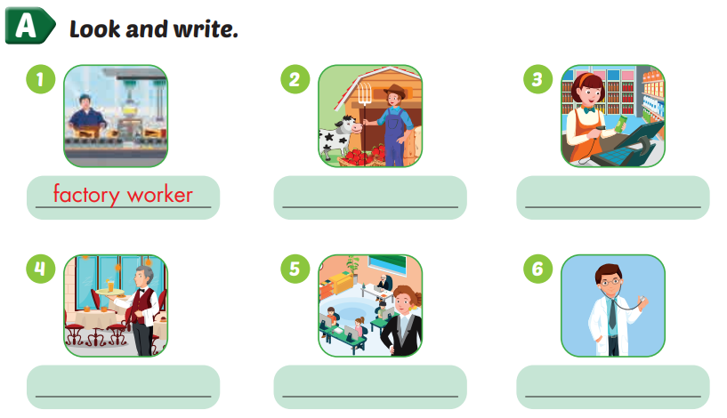  
2) (1)___________   
3) (2)___________   
4) (3)___________   
5) (4)___________   
6) ​ (5)___________​​​

|  |  |
| --- | --- |
| **PART 2** | **READING (7 questions)** |

**10. Read and draw lines to complete the sentence. There is one example. (7 questions)**

|  |  |  |  |
| --- | --- | --- | --- |
| Who | do | does | sweeps |

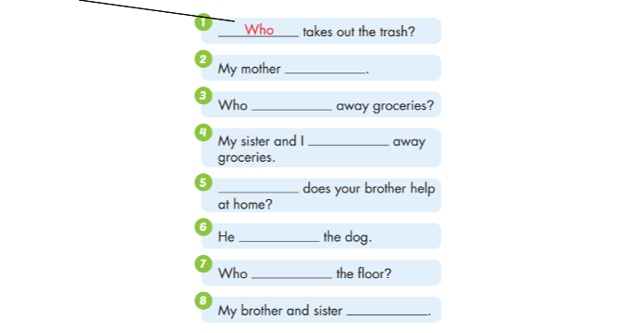

|  |  |  |  |
| --- | --- | --- | --- |
| puts | How | feeds | put |

|  |  |
| --- | --- |
| **PART 3** | **READING (5 questions)** |

**Read and tick True or False. (5 questions)**

|  |
| --- |
| My name’s Mai. There are four people in my family. My dad is a doctor. He works at a big hospital in the city. He helps sick people, and he’s busy.  My mom is a cashier. She works at a bank. She’s busy, too. My brother and I are students at a primary school. We walk to school because it’s near my house. We often go out on the weekends when my parents are free. I love my family. |

| **Answers** | **True** | **False** |
| --- | --- | --- |
| 17. Mai’s family has four people. | **◯** | **◯** |
| 18. Mai’s dad is a doctor at a hospital. | **◯** | **◯** |
| 19. Mai’s mom is a cashier in a store. | **◯** | **◯** |
| 20. Mai and her brother go to school on foot. | **◯** | **◯** |
| 21. Mai’s parents are busy on the weekends. | **◯** | **◯** |

**C. Consolidation** (5 minutes)

|  |  |
| --- | --- |
| **Teacher’s activities** | **Students’ activities** |
| **Consolidation** (5 minutes)  **“Conversation line”**   * Have students make two lines and stand face to face. * Give each student a picture/flashcard about places. Student 1 of the first line asks a question. E. g. “Were you at the museum yesterday?” Then student 1 of the second line answers. E.g., “Yes, I was/ No, I wasn’t.”. * Swap roles and continue to the end of the lines. | * Do as T’s guides * Work in groups. Try to join the conversations. |
| **Homework Assignment**   * Ask Ss to do exercise again * Have Ss review the vocabulary in Unit 8 | Do homework and review Unit 8.   * Prepare the new lesson. |

----------------------------------------------------------

**Period 132:**

**REVIEW UNIT 8**

**1. Objectives**

By the end of this lesson, students will be able to ask if people were at a place.

**1.1. Language knowledge and skills**

**Vocabulary:** *movie theater, playground, museum, mall, supermarket, amusement park*

**Sentence patterns:** *Where were you last night? I was at the movie theater.*

*Where was Nick last Saturday? He was at the mall.*

*Where were Alfie and Mai yesterday? They were at the park.*

**Skills:** Listening, Reading, Writing, and Speaking.

**1.2. Competences**

**Self-control and independent learning:** review asking if people were at a place.

**Communication and collaboration:** work in pairs or groups to ask if people were at a place.

**Critical thinking and creativity:** learn how to ask if people were at a place.

**1.3. Attributes**

**Kindness:** support their friends to complete the learning tasks or play the games.

**Diligence:** focus on the lesson and work hard to complete all the tasks.

**Honesty:** play fair.

**Accountability:** appreciate kindness, diligence, and honesty.

**2. Teaching aids and materials**

**- Teacher’s aids:** Tiếng Anh 4 i-Learn Smart Start Student’s Book and Teacher’s book, Class CDs, Flashcards, DCR & DHA on Eduhome, Projector/Interactive Whiteboard /TV (if any), PowerPoint slides.

**- Students’ aids:** Tiếng Anh 4 i-Learn Smart Start Student’s Book, Workbook, Notebook.

**3. Procedures**

**A. Warm up** (5 minutes)

**a. Objectives:** To help the students review the previous lessons, generate the students’ interests, and lead in the Review and Practice lesson.

**b. Content:** Playing the game: “Roll the dice” or “Bingo”.

**c. Expected outcomes and assessment**

- Task completed with excellence:Students can remember the words in each category or identify the vocabulary items on the flashcards quickly and correctly.

- Task completed: Students can remember the words in each category or identify the vocabulary items on the flashcards.

- Task uncompleted: Students are unable to remember the words in each category or identify the vocabulary items on the flashcards.

**d. Organization**

|  |  |
| --- | --- |
| **Teacher’s activities** | **Students’ activities** |
| **“Memory” game**   * Divide the class into four teams. * Invite 2 students from 2 groups to come to the board. * Place some flashcards or writes some words on the board (about 15 – 20 flashcards or words). * Give the students time to memorize as much words as possible. When the time is up, the students write down what they have memorized. The student who has the most correct words gets points for his/her team. * Repeat with different students. | - Follow and do as T’s guides.  - Join the game, try to say the correct word. |

**B. Main lesson** *(30 mins)*

**a. Objective:** review vocabulary related to common places and ask about where people were.

**b. Content:** Listen and draw lines, read and answer, and write about where you were.

**c. Expected outcomes and assessment**

- Task completed with excellence: Students can finish the given tasks quickly and correctly.

- Task completed: Students can finish the given tasks.

- Task uncompleted: Students are unable to finish the given tasks.

**d. Organization**

|  |  |
| --- | --- |
| **PART 1** | **READING (10 questions)** |

**Read and match. There is one example. (3 questions)**

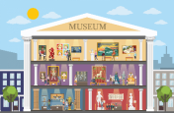

|  |  |  |  |
| --- | --- | --- | --- |
| **Example:** | You can see old paintings and models in this place. | ●  ● | A. museum |
| 11. | It’s the day before today. |  | B. hungry |
| 12. | You can watch movies on a big screen in this place. |  | C. movie theater |
| 13. | When you feel this, you want to eat something. |  | D. thirsty |
|  |  |  | E. yesterday |

**Look, read and tick True or False. There is one example. (3 questions)**

**Example:**

|  |  |  |  |
| --- | --- | --- | --- |
|  |  | Was he thirsty? Yes, he was. | **☑ True ☐ False** |

**Questions:**

|  |  |  |  |
| --- | --- | --- | --- |
| 14. |  | How was your weekend? It was relaxing. | **☐ True ☐ False** |
| 15. |  | Where were you last night? I was at the supermarket. | **☐ True ☐ False** |
| 16. |  | Where were your cousins last Friday? They were at the mall. | **☐ True ☐ False** |

**Read the text. Choose a word from the box. There is one example. (4 questions)**

Last week, Terry had a school trip to Happy Farm. It  *was*  in Green Hill town. Terry and his friends (17)___________ at school at 6 o’clock. Then, they traveled to the farm by bus. At Happy Farm, they were surprised because they could see a lot of different animals. Terry’s best friend, Joe wasn’t excited when he saw the cows. He was (18)___________. At 12 o’clock, they were all (19)___________ and hungry. They had lunch at a restaurant. The school trip was (20)___________, but Terry was really tired.

|  |  |  |  |  |  |  |
| --- | --- | --- | --- | --- | --- | --- |
| (17) | A. boring | B. were | C. thirsty | D. scared | E. was | F. fun |
| (18) | A. boring | B. were | C. thirsty | D. scared | E. was | F. fun |
| (19) | A. boring | B. were | C. thirsty | D. scared | E. was | F. fun |
| (20) | A. boring | B. were | C. thirsty | D. scared | E. was | F. fun |

|  |  |
| --- | --- |
| **PART 2** | **WRITING (10 questions)** |

**Order the letters. There is one example. (3 questions)**

**Example:**

|  |  |  |
| --- | --- | --- |
|  |  | Keywords: r/i/t/e/d  → t i r e d |

**Questions:**

|  |  |  |
| --- | --- | --- |
| 21. |  | Keywords: r/o/b/i/g/n  → ....................................... |

|  |  |  |
| --- | --- | --- |
| 22. |  | Keywords: p/r/u/s/i/r/e/s/d  → ....................................... |

|  |  |  |
| --- | --- | --- |
| 23. |  | Keywords: g/p/a/r/o/y/l/u/n/d  → ....................................... |

**Look and write.**



Was Lucy excited?   
No, she wasn’t. She was (24)___________.

**Look and write.**



How was your weekend, David?   
It was (25)___________.

**Look and write.**



Where were they last month?   
They were at the (26)___________.

**Look, read and complete the sentences. There is one example. (4 questions)**

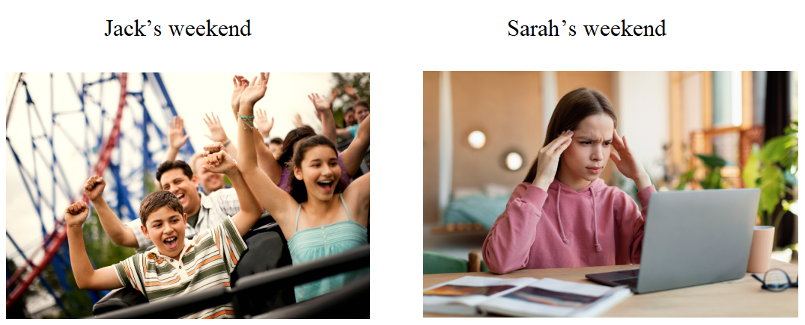

Ex. Last weekend, Jack was at the  *amusement park* .   
- It was fun and e (27)___________. He was there with his sister, Jane.   
- He wasn’t s (28)___________ when he was on the roller coaster. He liked it.   
- Sarah w (29)___________ at the amusement park. She was at home.   
- Her weekend wasn’t relaxing. It was t (30)___________ because she had lots of homework.

**C. Consolidation** (5 minutes)

|  |  |
| --- | --- |
| **Teacher’s activities** | **Students’ activities** |
| **Consolidation** (5 minutes)  : **“Conversation line”**   * Have students make two lines and stand face to face. * Give each student a picture/flashcard about places. Student 1 of the first line asks a question. E. g. “Were you at the museum yesterday?” Then student 1 of the second line answers. E.g., “Yes, I was/ No, I wasn’t.”. * Swap roles and continue to the end of the lines. | * Do as T’s guides * Work in groups. Try to join the conversations. * Do as T’s guides |
| **Homework Assignment**   * Ask Ss to do exercise again and prepare review Unit5- Unit8 | Do homework and review Unit 8.   * Prepare the new lesson. |

**----------------------------------------------------------------**