UNIT 6: ENGLISH AROUND THE WORLD
Period91: Lesson 6c - Vocabulary (page 86)
1. OBJECTIVES
1.1. Language knowledge & skills
- identification and memory vocabulary and phrases about ways of learning English: sign up for an English class, take online lessons, watch English-language films, practise the language with English friends, use English learning apps, read English books, write blogs in English, visit an English-speaking country.
- practice listening for specific information.
- discussing about how to improve students’ English.
1.2. Competences
- improve students’ communication, collaboration, analytical, and critical thinking skills.
1.3. Attributes
- used good at English to get a better future.
2. TEACHING AIDS AND MATERIALS
- Teacher’s aids: Student’s Book and Teacher’s Book, Class CDs, projector / interactive whiteboard / TV (if any), IWB (Phần mềm tương tác trực quan), PowerPoint slides
- Students’ aids: Student’s Book, notebook
3. PROCEDURES
A. Warm-up: (5’)
a) Objectives: To get students' attention at the beginning of the class with enjoyable and short activities and engage them in the follow-up steps.
b) Content: Talk about students’ English level.
c) Expected outcomes: Students can get some ideas relating to the topic of the lesson.
d) Organisation of the activity:
Teacher’s activities | Students’ activities
- Ask students about their English level:  “How do you feel about your English?” | - Answer the question.  - Present their ideas when invited.  Suggested Answer Key  - I think my English is not good. Sometimes, I can’t understand what people are saying. I must try my best to improve it.

B. New lessons (35 minutes)
1. Vocabulary Presentation: 20 minutes
a. Objectives: To present vocabulary relating to ways of learning English.
b. Content: Task 1 (SB), Task 1 (WB), Task 2 (WB), Task 3 (WB).
c. Expected outcomes: Students can remember vocabulary and do the tasks correctly.
d. Organisation:
Teacher’s activities | Students’ activities
Task 1. Fill in each gap with the correct verb from the list. Listen and check, then repeat.  - Direct students’ attention to the pictures, ask them to look at the phrases under the pictures and use the verbs in the list to complete them.  - Play the recording with pauses for students to listen and check their answers.  - Play the recording again with pauses for students to repeat chorally and/or individually.  - Check students’ pronunciation.  - Explain the meaning of the words.  - sign up for an English class  - take online lessons  - watch English-language film  - practise the language with English friends  - use English learning apps  - read English books  - write blogs in English  - visit an English-speaking country  Task 1, SB, p48. Complete each gap with practise, visit, watch, read, take, write, use or sign up in the correct form.  - Explain the task.  - Ask students to work in pairs to complete the task.  - Check students’ answers.  Task 2, WB, p.48. Match the sentences (1–8) in Exercise 1 to the pictures (a–h).  - Explain the task.  - Ask students to work individually to complete the task.  - Check students’ answers.  Task 3, WB, p.48. Fill in each gap with ONE correct word.  - Explain the task.  - Ask students to work in pairs to complete the task.  - Check students’ answers. | - Look at the pictures and the phrases.  - Listen and check the answers.  - Listen and repeat chorally and/or individually.  - Listen to the teacher.  - Listen and take notes.  - sign up for an English class /saɪn ʌp fɔː(r) ən ˈɪŋ.ɡlɪʃ klɑːs/ (phr): đăng kí một lớp học tiếng Anh  - take online lessons /teɪk ˌɒn.laɪn ˈles.ənz/ (phr): học trực tuyến  - watch English-language films /wɒtʃ ˈɪŋ.ɡlɪʃ ˈlæŋ.ɡwɪdʒ fɪlmz/ (phr): xem phim tiếng Anh  - practise the language with English friends /ˈpræk.tɪs ðə ˈlæŋ.ɡwɪdʒ wɪð ˈɪŋ.ɡlɪʃ frendz/ (phr): thực hành tiếng với các bạn người Anh  - use English-learning apps /juːz ˈɪŋ.ɡlɪʃ ˈlɜː.nɪŋ æps/ (phr): sử dụng các ứng dụng học tiếng Anh  - read English books /riːd ˈɪŋ.ɡlɪʃ bʊks/ (phr): đọc sách viết bằng tiếng Anh  - write blogs in English /raɪt blɒɡz ɪn ˈɪŋ.ɡlɪʃ (phr): viết blog bằng tiếng Anh  visit an English-speaking country /ˈvɪz.ɪt ən ˈɪŋ.ɡlɪʃ ˈspiː.kɪŋ ˈkʌn.tri/ (phr): đến thăm một đất nước nói tiếng Anh  - Listen to the teacher.  - Work in pairs to complete the gaps.  - Listen and take notes.  Answer Key  1.use 2.is practising 3.sign up  4.watch 5.take 6. Visiting 7.write 8. reading  - Listen to the teacher.  - Work individually to match the sentences (1-8) in Exercise 1 to pictures (a-h).  - Listen and take notes.  Answer Key  a – 7 b – 3 c – 4 d – 1 e – 2 f – 8  g – 6 h - 5  - Listen to the teacher.  - Work in pairs to complete the gaps.  - Listen and take notes.  Answer Key  1. blog 2. apps 3. language 4.class  5. books 6. country

2. Listening: 15 minutes
a. Objectives: To help students to practise listening to decide if the statements (1-5) are R (right) or W (wrong).
b. Content: Task 2 (SB).
c. Expected outcomes: Students can listen for specific information.
d. Organisation:
Teacher’s activities | Students’ activities
Task 2. Listen to Mark and his teacher talking about ways of learning English. Decide if the statements (1–5) are R (right) or W (wrong).  Pre-listening  - Explain the task.  - Ask students some questions:  - How many people are you going to listen to?  - Who are they?  - What do they talk about?  - What are you going to do in the task?  - Give students time to read the statements and underline the key words. | - Listen to the teacher.  - Answer the questions.  Answer Key  1. We are going to listen to a dialogue between 2 people.  2. They are Mark and his teacher.  3. They talk about ways of learning English.  4. We are going to listen and decide if the statements (1-5) are right or wrong.  - Read the statements and underline the key words.
While-listening  - Play the recording, twice if necessary for students to listen and complete the task.  - Elicit and check students’ answers. The teacher can play the recording with pauses for students to check their answers.  Audioscript  Mark: Miss, I really enjoy your English lessons and I would like to improve my English. What should I do?  Teacher: Well, you can watch English language films. There are many films available online. It’s a simple way to improve your listening skills.  Mark: Great, I love watching films. How can I improve my reading skills?  Teacher: At school, we have English reading lessons every week, but you can improve your reading skills by reading English books at home, too.  Mark: That sounds interesting! What about improving my writing skills?  Teacher: You can write a blog in English to connect with English speakers online.  Mark: Hmmm… I don’t really like blogs. How about getting an English-speaking pen pal?  Teacher: That’s a great idea! An English-speaking pen pal will help you a lot. You also need to practise speaking English. So, I think you should spend time talking to any English friends you have. | - Students listen and complete the task.  - Give answers when invited. Then check their answers.  Answer Key  1.R 2.R 3.W 4.R 5.W
Post-listening  There are some ways of learning English in Task 2. Choose one of them, and make a mind map about the advantages and disadvantages of that way.  - Explain the task.  - Ask students to work in groups of four and give students time to complete their mind map.  - Ask students to present their ideas in front of the class. | - Listen to the teacher.  - Do the task in groups.  - Give answers when invited.  Suggested Answer Key  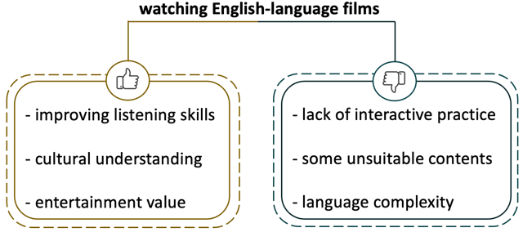

3. Production: 5 minutes
a. Objectives: To help students use the language and information to talk about what they should do to improve their English.
b. Content: Task 3 (SB)
c. Expected outcomes: Students can talk about what they should do to improve their English.
d. Organisation:
Teacher’s activities | Students’ activities
Task 4. What should you do to improve your English? Tell your partner.  - Explain the task to students.  - Ask students to work in pairs to talk about what they should do to improve their English.  - Monitor the activity around the class and  then ask some pairs of students to share their answers with the class. | - Listen to the teacher.  - Work in pairs to complete the task.  - Speak in front of the class when invited.  Suggested Answer Key  A: I should use English-learning apps on my phone to improve my English. I should also listen to English songs online and watch English TV series.  B: I should write blogs in English or get an English-speaking pen pal to improve my English writing skills. I could sign up for an English class, too.
C. Consolidation and homework assignment: 5 minutes
1. Consolidation
Vocabulary about ways of learning English: sign up for an English class, take online lessons, watch English-language films, practise the language with English friends, use English learning apps, read English books, write blogs in English, visit an English-speaking country.
2. Homework assignment
- Review the vocabulary learnt.
- Prepare for the next lesson: Lesson 6d – Everyday English (page 87, SB).
4. REFLECTION
a. What I liked most about this lesson today:
……………………………………………………………………………
b. What I learned from this lesson today:
……………………………………………………………………………
c. What I should improve for this lesson next time:
……………………………………………………………………………
******************************
UNIT 6: ENGLISH AROUND THE WORLD
Period 92: Lesson 6d – Everyday English (Page 87)

1. OBJECTIVES
1.1. Language knowledge & skills
- learning and practice intonation.
- discussing ways of learning English.
- listening and reading for cohesion and coherence.
1.2. Competences
- improve students’ communication, collaboration, analytical, and critical thinking skills.
1.3. Attributes
- used good at English to have a better future.
2. TEACHING AIDS AND MATERIALS
- Teacher’s aids: Student’s Book and Teacher’s Book, Class CDs, projector / interactive whiteboard / TV (if any), IWB (Phần mềm tương tác trực quan), PowerPoint slides
- Students’ aids: Student’s Book, notebook
3. PROCEDURES
A. Warm-up: (5 minutes)
a) Objectives: To get students' attention at the beginning of the class with enjoyable and short activities and engage them in the follow-up steps.
b) Content: Students’ periods of learning English every day.
c) Expected outcomes: Students can have ideas about the topic of the lesson.
d) Organisation of the activity:
Teacher’s activities | Students’ activities
Talk about time to learn English  - Ask students about their time for learning English:  “How much time do you spend learning English every day?” | - Work individually to do the task:  Suggested Answer Key  After school, I spend an hour a day learning English at home.

B. New lessons (35 minutes)
1. Pronunciation: 7 minutes
a. Objectives: To help students practise intonation.
b. Content: Pronunciation Task (SB), Task 4 (WB).
c. Expected outcomes: Students can practise intonation.
d. Organisation:
Teacher’s activities | Students’ activities
Pronunciation Task. Listen and mark the sentences ➚ (rising intonation) or ➘ (falling intonation). Practise saying them with your partner.  - Explain the task.  - Play the recording with pauses for students to tick in the right column.  - Check students’ answers.  - Ask students to repeat chorally and individually.  - Have students practise saying the sentences with their partner.  - Pay attention to students’ pronunciation and give corrections if necessary.  Task 4, WB, p49. Mark the sentences ➚ (rising intonation) or ➘ (falling intonation). Listen and check, then repeat.  - Explain the task.  - Ask students to work in pairs to complete the task.  - Play the recording with pauses for students to choose the correct answers.  - Check students’ answers.  - Ask students to repeat chorally and individually.  - Have students practise saying the sentences with their partners.  - Pay attention to students’ pronunciation and give corrections if necessary. | - Listen to the teacher.  - Listen and do the task individually.  - Check the answers and take notes.  - Repeat chorally and individually.  - Say the sentences aloud with their partner.  - Listen to the teacher’s feedback and corrections.  Answer Key  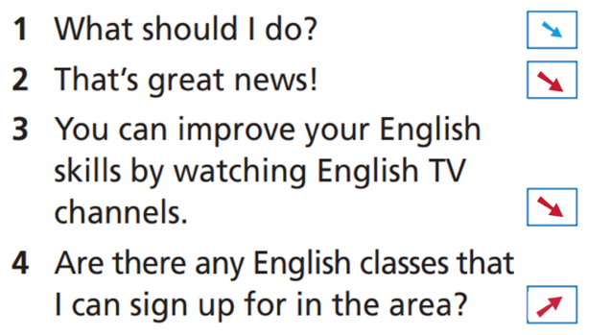  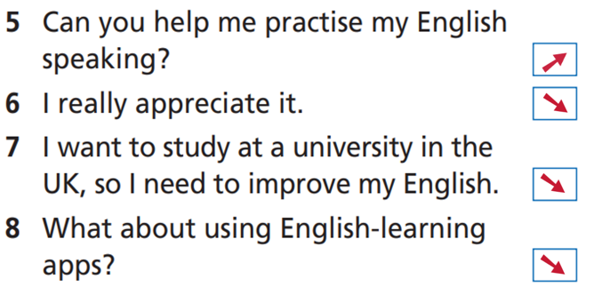  - Listen to the teacher.  - Listen and do the task in pairs.  - Check the answers and take notes.  - Repeat chorally and individually.  - Say the sentences aloud with their partners.  - Listen to the teacher’s feedback and corrections.  Answer Key  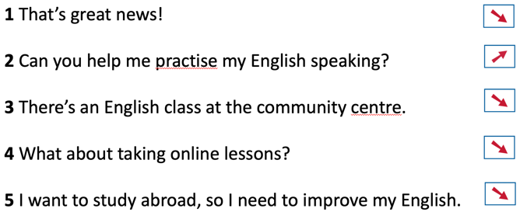
2. Speaking: Ways of learning English (28 minutes)
2.1. Pre-speaking: 10 minutes
a. Objectives: To listen and read for cohesion and coherence.
b. Content: Task 1 (SB), Task 2 (SB), Task 1 (WB), Task 2 (WB), Task 3 (WB).
c. Expected outcomes: Students can understand the dialogue and do the tasks correctly.
d. Organisation:
Teacher’s activities | Students’ activities
Task 1. Read the dialogue and fill in the gaps (1–4) with the sentences (A–D). Listen and check.  - Explain the task and give students time to read the gapped dialogue and the list of sentences.  - Give students time to complete the task individually.  - Elicit the answers from students.  - Play the recording for students to check their answers.  Task 2. Take roles and read out the dialogue.  - Explain the task to students.  - Give students time to take roles and read the dialogue in pairs.  - Ask some pairs to read in front of the class.  - Listen and give feedback to students.  Task 1, WB, p.49. Match the sentences to make exchanges.  - Explain the task to students.  - Ask them to work on their own.  - Elicit the answers from students.  - Correct students’ answers.  Task 2, WB, p.49. Choose the correct response.  - Explain the task to students.  - Ask them to work on their own.  - Elicit the answers from students.  - Correct students’ answers.  Task 3, WB, p.49. Complete the dialogue with sentences from Exercises 1 and 2.  - Explain the task to students.  - Ask them to work in pairs.  - Elicit the answers from students.  - Correct students’ answers. | - Listen to the teacher.  - Do the task on their own.  - Give ideas when invited.  - Listen to the recording and check their answers.  Answer Key  1 – C  2 – A  3 – B  4 - D  - Listen to the teacher.  - Do the task in pairs.  - Take roles and read the dialogue.  - Listen to the teacher and take notes.  - Listen to the teacher.  - Do the task individually.  - Give answers when invited.  - Listen to the teacher and take notes.  Answer Key  1 – d  2 – a  3 – b  4 - c  - Listen to the teacher.  - Do the task individually.  - Give answers when invited.  - Listen to the teacher and take notes.  Answer Key  1 B  2 A  3 B  - Listen to the teacher.  - Do the task in pairs.  - Give answers when invited.  - Listen to the teacher and take notes.  Answer Key  1. That’s great news!  2. Are there any English classes I can sign up for in the area?  3. What about taking online lessons?  4. You’re right.  5. Of course! I’m happy to help.

2.2. While-speaking: 10 minutes
a. Objectives: To practise role-playing.
b. Content: Task 3 (SB)
c. Expected outcomes: Students can understand the dialogue and do the task correctly.
d. Organisation:
Teacher’s activities | Students’ activities
Task 3. Act out a similar dialogue. Use the dialogue in Exercise 1 as a model and the ideas from Exercise 1 (page 86) and/or your own ideas.  - Explain the task and tell students to use the dialogue in Exercise 1 as a model and to use the ideas in Exercise 1 on page 86 to complete the task.  - Students complete the task in pairs.  - Monitor the activity around the class and ask some pairs to act out the dialogue in front of the class.  - Mind students’ intonation and rhythm. Give feedback and corrections if needed. | - Listen to the teacher.  - Work in pairs, using the sample dialogue and their own ideas to complete the task.  - Act out the dialogue in pairs.  - Act out the dialogue in front of the class when invited.  - Listen to the teacher’s feedback and corrections and take notes.  Suggested Dialogue  A: I want to go to travel abroad, so I need to improve my English. What should I do?  B: That’s great news! I think you should use English-learning apps.  A: Are there any good apps that I can use?  B: You can use the app that I am using. It’s very helpful.  A: That sounds great! What about writing blogs in English?  B: Yes, that’s a good idea, too. You can also learn English by watching English-language films and reading English books.  A: I see. Then reading my favourite English novels can help, too.  B: You’re right. You can improve your English skills by reading different types of books in English.  A: That’s wonderful! Your English is so good. Can you help me practise my English speaking?  B: Of course! I’m happy to help.  A: Thanks. I really appreciate it.  B: You’re welcome.

2.3. Post-speaking: 8 minutes
a. Objectives: To make a To-Do List to improve students’ English.
b. Content: Extra Practice.
c. Expected outcomes: Students can make their To-Do lists to improve their English.
d. Organisation:
Teacher’s activities | Students’ activities
Extra Practice. Make a To-Do List to improve your English.  - Explain the task to students.  - Ask them to work individually.  - Ask some students to present their ideas in front of the class.  - Listen and give feedback to students. | - Listen to the teacher.  - Work on their own to make a To-Do List to improve their English.  - Present their ideas when invited.  - Listen to the teacher’s feedback and take notes.  Suggested Answer Key  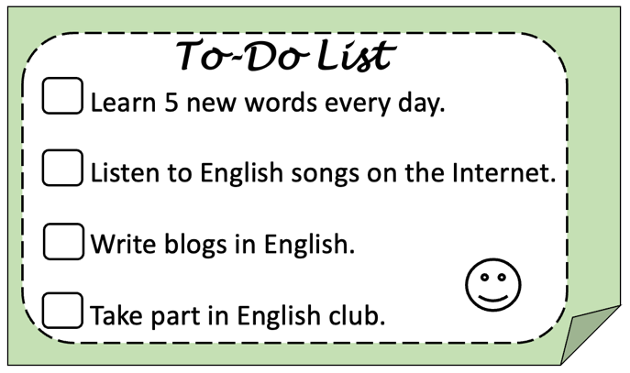

C. Consolidation and homework assignment: 5 minutes
1. Consolidation
- Speaking: Making and acting out a dialogue discussing ways of learning English.
- Pronunciation: Intonation.
2. Homework assignment
- Review pronunciation and practise role-playing about ways of learning English.
- Prepare for the next lesson: Lesson 6e – Grammar (page 88, SB).
4. REFLECTION
a. What I liked most about this lesson today:
……………………………………………………………………………
b. What I learned from this lesson today:
……………………………………………………………………………
c. What I should improve for this lesson next time:
……………………………………………………………………………
****************************

UNIT 6: ENGLISH AROUND THE WORLD
Period93: Lesson 6e - Grammar (Page 88)

1. OBJECTIVES
1.1. Language knowledge & skills
- Identification and practice clauses/phrases of concession.
1.2. Competences
- improve students’ communication, collaboration, analytical, and critical thinking skills.
1.3. Attributes
- recognisable opposing viewpoints, creative a balanced argument, and foster understanding between individuals.
2. TEACHING AIDS AND MATERIALS
- Teacher’s aids: Student’s Book and Teacher’s Book, Class CDs, projector / interactive whiteboard / TV (if any), IWB (Phần mềm tương tác trực quan), PowerPoint slides.
- Students’ aids: Student’s Book, notebook.
3. PROCEDURES
A. Warm-up: (5’)
a) Objectives: to check students’ homework; get students' attention at the beginning of the class with enjoyable and short activities and engage them in the follow-up steps.
b) Content: Ask students to match the sentences.
c) Expected outcomes: Students can match the sentences correctly.
d) Organisation of the activity:
Teacher’s activities | Students’ activities
- Explain the task to students.  - Ask students to match the sentences correctly with but.  - Elicit students’ answers. | - Listen to the teacher.  - Do the task.  - Answer the questions.
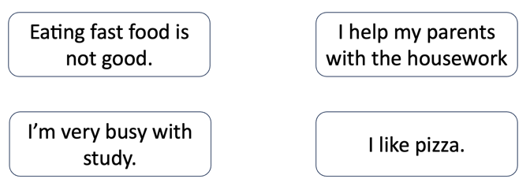 | Answer Key:  - Eating fast food is not good, but I like pizza.  - I have a lot of homework, but I help my parents with the housework.

B. New lessons (35 minutes)
1. Presentation: 5 minutes
a. Objectives: to present clauses/phrases of concession.
b. Content: Language box.
c. Expected outcomes: Students can understand and use clauses/phrases of concession correctly.
d. Organisation:
Teacher’s activities | Students’ activities
The usage  - Ask students to look at the example, and work out the usage of clauses/phrases of concession.  “Although she is tired, she has to finish her work.”  - Elicit students’ ideas.  - Give feedback and further explanation of clauses/phrases of concession.  More Explanation  - Ask students to look at the examples, get some points of clauses/phrases of concession.  - Give further explanation of clauses/phrases of concession.  - Although the exam was very difficult, we passed it.  - He went to work though he was ill.  - Even though John is short, he plays basketball very well.  - I went to my English class on time  despite/in spite of the heavy traffic.  - Despite getting up early,  Keith was late for school.  - Although it rained a lot, we enjoyed our holiday. | - Do the task.  - Present their ideas when invited.  - Listen to the teacher’s explanation and take notes.  Answer Key  Clauses/Phrases of concession express contrast.  - Listen to the teacher.  - Listen to the teacher’s explanation and take notes.  Answer Key  - although/though/even though + clause  - despite/in spite of + noun/verb-ing  - Note: when the clause/phrase of concession is at the beginning of a sentence, we separate it from the main clause with a comma.

2. Practice: 25 minutes
a. Objectives: To help students practice using clauses/phrases of concession correctly.
b. Content: Task 1 (SB), Task 1 (WB), Task 2 (SB), Task 2 (WB), Task 9 (GB).
c. Expected outcomes: Students can use clauses/phrases of concession correctly.
d. Organisation:
Teacher’s activities | Students’ activities
Task 1. Fill in the gaps with although/though/even though or despite/in spite of.  - Ask students to do the task on their own.  - Elicit and check students’ answers.  Task 1, WB, p.50. Choose the correct options.  - Ask students to do the task on their own.  - Elicit and check students’ answers.  Task 2. Rewrite the sentences without changing their meanings. Use the words in brackets.  - Explain the task to students.  - Ask students to do the task in pairs. Explain that some sentences can be written in more than one way. Remind students to use the word in bold in their sentences.  - Elicit and check students’ answers.  Task 2, WB, p.50. Rewrite the sentences without changing their meanings.  - Explain the task to students.  - Ask students to do the task in groups of three.  - Elicit and check students’ answers.  Task 9, GB, p.77. Rewrite the sentences without changing their meanings. Use the words in brackets.  - Explain the task to students.  - Ask students to do the task in groups of three.  - Elicit and check students’ answers. | - Do the task individually.  - Listen to the teacher and give their answers when invited.  - Check their answers.  Answer Key  - Although/Though/Even though  - despite/in spite of  - although/though/even though  - although/though/even though  - despite/in spite of  - despite/in spite of  - Do the task individually.  - Listen to the teacher and give their answers when invited.  - Check their answers.  Answer Key  1. Although 2. Despite 3. even though  4. Although 5.In spite of 6.In spite of  - Listen to the teacher.  - Do the task in pairs.  - Give answers when invited.  - Check their answers.  Answer Key  1. In spite of the bad weather, she went to her English class on time.  2. Ivy was able to get a high mark even though the English test was difficult. / Even though the English test was difficult, Ivy was able to get a high mark.  3. Bob is excited to learn a new language though he speaks three languages already. / Though Bob speaks three languages already, he is excited to learn a new language.  4. In spite of doing lots of research, I couldn’t find much information about the topic. / I couldn’t find much information about the topic in spite of doing lots of research.  5. Despite using our English-learning apps, we prefer our English lessons at school. / We prefer our English lessons at school despite using our English-learning apps.  6. Although Kate is the top student in her English class, she doesn’t feel confident about her speaking skills. / Kate doesn’t feel confident about her speaking skills although she is the top student in her English class.  - Listen to the teacher.  - Do the task in groups.  - Listen to the teacher and give their answers when invited.  - Check their answers.  Answer Key  1. In spite of his fear of flying, he wants to travel around the world.  2. Even though he had a headache, he attended his English class.  3. Paula decided not to sign up for a class although her level of English is low.  4. Emily loves travelling abroad despite not being good at English.  5. Though she lived in the UK for only a year, she sounds like a native speaker.  - Listen to the teacher.  - Do the task in groups.  - Listen to the teacher and give their answers when invited.  - Check their answers.  Answer Key  1. In spite of the rain, they played football outside.  2. Even though Harry signed up early, he didn’t get a place on the English course.  3. Xuân considers herself as a beginner despite speaking English well.  4. Although she loves technology, Jenny prefers learning English in an in-person class.  5. Despite starting English lessons three years ago, he can’t speak English well.  6. Emma wants to take up another sport though she already plays tennis and golf.

3. Production: 5 minutes
a. Objectives: To help students practise making sentences using clauses/phrases of concession.
b. Content: Task 3 (SB).
c. Expected outcomes: Students can make sentences using clauses/phrases of concession using clauses/phrases of concession.
d. Organisation:
Teacher’s activities | Students’ activities
Task 3. Make sentences using phrases/clauses of concession. You start a sentence and your partner completes it.  - Explain the task.  - Ask students to read out the example exchange.  Example:  A: Jane practises speaking English with friends online every day ...  B: Jane practises speaking English with friends online every day although she is busy with her homework.  - Ask students to work in pairs and complete the task using their own ideas.  - Ask some students to share their answers with the class.  - Give feedback. | - Listen to the teacher.  - Work in pairs to complete the task.  - Speak in front of the class when invited.  - Listen to the teacher.  Suggested Answer Key  A: Linh did well on her English exam ...  B: Linh did well on her English exam although she didn’t have much time to review the lessons.  A: We played football after school yesterday ...  B: We played football after school yesterday despite the bad weather.  A: I went to bed early last night ...  B: I went to bed early last night although I didn’t feel tired.  A: I read a chapter of an English book everyday...  B: I read a chapter of an English book every day in spite of being very busy.  A: I can understand a lot of English grammar ...  B: I can understand a lot of English grammar though I started studying English a few months ago.

C. Consolidation and homework assignment: 5 minutes
1. Consolidation
- Grammar point: clauses/phrases of concession.
2. Homework assignment
- Review clauses/phrases of concession.
- Prepare for the next lesson: Lesson 6e - Grammar (page 89, SB).
4. REFLECTION
a. What I liked most about this lesson today:
…………………………………………………………………………
b. What I learned from this lesson today:
…………………………………………………………………………
c. What I should improve for this lesson next time:
…………………………………………………………………………

