UNIT 5: LIVING ENVIRONMENT
Period 85: Lesson – Unit 5 Progress Check (Page 80)
1. OBJECTIVES
1.1. Language knowledge & skills
- revision and practice vocabulary in unit 5.
- revision and practice grammar points: comparative, as….as - not as/so…as, superlative, defining relative clauses and non-defining relative clauses.
- practice pronunciation.
1.2. Competences
- improve students’ communication, collaboration, analytical, and critical thinking skills.
1.3. Attributes
- encouraged students to study hard, and be accountable.
- enriched students with knowledge about urban and rural areas.
- aware of the importance of a green living environment.
2. TEACHING AIDS AND MATERIALS
- Teacher’s aids: Student’s Book and Teacher’s Book, Class CDs, projector / interactive whiteboard / TV (if any), IWB (Phần mềm tương tác trực quan), PowerPoint slides
- Students’ aids: Student’s Book, notebook
3. PROCEDURES
A. Main Lesson
Vocabulary: (15 minutes)
a. Objectives: To help students to review some vocabulary related to natural wonders and travel.
b. Content: Task 1 (SB), Task 2 (SB), WE (p.112).
c. Expected outcomes: Students can recall the vocabulary they learnt in the previous lessons.
d. Organisation:
Teacher’s activities | Students’ activities
Task 1. Choose the correct options.  - Give students time to read and choose the correct options.  - Check students’ answers and ask students to mark themselves. | - Read the sentences and choose the correct options.  - Check answers.  Suggested answers  1 green  2 Clean  3 waste  4 renewable  5 farming
Task 2. Fill in each gap with housing, opportunities, transport, stations or facilities.  - Give students time to complete the task.  - Check students’ answers using IWB and ask students to mark themselves. | - Complete the task.  - Check the answers and mark themselves.  Answer Key  1 opportunities  2 housing  3 transport  4 stations  5 facilities
WE, p.112. Write the correct forms of the words in brackets.  - Give students time to complete the task.  - Check students’ answers using IWB and ask students to mark themselves. | - Complete the task.  - Check the answers and mark themselves.  Answer Key  1 Homelessness 2 electricity  3 serve 4 farming  5 construction 6 environmental  7 electrical 8 polluted  9 service 10 insecure  11 transformation 12 developer  13 farmer 14 development  15 pollution
WE, p.112. Choose the correct options.  - Give students time to complete the task.  - Check students’ answers using IWB and ask students to mark themselves. | - Complete the task.  - Check the answers and mark themselves.  Answer Key  16 D 17 D 18 A 19 D 20 D

Grammar: (15 minutes)
a. Objectives: To help students review and practise grammar points: comparative, as….as - not as/so…as, superlative, defining relative clauses and non-defining relative clauses.
b. Content: Task 3 (SB), Task 4 (SB).
c. Expected outcomes: Students can recall the grammar points and do the task correctly.
d. Organisation:
Teacher’s activities | Students’ activities
Task 3. Choose the correct options.  - Have a quick review on comparative, as….as - not as/so…as, superlative.  - Ask students to do the task in pairs.  - Check students’ answers and ask students to mark themselves. | - Listen to the teacher.  - Do the task in pairs.  - Check the answers and mark themselves.  Answer Key  1 D 2 A  3 B 4 C  5 C 6 B  7 A
Task 4. Rewrite the sentences using the words in brackets in your notebook.  - Explain the task to students.  - Let students rewrite the sentences without changing their meanings on their own.  - Elicit students’ answers.  - Check students’ answers. | - Listen to the teacher.  - Do the task individually.  - Give answers when invited.  - Check answers and take notes.  Answer Key  1 They live in a good neighbourhood which/ that has lots of low-cost housing.  2 Tom, who lives next to my house, is a vertical farmer.  3 The cost of living in rural areas is cheaper than the cost of living in urban areas.  4 Cindy handed in the project the earliest of the students in her class.

Pronunciation: 5 minutes
a. Objectives: To help students consolidate stress patterns.
b. Content: Task 5 (SB).
c. Expected outcomes: Students can identify correct stress patterns and choose the correct answer.
d. Organisation:
Teacher’s activities | Students’ activities
Task 5. Choose the word that has a stress pattern different from the others.  - Ask students to pronounce the words silently and circle the correct options.  - Check students’ answers and ask students to mark themselves. | - Do the exercise individually.  - Check the answers and mark themselves.  Answer Key  1 D 2 B 3 C 4 B 5 D

C. Consolidation and homework assignment: 5 minutes
1. Consolidation
- Vocabulary in unit 5: housing, opportunities, transport, stations, facilities.
- Grammar points: comparative, as….as - not as/so…as, superlative, defining relative clauses and non-defining relative clauses.
- Pronunciation: the stress patterns.
2. Homework assignment
- Prepare for the next lesson: Lesson Progress Check (page 81, SB).
4. REFLECTION

a. What I liked most about this lesson today:
……………………………………………………………………………

b. What I learned from this lesson today:
……………………………………………………………………………
c. What I should improve for this lesson next time:
……………………………………………………………………………
*******************
UNIT 5: LIVING ENVIRONMENT
Period 86: Lesson – Unit 5 Progress Check (Page 81)
1. OBJECTIVES
1.1. Language knowledge & skills
-Identification listening to an interview about green buildings.
- Identification reading a blog entry.
- revision some phrases in everyday English.
- description an email making suggestions for improving the living environment.
1.2. Competences
- improve students’ communication, collaboration, analytical, and critical thinking skills.
1.3. Attributes
- encouraged students to study hard, and be accountable.
- responsible for improving the living environment.
2. TEACHING AIDS AND MATERIALS
- Teacher’s aids: Student’s Book and Teacher’s Book, Class CDs, projector / interactive whiteboard / TV (if any), IWB (Phần mềm tương tác trực quan), PowerPoint slides
- Students’ aids: Student’s Book, notebook
3.. PROCEDURES
A. Main Lesson
Listening: (10 minutes)
a. Objectives: to help students to listen for specific information.
b. Content: Task 6 (SB).
c. Expected outcomes: Students can listen to an interview about green buildings and decide if the statements (1–5) are R (right) or W (wrong).
d. Organisation:
Teacher’s activities | Students’ activities
Task 6. Listen to an interview about green buildings and decide if the statements (1–5) are R (right) or W (wrong).  - Explain the task to students.  - Give students time to read and underline the key words.  - Play the recording twice. Ask students to work individually to complete the task.  - Elicit students’ answers.  - Check students’ answers and give feedback.  Audioscript  (GBE: Green building expert)  Interviewer: On the show this afternoon is green building expert Mark Thomson. Welcome, Mark!  GBE: Thank you for having me.  Interviewer: What is a green building exactly? Are they green in colour?  GBE: (laughs) No, it’s not about the colour. Green buildings are better for the environment than other types of buildings. They are very popular today.  Interviewer: Of course, we should construct green buildings because taking care of the environment is important. But do green buildings actually use fewer resources than other buildings?  GBE: Yes, they do. For instance, they use less water and less energy than other buildings.  Interviewer: And we use resources that are more sustainable to build them, right?  GBE: Exactly. We can use wood to build them instead of other materials.  Interviewer: Are there any disadvantages to constructing more green buildings in our city?  GBE: Green buildings can be more expensive to construct than traditional buildings. However, they cost less to run, so it’s only a disadvantage at first. This means they lower our cost of living.  Interviewer: I see. It sounds like green buildings are very important. Thank you for speaking with us today.  GBE: You’re welcome. | - Listen to the teacher.  - Read the task and underline the key words.  - Listen to the recording and work on their own to fill in the gaps.  - Give answers when invited.  - Listen to the teacher and take notes.  Answer Key  1 W 2 R 3 W 4 R 5 R
Reading: (10 minutes)
a. Objectives: To help students practise reading for information to complete the task.
b. Content: Task 7 (SB).
c. Expected outcomes: Students can read the blog entry and decide if the statements are R(right), W (wrong), or DS (doesn’t say).
d. Organisation:
Teacher’s activities | Students’ activities
Task 7. Read the blog entry and decide if the statements (1–5) are R (right), W (wrong) or DS (doesn’t say).  - Explain the task to students.  - Give students time to read and underline the key words.  - Ask students to work in pairs to complete the task.  - Elicit students’ answers.  - Check students’ answers and give feedback. | - Listen to the teacher.  - Read the task and underline the key words.  - Do the task in pairs.  - Give answers when invited.  - Check the answers and mark themselves.  Answer Key  1 R 2 W 3 R 4 DS 5 R
Everyday English: 5 minutes
a. Objectives: To help students consolidate phrases learned in unit 5.
b. Content: Task 8 (SB).
c. Expected outcomes: Students can match the sentences to make exchanges.
d. Organisation:
Teacher’s activities | Students’ activities
Task 8. Choose the correct options (A or B) to make exchanges.  - Ask students to read the task and then do it on their own.  - Check students’ answers and give feedback. | - Do the task individually.  - Listen to the teacher’s feedback and take notes.  Answer Key  1 A 2 B 3 B 4 A 5 B
Writing: 10 minutes
a. Objectives: To help students practise writing an email making suggestions for making their areas greener.
b. Content: Task 9 (SB).
c. Expected outcomes: Students can write an email.
d. Organisation:
Teacher’s activities | Students’ activities
Task 9. Write an email to the city planners making suggestions for making your area greener (about 100–120 words). Include a greeting and the reason for writing, suggestions and expected results and a closing remark.  - Explain the task to students.  - Guide some parts of an email for students (greeting and the reason for writing, suggestions and expected results and a closing remark).  - Let them write their emails.  - Invite some students to read out loud their emails and give feedback. | - Listen to the teacher.  - Listen and brainstorm for ideas.  - Write the emails individually.  - Read the emails when invited.  - Listen to the teacher’s feedback and take notes.  Suggested writing:  To the City Planners,  I am worried about the living environment in our city. I have some ideas to make it greener.  First, we can create recycling programmes to reduce rubbish. If we do that, we will have fewer litter problems. My second suggestion is to install electric charging stations for people to power their cars around the city. In this way, we will encourage people to use electric vehicles. Another suggestion is to hold a cleanup event in the park. Then, we can reduce litter and make our cities clean and beautiful.  I hope my suggestions are helpful.  Yours faithfully,  (Student’s name)

C. Consolidation and homework assignment: 5 minutes
1. Consolidation
- Listening: listen to an interview about green buildings.
- Reading: read a blog entry.
- Everyday English: review some phrases in everyday English.
- Writing: practise writing an email making suggestions for making an area greener.
2. Homework assignment
- Prepare for the next lesson: Lesson 6.0: Unit Overview (page 82, SB).
4. REFLECTION

a. What I liked most about this lesson today:
……………………………………………………………………………

b. What I learned from this lesson today:
……………………………………………………………………………
c. What I should improve for this lesson next time:
……………………………………………………………………………
**************************
UNIT 6: ENGLISH AROUND THE WORLD
Period 87: Lesson 6.0 – Unit Overview (Page 82)
1. OBJECTIVES
1.1. Language knowledge & skills
- Identification and memory some new words about the benefits of learning English: study abroad, boost brainpower, enjoy entertainment, widen knowledge, improve communication skills, explore the world, have more job opportunities.
- identification and practice pronunciation of word stress.
- identification listening to two people talking about learning English.
- discussion about reasons to learn English.
1.2. Competences
- improve students’ communication, collaboration, analytical, and critical thinking skills.
1.3. Attributes
- memorable the ways learning English to adapt to the demands of modern life.
2. TEACHING AIDS AND MATERIALS
- Teacher’s aids: Student’s Book and Teacher’s Book, Class CDs, projector / interactive whiteboard / TV (if any), IWB (Phần mềm tương tác trực quan), PowerPoint slides
- Students’ aids: Student’s Book, notebook
3. PROCEDURES
A. Warm-up: (5’)
a) Objective: To introduce the new lesson and set the scene for students to acquire the new language; get students' attention at the beginning of the class with enjoyable and short activities and engage them in the follow-up steps.
b) Content: Some words in English.
c) Expected outcomes: Students have general ideas about the topic of the new lesson.
d) Organisation of the activity:

Teacher’s activities | Students’ activities
- Ask students to work in groups of four, and find 10 words in the word search puzzle.  - Check students’ answers.  - Lead in the lesson with a question:  “What is the subject related to 10 words?”  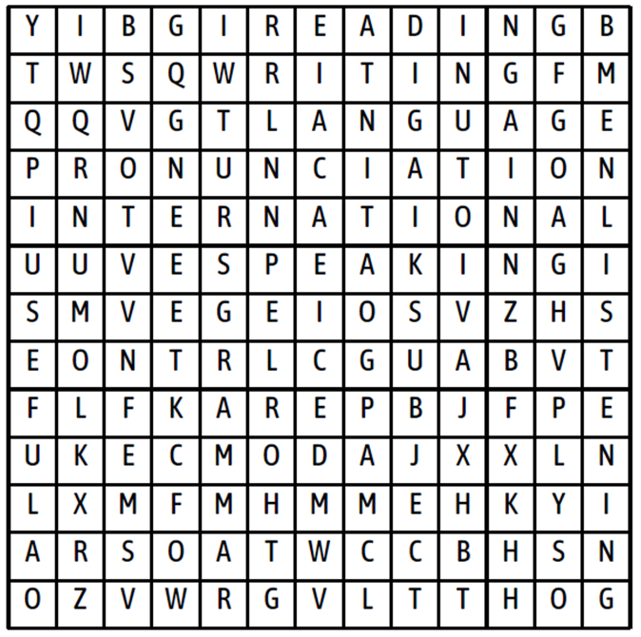 | - Work in groups to find the words.  - Listen to the teacher.  Suggested Answer Key:  The subject is English.  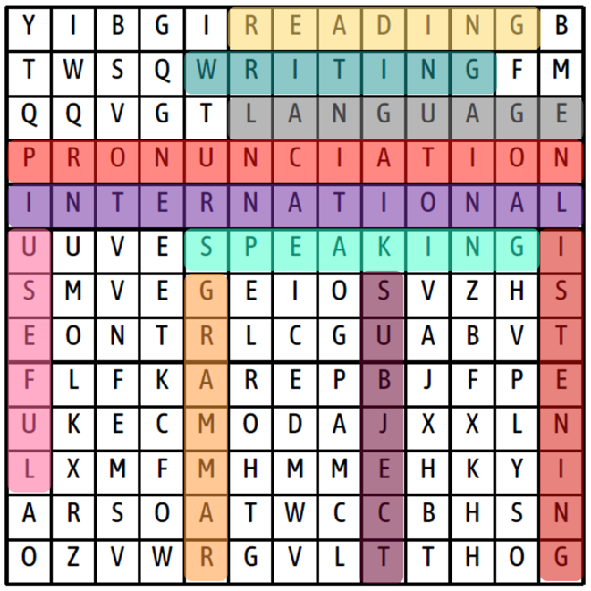
A. New lessons (35 minutes)
1. Presentation: 10 minutes
Vocabulary
a. Objectives: To present some vocabulary about the benefits of learning English.
b. Content: Task 1 (SB), Task 1 (WB), Task 2 (WB).
c. Expected outcomes: Students can remember words related to the benefits of learning English.
d. Organisation:
Teacher’s activities | Students’ activities
Task 1. Fill each gap with have, study, enjoy, improve, boost, explore or widen. Listen and check, then repeat.  - Direct students’ attention to the picture and ask them to look at the gapped phrases under the picture.  - Ask students to complete the gaps with the verbs in the list.  - Check student answers.  - Play the recording with pauses for students to listen and repeat chorally and/or individually.  - Check students’ pronunciation.  - Explain the meaning of the words.  Task 1, WB, p.46. Fill in each gap with the correct word.  - Explain the task.  - Ask students to work in pairs to complete the task.  - Check students’ answers.  Task 2, WB, p.46. Match the sentences in Exercise (1–7) to the pictures (a–g).  - Explain the task.  - Ask students to complete the task individually.  - Elicit students’ answers.  - Check students’ answers. | - Listen to the teacher.  - Do the task.  - Listen to the teacher.  - Listen and repeat chorally and/or individually.  - Listen to the teacher.  - Listen and take notes.  Answer Key  1. study abroad  2. boost brainpower  3. enjoy entertainment  4. widen knowledge  5. improve communication skills  6. explore the world  7. have more job opportunities  - Listen to the teacher.  - Work in pairs to match the words and complete the sentences.  - Listen and take notes.  Answer Key  1. opportunities  2. abroad  3. world  4. communication  5. entertainment  6. brainpower  7. knowledge  - Listen to the teacher.  - Do the task individually.  - Give answers when invited.  - Listen and take notes.  Answer Key  A – 4, b – 5, c – 7, d – 6, e – 3,f – 2,  g – 1

2. Practice: 20 minutes
2.1. Pronunciation: 8 minutes
a. Objectives: To help students identify correct word stress patterns.
b. Content: Task 2 (SB) and Task 4 (WB)
c. Expected outcomes: Students can pronounce words with correct word stress.
d. Organisation:
Teacher’s activities | Students’ activities
Task 2. Put the words into the correct columns. Practise saying them with your partner.  - Explain the task.  - Play the recording for students to complete the task.  - Check students’ answers.  - Play the recording with pauses for students to listen and repeat chorally and/or individually.  - Ask students to practise saying the words in pairs. Monitor the activity around the class.  Pay attention to students’ pronunciation and make corrections if necessary.  Task 4, WB, p.46. Choose the word that has stress pattern different from the others. Listen and check, then repeat.  - Explain the task.  - Play the recording for students to complete the task.  - Check students’ answers.  - Play the recording with pauses for students to listen and repeat chorally and/or individually. | - Listen to the teacher.  - Listen and complete the task.  - Check their answers.  Answer Key  words with first-syllable stress: study, travel, practise, widen, worry, happen  words with second-syllable stress: enjoy, improve, explore, allow  - Repeat after the recording chorally and/or individually.  - Practise saying the words in pairs.  - Listen to the teacher.  - Listen and complete the task.  - Check their answers.  Answer Key  1 – D, 2 – B, 3 – C, 4 - A  - Repeat after the recording chorally and/or individually.

2.2 Listening: 12 minutes
a. Objectives: To practise the learned vocabulary with listening inputs and improve students’ listening skills.
b. Content: Task 3 (SB)
c. Expected outcomes: Students can listen for specific information.
d. Organisation:
Teacher’s activities | Students’ activities
Task 3. Listen to Roy and Karen talking about learning English. Match the people (1–5) to the reasons why they are learning English (a–e).  Pre-listening  - Explain the task.  - Ask students to find the words related to the reasons (a-e). | - Listen to the teacher.  - Find the words related to the reasons.  Answer Key  a. for work: job, work, office, company, …  b. for school: class, subject, examination, …  c. to enjoy entertainment: movies, music, band, songs, …  d. to make new friends: meet, become friends, …  e. to travel: visit, explore, new places, …
While-listening  - Play the recording for students to complete the task.  - Check students’ answers. Play the recording with pauses for students to check their answers.  Audioscript  Roy: Hi Karen! Guess what! I’m learning English.  Karen: That’s really good for you, Roy! Are you taking English classes at school?  Roy: Yes. I’m also having extra lessons online because I want to understand English songs and films.  Karen: I see. Well, you know, I’m learning English, too. English is my favourite school subject. We’re reading Shakespeare this year. It’s difficult, but fun.  Roy: I know that you like reading books. Does your brother Ben have English lessons?  Karen: Yes. He’s learning English to have more job opportunities. He wants to work in an English-speaking country.  Roy: Oh! My sister Emily is really good at English. She wants to travel to many countries to explore the world after university.  Karen: Wow! That’s great! My cousin Annie starts university next year, so she’s studying English. In this way, she can communicate and make friends with foreign students, then improve her communication skills.  Roy: That’s a really good idea. I guess there are lots of benefits to learning English.  Karen: Yes! That’s true | - Listen and complete the task.  - Check their answers.  Answer Key  1 – c, 2 – a, 3 – b, 4 – e, 5 - d
Post-listening  - Ask students to work in pairs to answer the question:  “Do you think that English is the most important for your job in the future?”  - Ask some students to speak in front of the class. | - Work in pairs to answer the question.  - Speak in front of the class when invited.  Suggested Answer Key  It’s not sure whether English is the most important for my job or not. However, I’m sure English is very important for my job in the future because I can get a good job if my English is good. Moreover, it helps me to gain promotion quickly.

3. Production: 5 minutes
a. Objectives: To help students use the learned vocabulary in a real situation.
b. Content: Task 4 (SB)
c. Expected outcomes: Ss can use the learned vocabulary to talk about reasons why they learn English.
d. Organisation:
Teacher’s activities | Students’ activities
Task 4. Why do you learn English? Tell your partner.  - Explain the task.  - Read out the example answer.  - Ask students to work in pairs to complete the task.  - Ask some students to share their answers with the class. | - Listen to the teacher.  - Work in pairs and complete the task; refer to the examples.  - Speak in front of the class when invited.  Suggested Answer Key  A: I learn English to have more job opportunities because people use English a lot at work nowadays.  B: I learn English to study abroad because there are many good schools and universities in English-speaking countries.

C. Consolidation and homework assignment: 5 minutes
1. Consolidation
Vocabulary: study abroad, boost brainpower, enjoy entertainment, widen knowledge, improve communication skills, explore the world, have more job opportunities.
2. Homework assignment
- Learn by heart the words learned and make sentences using them.
- Prepare for the next lesson (page 83, SB).
4. REFLECTION
a. What I liked most about this lesson today:
……………………………………………………………………………………
b. What I learned from this lesson today:
…………………………………………………………………………
c. What I should improve for this lesson next time:
…………………………………………………………………………

