UNIT 3: HEALTHY LIFESTYLE
Period 43: Lesson – Unit 3E Grammar (Page 44)

1. OBJECTIVES
  - Language knowledge & skills
- Memory and practice modal verbs in conditional type 1
making a conversation using modal verbs.
1.2. Competences
- improve students’ communication, collaboration, analytical, and critical thinking skills.
1.3. Attributes
- promotional students’ holistic development, physical health, mental well-being, academic success, social skills, and lifelong habits of healthy living.
2. TEACHING AIDS AND MATERIALS
- Teacher’s aids: Student’s Book and Teacher’s Book, Class CDs, projector / interactive whiteboard / TV (if any), IWB (Phần mềm tương tác trực quan), PowerPoint slides
- Students’ aids: Student’s Book, notebook
3. PROCEDURES
A. Warm-up: (5’)
a) Objective: to introduce the new lesson and set the scene for students to acquire the grammar points; get students' attention at the beginning of the class with enjoyable and short activities and engage them in the follow-up steps.
b) Content: Discuss questions with “ IF ”
c) Expected outcomes: Students have general ideas about the grammar points of the new lesson.
d) Organisation of the activity:
Teacher’s activities | Students’ activities
Work in pairs, ask and answer the questions below:  - Ask Ss to work in pairs and discuss the questions.  1. What should you do if you want to keep fit?  2.What should you do if you want to improve your mood? | - Work in pairs and discuss the questions  Suggested Answers:  1.I should do exercise regularly if I want to keep fit.  2. should hang out with my friends if I want to improve my mood.

B. New lessons (35 minutes)
1. Presentation: 5 minutes
a. Objectives: to introduce the form and uses of modal verbs in Conditional Type 1.
b. Content: Modals in conditional type 1
c. Expected outcomes: Students can learn the forms and uses of Conditional Type 1.
d. Organisation:

Teacher’s activities | Students’ activities
- Present the examples and ask the Ss:  1. What kind of verbs follow must/ can/ may/ might/should?  2. What tense do we use in the clause beginning with if?  Examples:  - If we want to keep fit, we must eat a balanced diet.  - You can improve your mood if you usually socialise with your friends.  - If he practices football every day, he may/might join the school team.  - We shouldn’t eat junk food if we want to lose weight.  - Elicit the forms and uses of these modal verbs. | - Listen and answer the teacher’s questions.  Suggested answers:  - must/ can/ may/ might/should + infinitive without to  - Present Simple  - Listen to the teacher and take notes.  FORM: If + Present Simple, must/can/may/might/should + infinitive without to

2. Practice: 20 minutes
a. Objectives: to help students understand the uses of Conditional Type 1.
b. Content: Task 1,2 (SB), Task 1,2 (WB, p.28), Task 5 (WB, p.65)
c. Expected outcomes: Students can understand the uses of Conditional Type 1.
d. Organisation:
Teacher’s activities | Students’ activities
Task 1 Match the if-clauses (1–6) to the main clauses (a–f) to make meaningful sentences.  - Give students time to read and complete the task.  - Elicit students’ answers.  - Check students’ answers.  Task 2 Combine the sentences using conditional type 1.  - Explain the task and the example.  - Set time for Ss to finish the task.  - Ask them to compare the answers with a partner.  - Check the answers.  Task 1, WB, p.28 Match the if-clauses (1–5) to the main clauses (a–e) to make meaningful sentences.  - Explain the task and the example.  - Set time for Ss to finish the task.  - Ask them to compare the answers with a partner.  - Check the answers.  Task 2, WB, p.28 Write the sentences in conditional type 1.  - Explain the task and the example.  - Set time for Ss to finish the task.  - Ask them to compare the answers with a partner.  - Check the answers.  Task 5, WB, p.65 Combine the sentences using conditional type 1.  - Explain the task and the example.  - Set time for Ss to finish the task.  - Ask them to compare the answers with a partner.  - Check the answers. | - Read the instructions and complete the task.  - Give their answers when invited.  - Check their answers.  Answer Keys  1. D 2. E 3. B 4. A 5. F 6. C  - Listen to the teacher’s instructions.  - Finish the task individually.  - Compare the answers with a partner.  - Check the answers.  Answers:  - If we surf the Internet late at night, we can’t get up early the next morning. / We can’t get up early the next morning if we surf the Internet late at night.  - If they want to get fit, they should exercise for at least 30 minutes every day. / They should exercise for at least 30 minutes every day if they want to get fit.  - If you want to avoid sports injuries, you mustn’t skip your warm-up. / You mustn’t skip your warm-up if you want to avoid sports injuries.  - If she wants to stay in good health, she should have regular check-ups. / She should have regular check-ups if she wants to stay in good health.  - If you damage the equipment at the gym, you must pay a fine. / You must pay a fine if you damage the equipment at the gym.  - If you listen to your fitness instructor, you can learn some tips for getting in shape. / You can learn some tips for getting in shape if you listen to your fitness instructor.  - If he wants to avoid health problems, he shouldn’t get too stressed about exams. / He shouldn’t get too stressed about exams if he wants to avoid health problems.  - Listen to the teacher’s instructions.  - Finish the task individually.  - Compare the answers with a partner.  - Check the answers.  Answers:  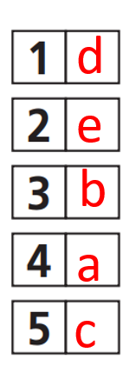  - Listen to the teacher’s instructions.  - Finish the task individually.  - Compare the answers with a partner.  - Check the answers.  Answers:  - If Mark wants to learn karate, he should join a martial arts class.  - If they use the equipment in the fitness class, they must put it back.  - If you don’t revise for the test, you might get a bad grade.  - If Lisa wants to eat a balanced diet, she shouldn’t eat sweets every day.  If you don’t start exercising, you can’t lose any weight.  - Listen to the teacher’s instructions.  - Finish the task individually.  - Compare the answers with a partner.  - Check the answers.  Answers:  - If Tim has free time, he may take up a hobby.  - If Claire wants to feel less stressed, she should do yoga.  - If you join a sports club, you can make new friends.  - If Franklin plays in both matches, he might feel tired afterwards.  If you want an active lifestyle, you can’t surf the Internet for too long.
3. Production: 10 minutes
a. Objectives: To help students use Conditional Type 1 to talk about a healthy lifestyle.
b. Content: Task 3 (SB)
c. Expected outcomes: Students can use Conditional Type 1 to talk about a healthy lifestyle.
b. Content: Task 3
d. Organisation:
Teacher’s activities | Students’ activities
Task 3 Make sentences using modals in conditional type 1. You start a sentence with an if-clause and your partner completes the sentence with a main clause.  - Explain the task.  - Ask students to work with a partner to make conversations using Conditional Type 1.  - Ask some students to present their ideas. | - Listen to the teacher.  - Work with a partner to make conversations using Conditional Type 1.  - Speak in front of the class when invited.  Suggested Answers:  B: If you don’t manage your weight, …  A: … you might have health problems.  B: If you study every day, …  A: … you can do well in your exams.  B: If I miss the bus for school, …  A: … I must walk.  B: If you want to strengthen your body, …  A: … you should exercise more.  B: If you don’t stop eating junk food, …  A: … you can’t lose any weight.  B: If I finish my homework early, …  A: … I may watch TV.

C. Consolidation and homework assignment: 5 minutes
1. Consolidation: Modals in conditional type 1
If + Present Simple, must/can/may/might/should + infinitive without to
2. Homework assignment
- Review modals in conditional type 1.
- Prepare for Lesson 3f – Grammar – SB – Page 45.
4. REFLECTION
a. What I liked most about this lesson today:

……………………………………………………………………………
b. What I learned from this lesson today:

……………………………………………………………………………
c. What I should improve for this lesson next time:
**********************
UNIT 3: HEALTHY LIFESTYLE
Period 44: Lesson – Unit 3E Grammar (Page 45)

1. OBJECTIVES
1.1. Language knowledge & skills
Memmory and practice phrasal verbs
1.2. Competences
- improve students’ communication, collaboration, analytical, and critical thinking skills.
1.3. Attributes
- promotional students’ holistic development, physical health, mental well-being, academic success, social skills, and lifelong habits of healthy living.
2. TEACHING AIDS AND MATERIALS
- Teacher’s aids: Student’s Book and Teacher’s Book, Class CDs, projector / interactive whiteboard / TV (if any), IWB (Phần mềm tương tác trực quan), PowerPoint slides
- Students’ aids: Student’s Book, notebook
3. PROCEDURES
A. Warm-up: (5’)
a) Objective: to introduce the new lesson and set the scene for students to acquire the grammar points; get students' attention at the beginning of the class with enjoyable and short activities and engage them in the follow-up steps.
b) Content: Discuss questions with “ phrasal verbs ”
c) Expected outcomes: Students have general ideas about the grammar points of the new lesson.
d) Organisation of the activity:
Teacher’s activities | Students’ activities
- Work in pairs, ask and answer the questions below:  - When do you often get up every morning?  - How often do you work out at the gym?  - Ask Ss to work in pairs and discuss the questions | - Work in pairs and discuss the questions  Suggested Answer Keys:  - I often get up at 6 o’clock every morning.  - I never work out at the gym because I am very busy.
B. New lessons (35 minutes)
1. Presentation: 5 minutes
a. Objectives: to introduce the uses of phrasal verbs.
b. Content: Phrasal verbs
c. Expected outcomes: Students can learn the uses of phrasal verbs.
d. Organisation:
Teacher’s activities | Students’ activities
- Present the examples and ask the Ss:  - 1. Underline the phrasal verb in the sentence below  You should give up junk food to lose weight.  - What does a phrasal verb consist of?  - Is the meaning of a phrasal verb different from the meanings of its separate parts?  - Where is the object of the phrasal verb when it is a noun?  I looked up the word online. (I looked the word up online)  - Where is the object of the phrasal verb when it is a pronoun?  I looked it up online.  - Ask the whole class the questions above.  - Elicit the uses of these phrasal verbs. | - Listen and answer the teacher’s questions.  - Listen to the teacher and take notes.  Suggested answers: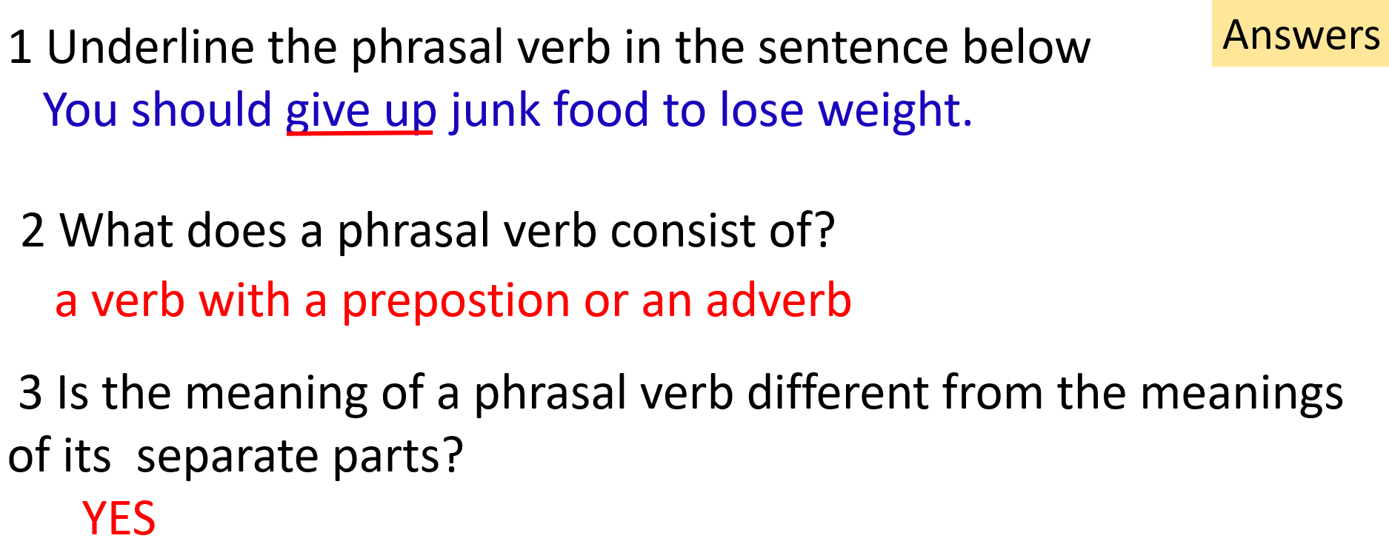  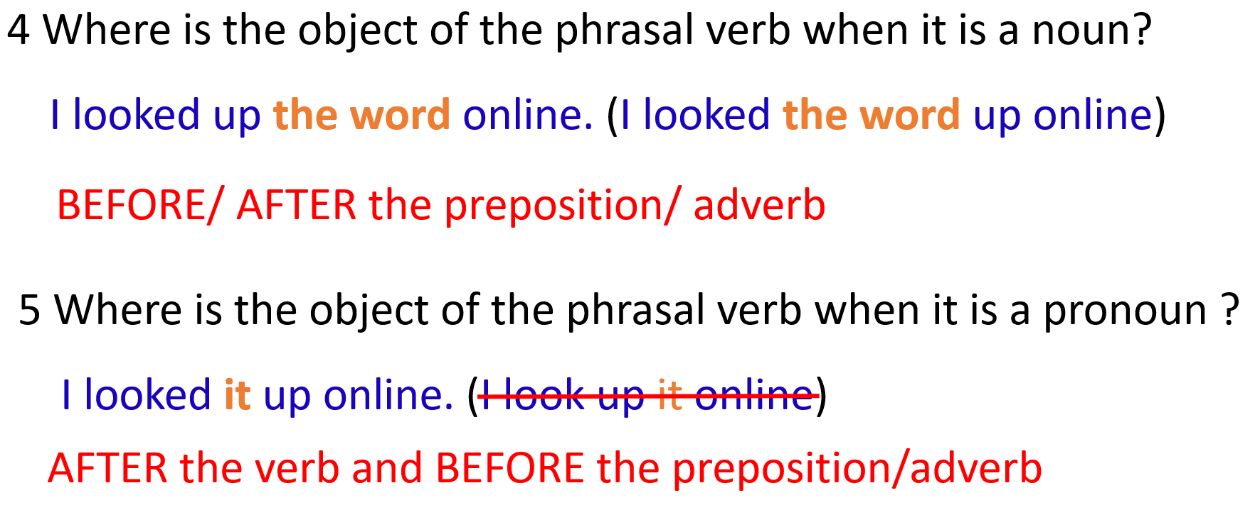

2. Practice: 20 minutes
a. Objectives: to help students understand the uses of phrasal verbs.
b. Content: Task 4,5 (SB), Task 3,4 (WB, p.28), Task 7 (WB, p.66)
c. Expected outcomes: Students can understand the uses of phrasal verbs.
d. Organisation:
Teacher’s activities | Students’ activities
Task 4 Choose the correct options.  - Give students time to read and complete the task.  - Elicit students’ answers.  - Check students’ answers.  Task 5: Correct one mistake in each sentence in your notebook.  - Explain the task.  - Set time for Ss to finish the task.  - Ask them to compare the answers with a partner.  - Check the answers.  Task 3: WB, p.28 Choose the correct options.  - Explain the task.  - Set time for Ss to finish the task.  - Ask them to compare the answers with a partner.  - Check the answers.  Task 4: WB, p.28 Correct ONE mistake in each sentence in your notebook.  - Explain the task.  - Set time for Ss to finish the task.  - Ask them to compare the answers with a partner.  - Check the answers.  Task 7: WB, p.66 Choose the correct options.  - Explain the task.  - Set time for Ss to finish the task.  - Ask them to compare the answers with a partner.  - Check the answers. | - Read the instructions and complete the task.  - Give their answers when invited.  - Check their answers.  Answer Keys  B 2. A 3. A 4. B 5. A 6. D 7. C 8. B  - Listen to the teacher’s instructions.  - Finish the task individually.  - Compare the answers with a partner.  - Check the answers.  Answers:  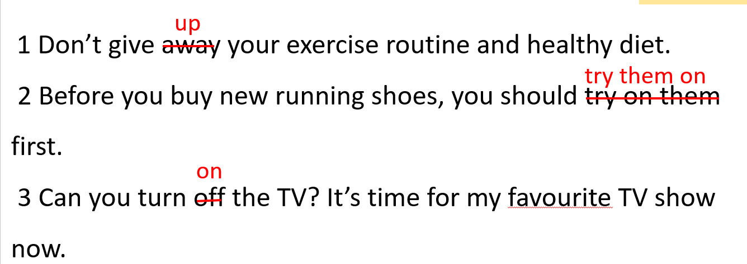  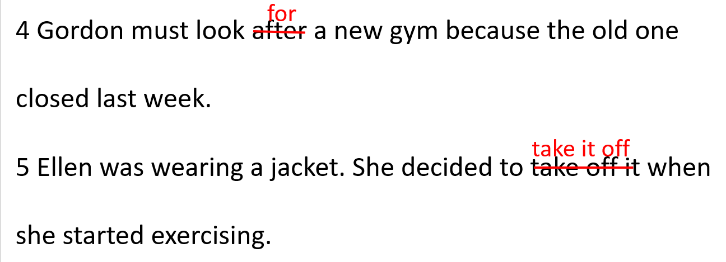  - Listen to the teacher’s instructions.  - Finish the task individually.  - Compare the answers with a partner.  - Check the answers.  Answers:  1.B 2. D 3. D 4. C 5. A 6. C 7. B 8. A  - Listen to the teacher’s instructions.  - Finish the task individually.  - Compare the answers with a partner.  - Check the answers.  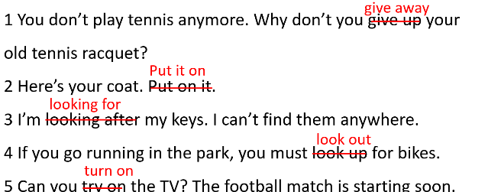  Answers:  - Listen to the teacher’s instructions.  - Finish the task individually.  - Compare the answers with a partner.  - Check the answers.  Answers:  A 2. B 3. C 4. D 5. A 6. C 7. A 8. A 9. D 10. C
3. Production: 10 minutes
a. Objectives: To help students use phrasal verbs to make sentences.
b. Content: Task 6
c. Expected outcomes: Students can use phrasal verbs to make sentences.
d. Organisation:
Teacher’s activities | Students’ activities
Task 6: Play in two teams. One team says a phrasal verb and the other team makes a sentence with it. The team with the most correct sentences will win.  - Explain the task.  - Ask students to work in 2 teams to make sentences using phrasal verbs.  Example:  Team A: work out  Team B: Jack works out at the gym three times a week. | - Listen to the teacher.  - Work in 2 teams to make sentences using phrasal verbs.  Suggested answers:  A: take up  B: I may take up a new sport this year.  A: look out  B: Look out! The baseball is going to hit you!  A: look for  B: You should look for new healthy recipes to add to your weekly diet plan.  A: look after  B: We need to look after our bodies, so we can stay healthy.  A: turn off  B: You must turn off the lights before you leave the gym.

C. Consolidation and homework assignment: 5 minutes
1. Consolidation: Task 8: WB, p.66: Fill in the gaps with up (x4), out (x2), after, on.

Start the day off right! (By Toby Keenan)
I know how important it is to look 1) ___________ my body. Exercising is really important to me. Every day, I get 2) ________ at 5:30 a.m., drink a glass of warm water and brush my teeth. Then, I put 3) ________ my T-shirt, shorts and running shoes and pick 4) ________ my friend Jenny from her house.
We took 5) ________ running about six months ago. We run from Jenny’s house to the park. It’s about 3 kilometres. Then, we work 6) ________ at the park. Sometimes we’re tired and it’s hard to carry 7) ________ the exercises, but we never give 8) ________ . We have one rule: it’s fine to slow down when things get tough, but we must never stop.

Answers:

1. after 2. up 3. on 4. up 5. up 6. out 7. out 8. up

2. Homework assignment
- Review phrasal verbs.
- Prepare for Lesson 3f – Reading – SB – Page 46.
4. REFLECTION
a. What I liked most about this lesson today:

……………………………………………………………………………
b. What I learned from this lesson today:

……………………………………………………………………………
c. What I should improve for this lesson next time:

…………………………………………………………………………………………
************************
UNIT 3: HEALTHY LIFESTYLE
Period 45: Lesson – Unit 3F Reading (Page 46)

1. OBJECTIVES
1.1. Language knowledge & skills
- identifiable the purpose of a text.
- reading for gist.
- description a typical meal in the UK.
1.2. Competences
- improve students’ communication, collaboration, analytical, and critical thinking skills.
1.3. Attributes
- promote students’ holistic development, physical health, mental well-being, academic success, social skills, and lifelong habits of healthy living.
2. TEACHING AIDS AND MATERIALS
- Teacher’s aids: Student’s Book and Teacher’s Book, Class CDs, projector / interactive whiteboard / TV (if any), IWB (Phần mềm tương tác trực quan), PowerPoint slides
- Students’ aids: Student’s Book, notebook
3. PROCEDURES
A. Warm-up: (5’)
a) Objective: to introduce the new lesson and set the scene for students to acquire the new language knowledge and skills; get students' attention at the beginning of the class with enjoyable and short activities and engage them in the follow-up steps.
b) Content: Discuss questions about balanced diets and healthy food.
c) Expected outcomes: Students have general ideas about the topic of the new lesson.
d) Organisation of the activity:
Teacher’s activities | Students’ activities
- Ask students to ask and answer the questions in pairs.  - Ask some students to share their ideas.  Questions:  - What common foods are considered part of a healthy diet?  - What is the main source of energy in our diet?  - Why is it important to include fruits and vegetables in your daily meals?  - Name two benefits of drinking enough water every day. | - Ask and answer the questions in pairs.  - Share the ideas when asked.  Suggested Answers:  - What common foods are considered part of a healthy diet?  Common healthy foods include fruits, vegetables, whole grains, lean proteins, and low-fat dairy products.  - What is the main source of energy in our diet?  Carbohydrates are the main source of energy in our diet.  - Why is it important to include fruits and vegetables in your daily meals?  Fruits and vegetables are important because they provide essential vitamins, minerals, and fibre, which support overall health and help prevent diseases.  - Name two benefits of drinking enough water every day.  Drinking enough water helps maintain vital bodily functions, such as digestion and temperature regulation.

B. New lessons (35 minutes)
1. . Pre-reading: 5 minutes
a. Objectives: to introduce the topic and help students learn new words/phrases in the text.
b. Content: Working out the meaning of some new words.
c. Expected outcomes: Students can learn new words/phrases about healthy food.
d. Organisation:
Teacher’s activities | Students’ activities
1. Pre-teaching vocabulary  - Teach students new words/phrases  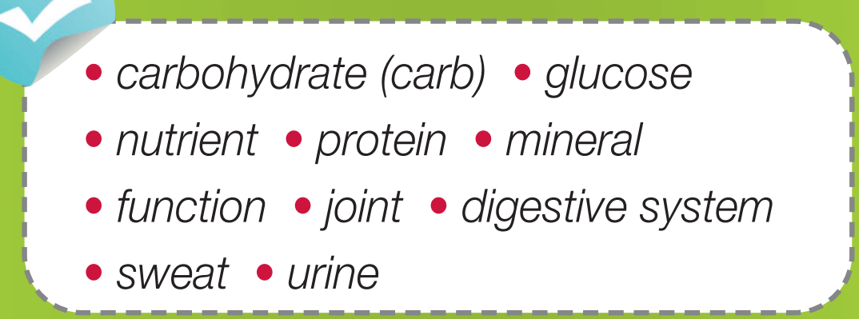  - Ask students to read the text and underline the words above.  - Get students to try guessing their meanings in the context first.  - Explain the meanings of the words.  - Ask students to listen and repeat chorally and individually.  - Check if students remember the words.  Vocabulary:  - Carbohydrate (carb) /ˌkɑː.bəʊˈhaɪ.dreɪt / (n): chất bột đường  - Carb /kɑːb/ (n): chất bột đường  - Glucose / ˈɡluː.kəʊs / (n): đường đơn  - Nutrient / ˈnjuː.tri.ənt / (n): chất dinh dưỡng  - Protein / ˈprəʊ.tiːn / (n): chất đạm  - Mineral /ˈmɪn.ər.əl / (n): chất khoáng  - Function/ ˈfʌŋk.ʃən / (n) chức năng  - Joint / dʒɔɪnt / (n): khớp (xương)  - Digestive system / daɪˈdʒes.tɪv ˌsɪs.təm / (n.phr): hệ tiêu hoá  - Sweat / swet / (n) mồ hôi  - Urine / ˈjʊə.rɪn / (n) nước tiểu | - Listen to the teacher and take notes.  - Read the text and underline the words.  - Try guessing their meanings in the context.  - Listen to the teacher and take notes on the meanings of those words.  - Listen and repeat chorally and individually.  - Answer the teacher

2. While – reading: 20 minutes
a. Objectives: to help students identify the text's purpose and read for the gist.
b. Content: Task 1,2,3 (SB), and Task 1,2 (WB, p.29)
c. Expected outcomes: Students can identify the text's purpose and read for the gist.
d. Organisation:
Teacher’s activities | Students’ activities
Task 1: Read the text quickly. Is the text about making an announcement? giving advice? advertising something?  - Ask students to scan the text and answer the question.  - Ask them to check the answers with a partner.  - Check the answers.  Task 2: Read the text again. Which of the sentences (A–D) best fits each gap (1–4)? Listen and check.  - Give students some time to finish the task individually.  - Ask Ss to check the answers with a partner.  - Ask Ss to listen to the audio and check the answers.  - For example, vitamin A is good for eyesight and calcium and strengthens our bones.  - It is also important for our joints and digestive system.  - The glucose we don’t use turns into fat.  - Another important nutrient is protein  Task 3: Read the text again and decide if the statements (1–5) are R (right), W (wrong) or DS (doesn’t say).  - Ask Ss to work alone and complete the task.  - Ask Ss to check the answers with a partner and show evidence.  - Check the answers with the whole class.  - The main source of energy for the body is glucose.  - Eating too many carbs can lead to weight problems.  - Protein is important for athletes only.  - Our bodies can store more vitamins than minerals.  - We lose water through breathing.  Extra Practice: WB – page 29  Task 1 ★ Read the text and complete the gaps (1–5) with the words from the list.  • fit • exercising • energy • improve • make  - Give Ss some time to complete the task individually, then ask them to check the answers with a partner.  - Check answers with the whole class.  Do you know why sports and exercise are good for us?  Firstly, sports and exercise can 1) ______________ your looks and your mood. That is because working out is a great way to maintain a healthy weight and when you look good, you will feel good. 2) ________________ for 30 minutes each day also helps you reduce stress. This is because your brain releases feel-good chemicals when you work out.  Therefore, if you’re unhappy, getting some fresh air by taking a stroll or riding your bike will make you feel better. Also, joining a sports team is an excellent way to build relationships and 3) ______________ new friends.  Secondly, there are other health benefits for our bodies besides getting 4) ________________. Our bodies can become stronger through sports and exercise, which boosts 5) ______________ levels. Also, physical activities can lower the chance of cancer and heart disease because they control our weight and strengthen our bodies. Regular physical activities can help you have a deep sleep, too. Just don’t exercise too close to bedtime, or you may have too much energy to go to sleep.  Task 2 ★★★ Read the text again. Decide if the sentences (1–5) are R (right), W (wrong) or DS (doesn’t say).  - Maintaining a healthy weight helps you feel good.  - When you work out, your brain releases chemicals that make you feel good.  - Joining a sports team can reduce stress.  - You can’t get cancer and heart diseases if you exercise.  - If you exercise close to bedtime, you may sleep better.  - Give Ss some time to complete the task individually, then ask them to check the answers with a partner.  - Check answers with the whole class. | - Work alone and complete the task.  - Check the answers with a partner.  - Check the answers.  Answers:  The text is about giving advice.  CLUE:  - We can find carbs in rice, bread, pasta and potatoes, but we shouldn’t eat too many.  - Our bodies cannot store some vitamins and minerals, so we need to eat foods with them daily.  - Finish the task individually.  - Check the answers with a partner.  - Listen to the audio and check the answers.  Answers:  - C - The glucose we don’t use turns into fat.  - D - Another important nutrient is protein.  - A - For example, vitamin A is good for eyesight and calcium, and strengthens our bones.  - B - It is also important for our joints and digestive system.  - Work alone and complete the task.  - Check the answers with a partner and show evidence.  - Give answers when asked.  Answers:  1. R: CLUE: Our bodies turn carbohydrates into glucose, a type of sugar and the body’s main source of energy.  2. R: CLUE: We can find carbs in rice, bread, pasta, and potatoes, but we shouldn’t eat too many. This can lead to weight problems.  3. W: CLUE: Our bodies use protein to build and repair bones and muscles, so it is especially important for growing children and athletes.  4. DS  5. R: CLUE: We lose water through sweat, urine and even breathing, so it is important to drink water throughout the day.  - Complete the task individually and check the answers with a partner.  - Check the answers with the teacher.  Answers:  - improve  - Exercising  - make  - fit  - energy  - Complete the task individually and check the answers with a partner.  - Check the answers with the teacher.  Answers:  1. R: CLUE: That is because working out is a great way to maintain a healthy weight and when you look good, you will feel good.  2. R: CLUE: This is because your brain releases feel-good chemicals when you work out.  3. DS  4. W: CLUE: Also, physical activities can lower the chance of cancer and heart disease because they control our weight and strengthen our bodies.  5. W: CLUE: Just don’t exercise too close to bedtime, or you may have too much energy to go to sleep.
3. Post-reading: 10 minutes
a. Objectives: To help students expand the topic, use the language and information in the text, and develop critical thinking.
b. Content: Task 4,5 (SB)
c. Expected outcomes: Students can use the learned vocabulary to talk about healthy diets and food.
Teacher’s activities | Students’ activities
Task 4: What do you learn from the text? Tell the class. Look at the example below:  - Explain the task by showing the example.  - Ask students to share their ideas with their partner.  - Ask some students to present their ideas.  Task 5: Work in pairs, ask and answer the question below:  What is a typical meal in the UK?  - Ask Ss to ask and answer the question in pairs.  - Then, ask some Ss to share their ideas with the class. | - Listen to the teacher.  - Share the answers with a partner.  - Speak in front of the class when invited.  Suggested Answers:  1. I learned that we can find carbs in rice, bread, pasta, and potatoes, but we shouldn’t eat too many. This can lead to weight problems.  2. I learned that our bodies use protein to build and repair bones and muscles.  3. I learned that our bodies cannot store some vitamins and minerals, so we need to eat foods with them daily.  4. I learned that we lose water through sweat, urine and even breathing, so it is important to drink water throughout the day.  - Work in pairs and brainstorm some ideas about the question.  - Share the answers when asked.  Suggested answers:  1. Fish and Chips - A classic British meal.  2. Full English Breakfast: includes a variety of items such as eggs, bacon, sausages, baked beans, grilled tomatoes, mushrooms, and served with toast or fried bread.  3. Roast Beef with Pudding: roasted beef slices served with a savoury baked pudding. This meal typically includes roasted potatoes and a selection of vegetables.

C. Consolidation and homework assignment: 5 minutes
1. Consolidation: In pairs, take turns to say these words out loud
Carbohydrate (carb) /ˌkɑː.bəʊˈhaɪ.dreɪt / (n): chất bột đường
Carb /kɑːb/ (n): chất bột đường
Glucose / ˈɡluː.kəʊs / (n): đường đơn
Nutrient / ˈnjuː.tri.ənt / (n): chất dinh dưỡng
Protein / ˈprəʊ.tiːn / (n): chất đạm
Mineral /ˈmɪn.ər.əl / (n): chất khoáng
Function/ ˈfʌŋk.ʃən / (n) chức năng
Joint / dʒɔɪnt / (n): khớp (xương)
Digestive system / daɪˈdʒes.tɪv ˌsɪs.təm / (n.phr): hệ tiêu hoá
Sweat / swet / (n) mồ hôi
Urine / ˈjʊə.rɪn / (n) nước tiểu
2. Homework assignment
- Learn by heart the words in the consolidation and make sentences using them.
- Prepare for the next lesson (Skills – Vocabulary & Listening – page 47 – SB).
4. . REFLECTION
a. What I liked most about this lesson today:

……………………………………………………………………………
b. What I learned from this lesson today:

……………………………………………………………………………
c. What I should improve for this lesson next time:

……………………………………………………………………………

