Unit 19: THE ANIMAL WORLD
Period 126: Lesson 2 (1, 2, 3)
I. Objectives: By the end of the lesson, Ss will be able to:
1. Knowledge:
- Vocabulary: dance beautifully, roar loudly, run quickly and sing merrily
- Model sentence: Why do you like ….? – Because they ……...
2. Competences:
- Specific competence:
+ Listening: Listen to and understand two communicative contexts (pictures) focusing on asking and answering questions about animals.
+ Speaking: Ask and answer questions about animals.
- General competence: teamwork, communication and interactive skill.
3. Qualities/ Attribute
- develop good personalities such as honesty and friendliness, carefulness, patience
- Studious and obedient students and love their hometown, family and friends.
- Educate Ss how to keep healthy.
II. Teaching aids / Materials
- Teacher’s: books, pictures, flashcards, website họclieu.vn, posters, laptop.
- Students’: books, notebooks, crayons, pens, boards
III. Method:
- Communicative Language Teaching approach
- Total Physical Response
- Natural Approach
- 3Ps
IV. Procedure/ Teaching Activities:
1. Organization: + Greeting.
2. Checking up
- During the lesson
3. New lesson.
Activities | Content
1. Warm- up: (3’)  Game: “ Whose tail is this?”  * Aims: to create a friendly and active atmosphere in the class to beginning the lesson.  * Procedure:  - Put Ss into pairs.  - Give Ss the dice. Ss in pairs answer the questions. For each correct answer pupil can roll the dice.  - The student (in each pair) who has the most points is the winner.  - Say “Open your book page 60” and look at “Unit 19, Lesson 2 (1,2,3)”.  2. New lesson:  2.1. Activity 1: (10’)  * Aims: Ss will be able to understand and correctly repeat the sentences in two communicative contexts focusing on asking for and giving reasons for liking animals  * Procedure:  - Have Ss look at the pictures and identify the characters and the animals.  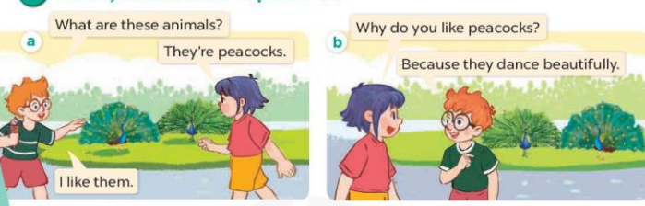  - Play the audio twice (sentence by sentence). Correct their pronunciation where necessary.  - Have Ss to practice the diaguage  - T invites a few pairs to the front of the class to practice.  - T checks pronunciation for ss.  2.2. Activity 2: (15’)  * Aims: Ss will be able to correctly say the phrases and use Why do you like ……? – Because they ……. to ask for and give reasons for liking animals  * Procedure:  - T Introduce and explain the newwords.  - T guide Ss to read and ask Ss read aloud  - T ask all the class copy the notebook.  * Model sentences:  - T asks Ss look at picture b and helps Ss know the structure from the dialogue.  - T introduces new structure for Ss.  - T explains, models and gives meaning.  - Have Ss repeat the model sentences  * Drill pictures  - Have Ss look at the pictures and elicit the names of the animals and what they are doing.  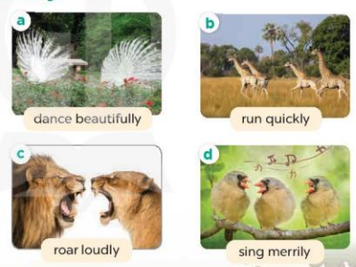  - Run through all the pictures.  - Run through model sentences.  +Run through the question sentences  +Run through the answer sentences  - Have Ss to practise:  + T asks, Ss answer picture a  + Ss ask, T answers picture b  + Group A ask, group B answer picture c  + Group B ask, group A answer picture d  - Ask Ss to work in pairs.  - T controls and corrects.  - Invite a few pairs to come to the front of the classroom, point at the pictures and say in front of the class.  - T gives feedbacks.  2.3. Activity 3: (8’)  * Aims: Ss will be able to enhance the correct use of Why do you like ……? – Because they …. to ask for and give reasons for liking animals in a freer context.  * Procedure:  - Have Ss look at the picture and elicit the names of the animals and reasons for liking them.  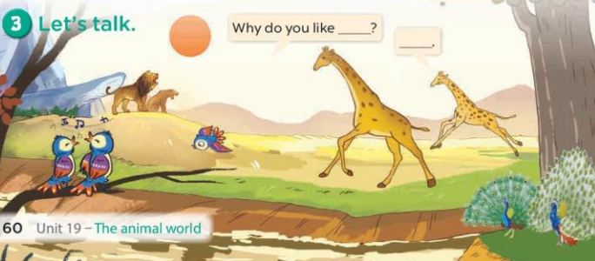  - Ask Ss work in pairs to ask and answer questions about Why do you like…….?  - Invite some pairs to role play in front of the class to point at the activity in the picture cue in their books.  * Consolidation  * Aims: Ss will be able consolidate and wrap up the content of the lesson.  * Procedure:  - T asks ss to answer the following questions:  + What have you learnt from the lesson today?  - T praises some Ss who are hardworking / active/ good…. as well as encourage others to try more.  3. Homework. (2’)  - Learn the vocabulary and model sentences by heart  - Prepare the new lesson: Unit 19, Lesson 2 (4,5,6). | 1/ Look, listen and repeat.  + In picture a:  Ben: What are these animals?  Linh: They’re peacocks.  Ben: I like them.  – In picture b:  Linh: Why do you like peacocks?  Ben: Because they dance beautifully.  2/ Listen, point and say.  */ New words:  + dance beautifully: nhảy thật đẹp (example)  + run quikly: chạy thật nhanh (mime)  + roar loudly : gầm thật to (situation)  + sing merrily : hát thật hay (translation)  */ Structure:  - Ask for and give reasons for liking animals (Hỏi và đưa ra lý do thích động vật)  Eg: Why do you like peacocks?  Because they dance beautifully.  */ Practice:  +Picture a: Two peacocks dancing  +Picture b: Four giraffes running  +Picture c: Two lions roaring  +Picture d: Three birds singing  3/ Let’s talk.  */ Practice:  + a view of wild animals: two peacocks, two giraffes, three birds and two lions.

