Date of preparation: 12/10 /2024
Date of teaching: 8A1: /10 / 2024
8A2: /10/ 2024
8A3: /10 / 2024

UNIT 2: LIFE IN THE COUNTRYSIDE
PERIOD 14: Looking back and Project

I. OBJECTIVES: By the end of the lesson, students will be able to:

1. Knowledge:
- Review the vocabulary and grammar of Unit 2 (Activity 1)
- Apply what they have learnt (vocabulary and grammar) into practice through a project
(Activity 2)

2. Competences:
- Use vocabulary related to life in the countryside to do Ex1 and Ex2 (Activity 1)
- Use the knowledge of the forms and uses of the comparative of adverbs to do Ex 3 and Ex4 (Activity 2)
- Apply what they have learnt about vocabulary and grammar of Unit 2 into practice through a project about life in the countryside to do Ex1 and Ex2 (Activity 3)
- Use the knowledge of the forms. (Project - if the time is available) (Activity 4)
*. Use the knowledge about vocabulary and grammar learnt of Unit 2 to talk about about the village or town where someone lives
3. Attitude:
- Love talking about activities in the countryside, love your hometown, country.
II. TEACHING AIDS
Ss’ books, text books, projector/ TV, computer, wifi, soft documentary, hoclieu.vn
III. PROCEDURE:

Teacher’s and Ss’ activities | Contents
1. Organization  8A1: …… 8A2: ………8A3: ……  2. Check old lesson/ Warm up. (3’)  - To create an active atmosphere in the class before the lesson.  - To lead into the revision.  - Revision.  - Ss can tell the teacher what they have learnt in unit 2.  3. New lesson:  * Activity 1: Vocabulary (10 mins)  a. Write a phrase from the box under the correct picture. (5 mins)  - Have Ss do Task 1 individually then compare their answers with their partners. Ask for Ss’ answers or ask some Ss to read out their answers in front of the class.  - Confirm the correct answers.  b. Choose the correct answer A, B, or C. (5 mins)  - Have Ss do Task 2 individually then compare their answers with their partners. Ask for Ss’ answers or ask some Ss to read out their answers in front of the class.  - Confirm the correct answers.  *Activity 2: Grammar (10 mins)  - To help Ss revise the forms and uses of comparative adverbs.  c. Task 3: Complete the sentences with the comparative forms of the adverbs in brackets. (6 mins)  - Ask Ss to do the exercise individually. Then they can check their answers with a partner before discussing the answers as a class.  - Teacher confirms the correct answers.  - Remind Ss to keep a record of their original answers so that they can use that information in the Now I can … section  d. Task 4: Underline the mistakes in the sentences and correct them. (6 mins)  - Have Ss do this activity individually then compare their answers with their partners.  - Ask for Ss’ answers or ask one student to write his / her answer on the board.  - Teacher confirms the correct answers.  - Remind Ss to keep a record of their original answers so that they can use that information in the Now I can … section.  * Activity 3: Project (8 mins)  - To help Ss practise making their own poster about their favourite village and present their work.  - To help Ss develop the skill of working in groups to do a project.  - Ask Ss to read the instructions again (T has already assigned the project since the first lesson of the Unit and checked their progress after each lesson). Let students have some time to check their posters for the final time and make any adjustments if necessary.  - T has groups show their posters and present them to the class. Remember to have the “show and tell” session and vote for the best poster.  - Students vote for the best poster.  - Teacher gives feedback.  4. Feedback (1’):  - Ss repeat the main points in the lesson.  5. Homework (2’):  - Give out homework and guide ss to prepare for the new lesson.  - Remind Ss to follow the traffic rules. | Questions:  - What have we learnt in Unit 2?  Suggested answers:  - words about life in the countryside  - the sounds /ə/ and /ɪ/ in words and sentences  - comparative forms of adverbs  - giving and responding to compliments  - reading about different aspects of a Vietnamese village  - talking about the village or town where someone lives  - listening to someone’s opinion about life in the countryside  - writing a paragraph about what someone likes or dislikes about life in the countryside  I. Vocabulary  Ex1. Answer key:  1. ploughing fields  2. catching fish  3. drying rice  4. unloading rice  5. feeding pigs  6. milking cows  Ex2. Answer key:  1. B  2. C  3. A  4. C  5. A  II. Grammar:  Ex3. Answer key:  1. earlier  2. more fluently  3. more easily  4. more heavily  5. harder / better  Ex4. Answer key:  1. as → than  2. quicklier → more quickly  3. more hardly → harder  4. the earlier → earlier  5. more highly → higher  III. Project  Suggested outcome:  Students’ posters & presentations  Homework  - Review all the grammar and vocabulary in the lesson  - Prepare: Unit 3 (Getting started)  + Listen and repeat the dialogue, look up the new words.  + Use pencils to do exercises given in the textbook.

Date of preparation: 12 /10 /2024
Date of teaching: 8A1: /10 / 2024
8A2: /10/ 2024
8A3: /10 / 2024

UNIT 3: TEENAGERS
PERIOD 15: GETTING STARTED

I. OBJECTIVES: By the end of the lesson, students will be able to:
1. Knowledge:
- Memorize the words related to the topic “teenager” and understand the context for introductory text. (Activity 1)
2. Competences:
- Gain an overview and vocabulary to talk about the topic teenagers (Activity 1)
- Use the knowledge learnt to do the Ex2,3,4. (Activity 2)
* Use the words/phrases learned to talk something about types of social media, kinds of pressure and clubs ss participate in.( Activity 2)
3. Attitude:
Be positive toward the teacher’s lesson.
Love talking about themselves and their problems
II. TEACHING AIDS
Ss’ books, text books, projector, computer, wifi, soft documentary
III. PROCEDURE:

Teacher’s and Ss’ activities | Contents
1. Organization (1’)  8A1: …… 8A2: ………8A3: ……  2. Warm up (4’)  Game: I.N.I.T.I.A.L GAME  - T divides the class into 2 teams.  - T shows 9 different pictures  - Students are shown different pictures and they need to take the first letter from each picture to form the mystery word.  - Which team finds the mystery word first will become the winner.  T leads to the new unit. Write the unit title Teenagers on the board. Ask Ss to guess what they are going to learn about in this unit.  3. New lesson  Activity 1 (10’)  - Have ss look at the picture and answer the questions.  + Who are the people?  + What might they be talking about?  - Encourage ss to give their answers  - Play the recording once  - Have ss underline the words that are related to the topic of the unit while they are listening and reading.  - Explain the new words. Guide ss to read new words.  * Have some good ss make sentences with the new words/ phrases.  Activity 2 (25’)  - Listen and read  - T gives a question: What pressure do chilren have?  - Ss answer  - Ask Ss to listen and read and then answer  - Teacher plays the recording again  - Have ss read the dialogue in pairs. Then call on 2 pairs of ss to read the conversation aloud.  - T checks Ss’ prediction  - Ss give the correct answer  - T elicits  2. Read the conversation again and tick (ν) T (True) or F (False).  -Ask Ss to work in pairs to read the conversation again.  - Ask them to underline the key words and phrases in the statements. Then have pairs work together for one or two minutes to do the task  - Have Ss read out the statements and say if the statements are true or false.  - Make sure they pronounce the words correctly.  - Teacher checks the answers as a class and gives feedback.  3. Write a word or phrase from the box under the correct picture  - Ask Ss to work in pairs to match the pictures with the words or phrases.  - Ask Ss to say the words / phrases aloud. Make sure they pronounce the words and phrases correctly.  - Teacher checks the answers as a class and gives feedback.  4. Complete each of the sentences with a word or phrase in 3. There is one extra word or phrase.  - Ask Ss to work independently to complete each sentence with a word or phrase in 3.  - Allow Ss to refer to the pictures, the words and phrases in 3, and the conversation if needed.  - Check the answers as a class.  Ask several Ss to read aloud the full sentences. Correct Ss’ pronunciation if needed.  5. Ask and answer the questions below. Report your friend’s answers to the class  - Ask Ss to work in pairs to ask and answer questions.  - Encourage Ss to provide their partners with as much information as possible, using vocabulary they have learnt when they answer the questions.  Ask some Ss to report information about their partners  4. Feedback (2’):  - Ss retell the main content of the lesson.  5. Homework:(3’)  - Give out homework and guide ss to prepare for the new lesson. | 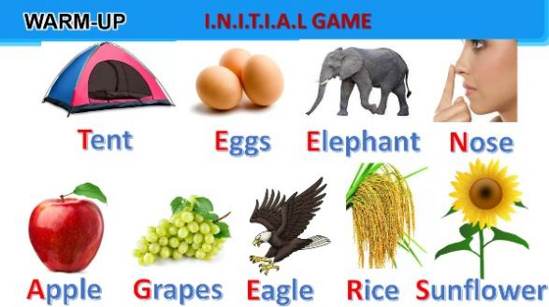  Mystery word: TEENAGERS  I. New words.  - forum (n)  - Stress (n)  - stressful (adj)  - presure (n)  - user-friendly (n)  - mid-term (n)  II. Practice  Ex1. Listen and read  Ex2. Read the conversation again and tick (ν) T (True) or F (False).  Answer key:  - F  - T  - T  - F  - T  Ex3. Write a word or phrase from the box under the correct picture  Answer key:  - language club  - pressure  - arts and crafts club  - forum  - sports club  - chess club  Ex4. Complete each of the sentences with a word or phrase in 3. There is one extra word or phrase.  Answer key:  - arts and crafts club  - forum  - language club  - pressure  sports club  Ex5. Ask and answer the questions below. Report your friend’s answers to the class  Questions:  - What types of social media do you have?  - What kind of pressure do you have?  - What clubs do you participate in?  Why did you choose to participate in that club?  * Homework:  - Learn by heart the new words  - Name a list of school clubs and pressures.  Practise reading the conversation again. Do the tasks again  - Prepare: A closer look 1:  + Look up the new words.  + Use pencil to do exercises given.

Date of preparation: 12 /10 /2024
Date of teaching: 8A1: /10 / 2024
8A2: /10/ 2024
8A3: /10 / 2024
UNIT 3: TEENAGERS
Period 16: A closer look 1

I. OBJECTIVES
By the end of this lesson, Ss will be able to:
1. Knowledge
- Identify the combination of some verbs and verb phrases that are often used when teens talk about using social media. ( Activity 1)
- Distinguish two sounds /ʊə/ and /ɔɪ/ correctly. ( Activity 2)
2. Competences
- Circle the correct options to complete the phrases to do Ex1, (Activity 1)
- Use the correct form of the verbs in 1 to complete the sentences in Ex2
- Choose the correct answer A, B, or C in Ex3
- Correctly pronounce words that contain the sounds sounds /ʊə/ and /ɔɪ/ to do ex 4,5 (Activity 2)
*. Use the expressions learnt to talk about talk about using social media. ( Activity 1)
3. Attitude:
Be positive toward the teacher’s lesson.
Respect for teachers and classmates.
II. TEACHING AIDS
Ss’ books, text books, projector, computer, wifi, soft documentary
III. PROCEDURE:
Teacher’s and Ss’ activities | Contents
1. Organization (1’)  2. Warm up (4’)  Game: Word puzzles  - Give Ss a few minutes to play a game. Have Ss play in two groups.  - Ask ss to find 6 meaningful words in the puzzles  - The team with the more correct answers wins.  - T leads in the new lesson.  - T checks Ss’ vocabulary and gives feedback.  3. New lesson  Activity 1: Vocabulary  Ex 1: Circle the correct options to complete the phrases ( 5’)  - Have Ss read aloud the verbs and the word / phrases given.  - Ask Ss to work in pairs to circle the correct options to complete the phrases.  - Explain the meaning of the new verb phrases by using pictures or synonyms or even their mother tongue  - Invite Ss to take turns to read out their answers. Correct their pronunciation if needed.  - Check the answers as a class.  - T can also ask Ss to add more words / phrases to the verbs to make other phrases. This way, T can broaden Ss’ vocabulary if they are ready.  Ex 2: Use the correct form of the verbs in 1 to complete the sentences. ( 5’)  - Ask Ss to work individually to complete each of the sentences with a suitable verb from 1.  - Check the answers as a class.  - Have some Ss read aloud the complete sentences.  - Correct Ss’ pronunciation if necessary.  EX 3: Choose the correct answer A, B, or C. ( 5’)  - T asks Ss to work individually to choose the correct answer for each sentence.  - Ss swap their answers with their partners.  - T check the answers as a class.  - T can also ask some Ss to read out their answers. Then have Ss read the sentences aloud as a class. Correct Ss’ pronunciation if necessary.  - Teacher checks students’ answers and gives feedback.  Activity 2. Pronunciation  Ex4: Listen and repeat the words. Pay attention to the sounds /ʊə/ and /ɔɪ/. Then put the words into the correct columns. (6’)  - Have Ss listen to the recording once first. Then ask Ss to read out the words.  - Play the recording for them to listen again and repeat each word as a class, then as individuals.  - Play the recording as many times as possible.  - Have Ss complete the task. Check answers as a class.  Ex 5: Listen and practise the sentences. Underline the words with /ʊə/ and circle the words with /ɔɪ/. (9’)  - Have some Ss read the sentences first.  - Play the recording for Ss to listen to, then repeat each sentence after the recording.  - Play the recording as many times as necessary.  - Ask them to underline the words with the sound /ʊə/ and circle the words with the sound /ɔɪ/.  - Check the answers as a class.  - Call some Ss to read the sentences individually.  4. Feedback (7’):  - Ss repeat the main points in the lesson.  - Have Ss use the phrases they have learnt to talk about their using social media  5. Homework:(3’)  - Give out homework and guide ss to prepare for the new lesson.  - Remind Ss to follow the traffic rules. | 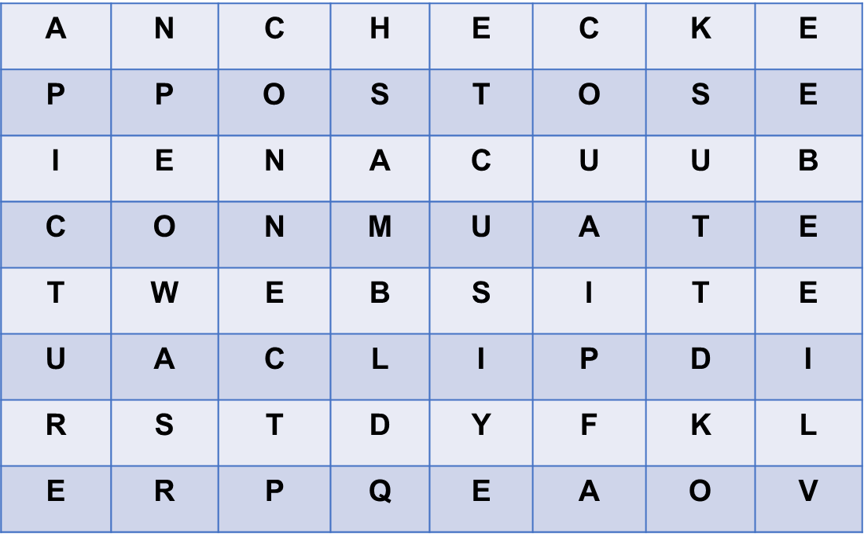  I. Vocabulary  Ex 1: Circle the correct options to complete the phrases  New words:  1. upload (v) = to copy or move programs or information to a larger computer system or to the internet  2. browse (v) = to look at things / check over sth  3. notifications (n)  4. log on (to) (v)  5. check (v)  6. account (n)  Answer key:  1. A  2. A  3. B  4. B  5. B  Ex 2: Use the correct form of the verbs in 1 to complete the sentences  Answer key:  1. browsed  2. uploaded  3. connects  4. checked  5. logs on  Ex 3: Choose the correct answer A, B, or C.  Answer key:  1. B  2. C  3. A  4. A  5. B  II. Pronunciation  Ex 4. 4: Listen and repeat the words. Pay attention to the sounds /ʊə/ and /ɔɪ/. Then put the words into the correct columns.  Answer key:  /ʊə/: tourist, ensure, sure, tournament  /ɔɪ/: boy, toy, avoid, choice  Ex 5: Listen and practise the sentences. Underline the words with /ʊə/ and circle the words with /ɔɪ/.  Answer key:  1. She is a noisy and curious girl.  2. They joined a full-day city tour.  3. I found it enjoyable to watch the tournament.  4. She’ll record our voices during the interview.  5. He is not acting very mature and is starting to annoy me.  * Homework  - Learn by heart new words, phrase verbs, do Ex2,3 again.  - Practice reading the two sounds: /ʊə/ and /ɔɪ/.  - Pprepare: A closer look 2:  + Look up new words  + Review the simple sentences and compound sentences  + Use pencils to do exercises given in the textbook.

Date of preparation: 12 /10 /2024
Date of teaching: 8A1: /10 / 2024
8A2: /10/ 2024
8A3: /10 / 2024
UNIT 3: TEENAGERS

PERIOD 17: A CLOSER LOOK 2

I. OBJECTIVES: By the end of the lesson, students will be able to:

1. Knowledge:
- Understand the usage of the simple sentences and compound sentences (Activity 1)

2. Competences:
- Use the simple sentences and compound sentences to make sentences. (Activity 1)
- Apply simple sentences and compound sentences to do exercises given. (Ex1,2,3,4,5) (Activity 2)
* Use simple sentences and compound sentences to talk about the activities of teenagers . (Activity 2)
3. Attitude:
- Be positive toward the teacher’s lesson.

- Respect for teachers and classmates.

II. TEACHING AIDS

Ss’ books, text books, projector, computer, wifi, soft documentary
III. PROCEDURE:

Teacher’s and Ss’ activities | Contents
1. Organization (1’)  2. Warm up: Game: Board race  - Give Ss a few minutes to revise the simple sentences.  - Ss work in two teams.  - Ss receive slips of paper with simple sentences or compound sentences.  - Pick out all the simple sentences and run as fast as possible to stick them on the board,  - Then underline the subjects and circle the verbs of those simple sentences.  - The team with the more correct answers will be the winner  + Ask each team to read out loud the sentences they have selected. Correct their pronunciation if necessary.  + The team with the most correct sentences wins.  - Ask Ss to look at A CLOSER LOOK 2 on page 31.  3. New lesson  * Activity 1 (10’)  Grammar: Simple sentences and compound sentences.  - T gives 2 sentences and asks ss to find their subject and verb.  - Ask them to check how many subjects and verbs are in each of the sentences.  - T guides Ss understand independent clause.  - Tell them to read the Remember! box in pairs before giving further explanation.  - Then T explains to ss what a simple sentence or a compound sentence is.  - Then ask Ss to underline the two independent clauses in Eg 2, circle the words in between the two independent clauses. Tell them that there are words other than and and but we use to connect two independent clauses in compound sentences.  - Ask Ss to read aloud as a class the words for, and, but, or, so, however, therefore, otherwise.  - Explain the meanings of these words if necessary. Tell Ss that they can also call these words connectors.  - Remind Ss to use a semicolon (;) before however, therefore, and otherwise, and the other connectors are followed by a comma (,)  * Activity 2 (25’)  Ex1  - Ask Ss to work individually to tick the simple sentences.  - Ask Ss to take turns to give their answers.  - Check the answers as a class.  - Then T asks some Ss to underline the subjects and circle the verbs of simple sentences.  - Ask several Ss to read aloud the full sentences. Correct their pronunciation if necessary.  Ex2.  - Have Ss work in pairs to write S for simple sentences and C for compound sentences.  - Ask some Ss to read out the sentences and say S or C.  - Correct their pronunciation mistakes if necessary.  - Check the answers as a class.  Ex3.  - Have Ss work individually to choose the correct answer A, B, or C.  - Remind them of the meanings of the connectors and the punctuation (the comma and semicolon) for the connectors.  - Ask some Ss to read out the complete sentences.  - Check the answers as a class.  Ex4.  - Have Ss work in groups of four for five minutes to write on their posters complete compound sentences using the words in the box.  - Remind them to use commas and semicolons when necessary. Then ask them to swap answers with other groups.  - Check the answers as a class.  - Have the class read out the sentences. Correct their spelling and grammar mistakes when necessary.  * Use simple sentences and compound sentences to talk about the activities of teenagers . (Activity 2)  Ex5.  - Instruct Ss to play the game in groups.  - Have Ss work for two minutes to write compound sentences using given words on their strips of paper (the words on the slips of paper given to Ss can be for, and, but, or, so, however, therefore, otherwise). T may instruct Ss to write their compound sentences on A1-size paper.  - Invite groups to read out their compound sentences or to stick the A2-size paper with compound sentences they have written on the board.  - The group with the most correct sentences is the winner.  4. Feedback (2’):  - Ask Ss to summarise what they have learnt in the lesson.  - Have them say out loud the connectors (coordinating conjunctions and conjunctive adverbs) they learnt in the lesson.  - Have them talk about the meanings of the connectors and how to use commas and semicolons with connectors.  5. Homework:(3’)  - Give out homework and guide ss to prepare for the new lesson.  - Remind Ss to follow the traffic rules. | 1. Organization (1’)  8: ………………...  2.Warm up: Game: Board race  1. She is a noisy and curious girl.  2. They joined a full-day city tour.  3. I found it enjoyable to watch the tournament.  4. She’ll record our voices during the interview.  5. Minh has some problems with his schoolwork.  6. Mark is hard-working; therefore, he usually gets high scores on exams.  7. Mai bought many books, for she likes reading.  8. He is a club member, but he never  - Grammar  Eg1: Minh has some problems with his  S V  Schoolwork.  Eg2: Mark is hard-working; therefore,  S1 V1 connectors  he usually gets high scores on exams.  S2 V2  * A simple sentence is made up of one independent clause.  * A compound sentence is made up of two or more independent clauses  * Connectors  - coordinating conjunctions: for, and, but, or, so  - conjunctive adverbs: however, therefore, otherwise.  - Practice  Ex1  Answer key: 1, 2, 4  Ex2.  Answer key:  1. S  2. S  3. C  4. S  5. C  Ex3.  Answer key:  1. C  2. B  3. A  4. A  5. C  Ex4.  Answer key:  1. Phong has to study harder; otherwise, he may fail the exam.  2. She is very sensitive, so don’t comment on her new hairstyle. / She is very sensitive; therefore, don’t comment on her new hairstyle.  3. Mi wants to have more friends, but she doesn’t connect well with others.  4. Students can work in groups, or they can work in pairs.  5. My friend likes showing off her new things; therefore, she often posts pictures on social media. / My friend likes showing off her new things, so she often posts pictures on social media.  Ex5. Play the game  EX:  - He came first; therefore, he got a good seat.  - My father’s job is very difficult, but he enjoys going to work every day.  * Homework:  - Learn by heart the simple sentences and compound sentences.  - Prepare: Communication  + Look up the new words  + Use pencils to do exercises given in the textbook.

TCM KÍ DUYỆT

Vũ Thị Thành

