Teaching day: ..../...../2025 – class 5A1,5A2
....../....../2025 – class 5A3

Unit 16: Seasons and the weather
Lesson 2 (1, 2, 3)
A. OBJECTIVES: By the end of the lesson, Ss will be able to:
1. Knowledge:

- understand and correctly repeat the sentences in two communicative contexts related to the weather and clothing choices during a specific season

- correctly say the words blouse, trousers, jeans and jumper and use What do you usually wear in ____? - I wear _____. to ask and answer questions about what someone wears in different seasons

- use What do you usually wear in ___? - I wear _____. in a freer context.

- Vocabulary: blouse, trousers, jeans and jumper
- Structures:
A: What do you usually wear in winter?
B: I wear a jumper.
- Skills: speaking and listening
2. Competences:
- Critical thinking and creativity: learn how to ask and answer questions about what someone wears in different seasons correctly and fluently
- Self-control and independent learning: perform pronunciation and speaking tasks.
3. Attitude/ Qualities:
- Express their feelings about the weather of each season.
- Show their knowledge of choosing suitable clothes in different seasons.
B. TEACHING AIDS:
- Teacher: Teacher’s guide Pages 262, 263, 264, audio Tracks 56, 57; website hoclieu.vn, posters, laptop, pictures, textbook, lesson plan, TV or projector.
- Students: Students’ book Page 42, notebooks, workbooks, school things.
C. PROCEDURES:
Teacher’s activities and Students’ activities | Contents
Warm- up : (3’)  Game: Questions and answers  - Tell ss that they are going to look at the pictures and ask and answer questions about the weather in different seasons.  - Model the activity. Stick a picture (summer) on the board. Invite a pair of volunteers to ask and answer the question about the picture, ex: How’s the weather in spring? - It’s hot and sunny.  - Divide the class into teams of four. Give them a set of pictures. Have them practice asking and answering questions about the weather in different seasons.  - Call some teams to perform in front of the class.  - Say “Open your book page 42” and look at “Unit 16, Lesson 2 (1,2,3)”.  Activity 1. Look, listen and repeat:  - Have Ss look at Pictures a and b and identify the characters and say what they are talking about.  - Play the audio twice (sentence by sentence). Correct their pronunciation where necessary.  - Have Ss to practice the dialogue  - T invites a few pairs to the front of the class to practice.  - T checks pronunciation for ss.  - Ask sts to give new words  Activity 3 Listen, point and say.  T elicits the new words  - T models (3 times).  - T writes the words on the board.  - Checking: Rub out and remember  - T asks Ss look at picture b in activity 1 and helps Ss know the structure from the dialogue.  - T introduces new structures for Ss.  - T explains, models and gives meaning.  - Have Ss repeat the structures  *Drill pictures  - Have Ss look at the pictures and say what they can see in the pictures.  - Have Ss point at pictures, listen and run through all the pictures.  - Have Ss point at the bubbles, listen and run through model sentences.  - Have Ss to practise:  + T asks the first picture, Ss answer  + Ss asks the second picture, T answers  + Group A asks the third picture, group B  answers  + Group B asks the last picture, group A  - Ask Ss to work in pairs to practise asking and answering the question What do you usually wear in ____? - I wear ____.  - T controls and corrects.  - Invite a few pairs to point at the pictures and say the questions and answers in front of the class.  Activity 4. Let’s talk.  - Ask Ss to look at the pictures and elicit the seasons and pieces of clothing.  - Remind Ss that How’s the weather in Ha Noi in ____? What do you usually wear in ____? are used to talk about the weather and clothing choices in different seasons in Ha Noi.  - Give Ss time to work in pairs and take turns pointing at each picture to ask and answer using How’s the weather in Ha Noi in __? What do you usually wear in ___?  - Invite a few pairs to come to the front of the classroom and act out the exchanges.  Home work  - Ask Ss to learn by heart vocabularies and ask and answer about what people wear in different seasons: A: What do you usually wear in___________?  B: I wear ________.  - Prepare the new lesson: Unit 16, Lesson 2 (4,5,6). | -  - Look, listen and repea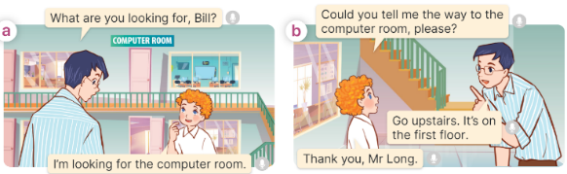  Wear: mặc ( mine)  Jumper: áo len cao cổ ( picture)  - Listen, point and say  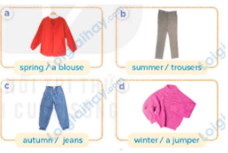+ +blouse: áo cánh nữ (realia)  + trousers: quần dài (realia)  + jeans: quần bằng vải bông (realia)  + coat: áo khoác, áo choàng (realia)  Model sentences:  A: What do you usually wear in winter?  B: I wear a jumper.  - Let’s talk  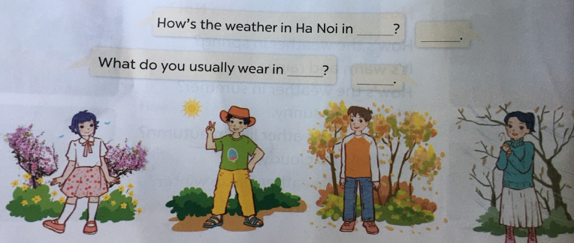
D. ADJUSTMENTS (if necessary):
……………………………………………………………………………………….…..……………………………………………………………………………...……

