Teaching day: ....../....../2025 – class 3A2,3A3
....../......./2025 – class 3A1

Unit 16: My pets
Lesson 1 (1, 2, 3)
I. Objective
By the end of the lesson, Ss will be able to:
1. Knowledge:
- use the words birds, cats, parrots, rabbits in relation to the topic "Pets".
- use some and many to identify the quantity of pets
- use Do you have any…….? – Yes, I do. / No, I don’t. to ask and answer questions about pets
- listen to and demonstrate understanding of simple communicative contexts in relation to the topic "Pets".
- Vocabulary: bird, cat, dog, parrot, rabbit, pet, any.
- Model sentences:
A: Do you have any cats?
B: Yes, I do. / No, I don’t.
2. Skills: speaking and listening
3. Competences:
- Co-operation: ready to help friends in pair work/ group work.
- Sociability: Talk to each other, say good words to others.
4. Attitude/ Qualities:
- Kindness: Help partners to complete learning tasks.
- Honesty: tell the truth about feelings and emotions
II. Methods: Communicative approach, group Ss and T's activities, play as a character, teaching methods with game, teaching methods by visual, teaching methods by practising, discussion group, technical present....
III. Teaching aids:
1. Teacher: Teacher’s guide Pages 179, 180, audio Tracks 54, 55, website sachmem.vn, posters, laptop, pictures, textbook, lesson plan, TV or projector.
2. Students: Pupil’s book Page 40, notebooks, workbooks, school things.
IV. Procedures
Teacher’s activities | Students’ activities
Activity 1. Warm- up:  - Divide class into 4 groups: Tom, Jerry, Miu and Chit.  - Ask Ss look at the pieces of picture.  - Ask Ss go to the board and jigsaw puzzle into the correct picture.  -T checks who’s the winner?  - Say “Open your book page 40” and look at “Unit 16, Lesson 1 (1,2,3).  Activity 2. Look, listen and repeat:  - Have Ss look at Pictures a and b and identify names of the speakers in the pictures.  - Look at the pictures and say  - Play the audio once  - T elicits the new words  + cat : con mèo (picture)  + dog : con chó (picture)  + any : bất cứ (translation)  - Ss listen and repeat new words  + Choral repetition (3 times).  + Individual repetition (3 ss)  - Ss take note  - Play the audio twice (sentence by sentence). Correct their pronunciation where necessary.  - Have Ss to practice the dialogue  - T invites a few pairs to the front of the class to practice.  - T checks pronunciation for ss.  Activity 3. Listen, point and say.  - T asks Ss look at picture a, b and helps Ss know the structure from the dialogue.  - T introduces new structure for Ss.  - T explains, models and gives meaning.  -Have Ss repeat the model sentences.  - Have Ss to practise:  + T asks, Ss answer picture a  + Ss ask, T answers picture b  + Group A ask, group B answer picture c  + Group B ask, group A answer picture d  - Ask Ss to work in pairs.  - T controls and corrects.  - Invite a few pairs to come to the front of the classroom and point at the pictures and say the questions and answers in front of the class.  - T gives feedbacks.  Activity 4. Let’s talk.  - Have Ss look at the picture and elicit the question and the answer in context.  + What can you see in the picture?  + How many pets are there?  - Put Ss into groups of four.  - Tell them to ask and answer questions using Do you have any…..? – Yes, / No,…..  - Invite some Ss to the front of the class to ask and answer questions about their pets.  Activity 5. Consolidation  - T review the vocabulary and model sentences.  - T praises some Ss who are hardworking / active/ good…. as well as encourage others to try more.  Home link  - Learn the vocabulary and model sentences by heart  - Prepare the new lesson: Unit 16, Lesson 1 (4,5,6). | Sing: Jigsaw puzzle  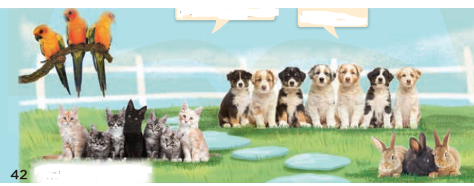  1. Look, listen and repeat:  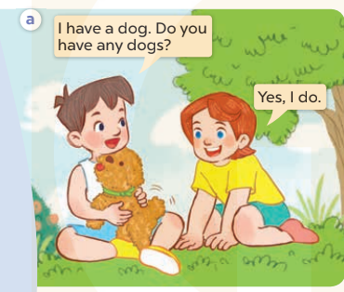  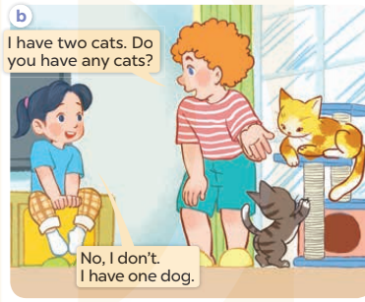  + In picture a: Minh says: I have a dog. Do you have any dogs? Lucy answers: Yes, I do.  + In picture b: Bill: I have two cats. Do you have any cats? Mai answers: No, I don’t. I have one dog.  2. Listen, point and say.  A: Do you have any cats?  B: Yes, I do. / No, I don’t.  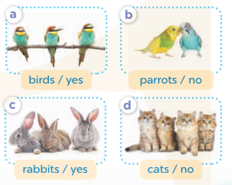  + Picture a: birds / yes  + Picture b: parrots / no  + Picture c: rabbits / yes  + Picture d: cats / no  3. Let’s talk.  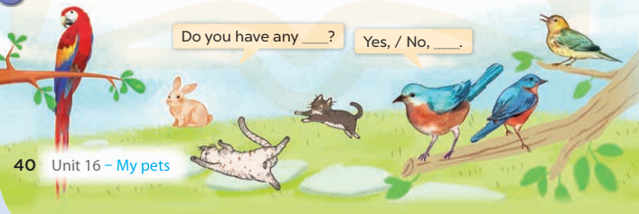
V. Adjustments (if necessary):
………………………………………………………………………………………….…..……………………………………………………………………………...

