Teaching day: ...../....../2024 – class 3A1,3A2,3A3

UNIT 7: CLASSROOM INSTRUCTIONS
Lesson 1 (4, 5, 6)
I. OBJECTIVES:
By the end of the lesson, Ss will be able to:
1. Knowledge:
- listen to and understand two communicative contexts in which pupils introduce someone and respond to the introduction.
- read and complete the sentences correctly.
- recognise target words while listening and acting out the classroom instructions by playing the game Sit down, please!
- Vocabulary: Review
- Skills: speaking, listening, reading and writing.
2. Competences:
- Critical Thinking: self-introduce
- Co-operation: ready to help friends in pair work/ group work.
- Self-control and independent learning: perform listening tasks.
3. Attitude/ Qualities:
- Kindness: Help partners to complete learning tasks.
- Honesty: tell the truth about feelings and emotions.
- Diligence: complete learning tasks.
II. TEACHING AIDS:
- Teacher: Teacher’s guide Pages 51, website sachmem.vn, laptop, pictures, textbook, lesson plan
- Students: Pupil’s book Page 51, notebooks, workbooks, school things.
III. PROCEDURES:
Teacher’s and Students’ activities | Contents
1. Warm up: Game: Simon says  *Procedure:  - T is the “Simon” and calls out the actions. Every student must follow and do the action, but only when they hear “Simon says ...”.  - If teacher leaves out “Simon says” before giving instruction, anyone who does the action is out.  - Then, teacher can choose one or more students as the leader to continue a game.  - Say “Open your book page 51” and look at “Unit 7, Lesson 1 (4,5,6)”.  2. New lesson:  Activity 1  *Procedure:  - Elicit the instruction used in each picture.  - Point at the pictures respectively to explain the context.  - T ask Ss to guess the answers.  + T writes Ss’guessing on the board.  - Listen to the tape:  + Play the recording  + Play the recording again and get Ss to swap books with their partners.  + Play the recording again to check answers together as a class.  + Write the answers on the board for Ss to correct their answers. Then checks Ss’ guessing.  - Play the recording, sentence by sentence, for the class to listen and repeat in chorus.  Activity 2  *Procedure:  - Get Ss to look at the pictures and identify the instruction used in each picture.  - Have Ss look at the four incomplete sentences. Elicit and model with picture 1  + Ask Ss to read the sentence 1 in chorus.  + Ask Ss what word is missing in the gap (Open). Then have them complete the sentence (Open your book, please!).  -Have Ss work in pairs and complete the sentences 2, 3, 4.  - Ask a few Ss to stand up and read the sentences aloud.  -T gives feedbacks.  Activity 3.  *Procedure:  - Put Ss into groups of 5 or 6. Choose one pupil from each group as aperson who gives instructions for the rest of the group to act out.  - Model by saying: Stand up, please! Ss respond to this instruction by  standing up.  - Have groups play the game. One pupil in each group gives instructions for his / her group to act out.  + Ss perform the wrong action are out of the game.  - The winning group is the one that has the highest number of members left at the end of the game.  3. Consolidation  *Procedure:  - T asks ss to answer the following questions:  + What have you learnt from the lesson today?  - T praises some Ss who are hardworking / active/ good…. as well as encourage others to try more.  4. Homewwork:  - Practice part 5 again.  - Prepare the new lesson: Unit 7, Lesson 2 (1,2,3). | 4. Listen and tick  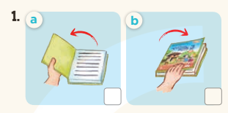  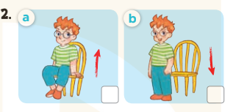  *Key: 1. a 2. a  5.Look, complete and read  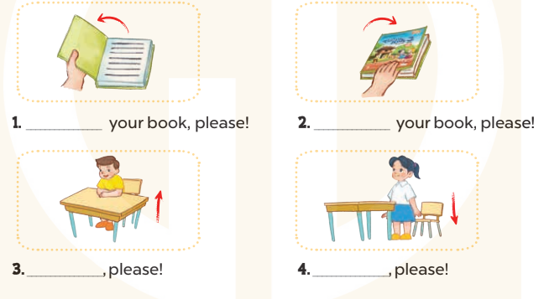  * Key  - Open your book, please!  - Close your book, please!  - Stand up, please!  - Sit down, please!  6.Let’s play  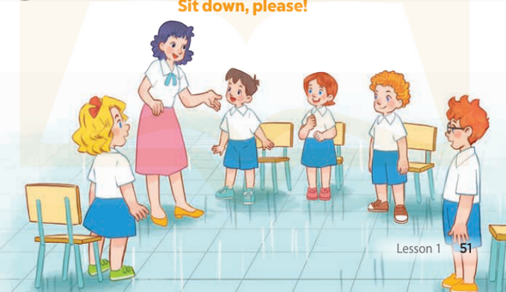
D. ADJUSTMENTS (if necessary):
………………………………………………………………………………………….…..……………………………………………………………………………......

