Teaching day: ..../...../2024 – class 5A1,5A2
..../...../2024 – class 5A3
Unit 5: My future job
Lesson 2 (1, 2, 3)
A. OBJECTIVES: By the end of the lesson, Ss will be able to:
1. Knowledge:

- understand and correctly repeat the sentences in two communicative contexts focusing on asking and answering questions about why someone would like to have a certain job in the future

- correctly say and use the phrases teach children, report the news, grow flowers and write stories and the sentence patterns Why would you like to be a ______ ? and Because I’d like to ________. to ask and answer questions about the reasons why someone would like to be a certain job in the future

- use Why would you like to be ___? – Because I like to____. to ask and answer questions about someone’s future jobs in a freer context.

- Vocabulary: help people, teach children, report the news, grow flowers, write stories.
- Structures:
A: Why would you like to be a doctor?
B: Because I’d like to help people.
- Skills: speaking and listening
2. Competences:
- Critical thinking and creativity: learn how to ask and answer questions about personal information correctly and fluently.
- Self-control and independent learning: perform pronunciation and speaking tasks.
3. Attitude/ Qualities:
- Show their love and interest in a certain job in the future.
B. TEACHING AIDS:
- Teacher: Teacher’s guide Pages 81, 82, 83, audio Tracks 49, 50; website hoclieu.vn, posters, laptop, pictures, textbook, lesson plan, TV or projector.
- Students: Students’ book Page 36, notebooks, workbooks, school things.
C. PROCEDURES:
Teacher’s and Students’ activities | Contents
1.Warm- up and review: (5’)  *Procedure:  - Draw Ss’ attention to the screen.  -Ss listen and pay attention  - Explain the rules of the game: Ss look at the clue and guess  + 1st clue: get 3 points  + 2nd clue: get 2 points  + 3rd clue: get 1 point  -Ss play the game  - Say “Open your book page 36” and look at “Unit 5, Lesson 2 (1,2,3)”.  - Ss listen and open their books  2. New lesson (23’)  Activity 1. Look, listen and repeat:  *Procedure:  - Have Ss look at Pictures a and b and identify the characters  + What can you see in the picture?  + What are they talking about?  -Ss look at the pictures and say.  - Play the audio twice (sentence by sentence). Correct their pronunciation where necessary.  -Ss listen and repeat in chorus (twice)  - Have Ss to practice the dialogue  -Ss work in pairs to practice  - T invites a few pairs to the front of the class to practice.  -Ss come to the front of the classroom to practice.  - T checks pronunciation for ss.  Activity 2 Listen, point and say.  -T elicits the new words  - T models (3 times).  - Ss listen and repeat  + Choral repetition (3 times).  + Individual repetition (3 ss)  - T writes the words on the board.  - Ss take note  - Checking: Rub out and remember  - Ss look, remember and write  - T asks Ss look at picture b in activity 1 and helps Ss know the structure from the dialogue.  - Ss look at the picture and answer.  - T introduces new structures for Ss.  -Ss listen  - T explains, models and gives meaning.  - Have Ss repeat the structures  -Ss repeat to the structures  - Have Ss look at the pictures and say what they can see in the pictures.  - Have Ss point at pictures, listen and run through all the pictures.  -Ss point at pictures, listen and repeat  - Have Ss point at the bubbles, listen and run through model sentences.  -Ss point at the bubbles, listen and repeat  - Have Ss to practise:  + T asks the first picture, Ss answer  + Ss asks the second picture, T answers  + Group A asks the third picture, group B  answers  + Group B asks the last picture, group A  - Ask Ss to work in pairs to practise asking and answering the question Why would you like to be a …….? – Because I’d like to ______.  -Ss work in pairs to practise asking and answering the question  - T controls and corrects.  - Invite a few pairs to point at the pictures and say the questions and answers in front of the class.  - Pairs of Ss point at the pictures and say in front of the class  Activity 3. Let’s talk.  *Procedure:  - Ask Ss to look at the pictures and elicit the personality of each character in the picture.  - Ss listen to the teacher  - Remind Ss that Why would you like to be a _______? are used to ask and answer questions about the reasons why someone would like to be a certain job.  - Give Ss time to work in pairs and take turns pointing at each picture to ask and answer  - Ss role-play to practise asking and answering questions  - Invite a few pairs to come to the front of the classroom and act out the exchanges  - Ss practise asking and answering questions in front of the class.  3. Fun corner and wrap- up (4’)  - Divide the class into 2 teams: boys and girls.  -Ss listen to the teacher  - Draw Ss’ attention to the questions on the screen.  - In teams, they take turns looking at the picture and answer the questions. Read the question aloud and answer it. If they have the correct ones, they will get the points.  -Ss play the game  - The team with more points wins the game.  -Ss congratulate the winner.  4. Home work (3’)  - Practice more at home.  - Prepare for the next lesson. | Game: Guessing game  - Look, listen and repeat:  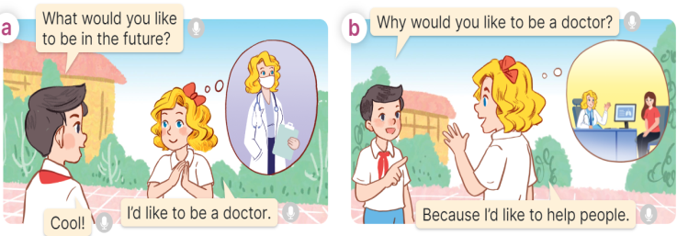  + In picture a: Nam and Mary talking in their schoolyard. Mary thinking of being a doctor in the future  Nam: What would you like to be in the future?  Mary: I’d like to be a doctor.  Nam: Cool!  + In picture b: Nam and Mary talking about the reasons for future jobs. Mary thinking of  helping people as a doctor  Nam: Why would you like to be a doctor?  Mary: Because I’d like to help people.  - Listen, point and say.  Vocabulary.  + help people: giúp mọi người (situation)  + teach children: dạy trẻ em (picture)  + report the new: đưa tin (situation)  + grow flowers: trồng hoa (picture)  + write stories: viết truyện (translation)  * Structures:  A: Why would you like to be a doctor?  B: Because I’d like to help people.      +Picture a: a female teacher teaching children in a classroom  + Picture b: a male reporter reporting the news  + Picture c: a female gardener working in a garden  + Picture d: a male writer writing something at his desk  3. Let’s talk.  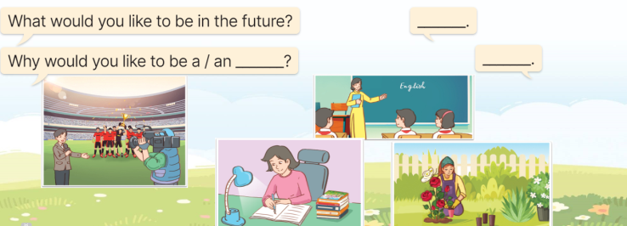  Using: What would you like to be in the future? And Why would you like to be a _______?  Game: Look and say

