Teaching day: ...../10/2024 – class 3A1
...../10/2024 – class 3A2

Unit 3: Our friends
Lesson 1 (1, 2, 3)
I. OBJECTIVES:
By the end of the lesson, Ss will be able to:
1. Knowledge:
- use the words this, that, it, yes, no, friend, teacher, Mr (Mr Long), Ms (Ms Hoa) in relation to the topic “Our friends”
- use This is / That’s ….. to introduce someone.
- Vocabulary: this, that, Mr, Ms.
- Skills: speaking and listening
2. Competences:
Listening: listen and recognize the contexts focusing on introduce someone, then repeat.
Oral Communication: talk about friends, ask and answer the questions
Self-control & independent learning: perform listening tasks
Communication and collaboration: work in pairs or groups
Sociability: talk to each other, say good words to others.
3. Attitude/ Qualities:
Kindness: help partners to complete learning tasks
Diligence: complete learning tasks
Honesty: tell the truth about feelings and emotions
Leadership: collaborate with teachers to enhance language skills
II.METHODS:
Communicative approach, group Ss and T's activities, play as a character, teaching methods with game, teaching methods by visual, teaching methods by practising, discussion group, technical present....
III. TEACHING AIDS:
- Teacher: Teacher’s guide Pages 39, 40, 41, audio Tracks 25, 26, website sachmem.vn, posters, laptop, pictures, textbook, lesson plan, TV or projector.
- Students: Pupil’s book Page 22, notebooks, workbooks, school things.
C. PROCEDURES:
Teacher’s and student’s activities | Contents
Activity 1.Warm- up:  Sing: How old are you?  - Show the song on the screen.  - Ask pupils to listen, sing and dance the song.  - Ss sing and dance the song  - Say “Open your book page 22” and look at “Unit 3, Lesson 1 (1,2,3)”.  - Ss open their books  Activity 2. 1. Listen, point and repeat:  - Have Ss look at Pictures a and b and identify the characters in the pictures.  -Look at the pictures and get to know the characters in the pictures.  - Play the audio twice (sentence by sentence). Correct their pronunciation where necessary.  - Have Ss to practice the dialogue  - T invites a few pairs to the front of the class to practice.  - T checks pronunciation for ss.  Activity 3 2. Listen, point and say.  - T asks Ss look at picture a, b and helps Ss know the structure from the dialogue.  - T introduces new structure for Ss.  - T explains, models and gives meaning.  -Have Ss repeat the model sentences.  * That’s = that is  - Ask Ss to work in pairs.  - T controls and corrects.  - Invite a few pairs to come to the front of the classroom, point at the relevant character in each picture, and act out his/her role.  - Encourage Ss to practise speaking English.  - T gives feedbacks.  Activity 4. Let’s talk.  - T asks ss to guess each character and what the children say.  + What can you see in the picture?  +Who are they?  +Where are they?  +What are they saying?  - T fills the gaps and writes the sentences on the board.  - T models  - T asks Ss to greet and introduce someone. (groups of four)  - Invite some groups to perform.  - Give feedbacks  Activity 5. Homelink:  - Learn the vocabulary and model sentences by heart  - Prepare the new lesson: Unit 3, Lesson 1 (4,5,6). | 1. Listen, point and repeat:  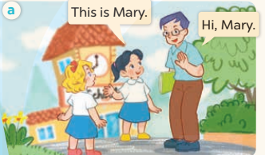  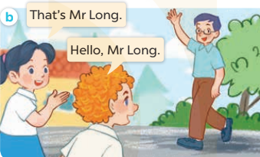  2. Listen, point and say.  + this : đây, này  + that : đó, kia  + Mr :ông, thầy  + Ms : bà, cô  This is Mary.  That’s Mr Long.  3. Let’s talk
D. ADJUSTMENTS (if necessary):
……………………………………………………………………………………….
………………………………………………………………………………………….…..……………………………………………………………………………….

