Teaching day: ......./04/2025 – class 3A1,3A2,3A3

UNIT 17: OUR TOYS
Lesson 1:4,5,6
I. OBJECTIVES:
By the end of the lesson, Ss will be able to:
1. Knowledge:
- Use the words car, kite, train, plane in relation to the topic “Our toys”;
- Listen to and understand four communicative contexts in which pupils identify someone’s toys and number the correct pictures.
- complete four target sentence patterns with the help of picture cues.
- sing the song Their toys with the correct pronunciation and melody.
- Vocabulary: Review
- Skills: Listening, reading and writing.
2. Competences:
- Co-operation: ready to help friends in pair work/ group work.
- Self-control and independent learning: perform listening tasks.
3. Attitude/ Qualities:
- Kindness: Help partners to complete learning tasks.
- Honesty: tell the truth about feelings and emotions.
- Diligence: complete learning tasks.
II. TEACHING AIDS:
- Teacher: Teacher’s guide Pages 212, 213; audio Tracks 66, 67; website sachmem.vn, posters, laptop, pictures, textbook, lesson plan, TV or projector.
- Students: Pupil’s book Page 47, notebooks, workbooks, school things.
III. PROCEDURES:
Teacher’s and students’ activities | Contents
Activity 1: Warm-up  Game: Brain storming  -Divide 2 teams to go to the board and write the words about topic “ Toys”. In 1 minute the team has the more right words and quickly is the winner.  -Monitor, check, find the winner and congratulate.  - Say “Open your book page 47” and look at “Unit 17, Lesson 1:4,5,6”.  Activity 2. Listen and number:  - Run through 4 pictures and elicit and ask students about things of toys in these pictures  - Ss to guess the answers.  + T writes Students’ guessing on the board.  -Sts listen and number  - Sts listen to the tape.  + Play the recording  + Play the recording again and get Ss to swap books with their partners.  + Play the recording again to check answers together as a class.  + Write the answers on the board for Ss to correct their answers. Then checks Ss’ guessing.  - Play the recording, sentence by sentence, for the class to listen and repeat in chorus.  Activity 3. Look, complete and read.  - Have Ss look at the pictures and identify the toys (a car, a kite, planes, trains).  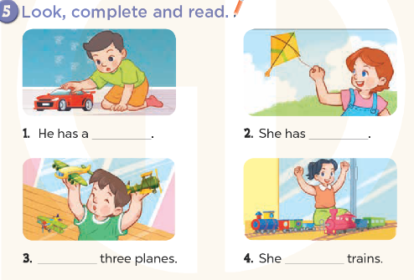  - Have Ss look at the four incomplete sentences and elicits the missing words in the sentences.  - T models with sentence 1  + Ask Ss what is missing in the sentence.  + Have Ss look at the picture and complete the gap, then read the completed sentence in chorus.  -Have Ss work in groups and complete the sentences 2,3 and 4.  - Ask a few Ss to stand up and read the completed sentences aloud.  -T gives feedbacks  Activity 3. Let’s sing.  - Introduce the title and lyrics of the song: “Their toys ” song.  - Play the recording for Ss to listen to the whole song.  + Have them repeat the title and lyrics line by line.  + Tell Ss to point at the relevant character while singing his or her name.  - Play the recording all the way through for Ss to listen to pronunciation and melody of the song.  - Play the recording line by line for Ss to listen, repeat and point at the relevant character.  - Play the recording for Ss to sing and do actions.  - Ask Ss to practice singing and doing actions in pairs or groups.  - Invite groups to the front of the classroom to perform the song  -T gives feedback.  Activity 5. Consolidation  -T asks ss to answer the following questions:  + What have you learnt from the lesson today?  +What are the core values of the lesson? (if the teacher can take from the lesson).  - T praises some Ss who are hardworking / active/ good…. as well as encourage others to try more.  Homelink:  - Ask and answer about the pictures on page 47.  - Prepare the new lesson: Unit 17, Lesson 2:1,2,3 on page 48. | 4. Listen and number  Key: 1. b 2. d 3. c 4. a  5. Look, complete and read  Key:  1. car  2. a kite  3. He has  4. has two  6. Let’s sing.  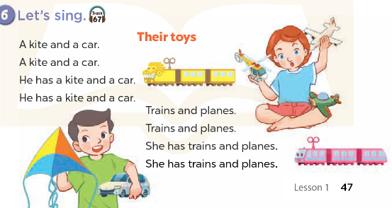
D. ADJUSTMENTS (if necessary):
………………………………………………………………………………………….…..……………………………………………………………………………...

