Teaching day: ...../...../2025 – class 5A1,5A2
....../....../2025 – class 5A3

Unit 15: Our health
Lesson 2 (1, 2, 3)
A. OBJECTIVES:
By the end of the lesson, Ss will be able to:
1. Knowledge:
- understand and correctly repeat the sentences in two communicative contexts focused on giving advice for health problems.
- correctly use the given phrases and sentence patterns You should _____. - Thanks for your advice and response to advice about health problems.
- correctly use the sentence patterns You should ____. and Thanks for your advice to advise and respond to advice about health problems in a freer context.
- Vocabulary: go to the dentist, have a rest, drink warm water, take some medicine, advice, rinse your mouth, salt water.
- Structures: A: You should go to the dentist.
B: Thanks for your advice.
- Skills: speaking and listening
2. Competences:
- Critical thinking and creativity: learn how to ask and answer questions about health problems correctly and fluently.
- Communication and collaboration: work in pairs and groups to complete the learning tasks.
3. Attitude/ Qualities:
- Raise their knowledge of health.
- Show ss how to give advice about health problems.
B. TEACHING AIDS:
- Teacher: Teacher’s guide Pages 242, 243, 244; audio Tracks 45, 46, website hoclieu.vn, posters, laptop, pictures, textbook, lesson plan, TV or projector.
- Students: Students’ book Page 32, notebooks, workbooks, school things.
C. PROCEDURES:
Teacher’s and Students’ activities | Contents
Activity 1.Warm- up and review:  Game: Lucky gift boxes  - Tell ss they are going to look at the picture and ask and answer about health.  - Prepare pictures of common diseases (toothache, headache, sore throat, stomach ache) and gift boxes.  - Have the class play the game in pairs.  - Each pair chooses a gift box they like, then asks and answers questions about health.  - If they ask and answer correctly, they will get gifts from the gift boxes.  - Continue with other pairs.  - Say “Open your book page 32” and look at “Unit 15, Lesson 2 (1,2,3)”.  Activity 2. Look, listen and repeat:  - Have Ss look at Pictures a and b and identify the characters in the pictures.  - Play the recording for them to listen.  - Play the recording again (sentence by sentence) for Ss to listen and repeat Correct their pronunciation where necessary.  - Invite a few pairs to the front of the classroom to listen to and repeat the sentences.  - T checks pronunciation for ss.  Activity 3. Listen, point and say.  -T elicits the new words  - T models (3 times).  - T writes the words on the board.  - Checking: Rub out and remember  - T asks Ss look at picture b and helps Ss know the structure from the dialogue.  - T introduces new structure for Ss.  - T explains, models and gives meaning.  - Have Ss repeat the structures.  - Have Ss look at the pictures and check comprehension.  -Look at the pictures and get to know the characters in the pictures.  - Have Ss point at pictures, listen and run through all the pictures.  - Have Ss point at the bubbles, listen and run through model sentences.  - Have Ss to practise:  + T asks the first picture, Ss answer  + Ss asks the second picture, T answers  + Group A asks the third picture, group B answers  + Group B asks the last picture, group A  - Ask Ss to work in pairs to practise asking and answering the question You should _____. - Thanks for your advice  - T controls and corrects.  - Invite a few pairs to point at the pictures and say the questions and answers in front of the class.  - Pairs of Ss point at the pictures and say in front of the class  - T gives feedbacks.  Activity 4. Let’s talk.  - Ask questions to help them identify the context.  - Elicit the answer in the speech bubble and write it on the board. Get Ss to say the completed sentences.  - Have Ss role-play to practise advising and responding to the advice in pairs, using the picture cue: What’s the matter? - ____ and You should ___.- Thanks for your advice  - Invite a few pairs to point at the pictures and ask and answer questions.  - Invite some pairs of ss to ask and answer questions about health problems  Activity 5. Consolidation  Game: Questions and answers  - Tell ss how the game is played. Give an example.  - Put ss into pairs.  - Encourage the ss to play rock, paper, scissors. The loser gives advice. The winner replies for the advice.  - Praise ss to encourage their performance.  Homework.  - Learn the vocabulary and model sentences by heart  - Prepare the new lesson | Ex:  A: What’s the matter?  B: I have a toothache.  1. Look, listen and repeat  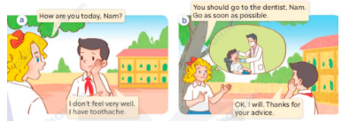  2. Listen, point and say  Vocabulary.  + go to the dentist: đi khám nha sĩ  (picture)  + have a rest: nghỉ ngơi(situation)  + drink warm water: uống nước ấm (example)  + take some medicine: uống thuốc (mime)  + advice: lời khuyên (translation)  + rinse your mouth: súc miệng (mime)  + salt water: nước muối (realia)  * Structures:  A: You should go to the dentist.  B: Thanks for your advice.  *Drill pictures  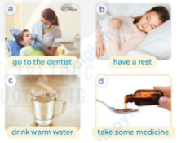  a: a dentist checking her patient’s teeth  b: a girl having a rest  c: a cup of warm water  d: some medicine  3. Let’s talk.  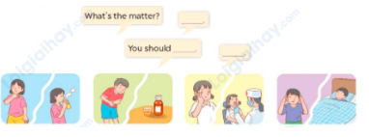  Ex:  A: You should drink warm water.  B: Thanks for your advice.
D. ADJUSTMENTS (if necessary):
………………………………………………………………………………………….…..………………………………………………………………………

