Week 24
Teaching date: 03/ 03/ 2025 – class 3A, 3B
Unit 14: My bedroom
Lesson 2 (1,2,3)
I. Objectives: By the end of the lesson Ps will be able to:
1. Knowledge:
- understand and correctly repeat the sentences in two communicative contexts (pictures) to describe things in the room.
- correctly say the words and use The …….. is ……. / The …… are …….. to describe things in the room.
- Vocabulary: big, small, old, new
- Model sentences:
The door is big.
The chairs are new.
2. Skills.
- Skills: speaking and listening
3. Attitude/ Quality:
Kindness: help partners to complete learning tasks
Diligence: complete learning tasks
Honesty: tell the truth about feelings and emotions
Responsibility: appreciate kindness
4. Forming competence:
- Listening: listen and recognize the characters, then repeat
- Critical Thinking: self-introduce
- Self-control & independent learning: perform listening tasks
- Communication and collaboration: work in pairs or groups
II. Methods:
Communicative approach, group Ss and T's activities, play as a character, teaching methods with game, teaching methods by visual, teaching methods by practising, discussion group, technical present....
III. Preparation.
1. Teacher’s preparation: Projector
- Speaker
- Website hoclieu.vn
2. Student’s preparation: books, notebooks.
IV. Procedures
Teacher’s and students’ activities | Contents
Activity 1: Warm- up: Sing a song: “If you happy and you know it”  - Say “Open your book page 25” and look at “Unit 14, Lesson 1 (4,5,6)”.  Activity 2. Listen, point and repeat:  - Have Ss look at Pictures a and b and identify the characters in the pictures.  - Play the audio twice (sentence by sentence). Correct their pronunciation where necessary.  - Have Ss to practice the diaguage  - T invites a few pairs to the front of the class to practice.  - T checks pronunciation for ss.  Activity 3. Listen, point and say.  - T asks Ss look at picture a, b and helps Ss know the structure from the dialogue.  - T introduces new structure for Ss.  - T explains, models and gives meaning.  - Have Ss repeat the model sentences.  - Have Ss look at the pictures and elicit the things in the room.  - Run through all the pictures.  - Run through model sentences.  - Have Ss to practise:  - Ask Ss to work in pairs.  - T controls and corrects.  - Invite a few pairs to come to the front of the classroom, point at the relevant character in each picture, and act out his/her role.  - T gives feedbacks.  Activity 4. Let’s talk.  - Have Ss look at the things in a bedroom and say their names.  + What can you see in the picture?  +What are they?  - T fills the gaps and writes the sentences on the board.  - T models  - T asks Ss use of The bed is new. The chair are new. to introduce the things in the room.  - Invite some groups to perform.  - Give feedbacks  Activity 5: Consolidation  - T asks ss to answer the following questions:  + What have you learnt from the lesson today?  - T praises some Ss who are hardworking / active/ good…. as well as encourage others to try more.  Homework.  - Prepare the new lesson: | 1. Listen, point and repeat:  + big : to, lớn  + small : nhỏ, bé  2 Listen, point and say.  + new : mới  + old : cũ  The door is big.  The chairs are new.  3. Let’s talk.
V. Adjustments (if necessary):
………………………………………………………………………………………….…..…………………………………………………………………………
------------------------------------------------
Week 24
Teaching date: 04/ 03/ 2025 – class 3A, 3B
Unit 14: My bedroom
Lesson 2 (4,5,6)
I. Objectives: By the end of the lesson Ps will be able to:
1. Knowledge:
- listen to and understand four communicative contexts in which characters introduce and describe things in a bedroom and number the correct pictures.
- complete four gapped sentences with the help of picture cues.
- sing the song My bedroom with the correct pronunciation, rhythm and melody
Vocabulary: Review
- Skills: speaking, listening, reading and writing.
2. Skills.
- Skills: speaking and listening
3. Attitude/ Quality:
Kindness: help partners to complete learning tasks
Diligence: complete learning tasks
Honesty: tell the truth about feelings and emotions
Responsibility: appreciate kindness
4. Forming competence:
- Listening: listen and recognize the characters, then repeat
- Critical Thinking: self-introduce
- Self-control & independent learning: perform listening tasks
- Communication and collaboration: work in pairs or groups
II. Methods:
Communicative approach, group Ss and T's activities, play as a character, teaching methods with game, teaching methods by visual, teaching methods by practising, discussion group, technical present....
III. Preparation.
1. Teacher’s preparation: Projector
- Speaker
- Website hoclieu.vn
2. Student’s preparation: books, notebooks.
IV. Procedures
Teacher’s and students’ activities | Contents
Activity 1: Warm- up: Sing a song: “throw the ball”  - Say “Open your book page 27” and look at “Unit 14, Lesson 2 (4,5,6)”.  Activity 2. Listen and number:  - Have Ss look at the pictures and ask them some questions such as What is this? and What are these?  - T ask Ss to guess the answers.  + T writes Ss’guessing on the board.  - Listen to the tape:  + Play the recording  + Play the recording again and get Ss to swap books with their partners.  + Play the recording again to check answers together as a class.  + Write the answers on the board for Ss to correct their answers. Then checks Ss’ guessing.  - Play the recording, sentence by sentence, for the class to listen and repeat in chorus.  Activity 3. Look, complete and read.  - Have Ss look at the pictures and ask identify things in the room in the pictures.  - T models with sentence 1.  + Have Ss look at the sentence.  + Ask them what is missing in the answer ( bed ).  + Have Ss complete the gap.  + Have Ss read the completed sentence in chorus.  -Have Ss work in pairs and complete the sentences 2, 3 and 4.  - Invite pairs of pupils to stand up and read aloud the sentences.  -T gives feedbacks.  Activity 4. Let’s sing.  - Introduce the title and lyrics of the song: “My bedroom? ” song.  - Play the recording for Ss to listen to the whole song.  + Have them repeat the title and lyrics line by line.  + Tell Ss to point at the relevant character while singing his or her name.  - Play the recording all the way through for Ss to listen to pronunciation and melody of the song.  - Play the recording line by line for Ss to listen, repeat and point at the relevant character.  - Play the recording for Ss to sing and do actions.  - Ask Ss to practice singing and doing actions in pairs or groups.  - Invite groups to the front of the classroom to perform the song  -T gives feedback  Activity 5: Consolidation  - T asks ss to answer the following questions:  + What have you learnt from the lesson today?  +What are the core values of the lesson?  - T praises some Ss who are hardworking / active/ good…. as well as encourage others to try more.  Homework.  - Prepare the new lesson: Unit 14, Lesson 3 (1,2,3). | 4. Listen and number:  Key: 1.b 2. a 3. c 4. d  5. Look, complete and read.  Key:  1. bed 2. two lamps 3. big 4. small  6. Let’s sing.
V. Adjustments (if necessary):
………………………………………………………………………………………….…..…………………………………………………………………………
------------------------------------------------
Week 24
Teaching date: 05/ 03/ 2025 – class 3A, 3B
Unit 14: My bedroom
Lesson 3 (1,2,3)
I. Objectives: By the end of the lesson Ps will be able to:
1. Knowledge:
- correctly repeat the sounds of the letters oo in isolation, the words room and door and the sentences There’s the bed in the room and The doors are big. with the correct pronunciation and intonation.
- identify the target words room and door while listening.
- say the chant with the correct rhythm and pronunciation.
- Vocabulary: Review
2. Skills.
- Skills: speaking and listening
3. Attitude/ Quality:
Kindness: help partners to complete learning tasks
Diligence: complete learning tasks
Honesty: tell the truth about feelings and emotions
Responsibility: appreciate kindness
4. Forming competence:
- Listening: listen and recognize the characters, then repeat
- Critical Thinking: self-introduce
- Self-control & independent learning: perform listening tasks
- Communication and collaboration: work in pairs or groups
II. Methods:
Communicative approach, group Ss and T's activities, play as a character, teaching methods with game, teaching methods by visual, teaching methods by practising, discussion group, technical present....
III. Preparation.
1. Teacher’s preparation: Projector
- Speaker
- Website hoclieu.vn
2. Student’s preparation: books, notebooks.
IV. Procedures
Teacher’s and students’ activities | Contents
Activity 1. Warm- up: play ‘slap the board’  - Say “Open your book page 17” and look at “Unit 12, Lesson 3 (1,2,3)”.  Activity 2. Listen and repeat:  - T gives instruction to the letters oo in isolation, in the words room and door, and in the sentences There’s the bed in the room. and The doors are big.  - Play the recording for the letter oo.  - Encourage Ss to point at the letter/ word/ sentence while listening.  - Play the recording again and encourage Ss to listen and repeat.  - Do this several times until Ss feel confident.  - T calls some Ss to practice.  - T gives feedbacks.  Activity 2. Listen and circle:  - Elicit the sentences and explain that they have to listen.  - T ask Ss to guess the answers.  + T writes Ss’guessing on the board.  - Listen to the tape:  + Play the recording  + Play the recording again and get Ss to swap books with their partners.  + Play the recording again to check answers together as a class.  + Write the answers on the board for Ss to correct their answers. Then checks Ss’ guessing.  - Play the recording, sentence by sentence, for the class to listen and repeat in chorus.  - Invite one or two Ss to stand up and read the completed sentences.  Activity 3. Let’s chant  - Introduce the title and lyrics of the chant.  - Play the recording for Ss to listen to the whole chant.  + Have them repeat the title and lyrics line by line.  + Ask Ss to attend to the sounds of the letters oo and the words room and door.  - Play the recording all the way through for Ss to listen to pronunciation and melody.  - Play the recording line by line for Ss to listen and repeat  - Play the recording for Ss to chant and clap along.  - Ask Ss to practice chant and clap along in pairs or groups.  - Invite groups to the front of the classroom to perform the chant  -T gives feedback.  Activity 5: Consolidation  - T asks ss to answer the following questions:  + What have you learnt from the lesson today?  +What are the core values of the lesson?  - T praises some Ss who are hardworking / active/ good…. as well as encourage others to try more.  Homework.  - Prepare the new lesson: Unit 14, Lesson 2 (1,2,3). | 1. Listen and repeat:  2. Listen and circle:  Key: 1.b 2.c  3. Let’s chant
V. Adjustments (if necessary):
………………………………………………………………………………………….…..…………………………………………………………………………
------------------------------------------------
Week 24
Teaching date: 06/ 03/ 2025 – class 3A, 3B
Unit 14: My bedroom
Lesson 3 (4,5,6)
I. Objectives: By the end of the lesson Ps will be able to:
1. Knowledge:
- read the text and complete the gapped sentences.
- read the text and complete the gapped sentences.
- complete a gapped paragraph with the help of the picture cue.
- Vocabulary: Review
2. Skills.
- Skills: speaking and listening
3. Attitude/ Quality:
Kindness: help partners to complete learning tasks
Diligence: complete learning tasks
Honesty: tell the truth about feelings and emotions
Responsibility: appreciate kindness
4. Forming competence:
- Listening: listen and recognize the characters, then repeat
- Critical Thinking: self-introduce
- Self-control & independent learning: perform listening tasks
- Communication and collaboration: work in pairs or groups
II. Methods:
Communicative approach, group Ss and T's activities, play as a character, teaching methods with game, teaching methods by visual, teaching methods by practising, discussion group, technical present....
III. Preparation.
1. Teacher’s preparation: Projector
- Speaker
- Website hoclieu.vn
2. Student’s preparation: books, notebooks.
IV. Procedures
Teacher’s and students’ activities | Contents
Activity 1. Warm- up: Play ‘passing the cards’  - Say “Open your book page 29” and look at “Unit 14, Lesson 3 (4, 5, 6)”.  Activity 2. Read and complete:  - Tell Ss how to complete the task.  - Point at the table and elicit the type of information they need to find in the texts.  - Ask Ss attend to the blank in number 1 and find the missing word.  - Write the missing word on the board and get the class to read the completeed sentence together.  - Have Ss work in pairs and complete  - Tell Ss to swap books with a partner, then check answers together as a class.  - Write the correct answers on the board for pupils to correct their answers.  - Invite Ss to read the complete text aloud  -T gives feedbacks.  Activity 3. Let’s write  - Explain to the class the goal of this activity.  - Ask Ss to read each gapped sentence, look at the picture and fill in the gap.  - Give Ss time to write their answers  - Ask Ss to swap and correct their answers in pairs.  - Check the answers as a class.  Activity 4. Project.  - Tell Ss to find a photo of a bedroom in a newspaper or a magazine as homework. They should bring their photos to class.  - Have Ss work in groups. Each member introduces the picture of the bedroom using the structures they have learnt in the unit.  - Invite one or two Ss to show their photos and describe them in front of the class.  +Example: Hello, everyone. My name’s Huong. I’m nine years old. This is my bedroom. There is a bed. It is bag. There are two windows. They are new.  - Create a class display of the projects and organise a vote to find the most beautiful ones.  Activity 5: Consolidation  - T asks ss to answer the following questions:  + What have you learnt from the lesson today?  - T praises some Ss who are hardworking / active/ good…. as well as encourage others to try more.  Homework.  - Prepare the new lesson: Unit 15: Lesson 1 (1,2,3). | 4. Read and complete:  Key:  1. desk 2. Chairs  3. big 4. small  5. Let’s write  Key: first gap: small  second gap: bed / desk  third gap: small / old  fourth gap: chairs  fifth gap: old / new  6. Project.
V. Adjustments (if necessary):
………………………………………………………………………………………….…..…………………………………………………………………………
------------------------------------------------
Week 24 - Grade 4
Teaching date: 03 /03/ 2025 – class 4B - class 4A
Unit 14: Daily activities
Lesson 2 (1, 2, 3)
I. OBJECTIVES:
By the end of the lesson, Ss will be able to:
1. Knowledge:
- use the phrases wash the clothes, clean the ﬂoor, help with the cooking and wash the dishes in relation to the topic “Daily activities”.
- use What do you do in the morning? – I …..to ask and answer questions about what daily activities someone does in the morning;
- Vocabulary: wash the clothes, clean the floor, help with the cooking, wash the dishes
- Model sentences:
A: What do you do in the morning?
B: I clean the floor.
2.Skills: speaking and listening
3. Competences:
- Co-operation: ready to help friends in pair work/ group work.
- Sociability: Talk to each other, say good words to others.
4. Attitude/ Qualities:
- Kindness: Help partners to complete learning tasks.
- Honesty: tell the truth about feelings and emotions
II. Methods: Communicative approach, group Ss and T's activities, play as a character, teaching methods with game, teaching methods by visual, teaching methods by practising, discussion group, technical present....
III. Teaching aids:
1. Teacher’s preparation: Projector/ TV
- Speaker
- Website hoclieu.vn
2. Student’s preparation: books, notebooks.
IV. Procedures:
Teacher’s and students’ activities | Contents
Activity 1.Warm- up:  - Sing a song.  - Say “Open your book ” and look at “Unit 14, Lesson 2 (1,2,3)”.  Activity 2. Look, listen and repeat:  - Have Ss look at Pictures a and b and identify what activities Linh does on Sundays.  - Play the audio twice (sentence by sentence). Correct their pronunciation where necessary.  - Have Ss to practice the diaguage  - T invites a few pairs to the front of the class to practice.  - T checks pronunciation for ss.  Activity 3. Listen, point and say.  -T elicits the new words  - T models (3 times).  - T writes the words on the board.  * Model sentences:  - T asks Ss look at picture b and helps Ss know the structure from the dialogue.  - T introduces new structure for Ss.  - T explains, models and gives meaning.  - Have Ss repeat the model sentences.  - Have Ss look at the pictures and elicit what activity each child is doing.  - Run through all the pictures.  - Run through model sentences.  - Have Ss to practise:  - Ask Ss to work in pairs.  - T controls and corrects.  - Invite a few pairs to come to the front of the classroom, point at the relevant character in each picture, and act out his/her role.  - T gives feedbacks.  Activity 4. Let’s talk.  - Explain that each picture shows the members of a family doing the housework together  - Ask Ss to repeat the question a few times: What do you do in the morning / afternoon / evening?  - Point at the boy who is cleaning the floor to elicit the answer (I clean the floor.).  - Have Ss repeat it a few times.  - Split the class into two groups to take turns pointing at each activity that a character is doing, asking and answering in chorus.  - Ask S to practise asking and answering What do you do in the morning / afternoon / evening? – I ……..  - Invite some pairs of pupils to the front of the class to take turns asking and answering  *.Consolidation  - T asks ss to answer the following questions:  +What are the core values of the lesson? (if the teacher can take from the lesson).  - T review the vocabulary and model sentences.  - T praises some Ss who are hardworking / active/ good…. as well as encourage others to try more.  *. Homework.  - Prepare the new lesson: Unit 14, Lesson 2 (4,5,6). | - Look, listen and repeat:  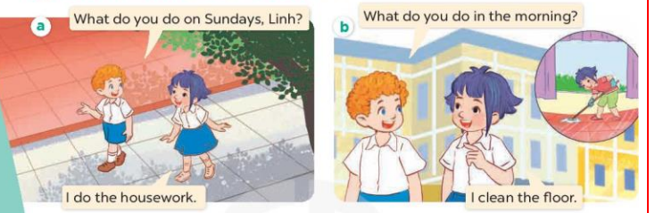  - Listen, point and say.  + clean the floor : lau sàn nhà  + wash the clothes: giặt quần áo  + wash the dishes : rửa chén bát  + help with the cooking : giúp đỡ việc nấu ăn  * Model sentences:  A: What do you do in the morning? B: I clean the floor.  *Drill pictures  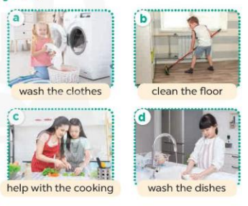  - Let’s talk.  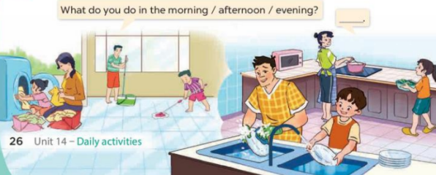
D. ADJUSTMENTS (if necessary):
………………………………………………………………………………………….…..……………………………………………………………………………...……
Week 24 - Grade 4
Teaching date: 04 /03/ 2025 – class 4B 05/03/ 2025 - class 4A
Unit 14: Daily activities
Lesson 2 (4, 5, 6)
I. OBJECTIVES:
By the end of the lesson, Ss will be able to:
1. Knowledge:
- use the phrases wash the clothes, clean the ﬂoor, help with the cooking and wash the dishes in relation to the topic “Daily activities”
- listen to and demonstrate understanding of simple communicative contexts in relation to the topic “Daily activities”
- Vocabulary: Review

2.Skills: speaking and listening
3. Competences:
- Co-operation: ready to help friends in pair work/ group work.
- Sociability: Talk to each other, say good words to others.
4. Attitude/ Qualities:
- Kindness: Help partners to complete learning tasks.
- Honesty: tell the truth about feelings and emotions
II. Methods: Communicative approach, group Ss and T's activities, play as a character, teaching methods with game, teaching methods by visual, teaching methods by practising, discussion group, technical present....
III. Teaching aids:
1. Teacher’s preparation: Projector/ TV
- Speaker
- Website hoclieu.vn
2. Student’s preparation: books, notebooks.
IV. Procedures:
Teacher’s and students’ activities | Contents
Activity 1.Warm- up:  Sing: Baby shark  - Show the song on the screen.  https://www.youtube.com/watch?v=XqZsoesa55w  - Ask Ss to listen, sing and dance the song.  - Ss sing and dance the song  - Say “Open your book” and look at “Unit 14, Lesson 2 (4,5,6)”.  Activity 2. Listen and number:  - Elicit the activity that the girl is doing in each picture.  - T ask Ss to guess the answers.  + T writes Ss’guessing on the board.  - Listen to the tape:  + Play the recording  + Play the recording again and get Ss to swap books with their partners.  + Play the recording again to check answers together as a class.  + Write the answers on the board for Ss to correct their answers. Then checks Ss’ guessing.  - Play the recording, sentence by sentence, for the class to listen and repeat in chorus.  Activity 3. Look, complete and read.  - Elicit the missing words in the question and answer from the picture cue and sentence.  - T models with sentence 1.  + Have Ss look at the sentence.  + Ask them what is missing in the answer ( clothes).  + Have Ss complete the gap.  + Have Ss read the completed sentence in chorus.  -Have Ss work in pairs and complete the sentences 2.  - Invite pairs of pupils to stand up and read aloud the sentences.  -T gives feedbacks.  Activity 3. Let’s play- Miming game  - Explain how the game is played.  + Write the question on the board What do you do in the ...?  +Ask one player from each team to come to the front of the class and whisper the answer to the question he / she wants to revise to the two players.  +They take turns miming the sentences they are told for their team to guess.  +The team gets one point if their guess is correct.  +The game continues until the time is up. + The team with the most points at the end of the game wins.  - Write all correct answers on the board, under the question What do you do in the …?  - When the game is over, get pairs of pupils to take turns asking and answering the question What do you do in the morning / afternoon / evening? using the answers on the board.  *.Consolidation  - T asks ss to answer the following questions:  + What have you learnt from the lesson today?  +What are the core values of the lesson? (if the teacher can take from the lesson).  - T praises some Ss who are hardworking / active/ good…. as well as encourage others to try more.  * Homework.  - Prepare the new lesson: Unit 14, Lesson 3 (1,2,3). | 4.Listen and number:  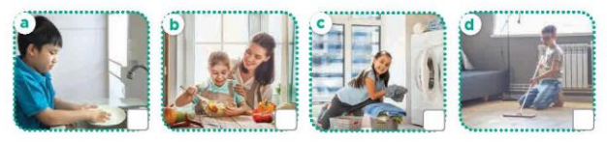  Key: 1.c 2. a 3. d 4. b  5.Look, complete and read.  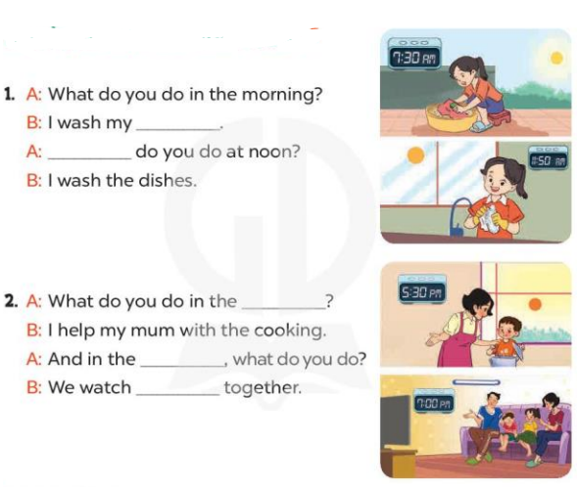  Key: 1. Clothes; What  2. afternoon; evening; TV  6.Let’s play- Miming game
V. ADJUSTMENTS (if necessary):
………………………………………………………………………………………….…..……………………………………………………………………………...……
Week 24 - Grade 4
Teaching date: 06 /03/ 2025 – class 4B - class 4A
Unit 14: Daily activities
Lesson 3 (1, 2, 3)
I. OBJECTIVES:
By the end of the lesson, Ss will be able to:
1. Knowledge:
- correctly repeat the sounds of the letters tch and sh in isolation, the words watch and wash and the sentences When do you watch TV? and I wash my clothes in the evening. with the correct pronunciation and intonation.
- identify the target words watch and wash while listening.
- say the chant with the correct rhythm and pronunciation.
- Vocabulary: Review
2.Skills: speaking and listening
3. Competences:
- Co-operation: ready to help friends in pair work/ group work.
- Sociability: Talk to each other, say good words to others.
4. Attitude/ Qualities:
- Kindness: Help partners to complete learning tasks.
- Honesty: tell the truth about feelings and emotions
II. Methods: Communicative approach, group Ss and T's activities, play as a character, teaching methods with game, teaching methods by visual, teaching methods by practising, discussion group, technical present....
III. Teaching aids:
1. Teacher’s preparation: Projector/ TV
- Speaker
- Website hoclieu.vn
2. Student’s preparation: books, notebooks.
IV. Procedures:
Teacher’s and Students’ activities | Contents
1.Warm- up:  Game: Brainstorming  - Say “Open your book ” and look at “Unit 14, Lesson 3 (4, 5, 6)”.  - Ss open their books  2.New lesson:  Activity 1. Listen and repeat:  - T gives instruction to the letters tch and sh in isolation, in the words watch and wash, and in the sentencesWhen do you watch TV? and I wash my clothes in the evening.  - Play the recording for the letter tch, sh  - Encourage Ss to point at the letter/ word/ sentence while listening.  - Play the recording again and encourage Ss to listen and repeat.  - Do this several times until Ss feel confident.  - T calls some Ss to practice.  - T gives feedbacks.  Activity 2. Listen and circle.  - Elicit the sentences and explain that they have to listen.  - T ask Ss to guess the answers.  + T writes Ss’guessing on the board.  - Listen to the tape:  + Play the recording  + Play the recording again and get Ss to swap books with their partners.  + Play the recording again to check answers together as a class.  + Write the answers on the board for Ss to correct their answers. Then checks Ss’ guessing.  - Play the recording, sentence by sentence, for the class to listen and repeat in chorus.  - Invite one or two Ss to stand up and read the completed sentences.  Activity 3. Let’s chant  - Introduce the title and lyrics of the chant.  - Play the recording for Ss to listen to the whole chant.  + Have them repeat the title and lyrics line by line.  + Ask Ss to attend to the sounds of the letters tch and sh and the words watch and wash.  - Play the recording all the way through for Ss to listen to pronunciation and melody.  - Play the recording line by line for Ss to listen and repeat  - Play the recording for Ss to chant and clap along.  - Ask Ss to practice chant and clap along in pairs or groups.  - Invite groups to the front of the classroom to perform the chant  -T gives feedback.  3.Consolidation  - T asks ss to answer the following questions:  + What have you learnt from the lesson today?  -Ss answer the questions  - T praises some Ss who are hardworking / active/ good…. as well as encourage others to try more.  -Ss listen and clap their hands  4. Homework.  - Practice the chant more.  - Prepare a poster about their school in order to introduce school to a new pupil.  - Prepare the new lesson: Unit 11, Lesson 3 (4,5,6). | 1.Listen and repeat:  tch watch When do you watch TV?  sh wash I wash my clothes in the evening.  2. Listen and circle.  Key: 1.c 2.b  3. Let’s chant  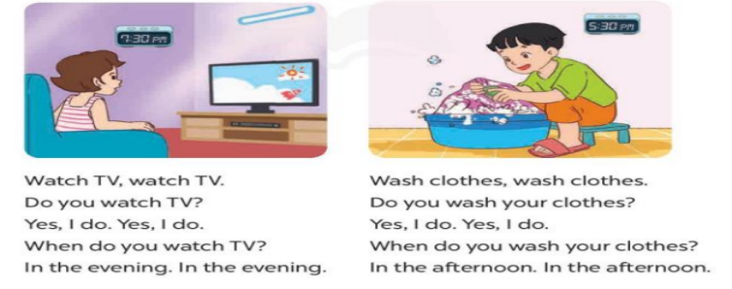
D. ADJUSTMENTS (if necessary):
………………………………………………………………………………………….…..……………………………………………………………………………...………………………………………….…..……………………………………………
Week 24 - Grade 4
Teaching date: 07 /03/ 2025 – class 4B - class 4A
Unit 14: Daily activities
Lesson 3 (4, 5, 6)
I. OBJECTIVES:
By the end of the lesson, Ss will be able to:
1. Knowledge:
- use the phrases wash the clothes, clean the ﬂoor, help with the cooking and wash the dishes in relation to the topic “Daily activities”
- read and write about someone’s daily activities.
- draw pictures or take notes of what daily activities pupils do at home and present the results to the class at Project time.
- Vocabulary: Review
2.Skills: speaking and listening
3. Competences:
- Co-operation: ready to help friends in pair work/ group work.
- Sociability: Talk to each other, say good words to others.
4. Attitude/ Qualities:
- Kindness: Help partners to complete learning tasks.
- Honesty: tell the truth about feelings and emotions
II. Methods: Communicative approach, group Ss and T's activities, play as a character, teaching methods with game, teaching methods by visual, teaching methods by practising, discussion group, technical present....
III. Teaching aids:
1. Teacher’s preparation: Projector/ TV
- Speaker
- Website hoclieu.vn
2. Student’s preparation: books, notebooks.
IV. Procedures:
Teacher’s and Students’ activities | Contents
Activity 1.Warm- up: Chant  - Ask Ss chant and do the actions in Lesson 3 Unit 14 in groups.  - Ss listen and chant  - Give point for the groups and encourage them.  - Say “Open your book” and look at “Unit 14, Lesson 3 (4, 5, 6)”.  - Ss open their books  Activity 2. Read and match:  - Have Ss read all the phrases under the paragraph. Tell them to read Phrase 1: in the morning.  - Ask Ss scan the paragraph for the appropriate activity related to the phrase.  -Have Ss to do the activity independently.  - Get Ss to swap books with their partners and check their answers before checking as a class.  - Invite some Ss to stand up and read the paragraph aloud.  Activity 3. Let’s write  - Explain to the class the goal of this activity.  - Ask Ss to read each gapped sentence, look at the picture and fill in the gap.  - Give Ss time to write their answers  - Ask Ss to swap and correct their answers in pairs.  - Check the answers as a class.  Activity 4. Project.  - Explain that they have to look at the pictures or notes they have prepared at home and present the results to the class.  - Have Ss work in groups of five.  + Each pupil looks at their pictures or notes and tells the group about what daily activities he / she does on Sundays.  - Invite a few Ss to look at their pictures or notes and tell the class about them  - Have the rest of class applaud if pupils perform well  *Procedure:  - T asks ss to answer the following questions:  + What have you learnt from the lesson today?  - T praises some Ss who are hardworking / active/ good…. as well as encourage others to try more.  - Ss listen and clap their hands  . Homework.  - Prepare the new lesson: Unit 12, Lesson 1 (1, 2, 3).  -Ss listen and take note | Game: Chant  4. Read and match:  Key: 1.a 2. a, d 3. b  5. Let’s write  Example:  I do a lot of housework on Sundays. In the morning, I wake up and have breakfast. In the afternoon, I watch TV and play games. In the evening, I have dinner with my family.  6.Project.  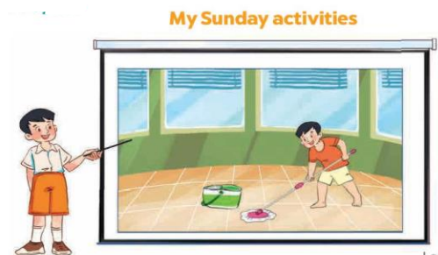  Example: Hello, everyone. My name’s Linh. I’m nine years old. This is my picture. I do housework on Sundays. In the morning, I wake up and have breakfast. In the afternoon, I watch TV and play games. In the evening, I have dinner with my family.
V. ADJUSTMENTS (if necessary):
………………………………………………………………………………………….…..……………………………………………………………………………...
………………………………………………………………………………………
Week 24 – Grade 5
Teaching day: 03 /03/2025 – class 5A, 5B
Unit 14: Staying healthy
Lesson 2 (1,2,3)
I. OBJECTIVES:
By the end of the lesson, Ss will be able to:
1. Knowledge:
- understand and correctly repeat the sentences in two communicative contexts in which characters ask and answer questions about the frequency of an activity
- correctly say the phrases and use How often does he / she ____? -____. to ask and answer questions about the frequency of an activity
- use How does your ____ stay healthy? – He / She ____. and How often does your ____? – He / She ____. in a freer context;
- Vocabulary: once a week, twice a week, three times a week and every day
- Structures: A: How often does he / she swim?
B: Every day.
2. Skills: speaking, listening, reading, and writing.
3. Competences:
- Communication and collaboration: work in pairs and groups to complete the learning tasks.
4. Attitude/ Qualities:
- Show their love and interest in outdoor activities.
- Raise their awareness of doing outdoor activities carefully.
II. METHODS: Communicative approach, group Ss and T's activities, play as a character, teaching methods with game, teaching methods by visual, teaching methods by practising, discussion group, technical present....
III. TEACHING AIDS:
1. Teacher’s preparation: TV, speaker.
- Teacher’s guide
- Website hoclieu.vn
2. Student’s preparation: books, notebooks.
IV. PROCEDURES:
Teacher's and students' activities | Contents
Activity 1.Warm- up and review:  - Divide the class into two groups. Each group chooses five ss.  - Ss listen to the teacher  - Ask the ss to form two lines.  - Whisper a sentence to the first student from each group. Then ask them to whisper the sentence into the ear of the student standing next to them. They continue whispering the sentence until the end of the line. The last student has to say it out loud.  - Ss play the game  - The student saying the correct sentence wins a point for their group. The group with more points will win the game.  - Say “Open your book page 26” and look at “Unit 14, Lesson 2 (1,2,3)”.  - Ss listen and open their books  Activity 2. Look, listen and repeat:  - Have Ss look at Pictures a and b and identify the characters and predict who they are talking about.  -Ss look at the pictures and say.  + Who are they?  + Where are they?  + What are they talking about?  - Play the audio twice (sentence by sentence). Correct their pronunciation where necessary.  -Ss listen and repeat in chorus (twice)  - Have Ss to practice the dialogue  -Ss work in pairs to practice  - T invites a few pairs to the front of the class to practice.  -Ss come to the front of the classroom to practice.  - T checks pronunciation for ss.  Activity 3 Listen, point and say.  -- Ss look, remember and write  - T asks Ss look at picture b in activity 1 and helps Ss know the structure from the dialogue.  - T introduces new structures for Ss.  -Ss repeat to the structures  - T explains, models and gives meaning.  - Have Ss repeat the model sentences.  -Ss listen and repeat  - Have Ss look at the pictures and say what they can see in the pictures.  - Ss look, listen and repeat  - Have Ss point at pictures, listen and run through all the pictures.  -Ss point at pictures, listen and repeat  - Have Ss point at the bubbles, listen and run through model sentences.  -Ss point at the bubbles, listen and repeat  - Have Ss to practise:  + T asks the first picture, Ss answer  + Ss asks the second picture, T answers  + Group A asks the third picture, group B  answers  + Group B asks the last picture, group A  -Ss practice in chorus  - Ask Ss to work in pairs to practise asking and answering the question  -Ss work in pairs to practise asking and answering the question  - T controls and corrects.  - Invite a few pairs to point at the pictures and say the questions and answers in front of the class.  - Pairs of Ss point at the pictures and say in front of the class  Activity 4. Let’s talk.  - Ask ss to look at the pictures and elicit the activities  -Ss look at the picture and say  - Point at the ﬁrst building and elicit the question in the ﬁrst speech bubble How does your __ stay healthy? and How often does your __? and the answer in the second speech – He/ she ____ as an example.  - Ss look at the first building and elicit the missing words in speech bubbles and say the completed sentences.  - Give Ss time to work in pairs and take turns pointing at each picture to ask and answer using bubble How does your __ stay healthy? – He / She ___. and How often does your __? –____.  - Ss role-play to practise asking and answering questions  - Invite a few pairs to come to the front of the classroom and act out the exchanges.  - Ss practise asking and answering questions in front of the class.  3. Consolidation  - Divide the class into two groups. Ask ss to stand in two lines.  - Ss listen  - Stick the cards on the board.  -Ss listen and play the game  - Call out a word and have the first student from each group race to slap the correct card on the board and say it correctly.  - The first student to slap the correct card wins a point for their group.  -Ss praise the winner.  - The group with the most points wins. Praise the winner.  .Homework.  - Learn the vocabulary and model sentences by heart  - Prepare the new lesson | Game: Whisper game  Ex.  Round 1: My mother does morning exercise every day.  Round 2: My father plays sports every day. Round 3: My grandmother drinks fresh juice every day.  Round 4: My grandfather eats healthy food every day.  1.Look, listen and repeat:  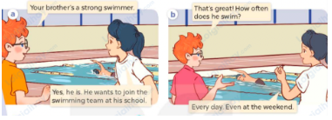  2.Listen, point and say.  Vocabulary.  + eat vegetables: ăn rau  + once a week: một lần một tuần  + twice a week: hai lần một tuần  + three times a week: ba lần một tuần (translation)  + every day: mỗi ngày  * Structures:  A: How often does he / she swim?  B: Every day.  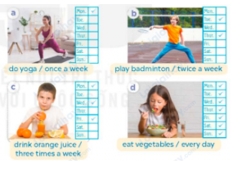  How often does he / she ____? -____.  3. Let’s talk  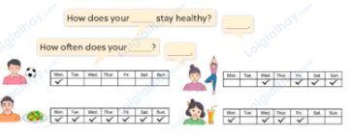  Game: Slap the board  (drink fresh juice, eat healthy food, play badminton, drink orange juice, eat vegetables)
D. ADJUSTMENTS (if necessary):
………………………………………………………………………………………….…..………………………………………………………………………………………………………………………………………………………………………
Week 24 – Grade 5
Teaching day: 04 /03/2025 – class 5A, 5B
Unit 14: Staying healthy
Lesson 2 (4,5,6)
I. OBJECTIVES:
By the end of the lesson, Ss will be able to:
1. Knowledge:
- listen to and understand a conversation in which the speakers talk about someone’s healthy activities and circle the correct answers
- complete two gapped exchanges with the help of picture cues;
- review the target vocabulary related to the topic “Staying healthy” by playing Frequency Game.
- Vocabulary: Review
2. Skills: speaking, listening, reading, and writing.
3. Competences:
- Communication and collaboration: work in pairs and groups to complete the learning tasks.
4. Attitude/ Qualities:
- Show their love and interest in outdoor activities.
- Raise their awareness of doing outdoor activities carefully.
II. METHODS: Communicative approach, group Ss and T's activities, play as a character, teaching methods with game, teaching methods by visual, teaching methods by practising, discussion group, technical present....
III. TEACHING AIDS:
1. Teacher’s preparation: TV, speaker.
- Teacher’s guide
- Website hoclieu.vn
2. Student’s preparation: books, notebooks.
IV. PROCEDURES:
Teacher's and students' activities | Contents
Activity 1.Warm- up and review:  Game: Pass the teddy bears  - Give two different coloured teddy bears to two ss, a black teddy bear (ask the question) and a white teddy bear (answer the question).  - Ss listen  - Ask ss to listen to music and pass the teddy bears.  - Ss play the game  - Stop music suddenly. Have the student with a black teddy bear make a question. Have the student with a white teddy bear answer the question.  - Continue playing the game.  - Repeat the game several times.  - Say “Open your book page 27” and look at “Unit 14, Lesson 2 (4,5,6)”.  - Ss open their books  Activity 2. Listen and circle:  - Ask ss to read the questions and the answer options  -Ss read  - T ask Ss to guess the answers.  -Ss guess the answers  + T writes Ss’guessing on the board.  - Listen to the tape:  + Play the recording  + Play the recording again for pupils to do the task.  + Play the recording a third time for pupils to check their answers.  - Ss listen to the tape  - Ss listen again and do the task  - Get Ss to swap books with their partner, then check answers as a class.  - Ss swap books with their partner, then check answers as a class  + Ss check the answer and the guessing  + Write the answers on the board for Ss to correct their answers. Then checks Ss’ guessing.  - Play the recording, sentence by sentence, for Ss to listen and repeat individually and in chorus.  Activity 2. Read and complete.  - Have ss look at the pictures and elicit  -Ss look at the picture and say  - Have Ss look at the two incomplete exchanges and elicits the missing words in the sentences.  -Ss look and follow the teacher demonstrating the exchange 1.  - T models with the first gap  + Have Ss look at the picture and identify the needed information (orange juice).  -Ss answer: (He drink orange juice.)  - Have Ss work in groups and complete  -Ss complete the sentences  - Get Ss to swap books with a partner and check their answers before checking as a class.  -Ss swap books with a partner and check their answers before checking as a class.  - Invite two pairs of Ss to act out the two completed exchanges in front of the class  -Ss read the completed exchanges aloud.  Activity 3. Let’s play  - Invite two teams, A and B, to play the game.  +Team A asks a question using How often _____?  +Team B picks a piece of paper with a number on it, and uses the number to answer the question.  -Ss listen  -If the question is asked correctly, Team A gets one point. If the answer is correct, Team B gets one point. If Team A fails to ask the question correctly, Team A does not get a point, and the teacher then asks the question correctly to Team B so that they can still earn a point. Then the teams swap roles – Team B  asks and Team A answers.  -Ss play a game  - After two minutes, the team with the most points wins.  - The game continues with other teams.  -Ss praise the winner  3. Consolidation  - Tell s they are going to answer different kinds of questions.  - Ss listen and answer  - Show the questions for the class in turns.  - Ask ss to answer the questions individually.  - If they answer the questions correctly, they will get gifts.  - Praise ss if they play the game well.  .Homework.  - Prepare the new lesson | 4.Listen and circle:  Key: 1. b 2. a 3. b 4. a  5.Read and complete.  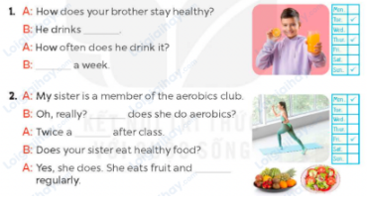  Key:  1. orange juice; three times  2 How often; week; vegetables  6.Let’s play  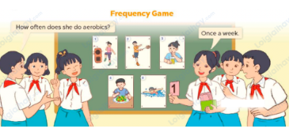  Ex: the number one means once a week or once a month.  Game: Quiz time
D. ADJUSTMENTS (if necessary):
………………………………………………………………………………………….…..………………………………………………………………………………………………………………………………………………………………………………………………………………………………………………………………
Week 24 – Grade 5
Teaching day: 05 /03/2025 – class 5A, 5B
Unit 14: Staying healthy
Lesson 3 (1,2,3)
I. OBJECTIVES:
By the end of the lesson, Ss will be able to:
1. Knowledge:
- stress the correct words in Yes / No questions Does she 'eat 'healthy 'food? and Is your 'brother a 'strong 'swimmer?
- identify and underline the missing stressed word in four questions, and to say the questions with the correct sentence stress while listening
- say the chant with the correct pronunciation, word stress and rhythm.
- Vocabulary: Review
2. Skills: speaking, listening, reading, and writing.
3. Competences:
- Communication and collaboration: work in pairs and groups to complete the learning tasks.
4. Attitude/ Qualities:
- Show their love and interest in outdoor activities.
- Raise their awareness of doing outdoor activities carefully.
II. METHODS: Communicative approach, group Ss and T's activities, play as a character, teaching methods with game, teaching methods by visual, teaching methods by practising, discussion group, technical present....
III. TEACHING AIDS:
1. Teacher’s preparation: TV, speaker.
- Teacher’s guide
- Website hoclieu.vn
2. Student’s preparation: books, notebooks.
IV. PROCEDURES:
Teacher's and students' activities | Contents
Activity 1.Warm- up and review:  - Divide the class into two groups.  - Ask ss in each group to stand closely in a straight line.  -Ss listen the rules  - Teacher says a sentence to the first student in each line- Then, the first student whispers what she/ he hears to the second person in the line and so on until the last student.  - Ss listen  - The last student will say the sentence out loud. If they say the sentence correctly, they will get points for their group.  - Ss play the game  - The group with more points wins the game.  - Say “Open your book page 28” and look at “Unit 14, Lesson 3 (1,2,3)”.  - Ss open their books  Activity 2. Listen and repeat:  - T gives instruction the sentences  - Ss pay attention  - Play the recording and encourage Ss to point at the stressed words (eat, healthy food, brother, strong, swimmer) in the sentence while listening.  - Play the recording again and encourage Ss to listen and repeat.  - Ss listen and point  - Have Ss work in pairs or groups to do this several times until Ss feel confident.  -Ss work in pairs and practice  - T invites some Ss to practice.  -Ss say the language in front of the class  Activity 3. Listen and underline one more stressed word. Then repeat  - Explain what ss have to do and tell ss that the two underlined words in each question are stressed but that one additional stress is missing.  - Ss follow the teacher’s explanation.  - Play the recording for ss to listen.  - Play the recording again for ss to listen and underline one more stressed word in each sentence.  - Ss listen and underline one more stressed word in each sentence.  - Tell ss to swap books with a partner, then check the answers as a class.  - Ss swap books and check their answers as a class.  - Write the correct answers on the board.  - Ss write the answer into notebooks  - Play the recording again for ss to listen and check their answers again.  - Ss listen to the recording and check the correct answers again.  - Get some ss to say the sentences aloud in front of the class. Praise them if they do a good job.  - Ss say the sentences aloud  Activity 4. Let’s chant  - Introduce the title and lyrics of the chant.  - Play the recording for Ss to listen to the whole chant.  - Ss listen to the chant  + Have them repeat the title and lyrics line by line.  - Ss listen and repeat line by line without clap their hands  + Ask Ss to atten the word stress in the sentences  - Ss note the rhythm and pronunciation.  - Play the recording all the way through for Ss to listen to pronunciation and melody.  -Ss listen to melody of the chant  - Play the recording line by line for Ss to listen and repeat  - Ss listen and chant line by line.  - Play the recording for Ss to chant and clap along.  - Ss chant and clap along.  - Ask Ss to practice chant and clap along in pairs  - Ss work in groups (two groups) to chant or groups.  - Invite groups to the front of the classroom to perform the chant  -Ss perform in front of the class.  . Consolidation  - Explain that ss are going to look at the picture and say the sentence about staying healthy and the frequency of an activity.  -Ss listen  - Put some flash cards in a bag.  - Have ss make two circles.  - Ask ss to pass the bag around the circle while music plays.  - When the music stops, have the student holding the bag take out a flash card in the bag and ask a question,  -Ss play the game  - Teacher invites another ss to answer the question.  - Praise ss to encourage their performance. Give gifts if they ask and answer the question correctly.  .Homework.  - Prepare the new lesson  - learn the chant | Game: Whisper  ex: My sister eats vegetables every day.  1.Listen and repeat:  Does she 'eat 'healthy 'food? and Is your 'brother a 'strong 'swimmer?  2.Listen and underline one more stressed word. Then repeat  Key: 1. once 2. week  3. have 4. chips  3.Let’s chant  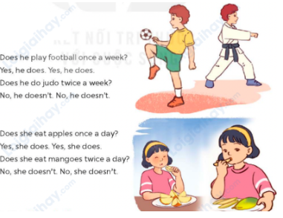  Game: Pass the bag  cards (play sports, drink fresh juice, eat healthy food, do yoga, play badminton, drink orange juice)  ex. How does your mother stay healthy? or How often does your mother eat vegetables?
D. ADJUSTMENTS (if necessary):
………………………………………………………………………………………….…..………………………………………………………………………………………………………………………………………………………………………………………………………………………………………………………………
Week 24 – Grade 5
Teaching day: 06 /03/2025 – class 5B 07 /03/2025 – class 5A
Unit 14: Staying healthy
Lesson 3 (4,5,6)
I. OBJECTIVES:
By the end of the lesson, Ss will be able to:
1. Knowledge:
- read and show understanding of the text by choosing the correct answer options to complete the sentences
- write a paragraph of about 40 words about healthy habits
- make a healthy circle and present their healthy lifestyles to the class.
- Vocabulary: Review
2. Skills: speaking, listening, reading, and writing.
3. Competences:
- Communication and collaboration: work in pairs and groups to complete the learning tasks.
4. Attitude/ Qualities:
- Show their love and interest in outdoor activities.
- Raise their awareness of doing outdoor activities carefully.
II. METHODS: Communicative approach, group Ss and T's activities, play as a character, teaching methods with game, teaching methods by visual, teaching methods by practising, discussion group, technical present....
III. TEACHING AIDS:
1. Teacher’s preparation: TV, speaker.
- Teacher’s guide
- Website hoclieu.vn
2. Student’s preparation: books, notebooks.
IV. PROCEDURES:
Teacher's and students' activities | Contents
Activity 1.Warm- up and review:  - Divide the class into four groups.  - Have ss from each group discuss what activities they do to stay healthy.  - Ss listen to the rules  - Give time for ss to do the task.  - Have the presenter of each group come to the front to present what they have discussed.  - Give comments and praise ss.  -Ss play game  - Say “Open your book page 29” and look at “Unit 14, Lesson 3 (4,5,6)”.  - Ss open their books  Activity 2. Read and circle:  - Draw ss’ attention to the text and read it as a class.  - S pay attention to the text and read it as a class.  - Model sentence 1. First, have ss read the gapped sentence and find the information about the food Peter eats in the text. (fish and vegetables). Then, have ss find the information  - Ss follow the teacher’s instruction with sentence 1.  + Ask ss to choose the correct option to complete Sentence 1.  +Ss choose the correct option  - Ask Ss circle with Sentences 2, 3, 4.  - Ss do the task  - Tell Ss to swap books with a partner, then check answers as a class.  - Ss swap books and check the answers  - Get Ss to look at the board and check their answers again.  - Ss look at the board and check their answers again.  + Have ss read the words / sentences in the reading text that help them find the  + Ss read the words / sentences in the reading text  information they need to circle  - Invite some Ss to say four or five sentences about Peter’s healthy lifestyle  - Ss say about Peter’s healthy lifestyle  Activity 3. Let’s write  - Tell the class the goal of the activity and explain that they should read and complete the table before writing a paragraph about their healthy habits.  - Ss listen to the teacher’s explanation.  - Have ss read the first row and elicit some activities they usually do to stay healthy and the frequency of these activities. Have them read the healthy habit in the second row and complete the first gap with their own answers.  - Ss read and elicit some activities  - Give s time to complete the table independently.  - Ss complete the table independently.  - Have ss use the information in the table to write about their healthy habits.  - Ss use the information in the table to write about their healthy habits.  - Have some ss read their paragraphs aloud. Give feedback where necessary.  - Some ss read their paragraphs aloud.  Activity 4. Project.  - Tell ss about the goal of the activity and explain that they have prepared a healthy habit circle. In the healthy habit circle, there is information about what they eat, drink and do to stay healthy. Ask them to show their healthy habit circle and share it to their friends.  - Ss listen to the teacher’s explanation.  - Have ss work in groups to practise their presentation.  - Ss work in groups to practise their presentation.  - Invite a few ss to show their healthy habit circle and give presentations in front of the class. Praise good performances.  - Ss show their healthy habit circle and give presentations in front of the class.  *. Consolidation  Game: Lucky balloons  - Tell ss they are going to look at the picture, then ask and answer the question about staying healthy or the frequency of an activity.  -Ss listen to the teacher  - Divide the class into two groups.  - Have two ss from each group choose a balloon in turn.  - Ss play the game  - Have them look at the pictures and ask and answer the questions suitable with the pictures.  - Ss ask and answer.  - If they ask and answer correctly, they get corresponding points for their group.  - Continue playing the game with the other ss.  - The group that gets more points wins. Praise the winner.  -Ss praise the winner  .Homework.  - Prepare the new lesson | Game: Discussion  4.Read and circle:  Ex: Peter likes fish and vegetables. Peter drinks lots of water and fresh juice. He exercises every morning. He does judo on Tuesdays and Thursdays.  Key:  1. a 2. b 3. c 4. b  5. Let’s write  Key: Pupil’s answer  Ex I have some healthy habits. I eat vegetables every day. My favourite vegetables are carrots and tomatoes. I like drinking fresh juice. I drink orange juice twice a week. I play basketball three times a week. I want to stay healthy.  6. Project.  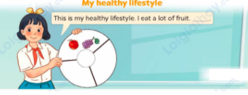  Suggested presentation:  This is my healthy habit circle. I eat fruit every day. I like apples, grapes and mangoes. I drink lots of water and fresh juice. I like coconut water and apple juice. I do morning exercise with my parents every day. I play badminton with my sister three times a week. I want to stay healthy.  Game: Lucky balloons  Ex:  A: How does he stay healthy?  B: He eats vegetables.
D. ADJUSTMENTS (if necessary):
………………………………………………………………………………………….…..………………………………………………………………………………………………………………………………………………………………………………………………………………………………………………………………

