Date of preparation: 2/3/2025
Date of teaching: 4/3/2025

PERIOD 80 UNIT 10: ENERGY SOURCES
Lesson 1: Getting started

I. OBJECTIVES: By the end of the lesson, students will be able to:
1. Knowledge:
1.1. Get more the words relate to the topic: “Energy sources” to understand the context for introductory text.
1.2. Practice the conversation
2. Competence:
2.1. Read for specific information about the conversation to do Ex 2,3,5
2.2. Use the knowledge to match the words/ phrases to correct pictures about energy Ex 4
2.3. List some types of energy sources to your classmates.
3. Quality: Develop communication skills and cultural awareness; Be collaborative and supportive in pair work and teamwork; Actively join in class activities.
II. TEACHING AIDS
Ss’ books, text books, projector, computer, wifi, soft documentary.
III. PROCEDURES:
Teacher’s and Ss’ activities | Contents
1. Organization (1’)  - Checking Ss’ attendances  2. Warm up (4’)  - Teacher gives instructions  - Asks Ss tell some type of energy that they know  - T introduces new lesson.  3. New lesson (35’)  + Activity 1 (15’)  * Teacher introduces the vocabulary by:  + Providing the synonym or antonym of the words.  + Providing the pictures of the words.  + Providing the definition of the words.  Teacher shows and says the words aloud and asks Ss to repeat them.  Teacher asks Ss to translate the word into Vietnamese  EX 2 (1.1; 2.1) (5’)  * Teacher asks Ss to look at the picture (p.107), answer the question:  What are Lan and her father talking about?  EX 3 (1.2; 2.1) (10’)  Teacher asks Ss to work individually to read and listen to the conversation and answer the questions and then share their answers with their partners who sit next to them. (peer check)  Ss do exercise 3 individually  Ss share and discuss with their partners to write all answer down on the notebooks.  Teacher corrects their answers as a class.  EX 4 ( 1.2; 2.2) (5’)  Teacher nominates Ss to read the words aloud and  Teacher checks and gives the correct answers  EX 5 (1.1; 2.1) (5’)  Teacher asks Ss to work individually to find the words/phrases from the conversation and then share their answers with their partners who sit next to them. (peer check)  Ss do exercise 5 individually  Teacher corrects their answers as a class  4. Feedback (2’) (1.1; 1.2; 2.3)  - Ask some good students list some types of energy sources to your classmates.  - Teacher asks students to talk about what they have learnt in the lesson.  5. Homework (3’)  - Learn the new word by heart  - Prepare: Unit 10 - A closer look 1  + List some types of energy. | BRAIN STORMING  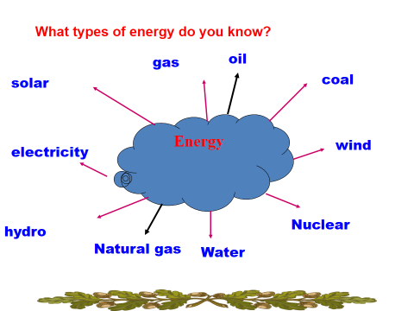  1. Listen and read.  *Vocabulary:  1. enery source (n)  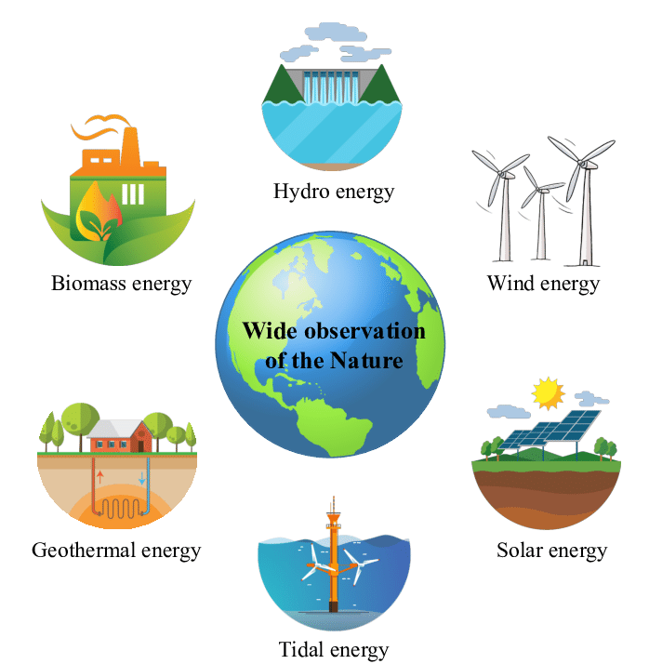  2. coal (n) 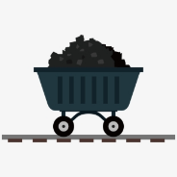  3. renewable (a): Can be replaced naturally and can be used without the risk of using it all up  4. run out (phr v): To use up or finish a supply of something  2. Read for main ideas: What are Lan and her father talking about?  Answer: C  3. Read the conversation again and answer the questions.  Answers  1. Lan is doing a project on energy sources.  2. It’s power that we use to provide us with light, heat or electricity.  3. It comes from many different sources like coal, oil, natural gas, … and renewable sources  4. Renewable sources are those we can easily replace them such as: water, sun,…  4. Match the words / phrases in the box with the correct pictures.  Suggested answers:  1. c 2. a 3. b 4. d  5. Complete each of the sentences with the correct word from the conversation  Answers  1. power  2. sun  3. wind  4. run  5. cheap

PERIOD 81 UNIT 10: ENERGY SOURCES

Lesson 2: A closer look 1

I. OBJECTIVES: By the end of the lesson, students will be able to:
1. Knowledge:

1.1. Know and use words/phrases related to the topic energy sources ( energy, renewable; non-renewable energy...)

1.2. Pronunciation : stress in three- syllable words

2. Competence:

2.1. Use vocabulary to do ex 1,2, 3
2.2. Know how to pronounce stress in three- syllable words to do the Ex 4,5.
2.3. Use words to make some sentences about energy sources.
3. Quality: Develop communication skills and cultural awareness Develop awareness of energy sources and energy saving.
II. TEACHING AIDS
Ss’ books, text books, projector, computer, wifi, soft documentary.
III. PROCEDURES:
Teacher’s and Ss’ activities | Contents
1. Organization (1’)  - Checking Ss’ attendance  2.Warm up (4’)  T asks Ss look at the picture and repeat energy sources  - T guides to new lesson  3. New lesson (35’)  + Activity 1 (10’)  Ex1. (1.1); (1.2)  -Teacher asks Ss to look at the table and match the energy with its source.  Ss work out and answer questions in pairs.  Ss share their answers as a whole class.  - T asks them to to check their answers.  - Teacher asks students to make full sentences to tell about the sources of different energy. Then tell share them to share their sentences with a partner and correct for them.  Ex2. (1.1)(2.1)  -Teacher asks Ss to look at the pictures and use the knowledge from Task 1 to guess the pictures.  Then work and share their answers with their partners who sit next to them. (peer check)  -Ss do exercise 2 in pairs.  -Ss share and discuss with their partners to write all words/ phrases down on the notebooks.  -Teacher corrects their answers as a class.  Ex 3: (1.1; 2.1; 2.3)  - Teacher gives students time to do the exercise individually, then share their sentences.  -Teacher nominates Ss to say the sentences aloud.  - Teacher checks and gives the corrections if they have mistakes.  - Ask some good Ss use words to make some sentences about energy sources.  + Activity 2 (25’)  - T gives some example, guide Ss how to stress in three syllable Nouns and Adjectives.  - Gives Ss some rules  Ex 4 (1.2; 2.2)  -Teacher gives Ss time to listen and practice pronouncing the words with correct primary stress.  Task 5 (1.2,2.2, 2.3)  -Ss do as instructed  -Teacher gives Ss feedback.  - choose some common mispronounced words and suggest students practise using them.  - choose some typical errors and correct as a whole class  4.Feedback (2’)  - Ask Ss to retell the content of this lesson.  -Vocabulary about sources of energy.  - Pronunciation: Stress in three-syllable words  5. Homework (3’)  - T reminds Ss to do homework and prepare the new lesson. | 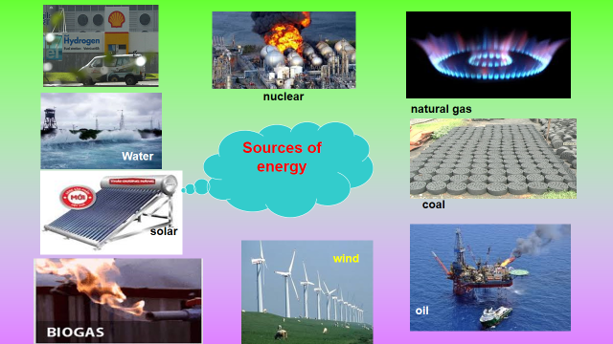  1 Match the types of energy in A with the energy sources in B  Answers:  1- D 2 – C 3 – A 4 – B  2. Write the phrases to label the pictures:  Answers  1. Nuclear energy  2. Hydro energy  3. Solar energy  4. Wind energy  3. Complete the sentences with the words and phrases from 1 or 2  Answers  1. wind  2. solar energy  3. water  4. nuclear  II. PRONUNCIATION  * How to stress in three-syllable Nouns and Adjectives .  Rule1 : Ooo When Sylablel2 &3 are short vowels. ( very popular)  Eg: excellent , difficult , president , plentiful , energy accident , dangerous  Rule2 : oOo When Syllable 2 is a long vowel or a dipthong and Syllable3 is a short vowel or dipthong /ou/ . ( popular)  Eg : disaster , potato , enormous , expensive , convenient , advantage ..  4. Listen and repeat. Pay attention to the stressed syllables in the words.  5. Listen and repeat, paying attention to the stressed syllables in the underlined words.  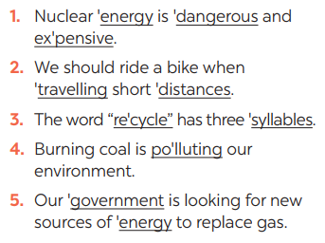  - Learn the new word by heart and read again the stress  - Prepare: Unit 10 - A closer look 2

Period 83:

Unit 10 : ENERGY SOURCES

Communication
I. OBJECTIVES: By the end of the lesson, students will be able to:
1. Knowledge:
1.1. Asking for explanations
1.2. Talking about how to save energy
2. Competence:
2.1. Make conversations to ask for explanations in ex 2
2.2. Use the vocabulary and knowledge about the topic to ask their partner some questions in ex 3
2.3. Tell the class about your interview Ex 4,5
3. Quality:
Be benevolent and responsible.
II. TEACHING AIDS
Ss’ books, text books, projector, computer, wifi, soft documentary.

III. PROCEDURES:
Teacher’s and Ss’ activities | Contents
1. Organization (1’)  - Greetings  - Attendance-checking:  2.Warm up (4’)  - Teacher divides class into 2 teams and asks them to think of “TYPES OF ENERGY”  - Ss have 1 min to think of the words related to the topic or they can discuss with their partners.  - Each member from each team turn by turn run to the board and write one word.  - Teacher corrects their answers.  - The team which has more correct words will be the winner.  -T lead in new lesson  “Teacher leads students into the lesson by telling what they are going to learn: “We are going to learn how to ask and answer for explanations and find out how well we save energy”.  3-New lesson  a, Activity 1 (15’)(1.1)  -Teacher plays the record for SS to listen and read the conversation.  -Ss listen and practice saying with their partners.  -Teacher calls some pairs to read aloud.  -Teacher corrects pronunciation if needed.  -Teacher asks Ss to pay attention to the highlighted parts and asks them some questions to elicit the new structure:  - Which tense do we use to ask and answer?  - Which question word and verb do we use?  - …..  -Ss answer teacher’s questions to find out new structure to ask and answer for explanations.  -Some students give the new structure to the teacher.  -Teacher corrects and writes on the board.  b, Activity 2 (8’)  Ex 2 (1.1; 2.1)  -Teacher has SS look at the phrases in Ex 2 to make similar dialogue.  -Ss work in pairs to make similar dialogue.  -Teacher calls some pairs to present it in front of the class.  -Teacher gives feedback and some comments.  -Teacher asks Ss to work in pairs and tick.  -Ss so the task in pairs  Ex3: 1.2, 2.2  -Teacher asks Ss to work in pairs and tick.  -Ss do the task in pairs  - Ask them check across  - T gives correct answer  Ex4: 1.2, 2.3  - Teacher gives students time to prepare. Meanwhile, teacher walks around the classroom to help students if they have difficulties find proper words/phrases/structures  -Teacher calls some Ss to read aloud their work  - Teacher let Ss listen and correct mistakes (if needed).  Ex 5 (1.2, 2.3)  -Teacher allows students time to answer the questions onto their notebooks and prepare.  -Ss work individually.  -Ss can practicing sharing to their partners  -Teacher calls some students to read aloud their work. Teacher let Ss listen and correct mistakes (if needed).  4.Feedback (2’)  Teacher asks students to talk about what they have learnt in the lesson.  5. Home work (3’)  - Give out the homework and guide ss to prepare for the new lesson. | Suggested answers:  Solar, hydro, coal, natural gas, oil, wind,…  1.Listen and read the conversation. Pay attention to the highlighted questions.  - Structure:  to ask:  - What do/does + S + mean?  to answer:  - S + mean(s)/be …  2. Work in pairs. Make similar conversations to ask for explanations.  Suggested answers:  A: What does hydro energy mean?  B: It’s energy that comes from the sun. What does nuclear energy mean?  A: It’s energy that comes from the nuclear power  II. SAVING ENERGY  3. Work in pairs. Ask your partner the following questions and tick his or her answers in the boxes.  4. Work in groups. Speech: how well your partner saves energy.  5. Answer the questions in 3 on your own. Speech: how well you save energy  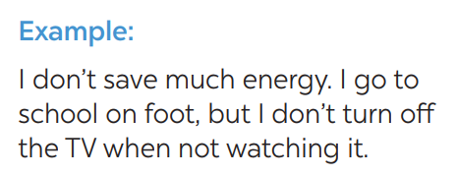  *Homework:  - Prepare for the next lesson: Unit 10: Skills 1.  + Read the lecture on energy sources  + Use pencils to do exercises in the text books.

Period 84: Unit 10 : ENERGY SOURCES

Skills 1
I. OBJECTIVES: By the end of the lesson, students will be able to:
1. Knowledge
1.1. Reading for general and specific information about energy sources.
1.2. Talking about some advantages and disadvantages of different energy sources
2. Competence:
2.1. Use the information in reading to do Ex 1,2,3
2.2. Use the words/ phrases to distinguish advantages and disadvantages of different energy sources in ex 4
2.3. Students can apply grammar and vocabulary to talk about advantages and disadvantages of different energy sources 3. Quality:
Love about our natural; Develop awareness of energy sources and energy saving.
II. TEACHING AIDS
Ss’ books, text books, projector, computer, wifi, soft documentary.

III. PROCEDURES:
Teacher’s and Ss’ activities | Contents
1. Organization (1’)  - Greetings  - Attendance-checking:  2. Warm up (4’)  DISCUSSION  -Teacher asks Ss to work in pairs to look at the Picture in Ex1 and discuss to answer the questions.  -Ss work in pairs.  -Teacher calls some Ss to check what they have discussed.  -Teacher corrects  “Teacher leads students into the lesson by telling what they are going to learn: “We are going to read a passage about renewable and non-renewable source of energy.”  3-New lesson  a, Activity 1 (20’)  - Teacher introduces the vocabulary by:  + Providing the definition of the words and gives examples  Ex1: 1.1, 2.1  - Teacher gives Ss time to: read each question, locate where the information appears in the text, read that part carefully and circle the correct answer.  - Ss do the task independently  - Teacher tells Ss to compare their answers in pairs before calling some of them to check.  - Teacher confirms the correct answer and explains if needed.  Ex2: 1.1, 2.1  -Teacher asks Ss to do the exercise carefully and individually.  -Ss do the task independently.  -Teachers has Ss compare their answers in pairs and call some Ss to give their ideas.  -Teacher checks and confirms the correct answers.  Ex3: 1.1, 2.1  - Teacher asks Ss to work in groups and tells them to focus on the table.  - Ss work in groups. Teacher goes around and listens and gives help if needed.  - Teacher calls on some Ss to share their answers with the class. Teacher encourages  - Teacher listens and corrects if needed  b, Activity 2 (15’)  Ex4: 1.2, 2.2  -Teacher has Ss work in pairs and asks them to take turns to ask and answer  -Ss work in pairs to do the task. Teacher goes around, listens and gives help if needed.  -Teacher calls on some pairs to share their answers with the class.  -Teacher comments and correct.  Ex5: 1.2, 2.3  - Teacher has students work in groups to prepare a presentation (poster/pictures/notes…)  - Teacher calls on some groups to share their answers with the class.  - Teacher comments and corrects if needed  4. Feedback (2’) (1.1;2.2; 2.3)  Teacher asks students to talk about what they have learnt in the lesson.  - Ask some good students can apply grammar and vocabulary to talk about advantages and disadvantages of different energy sources  5. Home work (3’)  - Give out the homework and guide ss to prepare for the new lesson. | Vocabulary  - produce (v)/prəˈdjuːs/ sản xuất  = to make things, mostly in large quantity  Examples: Companies produce many toys for children before Christmas.  - limited (a) /ˈlɪmɪtɪd/ bị hạn chế  = not very great in amount or extent  Examples: coal, oil, …  - available (a)/əˈveɪləbl/ có sẵn  = that you can get, buy or find  Examples: The coal takes a long time to be available again.  Suggested keys:  1. Coal, oil, hydro,…  2. Wind, solar,…  I. READING  1. Read the text and choose the best option to complete the sentences.  Answer key:  1. B 2. A 3. C 3. A  2. Read the text again and answer  the questions  Answer key:  1. There are two energy sources. They  are non-renewable sources and renewable sources.  2. Non-renewable sources are coal, oil  and natural gas.  3. Renewable sources are available, clean and safe to use.  4. In the future, we will rely more on  renewable energy sources  3. Work in groups. Discuss and put the following words or phrases in the appropriate columns.  Answer key:  Advantages: easy to use, safe to use, good for environment, cheap, available  Disadvantages: run out, expensive, limited, cheap  II. SPEAKING  4. Work in pairs. Ask and answer questions about the advantages and disadvantages of different energy sources  5. Give the advices on dangerous situations on the road  * Homework:  - Read and understand the passage  - Prepare for the next lesson: Unit 10: Skills 2.  + find new words

Period 84: Unit 10 : ENERGY SOURCES

Skills 2
I. OBJECTIVES: By the end of the lesson, students will be able to:
1. Knowledge:
1.1. Listening for general & specific information about how to save energy
1.2. Writing a paragraph about how to save energy
2. Competence:

2.1. Listen the conversation to get information to do ex 1,2,3
2.2. Discuss three ways to save energy at home in ex 4
2.3. Write a paragraph within 70 words how to save energy at home ex 5

2.4. Write a paragraph how to save energy at home by their own ideas.
3. Quality:
Be benevolent and responsible.
II. TEACHING AIDS
Ss’ books, text books, projector, computer, wifi, soft documentary.

III. PROCEDURES:
Teacher’s and Ss’ activities | Contents
1. Organization (1’)  - Greetings  - Attendance-checking:  2.Warm up (4’)  PASS THE CHALK  -Teacher writes on the board the word “HOW TO SAVE ENERGY” and divide the class into 2 groups.  - Ss take turns to go to the board  -Teacher calls some students to give their answers.  -Teacher listens and give comments  Teacher introduces students the content of the lesson: “In the lesson today, we are going to listen to a person talking about how to save energy at home.”  3-New lesson  a, Activity 1 (18’)  Ex1: 1.1, 2.1  -Teacher asks Ss to work in pairs to answer the questions in the picture  -Ss work with their partner to do the task.  - Teacher calls on some Ss to answer.  - Teacher gives comments and leads Ss to task  Ex2: 1.1, 2.1  -Teacher asks Ss to read and underline the key words.  - Ss work independently to guess then listen to the recording once to check their guess.  - Teacher calls on some students to give the answers the have listened.  Ex3: 1.2, 2.2  -Teacher asks Ss to read and underline the key words.  -Ss work independently listen to the recording and tick T or F  -Teacher calls on some students to give the answers the have listened.  b, Activity 2 (18’)  Ex4: 1.2, 2.2  -Teacher asks Ss to write the methods they use to save energy at home then asks them to give out more if they can.  -Ss think of it and can discuss with their partners.  -Teacher calls on some Ss to raise their ideas.  -Teacher listens and confirms.  EX 5: (1.2; 2.3)  -Teacher tells Ss that they are going to write a passage about how you save energy at home.  -Teacher reminds Ss of the structure of a passage and steps to make an outline for the passage  Ss work independently to do the task and try to use the notes from the previous tasks.  Teacher goes around and help if necessary  Peer check and cross check  -Teacher asks Ss to share their writing with their partners. Then, call on some Ss to show their writing in front of the class.  -Teacher checks ideas, grammar, vocabulary and gives comments.  4. Feedback: 3’ (1.2; 2.3; 2.4)  Summarize the main point of the lesson.  - Ask good student write a paragraph how to save energy at home by their own ideas at home  5. Home work : (3’)  - Give out the homework and guide ss to prepare for the new lesson. | I. Listening  1. What can you see in this picture? What is special about it?  Suggested answers:  - solar energy  - turn off the tap while brushing your teeth, use paper fan, …  2. Listen and circle the phrases you hear  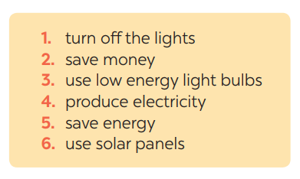  3. Listen again and tick T (True) or F (False) for each sentence  II. Writing  4. Work in pairs. Read some ways to save energy at home. Choose three ways and write them in your notebook.  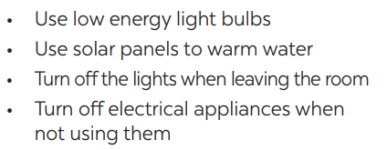  5. Write a paragraph of about 70 words about how you save energy at home.  Suggested answers:  We use a lot of energy at home and it costs us a lot. To save energy, we should try making use of natural light more instead of keep the lights unnecessarily in the morning and afternoons. Moreover, we should unplug your electrical gadgets when not in use. These devices consume at least 10% of electricity even when inactive. Therefore, unplug them to save electricity. Most importantly, installing solar panels can help you excessively. They are very economical and help in saving a lot of energy. This can help in getting cheap electricity and protect the environment.  * Homework:  - Write a paragraph of about 70 words about how you save energy at home.  - Prepare for the next lesson: Unit 10: Looking back & Project

Period 85:

Unit 10 : ENERGY SOURCES

Looking back + project
I. OBJECTIVES: By the end of the lesson, students will be able to:
1. Knowledge:

1.1. Vocabulary: combination words about “Energy sources”

1.2. Grammar: The present continuous tense.

2. Competence:

2.1 Combinations words & words to do Ex 1,2

2.2. Use the knowledge about the present continuous tense to do Ex 3,4
2.3. Do some further practice exercises using all the advanced knowledge they’ve learn in the unit
3. Quality:
- Be benevolent and responsible ; Develop self-study skills
II. TEACHING AIDS
Ss’ books, text books, projector, computer, wifi, soft documentary.

III. PROCEDURES:
Teacher’s and Ss’ activities | Contents
1. Organization (1’)  - Greetings  - Attendance-checking:  2.Warm up (4’)  Quick revision check  -Teacher asks Ss to think of what they have learnt already in Unit 10.  -Ss work in pairs to do the task.  -Teacher calls some students to retell.  -Teacher confirms and leads them to do all the exercises in books  3-New lesson  a, Activity 1. (13’)  Ex1 : 1.1, 2.1  -Teacher has Ss work individually.  -Ss do this activity individually, then compare their answers with their partners.  -Teacher asks for Ss’ answers.  -Teacher confirms the correct ones and asks students to make sentences using the phrases.  Ex 2: (1.1; 2.1)  -Teacher has Ss work individually.  -Ss do this activity then compare their answers with their partners.  -Teacher asks for Ss’ answers. **** Teacher confirms the correct ones  b, Activity 2 (15’)  Ex3: 1.2, 2.2  -Teacher asks Ss to recall the structures of “The present continuous”, and tell them to do Ex 3 in the book.  -Ss do the exercise individually and swap with their partners.  -Teacher calls some Ss to check their answer.  - Teacher confirms the correct answer  Ex4: 1.2, 2.2  -Teacher asks Ss to do the task.  - Ss work individually to do the task.  -Teacher calls Ss to give out their answers.  - Teacher checks and confirms their answer.  4. Feedback (2’)(1.1; 1.2; 2.3)  Summarize the main point of the lesson.  Do some further practice exercises using all the advanced knowledge they’ve learn in the unit in work book  5. Home work : (3’)  - Guide Ss do project at home.  - Give out the homework and guide ss to prepare for the new lesson. | I. Vocabulary:  1.Match the adjectives in A with the nouns in B to make phrases  Answer keys:  1. e 2. a  3. d 4. b 5. c  2. Complete the sentences, using the phrases in 1  Answer keys:  1. low energy light bulbs  2. electrical applicances  3. renewable energy sources  4. solar energy  5. hot water  II. Grammar  3. Complete the sentences by using the correct form of the present continuous or present simple of the verbs in brackets.  Answer keys:  1- is raining  2- start  3- is walking  4- does  5- am writing  4. Find ONE mistake in each sentence and correct it  Answer keys:  1. do -> are doing  2. explain -> explaining  3. is -> are  4. use -> using  5. look -> are looking  * Homework:  - Do the project  - Review all the lessons  - Prepare for Review –Language

