Planning date: 12/1/2025
Teaching date: 13/1/2025
PERIOD 55:
UNIT 7: TRAFFIC
GETTING STARTED
I. OBJECTIVES: By the end of the lesson, students will be able to:
1. Knowledge:
1.1. Memorize the words related to mean of transport and road signs.
2. Competence:
2.1 Understand the text and read the conversation, get the information to do the exercises. (Ex2,3)
2.2. Use the knowledge to do exercise given. (Ex4,5)
2.3. Use the words learned to write the transport they like.
3. Quality:
3.1 Develop awareness of travelling in town/city
II. TEACHING AIDS
Ss’ books, text books, projector, computer, Wi-Fi, soft documentary.
III. PROCEDURES:
Teacher’s and students’ activities | Contents
1. Organization (1’)  Checking Ss’ attendance.  2. Warm up (2’)  - Greeting: Chatting  - T asks students to answer the questions related to means of transport.  - Ss answer some questions which the teacher gives  3. New lesson (35’)  + Activity 1 (10’) (1.1).  Teacher shows and says the words aloud and asks Ss to repeat them.  * Teacher asks Ss to translate the word into Vietnamese.  Concept check: Slap the board  1. What is he doing?  2. What is this?  3. What are they doing?  4. Which time of the day usually has traffic jam?  - T lets students listen to the tape and read the dialogue and act out.  - Ss listen and practice the dialogue in pairs.  - T elicits words from Ss  - Ss read and copy and remember  - T asks students to read in chorus.  Activity 2(25’)  Task 1 (1.1) (2.1)  To get students interested in the topic  - To set the context  - To help Ss understand the main idea of the text  Ss work out and answer questions in pairs.  Ss share their answers as a whole class.  T asks them to read and listen to the conversation to check their answers. T encourages students to explain where they have found the answers from the conversation.  Task 2. (1.1) (2.1).  Teacher asks Ss to work individually to read and listen to the conversation and find the words and phrases and then share their answers with their partners who sit next to them. (peer check)  Ss do exercise 3 individually  Ss share and discuss with their partners to write all words/ phrases down on the notebooks.  Teacher corrects their answers as a class.  Task 3. (1.1) (2.2).  - T asks Ss to work independently.  - Ss work individually.  - T allows Ss to share their answers and discuss.  Teacher nominates to Ss to read the word aloud and checks give the correct answer.  Task 4 (1.1) (2.2).  - Students goes around the class and ask at least 20 classmates and ask them (Do you usually walk to school? Have you ever gone to school by bus? …)  - observer Ss while they are role playing, note their language errors  Ss do as instructed  Teacher gives Ss feedback.  - choose some useful or excellent words/ phrases/ expressions/ word choices Ss have used to suggest other students use them.  -choose some typical errors and correct as a whole class without nominating the students’ names  4. Feedback (5’)  - Ask one or two Ss to tell the class about the means of transport.  - Ask them to say aloud some words they remember from the lesson. | * Questions  How do you go to school?  1. Listen and read.  * Vocabulary  - cycle/ˈsaikl/ (n): đạp xe    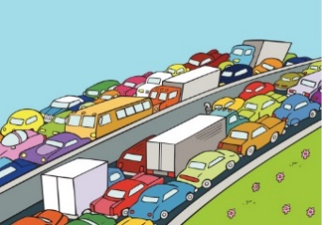  - traffic jam /ˈtræfik dꝫæm/ (n): tắc đường  - cross the road /krɒs Ѣә rəᴜd/ (v): băng qua đường    - rush hour /ˈrᴧʃ aᴜə/giờ cao điểm    ?  Practice:  Task 1. Ex 2 (p.74):  * Teacher asks Ss to look at the picture (p.73), answer the question:  + Where are they?  Answers  1. A 2. B 3. C  Task 2. Ex 3 (p.74): Write one word from the conversation to complete each sentence.  Answers  1. cycled 2. should 3. jams 4. How 5. crowded  Task 3: Ex4. Look at the pictures and write a word under each.  answers:  1. bicycle 2. car 3. bus 4. motorbike  5. plane/air-plane 6. train 7. boat 8. ship  Task 4. Ex5. Find someone who … Write your friends’ names in the blanks. Then report to the class  Do you usually walk to school?  Yes, I do/ No, I don’t.
5. Homework:2’
-Talk about the traffic in your neighbourhood.
- Exercises in the workbook
- Learn the new words and structures by heart and do Ex 5
- Prepare the lesson: Unit 7: A closer look 1

-------------------------------------------------------------------------------------------------

PERIOD 56:
UNIT 7: TELEVISION
A CLOSER LOOK 1
I. OBJECTIVES: By the end of the lesson, students will be able to:
1. Knowledge:
1.1. Memorize the words/ phrases related to means transport
1.2. Identify the words to road signs.
1.3. Pronounce the sounds /ai/ and /ei/.
2. Competence:
2.1. Use the knowledge to do the exercises given. (Ex1)
2.2. Use the knowledge to do the exercises given. (Ex2,3)
2.3. Pronoun the sounds /ai/ and /ei/ correctly to do exercise. Ex4,5)
2.4. Use the words learned to talk about means of transport and road signs, use words in Ex1,2
3. Quality:
Develop awareness of understanding the road signs and obeying the traffic rules.
II. TEACHING AIDS
Ss’ books, text books, projector, computer, Wi-Fi, soft documentary.
III. PROCEDURES:
Teacher’s and students’ activities | Contents
1. Organization (1’)  Checking Ss’ attendance.  2. Warm up (2’)  JUMBLED WORDS  * Teacher gives instructions  ** In groups of 5, Ss will be given a small white board and marker.  - Teacher show the jumbled words onto the screen one by one  - Students work in groups to make the correct words and write down onto the small boards. When they finish, they hold it up to show their answers to teacher.  - take turns to write until finish all the words.  3. New lesson (35’)  + Activity 1 (8’) (1.1)  T asks Ss to look at the photos and answer the question  Ss say the words.  1.What are they?  2. What is this?  3. What is this?  Other Ss correct if the previous answers are incorrect.  Teacher shows and says the words aloud and asks Ss to repeat them.  Teacher asks Ss to translate the word into English.  Task1 (1.1) (2.1)  - Teacher asks Ss to look at the table (p.74), identify the form (verbs and nouns – means of transport):  - Ss work out and answer questions in pairs.  Ss share their answers as a whole class.  T asks them to to check their answers.  Teacher asks students to make your own sentences with these phrases. Then tell share them to share their sentences with a partner and correct for them.  - T checks their answer as a class.  Activity 2 (10’)  Task 2 (1.2) (2.2)  Teacher asks Ss to look at the road signs and guess their meanings. Then work and share their answers with their partners who sit next to them. (peer check) Ss do exercise 3 in pairs.  Ss share and discuss with their partners to write all words/ phrases down on the books.  Teacher corrects their answers as a class.  Task 3. (1.2) (2.2)  Teacher gives suggestions and asks students to share their sentences.  Teacher nominates Ss to say the sentences aloud  Teacher checks and gives the corrections if they have mistakes  Activity 3(17’).  Task 4 (1.2) (2.3)  Teacher gives Ss time to listen and practice pronouncing the sounds individually and words.  - T corrects and remarks  - T plays the recording;  - Ss listen and repeat the words they hear.  Ex5 (1.3) (2.3)  Ss do as instructed  Teacher gives Ss feedback.  - choose some common mispronounced words that contain the sounds and suggest students practice using them.  - choose some typical errors and correct as a whole class  4. Feedback (5’)  Use the words in the picture about road signs to talk what you should and shouldn’t do, use words in Ex 3. | Answers:  1- otba -> boat  2- itanr -> train  3- npeilapra -> airplane  4- rsotrpca -> sport car  5- otmiroekb -> motorbike  I. Vocabulary  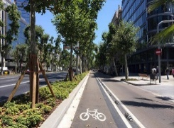  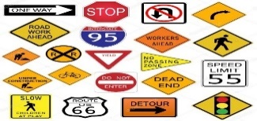  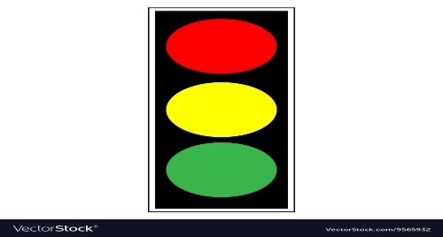  Task 1. Exercise 1 (p.74): Match the words in A with the phrases in B.  Answers:  1- C 2 – A 3 – B 4 – E 5 – D  Task2.Ex 2. (p.74): Look at these road signs. Then write the correct phrases under the signs.  Answers  1. traffic lights 2. Hospital ahead 3. No right turn  4. cycle lane 5. School ahead 6. No cycling  Task 3: Work in pairs. Take turns to say which of the signs in 2 you see on the way to school.  Eg: On the way to school, there is a market, so I see a market ahead’ sign.  II. Pronunciation  Task 4.  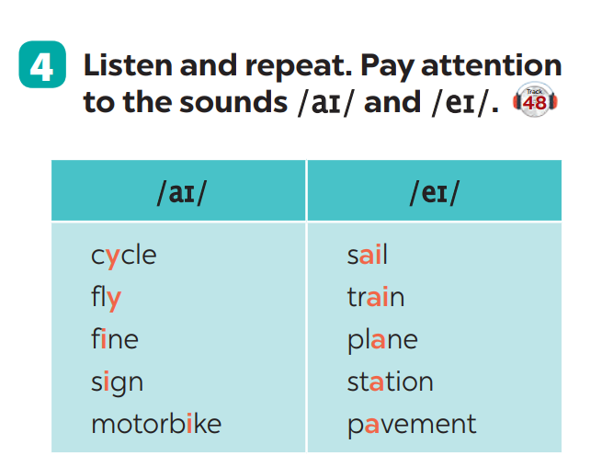  Task 5: Underline the words with the sound /aɪ/ and circle the words with the sound /eɪ/. Then listen, check and repeat  1. They are thinking about the weather there.  2. The new theater opens on Thursday the third.
5. Homework (2’)
- Learn the new words by heart read again the sounds /ei /and / ai/
- Prepare the lesson: Unit 7: A closer look 2.

PERIOD 57:
UNIT 7: TELEVISION
A CLOSER LOOK 2
I. OBJECTIVES: By the end of the lesson, students will be able to:
1. Knowledge:
1.1. Memorize the indicate distance.
1.2. Memorize should and shouldn’t.
2. Competence:
2.1 Use the knowledge to do exercises given. (Ex1,2)
2.2 Use should and shouldn’t to do exercise given. (Ex3,4,5)
2.3 Use the indicate distance, should and shouldn’t to make the sentences.
3. Quality:
- Develop awareness of understanding the road signs and obeying the traffic rules.
II. TEACHING AIDS
Ss’ books, text books, projector, computer, Wi-Fi, soft documentary.
III. PROCEDURES:
Teacher’s and students’ activities | Contents
1. Organization (1’)  Checking Ss’ attendance.  2. Warm up (2’)  SLAP THE BOARD  Teacher gives instructions and sticks some road signs pictures onto the board.  In 2 group, Ss will choose 1 student in each group to go to the board.  - Teacher says a road sign message.  - Student quickly run and slap onto the correct road signs.  - Students take turns until finish all of the signs.  3. New lesson (35’)  + Activity 1 (15)(1.1):Grammar  - Teacher says: “This lesson today is going to tell you about “it indicating distance”  Teacher draws students’ attention to the grammar point and the example  Teacher asks Ss:  - What does the sentences tell us about?  Answer: Distance from his/her house to the bus stop  - What is the structure using in the sentence?  Answer: It be (about) + distance from A to B.  Ss read the grammar explicit and study the example.  Ss may discuss within groups/pairs before answering.  Teacher shows and says the sentences aloud and asks Ss to make similar sentences.  Task 1 (1.1) (2.1)  Teacher asks Ss to look at the example and the task.  Ss work out and answer questions individually.  Ss share their answers in pairs.  T asks them to to check their answers.  Then tell share them to share their sentences as a whole in class and correct for them.  Task 2: (1.1) (2.1)  Teacher asks Ss to look at the example and identify the structure of the question: How far is it from … to …?  Then work with their partners who sit next to them to make similar conversations.  Ss do exercise 2 in pairs.  Ss write all conversations down on the notebooks.  Teacher corrects their answers as a class.  Activity 2(1.2)(20’)  Should / shouldn’t  Teacher draws students attention to the remember box. Teacher asks them to study the examples and identify the structure: S + should/shouldn’t + Vinf  Teacher gives suggestions and asks students to make some similar sentences using the structures.  Teacher nominates Ss to read aloud the sentences.  Teacher checks and gives the corrections if they have mistakes.  Task 3(1.2) (2.2)  T asks Ss to work individually.  Call each student to read the answer.  Teacher checks and gives the corrections if they have mistakes.  Task 4(1.2) (2.2)  Teacher gives Ss time to do the exercise individually and peer check with their partner.  Teacher nominates Ss to read aloud the sentences.  Teacher checks and gives the corrections if they have mistakes.  Task 5. (1.2) (2.2)  Ss do as instructed  Teacher gives Ss feedback.  - choose some common mistakes and suggest students how to avoid them.  - choose some typical errors and correct as a whole class  4. Feedback (5’)  - Use should/ shouldn’t to make the sentence | SLAP THE BOARD  1- Cycle lane  2- School ahead  3- No cycling  4- No right turn  5- Schools ahead  * Grammar:  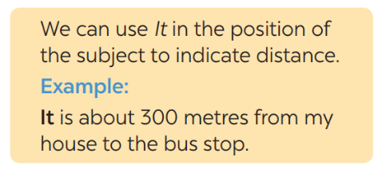  I. IT INDICATING DISTANCE  Task 1. Ex 1: Write sentences with It. Use these cues.  1- It is 700m from my house/home to the Youth club.  2- It is 5 kilometers from my village to the nearest town.  3- It is about 120 km from Ho Chi Minh city to Vung Tau.  4- It is 384,400 km from the Earth to the Moon.  5- It is not very far from Hanoi center to Noi Bai airport.  Task 2. Ex 2: Work in pairs. Ask and answer questions about distances in your neighbourhood.  A: How far is it from your house to the open market?  B: It is about……..km(s).  II. Should / shouldn’t  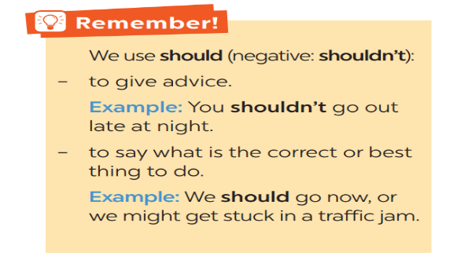-  Task 3: Choose the correct option in brackets  1.should; 2. should; 3. shouldn’t; 4.should; 5. shouldn’t  Task 4. Complete each sentence, using should / shouldn’t.  Answers:  1- shouldn’t 2- should 3- shouldn’t 4- should  5- should 6- shouldn’t  Task 5. Look at the pictures. Make sentences, using should / shouldn’t and the cues.  Key:  1- He shouldn’t waste water.  2- They should wear their helmets.  3- She should be more careful.  4- They shouldn’t play football on the pavement.  5- They shouldn’t ride their bikes dangerously
5. Homework (2’)
- Make sentences with should/ shouldn’t and indicating distance.
- Prepare the lesson: Unit 7- Communication

PERIOD 58:
UNIT 7: TRAFFIC
COMMUNICATION

I. OBJECTIVES: By the end of the lesson, students will be able to:
1. Knowledge:
1.1.Introduce and giving information about means transport and some strange
traffic rules
1.2.Practice about means transport and some strange traffic rules.
2. Competence:
2.1 Use the knowledge to do the exercises given. (Ex2).
2.2. Use the knowledge about strange traffic rules to do the exercises given.
(Ex3,4,5).
* 2.3. Ask and answer the questions about the means of transport in Ex 1
they prefer
3. Quality:
3.1. Develop awareness of travelling in town/city.
3.2. Be concerned to the local traffice.
II. TEACHING AIDS
Books, text books, projector, computer.
III. PROCEDURES:
Teacher's and Ss' activities | Contents
1. Organization (1')  Checking Ss attendance:  6A1: ...........................  6A2: ...........................  2. Warm up: 4'  * Teacher divides class into 2 teams and asks them to think of “means of transport” (even the strangest ones).  -Ss have 1 minute to think of the words related to the topic or they can discuss with their partners.  - Each member from each team will take turns running to the board and write one word.  - Teacher corrects their answers.  - The team which has more correct words will be the winner  * Lead in:  -Teacher leads students into the lesson by telling what they are going to learn: “We are going to learn how to ask and answer about means of transport and some strange traffic rules”.  3. New lesson:  * Actyvity 1: 10'  * Task 1: Listen and read the conversation, paying attention to the highlighted part. (Ex 1, p. 76)  - Teacher plays the record for Ss to listen and read the conversation about means of transport.  - Ss listen and practice saying with their partners.  - Teacher calls some pairs to read aloud.  -Teacher corrects pronunciation if needed.  - Teacher asks Ss to pay attention to the highlighted parts and asks them some questions to elicit the new structure:  - Which tense do we use to ask and answer?  - Which question word do we use?  - …  - Ss answer teacher’s questions to find out new structure to ask and answer about means of transport to travel to places.  *** Some students give the new structure to the teacher.  - Teacher corrects and writes on the board:  * Actyvity 2: 25'  * Task 2: Work in pairs. Take turns to ask and answer about the means of transport your family members use every day.(2.1)  - Teacher has Ss look at the situation in Ex 2 to make similar dialogue:  - Ss work in pairs to make similar dialogue.  - Teacher calls some pairs to present it in front of the class.  - Teacher gives feedback and some comments.  * Activity 3.Task 3: When you go on the road which side do you keep, to the right or to the left, which countries below keep to the left? Tick the correct answers. (2.2)  1.The United Kingdom  2.The United States of America  3. Australia  4.Thailand  5.China  - Teacher asks Ss to discuss in pairs and tick.  -Ss do the task in pairs.  -Teachers discuss with students about their answers.  * Activity 4.Task 4: Listen and check your answers in 3.Then listen again and complete the sentence with no more than three words. (2.2)  - Teacher plays the recording twice (if necessary).  - Teacher calls some Ss to give their answer and explain it.  - Teacher lets Ss listen and confirms the correct answers.  * Activity 5.Task 5: Read, discuss which one do is the stragest rule? (2.2)  - Teacher has students work in groups to discuss which one they find strangest.  - Ss work in groups.  - 2-3 groups share their ides  - Teacher encourages students to add more if they know.  4. Feedback: 2'  -Teacher asks students to talk about what they have learnt in the lesson.  5. Homework: 3'  - Learn by heart the lesson.  - Do exercises in the workbook.  - Prepare for the next lesson. | Game: Brainstorming  HOW DO YOU GO TO SCHOOL?  Suggested answers:  Motorbike, bicycle, train, bus, plane, helicopter,…  * Task 1: Listen and read the conversation, paying attention to the highlighted part. (Ex 1, p. 76)  - Structure:  to ask:  - How do/ does + S + go to …?  to answer:  - S + go/goes by …  - S + V  * Task 2: Work in pairs. Take turns to ask and answer about the means of transport your family members use every day.  Suggested answers:  A: How does your father go to school?  B: He usually drives his car but sometimes he goes by bus. How about your father?  A: He walks because we live near his office.  * Task 3: When you go on the road which side do you keep, to the right or to the left, which countries below keep to the left? Tick the correct answers. (Ex 3, p.76)  1.The United Kingdom √  2.The United States of America  3. Australia √  4.Thailand √  5.China  * Task 4: Listen and check your answers in 3.Then listen again and complete the sentence with no more than three words . (Ex 4, p. 77)  Answer key:  - Task 3: The United Kingdom, Australia, Thailand  - Task 4: the same system  * TASK 5: READ, DISCUSS WHICH ONE DO IS THE STRANGEST RULE? (Ex 5, p. 77)  * Task 5: Read, discuss which one do is the stragest rule?

PERIOD 59:
UNIT 7: TRAFFIC
SKILLS 1

I. OBJECTIVES: By the end of the lesson, students will be able to:
1. Knowledge:
1.1 Read for general and specific information about some rules, road safety
1.2. Talk about how to avoid traffic accidents.
2. Competence:
2.1 Active the knowledge of the topic about road safety to do exercise.
(Ex1,2,3)
2.2 Use the knowledge about rules to give advice when someone is on the
road. (Ex 4,5)
* 2.3 Talk about how the rules can apply in the road .
3. Quality:
3.1. Be benevolent and responsible
II. TEACHING AIDS
Books, text books, projector, computer.
III. PROCEDURES:
Teacher's and Ss' activities | Contents
1. Organization (1')  Checking Ss attendance:  6A1: ...........................  6A2: ...........................  2. Warm up: 5'  GAME: Hang man  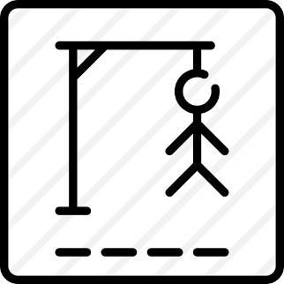  D A N G E R O U S  - Asks them to think of the word which has 9 letters in it related the topic “ON THE ROAD”.  - Ss have 1 min to think of the words related to the topic or they can discuss with their partners.  - Each member from each team turn by turn guesses the letter in the secret word.  - Teacher corrects their answers.  - The team which can find or guess the secret first will be the winner.  * Lead in:  - Teacher leads students into the lesson by telling what they are going to learn: “We are going to read a passage about some rules about road safety.”  3. New lesson:  * Actyvity 1: 19'  Task 1: (2.1)  - Teacher introduces the vocabulary by:  + Providing the synonym or antonym of the words.  + Providing the pictures of the words.  + Providing the definition of the words.  *  Concept check: Rub out and Remember  - Teacher asks Ss to work in pairs to look at the Picture in Ex 1 and discuss on what they see that is dangerous?  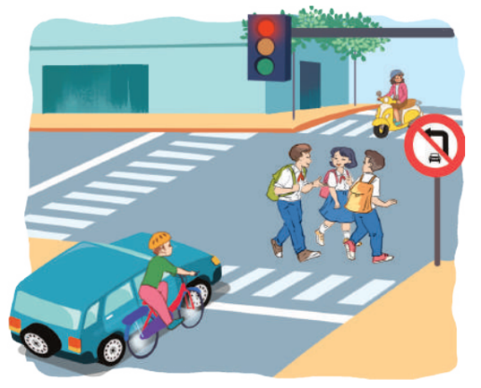  -Ss work in pairs.  - Teacher calls some Ss to check what they have discussed.  - Teacher corrects.  *Activity 2. Task 2: Read the following text and choose the correct answers. (2.1)  This text is about ______.  A. rules for pedestrians  B. traffic lights  C. traffic rules  - Teacher has Ss read the first sentence of the text in detail to do the exercise and asks them how to do this kind of exercise.  - Ss do the task independently.  - Teacher tells Ss to compare their answers in pairs before calling some of them to check.  - Teacher confirms the correct answer and explains if needed.  * Activity 3.Task 3: Read the text again and answer the questions (2.1)  - Teacher asks Ss: reading each question, locating where the information appears in the text, reading that part carefully and circling the correct answer.  - Ss do the task independently.  - Teachers has Ss compare their answers in pairs and call some Ss to give their ideas.  - Teacher checks and confirms the correct answers.  * Actyvity 4. Task 4. Work in group. Ask and answer the following question: 15'(2.2)  “When you are a road user, what should you NOT do?”  Make list in groups compare your list with other groups’.  - Teacher asks Ss to work in groups and tells them to focus on the rules for road users in the text to talk about which one they have to obey every day.  - Ss work in groups. Teacher goes around and listens and gives help if needed.  - Teacher calls on some Ss to share their answers with the class.  - Teacher listens and gives comment.  * Activity 5. Task 5: Read the following sentences about these people. Then work in groups. Discuss who is being safe and who isn’t. (2.3)  - Teacher has Ss work in groups and asks them to take turns to discuss the situations.  - Ss work in groups to do the task. Teacher goes around, listens and gives help if needed.  - Teacher calls on some groups to share their answers with the class.  - Teacher comments.  * Give the advices on dangerous situations on the road.  Structure: S + should/shouldn’t + V-inf  - Teacher has students give advices on how to avoid the dangerous situations on the road.  - Students do the task in groups.  - Teacher calls on some groups to share their answers with the class.  -Teacher comments and corrects if needed.  4. Feedback: 2'  -Teacher asks students to talk about what they have learnt in the lesson.  5. Homework: 3'  -Learn by heart the lesson.  -Do the homework.  -Prepare for the next lesson: Skills 2. | GAME: Hang man  D A N G E R O U S  * Newwords:  Vocabulary  - pedestrian (n): người đi bộ  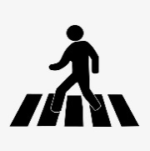  - passenger (n): hành khách    - (to) obey : tuân thủ  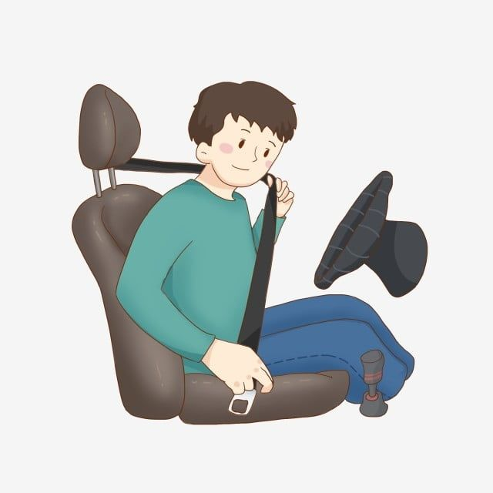  - seatbelt (n): dây an toàn  * Task 1: Look at the picture. Can you see anything that is dangerous ? (Ex 1, p. 78)  Suggested answers:  The students who are crossing the road.  Because they do not walk on the right place and they are not careful.  * Task 2: Read the following text and choose the correct answers. (Ex 2, p. 78)  This text is about ______.  A. rules for pedestrians  B. traffic lights  C. traffic rules  Answer key: C  * Task 3: Read the text again and answer the questions (Ex 3, p. 78)  Answer key:  1. They shoud cross the street at the zebra crossing.  2. We should use the cycle lane.  3. We should give a signal (before we turn while riding a bike).  4. We must wait for buses to fully stop when you get on or off a bus.  5. We mustn’t stick any body parts out of the window (when you are in a moving vehicle).  * Task 4: Work in group. Ask and answer the following question (Ex 4, p.78)  “When you are a road user, what should you NOT do?”  Make list in groups compare your list with other groups’.  * Task 5: Read the following sentences about these people. Then work in groups. Discuss who is being safe and who isn’t. (Ex 5, p.78)  * Give the advices on dangerous situations on the road.  Structure: S + should/shouldn’t + V-inf

PERIOD 60: UNIT 7: TRAFFIC
SKILLS 2

I. OBJECTIVES: By the end of the lesson, students will be able to:
1. Knowledge:
1.1. Listen for specific information about traffic problems.
1.2. Write a paragraph of about traffic problems in your area.
2. Competence:
2.1. Listen the specific information to do exercise given. (Ex2,3)
2.2. Write the traffic problems in your cities(Ex4)
* 2.3. Write the paragraph of about 70 words about the traffic problems in
your cities.( Ex5)
3. Quality:
Be benevolent and responsible
II. TEACHING AIDS
Books, text books, projector, computer.
III. PROCEDURES:
Teacher's and Ss' activities | Contents
1. Organization (2')  Checking Ss attendance:  6A1: ...........................  6A2: ...........................  2. Warm up: 5'  BRAIN STORMING  - Teacher writes on the board the word “Traffic problems” and asks Ss some questions:  + What does this word mean?  + What do we have to suffer from these problems?  + Can you name some traffic problems?  - Ss think of these questions and discuss with their partners if needed.  - Teacher calls some students to give their answers.  - Teacher listens and give comments.  * Lead in:  -Teacher introduces students the content of the lesson: “In the lesson today, we are going to listen to a person talking about traffic problems in his city - Mumbai.”  3. New lesson:  * Pre-listening:1'  *Activity 1. Task 1: What can you see in this picture? What is special about it?.(1.1)  -Teacher asks Ss to work in pairs to the problems they can find in the picture on page 79.  - Ss work with their partner to do the task.  - Teacher calls on some Ss to answer.  - Teacher gives comments and leads Ss to task.  * While – listening: 10'  *Activity 2.Task 2: Listen to the recording and choose the correct answer A, B, OR C. (2.1)  - Teacher asks Ss to read and underline the key words.  - Ss work independently to guess then listen to the recording once to check their guess.  -Teacher calls on some students to give the answers the have listened.  - Teacher gives feedback.  * Activity 3.Task 3: Listen again and write one word or number in each gap. (2.1)  - Teacher asks Ss to read and underline the key words.  - Ss work independently then listen to the recording again  - Teacher confirms the correct answers for their predictions.  * Post-listening: 3’  * Activity 4. Discuss: Compare trafic problems in MumBai to the traffic problems in Ha Noi  - Teacher tells Ss to work in groups to discuss and compare traffic problems in Mumbai to the traffic problems in Ha Noi. Write down onto the notebooks in full sentences.  - Ss work in groups. Teacher moves around and offers help if needed.  - Teacher invites some Ss to share their answers.  -Teacher corrects if needed.  * Pre-writing: 5'  * Activity 5. Task 4: Tick the traffic problems in big cities in Viet Nam. (2.2)  - Teacher writes on the board “Your city’s Traffic Problems” and asks Ss to Tick the traffic problems in big cities in Viet Nam and asks them to give out more problems that they see in their city.  - Ss think of it and can discuss with their partners.  - Teacher calls on some Ss to raise their ideas.  - Teacher listens and confirms.  * While – writing: 10'  * Actyvity 6. Task 5: Write a paragraph of about 70 words about the traffic problems in your town/ city.. (2.3)  - Teacher tells Ss that they are going to write a passage about the traffic problems in your town / city.  - Teacher reminds Ss of the structure of a passage and steps to make an outline for the passage.  - Ss work independently to do the task and try to use the notes from the previous tasks.  -Teacher goes around and help if necessary.  * Post – Writing: 4'  * Activity 7. Peer check and cross check  - Teacher asks Ss to share their writing with their partners. Then, call on some Ss to show their writing in front of the class.  - Teacher checks ideas, grammar, vocabulary and gives comments.  4. Consolidation: 3'  -Teacher asks students to talk about what they have learnt in the lesson.  5. Homework:1'  -Learn by heart the lesson.  - Rewrite the passage on the notebook.  - Do exercise in the workbook.  -Prepare new lesson | *Task 1: What can you see in this picture? What is special about it? (Ex 1, p. 79)  Suggested answers: traffic jams, vehicle overload, people’s awareness about traffic rules…  *Task 2: Listen to the recording and choose the correct answer A, B, OR C. (Ex 2, p. 79)  Answer key: C  * Task 3: Listen again and write one word or number in each gap. (Ex 3, p. 79)  Answer key:  1. jams 2. problem / jams  3. 20 / twenty 4. roads  5. obey  * Discuss: Compare trafic problems in MumBai to the traffic problems in Ha Noi.  E.g. The traffic jams in Ha Noi is as serious and frequent as they are in Mumbai.  * Task 4: Tick the traffic problems in big cities in Viet Nam. (Ex 4, p. 79)  Suggested answers:  Too many vehicles  Narrow roads  People’s awareness  *Task 5: Write a paragraph of about 70 words about the traffic problems in your town/ city. (Ex 5. p.79  Peer check and cross check  Suggested answers:  The most serious traffic problem in our city – Ha Noi is the traffic jam. Although the public transport system in Ha Noi is quite modern and covenient, many people prefer using their own motorbikes. The reason for that is because most roads and streets in Ha Noi are quite smalls and include many tiny lanes. Therefore, using private vehicles allows them to get the destinations without walking long distance. The situation usually gets worse at rush hours when people all go to work or return home from work and schools. In conclusion, people should try to use public transport more often to reduce the traffic jams and exhaust.

PERIOD 61: UNIT 7: TRAFFIC
LOOKING BACK & PROJECT

I. OBJECTIVES: By the end of the lesson, students will be able to:
1. Knowledge:
1.1. Revise the vocabulary about means of transport.
1.2. Revise the indicate distance.
1.3. Revise the using should and shouldn’t.
2. Competence:
2.1. Use the vocabulary about road signs and means of transport to do
exercises given( Ex1,2).
2.2 Use the indicate distance to do exercise given (Ex3)
2.3. Use the should and shouldn’t to do exercise 4
* 2.4.Interview their friends about traffic signs in Project
3. Quality:
3.1. Be benevolent and responsible
3.2. Develop self-study skills
II. TEACHING AIDS
Books, text books, projector, computer.
III. PROCEDURES:
Teacher's and student's activities | Contents
1. Organization (2')  Checking Ss attendance:  6A1: ...........................  6A2: ...........................  2. Warm up: 5'  *QUICK REVISION CHECK  - Teacher asks Ss to think of what they have learnt already in Unit 7.  - Ss work in pairs to do the task.  - Teacher calls some students to retell.  - Teacher confirms and leads them to do all the exercises in books.  3. New lesson  * LOOKING BACK: 20'  * Activity 1 Task 1: Lable each sign, work in pairs. What does each sign tell us to do?. (2.1)  - Teacher has Ss work individually.  - Ss do this activity individually, then compare their answers with their partners.  - Teacher asks for Ss’ answers.  - Teacher confirms the correct ones.  * What does each sign tell us to do?  * Actyvity 2. Task 2. Fill in each gap with one word to complete the sentences. (2.1)  - Teacher has Ss work individually.  - Ss do this activity individually, then compare their answers with their partners.  - Teacher asks for Ss’ answers.  - Teacher confirms the correct ones.  * Actyvity 3. Task 3: Write complete senteces, using these cue. (2.2)  - Teacher asks Ss to recall the structures of asking and answering about distance, and tell them to do Ex 3 in the book.  - Ss do the exercise individually and swap with their partners.  - Teacher calls some Ss to check their answer.  - Teacher confirms the correct answer.  * Actyvity 4. Task 4: Choose A, B, OR C to complete the sentences.. (2.3)  - Teacher asks Ss to do the task.  - Ss work individually to do the task.  - Teacher calls Ss to give out their answers.  - Teacher checks and confirms their answer.  * PROJECT: 5'  * Actyvity 5. Task 5: Traffic signs exhibition. (2.4)  - Teacher has students work in groups as divided in Lesson 1 and gives instructions to students as follow:  1. Review about all the signs they have prepared at home.  2. Discuss and finalize in groups.  3. Tell the class about the signs.  - Ss work in group to do the task.  - Teacher calls some groups to present their signs to the class.  -Teacher listens and confirms.  4. Consolidation: 3'  -Teacher asks students to talk about what they have learnt in the lesson.  5. Homework: 1'  -Learn by heart the lesson.  -Do exercises.  -Prepare for the next lesson: Unit 8 – Getting started. | *QUICK REVISION CHECK  *Task 1: Lable each sign, work in pairs. What does each sign tell us to do? (Ex 1, p. 80)  Answer keys:  1. Red light  2. School ahead  3. Hospital ahead  4. Cycle lane  5. No left turn  6. Do not cycle  * What does each sign tell us to do?  Suggested answers:  2. A ‘School ahead’ sign means (that) you must go slowly.  3. A ‘Hospital ahead’ sign tells you that there is a hospital ahead.  4. A ‘Cycle lane’ sign means (that) you can cycle there.  5. A ‘No left turn’ sign means (that) you can’t turn left.  6. A ‘No cycling’ sign means (that) you can’t cycle there.  * Task 2: Fill in each gap with one word to complete the sentences. (Ex 2, p. 80)  Answer keys:  1. user  2. ride  3. passenger  4. fly  5. traffic  * Task 3: Write complete senteces, using these cue. (Ex 3, p. 80)  Answer keys:  1. It is over 100 km from my home town to Ho Chi Minh City.  2. It is about 25 km from here to my grandparents’ house.  3. It is not very far from our school to the city museum.  4. How far is it from your house to the gym?  5. Is it a long distance from Ha Noi to Ban Gioc Waterfall?  * Task 4: Choose A, B, OR C to complete the sentences. (Ex 4, p. 80)  Answer keys:  1. A 2. B 3. C  4. A 5. C 6. B  *Task 5: Traffic signs exhibition.  (Ss do at home)

