Week 4 Preparing date: 06/10/2024
Period 13 Teaching date: 07/10/2024

Unit 2: Our names
Lesson 2 (1, 2, 3)
I. OBJECTIVES:
By the end of the lesson, Ss will be able to:
1. Knowledge:
- use the words what, your, name, my, how old, years old in relation to the topic “Our names”;
- use How old are you? - I'm……. to ask and answer questions about someone’s age;
- Vocabulary: how old, year
2. Skills: speaking and listening
3. Attitude/ Qualities:
- Kindness: Help partners to complete learning tasks.
- Honesty: tell the truth about feelings and emotions
- Diligence: complete learning tasks
4. Forming competences:
- Oral Communication: speak about names, ask and answer the questions
- Co-operation: ready to help friends in pair work/ group work.
- Sociability: Talk to each other, say good words to others.
II. Methods:
- Communicative approach, group Ss and Ts activities, play as a character, teaching method with game/ by visual/ by practicing, discussion group, technical present
III. Preparation
1. Teacher’s preparation: CDs player, book
2. Students’ preparation: Students’ aid: book, notebook
IV. PROCEDURES:
Teacher’s activities | Students’ activities
1.Warm- up: (3’)  Game: Guess the pictures  *Aims: to create a friendly and active atmosphere in the class to beginning the lesson.  *Procedure:  - The first Ss has to take the last four or three letters of that word and form a new word.  - The second Ss does the same, and the chain continues until a Ss is unable to form a word.  - The Ss who fails to form a word or misspells it is out of the game.  -T give feedback  - Say “Open your book page 18” and look at “Unit 2, Lesson 2 (1,2,3)”.  2. Presentation (16’)  Activity 1. Vocabulary.  *Aims: Ss will be able to know the vocabulary in front of starting the new lesson.  *Procedure:  -T elicits the new words  + how old : bao nhiêu tuổi (situation)  + year : tuổi, năm (situation)  - T models (3 times).  - T writes the words on the board.  - Checking: Rub out and remember  Activity 2. Listen, point and repeat:  *Aims: Ss will be able to understand and correctly repeat the sentences in two communicative contexts (pictures) focusing on asking and answering questions about the character’s age.  *Procedure:  - Have pupils look at Pictures a and b and identify the characters in the pictures.  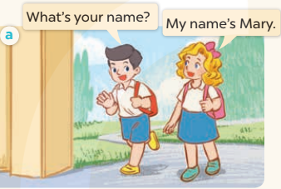  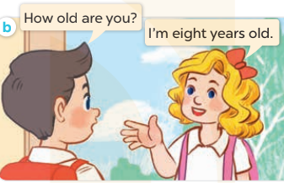  - Play the audio twice (sentence by sentence). Correct their pronunciation where necessary.  - Have Ss to practice the dialogue  - T invites a few pairs to the front of the class to practice.  - T checks pronunciation for ss.  Activity 3 Listen, point and say.  *Aims: Ss will be able to correctly say the words and use How old are you? – I’m………years old. to ask and answer questions about someone’s age.  *Procedure:  * Model sentences:  - T asks Ss look at picture a and helps Ss know the structure from the dialogue.  - T introduces new structure for Ss.  - T explains, models and gives meaning.  - Have Ss repeat the model sentences.  A: How old are you?  B: I’m eight years old.  3.Practice: (7’)  *Drill pictures  - Elicit and check comprehension the name of each character.  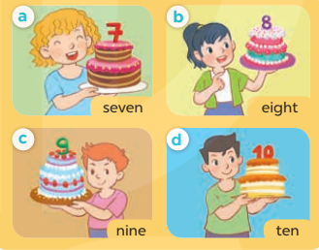  - Run through all the pictures.  - Run through model sentences.  + Run through the questions.  + Run through the answers.  - Have Ss to practise:  + T asks the first – Ss answer (change role).  + Ss – Ss (change role).  - Ask Ss to work in pairs to ask and answer the question How old are you? I’m……  - T controls and corrects.  - Invite a few pairs to come to the front of the classroom, point at the relevant character in each picture, and act out his/her role.  - Encourage Ss to practise speaking English.  - T gives feedbacks.  4. Production: (7’)  Activity 4. Let’s talk.  *Aims: Ss will be able to enhance the correct use of How old are you? and to correctly respond using their own ages.  *Procedure:  - Have Ss look at the picture and explain that the two children want to buy some birthday cakes. The shop assistant asks their ages and the children answer  - T asks Ss look at the first speech bubble and ask How old are you?  - Get Ss to repeat the question and the answer several times in pairs.  - T models: Go around the classroom, pointing to Ss and asking What’s your name?  - Ask Ss ask and answer about their own ages in pairs.  - Invite some groups to perform in front of the class.  - Give feedbacks  *Consolidation  *Aims: Ss will be able consolidate and wrap up the content of the lesson.  *Procedure:  - T asks ss to answer the following questions:  + What have you learnt from the lesson today?  +What are the core values of the lesson? (if the teacher can take from the lesson).  - T review the vocabulary and model sentences.  - T praises some Ss who are hardworking / active/ good…. as well as encourage others to try more.  5. Homework. (2’)  - Learn the vocabulary and model sentences by heart  - Prepare the new lesson: Unit 2, Lesson 2 (4,5,6). | - Ss listen.  -Ss look at the board  - Ss play the game  - Ss listen and clap their hands  - Ss open their books  -Ss listen and answer  - - Ss listen and repeat  + Choral repetition (3 times).  + Individual repetition (3 ss)  - Ss take note  - Ss look, remember and write  - Look at the pictures and get to know the characters in the pictures.  + In picture a: Nam asks: What’s your name? And Mary answers: My name’s Mary.  + In pucture b: Nam asks: How old are you? And Mary answers: I’m eight years old..  - Ss listen and repeat in chorus (twice)  - Ss work in pairs to practice  - Ss practice the dialogue  - Ss listen  - Ss look at the picture and answer.  - Ss listen  - Ss listen and repeat  - Ss repeat to the introduce and respond to greetings.  - Ss look at the picture and answer  + In picture a: A girl is holding a birthday cake with number 7.  + In picture b: A girl is holding a birthday cake with number 8.  + In picture c: A boy is holding a birthday cake with number 9.  + In picture d: A boy is holding a birthday cake with number 10.  - Ss look, listen and repeat  - Ss practice in chorus  - Ss work in pairs to practice  - Ss point and ask and answer  - Ss listen.  - Ss listen  - Ss look at the picture and listen  - Ss look and answer  + I’m four years old.  - Ss ask and answer  - Ss answer  - Ss work in pairs  - Ss perform in front of the class.  - Ss answer the questions  - Ss listen  - Ss listen and clap their hands  - Ss listen and take note
V. ADJUSTMENTS (if necessary):
………………………………………………………………………………………….…..……………………………………………………………………………...………………………………………….…..………………………………
**************************
Week 4 Preparing date: 06/10/2024
Period 14 Teaching date: 08/10/2024

Unit 2: Our names
Lesson 2 (4,5,6)
I. OBJECTIVES:
By the end of the lesson, Ss will be able to:
1. Knowledge:
- listen to and demonstrate understanding of simple communicative contexts in relation to the topic "Our names"
- read and write about people’s names and ages.
- Vocabulary: Review
2. Skills: speaking, listening, reading and writing.
3. Attitude/ Qualities:
- Kindness: Help partners to complete learning tasks.
- Honesty: tell the truth about feelings and emotions.
- Diligence: complete learning tasks.
4. Forming competences:
- Critical Thinking: self-introduce
- Co-operation: ready to help friends in pair work/ group work.
- Self-control and independent learning: perform listening tasks.
II. Methods:
- Communicative approach, group Ss and Ts activities, play as a character, teaching method with game/ by visual/ by practicing, discussion group, technical present
III. Preparation
1. Teacher’s preparation: CDs player, book
2. Students’ preparation: Students’ aid: book, notebook
IV. PROCEDURES:
Teacher’s activities | Students’ activities
1.Warm- up: (5’)  Game: Chain game  *Aims: to create a friendly and active atmosphere in the class to beginning the lesson.  *Procedure:  - Have Ss look at the example.  - Divide the class into groups of four.  - Have the ss stand up.  - Have Student A turn to Student B and ask the question, then have Student B answer.  - Next, have Student B turn to Student C and ask the question, then have Student C answer.  - Continue until all students have practiced.  - Have some groups demonstrate the activity in front of the class.  - T gives feedback.  - Say “Open your book page 19” and look at “Unit 2, Lesson 2 (4,5,6)”.  2.Practice: (27’)  Activity 1. Listen and number:  *Aims: Ss will be able to listen to and understand four communicative contexts in which pupils ask and answer questions about ages.  *Procedure:  - Elicit the ages of the characters in the pictures.  - Point at the pictures respectively to explain the context.  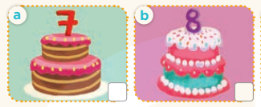    - T ask Ss to guess the answers.  + T writes Ss’guessing on the board.  - Listen to the tape:  + Play the recording  + Play the recording again and get Ss to swap books with their partners.  + Play the recording again to check answers together as a class.  + Write the answers on the board for Ss to correct their answers. Then checks Ss’ guessing.  - Play the recording, sentence by sentence, for the class to listen and repeat in chorus.  Key: 1. b 2. d 3. c 4. a  Activity 2. Look, complete and read.  *Aims: Ss will be able to complete three gapped dialogues with the help of picture cues.  *Procedure:  - Get Ss to look at the pictures and identify the ages  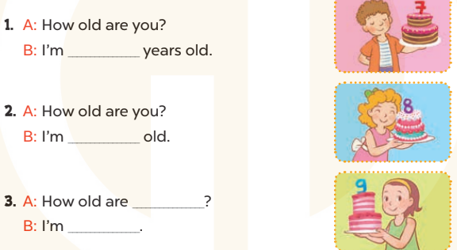  - Have Ss look at the four incomplete sentences and elicits the missing words in the sentences.  - T models with sentence 1  + Ask Ss what is missing in the sentence.  + Have Ss look at the picture and complete the gap, then read the completed sentence in chorus.  - Have Ss work in groups and complete the sentence 2, 3.  - Ask a few Ss to stand up and read the completed sentences aloud.  - T gives feedbacks.  Key:  1. seven 2. eight years  3. you; nine years’ old  Activity 3. Let’s sing.  *Aims: Ss will be able to sing the song How old are you? with the correct pronunciation and melody.  *Procedure:  - Introduce the title and lyrics of the song: “How old are you?” song.  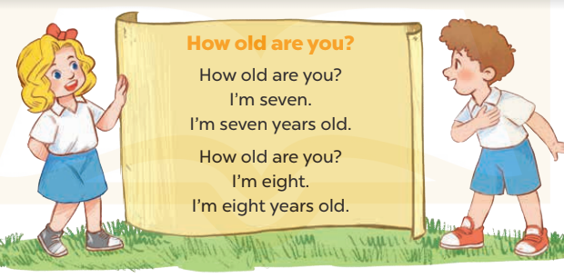  - Play the recording for Ss to listen to the whole song.  + Have them repeat the title and lyrics line by line.  - Play the recording all the way through for Ss to listen to pronunciation and melody of the song.  - Play the recording line by line for Ss to listen, repeat  - Play the recording for Ss to sing and do actions.  - Ask Ss to practice singing and doing actions in pairs or groups.  - Invite groups to the front of the classroom to perform the song  -T gives feedback.  *Consolidation  *Aims: Ss will be able consolidate and wrap up the content of the lesson.  *Procedure:  - T asks ss to answer the following questions:  + What have you learnt from the lesson today?  +What are the core values of the lesson? (if the teacher can take from the lesson).  - T praises some Ss who are hardworking / active/ good…. as well as encourage others to try more.  3. Homework. (3’)  - Ask and answer about the pictures on page 19.  - Prepare the new lesson: Unit 2, Lesson 3 (1,2,3). | - Ss listen  - Ss play game  - Ss open their books  - Look at the pictures and say:  + Picture a: birthday cake with number 7  + Picture b: birthday cake with number 8  + Picture c: birthday cake with number 9  + Picture d: birthday cake with number 10  - Ss guess the answers  - Ss listen to the tape and write number  - Ss listen again, write and swap books with their partners.  - Ss check their answers and guessing  - Ss listen and repeat.  - Ss look at the pictures and say:  + A boy is holding a birthday cake with number 7 in picture a  + A girl is holding a birthday cake with number 8 in picture b  +A girl is holding a birthday cake with number 9 in picture b  - Ss listen and answer  - Ss answer: I’m seven years old  - Ss look, complete and read the completed sentence in chorus.  - Ss complete the sentence  - Ss read aloud  - Ss look and listen to the teacher  - Ss listen to the song  - Ss listen and repeat line by line without the action.  - Ss listen to melody of the song  - Ss listen and sing line by line.  - Ss sing and do actions.  - Ss work in groups (two groups) to sing.  - Ss perform in front of the class.  - Ss listen  - Ss listen to the teacher.  - Ss answer the questions  - Ss listen and clap their hands  - Ss listen and take note
V. ADJUSTMENTS (if necessary):
………………………………………………………………………………………….…..……………………………………………………………………………...…...………………………………………….…..……………………………
Week 4 Preparing date: 06/10/2024
Period 15 Teaching date: 09/10/2024

Unit 2: Our names
Lesson 3 (1, 2, 3)
I. OBJECTIVES:
By the end of the lesson, Ss will be able to:
1. Knowledge:
- correctly pronounce the sounds of the letters m and n in isolation, in the words Mary and Nam, and in the sentences I’m Mary and My name’s Nam;
- use the words what, your, name, my, how old, years old in relation to the topic “Our names”;
- Vocabulary: Review
2. Skills: speaking, listening, reading and writing.
3. Attitude/ Qualities:
- Kindness: Help partners to complete learning tasks.
- Honesty: tell the truth about feelings and emotions
4. Forming competences:
- Co-operation: ready to help friends in pair work/ group work.
- Sociability: Talk to each other, say good words to others.
II. Methods:
- Communicative approach, group Ss and Ts activities, play as a character, teaching method with game/ by visual/ by practicing, discussion group, technical present
III. Preparation
1. Teacher’s preparation: CDs player, book
2. Students’ preparation: Students’ aid: book, notebook
IV. PROCEDURES:
Teacher’s activities | Students’ activities
1.Warm- up: (5’)  Game: Pass the ball  *Aims: to create a friendly and active atmosphere in the class to beginning the lesson.  *Procedure:  - T gives Ss a ball.  - T asks Ss to listen to music and transfer a ball around the class.  - When the music stops, Ss who keep a ball have to answer the question using: How old are you? and I’m…..years old  - T gives feedback.  - Say “Open your book page 14” and look at “Unit 2, Lesson 3 (1,2,3)”.  2. Presentation (9’)  Activity 1. Listen and repeat:  *Aims: Ss will be able to correctly repeat the sounds of the letters m and n in isolation, the words Mary and Nam, and the sentences I’m Mary. and My name’s Nam. with correct pronunciation and intonation.  *Procedure:  - T gives instruction to the letter m and n, the word Mary and Nam, and the sentences I’m Mary. and My name’s Nam.  - Play the recording for the letter m, n  - Encourage Ss to point at the letter/ word/ sentence while listening.  - Play the recording again and encourage Ss to listen and repeat. - Do this several times until Ss feel confident.  - T calls some Ss to practice.  - T gives feedbacks.  3.Practice: (19’)  Activity 2. Listen and circle.  *Aims: Ss will be able to identify the target words Mary and Nam while listening.  *Procedure:  - Elicit the sentences and the gap-fill options.  - T ask Ss to guess the answers.  + T writes Ss’guessing on the board.  - Listen to the tape:  + Play the recording  + Play the recording again and get Ss to swap books with their partners.  + Play the recording again to check answers together as a class.  + Write the answers on the board for Ss to correct their answers. Then checks Ss’ guessing.  - Play the recording, sentence by sentence, for the class to listen and repeat in chorus.  - Invite one or two Ss to stand up and read the completed sentences.  Key: 1.b 2.c  Activity 3. Let’s chant  *Aims: Ss will be able to say the chant with the correct rhythm and pronunciation.  *Procedure:  - Introduce the title and lyrics of the chant.  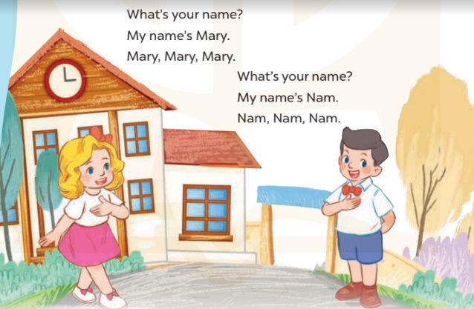  - Play the recording for Ss to listen to the whole chant.  + Have them repeat the title and lyrics line by line.  + Ask Ss to attend to the sounds of the letters m and n and the words Mary and Nam.  - Play the recording all the way through for Ss to listen to pronunciation and melody.  - Play the recording line by line for Ss to listen and repeat  - Play the recording for Ss to chant and clap along.  - Ask Ss to practice chant and clap along in pairs or groups.  - Invite groups to the front of the classroom to perform the chant  - T gives feedback.  *Consolidation  *Aims: Ss will be able consolidate and wrap up the content of the lesson.  *Procedure:  - T asks ss to answer the following questions:  + What have you learnt from the lesson today?  +What are the core values of the lesson? (if the teacher can take from the lesson).  - T review the vocabulary and model sentences.  - T praises some Ss who are hardworking / active/ good…. as well as encourage others to try more.  4. Homework. (2’)  - Practice the chant more.  - Draw and colour a paper birthday cake.  - Prepare the new lesson: Unit 2, Lesson 3 (4,5,6). | - Ss listen  - Ss listen the rules  - Ss play the game  - Ss open their books  - Ss recognize the differences about color of letter  - - Ss listen  - Ss listen and point  - Ss listen again and repeat  - Ss listen again and repeat  - Ss practice  - Ss listen  -Ss listen and say:  + Number 1: Hi, I’m…..  + Number 2:Hello, My name’s …..  -Ss guess the answers  - Ss listen to the tape and circle  - Ss listen again, circle and swap books with their partners.  - Ss check their answers and guessing  -Ss listen and repeat.  -Ss read the sentences  - Ss look and listen.  - Ss listen to the chant  - Ss listen and repeat line by line without clap their hands  - Ss note the sounds, word  - Ss listen to melody of the song  - Ss listen and chant line by line.  - Ss chant and clap along.  - Ss work in groups (two groups) to chant  - Ss perform in front of the class.  - Ss listen  - Ss listen  - Ss answer the questions  - Ss listen  - Ss listen and clap their hands  - Ss listen and take note

V. ADJUSTMENTS (if necessary):
………………………………………………………………………………………….…..……………………………………………………………………………...………………………………………….…..………………………………
**************************
Week 4 Preparing date: 06/10/2024
Period 16 Teaching date: 09/10/2024

Unit 2: Our names
Lesson 3 (4,5,6)
I. OBJECTIVES:
By the end of the lesson, Ss will be able to:
1. Knowledge:
- use the words what, your, name, my, how old, years old in relation to the topic “Our names”
- read and write about people’s names and ages.
- Vocabulary: Review
2. Skills: speaking, listening, reading and writing.
3. Attitude/ Qualities:
- Kindness: Help partners to complete learning tasks.
- Honesty: tell the truth about feelings and emotions.
- Diligence: complete learning tasks.
4. Forming competences:
- Critical Thinking: self-introduce
- Co-operation: ready to help friends in pair work/ group work.
- Self-control and independent learning: perform listening tasks.
II. Methods:
- Communicative approach, group Ss and Ts activities, play as a character, teaching method with game/ by visual/ by practicing, discussion group, technical present
III. Preparation
1. Teacher’s preparation: CDs player, book
2. Students’ preparation: Students’ aid: book, notebook
IV. PROCEDURES:
Teacher’s activities | Students’ activities
1.Warm- up: (5’)  Game: “Chant”  *Aims: to review the vocabulary and structure about greet and respond to greetings.  *Procedure:  - Ask Ss chant and do the actions in Unit 2, Lesson 3 page 20 in groups.  - Give point for the groups and encourage them.  - Say “Open your book page 21” and look at “Unit 2, Lesson 3 (4,5,6)”.  2.Practice: (8’)  Activity 1. Read and match:  *Aims: Ss will be able to read and match three dialogues with pictures.  *Procedure:  - Ask Ss some questions:  + Who are they?  + What are they talking about?  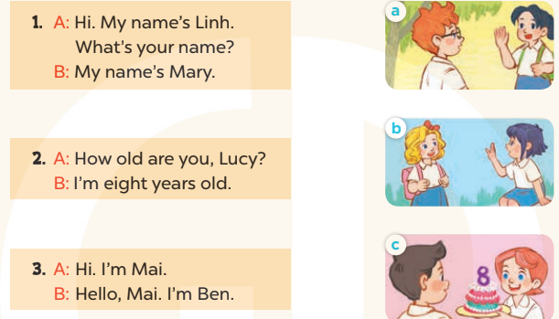  - T models with sentence 1.  + Get Ss to read Sentence 1  + Have Ss look at the pictures and match the dialogue with the correct one.  - Have Ss work in pairs and match the sentences 2, 3.  - Tell Ss to swap books with a partner, then check answers together as a class.  - Write the correct answers on the board for pupils to correct their answers.  - Invite pairs of Ss to stand up and role play  -T gives feedbacks.  Key: 1. b 2. c 3. a  3.Production: (19’)  Activity 2. Let’s write  *Aims: Ss will be able to read, understand and complete an exchange with their personal information.  *Procedure:  - Have Ss read the dialogue and ask some questions:  + Who asks the questions?  + What are the questions about?  + Who has to write the answers?  - Check their comprehension and remind Ss to write their personal information.  - Give Ss time to write the answers to the questions independently  - Get Ss to swap books with a partner, then check the answers together as a class.  - Ask a few Ss to stand up and role play the dialogue in front of the class.  - T gives feedbacks.  Key: Pupil’s answer  Activity 3. Project.  *Aims: Ss will be able to make birthday cakes and use them to introduce names and ages.  *Procedure:  - Ask Ss to make a paper birthday cake as homework at the beginning of Unit 2 -Lesson 3 (4,5,6)  - Stick the birthday cake sample on the board and model with the name, age.  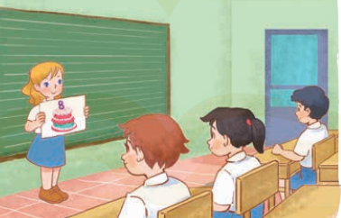  - T asks ss to work in groups and show his / her birthday cake and say about his / her name and age.  - T calls some Ss to the front of the class to present their cake, and saying Hello. My name’s….  I’m…….years old.  - Have Ss to stick their birthday cakes on the wall of the classroom  - Create a class display of birthday cakes and vote for the best decorated one.  - T gives feedback.  *Consolidation  *Aims: Ss will be able consolidate and wrap up the content of the lesson.  *Procedure:  - T asks ss to answer the following questions:  + What have you learnt from the lesson today?  +What are the core values of the lesson? (if the teacher can take from the lesson).  - T praises some Ss who are hardworking / active/ good…. as well as encourage others to try more.  4. Homework. (3’)  - Prepare the new lesson: Unit 3, Lesson 1 (1,2,3). | - Ss listen and chant  - Ss open their books  - Ss look at the pictures and answer  + In picture a: Ben and Mai say to greeting  + In picture b: Mary and Linh say to greeting  + In picture c: Lucy is holding a birthday cake with number 8.  - Ss read and match  - Ss work in pairs and match  - Ss swap books and check  - Ss check the correct their answers  - Ss role play  - Ss listen  - Ss look at the dialogue and say:  + It’s Minh  + Names and ages.  + Themself  - Ss listen to the teacher  - Ss write  - Ss swap books and check their answers  - Ss role play  - Ss listen  - Ss drew and coloured a paper bithday cale at home.  - Ss listen to the teacher  - Ss work in groups  - Ss present their birthday cake  - Ss stick their birthday cakes on the wall of the classroom.  - Ss vote  - Ss listen  - Ss answer the questions  - Ss listen and clap their hands  - Ss listen and take note
V. ADJUSTMENTS (if necessary):
………………………………………………………………………………………….…..……………………………………………………………………………………………………………………………………………………………

Week 5 Preparing date: 06/10/2024
Period 17 Teaching date: 09,10/10/2024

Unit 3: Our friends
Lesson 1 (1, 2, 3)
I. OBJECTIVES:
By the end of the lesson, Ss will be able to:
1. Knowledge:
- use the words this, that, it, yes, no, friend, teacher, Mr (Mr Long), Ms (Ms Hoa) in relation to the topic “Our friends”
- use This is / That’s ….. to introduce someone.
- vocabulary: this, that, Mr, Ms.
2. Skills: speaking and listening
3. Attitude/ Qualities:
- Kindness: Help partners to complete learning tasks.
- Honesty: tell the truth about feelings and emotions
4. Forming competences:
- Critical Thinking: self-introduce
- Co-operation: ready to help friends in pair work/ group work.
- Sociability: Talk to each other, say good words to others.
II. Methods:
- Communicative approach, group Ss and Ts activities, play as a character, teaching method with game/ by visual/ by practicing, discussion group, technical present
III. Preparation
1. Teacher’s preparation: CDs player, book
2. Students’ preparation: Students’ aid: book, notebook
IV. PROCEDURES:
Teacher’s activities | Students’ activities
1.Warm- up: (3’)  Sing: How old are you?  *Aims: to create a friendly and active atmosphere in the class to beginning the lesson.  *Procedure:  - Show the song on the screen.  https://www.youtube.com/watch?v=-2to7NkYMPk  - Ask pupils to listen, sing and dance the song.  - Say “Open your book page 22” and look at “Unit 3, Lesson 1 (1,2,3)”.  2. Presentation(16’)  Activity 1. Vocabulary.  *Aims: Ss will be able to know the vocabulary in front of starting the new lesson.  *Procedure:  - T elicits the new words  + this : đây, này  + that : đó, kia  + Mr :ông, thầy  + Ms : bà, cô  - T models (3 times).  - T writes the words on the board.  - Checking: Matching  ctivity 2. 1. Listen, point and repeat:  *Aims: Ss will be able to understand and correctly repeat the sentences in two communicative contexts (pictures) focusing on introducing someone.  *Procedure:  - Have Ss look at Pictures a and b and identify the characters in the pictures.  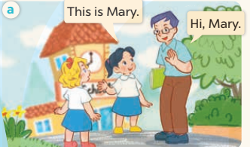  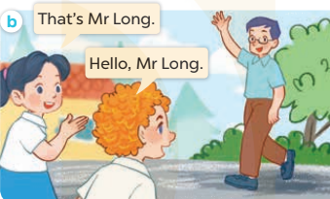  - Play the audio twice (sentence by sentence). Correct their pronunciation where necessary.  - Have Ss to practice the dialogue  - T invites a few pairs to the front of the class to practice.  - T checks pronunciation for ss.  Activity 3 2. Listen, point and say.  *Aims: Ss will be able to correctly say the character names and use This is / That’s …….. to introduce someone.  *Procedure:  * Model sentences:  - T asks Ss look at picture a, b and helps Ss know the structure from the dialogue.  - T introduces new structure for Ss.  - T explains, models and gives meaning.  - Have Ss repeat the model sentences.  This is Mary.  That’s Mr Long.  * That’s = that is  3.Practice: (7’)  *Drill pictures  - Elicit and check comprehension the name of each character.  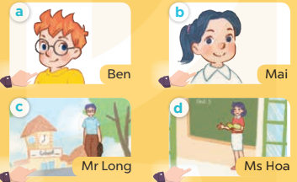  - Run through all the pictures.  - Run through model sentences.  - Have Ss to practise:  + T says the first picture  + Ss says the second picture  + Group A says the third picture  + Group B say the last picture.  - Ask Ss to work in pairs.  - T controls and corrects.  - Invite a few pairs to come to the front of the classroom, point at the relevant character in each picture, and act out his/her role.  - Encourage Ss to practise speaking English.  - T gives feedbacks.  4.Production: (7’)  Activity 4. Let’s talk.  *Aims: Ss will be able to enhance the correct use of This is / That’s ……... to introduce someone.  *Procedure:  - T asks ss to guess each character and what the children say.  + What can you see in the picture?  +Who are they?  +Where are they?  +What are they saying?  - T fills the gaps and writes the sentences on the board.  - T models  - T asks Ss to greet and introduce someone. (groups of four)  - Invite some groups to perform.  - Give feedbacks  *Consolidation  *Aims: Ss will be able consolidate and wrap up the content of the lesson.  *Procedure:  - T asks ss to answer the following questions:  + What have you learnt from the lesson today?  +What are the core values of the lesson? (if the teacher can take from the lesson).  - T review the vocabulary and model sentences.  - T praises some Ss who are hardworking / active/ good…. as well as encourage others to try more.  5. Homework. (2’)  - Learn the vocabulary and model sentences by heart  - Prepare the new lesson: Unit 3, Lesson 1 (4,5,6). | - Ss sing and dance the song  - Ss open their books  - Ss listen and answer  - - Ss listen and repeat  + Choral repetition (3 times).  + Individual repetition (3 ss)  - Ss take note  - Ss look, remember and match  - Look at the pictures and get to know the characters in the pictures.  + In picture a: Mai says: This is Mary. And Mr Long says: Hi, Mary.  + In picture b: Mai says: That’s Mr Long. And Bill says: Hello, Mr Long.  - Ss listen and repeat in chorus (twice)  - Ss work in pairs to practice  - Ss practice the dialogue  - Ss listen  - Ss look at the picture and answer.  - Ss listen  - Ss listen and repeat  - Ss repeat to the introduce someone.  - Ss look, listen and answer  +Picture a: Ben, a British male pupil  + Picture b: Mai, a Vietnamese female pupil  + Picture c: Mr Long, a Vietnamese male teacher  + Picture d: Ms Hoa, a Vietnamese female teacher  - Ss listen and repeat  - Ss practice in chorus  - Ss work in pairs to practice  - Ss point and say  - Ss listen.  - Ss listen  - Ss look at the picture and answer  + Minh and Mai meet Bill and Mary in the school playground. Minh introduces Bill to Mai, then Minh introduces Mary to Mai. They greet and introduce themselves to each other.  - Ss note  - Ss say the completed sentences.  - Ss work in groups  - Ss perform in front of the class.  - Ss answer the questions  - Ss listen  -Ss listen and clap their hands  - Ss listen and take note
V. ADJUSTMENTS (if necessary):
………………………………………………………………………………………….…..……………………………………………………………………………...………………………………………….…..………………………………

