Week 4 Preparing date:06/10/2014
Period 13 Teaching date: 07/10/2024;4a1
08/10/2024;4a2
Unit 2: Time and daily routines
Lesson 2 (1, 2, 3)
A. OBJECTIVES:
By the end of the lesson, Ss will be able to:
1. Knowledge:
- understand and correctly repeat the sentences in two communicative contexts focusing on asking and answering questions about the characters’ daily routines.
- correctly say the phrases and use What time do you…… – I……. at ……. to ask and answer questions about daily routines.
-enhance the correct use of What time do you ……..? - I …….at ………… to ask and answer about someone’s daily routines.
- Vocabulary: get up, have breakfast, go to school, go to bed, do homework.
- Skills: speaking and listening
2. Competences:
- Oral Communication: speak about names, ask and answer the questions.
- Co-operation: ready to help friends in pair work/ group work.
- Self-control and independent learning: perform learning tasks.
3. Attitude/ Qualities:
- Show their responsibility by noticing the time and follow the timetable on time.
B. TEACHING AIDS:
- Teacher: Teacher’s guide Pages 34, 35, 36, 37, audio Tracks 19,20, website hoclieu.vn, posters, laptop, pictures, textbook, lesson plan, TV or projector.
- Students: Pupil’s book Page 18, notebooks, workbooks, school things.
C. PROCEDURES:
Teacher’s activities | Students’ activities
1.Warm- up: (3’)  Game: Which clocks says…..  *Aims: to create a friendly and active atmosphere in the class to beginning the lesson.  *Procedure:  - Spend a few minutes revising the previous lesson by having the class play the game Which clock says ...?  - Say “Open your book page 18” and look at “Unit 2, Lesson 2 (1,2,3)”.  2. Presentation (16’)  Activity 1. Vocabulary.  *Aims: Ss will be able to know the vocabulary in front of starting the new lesson.  *Procedure:  -T elicits the new words  + get up : thức dậy (situation)  + have breakfast : ăn sáng (situation)  + go to school : đi học (picture)  + go to bed : đi ngủ (picture)  + do homework:làm bài tập về nhà (picture)  +wash face : rửa mặt (mime)  + clean teeth : đánh răng (mime)  - T models (3 times).  - T writes the words on the board.  - Checking: Rub out and remember  Activity 2. Look, listen and repeat:  *Aims: Ss will be able to understand and correctly repeat the sentences in two communicative contexts focusing on asking and answering questions about the characters’ daily routines.  *Procedure:  - Have pupils look at Pictures a and b and identify the characters in the pictures.  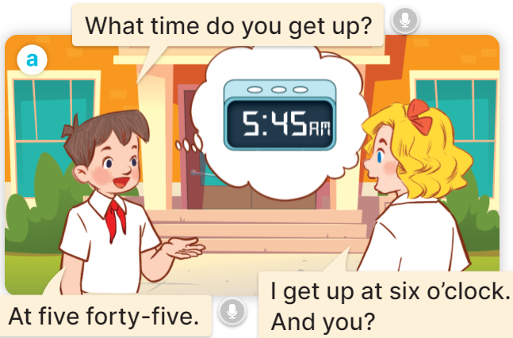  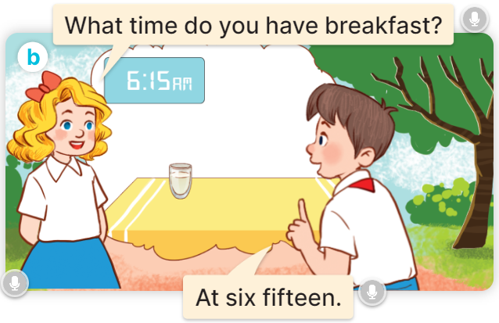  - Play the audio twice (sentence by sentence). Correct their pronunciation where necessary.  - Have Ss to practice the dialogue  - T invites a few pairs to the front of the class to practice.  - T checks pronunciation for ss.  Activity 3 Listen, point and say.  *Aims: Ss will be able to correctly say the phrases and use What time do you ……? – I ……. at ………. to ask and answer questions about daily routines.  *Procedure:  * Model sentences:  - T asks Ss look at picture a and helps Ss know the structure from the dialogue.  - T introduces new structure for Ss.  - T explains, models and gives meaning.  -Have Ss repeat the model sentences.  A: What time do you get up?  B: I get up at six o’clock.  3.Practice: (7’)  *Drill pictures  - Elicit and check comprehension the activities and the time from them.      - Run through all the pictures.  - Run through model sentences.  + Run through the questions.  + Run through the answers.  - Have Ss to practise:  + T asks the first – Ss answer (change role).  + Ss – Ss (change role).  - Ask Ss to work in pairs to ask and answer the question What time do you….? I……at…  - T controls and corrects.  - Invite a few pairs to come to the front of the classroom, point at the relevant character in each picture, and act out his/her role.  - Encourage Ss to practise speaking English.  - T gives feedbacks.  4.Production: (7’)  Activity 4. Let’s talk.  *Aims: Ss will be able to enhance the correct use of What time do you …..? – I …… at ……... to ask and answer questions about pupils’ daily routines in a freer context.  *Procedure:  - Have pupils look at the picture and explain that Nam and Lucy are asking and answering questions about Lucy’s daily routines.  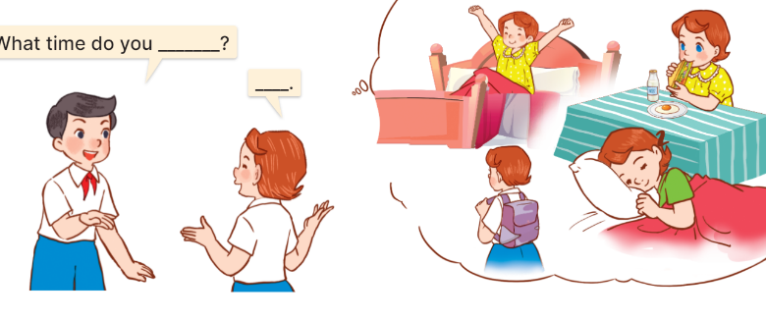  - T asks Ss look at the first speech bubble and ask What time do you get up?  - Get Ss to repeat the question and the answer several times in pairs.  - T models: Go around the classroom, pointing to Ss and asking What time do you……?  - Ask Ss ask and answer the question What time do you …..? – I ……at ………..  - Invite some groups to perform in front of the class.  - Give feedbacks  *Consolidation  *Aims: Ss will be able consolidate and wrap up the content of the lesson.  *Procedure:  - T asks ss to answer the following questions:  + What have you learnt from the lesson today?  +What are the core values of the lesson? (if the teacher can take from the lesson).  - T review the vocabulary and model sentences.  - T praises some Ss who are hardworking / active/ good…. as well as encourage others to try more.  5. Homework. (2’)  - Learn the vocabulary and model sentences by heart  - Prepare the new lesson: Unit 2, Lesson 2 (4,5,6). | - Ss listen.  - Ss play the game  - Ss open their books  -Ss listen and answer  - - Ss listen and repeat  + Choral repetition (3 times).  + Individual repetition (3 ss)  - Ss take note  - Ss look, remember and write  -Look at the pictures and get to know the characters in the pictures.  + In picture a: Minh asks: What time do you get up? And Mary answers: I get up at six o’clock. And you?  Minh answers: At five forty five.  + In pucture b: Mary asks: What time do you have breakfast? And Minh answers: At six fifteen.  -Ss listen and repeat in chorus (twice)  -Ss work in pairs to practice  -Ss practice the dialogue  -Ss listen  -Ss look at the picture and answer.  -Ss listen  -Ss listen and repeat  -Ss repeat to the introduce and respond to greetings.  -Ss look at the picture and answer  + In picture a: a girl is getting up; a clock shows 5:00 AM  + In picture b: a boy is having breakfast; a clock shows 6:15 AM  + In picture c: a pupil is going to school; a clock shows 1:15 PM  + In picture d: a boy is sleeping in bed; a clock shows 9:00 PM  - Ss look, listen and repeat  - Ss practice in chorus  - Ss practice in chorus  -Ss work in pairs to practice  -Ss take turns pointing at the pictures, asking and answering the question in front of the class.  -Ss note  -Ss look at the picture and listen  -Ss look and answer  + I get up at five fifteen.  -Ss repeat the question and answer  -Ss ask and answer  - Ss ask and answer the question  - Ss perform in front of the class.  -Ss answer the questions  - Ss listen  -Ss listen and clap their hands  -Ss listen and take note

D. ADJUSTMENTS (if necessary):
………………………………………………………………………………………….…..……………………………………………………………………………...………………………………………….…..……………………………………………………………………………….……………………………………………………………………...

Week 4 Preparing date: 06/10/2024
Period 14 Teaching date: 07/10/2024; 4a1
09/10/2024 ;4a2

Unit 2: Time and daily routines
Lesson 2 (4,5,6)
A. OBJECTIVES:
By the end of the lesson, Ss will be able to:
1. Knowledge:
- listen to and understand four communicative contexts in which pupils ask and answer questions about daily routines and number the correct pictures.
- complete four gapped exchanges with the help of picture cues.
- sing the song What time do you go to school? with the correct pronunciation, rhythm, and melody.
- Vocabulary: Review
- Skills: speaking, listening, reading and writing.
2. Competences:
- Critical Thinking: self-introduce
- Communication and collaboration: work in pairs and groups to complete the learning tasks.
- Self-control and independent learning: perform listening tasks.
3. Attitude/ Qualities:
- Kindness: Help partners to complete learning tasks.
- Show their responsibility by noticing the time and follow the timetable on time.
- Diligence: complete learning tasks.
B. TEACHING AIDS:
- Teacher: Teacher’s guide Pages 37,38,39; audio Tracks 21, 22; website hoclieu.vn, posters, laptop, pictures, textbook, lesson plan, TV or projector.
- Students: Pupil’s book Page 19, notebooks, workbooks, school things.
C. PROCEDURES:
Teacher’s activities | Students’ activities
1.Warm- up: (5’)  Game: Magic wheel  *Aims: to create a friendly and active atmosphere in the class to beginning the lesson.  *Procedure:  - Press “Spin” to play.  - If pupils have the correct answer, they will get the points shown on the slide.  - The team having higher scores will be the winner at the end of the game.  - Say “Open your book page 19” and look at “Unit 2, Lesson 2 (4,5,6)”.  2.Practice: (27’)  Activity 1. Listen and number:  *Aims: Ss will be able to listen to and understand four communicative contexts in which pupils ask and answer questions about daily routines and number the correct pictures.  *Procedure:  - Elicit the activities and the time in the pictures  - Draw pupils’ attention to the boxes at the bottom right-hand corners of the pictures.  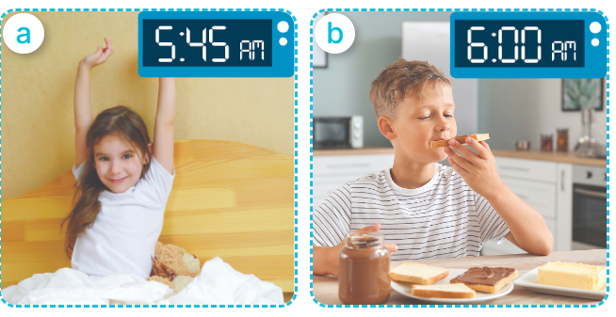  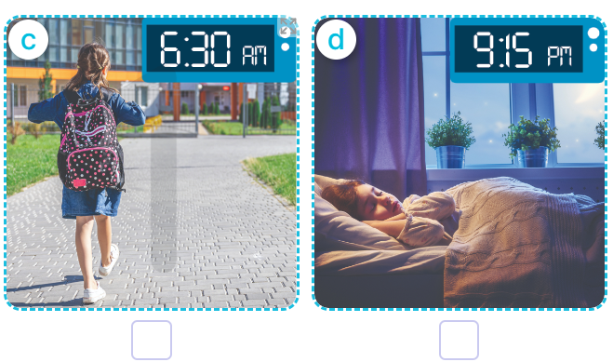  - T ask Ss to guess the answers.  + T writes Ss’guessing on the board.  - Listen to the tape:  + Play the recording  + Play the recording again and get Ss to swap books with their partners.  + Play the recording again to check answers together as a class.  + Write the answers on the board for Ss to correct their answers. Then checks Ss’ guessing.  - Play the recording, sentence by sentence, for the class to listen and repeat in chorus.  Key: 1. d 2. c 3. a 4. b  Activity 2. Look, complete and read.  *Aims: Ss will be able complete four gapped exchanges with the help of picture cues.  *Procedure:  - Get Ss to look at the pictures and identify the ages  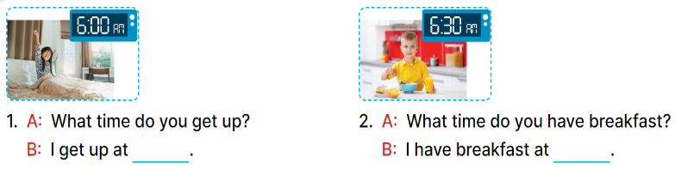  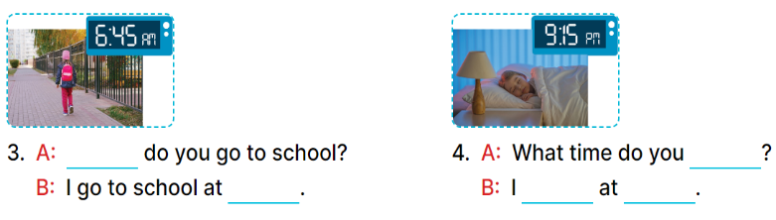  - Have Ss look at the four incomplete sentences and elicits the missing words in the sentences.  - T models with sentence 1  + Ask Ss what is missing in the sentence.  + Have Ss look at the picture and complete the gap, then read the completed sentence in chorus.  -Have Ss work in groups and complete the sentence 2, 3, 4.  - Ask a few Ss to stand up and read the completed sentences aloud.  -T gives feedbacks.  Key:  1. six o’clock 2. six thirty  3. What time; six forty-five  4. go to bed; go to bed; nine fifteen  Activity 3. Let’s sing.  *Aims: Ss will be able to sing the song What time do you go to school? with the correct pronunciation, rhythm, and melody.  *Procedure:  - Introduce the title and lyrics of the song:  “ What time do you go to school?” song.  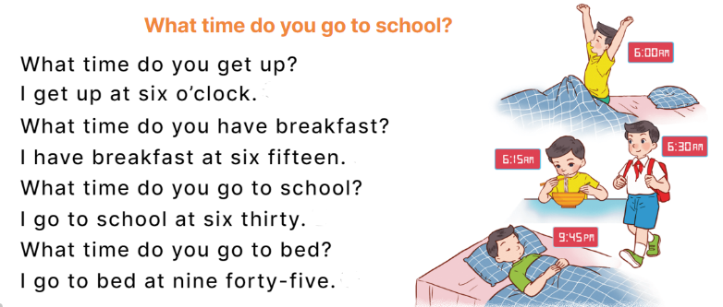  - Play the recording for Ss to listen to the whole song.  + Have them repeat the title and lyrics line by line.  - Play the recording all the way through for Ss to listen to pronunciation and melody of the song.  - Play the recording line by line for Ss to listen, repeat  - Play the recording for Ss to sing and do actions.  - Ask Ss to practice singing and doing actions in pairs or groups.  - Invite groups to the front of the classroom to perform the song  -T gives feedback.  *Consolidation  *Aims: Ss will be able consolidate and wrap up the content of the lesson.  *Procedure:  - T asks ss to answer the following questions:  + What have you learnt from the lesson today?  +What are the core values of the lesson? (if the teacher can take from the lesson).  - T praises some Ss who are hardworking / active/ good…. as well as encourage others to try more.  3. Homework. (3’)  - Prepare the new lesson: Unit 2, Lesson 3 (1,2,3). | - Ss listen  -Ss play game  - Ss open their books  -Look at the pictures and say:  + Picture a: a girl getting up at 5:45 a.m.  + Picture b: a boy having breakfast at 6:00 a.m.  + Picture c: a girl going to school at 6:30 a.m.  + Picture d: a girl is in bed at 9:15 p.m.  -Ss guess the answers  - Ss listen to the tape and write number  - Ss listen again, write and swap books with their partners.  - Ss check their answers together  -Ss write the correct answers and check ss’ answers  -Ss listen and repeat.  -Ss look at the pictures and say:  + A boy is holding a birthday cake with number 7 in picture a  + A girl is holding a birthday cake with number 8 in picture b  +A girl is holding a birthday cake with number 9 in picture b  - Ss listen and answer  -Ss answer: I get up at six o’clock.  -Ss look, complete and read the completed sentence in chorus.  -Ss complete the sentence  -Ss read the sentence aloud  -Ss look and listen to the teacher  -Ss listen to the song  - Ss listen and repeat line by line without the action.  -Ss listen to melody of the song  - Ss listen and sing line by line.  - Ss sing and do actions.  - Ss work in groups (two groups) to sing.  -Ss perform in front of the class.  -Ss listen  -Ss listen to the teacher.  -Ss answer the questions  -Ss listen and clap their hands  -Ss listen and take note
D. ADJUSTMENTS (if necessary):
………………………………………………………………………………………….…..……………………………………………………………………………...………………………………………….…..…………………………………………………………

Week 4 Preparing date: 06/10/2024
Period 15 Teaching date: 08/10/2024

Unit 2: Time and daily routines
Lesson 3 (1, 2, 3)
A. OBJECTIVES:
By the end of the lesson, Ss will be able to:
1. Knowledge:
- correctly repeat the sounds of the letters t and d in isolation, in the words get and bed, and in the questions What time do you get up? and What time do you go to bed?
- identify the sounds of the letters t and d in sentences while listening.
- say the chant with the correct rhythm and pronunciation.
- Vocabulary: Review
- Skills: speaking, listening, reading and writing.
2. Competences:
- Co-operation: ready to help friends in pair work/ group work.
- Sociability: Talk to each other, say good words to others.
3. Attitude/ Qualities:
- Kindness: Help partners to complete learning tasks.
- Honesty: tell the truth about feelings and emotions
B. TEACHING AIDS:
- Teacher: Teacher’s guide Pages 39, 40; audio Tracks 23, 24, 25; website hoclieu.vn, posters, laptop, pictures, textbook, lesson plan, TV or projector.
- Students: Pupil’s book Page 20, notebooks, workbooks, school things.
C. PROCEDURES:
Teacher’s activities | Students’ activities
1.Warm- up: (5’)  Game: Pass the ball  *Aims: to create a friendly and active atmosphere in the class to beginning the lesson.  *Procedure:  - T gives Ss a ball.  - T asks Ss to listen to music and transfer a ball around the class.  - When the music stops, Ss who keep a ball have to answer the question using: What time do you …….and I ……..  - T gives feedback.  - Say “Open your book page 20” and look at “Unit 2, Lesson 3 (1,2,3)”.  2. Presentation (9’)  Activity 1. Listen and repeat:  *Aims: Ss will be able to correctly repeat the sounds of the letters t and d in isolation, in the words get and bed, and in the questions What time do you get up? and What time do you go to bed?  *Procedure:  - T gives instruction to the letter t and d, the word get and bed , and the sentences What time do you get up? and What time do you go to bed?  - Have pupils look at the letter t, d, listen to the recording and repeat the letter until they feel confident.  - Have pupils point at the word get, listen to the recording and repeat the word until they feel confident.  - Get pupils to point at the sentence What time do you get up?, What time do you go to bed?  listen to the recording and repeat it several times.  - Invite a few pupils to stand up to listen to and repeat the sentence.  - Give pupils a time limit to practise pronouncing the letters, saying the words, and reading the sentences in pairs or groups.  3.Practice: (19’)  Activity 2. Listen and circle.  *Aims: Ss will be able to identify the sounds of the letters t and d in sentences while listening.  *Procedure:  - Have pupils read the incomplete sentences.  - Explain that they must listen to the recording and circle the correct options to complete the sentences.  - Play the recording and have pupils listen and circle the correct options.  - Get pupils to swap books with a partner to check their answers before checking as a class.  - Invite a few pupils to stand up and read the completed sentences.  Key: 1.c 2.a  Activity 3. Let’s chant  *Aims: Ss will be able to say the chant with the correct rhythm and pronunciation.  *Procedure:  - Introduce the title and lyrics of the chant.  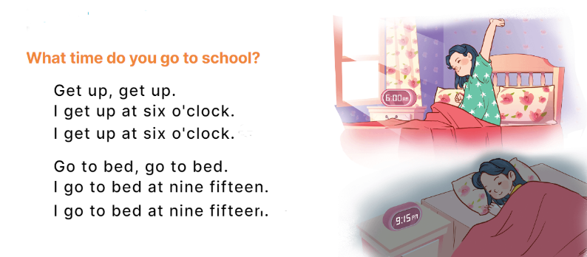  - Play the recording for Ss to listen to the whole chant.  + Have them repeat the title and lyrics line by line.  + Ask Ss to attend to the sounds of the letters t and d and the words get and bed.  - Play the recording all the way through for Ss to listen to pronunciation and melody.  - Play the recording line by line for Ss to listen and repeat  - Play the recording for Ss to chant and clap along.  - Ask Ss to practice chant and clap along in pairs or groups.  - Invite groups to the front of the classroom to perform the chant  -T gives feedback.  *Consolidation  *Aims: Ss will be able consolidate and wrap up the content of the lesson.  *Procedure:  - T asks ss to answer the following questions:  +What are the core values of the lesson? (if the teacher can take from the lesson).  - T review the vocabulary and model sentences.  - T praises some Ss who are hardworking / active/ good…. as well as encourage others to try more.  4. Homework. (2’)  - Practice the chant more.  - Draw and colour a paper birthday cake.  - Prepare the new lesson: Unit 2, Lesson 3 (4,5,6). | - Ss listen  -Ss listen the rules  - Ss play the game  - Ss open their books  - Ss recognize the differences about color of letter  - - Ss listen and repeat  - Ss listen, point and repeat  - Ss listen again and repeat  -Ss listen again and repeat  -Ss practice in pairs/ groups  -Ss listen and say:  + Number 1: I……..at six thirty.  + Number 2:I …..at five forty-five.  -Ss listen  - Ss listen to the tape and circle  - Ss listen again, circle and swap books with their partners.  -Ss read the sentences  - Ss look and listen.  -Ss listen to the chant  - Ss listen and repeat line by line without clap their hands  -Ss note the sounds, word  -Ss listen to melody of the song  - Ss listen and chant line by line.  - Ss chant and clap along.  - Ss work in groups (two groups) to chant  -Ss perform in front of the class.  -Ss listen  -Ss answer the questions  - Ss listen  -Ss listen and clap their hands  -Ss listen and take note
D. ADJUSTMENTS (if necessary):
………………………………………………………………………………………….…..……………………………………………………………………………...…………………………………………………………………………………………………………
Week 4 Preparing date: 06/10/2024
Period 16 Teaching date: 10/10/2024

Unit 2: Time and daily routines
Lesson 3 (4,5,6)
A. OBJECTIVES:
By the end of the lesson, Ss will be able to:
1. Knowledge:
- read and match the activities in a paragraph with the clocks showing the corresponding time.
- complete a paragraph about pupils’ daily routines.
- draw pictures of their daily routines at home and present them to the class by using the target language.
- Vocabulary: Review
- Skills: speaking, listening, reading and writing.
2. Competences:
- Critical Thinking: self-introduce
- Co-operation: ready to help friends in pair work/ group work.
- Self-control and independent learning: perform presentation skill.
3. Attitude/ Qualities:
- Kindness: Help partners to complete learning tasks.
- Honesty: tell the truth about feelings and emotions.
- Diligence: complete learning tasks.
B. TEACHING AIDS:
- Teacher: Teacher’s guide Pages 41,42; website hoclieu.vn, posters, laptop, pictures, textbook, lesson plan, TV or projector.
- Students: Pupil’s book Page 21, notebooks, workbooks, school things.
C. PROCEDURES:
Teacher’s activities | Students’ activities
1.Warm- up: (5’)  Game: “Chant”  *Aims: to review the vocabulary and structure about greet and respond to greetings.  *Procedure:  - Ask Ss chant and do the actions in Unit 2, Lesson 3 page 20 in groups.  - Give point for the groups and encourage them.  - Say “Open your book page 21” and look at “Unit 2, Lesson 3 (4,5,6)”.  2.Practice: (8’)  Activity 1. Read and match:  *Aims: Ss will be able to read and match the activities in a paragraph with the clocks showing the corresponding time.  *Procedure:  - Show the pictures and ask Ss some questions:  + What’s this?  + What time is it?  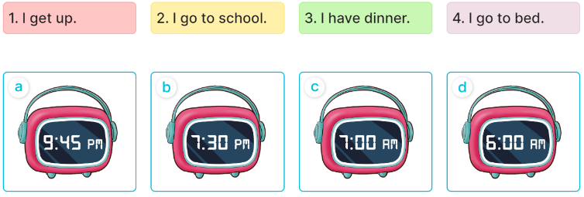  - Have pupils read the paragraph, the sentences, and the time on the clocks.  - Model Sentence 1 (clock d).  - Set a time limit for pupils to do the activity independently.  - Get pupils to swap books with a partner and check their answers before checking as a class.  - Invite some pupils to stand up to read the paragraph aloud.  -Tgives feedback.  Key: 1. d 2. c 3. b 4. a  3.Production: (19’)  Activity 2. Let’s write  *Aims: Ss will be able to complete a paragraph about pupils’ daily routines *Procedure:  - Tell pupils what they are going to do.  - Ask pupils what the paragraph is about (daily routines).  - Set a time limit for pupils to complete the paragraph independently.  - Get pupils to swap books and check their answers in pairs or groups before checking as a class.  - T gives feedback.  .Key: Pupil’s answer  Ex: I get up at six o’clock. I have breakfast at seven o’clock. I go to school at seven fifteen. What about you? What time do you go to school?  Activity 3. Project.  *Aims: Ss will be able to draw pictures of their daily routines at home and present them to the class by using the target language.  *Procedure:  - Ask Ss to draw pictures of their daily routines at home as homework before learning Unit 2 -Lesson 3 (4,5,6)  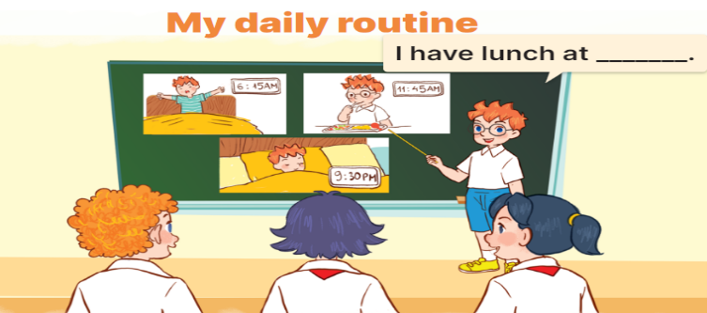  - Explain that pupils have to show simple pictures of their daily routines (getting up, having breakfast, etc.)  - Invite a pupil to the front of the class to model the presentation.  - Put the key presentation language on the board (ex: I get up at six fifteen.).  - Have pupils repeat the key presentation language a few times to make them feel confident when they present their daily routines before an audience.  - Set a time limit for pupils to work in groups.  - Invite a few pupils to the front of the class to present the project.  *Consolidation  *Aims: Ss will be able consolidate and wrap up the content of the lesson.  *Procedure:  - T asks ss to answer the following questions:  + What have you learnt from the lesson today?  +What are the core values of the lesson? (if the teacher can take from the lesson).  - T praises some Ss who are hardworking / active/ good…. as well as encourage others to try more.  4. Homework. (3’)  - Prepare the new lesson: Unit 3, Lesson 1 (1,2,3). | - Ss listen and chant  - Ss open their books  - Ss look at the pictures and answer  -Ss read and match  -Ss listen  -Ss do the activity and match  -Ss swap books and check their answer  -Ss read the paragraph aloud.  -Ss listen  -Ss listen to the teacher  -Ss listen and answer  -Ss complete the paragraph  -Ss swap books and check their answers  -Ss listen  - Ss draw pictures of their daily routines at home.  -Ss listen to the teacher  -Ss pay attention  -Ss repeat the key presentation  -Ss work in groups  -Ss present the project  -Ss answer the questions  -Ss listen and clap their hands  -Ss listen and take note
D. ADJUSTMENTS (if necessary):
………………………………………………………………………………………….…..……………………………………………………………………………...…………

Week 5 Preparing date: 06/10/2024
Period 17 Teaching date: 10/10/2024

Unit 3: My week
Lesson 1 (1, 2, 3)
A. OBJECTIVES:
By the end of the lesson, Ss will be able to:
1. Knowledge:
- understand and correctly repeat the sentences in two communicative contexts (pictures) in which pupils ask and answer questions about the days of the week.
- correctly say the words and use What day is it today? – It’s ………. to ask and answer questions about the days of the week.
- enhance the correct use of What day is it today? – It’s …….. to ask and answer questions about the days of the week in a freer context.
- Vocabulary: Monday, Tuesday, Wednesday, Thursday, Friday, Saturday, Sunday, today.
- Skills: speaking and listening
2. Competences:
- Critical Thinking: self-introduce
- Co-operation: ready to help friends in pair work/ group work.
- Sociability: Talk to each other, say good words to others.
3. Attitude/ Qualities:
- Kindness: Help partners to complete learning tasks.
- Honesty: tell the truth about feelings and emotions
B. TEACHING AIDS:
- Teacher: Teacher’s guide Pages 43, 44, 45, audio Tracks 26, 27, website hoclieu.vn, posters, laptop, pictures, textbook, lesson plan, TV or projector.
- Students: Pupil’s book Page 22, notebooks, workbooks, school things.
C. PROCEDURES:
Teacher’s activities | Students’ activities
1.Warm- up: (3’)  Sing: What day is it today?  *Aims: to create a friendly and active atmosphere in the class to beginning the lesson.  *Procedure:  - Show the song on the screen.  https://www.youtube.com/watch?v=ij0iWJB2uMo  - Ask pupils to listen, sing and dance the song.  - Say “Open your book page 22” and look at “Unit 3, Lesson 1 (1,2,3)”.  2. Presentation (16’)  Activity 1. Vocabulary.  *Aims: Ss will be able to know the vocabulary in the new lesson.  *Procedure:  -T elicits the new words  + Monday : thứ 2 (situation)  + Tuesday : thứ 3 (situation)  + Wednesday :thứ 4 (situation)  + Thursday : thứ 5 (translation)  + Friday : thứ 6 (translation)  + Saturday : thứ 7 (situation)  + Sunday : chủ nhật (situation)  + today : hôm nay (translation)  - T models (3 times).  - T writes the words on the board.  - Checking: Matching  Activity 2. Look, listen and repeat:  *Aims: Ss will be able to understand and correctly repeat the sentences in two communicative contexts (pictures) in which pupils ask and answer questions about the days of the week.  *Procedure:  - Have Ss look at Pictures a and b and identify the characters in the pictures.  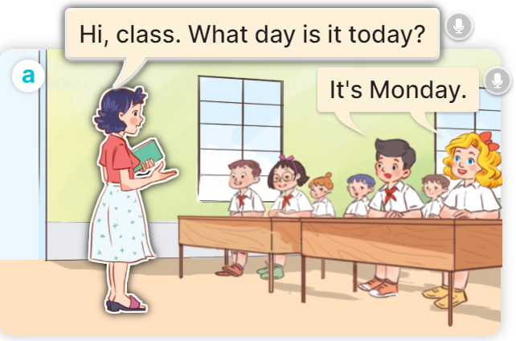  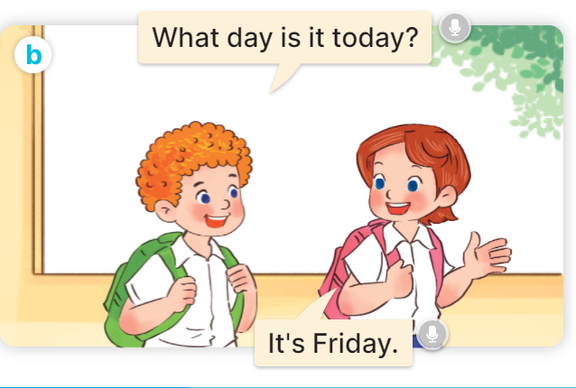  - Play the audio twice (sentence by sentence). Correct their pronunciation where necessary.  - Have Ss to practice the dialogue  - T invites a few pairs to the front of the class to practice.  - T checks pronunciation for ss.  Activity 3 Listen, point and say.  *Aims: Ss will be able to correctly say the words and use What day is it today? – It’s …….. to ask and answer questions about the days of the week.  *Procedure:  * Model sentences:  - T asks Ss look at picture a, b and helps Ss know the structure from the dialogue.  - T introduces new structure for Ss.  - T explains, models and gives meaning.  - Have Ss repeat the model sentences.  A: What day is it today?  B: It’s Monday.  3.Practice: (7’)  *Drill pictures  - Elicit and check comprehension the name of each character.      - Run through all the pictures.  - Run through model sentences.  - Have Ss to practise:  + T says the first picture  + Ss says the second picture  + Group A says the third picture  + Group B say the last picture.  - Ask Ss to work in pairs.  - T controls and corrects.  - Invite a few pairs to come to the front of the classroom, point at the relevant character in each picture, and act out his/her role.  - Encourage Ss to practise speaking English.  - T gives feedbacks.  4.Production: (7’)  Activity 4. Let’s talk.  *Aims: Ss will be able to enhance the correct use of What day is it today? – It’s …….. to ask and answer questions about the days of the week in a freer context.  *Procedure:  - T asks ss to guess each character and what the children say.  + What can you see in the picture?  +Who are they?  +Where are they?  +What are they saying?  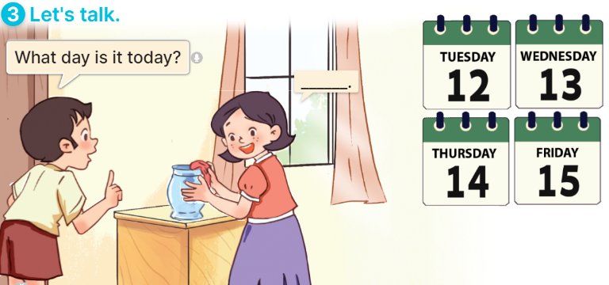  - T fills the gaps and writes the sentences on the board.  - T models  - T asks Ss to greet and introduce someone. (groups of four)  - Invite some groups to perform.  - Give feedbacks  *Consolidation  *Aims: Ss will be able consolidate and wrap up the content of the lesson.  *Procedure:  - T asks ss to answer the following questions:  + What have you learnt from the lesson today?  +What are the core values of the lesson? (if the teacher can take from the lesson).  - T review the vocabulary and model sentences.  - T praises some Ss who are hardworking / active/ good…. as well as encourage others to try more.  5. Homework. (2’)  - Learn the vocabulary and model sentences by heart  - Prepare the new lesson: Unit 3, Lesson 1 (4,5,6). | - Ss sing and dance the song  - Ss open their books  -Ss listen and answer  - - Ss listen and repeat  + Choral repetition (3 times).  + Individual repetition (3 ss)  - Ss take note  - Ss look, remember and match  -Look at the pictures and get to know the characters in the pictures.  + In picture a: Ms Hoa says: Hi, class. What day is it today? And Mr Long says: It’s Monday.  + In picture b: Mai says: That’s Mr Long. And Bill says: Hello, Mr Long.  -Ss listen and repeat in chorus (twice)  -Ss work in pairs to practice  -Ss practice the dialogue  -Ss listen  -Ss look at the picture and answer.  -Ss listen  -Ss listen and repeat  -Ss repeat to the introduce someone.  - Ss look, listen and answer  +Picture a: Monday  + Picture b: Tuesday  + Picture c: Wednesday  + Picture d: Thursday  -Ss listen and repeat  -Ss practice in chorus  -Ss practice  -Ss work in pairs to practice  -Ss point and say  -Ss listen.  -Ss listen  -Ss look at the picture and answer  + a boy asks a girl about the days of the week: Tuesday, Wednesday, Thursday, Friday (illustrated by calendars).  -Ss note  - Ss say the completed sentences.  -Ss pay attention  -Ss work in groups  -Ss perform in front of the class.  -Ss answer the questions  - Ss listen  -Ss listen and clap their hands  -Ss listen and take note

D. ADJUSTMENTS (if necessary):

