Week 4 Preparing date: 07/10, 2024
Period 13 Teaching date: 09/10/ 2024

Unit 2: Our homes
Lesson 2 (1, 2, 3)
A. OBJECTIVES:
By the end of the lesson, Ss will be able to:
1. Knowledge:

- understand and correctly repeat the sentences in two communicative contexts focusing on asking and answering questions about someone’s home and address

- correctly say the words and use What’s your address? – It’s ____. to ask and answer questions about someone’s address

- use What’s your address? – It’s __________. to ask and answer questions about someone’s address.

- Vocabulary: address, 45, 23, 38, 93 and 116
- Structures: A: What’s your address?
B: It’s 45 Ba Trieu Street.
- Skills: speaking and listening
2. Competences:
- Critical thinking and creativity: learn how to ask and answer questions about personal information correctly and fluently.
- Self-control and independent learning: perform pronunciation and speaking tasks.
3. Attitude/ Qualities:
- Show their pride in their personal information and where they live.
B. TEACHING AIDS:
- Teacher: Teacher’s guide Pages 38, 39, 40, audio Tracks 18, 19, website hoclieu.vn, posters, laptop, pictures, textbook, lesson plan, TV or projector.
- Students: Students’ book Page 18, notebooks, workbooks, school things.
C. PROCEDURES:
Teacher’s activities | Students’ activities
1.Warm- up and review: (3’)  Game: Roll the dice  *Aims: to revise the words about different types of homes.  *Procedure:  - Divide the class into groups of six. Have each student count the numbers from one to six.  - Ask a student from each group to roll the dice to choose a student asking the question.  - Ask that student to put up a picture and ask the question and invite another student of the group to answer the question about their homes.  - The student who answers the correct answers will continue rolling the dice.  - Say “Open your book page 18” and look at “Unit 2, Lesson 2 (1,2,3)”.  2. Presentation (15’)  Activity 1. Vocabulary.  *Aims: Ss will be able to know the vocabulary in the new lesson.  *Procedure:  -T elicits the new words  + address : địa chỉ (situation)  + twenty- three : số 23 (picture)  + thirty- eight : số 38 (picture)  +ninety- three : số 93 (picture)  +forty- five : số 45 (picture)  - T models (3 times).  - T writes the words on the board.  - Checking: Rub out and remember  Activity 2. Look, listen and repeat:  *Aims: Ss will be able to understand and correctly repeat the sentences in two communicative contexts (pictures) focusing on asking and answering questions about someone’s home and address.  *Procedure:  - Have Ss look at Pictures a and b and identify the characters and say what they are talking about.  + Who is he/ she?  + Where is he/ she?  + What are they talking about?  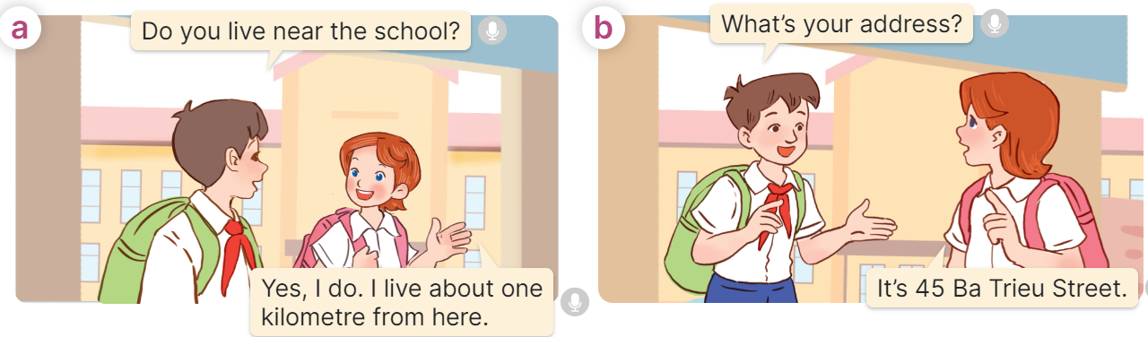  - Play the audio twice (sentence by sentence). Correct their pronunciation where necessary.  - Have Ss to practice the dialogue  - T invites a few pairs to the front of the class to practice.  - T checks pronunciation for ss.  Activity 3 Listen, point and say.  *Aims: Ss will be able to correctly say the words and use What’s your address? – It’s _____. to ask and answer questions about someone’s address.  *Procedure:  * Structures:  - T asks Ss look at picture b in activity 1 and helps Ss know the structure from the dialogue.  - T introduces new structures for Ss.  - T explains, models and gives meaning.  - Have Ss repeat the model sentences.  A: What’s your address??  B: It’s 45 Ba Trieu Street.  3.Practice: (7’)  *Drill pictures  - Have Ss look at the pictures and say what they can see in the pictures.  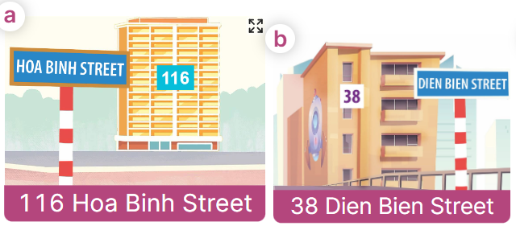  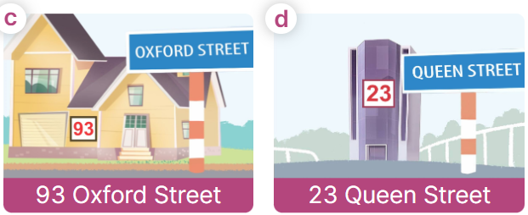  - Have Ss point at pictures, listen and run through all the pictures.  - Have Ss point at the bubbles, listen and run through model sentences.  - Have Ss to practise:  + T asks the first picture, Ss answer  + Ss asks the second picture, T answers  + Group A asks the third picture, group B  answers  + Group B asks the last picture, group A  - Ask Ss to work in pairs to practise asking and answering the question What’s your address? – It’s _____.  - T controls and corrects.  - Invite a few pairs to point at the pictures and say the questions and answers in front of the class.  4. Production: (6’)  Activity 4. Let’s talk.  *Aims: Ss will be able to use Do you live in ___? – Yes, / No, ___. and What’s your address? – It’s___. to ask and answer questions about someone’s address in a freer context.  *Procedure:  - Ask Ss to look at the pictures and elicit the addresses.  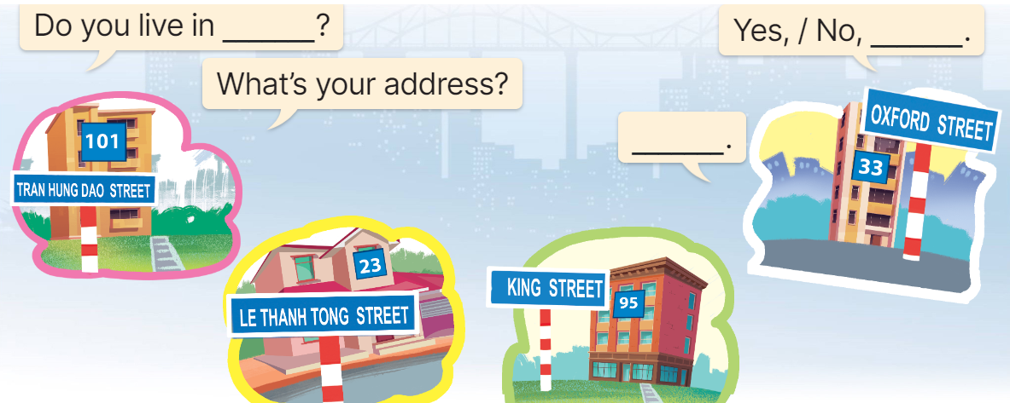  - Point at the ﬁrst building and elicit the question in the ﬁrst speech bubble Do you live in __? and the answer in the second speech bubble Yes, / No, ____. as an example. If the answer is No, then point at the question What’s your address?  - Give Ss time to work in pairs and take turns pointing at each picture to ask and answer using Do you live in ___? Yes, / No, __. and What’s your address? – ___.  - Invite a few pairs to come to the front of the classroom and act out the exchanges.  5. Fun corner and wrap- up (4’)  Game: Racing  - Divide the class into three groups. Each group has equal numbers of Ss.  - Ask Ss to stand in lines. Set the timer.  - Ask the first pupil from each line What’s your address? he/ she must answer and in turn ask the second student in the line. The second pupil then answers and asks the third, and so on.  - The group which has the shortest time to finish asking and answering wins the game. | -Ss listen and pay attention  - Ss listen to the teacher  -Ss play the game  Ex: A: Do you live in this house?  B: Yes, I do.  -Ss continute playing the game  - Ss listen and open their books  -Ss listen and answer  - - Ss listen and repeat  + Choral repetition (3 times).  + Individual repetition (3 ss)  - Ss take note  - Ss look, remember and write  -Look at the pictures and say.  + In picture a:  Nam: Do you live near the school?  Lucy: Yes, I do. I live about one kilometre from here.  + In picture b:  Nam: What’s your address?  Lucy: It’s 45 Ba Trieu Street.  -Ss listen and repeat in chorus (twice)  -Ss work in pairs to practice  -Ss come to the front of the classroom to practice.  -Ss listen  - Ss look at the picture and answer.  -Ss listen  -Ss listen and repeat  -Ss repeat to the structures  - Ss look, listen and repeat  +Picture a: 116 Hoa Binh Street  + Picture b: 38 Dien Bien Street  + Picture c: 93 Oxford Street  + Picture d: 23 Queen Street  Notes:  We say: 116: one-sixteen or one-one-six.  Don’t say: one hundred and sixteen  -Ss point at pictures, listen and repeat  -Ss point at the bubbles, listen and repeat  -Ss practice in chorus  -Ss practice in chorus  -Ss work in pairs to practise asking and answering the question  - Pairs of Ss point at the pictures and say in front of the class  -Ss look at the picture and say  - Ss look at the first building and elicit the missing words in speech bubbles and say the completed sentences.  - Ss role-play to practise asking and answering questions  - Ss practise asking and answering questions in front of the class.  -Ss listen to the teacher  -Ss play the game  -Ss congratulate the winner
D. ADJUSTMENTS (if necessary):
………………………………………………………………………………………….…..……………………………………………………………………………...……
Week 4 Preparing date: 07/10, 2024
Period 14 Teaching date: 09/10., 2024

Unit 2: Our homes
Lesson 2 (4, 5, 6)
A. OBJECTIVES:
By the end of the lesson, Ss will be able to:
1. Knowledge:
- listen to and understand two communicative contexts in which speakers ask and answer questions about their addresses and circle the correct pictures.
- complete two gapped dialogues with the help of picture cues.
- listen to and complete the song Homes and to sing it with the correct pronunciation, rhythm and melody.
- Vocabulary: Review
- Skills: speaking, listening, reading and writing.
2. Competences:
- Communication and collaboration: work in pairs and groups to complete the learning tasks.
- Self-control and independent learning: perform listening and reading tasks.
3. Attitude/ Qualities:
- Show their pride in their personal information and where they live.
B. TEACHING AIDS:
- Teacher: Teacher’s guide Pages 40, 41, 42; audio Tracks 20, 21; website hoclieu.vn, posters, laptop, pictures, textbook, lesson plan, TV or projector.
- Students: Student’s book Page 19, notebooks, workbooks, school things.
C. PROCEDURES:
Teacher’s activities | Students’ activities
1.Warm- up and review: (5’)  “Listen and choose the number”  *Aims: to revise the learned numbers.  *Procedure:  - Ask Ss to take out the board and chalk or marker.  - Play the audio and have Ss listen to the audio and write the number they hear in 5 seconds.  - Ask Ss to hold the board up to show the answer.  - Check the answer with the whole class.  - Say “Open your book page 19” and look at “Unit 2, Lesson 2 (4,5,6)”.  2.Practice: (25’)  Activity 1. Listen and circle:  *Aims: Ss will be able to listen to and understand two communicative contexts in which speakers ask and answer questions about their addresses and circle the correct pictures.  *Procedure:  - Draw Ss’ attention to the pictures and ask questions to elicit the addresses  + What can you see in this picture?  + Is it at 67 Tay Son street?  + Is it a flat?  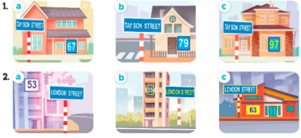  - T ask Ss to guess the answers.  + T writes Ss’guessing on the board.  - Listen to the tape:  + Play the recording  + Play the recording again for pupils to do the task.  + Play the recording a third time for pupils to check their answers.  - Get Ss to swap books with their partner, then check answers as a class.  + Write the answers on the board for Ss to correct their answers. Then checks Ss’ guessing.  - Play the recording, sentence by sentence, for Ss to listen and repeat individually and in chorus  Key: 1. b 2. a  Activity 2. Read and complete.  *Aims: Ss will be able to read and complete two gapped dialogues with the help of picture cues.  *Procedure:  - Have Ss read the dialogue. Draw Ss’ attention to the address and the distance from the address to the place.  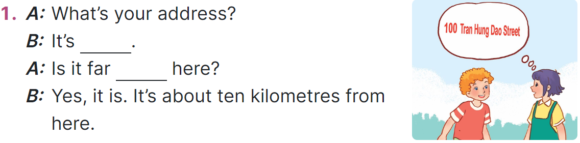  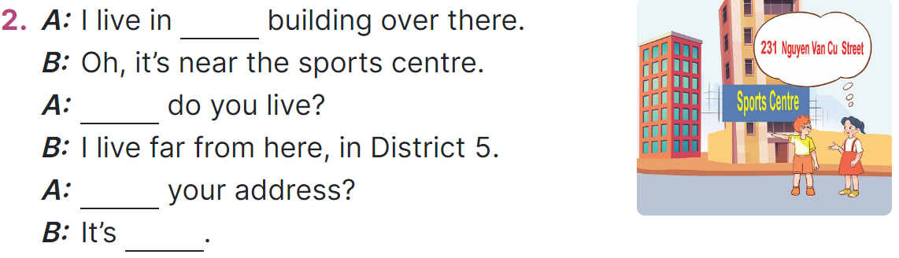  - Read the second dialogue. Point at the building and draw Ss’ attention to the boy’s hand toward the building on the left-hand side.  + Elicit the missing word (that).  - Give Ss a time limit to read the gapped dialogues, look at the pictures and fill in the gaps independently.  - Get Ss to swap books with a partner and check their answers before checking as a class.  + Invite one student to write the answers on the board.  - Invite two pairs of Ss to act out the completed dialogues.  Key: 1.100 Tran Hung Dao Street; from  2. that; Where; What’s;  231 Nguyen Van Cu Street  Activity 3. Listen, complete and sing.  *Aims: Ss will be able to listen to and complete the song Homes and to sing it with the correct pronunciation, rhythm and melody.  *Procedure:  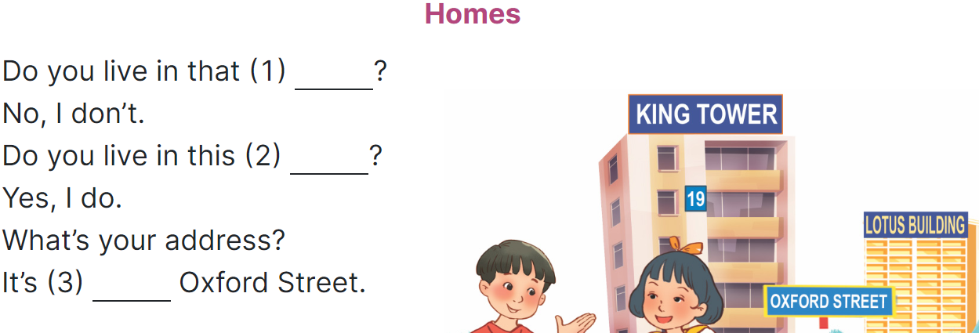  - Have Ss read the song lyrics and guess the missing words with the help of the picture.  + Give Number 1 as an example (building).  - Give a time limit for Ss to read and fill the gaps.  - Play the recording again for  Ss to check the answers.  - Play the recording again for Ss to listen and sing along before they practise singing the song.  3. Fun corner and wrap- up (5’)  Game: Lucky number  - Divide the class into 2 teams.  - Each team takes turns to choose the number and answer the question.  - T checks the answer with the whole class.  - Ss get the point(s) if they answer the question correctly.  - The team with more points is the winner. | - Ss take out the board and chalk or marker.  - Ss listen and write the numbers.  - Ss show the answer and check.  - Ss open their books  -Look at the pictures and say:  + Picture 1a: a private house at 67 Tay Son Street  + Picture 1b: a private house at 79 Tay Son Street  + Picture 1c: a private house at 97 Tay Son Street  + Picture 2a: a block of flats at 53 London Street  + Picture 2b: a block of flats at 35 London Street  + Picture 2c: a block of flats at 63 London Street  -Ss guess the answers  - Ss listen to the tape  - Ss listen again and do the task.  - Ss listen and check their answers  - Ss swap books with their partner, then check answers as a class.  -Ss check the guessing  -Ss listen and repeat  -Ss look at the picture and say  - Ss read the second dialogue.  - Ss follow the teacher’s instruction.  - Ss complete gapped independently.  - Ss swap books with a partner and check their answers.  +Ss write the answers  - Ss read the completed dialogues aloud  - Ss read the song and guess the missing words.  - Ss follow the teacher's instructions.  - Ss work individually, listen and complete.  - Ss listen to the recording to check their answers again.  - Ss listen and sing along.  -Ss listen to the teacher  - Ss play the game.  - Ss cheer up whenever the guess is correct.
D. ADJUSTMENTS (if necessary):
………………………………………………………………………………………….…..……………………………………………………………………………...…..…

Week 4 Preparing date: 07/10, 2024
Period 15 Teaching date: 11/10., 2024

Unit 2: Our homes
Lesson 3 (1, 2, 3)
A. OBJECTIVES:
By the end of the lesson, Ss will be able to:
1. Knowledge:
- correctly pronounce the two-syllable words with the stress on the second syllable as in ﬁf’teen and six’teen in isolation and as in the sentences I live at fifteen Ba Dinh Street; She lives at sixteen London Street
- identify the stress on some two-syllable words and circle the word with a diﬀerent stress pattern from the other two words
- say the chant with the correct pronunciation, word stress and rhythm.
- Vocabulary: Review
- Skills: speaking, listening, reading and writing.
2. Competences:
- Communication and collaboration: work in pairs and groups to complete the learning tasks.
- Self-control and independent learning: perform pronunciation and listening tasks.
3. Attitude/ Qualities:
- Show their pride in their personal home and address.
B. TEACHING AIDS:
- Teacher: Teacher’s guide Pages 42, 43, 44; audio Tracks 22, 23, 24; website hoclieu.vn, posters, laptop, pictures, textbook, lesson plan, TV or projector.
- Students: Students’ book Page 20, notebooks, workbooks, school things.
C. PROCEDURES:
Teacher’s activities | Students’ activities
1.Warm- up and review: (5’)  Game: Matching game  *Aims: to revise the number.  *Procedure:  - Explain how to play the game:  + Ss take turns to open two cards, trying to find the pairs of numbers (as numbers and words).  + If the cards don’t match, teacher clicks to turn them back.  + If the cards match, praise Ss and give them points for their team.  - Say “Open your book page 20” and look at “Unit 2, Lesson 3 (1,2,3)”.  2. Presentation (9’)  Activity 1. Listen and repeat:  *Aims: Ss will be able to correctly pronounce the two-syllable words with the stress on the second syllable as in ﬁf’teen and six’teen in isolation and as in the sentences I live at fif'teen Ba Dinh Street and She lives at six'teen London Street.  *Procedure:  - Have Ss point at the words ‘ﬁf’teen and six’teen and the sentences I live at fif'teen Ba Dinh Street and She lives at six'teen London Street.  - Play the recording for Ss to listen and repeat in chorus and individually until they feel confident.  - Let Ss work in pairs or groups, saying the words and reading the sentences.  - T invites some Ss to practice.  3.Practice: (17’)  Activity 2. Circle, listen and check.  *Aims: Ss will be able to identify the stress on some two-syllable words and circle the word with a diﬀerent stress pattern from the other two words  *Procedure:  - Tell Ss circle the word having a different stress from each line. Then listen to the recording to check their answers.  - Set a time for Ss to do the task.  - Play the recording, once or twice, for Ss to listen and check their answers.  - Get Ss to swap books with a partner and check their answers before checking as a class.  - Play the recording again for Ss to double-check their answers.  - Invite a few Ss to read aloud all the words in the three lines.  Key: 1.c 2.a 3.a  Activity 3. Let’s chant  *Aims: Ss will be able to say the chant with the correct pronunciation, word stress and rhythm.  *Procedure:  - Introduce the title and lyrics of the chant.  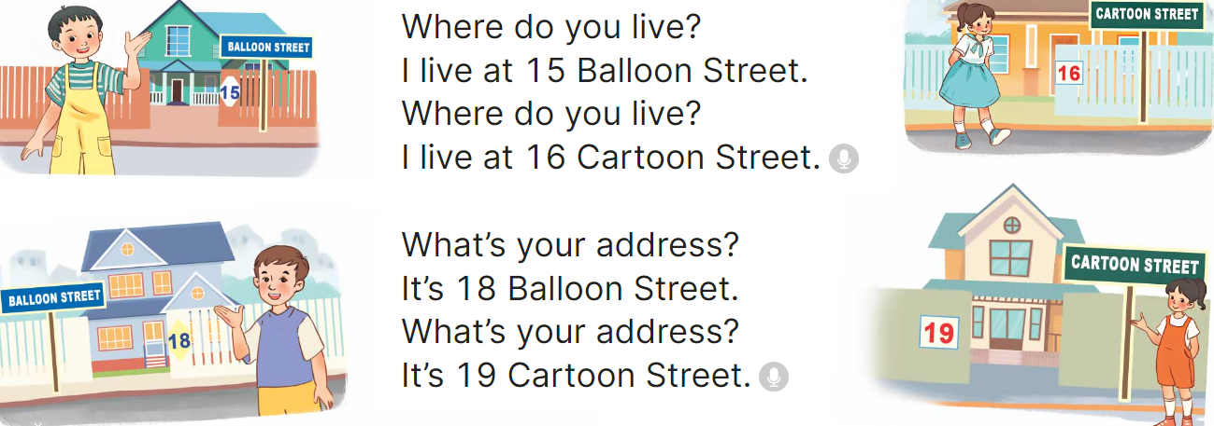  - Play the recording for Ss to listen to the whole chant.  + Have them repeat the title and lyrics line by line.  + Ask Ss to attend to two-syllable words with the stress on the first syllable in the chant, fifteen, sixteen, eighteen, nineteen, balloon and cartoon.  - Play the recording all the way through for Ss to listen to pronunciation and melody.  - Play the recording line by line for Ss to listen and repeat  - Play the recording for Ss to chant and clap along.  - Ask Ss to practice chant and clap along in pairs or groups.  - Invite groups to the front of the classroom to perform the chant  3. Fun corner and wrap- up (4’)  Game: Jumping  - Tell Ss they are going to play the game Jumping.  + If teacher reads a word that is the same as what she writes on the board, Ss jump. + If it is not, they keep still.  + Ask Ss to say the word written on the board.  - Ask Ss to stand at their desks.  - Write a number from the lesson and say a word. Have Ss play the game. | - Ss listen  -Ss listen the rules  - Ss play the game  - Ss open their books  - - Ss pay attention  - Ss listen to the recording again and repeat.  -Ss work in pairs and practice  -Ss say the language in front of the class  - Ss pay and listen to the teacher’s explanation.  - Ss do the task  - Ss listen to the recording to check their answers (individual)  - Ss swap books with a partner and check the answers  - Ss listen to the recording again and check their answers again.  - Ss stand up and read aloud the words.  - Ss look and listen.  - Ss listen to the chant  - Ss listen and repeat line by line without clap their hands  - Ss note the rhythm and pronunciation.  -Ss listen to melody of the chant  - Ss listen and chant line by line.  - Ss chant and clap along.  - Ss work in groups (two groups) to chant  -Ss perform in front of the class.  -Ss listen  -Ss listen  -Ss play the game
D. ADJUSTMENTS (if necessary):
………………………………………………………………………………………….…..……………………………………………………………………………...………………………………………….…..………………………………………………

Week 4 Preparing date: 07/10, 2024
Period 16 Teaching date: 11/10, 2024

Unit 2: Our homes
Lesson 3 (4, 5, 6)
A. OBJECTIVES:
By the end of the lesson, Ss will be able to:
1. Knowledge:
- read a letter and show understanding by deciding if the sentences are true or false
- write the answers to the guiding questions based on their personal information
- present the results of a survey of pupils’ homes to the class.
- Vocabulary: Review
- Skills: speaking, listening, reading and writing.
2. Competences:
- Communication and collaboration: work in pairs and groups to complete the learning tasks.
- Self-control and independent learning: perform reading and writing tasks.
3. Attitude/ Qualities:
- Show their knowledge about houses and addresses.
B. TEACHING AIDS:
- Teacher: Teacher’s guide Pages 44, 45; website hoclieu.vn, posters, laptop, pictures, textbook, lesson plan, TV or projector.
- Students: Student’s book Page 21, notebooks, workbooks, school things.
C. PROCEDURES:
Teacher’s activities | Students’ activities
1.Warm- up and review: (5’)  Game: “Board race”  *Aims: to create a friendly and active atmosphere in the class to beginning the lesson.  *Procedure:  - T numbers the students in each team.  - T plays the recording then calls out the number, the ss of that number from each team comes to the board, write the number they hear and read it aloud.  - Say “Open your book page 21” and look at “Unit 2, Lesson 3 (4,5,6)”.  2.Practice: (8’)  Activity 1. Read and tick True or False:  *Aims: Ss will be able to read a letter and show understanding by deciding if the sentences are True or False.  *Procedure:  - Tell Ss the goal of the activity and explain that they should read the letter and tick True or False for the sentences provided.  - Model number 1. Have Ss read the sentence number 1; then scan the letter above quickly to find the correct fact (Sydney). Then tell them to compare with the information given in the sentence provided (London). Tell the Ss to tick the box False.  - Set a time limit for Ss to do the task independently.  - Get Ss to swap books with a partner and check their answers before checking as a class.  - Invite one or two Ss to read aloud the letter.  Key: 1. F 2. T 3. T 4. F 5. F  3.Production: (18’)  Activity 2. Let’s write  *Aims: Ss will be able to write the answers to guiding questions based on their personal information  *Procedure:  - Tell the class the goal of the activity and explain that they should read the questions and write the answers based on their personal information.  - Model question 1.  - Give Ss time to do the writing task independently.  - Get Ss to swap books with a partner and check their answers before checking as a class.  - Invite one or two Ss to stand up and read aloud their answers.  Key: Pupil’s answer  Ex: 1. Where do you live?  I live in the countryside.  2. What’s your address?  It’s Nghia Lam Village.  3. Where does your best friend live?  She lives in the city.  4. What’s his/her address?  It's 77 Nghia Lam Road.  Activity 3. Project.  *Aims: Ss will be able to present the results of a survey of pupils’ homes to the class.  *Procedure:  - Check Ss’ preparation of their survey.  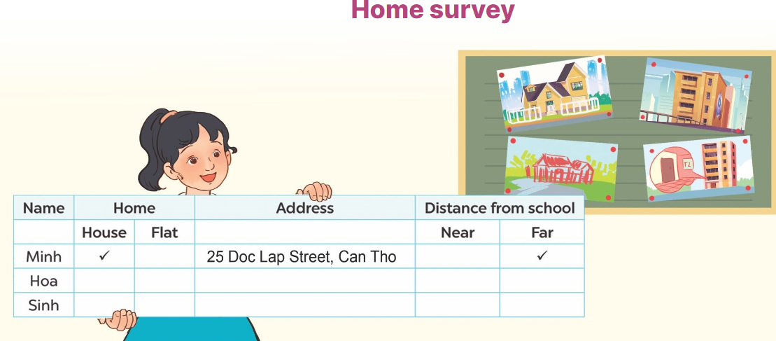  - Invite a student to report his / her survey with your help.  - Have Ss work in groups to practise reporting their own surveys.  - Invite a few Ss to report their surveys in front of the class.  - Praise Ss when they do a good job.  4. Fun corner and wrap- up (4’)  Game: Mystery Box  - Divide the class into two groups: Boys and Girls.  - In teams, Ss take turns to choose the letters and answer the questions.  + If they have the correct answers, they can give the mystery box or keep it to the other teams.  +The group with more points wins the game. | - Ss listen  - Ss listen to the rules  -Ss play game  - Ss open their books  - Ss listen to the teacher’s instruction.  - Ss read the letter as a class.  - Ss do sentence number 1  - Ss do the task individually.  - Ss swap books with a partner, and check answers  - One or two Ss read aloud the letter.  - Ss listen to the teacher’s explanation.  - Ss follow the teacher’s instructions.  - Ss do the task individually.  - Ss swap books and check their answers  - Ss read aloud their answers.  - Ss listen to the teacher’s instruction.  - One student does an example with the teacher’s help.  - Ss show their posters that they have made at home and tell the group about different types of homes.  - Ss show their work and talk  -Ss congratulate  -Ss listen to the teacher  -Ss play the game  -Ss congratulate the winner
D. ADJUSTMENTS (if necessary):
………………………………………………………………………………………….…..……………………………………………………………………………...……

