Week 3 Preparing date: 29/9/2024
Period 9 Teaching date: 01/10/2024

Unit 1: My friends
Lesson 3 (1, 2, 3)
A. OBJECTIVES:
By the end of the lesson, Ss will be able to:
1. Knowledge:
- correctly pronounce the sounds of the letters a and ia in isolation, in the words
America and Australia, and in the sentences I’m from America. and She’s from
Australia.
- use the words America, Australia, Britain, Japan, Malaysia, Singapore,
Thailand, and Viet Nam in relation to the topic “My friends”.
- use Where are you from? – I’m from ……….. and Where’s he / she from?
– He’s / She’s from …………. to ask and answer questions about where someone
comes from
- listen to and demonstrate understanding of simple communicative contexts
in relation to the topic “My friends”.
- read and write about where someone comes from.
- Vocabulary: Review
- Skills: speaking, listening, reading and writing.
2. Competences:
- Communication and collaboration: work in pairs and groups to complete the
learning tasks.
- Self-control & independent learning: perform listening tasks.
3. Attitude/ Qualities:
- Kindness: Help partners to complete learning tasks.
- Honesty: tell the truth about feelings and emotions
B. TEACHING AIDS:
- Teacher: Teacher’s guide Pages 26, 27, 28; audio Tracks 13, 14, 15; website hoclieu.vn, posters, laptop, pictures, textbook, lesson plan, TV or projector.
- Students: Pupil’s book Page 14, notebooks, workbooks, school things.
C. PROCEDURES:
Teacher’s activities | Students’ activities
1.Warm- up: (5’)  Game: Slap the board  *Aims: to create a friendly and active atmosphere in the class to beginning the lesson.  *Procedure:  - Divide class into 2 groups  - How to play:  + Each group chooses five Ss to play.  + Class will read aloud.  + Look at the picture, listen and slap the picture you heard.  + Who faster will get 1 mark.  + Which group with higher mark is the winner.  - T gives feedback.  - Say “Open your book page 14” and look at “Unit 1, Lesson 3 (1,2,3)”.  2. Presentation (9’)  Activity 1. Listen and repeat:  *Aims: Ss will be able to correctly pronounce the sounds of the letters a and ia in isolation, in the words America and Australia, and in the sentences I’m from America. and She’s from Australia.  *Procedure:  - T gives instruction to the letter a and ia, the word America and Australia the sentence I’m from America. and She’s from Australia  - Play the recording for the letter a, ia  - Encourage Ss to point at the letter/ word/ sentence while listening.  - Play the recording again and encourage Ss to listen and repeat.  - Have pupils work in pairs or groups to do this several times until Ss feel confident.  - T calls some Ss to practice.  - T gives feedbacks.  3.Practice: (19’)  Activity 2. Listen and circle.  *Aims: Ss will be able to identify the target words America and Australia while listening.  *Procedure:  - Elicit the sentences and the gap-fill options.  - T ask Ss to guess the answers.  + T writes Ss’guessing on the board.  - Listen to the tape:  + Play the recording  + Play the recording again and get Ss to swap books with their partners.  + Play the recording again to check answers together as a class.  + Write the answers on the board for Ss to correct their answers. Then checks Ss’ guessing.  - Play the recording, sentence by sentence, for the class to listen and repeat in chorus.  - Invite one or two Ss to stand up and read the completed sentences.  Key: 1.a 2.b  Activity 3. Let’s chant  *Aims: Ss will be able to say the chant with the correct rhythm and pronunciation.  *Procedure:  - Introduce the title and lyrics of the chant.  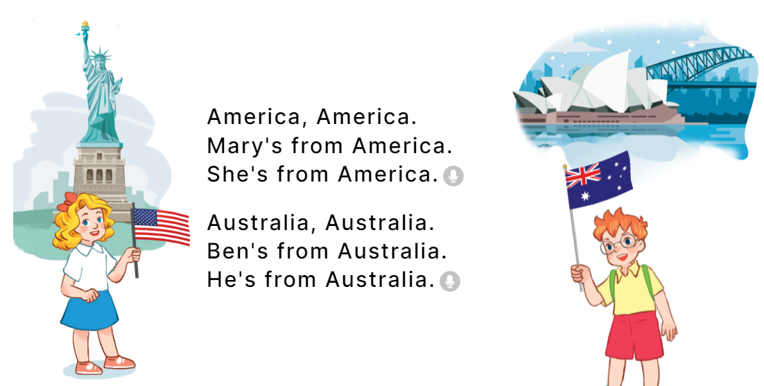  - Play the recording for Ss to listen to the whole chant.  + Have them repeat the title and lyrics line by line.  + Ask Ss to attend to the sounds of the letters a and ia and the words America and Australia.  - Play the recording all the way through for Ss to listen to pronunciation and melody.  - Play the recording line by line for Ss to listen and repeat  - Play the recording for Ss to chant and clap along.  - Ask Ss to practice chant and clap along in pairs or groups.  - Invite groups to the front of the classroom to perform the chant  -T gives feedback.  *Consolidation  *Aims: Ss will be able consolidate and wrap up the content of the lesson.  *Procedure:  - T asks ss to answer the following questions:  + What have you learnt from the lesson today?  +What are the core values of the lesson? (if the teacher can take from the lesson).  - T review the vocabulary and model sentences.  - T praises some Ss who are hardworking / active/ good…. as well as encourage others to try more.  4. Homework. (2’)  - Practice the chant more.  - Prepare the new lesson: Unit 1, Lesson 3 (4,5,6). | - Ss listen  -Ss listen the rules  - Ss play the game  - Ss open their books  - Ss recognize the differences about color of letter  - - Ss listen  - Ss listen and point  - Ss listen again and repeat  -Ss work in pairs and practice  -Ss practice in font of the class  -Ss listen  -Ss listen and say:  + Number 1: I’m from…..  + Number 2: He’s from…..  -Ss guess the answers  - Ss listen to the tape and circle  - Ss listen again, circle and swap books with their partners.  - Ss check their answers and guessing  -Ss listen and repeat.  -Ss read the sentences  - Ss read aloud the completed sentences.  - Ss look and listen.  -Ss listen to the chant  - Ss listen and repeat line by line without clap their hands  -Ss note the sounds, words  -Ss listen to melody of the song  - Ss listen and chant line by line.  - Ss chant and clap along.  - Ss work in groups (two groups) to chant  -Ss perform in front of the class.  -Ss listen  -Ss answer the questions  - Ss listen  -Ss listen and clap their hands  -Ss listen and take note
D. ADJUSTMENTS (if necessary):
………………………………………………………………………………………….…..……………………………………………………………………………...………………………………………….…..……………………………………………………………………………….……………………………………………………………………...

Week 3 Preparing date: 29/9/2024
Period 10 Teaching date: 02/10/2024

Unit 1: My friends
Lesson 3 (4,5,6)
A. OBJECTIVES:
By the end of the lesson, Ss will be able to:
1. Knowledge:
- correctly pronounce the sounds of the letters a and ia in isolation, in the words
America and Australia, and in the sentences I’m from America. and She’s from
Australia.
- use the words America, Australia, Britain, Japan, Malaysia, Singapore,
Thailand, and Viet Nam in relation to the topic “My friends”.
- use Where are you from? – I’m from ……….. and Where’s he / she from?
– He’s / She’s from …………. to ask and answer questions about where someone
comes from
- read and write about where someone comes from.
- Vocabulary: Review
- Skills: speaking, listening, reading and writing.
2. Competences:
- Critical Thinking: self-introduce
- Co-operation: ready to help friends in pair work/ group work.
- Self-control and independent learning: perform listening tasks.
3. Attitude/ Qualities:
- Kindness: Help partners to complete learning tasks.
- Honesty: tell the truth about feelings and emotions.
- Diligence: complete learning tasks.
B. TEACHING AIDS:
- Teacher: Teacher’s guide Pages 25, 26; website hoclieu.vn, posters, laptop, pictures, textbook, lesson plan, TV or projector.
- Students: Pupil’s book Page 15, notebooks, workbooks, school things.
C. PROCEDURES:
Teacher’s activities | Students’ activities
1.Warm- up: (5’)  Game: “ Backward spelling”  *Aims: to review the vocabulary and structure about greet and respond to greetings.  *Procedure:  - T divides class into teams.  - Each team takes turns to have a pupil stand in front of the board.  - The rest spell the word written by the teacher on the board backwards.  - The team that guesses the word first gets 1 point. The team with the most points is the winner.  Ex: N-A-P-A-J JAPAN  M-A-N-T-E-I-V VIETNAM  E-R-O-P-A-G-N-I-S SINGAPORE  - Say “Open your book page 15” and look at “Unit 1, Lesson 3 (4,5,6)”.  2.Practice: (8’)  Activity 1. Read and tick True or False:  *Aims: Ss will be able to read and show understanding the sentences by deciding if the  statements are true or false  *Procedure:  - Tell pupils the goal of the activity and explain that they should read the sentences and tick True or False.  - Model the first sentence. First, have pupils read the sentence and identify Minh’s age.  -Then have them read the text and find the correct information to tick the appropriate  box  - Set a time limit for pupils to do the task independently.  - Get pupils to swap their books with a partner and check their answers before checking as a class.  - Correct the answers where necessary.  - Invite one or two pupils to read the text and the sentences in front of the class.  -T gives feedbacks.  Key: 1. True 2. True 3. False 4. False  3.Production: (19’)  Activity 2. Let’s write  *Aims: Ss will be able to complete a gapped text about themselves and their friends  *Procedure:  - Tell and explain the class the goal of the activity.  - Explain that the gaps in the text focus on  their names and age(s), their friends’ names and where they are from  - Have pupils do the first gapped sentence together as an example.  - Give pupils time to complete the text independently.  - Get pupils to swap their books with a partner and check their answers before checking as a class.  - Invite one or two pupils to read their completed texts in front of the class.  Key:  1. Pupil’s answer  Activity 3. Project.  *Aims: Ss will be able to make pupil cards at home and present them to the class by using the target language  *Procedure:  - Stick the pupil card sample on the board and model with the name, age and country.  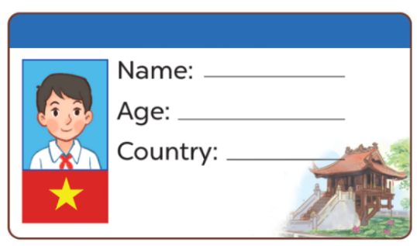  - T asks Ss to make their name cards and present them to their class.  - T asks ss to work in groups of five and do the project in class.  - Invite a few pupils to show their cards and tell the class about them.  - T gives feedback.  *Consolidation  *Aims: Ss will be able consolidate and wrap up the content of the lesson.  *Procedure:  - T asks ss to answer the following questions:  + What have you learnt from the lesson today?  +What are the core values of the lesson? (if the teacher can take from the lesson).  - T praises some Ss who are hardworking / active/ good…. as well as encourage others to try more.  4. Homework. (3’)  - Read again the text.  - Prepare the new lesson: Unit 2, Lesson 1 (1,2,3). | - Ss listen and answer  - Ss listen to the rules  -Ss play game  - Ss open their books  - Ss look at the sentences and listen  -Ss read and circle  -Ss read the text and tick  -Ss read again and tick  -Ss swap books and check  -Ss check the correct their answers  -Ss read the text in front of the class  -Ss listen  -Ss listen and pay attention  -Ss look, listen and pay attention  -Ss write their names in the gap.  -Ss complete the text  -Ss swap books and check their answers  -Ss read the completed texts in font of the class  - Ss look and listen  -Ss prepare necessary school things to carry out the project (paper, pens, pencils, coloured pencils, scissors , glue,…..)  -Ss make their name cards and present them to their class.  -Ss work in groups  -Ss present their cards  Ex: Hi. My name’s Huong. I’m from Viet Nam. This is Jenny. She’s nine years old. She’s from England. And this is Kate. He’s ten years old. He’s from Australia.  -Ss answer the questions  -Ss listen and clap their hands  -Ss listen and take note
D. ADJUSTMENTS (if necessary):
………………………………………………………………………………………….…..……………………………………………………………………………...…………

Week 3 Preparing date: September ……29. 2024
Period 11 Teaching date: 03/10/2024

Unit 2: Time and daily routines
Lesson 1 (1, 2, 3)
A. OBJECTIVES:
By the end of the lesson, Ss will be able to:
1. Knowledge:
- understand and correctly repeat the sentences in two communicative contexts focusing on asking and telling the time.
- correctly say the phrases and use What time is it? – It’s …….. to ask and tell the time.
- enhance the correct use of What time is it? – It’s ………. to ask and tell the time in a freer context.
- Vocabulary: o’clock, thirty, forty five.
- Skills: speaking and listening
2. Competences:
- Oral Communication: speak about names, ask and answer the questions
- Co-operation: ready to help friends in pair work/ group work.
- Sociability: Talk to each other, say good words to others.
3. Attitude/ Qualities:
- Kindness: Help partners to complete learning tasks.
- Honesty: tell the truth about feelings and emotions
- Diligence: complete learning tasks
B. TEACHING AIDS:
- Teacher: Teacher’s guide Pages 30,31,32, audio Tracks 16,17, website hoclieu.vn, posters, laptop, pictures, textbook, lesson plan, TV or projector.
- Students: Pupil’s book Page 16, notebooks, workbooks, school things.
C. PROCEDURES:
Teacher’s activities | Students’ activities
1.Warm- up: (3’)  Game: Slap the board (with numbers)  *Aims: to create a friendly and active atmosphere in the class to beginning the lesson.  *Procedure:  - Divide the class into 3 teams. For each turn, invite 1 member from each team.  - Teacher says the numbers for the pupils to slap and say aloud.  - Give points to the pupils with the correct choice and encourage them.  - Sum up and lead in to the lesson.  - Say “Open your book page 16” and look at “Unit 2, Lesson 1 (1,2,3)”.  2. Presentation (16’)  Activity 1. Vocabulary.  *Aims: Ss will be able to know the vocabulary in the new lesson.  *Procedure:  -T elicits the new words  + o’clock : giờ đúng (translation)  + thirty : số 30 (picture)  + forty five : số 45 (picture)  + time : thời gian, giờ (translation)  - T models (3 times).  - T writes the words on the board.  - Checking: Rub out and remember  Activity 2. Look, listen and repeat:  *Aims: Ss will be able to understand and correctly repeat the sentences in two communicative contexts focusing on asking and telling the time.  *Procedure:  - Have pupils look at Pictures a and b and identify the characters in the pictures.  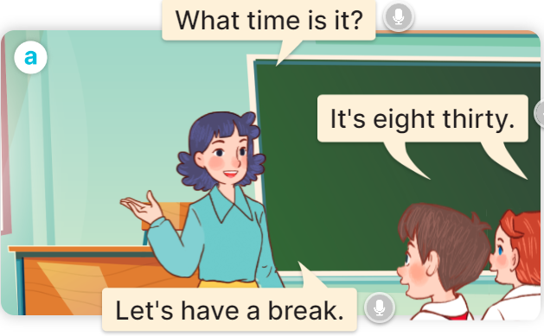  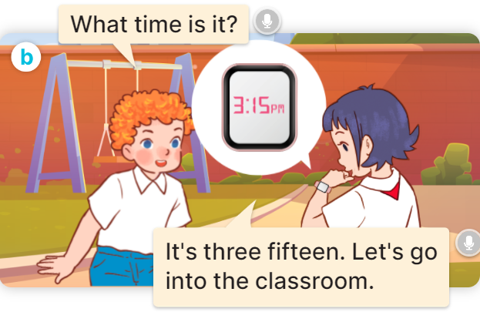  - Play the audio twice (sentence by sentence). Correct their pronunciation where necessary.  - Have Ss to practice the dialogue  - T invites a few pairs to the front of the class to practice.  - T checks pronunciation for ss.  Activity 3 Listen, point and say.  *Aims: Ss will be able to correctly say the phrases and use What time is it? – It’s …… to ask and tell the time.  *Procedure:  * Model sentences:  - T asks Ss look at picture a and helps Ss know the structure from the dialogue.  - T introduces new structure for Ss.  - T explains, models and gives meaning.  - Have Ss repeat the model sentences.  A: What time is it?  B: It’s six o’clock.  * Note:  - a.m. is used to tell the time in the morning, from 00:00 to 12:00;  - p.m. is used to tell the time in the afternoon and evening (afternoon is from 12:00:01 to 17:00 or 18:00, and evening is from 17:00 or 18:00 to 23:59:59).  3.Practice: (7’)  *Drill pictures  - Elicit and check comprehension to tell the time  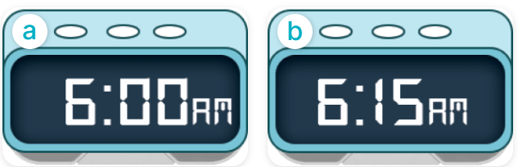  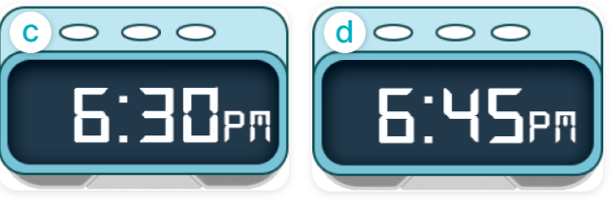  - Run through all the pictures.  - Run through model sentences.  + Run through the questions.  + Run through the answers.  - Have Ss to practise:  + T asks the first – Ss answer (change role).  + Ss – Ss (change role).  - Ask Ss to work in pairs to ask and answer the question What time is it? It’s…….  - T controls and corrects.  - Invite a few pairs to the front of the class to take turns pointing at the pictures and saying the questions and answers.  - Encourage Ss to practise speaking English.  - T gives feedbacks.  4.Production: (7’)  Activity 4. Let’s talk.  *Aims: Ss will be able to enhance the correct use of What time is it? – It’……. to ask and tell the time in a freer context.  *Procedure:  - T asks ss look at the two speech bubbles and ask:  +Who are they?  + What are they talking about?  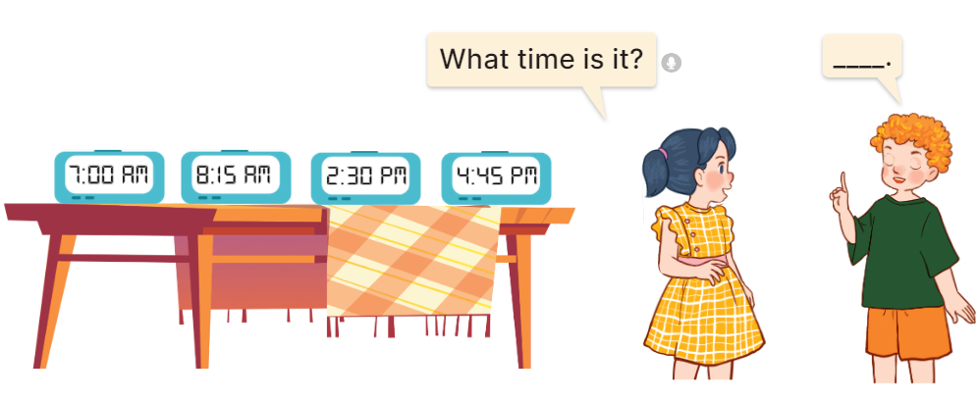  - Get Ss to repeat the question and the answer several times in pairs: It’s seven o’clock.  - T models: Go around the classroom, pointing to Ss and asking What time is it?  - Ask Ss ask and answer about their own names in pairs.  - Invite some groups to perform in front of the class.  - Give feedbacks  *Consolidation  *Aims: Ss will be able consolidate and wrap up the content of the lesson.  *Procedure:  - T asks ss to answer the following questions:  + What have you learnt from the lesson today?  +What are the core values of the lesson? (if the teacher can take from the lesson).  - T review the vocabulary and model sentences.  - T praises some Ss who are hardworking / active/ good…. as well as encourage others to try more.  5. Homework. (2’)  - Learn the vocabulary and model sentences by heart  - Prepare the new lesson: Unit 2, Lesson 1 (4,5,6). | - Ss listen.  -Ss look at the board  - Ss play the game  - Ss listen and clap their hands  - Ss open their books  -Ss listen and answer  - - Ss listen and repeat  + Choral repetition (3 times).  + Individual repetition (3 ss)  - Ss take note  - Ss look, remember and write  -Look at the pictures and get to know the characters in the pictures.  + In picture a: Ms Hoa asks: What time is it?  Class answer: It’s eight thirty.  Ms Hoa says: Let’s have a break.  + In pucture b: Bill asks: What time is it?  Linh answers: It’s three fifteen. Let’s go into the classroom.  -Ss listen and repeat in chorus (twice)  -Ss work in pairs to practice  -Ss practice the dialogue  -Ss listen  -Ss look at the picture and answer.  -Ss listen  -Ss listen and repeat  -Ss repeat to the introduce and respond to greetings.  - Ss look, listen and repeat  -Ss practice in chorus  -Ss practice in chorus  - Ss point at the pictures and repeat the time a few times.  -Ss work in pairs to practice  -Ss point and ask and answer  -Ss listen.  -Ss listen  -Ss look at the picture and answer  + Two pupils ask and tell the time shown on different clocks: 7:00 AM, 8:15 AM, 2:30 PM and 4:45 PM.  -Ss listen and say  - Ss answer  -Ss work in pairs  -Ss perform in front of the class.  - Ss listen  -Ss answer the questions  - Ss listen  -Ss listen and clap their hands  -Ss listen and take note
D. ADJUSTMENTS (if necessary):
………………………………………………………………………………………….…..……………………………………………………………………………...………………………………………….…..………………………………………………………….
Week 3 Preparing date: 29/9/2024
Period 12 Teaching date;03,04/10/2024

Unit 2: Time and daily routines
Lesson 1 (4,5,6)
A. OBJECTIVES:
By the end of the lesson, Ss will be able to:
1. Knowledge:
- listen to and understand two communicative contexts in which two pupils play a game asking and telling the time and tick the correct pictures.
- complete four gapped exchanges with the help of picture cues.
- review telling the time by playing the game Which clock says ...?
- Vocabulary: Review
- Skills: speaking, listening, reading and writing.
2. Competences:
- Critical Thinking: self-introduce
- Co-operation: ready to help friends in pair work/ group work.
- Self-control and independent learning: perform listening tasks.
3. Attitude/ Qualities:
- Kindness: Help partners to complete learning tasks.
- Honesty: tell the truth about feelings and emotions.
- Diligence: complete learning tasks.
B. TEACHING AIDS:
- Teacher: Teacher’s guide Pages 32,33,34; audio Tracks 18; website hoclieu.vn, posters, laptop, pictures, textbook, lesson plan, TV or projector.
- Students: Pupil’s book Page 17, notebooks, workbooks, school things.
C. PROCEDURES:
Teacher’s activities | Students’ activities
1.Warm- up: (5’)  Sing a song: What time is it?  *Aims: to create a friendly and active atmosphere in the class to beginning the lesson.  *Procedure:  - Show the song on the screen.  https://www.youtube.com/watch?v=0Yq_rztquuU  - Ask pupils to listen, sing and dance the song.  - Say “Open your book page 17” and look at “Unit 2, Lesson 1 (4,5,6)”.  2.Practice: (27’)  Activity 1. Listen and tick:  *Aims: Ss will be able to listen to and understand two communicative contexts in which two pupils play a game asking and telling the time and tick the correct pictures.  *Procedure:  - Elicit the names of the characters in the pictures.  - Point at the pictures respectively to explain the context.  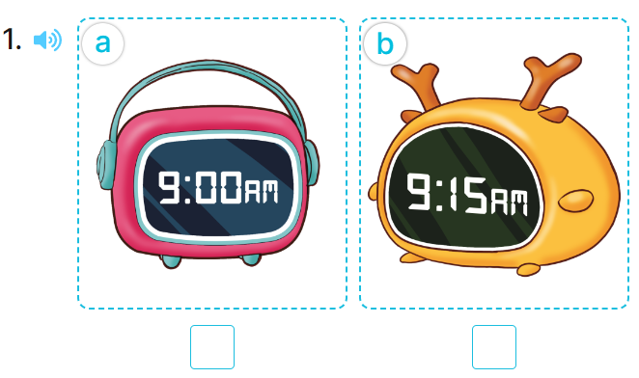  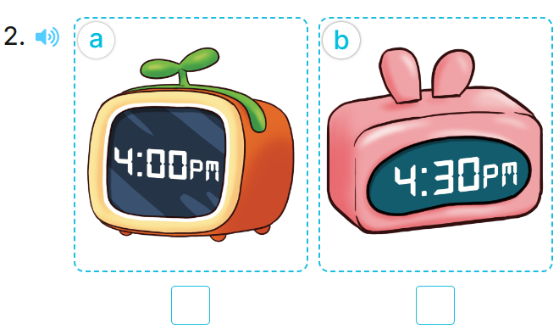  - T ask Ss to guess the answers.  + T writes Ss’guessing on the board.  - Listen to the tape:  + Play the recording  + Play the recording again and get Ss to swap books with their partners.  + Play the recording again to check answers together as a class.  - Play the recording, sentence by sentence, for the class to listen and repeat in chorus.  Key: 1.b 2.b  Activity 2. Look, complete and read.  *Aims: Ss will be able to complete four gapped exchanges with the help of picture cues.  *Procedure:  - Get Ss to look at the pictures and identify the time on the four clocks.  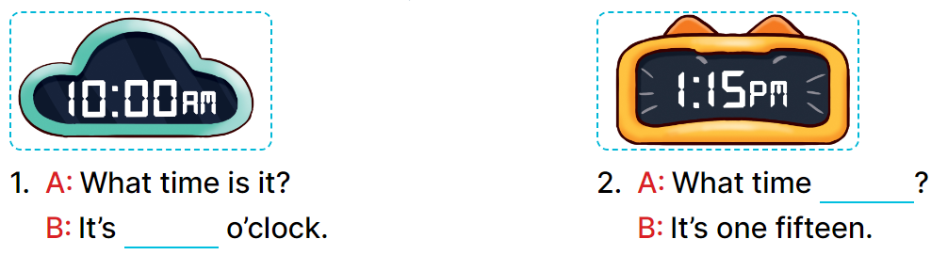  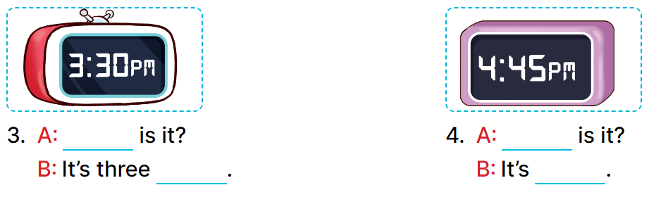  - Ask pupils to look at each gapped exchange. Draw their attention to the missing words and time.  - Have pupils look at Picture 1. Ask them what is missing in the answer (ten).  + Then have them complete the gap (It’s ten o’clock.).  + Repeat the same procedure with Pictures 2, 3 and 4.  - Set a time limit for pupils to complete the gapped exchanges individually  - Invite a few pairs to stand up to ask and tell the time on the clock faces.  Key:  1. ten 2. is it  3. What time; thirty  4. What time; four forty-five  Activity 3. Let’s play.  *Aims: Ss will be able to review telling the time by playing the game Which clock says ...?  *Procedure:  - Divide class into 2 groups  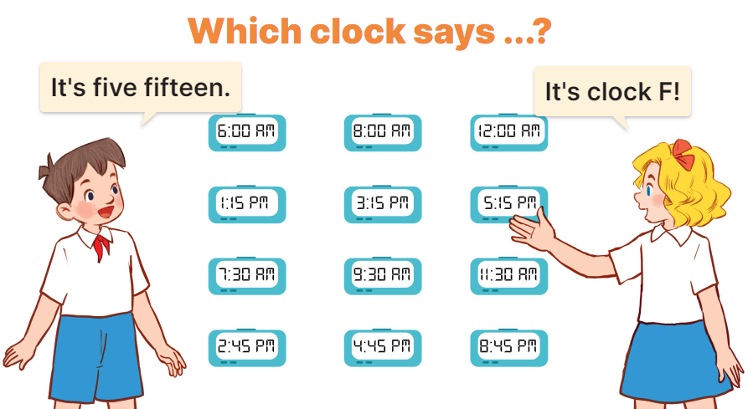  - Tell pupils that they are going to play a game that involves finding and saying which clock shows the time told by another player.  - Invite two volunteers to stand in front of the board.  +Tell them to decide who is the time teller and who is the clock finder.  - The time teller will tell a certain time.  - When the game is over, the player who has the most points is the winner.  *Consolidation  *Aims: Ss will be able consolidate and wrap up the content of the lesson.  *Procedure:  - T asks ss to answer the following questions:  + What have you learnt from the lesson today?  +What are the core values of the lesson? (if the teacher can take from the lesson).  - T praises some Ss who are hardworking / active/ good…. as well as encourage others to try more.  3. Homework. (3’)  - Ask and answer about the pictures in part 5.  - Prepare the new lesson: Unit 2, Lesson 2 (1,2,3). | - Ss listen  -Ss sing and dance  - Ss open their books  -Look at the pictures and say:  + Picture 1a: a clock showing 9:00 AM + Picture 1b: a clock showing 9:15 AM + Picture 2a: a clock showing 4:00 PM + Picture 2b: a clock showing 4:30 PM  -Ss guess the answers  - Ss listen to the tape and tick  - Ss listen again, tick and swap books with their partners.  - Ss check their answers and guessing  -Ss listen and repeat.  -Ss look at the picture and say  -Ss listen and answer  -Ss answer: It’s ten o’clock.  -Ss look and complete  .  -Ss complete the sentence  -Ss ask and tell the time on the clock faces.  - Ss look and listen.  -Ss play game  Example: 5:15, for the other player to find the clock which shows the correct time by saying its letter.  + If it is correct, the correct finder will get one point.  +Every player has eight times to try. +After the first round, the time teller will become the clock finder.  +All the clocks on the board are kept for later use  -Ss listen to the teacher  -Ss answer the questions  -Ss listen and clap their hands  -Ss listen and take note
D. ADJUSTMENTS (if necessary):
………………………………………………………………………………………….…..……………………………………………………………………………...………………………………………….…..……………………………………………………………………………….……………………………………………………………………...

