Unit 20: At summer camp
Lesson 1 (1, 2, 3)
A. OBJECTIVES:
By the end of the lesson, Ss will be able to:
1. Knowledge:
- use the phrases building a campfire, putting up a tent, taking a photo and telling a story in relation to the topic “At summer camp”
- use What’s he / she doing? – He's / She’s _____. to ask and answer questions about what someone is doing at a camp
- Vocabulary: building a campfire, putting up a tent, taking a photo and telling a story
- Model sentences:
A: What’s he / she doing?
B: He's / She’s building a campsite
- Skills: speaking and listening
2. Competences:
- Co-operation: ready to help friends in pair work/ group work.
- Sociability: Talk to each other, say good words to others.
3. Attitude/ Qualities:
- Kindness: Help partners to complete learning tasks.
- Honesty: tell the truth about feelings and emotions
B. TEACHING AIDS:
- Teacher: Teacher’s guide Pages 280, 281, audio Tracks 92, 93, website hoclieu.vn, posters, laptop, pictures, textbook, lesson plan, TV or projector.
- Students: Pupil’s book Page 64, notebooks, workbooks, school things.
C. PROCEDURES:
Teacher’s and students’ activities | Contents
1.Warm- up: (3’)  Sing: Summer camp  *Aims: to create a friendly and active atmosphere in the class to beginning the lesson.  *Procedure:  - Show the song on the screen.  https://www.youtube.com/watch?v=ifPAX00PRRk  - Ask Ss to listen, sing and dance the song.  - Say “Open your book page 64” and look at “Unit 20, Lesson 1 (1,2,3)”.  Activity 1. Look, listen and repeat:  *Aims: Ss will be able to understand and correctly repeat the sentences in two communicative contexts focusing on asking and answering questions about what someone is doing at a camp.  *Procedure:  - Have Ss look at Pictures a and b and identify the characters and their activities at the summer camp.  - Play the audio twice (sentence by sentence). Correct their pronunciation where necessary.  - Have Ss to practice the dialogue  - T invites a few pairs to the front of the class to practice.  - T checks pronunciation for ss.  Activity 2 Listen, point and say.  *Aims: Ss will be able to correctly say the phrases and use What's he / she doing? – He's / She's ……. to ask and answer questions about what someone is doing at a camp.  -T elicits the new words  - T models (3 times).  - T writes the words on the board.  - Checking: Matching  *Procedure:  * Model sentences:  - T asks Ss look at picture b and helps Ss know the structure from the dialogue.  - T introduces new structure for Ss.  - T explains, models and gives meaning.  -Have Ss repeat the model sentences.  3.Practice: (7’)  *Drill pictures  - Have Ss look at the pictures and elicit the activities of the characters.  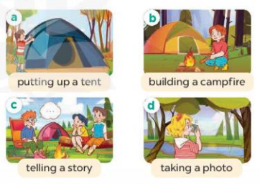  - Run through all the pictures.  - Run through model sentences.  +Run through the question sentences  +Run through the answer sentences  - Have Ss to practise:  + T asks, Ss answer picture a  + Ss ask, T answers picture b  + Group A ask, group B answer picture c  + Group B ask, group A answer picture d  - Ask Ss to work in pairs.  - T controls and corrects.  - Invite a few pairs to come to the front of the classroom and point at the pictures and say the questions and answers in front of the class.  - T gives feedbacks.  4.Production: (7’)  Activity 3. Let’s talk.  *Aims: Ss will be able to enhance the correct use of What's he / she doing? – He's / She's ……. to ask and answer questions about what someone is doing at a camp in a freer context.  *Procedure:  - Have Ss look at the picture and ask questions to help them identify the context  - Elicit the missing words in the speech bubble and write them on the board. Get Ss to say the completed sentences.  - Put Ss into pairs and encourage them to practise asking and answering questions about what someone is doing at a camp.  - Invite a few pairs to the front of the class to ask and answer questions about what someone is doing at a camp using the picture cue.  *Consolidation  *Aims: Ss will be able consolidate and wrap up the content of the lesson.  *Procedure:  - T asks ss to answer the following questions:  + What have you learnt from the lesson today?  - T review the vocabulary and model sentences.  - T praises some Ss who are hardworking / active/ good…. as well as encourage others to try more.  5. Homework. (2’)  - Learn the vocabulary and model sentences by heart  - Prepare the new lesson: Unit 20, Lesson 1 (4,5,6). | 1. Look, listen and repeat:  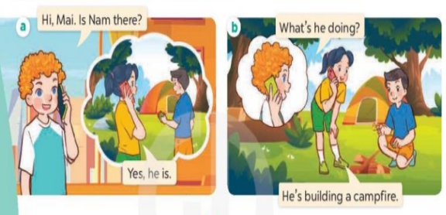  2.Listen, point and say.  New words  + build a campfire: đốt lửa trại (picture)  + put up a tent : dựng, cắm trại (picture)  + tell a story :kể chuyện (situation)  + take photos : chụp hình (mime)  * Model sentences:  A: What’s he / she doing?  B: He's / She’s building a campsite  3.Let’s talk.  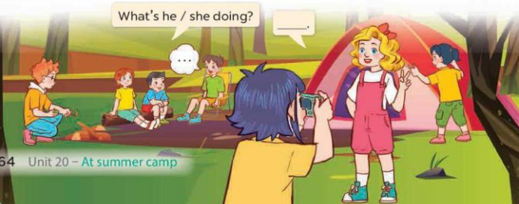
V. Adjustment (if necessary):
………………………………………………………………………………………….…..………………………………………………………………………
-------------------------------------------------------------
Unit 20: At summer camp
Lesson 1 (4, 5, 6)
A. OBJECTIVES:
By the end of the lesson, Ss will be able to:
1. Knowledge:
- use the phrases building a campfire, putting up a tent, taking a photo and telling a story in relation to the topic “At summer camp”
- listen to and understand four communicative contexts in which characters ask and answer questions about what someone is doing at a camp and match the correct pictures.
- complete four gapped exchanges with the help of picture cues.
- Vocabulary: Review
- Skills: speaking, listening, reading and writing.
2. Competences:
- Co-operation: ready to help friends in pair work/ group work.
- Self-control and independent learning: perform listening tasks.
3. Attitude/ Qualities:
- Kindness: Help partners to complete learning tasks.
- Honesty: tell the truth about feelings and emotions.
B. TEACHING AIDS:
- Teacher: Teacher’s guide Pages 283, 284; audio Tracks 94; website hoclieu.vn, posters, laptop, pictures, textbook, lesson plan, TV or projector.
- Students: Pupil’s book Page 65, notebooks, workbooks, school things.
C. PROCEDURES:
Teacher’s and students’ activities | Contents
1.Warm- up: (5’)  Game: Who says faster?  *Aims: to create a friendly and active atmosphere in the class to beginning the lesson.  *Procedure:  - - Hold a activity card, then reveal it slowly.  - Ask What’s he/ she doing?  - Ask the Ss guess the answer as fast as possible.  - Then have Ss do the same with the rest.  - This can be played in groups to make it more interesting.  - Say “Open your book page 65” and look at “Unit 20, Lesson 1 (4,5,6)”.  2.Practice: (27’)  Activity 1. Listen and match:  *Aims: Ss will be able to listen to and understand four communicative contexts in which characters ask and answer questions about what someone is doing at a camp and match the correct pictures.  *Procedure:  - Ask questions to help Ss identify the characters in the pictures and the activities of the stick figures.  - Play the recording for Ss to listen to.  - Play the recording again for them to do the task by matching the characters to their activities.  - Play the recording a third time to give Ss another listening opportunity.  - Check answers as a class.  - Play the recording, sentence by sentence, for the class to listen and repeat individually and in chorus.  Activity 2. Look, complete and read  *Aims: Ss will be able to complete four gapped exchanges with the help of picture cues.  *Procedure:  - Have Ss look at the pictures and get them to identify the characters and their activities in the pictures  - Have Ss look at the four sentences and the pictures. Elicit and model with picture 1  + Ask Ss to read the sentence 1 in chorus.  + Ask them what is missing in the question (a story). Then have them complete the gap (He’s telling a story).  -Have Ss work in pairs and complete the dialogue 2, 3, 4.  - Ask a few Ss to stand up and read the sentences aloud.  -T gives feedbacks.  Activity 3. Let’s play  *Aims: Ss will be able to revise target words about what someone is doing at a camp by playing “Guess what they are doing”.  *Procedure:  - Explain how the game is played.  - Divide Ss into groups of five  + Have Ss look at the first picture and answer the question What’s she doing?  + The Ss in each group guess the girl’s activities in the picture and give the answers  (Ex: She’s singing. She’s dancing….)  - Have Ss practise asking and answering questions about what the pupils are doing with the help of picture.  *Consolidation  *Aims: Ss will be able consolidate and wrap up the content of the lesson.  *Procedure:  - T asks ss to answer the following questions:  + What have you learnt from the lesson today?  - T praises some Ss who are hardworking / active/ good…. as well as encourage others to try more.  3. Homework. (3’)  - Prepare the new lesson: Unit 20, Lesson 2 (1,2,3). | 4.Listen and match:  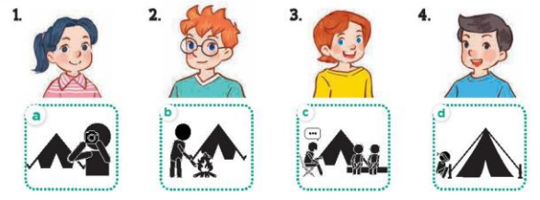  Key: 1. c 2. d 3. a 4. b  5.Look, complete and read  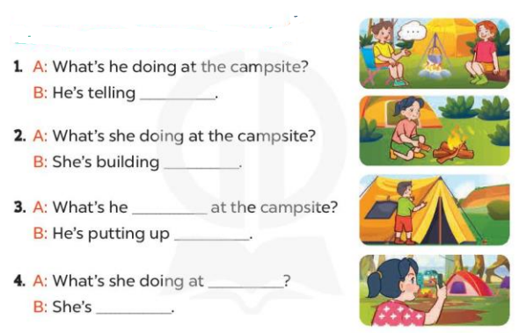  Key:  1. a story 2. a campfire  3. doing; a tent 4. the campsite; taking a photo  6. Let’s play  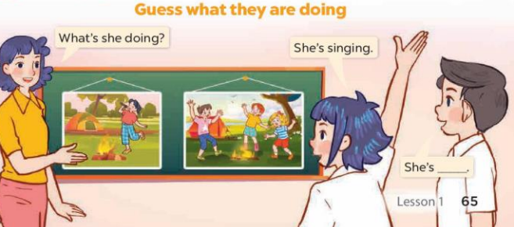
D. ADJUSTMENTS (if necessary):
………………………………………………………………………………………….…..……………………………………………………………………………
-------------------------------------------------------
Unit 20: At summer camp
Lesson 2 (1, 2, 3)
A. OBJECTIVES:
By the end of the lesson, Ss will be able to:
1. Knowledge:
- use the phrases dancing around the campfire, playing card games, playing tug of war, singing songs in relation to the topic “At summer camp”.
- use What are they doing? – They’re ……. to ask and answer questions about what people are doing at a camp
- Vocabulary: dancing around the campfire, playing card games, playing tug of war, singing songs
- Model sentences: A: What are they doing?
B: They’re playing card games.
- Skills: speaking and listening
2. Competences:
- Co-operation: ready to help friends in pair work/ group work.
- Sociability: Talk to each other, say good words to others.
3. Attitude/ Qualities:
- Kindness: Help partners to complete learning tasks.
- Honesty: tell the truth about feelings and emotions
B. TEACHING AIDS:
- Teacher: Teacher’s guide Pages 285, 286; audio Tracks 95, 96, website hoclieu.vn, posters, laptop, pictures, textbook, lesson plan, TV or projector.
- Students: Pupil’s book Page 66, notebooks, workbooks, school things.
C. PROCEDURES:
1.Warm- up: (3’)  Game: Pass the ball  *Aims: to create a friendly and active atmosphere in the class to beginning the lesson.  *Procedure:  - Stand up and pass the ball with music.  - When music stops, those who keep the ball must look at a picture on the board and say a sentence: He’s/ she’s…….  - Say “Open your book page 66” and look at “Unit 20, Lesson 2 (1,2,3)”.  2. Presentation(16’)  Activity 1. Look, listen and repeat:  *Aims: Ss will be able to understand and correctly repeat the sentences in two communicative contexts focusing on asking and answering questions about what people are doing at a camp.  *Procedure:  - Have Ss look at Pictures a and b and identify the places, characters and their activities.  - Play the audio twice (sentence by sentence). Correct their pronunciation where necessary.  - Have Ss to practice the diaguage  - T invites a few pairs to the front of the class to practice.  - T checks pronunciation for ss.  Activity 2. Listen, point and say.  *Aims: Ss will be able to correctly say the phrases and use What are they doing? – They’re ……. to ask and answer questions about what people are doing at a camp.  *Procedure:  -T elicits the new words  - T models (3 times).  - T writes the words on the board.  - Checking: What and where  - T asks Ss look at picture a, b and helps Ss know the structure from the dialogue.  - T introduces new structure for Ss.  - T explains, models and gives meaning.  - Have Ss repeat the model sentences.  - Ask Ss to look at Pictures a, b, c, and d and identify the places in the pictures and directions.  - Run through all the pictures.  - Run through model sentences.  - Ask Ss to work in pairs.  - T controls and corrects.  - Invite a few pairs to come to the front of the classroom, point at the pictures and say in front of the class.  - T gives feedbacks.  4.Production: (7’)  Activity 3. Let’s talk.  *Aims: Ss will be able to enhance the correct use of What are they doing? – They’re …… to ask and answer questions about what people are doing at a camp in a freer context.  *Procedure:  - Draw Ss’ attention to the pictures and ask questions to help them identify the context.  - Elicit the missing words in the bubble and write them on the board. Get Ss to say the completed sentences.  - Put Ss into pairs and encourage them to ask and answer questions about what people are doing at the camp, using What are they doing? – They’re ……..  - Invite a few pairs to the front of the class to perform their conversations.  *Consolidation  *Aims: Ss will be able consolidate and wrap up the content of the lesson.  *Procedure:  - T asks ss to answer the following questions:  + What have you learnt from the lesson today?  - T review the vocabulary and model sentences.  - T praises some Ss who are hardworking / active/ good…. as well as encourage others to try more.  5. Homework. (2’)  - Learn the vocabulary and model sentences by heart  - Prepare the new lesson: Unit 20, Lesson 2 (4,5,6). | 1. Look, listen and repeat:  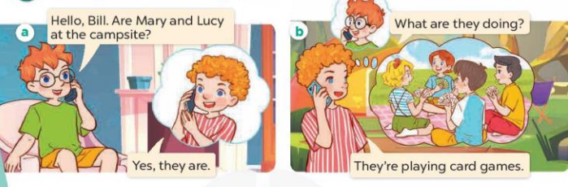  2. Listen, point and say.  * New words  + play tug a war : chơi kéo co (picture)  + play card games : chơi bài (picture)  + dance around the campfire: nhảy múa quanh lửa trại (explain)  + sing songs: hát hò  Model sentences:  A: What are they doing?  B: They’re playing card games.  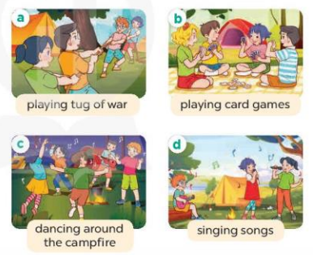  3. Let’s talk.  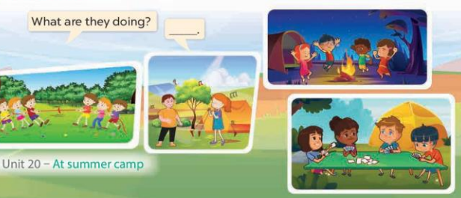
D. ADJUSTMENTS (if necessary):
………………………………………………………………………………………….…..……………………………………………………………………………
-------------------------------------------------
Unit 20: At summer camp
Lesson 2 (4, 5, 6)
A. OBJECTIVES:
By the end of the lesson, Ss will be able to:
1. Knowledge:
- listen to and demonstrate understanding of simple communicative contexts in relation to the topic “At summer camp”.
- complete two gapped exchanges with the help of picture cues.
- Vocabulary: Review
- Skills: speaking, listening, reading and writing.
2. Competences:
- Co-operation: ready to help friends in pair work/ group work.
- Self-control and independent learning: perform listening tasks.
3. Attitude/ Qualities:
- Kindness: Help partners to complete learning tasks.
- Honesty: tell the truth about feelings and emotions.
B. TEACHING AIDS:
- Teacher: Teacher’s guide Pages 287, 288, 289; audio Tracks 97, 98; website hoclieu.vn, posters, laptop, pictures, textbook, lesson plan, TV or projector.
- Students: Pupil’s book Page 67, notebooks, workbooks, school things.
C. PROCEDURES:
Teacher’s and students’ activities | Contents
1.Warm- up: (5’)  Sing a song: “Pass the picture.”  *Aims: to create a friendly and active atmosphere in the class to beginning the lesson.  - Say “Open your book page 67” and look at “Unit 20, Lesson 2 (4,5,6)”.  2.Practice: (27’)  Activity 1. Listen and tick:  *Aims: Ss will be able to listen to and understand two communicative contexts in which pupils ask and answer questions about what people are doing at a camp and tick the correct pictures.  *Procedure:  - Have Ss look at the pair of picture and ask questions to help them identify the characters and their activities.  - T ask Ss to guess the answers.  + T writes Ss’guessing on the board.  - Listen to the tape:  + Play the recording  + Play the recording again and get Ss to swap books with their partners.  + Play the recording again to check answers together as a class.  + Write the answers on the board for Ss to correct their answers. Then checks Ss’ guessing.  - Play the recording, sentence by sentence, for the class to listen and repeat in chorus.  a  Activity 2. Look, complete and read.  *Aims: Ss will be able to complete two gapped exchanges with the help of picture cues.  *Procedure:  - Have Ss look at the pictures and identify the places, characters and their activities in the pictures  - T models with sentence 1.  + Have Ss look at the sentence.  + Ask them what is missing in the answer (campsite).  + Have Ss complete the gap.  + Have Ss read the completed sentence in chorus.  -Have Ss work in pairs and complete the other sentences.  - Invite pairs of pupils to stand up and read aloud the sentences.  - T gives feedbacks.  Activity 3. Let’s sing  *Aims: Ss will be able to sing the song What are you doing? with the correct pronunciation, melody and intonation.  *Procedure:  - Introduce the title and lyrics of the song  “ What are you doing? ”  - Play the recording for Ss to listen to the whole song.  + Have them repeat the title and lyrics line by line.  + Tell Ss to point at the pictures  while singing.  - Play the recording all the way through for Ss to listen to pronunciation and melody of the song.  - Play the recording line by line for Ss to listen, repeat and point to the pictures  - Play the recording for Ss to sing and do actions.  - Ask Ss to practice singing and doing actions in pairs or groups.  - Invite groups to the front of the classroom to perform the song  -T gives feedback.  *Consolidation  *Aims: Ss will be able consolidate and wrap up the content of the lesson.  *Procedure:  - T asks ss to answer the following questions:  + What have you learnt from the lesson today?  +What are the core values of the lesson? (if the teacher can take from the lesson).  - T praises some Ss who are hardworking / active/ good…. as well as encourage others to try more.  3. Homework. (3’)  - Prepare the new lesson: Unit 20, Lesson 3 (1,2,3). | 4. Listen and tick:  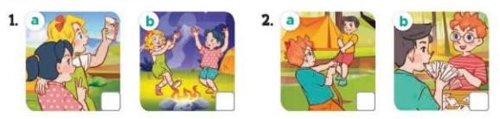  Key: 1.b 2. a  5. Look, complete and read.  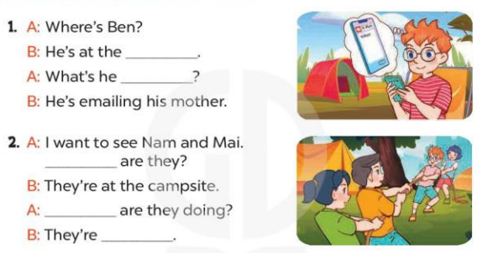  Key: 1. campsite; doing  2. Where; What; playing tug of war  6. Let’s sing.  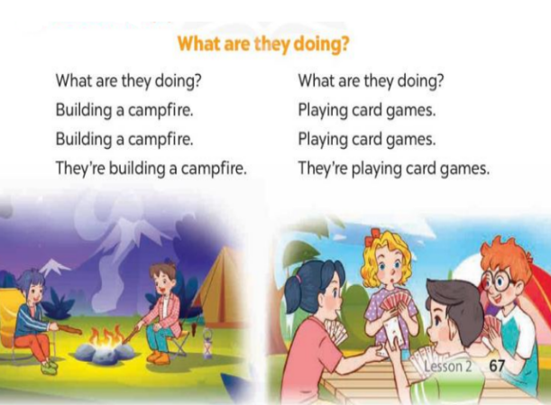
D. ADJUSTMENTS (if necessary):
………………………………………………………………………………………….…..……………………………………………………………………………

Unit 20: At summer camp
Lesson 3 (1, 2, 3)
A. OBJECTIVES:
By the end of the lesson, Ss will be able to:
1. Knowledge:
- correctly repeat the words 'visit and 'email with the stress on the first syllable in isolation and in the sentences They 'visit their grandparents in summer. and We 'email our friends at the weekend. with the correct pronunciation and intonation.
- identify the target words visit and email while listening.
- say the chant with the correct rhythm and pronunciation.
- Vocabulary: Review
- Skills: speaking, listening, reading and writing.
2. Competences:
- Co-operation: ready to help friends in pair work/ group work.
- Self-control and independent learning: perform listening tasks.
3. Attitude/ Qualities:
- Kindness: Help partners to complete learning tasks.
- Honesty: tell the truth about feelings and emotions
B. TEACHING AIDS:
- Teacher: Teacher’s guide Pages 289, 290; audio Tracks 99, 100, 101; website hoclieu.vn, posters, laptop, pictures, textbook, lesson plan, TV or projector.
- Students: Pupil’s book Page 68, notebooks, workbooks, school things.
C. PROCEDURES:
Teacher’s and students’ activities | Contents
1.Warm- up: (5’)  Game: lip-reading  *Aims: to create a friendly and active atmosphere in the class to beginning the lesson.  *Procedure:  - Guide Ss to pronounce without making sound  - Divide Ss into groups, each pupil takes turns to pronounce without making sound while the rest guess the sound  - Say “Open your book page 68” and look at “Unit 20, Lesson 3 (1,2,3)”.  2. Presentation (9’)  Activity 1. Listen and repeat:  *Aims: Ss will be able to correctly repeat the words 'visit and 'email with the stress on the first syllable in isolation and in the sentences They 'visit their grandparents in summer. and We 'email our friends at the weekend. with the correct pronunciation and intonation  *Procedure:  - Draw pupils’ attention to the words 'visit and ‘email, the sentence They 'visit their grandparents in summer and We 'email our friends at the weekend.  - Play the recording and encourage them to point at the word and the sentence while listening.  - Play the recording again and encourage pupils to listen to and repeat the word and the sentence.  - Have Ss work in pairs or groups, saying the words and reading the sentences until they feel confident.  3.Practice: (19’)  Activity 2. Listen and circle.  *Aims: Ss will be able to identify the target words visit and email while listening.  *Procedure:  - Explain that they have to listen to the recording and circle the correct options.  - T ask Ss to guess the answers.  + T writes Ss’guessing on the board.  - Listen to the tape:  + Play the recording  + Play the recording again and get Ss to swap books with their partners.  + Play the recording again to check answers together as a class.  + Write the answers on the board for Ss to correct their answers. Then checks Ss’ guessing.  - Play the recording, sentence by sentence, for the class to listen and repeat in chorus.  - Invite one or two Ss to stand up and read the completed sentences.  Activity 3. Let’s chant  *Aims: Ss will be able to say the chant with the correct rhythm and pronunciation.  *Procedure:  - Introduce the title and lyrics of the chant.  - Play the recording for Ss to listen to the whole chant.  + Have them repeat the title and lyrics line by line.  + Ask Ss to attend to the sounds of the words visit and email.  - Play the recording all the way through for Ss to listen to pronunciation and melody.  - Play the recording line by line for Ss to listen and repeat  - Play the recording for Ss to chant and clap along.  - Ask Ss to practice chant and clap along in pairs or groups.  - Invite groups to the front of the classroom to perform the chant  -T gives feedback.  *Consolidation  *Aims: Ss will be able consolidate and wrap up the content of the lesson.  *Procedure:  - T asks ss to answer the following questions:  + What have you learnt from the lesson today?  +What are the core values of the lesson? (if the teacher can take from the lesson).  - T praises some Ss who are hardworking / active/ good…. as well as encourage others to try more.  4. Homework. (2’)  - Practice the chant more.  - Prepare the new lesson: Unit 20, Lesson 3 (4,5,6). | 1. Listen and repeat:  'visit They 'visit their grandparents in summer.  'email We 'email our friends at the weekend.  2. Listen and circle.  Key: 1.b 2.c  3. Let’s chant  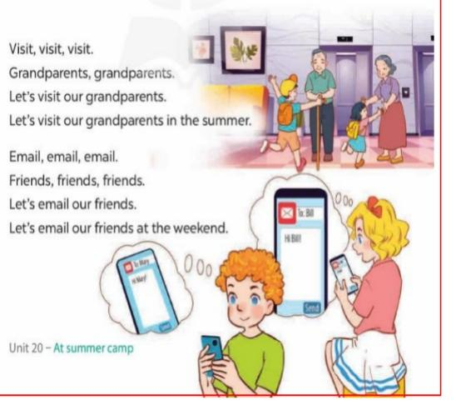
D. ADJUSTMENTS (if necessary):
………………………………………………………………………………………….…..…………………………………………………………………………
--------------------------------------------
Unit 20: At summer camp
Lesson 3 (4, 5, 6)
A. OBJECTIVES:
By the end of the lesson, Ss will be able to:
1. Knowledge:
- read and write about what someone is / people are doing at a camp.
- draw a simple picture of friends and their activities at a camp, then tell the class about it at Project time.
- Vocabulary: Review
- Skills: speaking, listening, reading and writing.
2. Competences:
- Co-operation: ready to help friends in pair work/ group work.
- Self-control and independent learning: perform reading tasks.
3. Attitude/ Qualities:
- Kindness: Help partners to complete learning tasks.
- Honesty: tell the truth about feelings and emotions.
B. TEACHING AIDS:
- Teacher: Teacher’s guide Pages 291, 292; website hoclieu.vn, posters, laptop, pictures, textbook, lesson plan, TV or projector.
- Students: Pupil’s book Page 69, notebooks, workbooks, school things.
C. PROCEDURES:
Teacher’s and students’ activities | Contents
1.Warm- up: (5’)  Game: Who’s faster?  *Aims: to review the vocabulary and structure about greet and respond to greetings.  *Procedure:  - Tell Ss that they are going to look at the cards in 60 seconds, memorise the phrases  (building a campfire, dancing around the campfire, playing card games, playing tug of war, putting up a tent, singing songs, taking a photo and telling a story ) then remember as many of the words as possible.  - Put the cards on a desk or stick them on the board. Then cover them with a piece of cloth.  - Divide the class into 2 or 4 groups. - Remove the cloth and show the cards for 60 seconds. Then cover them again.  - In their groups, Ss try to say as many of the words as they can remember.  - Have the groups say the names of the things aloud.  - For each correct word, give them a star or a point.  - The group with the most stars / points wins.  - Say “Open your book page 69” and look at “Unit 20, Lesson 3 (4,5,6)”.  2.Practice: (8’)  Activity 1. Read and tick True or False:  *Aims: Ss will be able to read a text and decide whether statements about Minh and his friends’ activities are true or false. *Procedure:  - Draw pupils’ attention to the four statements focusing on what Minh and his friends are doing.  - Ask Ss to read the text individually first, then in pairs to decide if the statements are true or false.  - Set a time limit for Ss to do the task.  - Get Ss to provide reasons for their answers, then check their answers.  3.Production: (19’)  Activity 2. Let’s write  *Aims: Ss will be able to complete a text about what pupils are doing at a camp.  *Procedure:  - Ask Ss to read the gapped text and fill in the gaps with details about what pupils and their friends are doing at a camp.  - Have Ss do the first gapped sentence together as an example. Ask them to read the sentence and elicit what day it is today.  - Give Ss time to complete the text independently.  - Get Ss to swap their books with a partner and check their answers in pairs before checking as a class.  - Invite a few Ss to read their completed texts in front of the class.  Activity 3. Project.  *Aims: Ss will be able to draw a simple picture of three or four friends and their activities at a camp, and tell the class about what the friends are doing.  *Procedure:  - Explain that each pupil has to show a simple picture of three or four friends and their activities at a camp which they have drawn at home.  - Have Ss work in groups of six. Each pupil shows his / her picture to the group and describes what the characters in the picture are doing.  - Invite a few Ss to show their pictures and tell the class about the activities of their friends,  *Consolidation  *Aims: Ss will be able consolidate and wrap up the content of the lesson.  *Procedure:  - T asks ss to answer the following questions:  + What have you learnt from the lesson today?  - T praises some Ss who are hardworking / active/ good…. as well as encourage others to try more.  4. Homework. (3’)  - Prepare the new lesson: Review 4 | 4. Read and tick True or False:  Key: 1. True 2. False  3. True 4. True  5. Let’s write  Key: Pupils’ own answers  Example: Today is Sunday. We are at the campsite. Teacher is telling a story with the girls. Some girls are singing songs. The boys are playing soccer. I am taking a photo.  6. Project.  ex: Look at this picture. They are my friends. They’re dancing around the campfire.

D. ADJUSTMENTS (if necessary):
………………………………………………………………………………………….…..……………………………………………………………………………

