Week 32 – Grade 4
Unit 19: The animal world
Lesson 1 (1, 2, 3)

I. Objectives:
By the end of the lesson, Ss will be able to:
1. Knowledge:
- use the words and phrases crocodiles, giraffes, hippos, lions, in relation to the topic “The animal world”.
– use What are these animals? – They’re ……. to ask and answer questions about animals;
- Vocabulary: crocodile, giraffe, hippo, lion
- Model sentences: A: What are these animals?
B: They’re lions.
2. Skills: speaking, listening, reading and writing.
3. Competences:
- Communication and collaboration: work in pairs and groups to complete the learning tasks.
- Self-control & independent learning: perform learning tasks.
4. Attitude/ Qualities:
- Kindness: Help partners to complete learning tasks.
- Honesty: tell the truth about feelings and emotions
II. Methods: Communicative approach, group Ss and T's activities, play as a character, teaching methods with game, teaching methods by visual, teaching methods by practising, discussion group, technical present....
III. Teaching aids:
1. Teacher’s preparation: Projector/ TV
- Speaker
- Website hoclieu.vn
2. Student’s preparation: books, notebooks.
IV. Procedures:
Teacher’s and students’ activities | Contents
Activity 1.Warm- up:  Sing: “I like animal”  - Show the song on the screen.  https://www.youtube.com/watch?v=yS1zl4g7HLA  - Ask Ss to listen, sing and dance the song.  - Say “Open your book page 58” and look at “Unit 19, Lesson 1 (1,2,3)”.  Activity 2. Look, listen and repeat:  - Have Ss look at Pictures a and b and identify the characters and the animals in the pictures.  - Play the audio twice (sentence by sentence). Correct their pronunciation where necessary.  - Have Ss to practice the dialogue  - T invites a few pairs to the front of the class to practice.  - T checks pronunciation for ss.  Activity 3 Listen, point and say.  - T asks Ss look at picture a, b and helps Ss know the structure from the dialogue.  - T introduces new structure for Ss.  - T explains, models and gives meaning.  -Have Ss repeat the model sentences.  - Elicit the names of the animals.  - Run through all the pictures.  - Run through model sentences.  - Have Ss to practise:  - Ask Ss to work in pairs.  - T controls and corrects.  - Invite a few pairs to come to the front of the classroom and point at the pictures and say the questions and answers in front of the class.  - T gives feedbacks.  Activity 4. Let’s talk.  - Have Ss look at the picture and tell them about the animals.  - Put Ss work in pairs  - Ask Ss to say using What are these animals?  They’re…….  - Get Ss to repeat the questions and answers several times.  - Invite some Ss to the front of the class to say about the activity.  Activity 5.*Consolidation  - T asks ss to answer the following questions:  + What have you learnt from the lesson today?  +What are the core values of the lesson? (if the teacher can take from the lesson).  - T review the vocabulary and model sentences.  - T praises some Ss who are hardworking / active/ good…. as well as encourage others to try more  * Homework.  - Learn the vocabulary and model sentences by heart  - Prepare the new lesson: Unit 19, Lesson 1 (4,5,6). | 1. Look, listen and repeat:  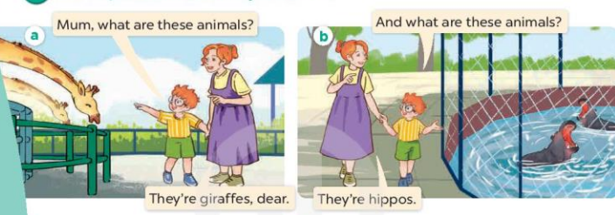  + giraffe : hươu cao cổ  + hippo : hà mã  2.Listen, point and say.  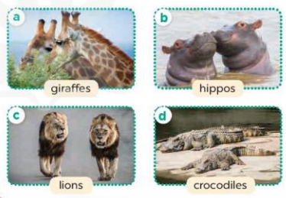  + lion :sư tử (visual)  + crocodile : cá sấu (visual)  A: What are these animals?  B: They’re lions  3. Let’s talk.  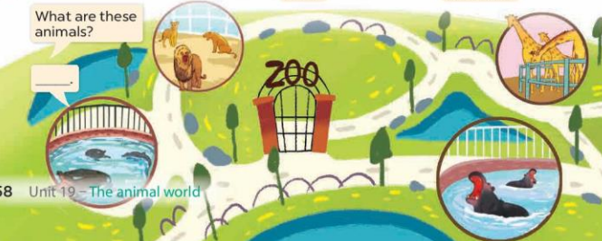
V. Adjustments (if necessary):
………………………………………………………………………………………….…..……………………………………………………………………………...………………………………………….…..………………………………...
--------------------------------------------------------------

Week 32 – Grade 4
Unit 19: The animal world
Lesson 1 (4,5,6)

I. Objectives:
By the end of the lesson, Ss will be able to:
1. Knowledge:
- use the words and phrases crocodiles, giraffes, hippos, lions in relation to the topic “The animal world”.
- listen to and demonstrate understanding of simple communicative contexts in relation to the topic “The animal world”.
- Vocabulary: Review
2. Skills: speaking, listening, reading and writing.
3. Competences:
- Communication and collaboration: work in pairs and groups to complete the learning tasks.
- Self-control & independent learning: perform learning tasks.
4. Attitude/ Qualities:
- Kindness: Help partners to complete learning tasks.
- Honesty: tell the truth about feelings and emotions
II. Methods: Communicative approach, group Ss and T's activities, play as a character, teaching methods with game, teaching methods by visual, teaching methods by practising, discussion group, technical present....
III. Teaching aids:
1. Teacher’s preparation: Projector/ TV
- Speaker
- Website hoclieu.vn
2. Student’s preparation: books, notebooks.
IV. Procedures:
Teacher’s and students’ activities | Contents
Activity 1.Warm- up:  Game: What is missing?  - Show the pictures of animals “lions, crocodiles, giraffes, hippos”.  - Ask Ss to close their eyes and take away 1 picture.  + Ss open their eyes and guess what is missing.  - Say “Open your book page 59” and look at “Unit 19, Lesson 1 (4,5,6)”.  Activity 2. Listen and number  - Get Ss to look at the pictures and ask them to identify the animals  - T ask Ss to guess the answers.  + T writes Ss’guessing on the board.  - Listen to the tape:  + Play the recording  + Play the recording again and get Ss to swap books with their partners.  + Play the recording again to check answers together as a class.  + Write the answers on the board for Ss to correct their answers. Then checks Ss’ guessing.  - Play the recording, sentence by sentence, for the class to listen and repeat in chorus.  Activity 3. Look, complete and read  - Get Ss to look at the pictures and identify the animals.  - Have Ss look at the four sentences and the pictures. Elicit and model with picture 1  + Ask Ss to read the sentence 1 in chorus.  + Ask them what is missing in the question (playing football). Then have them complete the gap (he’s playing football.).  -Have Ss work in pairs and complete the dialogue 2, 3, 4.  - Ask a few Ss to stand up and read the sentences aloud.  -T gives feedbacks.  Activity 4. Let’s sing  - Introduce the title and lyrics of the song: “What are these animals?  - Play the recording for Ss to listen to the whole song.  + Have them repeat the title and lyrics line by line.  + Tell Ss to point at the pictures while singing.  - Play the recording all the way through for Ss to listen to pronunciation and melody of the song.  - Play the recording line by line for Ss to listen, repeat and point to the pictures  - Play the recording for Ss to sing and do actions.  - Ask Ss to practice singing and doing actions in pairs or groups.  - Invite groups to the front of the classroom to perform the song  -T gives feedback.  *Consolidation  - T asks ss to answer the following questions:  + What have you learnt from the lesson today?  - T praises some Ss who are hardworking / active/ good…. as well as encourage others to try more.  *. Homework.  - Prepare the new lesson: Unit 19, Lesson 2 (1,2,3). | 4. Listen and number  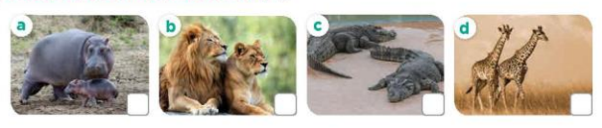  Key: 1. d 2. a 3. b 4. c  5. Look, complete and read.  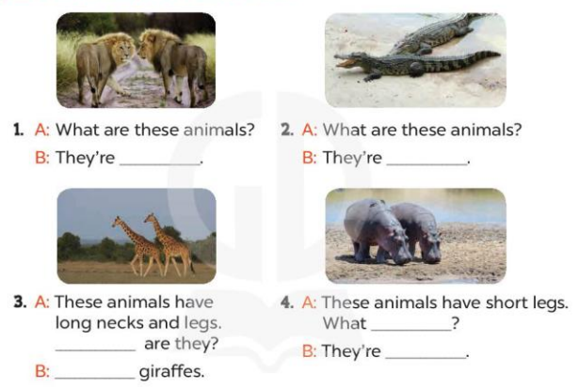  Key:  - lions  2. crocodiles  3. What; They’re  4. are they; hippos  6. Let’s sing.  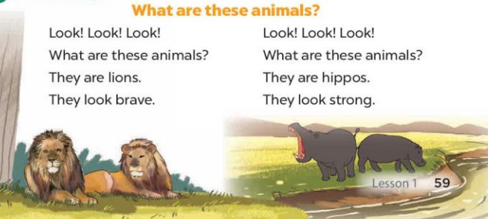
V. Adjustments (if necessary):
………………………………………………………………………………………….…..……………………………………………………………………………...………………………………………….…..………………………………...
--------------------------------------------------------------

Week 32 – Grade 4
Unit 19: The animal world
Lesson 2 (1,2,3)

I. Objectives:
By the end of the lesson, Ss will be able to:
1. Knowledge:
- use the words and phrases dance beautifully, roar loudly, run quickly and sing merrily in relation to the topic “The animal world”
- use Why do you like ….? – Because they …….. to ask for and give reasons for liking animals;
- Vocabulary: dance beautifully, roar loudly, run quickly and sing merrily.
- Model sentences:
A: Why do you like peacocks?
B: Because they dance beautifully.
2. Skills: speaking, listening, reading and writing.
3. Competences:
- Communication and collaboration: work in pairs and groups to complete the learning tasks.
- Self-control & independent learning: perform learning tasks.
4. Attitude/ Qualities:
- Kindness: Help partners to complete learning tasks.
- Honesty: tell the truth about feelings and emotions
II. Methods: Communicative approach, group Ss and T's activities, play as a character, teaching methods with game, teaching methods by visual, teaching methods by practising, discussion group, technical present....
III. Teaching aids:
1. Teacher’s preparation: Projector/ TV
- Speaker
- Website hoclieu.vn
2. Student’s preparation: books, notebooks.
IV. Procedures:
Teacher’s and students’ activities | Contents
Activity 1.Warm- up:  Game: “ Whose tail is this?”  - Put Ss into pairs.  - Give Ss the dice. Ss in pairs answer the questions. For each correct answer pupil can roll the dice.  - The student (in each pair) who has the most points is the winner.  - Say “Open your book page 60” and look at “Unit 19, Lesson 2 (1,2,3)”.  Activity 2. Look, listen and repeat:  - Have Ss look at the pictures and identify the characters and the animals.  - Play the audio twice (sentence by sentence). Correct their pronunciation where necessary.  - Have Ss to practice the diaguage  - T invites a few pairs to the front of the class to practice.  - T checks pronunciation for ss.  Activity 3. Listen, point and say.  - T asks Ss look at picture b and helps Ss know the structure from the dialogue.  - T introduces new structure for Ss.  - T explains, models and gives meaning.  - Have Ss repeat the model sentences.  - Have Ss look at the pictures and elicit the names of the animals and what they are doing.  - Run through all the pictures.  - Run through model sentences.  +Run through the question sentences  +Run through the answer sentences  - Have Ss to practise:  + T asks, Ss answer picture a  + Ss ask, T answers picture b  + Group A ask, group B answer picture c  + Group B ask, group A answer picture d  - Ask Ss to work in pairs.  - T controls and corrects.  - Invite a few pairs to come to the front of the classroom, point at the pictures and say in front of the class.  - T gives feedbacks.  Activity 4. Let’s talk.  - Have Ss look at the picture and elicit the names of the animals and reasons for liking them.  - Ask Ss work in pairs to ask and answer questions about Why do you like…….?  - Invite some pairs to role play in front of the class to point at the activity in the picture cue in their books.  *Consolidation  - T asks ss to answer the following questions:  + What have you learnt from the lesson today?  - T praises some Ss who are hardworking / active/ good…. as well as encourage others to try more.  *. Homework.  - Learn the vocabulary and model sentences by heart  - Prepare the new lesson: Unit 19, Lesson 2 (4,5,6). | 1. Look, listen and repeat:  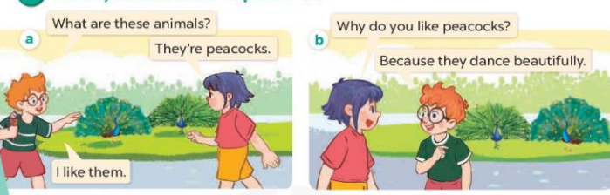  - animal:  - peacock:  + dance beautifully : nhảy thật đẹp  2. Listen, point and say.  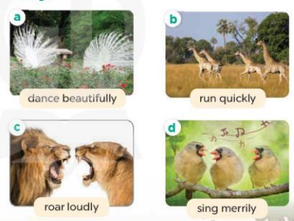  + run quikly: chạy thật nhanh (mime)  + roar loudly : gầm thật to (situation)  + sing merrily : hát thật hay (translation)  A: Why do you like peacocks?  B: Because they dance beautifully.  3. Let’s talk.  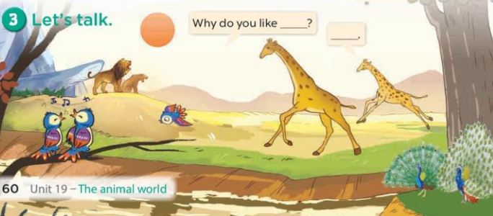
V. Adjustments (if necessary):
………………………………………………………………………………………….…..……………………………………………………………………………...………………………………………….…..………………………………...
--------------------------------------------------------------
Week 32 – Grade 4
Unit 19: The animal world
Lesson 2 (4,5,6)

I. Objectives:
By the end of the lesson, Ss will be able to:
1. Knowledge:
- use the words and phrases dance beautifully, roar loudly, run quickly and sing merrily in relation to the topic “The animal world”
- listen to and demonstrate understanding of simple communicative contexts in relation to the topic “The animal world”.
- Vocabulary: Review
2. Skills: speaking, listening, reading and writing.
3. Competences:
- Communication and collaboration: work in pairs and groups to complete the learning tasks.
- Self-control & independent learning: perform learning tasks.
4. Attitude/ Qualities:
- Kindness: Help partners to complete learning tasks.
- Honesty: tell the truth about feelings and emotions
II. Methods: Communicative approach, group Ss and T's activities, play as a character, teaching methods with game, teaching methods by visual, teaching methods by practising, discussion group, technical present....
III. Teaching aids:
1. Teacher’s preparation: Projector/ TV
- Speaker
- Website hoclieu.vn
2. Student’s preparation: books, notebooks.
IV. Procedures:
Teacher’s and students’ activities | Contents
Activity 1.Warm- up:  Game: Piggy bank game (PPT)  - Divide the class into 3 teams.  - Have Ss from each team choose a pig, ask and answer the questions.  + If the Ss answer correctly, they get the points for that question.  - After 8 pigs, the team with the most points is the winner.  - Say “Open your book page 61” and look at “Unit 19, Lesson 2 (4,5,6)”.  Activity 2. Listen and circle:  - Have Ss look at the pictures and elicit the names of the animals.  - T ask Ss to guess the answers.  + T writes Ss’guessing on the board.  - Listen to the tape:  + Play the recording  + Play the recording again and get Ss to swap books with their partners.  + Play the recording again to check answers together as a class.  + Write the answers on the board for Ss to correct their answers. Then checks Ss’ guessing.  - Play the recording, sentence by sentence, for the class to listen and repeat in chorus.  Activity 2. Look, complete and read.  - Have Ss look at the pictures and ask them the names of the animals they see in the picture and what they are doing.  - T models with sentence 1.  + Have Ss look at the sentence.  + Ask them what is missing in the answer (lions).  + Have Ss complete the gap.  + Have Ss read the completed sentence in chorus.  -Have Ss work in pairs and complete the other sentences.  - Invite pairs of pupils to stand up and read aloud the sentences.  - T gives feedbacks.  Activity 3. Let’s play.  - Invite two teams, each team has three players, to the front of the class.  - Give an example by describing some physical features of animals for the players in the teams to guess.  - One of the teams describes animals for the other one to guess.  - If the guessing team gives a wrong guess, the describing team gives the correct answer, and gets one point.  + Write the correct answer on the board. The game continues.  - If the guessing team gives a correct guess, they take over the role of describing. The team with the most points wins the game when time is up.  - Give a time limit for pupils to play the game.  - When the game is over, get some pairs of pupils to take turns asking and answering the question What are these animals? and use the animal names on the board as the answers.  *Consolidation  - T asks ss to answer the following questions:  + What have you learnt from the lesson today?  +What are the core values of the lesson? (if the teacher can take from the lesson).  - T praises some Ss who are hardworking / active/ good…. as well as encourage others to try more.  . Homework.  - Prepare the new lesson: Unit 19, Lesson 3 (1,2,3). | 4. Listen and circle:  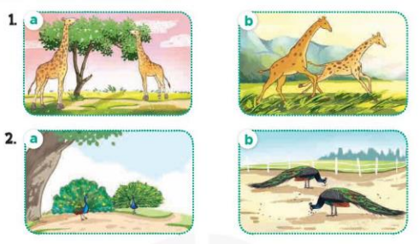  Key: 1.b 2. a  5. Look, complete and read.  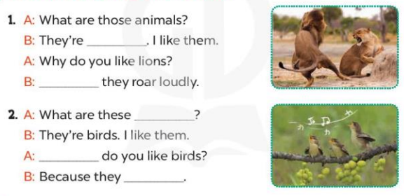  Key:  1. lions; Because  2. animals; Why; sing merrily  3.Let’s play.  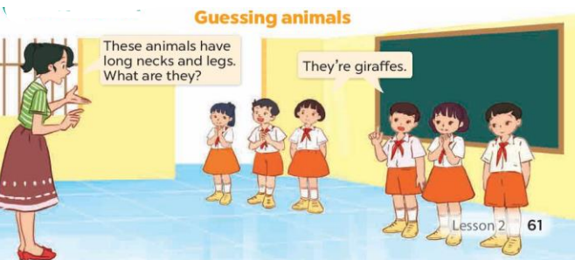
V. Adjustments (if necessary):
………………………………………………………………………………………….…..……………………………………………………………………………...………………………………………….…..………………………………...
--------------------------------------------------------------

Week 32 – Grade 4
Unit 19: The animal world
Lesson 3 (1,2,3)

I. Objectives:
By the end of the lesson, Ss will be able to:
1. Knowledge:
- correctly pronounce the words 'loudly and 'quickly with the stress on the first syllable in isolation and in the sentences These animals are roaring 'loudly. and Those animals are running 'quickly.
- identify the target words 'loudly and 'quickly while listening.
- say the chant with the correct rhythm and pronunciation.
- Vocabulary: Review
2. Skills: speaking, listening, reading and writing.
3. Competences:
- Communication and collaboration: work in pairs and groups to complete the learning tasks.
- Self-control & independent learning: perform learning tasks.
4. Attitude/ Qualities:
- Kindness: Help partners to complete learning tasks.
- Honesty: tell the truth about feelings and emotions
II. Methods: Communicative approach, group Ss and T's activities, play as a character, teaching methods with game, teaching methods by visual, teaching methods by practising, discussion group, technical present....
III. Teaching aids:
1. Teacher’s preparation: Projector/ TV
- Speaker
- Website hoclieu.vn
2. Student’s preparation: books, notebooks.
IV. Procedures:
Teacher’s and students’ activities | Contents
Activity 1.Warm- up:  Game: Animal dice  - Divide the class into 8 groups.  - Each pupil in groups takes a turn rolling the dice.  - Then he/she names the animal. Next he/she will read the sentence “I like … because ….” Lastly, he/she moves/makes a sound like that animal.  - Say “Open your book page 62” and look at “Unit 19, Lesson 3 (1,2,3)”.  Activity 2: Listen and repeat:  - Draw Ss’ attention to the word 'loudly and ‘quickly the sentence These animals are roaring 'loudly. And Those animals are running 'quickly. Play the recording and encourage them to point at the word and the sentence while listening.  - Play the recording again for pupils to listen and repeat.  - Invite a few pupils to stand up, listen to and repeat the word and the sentence.  - Give Ss work in pairs to practise saying the words 'slowly and 'quickly, and reading the sentences These animals are roaring 'loudly. and Those animals are running 'quickly.  Activity 3. Listen and circle.  - Elicit the sentences and explain that they have to listen.  - T ask Ss to guess the answers.  + T writes Ss’guessing on the board.  - Listen to the tape:  + Play the recording  + Play the recording again and get Ss to swap books with their partners.  + Play the recording again to check answers together as a class.  + Write the answers on the board for Ss to correct their answers. Then checks Ss’ guessing.  - Play the recording, sentence by sentence, for the class to listen and repeat in chorus.  - Invite one or two Ss to stand up and read the completed sentences.  Activity 3. Let’s chant  - Introduce the title and lyrics of the chant.  - Play the recording for Ss to listen to the whole chant.  + Have them repeat the title and lyrics line by line.  + Ask Ss to attend to the sounds of the words loudly and quickly.  - Play the recording all the way through for Ss to listen to pronunciation and melody.  - Play the recording line by line for Ss to listen and repeat  - Play the recording for Ss to chant and clap along.  - Ask Ss to practice chant and clap along in pairs or groups.  - Invite groups to the front of the classroom to perform the chant  -T gives feedback.  *Consolidation  - T asks ss to answer the following questions:  + What have you learnt from the lesson today?  +What are the core values of the lesson? (if the teacher can take from the lesson).  - T praises some Ss who are hardworking / active/ good…. as well as encourage others to try more.  *. Homework.  - Practice the chant more.  - Prepare the new lesson: Unit 19, Lesson 3 (4,5,6). | 1.Listen and repeat:  2. Listen and circle.  Key: 1.a 2.a  3. Let’s chant.  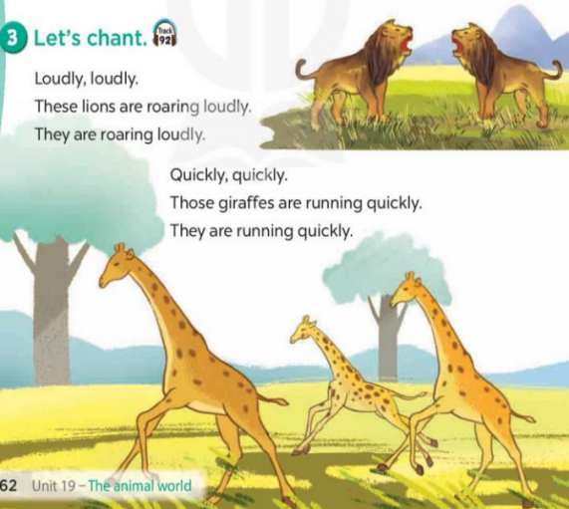
V. Adjustments (if necessary):
………………………………………………………………………………………….…..……………………………………………………………………………...………………………………………….…..………………………………...
--------------------------------------------------------------

Week 32 – Grade 4
Unit 19: The animal world
Lesson 3 (4,5,6)

I. Objectives:
By the end of the lesson, Ss will be able to:
1. Knowledge:
- read and show understanding of a paragraph by answering four questions about it.
- complete a gapped paragraph about a visit to the zoo, their favourite animals and the reasons why they like these animals.
- collect or draw pictures of favourite animals at home and present them to the class by using the target language.
- Vocabulary: Review
2. Skills: speaking, listening, reading and writing.
3. Competences:
- Communication and collaboration: work in pairs and groups to complete the learning tasks.
- Self-control & independent learning: perform learning tasks.
4. Attitude/ Qualities:
- Kindness: Help partners to complete learning tasks.
- Honesty: tell the truth about feelings and emotions
II. Methods: Communicative approach, group Ss and T's activities, play as a character, teaching methods with game, teaching methods by visual, teaching methods by practising, discussion group, technical present....
III. Teaching aids:
1. Teacher’s preparation: Projector/ TV
- Speaker
- Website hoclieu.vn
2. Student’s preparation: books, notebooks.
IV. Procedures:
Teacher’s and students’ activities | Contents
Activity 1.Warm- up:  Game: “collect the candies”  - Have Ss compete in two groups, answer questions to get candy.  + Ss choose a number, and the teacher clicks on the number to go to the question.  + If pupils answer correctly, the teacher clicks back to this slide, clicks the play button with the color of that team to get candy into the jars.  - Once finished, click the candy machine to go to the next slide.  - Say “Open your book page 63” and look at “Unit 19, Lesson 3 (4,5,6)”.  Activity 2. Read and answer:  - Ask Ss to attend to four questions and the animals in the passage.  - Have Ss work individually.  - Set a time limit for Ss to read and answer the questions.  - Tell Ss to swap the answers with a partner, then check answers as a class.  - Write the answers on the board.  - Invite Ss to read the texts aloud  -T gives feedbacks.  Activity 3. Let’s write  - Tell Ss what they are going to do: complete a paragraph about a visit to the zoo.  - Remind Ss to pay attention to the context (the words before and after the gaps) before completing the paragraph with appropriate words.  - Have Ss fill in the first gap as an example, using the animals they like.  - Set a time limit for SS to complete the paragraph independently.  - Get Ss to swap books with their partners and check their answers in pairs or groups before checking as a class  Activity 3. Project.  - Explain that each pupil has to show a simple picture of their favourite animals (ex: lions) which they have prepared at home as homework  - Have Ss work in groups of six.  + Each pupil shows his / her picture to the group and describes what the animals in his / her picture are, and tells why he / she likes these animals.  - Invite a few pupils to show their pictures and tell the class about the animals and the reasons why they like these animals in front of the class, ex: These are lions. I like them because they roar loudly.  - Have the rest of the class comment and praise their friends’ performance.  *Consolidation  - T asks ss to answer the following questions:  + What have you learnt from the lesson today?  - T praises some Ss who are hardworking / active/ good…. as well as encourage others to try more.  *. Homework.  - Prepare the new lesson: Unit 20- Lesson 1 (1,2,3). | 4. Read and answer:  Key: 1. They are at the zoo.  2. They want to see the animals  3. Because they have long necks and legs. They can run very quickly.  4. Because they sing merrily.  5. Let’s write.  Key: Pupils’ own answers  Example: It is a sunny Sunday. My brother and I are at the zoo. I like giraffes because they have long necks and legs. My brother likes lions because they run quickly.  6. Project.  