Week 30
Teaching date: 4A: / /2024; 4B: / /2024
Unit 18: At the shopping centre
Period 118: Lesson 1 (1, 2, 3)
I. OBJECTIVES:
By the end of the lesson, Ss will be able to:
1. Knowledge:
- use the words behind, between, near, opposite, gift shop in relation to the topic “At the shopping centre”.
-use Where’s the bookshop? – It’s…. to ask and answer questions about locations.
- Vocabulary: behind, between, near, opposite, gift shop
- Model sentences: A: Where’s the bookshop?
B: It’s near the gift shop.
- Skills: speaking and listening
2. Competences:
- Co-operation: ready to help friends in pair work/ group work.
- Sociability: Talk to each other, say good words to others.
3. Attitude/ Qualities:
- Kindness: Help partners to complete learning tasks.
- Honesty: tell the truth about feelings and emotions
II. TEACHING AIDS:
- Teacher: Teacher’s guide Pages 253, 254, audio Tracks 72, 73, website hoclieu.vn, posters, laptop, pictures, textbook, lesson plan, TV or projector.
- Students: Pupil’s book Page 52, notebooks, workbooks, school things.
III. PROCEDURES:
Teacher’s activities and students’ activities | Contents
Warm- up:  Sing: Head, shoulders, knees and toes  - Show the song on the screen.  https://www.youtube.com/watch?v=WX8HmogNyCY  - Ask Ss to listen, sing and dance the song.  - Say “Open your book page 52” and look at “Unit 18, Lesson 1 (1,2,3)”.  Activity 1. Look, listen and repeat:  - Have Ss look at Pictures a and b and identify the characters in the pictures  - Play the audio twice (sentence by sentence). Correct their pronunciation where necessary.  -T elicits and ask sts to give the new words  - T models (3 times).  - T writes the words on the board.  - Checking: Rub out and remember  - Have Ss to practice the dialogue  - T invites a few pairs to the front of the class to practice  - T checks pronunciation for ss.  Activity 2 . Listen, point and say.  - Run through 4 pictures to teach vocabularies  T elicits the new words  - T models (3 times).  -Ss listen and repeat in chorus ( 3 times)  + Individual repetition (3 ss)  - T writes the words on the board.  - Checking: Slap the board  - Ss take note  - T asks Ss look at picture a and helps Ss know the structure from the dialogue.  - T introduces new structure for Ss.  - T explains, models and gives meaning.  -Have Ss repeat the model sentences.  - Have Ss look at the pictures and elicit  - Run through all the pictures.  - Run through model sentences.  -Play the recording for students to listen and repeat the sentences in both bubbles a few times  - Have Ss to practice using the pictures  - T controls and corrects.  - Invite some pairs to stand up, point at the pictures and say the questions and answer in front of the class.  - T gives feedbacks.  Activity 3. Let’s talk.  - Elicit the words or phrases to describe locations.  - Elicit the missing word in the first bubble.  + Ask Ss to look at the second bubble and identify what the answer should be.  + Give an example conversation: Where’s the bakery? – It’s near the bookshop.  + Get Ss to repeat the question and answer several times.  - Have pairs practise asking and answering questions about the locations of the shops in the picture.  - Invite a few pairs to practise asking and answering questions in front of the class.  *Consolidation  - T asks ss to answer the following questions:  + What have you learnt from the lesson today?  +What are the core values of the lesson? (if the teacher can take from the lesson).  - T review the vocabulary and model sentences.  - T praises some Ss who are hardworking / active/ good…. as well as encourage others to try more.  Homework.  - Learn the vocabulary and model sentences by heart  - Prepare the new lesson: Unit 18, Lesson 1 (4,5,6). | 1.Look,listen and repeat  + gift shop : cửa hàng quà tặng (picture)  + near : gần (situation)  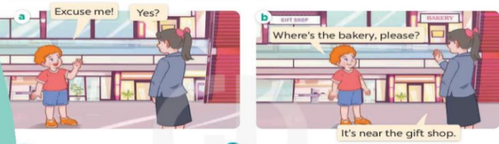  2. Listen, point and say.  + opposite :đối diện (situation)  + behind : đằng sau (picture)  + between :ở giữa (translation)  *Ask and answer about the locations.  A: Where’s the bookshop?  B: It’s near the bakery.  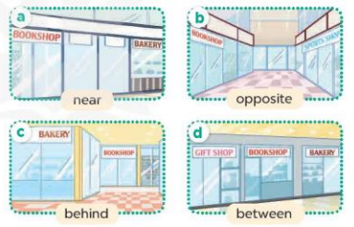  3. Let’s talk  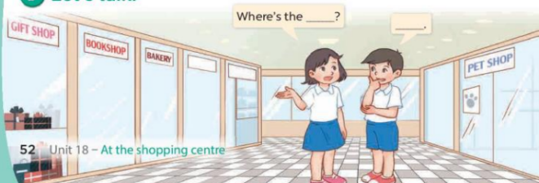
IV. ADJUSTMENTS (if necessary):
………………………………………………………………………………………….…..……………………………………………………………………………...…

------------------------------------
Teaching date: 4A: / /2024; 4B: / /2024
Unit 18: At the shopping centre
Period 119: Lesson 1 (4, 5, 6)
I. OBJECTIVES:
By the end of the lesson, Ss will be able to:
1. Knowledge:
- listen to and understand two communicative contexts.
- complete four gapped exchanges about locations with the help of picture cues.
- sing the song Where’s the bookshop? with the correct pronunciation, rhythm and melody.
- Vocabulary: Review
- Skills: speaking, listening, reading and writing.
2. Competences:
- Co-operation: ready to help friends in pair work/ group work.
- Self-control and independent learning: perform listening tasks.
3. Attitude/ Qualities:
- Kindness: Help partners to complete learning tasks.
- Honesty: tell the truth about feelings and emotions.
- Diligence: complete learning tasks.
II. TEACHING AIDS:
- Teacher: Teacher’s guide Pages 256, 257; audio Tracks 74, 75; website hoclieu.vn, posters, laptop, pictures, textbook, lesson plan, TV or projector.
- Students: Pupil’s book Page 53, notebooks, workbooks, school things.
III. PROCEDURES:
Teacher’s activities and students’ activities | Contents
Warm- up: Matching  - Divide the class into 2 teams  - Give instructions of this game  - Make model, monitor and check  - Find the winner and congratulate  Sts play game in teams  - Say “Open your book page 53” and look at “Unit 18, Lesson 1 (4,5,6)”. Sts listen and open the book.  Activity 1. Listen and tick  - Run through the pictures  Sts look at the pictures and say:  + Picture 1a: a gift shop that is opposite a bookshop  + Picture 1b: a gift shop that is near a bookshop  + Picture 2a: a bakery that is behind a sports shop  + Picture 2b: a bakery that is between a sports shop and a pet shop  - T ask Ss to guess the answers.  + T writes Ss’guessing on the board.  - Listen to the tape:  + Play the recording  + Play the recording again and get Ss to swap books with their partners  - Ss listen to the tape and tick  + Play the recording again to check answers together as a class.  Ss listen again, tick and swap books with their partners.  + Write the answers on the board for Ss to correct their answers. Then checks Ss’ guessing.  - Play the recording, sentence by sentence, for the class to listen and repeat in chorus.  Activity 2. Look, complete and read  - Ask Ss to look at the pictures and identify the locations of shops  - Have Ss look at the four sentences and the pictures. Elicit and model with picture 1  + Ask Ss to read the sentence 1 in chorus.  + Ask them what is missing in the question (near). Then have them complete the gap (It’s near the bakery)  -Have Ss work in pairs and complete the dialogue 2, 3, 4.  - Ask a few Ss to stand up and read the sentences aloud.  -T gives feedbacks.  Activity 3. Let’s sing  - Have pupils read the song to familiarize themselves with the lyrics  - Play the recording for Ss to listen to the whole song.  + Have them repeat the title and lyrics line by line.  + Tell Ss to point at the pictures while singing.  - Play the recording all the way through for Ss to listen to pronunciation and melody of the song.  - Play the recording line by line for Ss to listen, repeat and point to the pictures  - Play the recording for Ss to sing and do actions.  - Ask Ss to practice singing and doing actions in pairs or groups.  - Invite groups to the front of the classroom to perform the song  -T gives feedback.  *Consolidation  - T asks ss to answer the following questions:  + What have you learnt from the lesson today?  +What are the core values of the lesson? (if the teacher can take from the lesson).  - T praises some Ss who are hardworking / active/ good…. as well as encourage others to try more.  Homework  - Practice part 5 again.  - Prepare the new lesson: Unit 18, Lesson 2 (1,2,3).Sts listen and take note | 4. Listen and tick  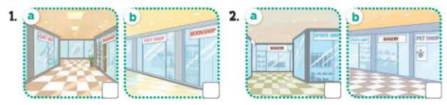  Key: 1. a 2. b  5. Look, complete and read  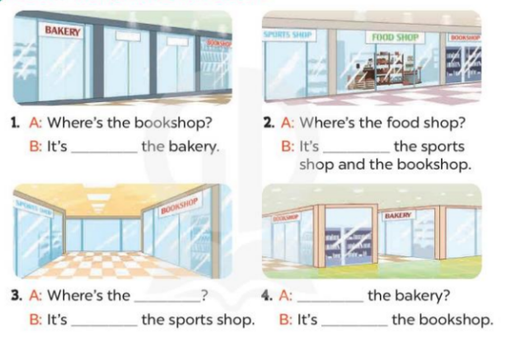  Key:  1.near  2. between  3. bookshop; opposite  4. Where’s; behind  6. Let’s sing  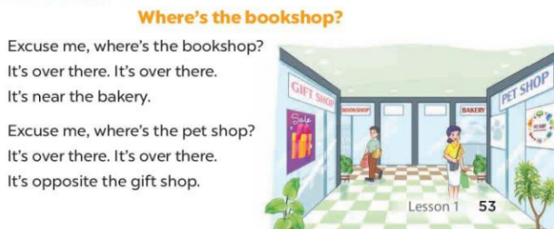
IV. ADJUSTMENTS (if necessary):
………………………………………………………………………………………….…..……………………………………………………………………………...…

Teaching date: 4A: / /2024; 4B: / /2024
Unit 18: At the shopping centre
Period 120: Lesson 2 (1, 2, 3)
I. OBJECTIVES:
By the end of the lesson, Ss will be able to:
1. Knowledge:
- use the words skirt, T-shirt, dong and thousand in relation to the topic “At the shopping centre”.
- use How much is the …….? – It’s ……to ask and answer questions about prices.
- Vocabulary: skirt, T-shirt, dong, thousand, pet shop
- Model sentences:
A: How much is the skirt?
B: It’s seventy thousand dong.
- Skills: speaking and listening
2. Competences:
- Co-operation: ready to help friends in pair work/ group work.
- Sociability: Talk to each other, say good words to others.
3. Attitude/ Qualities:
- Kindness: Help partners to complete learning tasks.
- Honesty: tell the truth about feelings and emotions
II. TEACHING AIDS:
- Teacher: Teacher’s guide Pages 258, 259; audio Tracks 76, 77, website hoclieu.vn, posters, laptop, pictures, textbook, lesson plan, TV or projector.
- Students: Pupil’s book Page 54, notebooks, workbooks, school things.
III. PROCEDURES:
Teacher’s activities and students’ activities | Contents
Warm up: Game: Pass the ball  - Stand up and pass the ball with music.  - When music stops, those who keep the ball must look at a picture on the board and say a sentence. I have……..  - Say “Open your book page 54  Activity 1. Look, listen and repeat:  - Have Ss look at Pictures a and b and identify the characters in the pictures  - Play the audio twice (sentence by sentence). Correct their pronunciation where necessary.  -T elicits and ask sts to give the new words  - T models (3 times).  - T writes the words on the board.  - Checking: Rub out and remember  - Have Ss to practice the dialogue  - T invites a few pairs to the front of the class to practice  - T checks pronunciation for ss.  Activity 2 . Listen, point and say.  - Run through 4 pictures to teach vocabularies  T elicits the new words  - T models (3 times).  -Ss listen and repeat in chorus ( 3 times)  + Individual repetition (3 ss)  - T writes the words on the board.  - Checking: Slap the board  - Ss take note  - T asks Ss look at picture a and helps Ss know the structure from the dialogue.  - T introduces new structure for Ss.  - T explains, models and gives meaning.  -Have Ss repeat the model sentences.  - Have Ss look at the pictures and elicit  - Run through all the pictures.  - Run through model sentences.  -Play the recording for students to listen and repeat the sentences in both bubbles a few times  - Have Ss to practice using the pictures  - T controls and corrects.  - Invite some pairs to stand up, point at the pictures and say the questions and answer in front of the class.  - T gives feedbacks.  Activity 3 . Let’s talk.  - Elicit the words or phrases used to describe prices.  - Elicit the missing words in the first bubble.  + Ask Ss to look at the second bubble and identify what the answer should be.  + Give an example conversation, ex: How much is the T-shirt? – It’s fifty thousand dong.  + Get Ss to repeat the question and the answer several times  - Have pairs practise asking and answering the questions about the prices of the items in the picture.  - Invite a few pairs to practise asking and answering questions in front of the class.  *Consolidation  - T asks ss to answer the following questions  + What have you learnt from the lesson today?  +What are the core values of the lesson? (if the teacher can take from the lesson).  - T praises some Ss who are hardworking / active/ good…. as well as encourage others to try more  Homework.  - learn by heart new words and structure  - Prepare the new lesson: Unit 18, Lesson 2(4,5,6).: | 1 . Look, listen and repeat: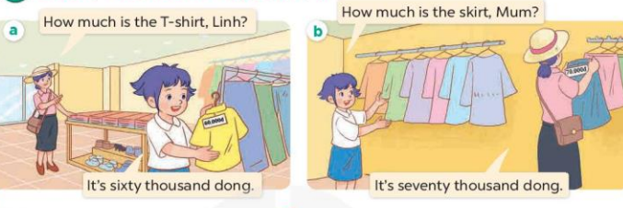  How much? Hỏi giá tiền  T-shirt: áo phông  Sixty thousand dong: 60 000đ  Seventy thousand dong: 70000đ  -  2 . Listen, point and say. 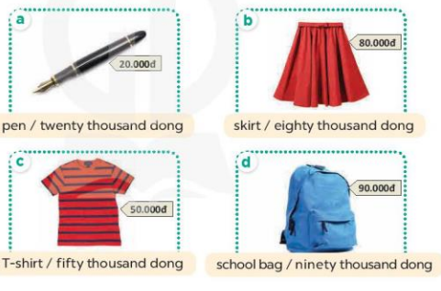  -Skirt: váy ngắn ( visual)  -Eighty thousand dong: 80 000 đ( translation)  -Fifty thousand dong: 50000đ ( visual)  Ninety thousand dong: 90 000đ ( visual)  * Ask and answer about prices  A: How much is the pen?  B. It’s twenty thousand dong.  3. Let’s talk.  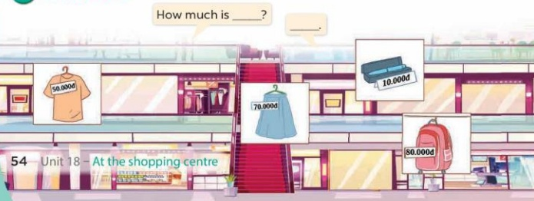
IV. ADJUSTMENTS (if necessary):
………………………………………………………………………………………….…..……………………………………………………………………………...
____________________________________--
Week 31
Teaching date: 4A: / /2024; 4B: / /2024
Unit 18: At the shopping centre
Period 121: Lesson 2: 4,5,6
I. OBJECTIVES:
By the end of the lesson, Ss will be able to:
1. Knowledge:
- listen to and demonstrate understanding of simple communicative contexts in relation to the topic “At the shopping centre”.
- read and write about locations and prices
- Vocabulary: Review
- Skills: speaking, listening, reading and writing.
2. Competences:
- Co-operation: ready to help friends in pair work/ group work.
- Self-control and independent learning: perform listening tasks.
3. Attitude/ Qualities:
- Kindness: Help partners to complete learning tasks.
- Honesty: tell the truth about feelings and emotions.
II. TEACHING AIDS:
- Teacher: Teacher’s guide Pages 260, 261; audio Tracks 78; website hoclieu.vn, posters, laptop, pictures, textbook, lesson plan, TV or projector.
- Students: Pupil’s book Page 55, notebooks, workbooks, school things.
III. PROCEDURES:
Teacher’s activities and students’ activities | Contents
Warm- up: Let’s go shopping game (PPT)  - Divide the class into 2 teams.  - Have Ss from each team choose an object they want to buy, then answer the question.  - If the Ss answer correctly, they get the points (coins) for that question to buy that object.  - After 6 numbers, the team with the most points is the winner  - Say “Open your book page 55” and look at “Unit 18, Lesson 2 (4,5,6)”.  Activity 1. Listen and number:  - Have Ss look at the four picture cues and ask:  + How many pictures are there?  + What can you see in each picture?  + Picture a: a T-shirt with its price tag of forty thousand dong  + Picture b: a skirt with its.  + Picture c: a school bag with its price tag of seventy thousand dong  + Picture d: a hat with its price tag of twenty thousand dong  -T ask Ss to guess the answers.  + T writes Ss’guessing on the board.  - Listen to the tape:  + Play the recording  + Play the recording again and get Ss to swap books with their partners.  + Play the recording again to check answers together as a class.  + Write the answers on the board for Ss to correct their answers. Then checks Ss’ guessing.  - Play the recording, sentence by sentence, for the class to listen and repeat in chorus.  Activity 2. Look, complete and read  - Have Ss look at the picture in Question 1 and prompt them to ask and answer questions about the items and their prices  - T models with sentence 1.  + Have Ss look at the sentence.  + Ask them what is missing in the answer (fifty).  + Have Ss complete the gap.  + Have Ss read the completed sentence in chorus.  -Have Ss work in pairs and complete the other sentences.  - Invite pairs of pupils to stand up and read aloud the sentences.  - T gives feedbacks.  Activity 3. Let’s play- Guess the price!  - Tell Ss that they are going to guess the prices of some items as quickly as possible  - Put a picture card ( example: a school bag) on the board.  - Write a price range as a clue to help pupils guess the price (ex: 50.000đ – 60.000đ). Write the correct price on a piece of paper (ex: 55.000đ).  - Ask How much is the school bag?  - Invite some Ss to guess the correct price  + If anyone guesses correctly, show the class the piece of paper.  + Ask the class to read the price.  - Play the game several times with different items.  *Consolidation  - T asks ss to answer the following questions:  + What have you learnt from the lesson today?  +What are the core values of the lesson? (if the teacher can take from the lesson).  - T praises some Ss who are hardworking / active/ good…. as well as encourage others to try more.  Homework.  - Prepare the new lesson: Unit 18, Lesson 3 (1,2,3). | 4.Listen and number  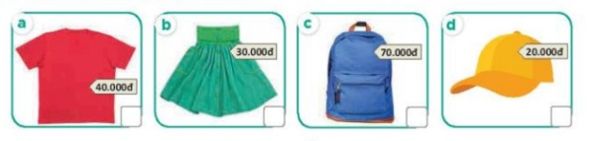  Key: 1.c 2. a 3.d 4.b  5. Look, complete and read  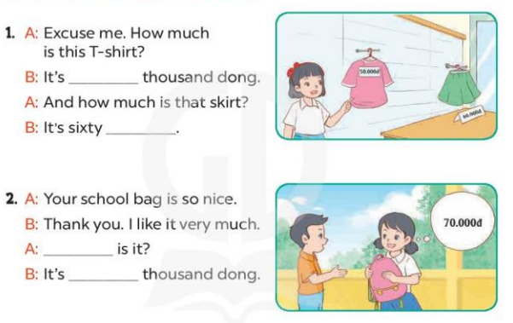  Key: 1. fifty; thousand dong  2. How much; seventy  6. Let’s play  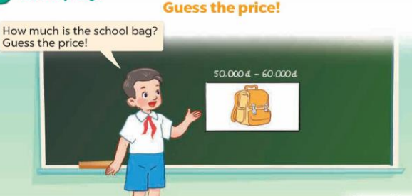

IV. ADJUSTMENTS (if necessary):
………………………………………………………………………………………….…..……………………………………………………………………………...…

--------------------------------------------------
Week 31
Teaching date: 4A: / /2024; 4B: / /2024
Unit 18: At the shopping centre
Period 122: Lesson 3: 1,2,3
I. OBJECTIVES:
By the end of the lesson, Ss will be able to:
1. Knowledge:
- correctly pronounce the two-syllable words be'hind and be'tween with the stress on the second syllable in isolation and in the sentences The bakery is be'hind the bookshop. and The bakery is be'tween the bookshop and the sports shop.
- listen to and demonstrate understanding of simple communicative contexts in relation to the topic “At the shopping centre”
- Vocabulary: Review
- Skills: speaking, listening, reading and writing.
2. Competences:
- Co-operation: ready to help friends in pair work/ group work.
- Self-control and independent learning: perform listening tasks.
3. Attitude/ Qualities:
- Kindness: Help partners to complete learning tasks.
- Honesty: tell the truth about feelings and emotions
II. TEACHING AIDS:
- Teacher: Teacher’s guide Pages 262, 263; audio Tracks 79, 80, 81; website hoclieu.vn, posters, laptop, pictures, textbook, lesson plan, TV or projector.
- Students: Pupil’s book Page 56, notebooks, workbooks, school things.
III. PROCEDURES:
Teacher’s activities and students’ activities | Contents
1.Warm- up: (5’)  Game: Who’s faster?  - Ask Ss look at the screen  - They look, read and say the number  - If they have the answers they can raise their hands to give the answers  - Say “Open your book page 56” and look at “Unit 18, Lesson 3 (1,2,3)”.  Activity 1. Listen and repeat:  - T gives instruction to the two-syllable words be'hind and be'tween with the stress on the second syllable in isolation and in the sentences The bakery is be'hind the bookshop. and The bakery is be'tween the bookshop and the sports shop.  - Play the recording for the word behind, between  - Encourage Ss to point at the word, sentence while listening.  - Play the recording again and encourage Ss to listen and repeat.  - Do this several times until Ss feel confident.  - T calls some Ss to practice.  - T gives feedbacks.  Activity 2. Listen and circle.  - Elicit the sentences and explain that they have to listen.  - T ask Ss to guess the answers.  + T writes Ss’guessing on the board.  - Listen to the tape:  + Play the recording  + Play the recording again and get Ss to swap books with their partners.  + Play the recording again to check answers together as a class.  + Write the answers on the board for Ss to correct their answers. Then checks Ss’ guessing.  - Play the recording, sentence by sentence, for the class to listen and repeat in chorus.  - Invite one or two Ss to stand up and read the completed sentences.  Activity 3. Let’s chant  - Introduce the title and lyrics of the chant.  - Play the recording for Ss to listen to the whole chant.  + Have them repeat the title and lyrics line by line.  + Ask Ss to attend to the sounds of the the words behind and between.  - Play the recording all the way through for Ss to listen to pronunciation and melody.  - Play the recording line by line for Ss to listen and repeat  - Play the recording for Ss to chant and clap along.  - Ask Ss to practice chant and clap along in pairs or groups.  - Invite groups to the front of the classroom to perform the chant  -T gives feedback.  *Consolidation  - T asks ss to answer the following questions:  + What have you learnt from the lesson today?  +What are the core values of the lesson? (if the teacher can take from the lesson).  - T praises some Ss who are hardworking / active/ good…. as well as encourage others to try more.  Homework.  - Practice the chant more.  - Prepare the new lesson: Unit 18, Lesson 3 (4,5,6). | - Listen and repeat:  be'hind The bakery is be'hind the bookshop  be'tween The bakery is be'tween the bookshop and the sports shop.  2.Listen and circle  Key: 1.b 2.c  3.Let’s chant  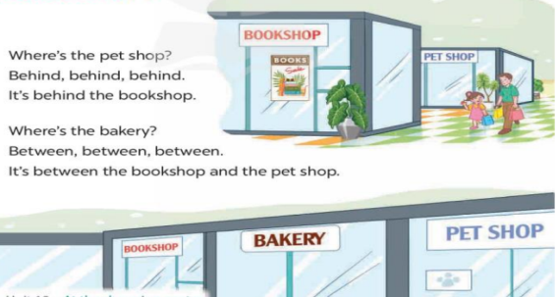
IV. ADJUSTMENTS (if necessary):
………………………………………………………………………………………….…..……………………………………………………………………………...…
=============================

Week 31
Teaching date: 4A: / /2024; 4B: / /2024
Unit 18: At the shopping centre
Period 123: Lesson 3: 4,5,6
I. OBJECTIVES:
By the end of the lesson, Ss will be able to:
1. Knowledge:
- read and write about locations and prices.
- make a shopping list and use it to practise talking about locations and prices in the classroom at Project time.
- Vocabulary: Review
- Skills: speaking, listening, reading and writing.
2. Competences:
- Co-operation: ready to help friends in pair work/ group work.
- Self-control and independent learning: perform reading tasks.
3. Attitude/ Qualities:
- Kindness: Help partners to complete learning tasks.
- Honesty: tell the truth about feelings and emotions.
- Diligence: complete learning tasks.
II. TEACHING AIDS:
- Teacher: Teacher’s guide Pages 264, 265, website hoclieu.vn, posters, laptop, pictures, textbook, lesson plan, TV or projector.
- Students: Pupil’s book Page 57, notebooks, workbooks, school things.
III. PROCEDURES:
Teacher’s activities and students activities | Contents
Warm- up: Game matching  - Divide the class into 2 teams  - Give instructions of this game  - Make model, monitor and check  - Find the winner and congratulate  Sts play game in teams  - Say “Open your book page 57” and look at “Unit 18, Lesson 3 (4,5,6)”.  Activity 1. Read and complete:  - Have Ss look at the table of gapped information and guess what the missing information is, and what the paragraph is about  - Ask Ss to read through the paragraph once or twice.  - Ask Ss to look at the first gap in the table and encourage them to make a question for it (ex: What is at the bookshop?).  + Help Ss find out the correct answer (book).  + Repeat the same procedure with the other gaps.  + Allow Ss to do the activity independently.  - Have Ss swap their books with a partner and check the answers.  - Select a few pupils to read their answers in front of the class. Check their answers.  Activity 2. Let’s write  - Ask pupils to read the title, the given sentence and the questions, then look at the picture to get ideas for their writing.  - First, have Ss read the guiding sentence.  + Then ask them to look at the picture to write a sentence about the location of the clothes shop.  + Next, let them write the answer to the question about the price of the skirt.  + After that, let them write sentences about the gift shop and the price of the pen.  -Ask Ss to write the paragraph independently.  - Get Ss to swap books with their partners and check their answers in pairs or groups before checking as a class.  Activity 3. Project.  - Explain that Ss are going to talk about the shopping list that they have made at home.  - Have Ss show their shopping lists to their partner.  - Give Ss some time to practise their presentations by themselves and in groups.  - Select a few Ss to give their presentations in front of the class.  *Consolidation  - T asks ss to answer the following questions:  + What have you learnt from the lesson today?  - T praises some Ss who are hardworking / active/ good…. as well as encourage others to try more.  Homework.  - Prepare the new lesson: Unit 19- Lesson 1 (1,2,3). | 4.Read and complete  The shoe shop: cửa hàng giày  Key:  1. book  2. behind the shoe shop  3. 50,000  4. ice cream  5. Let’s write  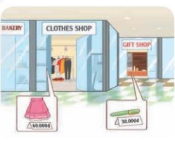  Key: Pupils’ own answers  Example: My mother and I are at the shopping centre. The clothes shop is near the bakery. My mother wants to buy a skirt. It’s sixty thousand dong. The gift shop is behind the clothes shop. I want to buy a pen. It’s thirty thousand dong.  6.Project.  At the shopping centre
IV. ADJUSTMENTS (if necessary):
………………………………………………………………………………………….…..……………………………………………………………………………...

