Unit 17: In the city
Lesson 1 (1, 2, 3)
I. Objectives:
By the end of the lesson, Ss will be able to:
1. Knowledge:
- use the words and phrases go straight, stop, turn left, turn right in relation to the topic “In the city”.
-use What does it say? – It says ʽ……..ʼ. ask and answer questions to identify road signs.
- Vocabulary: go straight, stop, turn left, turn right
- Model sentences:
A: What does it say?
B: It says “stop”
- Skills: speaking and listening
2. Competences:
- Co-operation: ready to help friends in pair work/ group work.
- Sociability: Talk to each other, say good words to others.
3. Attitude/ Qualities: Raise pupils’ awareness about their neighborhood and traffic safety.
II. Methods: Communicative approach, group Ss and T's activities, play as a character, teaching methods with game, teaching methods by visual, teaching methods by practising, discussion group, technical present....
III. Teaching aids:
- Teacher: Teacher’s guide Pages 1241, 242, 243; audio Tracks 62, 63, website hoclieu.vn, posters, laptop, pictures, textbook, lesson plan, TV or projector.
- Students: Pupil’s book Page 46, notebooks, workbooks, school things.
IV. Procedures:
Teacher’s and students’ activities | Contents
Activity 1. Warm- up:  Game: Jigsaw puzzle  - Divide class into 4 groups: Tom, Jerry, Miu and Chit.  - Ask Ss look at the pieces of picture.  - Ask Ss go to the board and jigsaw puzzle into the correct picture.  -T checks who’s the winner?  - Say “Open your book page 46” and look at “Unit 17, Lesson 1 (1,2,3)”.  Activity 2. Look, listen and repeat:  - Have Ss look at Pictures a and b and identify the characters and say what they can see in the pictures.  - Play the audio twice (sentence by sentence). Correct their pronunciation where necessary.  - Have Ss to practice the dialogue  - T invites a few pairs to the front of the class to practice.  - T checks pronunciation for ss.  Activity 3. Listen, point and say.  -T elicits the new words  - T models (3 times).  - T writes the words on the board.  - Checking: Matching  * Model sentences:  - T asks Ss look at picture b and helps Ss know the structure from the dialogue.  - T introduces new structure for Ss.  - T explains, models and gives meaning.  -Have Ss repeat the model sentences.  - Have Ss look at picture and identify the meaning of the road signs using gestures.  - Run through all the pictures.  - Run through model sentences.  - Have Ss to practise:  - Ask Ss to work in pairs.  - T controls and corrects.  - Invite a few pairs to come to the front of the classroom and point at the pictures and say the questions and answers in front of the class.  - T gives feedbacks.  Activity 4. Let’s talk.  - Have Ss look at the picture and ask questions to help them understand the context.  - Put Ss into groups of four.  - Ask Ss to say using What does it say?  - Invite a few pairs to the front of the classroom to ask and answer questions to identify road signs.  Activity 5. Consolidation  - T review the vocabulary and model sentences.  - T praises some Ss who are hardworking / active/ good…. as well as encourage others to try more.  * Home work.  - Learn the vocabulary and model sentences by heart  - Prepare the new lesson: Unit 17, Lesson 1 (4,5,6). | 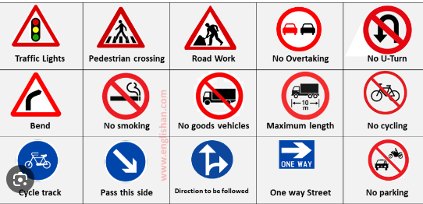  1. Look, listen and repeat:  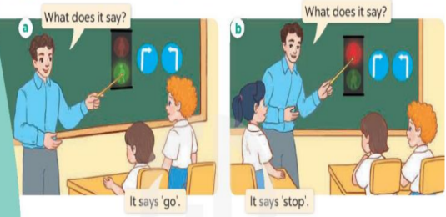  2. Listen, point and say.  * New words  + stop : dừng lại (situation)  + go straight: đi thẳng (situation)  + turn right: rẽ phải (picture)  + turn left: rẽ trái (picture)  + cross the road :qua đường (picture)  * Model sentences:  A: What does it say?  B: It says “stop”  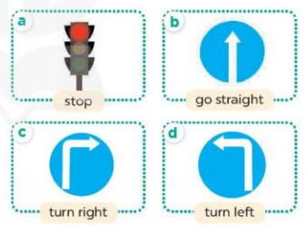  3. Let’s talk.  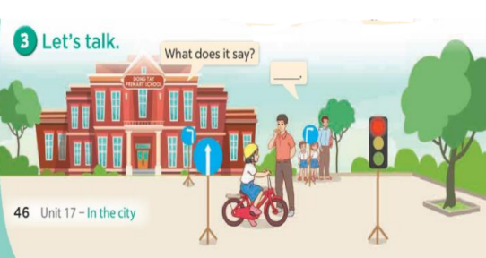
V. Adjustment (if necessary):
………………………………………………………………………………………….…..…………………………………………………………………………
-----------------------------------------------------
Unit 17: In the city
Lesson 1 (4, 5, 6)
I. Objectives:
By the end of the lesson, Ss will be able to:
1. Knowledge:
- use What does it say? – It says ʽ_____ʼ. ask and answer questions to identify road signs.
- listen to and demonstrate understanding of simple communicative contexts in relation to the topic “In the city”
- Vocabulary: Review
- Skills: speaking, listening, reading and writing.
2. Competences:
- Co-operation: ready to help friends in pair work/ group work.
- Self-control and independent learning: perform listening tasks.
3. Attitude/ Qualities:
- Kindness: Help partners to complete learning tasks.
- Diligence: complete learning tasks.
II. Methods: Communicative approach, group Ss and T's activities, play as a character, teaching methods with game, teaching methods by visual, teaching methods by practising, discussion group, technical present....
III. Teaching aids:
- Teacher: Teacher’s guide Pages 243, 244; audio Tracks 64, 65; website hoclieu.vn, posters, laptop, pictures, textbook, lesson plan, TV or projector.
- Students: Pupil’s book Page 47, notebooks, workbooks, school things.
IV. Procedures:
Teacher’s and students’ activities | Contents
Activity 1. Warm- up:  Game: Lucky Number (PPT)  - Divide the class into 2 teams.  - Have Ss from each team choose a number, then answer the question.  + If the Ss answer correctly, they get the points for that question.  - After 5 numbers, the team with the most points is the winner.  - Say “Open your book page 47” and look at “Unit 17, Lesson 1 (4,5,6)”.  Activity 2. Listen and tick or cross:  - Elicit the meaning of the road signs..  - T ask Ss to guess the answers.  + T writes Ss’guessing on the board.  - Listen to the tape:  + Play the recording  + Play the recording again and get Ss to swap books with their partners.  + Play the recording again to check answers together as a class.  + Write the answers on the board for Ss to correct their answers. Then checks Ss’ guessing.  - Play the recording, sentence by sentence, for the class to listen and repeat in chorus.  Activity 3. Look, complete and read  - Have pupils read the exchange and guess the missing word in the answer.  - Have Ss look at the four sentences and the pictures. Elicit and model with picture 1  + Ask Ss to read the sentence 1 in chorus.  + Ask them what is missing in the question (stop). Then have them complete the gap (It say ‘stop’).  -Have Ss work in pairs and complete the dialogue 2, 3, 4.  - Ask a few Ss to stand up and read the sentences aloud.  -T gives feedbacks.  Activity 4. Let’s sing  - Introduce the title and lyrics of the song: “When I cross the road”  - Play the recording for Ss to listen to the whole song.  + Have them repeat the title and lyrics line by line.  + Tell Ss to point at the pictures while singing.  - Play the recording all the way through for Ss to listen to pronunciation and melody of the song.  - Play the recording line by line for Ss to listen, repeat and point to the pictures  - Play the recording for Ss to sing and do actions.  - Ask Ss to practice singing and doing actions in pairs or groups.  - Invite groups to the front of the classroom to perform the song  -T gives feedback.  Activity 5: Consolidation  - T asks ss to answer the following questions:  + What have you learnt from the lesson today?  - T praises some Ss who are hardworking / active/ good…. as well as encourage others to try more.  Home work.  - Practice part 5 again.  - Prepare the new lesson: Unit 17, Lesson 2 (1,2,3). | 4. Listen and tick or cross:    Key: 1. ✓ 2. x 3. ✓ 4. X  5. Look, complete and read  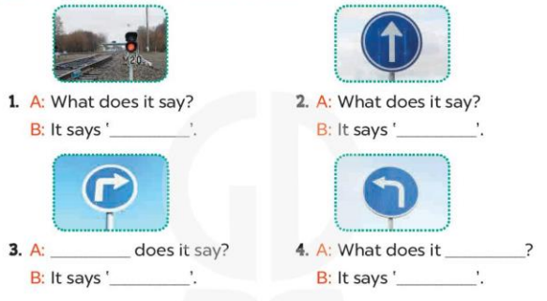  Key: 1. stop 2. go straight  3. What; turn right 4. say; turn left  6. Let’s sing  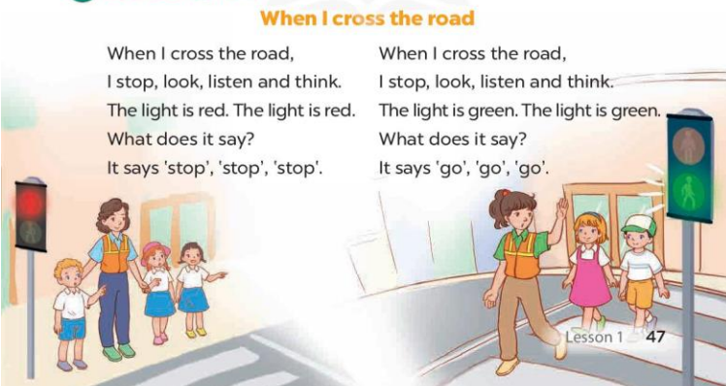
V. Adjustment (if necessary):
………………………………………………………………………………………….…..…………………………………………………………………………
-----------------------------------------------------
Unit 17: In the city
Lesson 2 (1, 2, 3)
I. Objectives:
By the end of the lesson, Ss will be able to:
1. Knowledge:
- Use the words and phrases get, turn round in relation to the topic “In the city”
- Use How can I get to the …….? – ………. to ask for and give directions.
- Vocabulary: get, turn round, excuse me
- Model sentences: A: How can I get to the bookshop?
B: Go straight and turn left.
- Skills: speaking and listening
2. Competences:
- Co-operation: ready to help friends in pair work/ group work.
- Sociability: Talk to each other, say good words to others.
3. Attitude/ Qualities:
- Kindness: Help partners to complete learning tasks.
- Honesty: tell the truth about feelings and emotions
II. Methods: Communicative approach, group Ss and T's activities, play as a character, teaching methods with game, teaching methods by visual, teaching methods by practising, discussion group, technical present....
III. Teaching aids:
- Teacher: Teacher’s guide Pages 246, 247; audio Tracks 66, 67 website hoclieu.vn, posters, laptop, pictures, textbook, lesson plan, TV or projector.
- Students: Pupil’s book Page 48, notebooks, workbooks, school things.
IV. Procedures:
Teacher’s and students’ activities | Contents
Activity 1. Warm- up:  Game: Angry bird (PPT)  - Divide the class into 2 teams.  - Ask Ss from each team choose a number, then choose the correct answer or answer.  + If the Ss answer correctly, they get the points for that question.  - After 8 numbers, the team with the most points is the winner.  - Say “Open your book page 48” and look at “Unit 17, Lesson 2 (1,2,3)”.  Activity 2. Look, listen and repeat:  - Have Ss look at Pictures a and b and identify the characters and predict what they want to buy, where they can buy it.  - Play the audio twice (sentence by sentence). Correct their pronunciation where necessary.  - Have Ss to practice the diaguage  - T invites a few pairs to the front of the class to practice.  - T checks pronunciation for ss.  Activity 3. Listen, point and say.  -T elicits the new words  - T models (3 times).  - T writes the words on the board.  - Checking: What and where  - T asks Ss look at picture a, b and helps Ss know the structure from the dialogue.  - T introduces new structure for Ss.  - T explains, models and gives meaning.  - Have Ss repeat the model sentences.  - Ask Ss to look at Pictures a, b, c, and d and identify the places in the pictures and directions.  - Run through all the pictures.  - Run through model sentences.  - Ask Ss to work in pairs.  - T controls and corrects.  - Invite a few pairs to come to the front of the classroom, point at the pictures and say in front of the class.  - T gives feedbacks.  Activity 4. Let’s talk.  - Ask Ss to look at the picture and elicit the places on the map and the direction to each place.  - Put Ss into pairs and encourage them to ask and answer using How can I get to the….?-….  - Invite some pairs to stand up to perform their exchanges.  Activity 5. Consolidation  - T review the vocabulary and model sentences.  - T praises some Ss who are hardworking / active/ good…. as well as encourage others to try more.  Homework.  - Learn the vocabulary and model sentences by heart  - Prepare the new lesson: Unit 17, Lesson 2 (4,5,6). | 1. Look, listen and repeat:  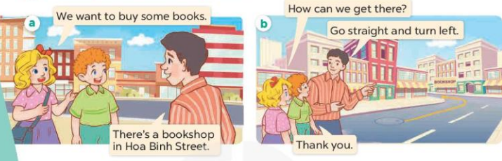  2. Listen, point and say.  * New words  + get (to): đến địa điểm (translation)  + turn round : quay lại (picture)  +excuse me : xin lỗi (situation)  * Model sentences:  A: How can I get to the bookshop?  B: Go straight and turn left.  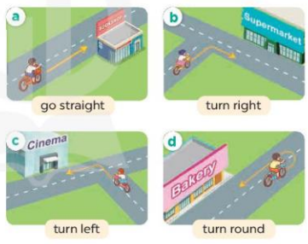  3. Let’s talk.  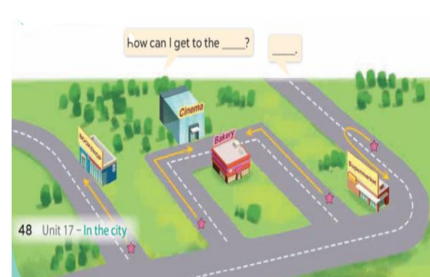
V. Adjustment (if necessary):
………………………………………………………………………………………….…..…………………………………………………………………………
-----------------------------------------------------
Unit 17: In the city
Lesson 2 (4, 5, 6)
I. Objectives:
By the end of the lesson, Ss will be able to:
1. Knowledge:
- use How can I get to the ……? – …….to ask for and give directions.
- listen to and demonstrate understanding of simple communicative contexts in relation to the topic “In the city”.
- Vocabulary: Review
- Skills: speaking, listening, reading and writing.
2. Competences:
- Co-operation: ready to help friends in pair work/ group work.
- Self-control and independent learning: perform listening tasks.
3. Attitude/ Qualities:
- Honesty: tell the truth about feelings and emotions.
- Diligence: complete learning tasks.
II. Methods: Communicative approach, group Ss and T's activities, play as a character, teaching methods with game, teaching methods by visual, teaching methods by practising, discussion group, technical present....
III. Teaching aids:
- Teacher: Teacher’s guide Pages 248, 49 audio Tracks 68; website hoclieu.vn, posters, laptop, pictures, textbook, lesson plan, TV or projector.
- Students: Pupil’s book Page 49, notebooks, workbooks, school things.
IV. Procedures:
Teacher’s and students’ activities | Contents
Activity 1: Warm up  Game: “Miming”  - Teacher divides the class into teams.  - One student in each team stands in front of the board and faces his/her team.  - Teacher writes/shows a phrase (stop).  - The rest Ss mime the action written on the board while their teammate guesses the action and gives the answer.  + The team that gives the correct answer first gets one point.  + The team with the most points is the winner.  - Say “Open your book page 49” and look at “Unit 17, Lesson 2 (4,5,6)”.  Activity 2. Listen and tick:  - Have Ss look at the pictures and ask questions to elicit the places and directions to the places in the pictures.  - T ask Ss to guess the answers.  + T writes Ss’guessing on the board.  - Listen to the tape:  + Play the recording  + Play the recording again and get Ss to swap books with their partners.  + Play the recording again to check answers together as a class.  + Write the answers on the board for Ss to correct their answers. Then checks Ss’ guessing.  - Play the recording, sentence by sentence, for the class to listen and repeat in chorus.  Activity 3. Look, complete and read.  - Have Ss read the dialogue and guess the missing words.  - T models with sentence 1.  + Have Ss look at the sentence.  + Ask them what is missing in the answer (the shopping centre).  + Have Ss complete the gap.  + Have Ss read the completed sentence in chorus.  -Have Ss work in pairs and complete the other sentences.  - Invite pairs of pupils to stand up and read aloud the sentences.  - T gives feedbacks.  Activity 4. Let’s play.  - Divide class into two teams.  - Have Ss look at the map listen to the teacher, fid the place and give the directions.  - If a student’s answer is correct, the team gets one star.  - After 5 minutes, the team that gets the most stars wins.  - Have Ss in one team give direction, and the other team listen and find the place.  Activity 5: Consolidation  - T praises some Ss who are hardworking / active/ good…. as well as encourage others to try more.  Homework.  - Prepare the new lesson: Unit 17, Lesson 3 (1,2,3). | 4. Listen and tick:  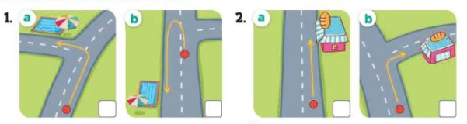  Key: 1.a 2. b  5. Look, complete and read.  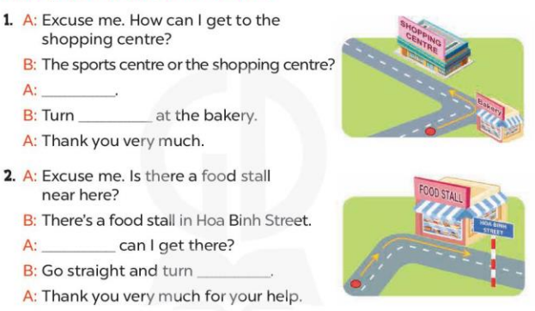  Key: 1. The shopping centre; left 2. How; right  6. Let’s play.  Show me the way  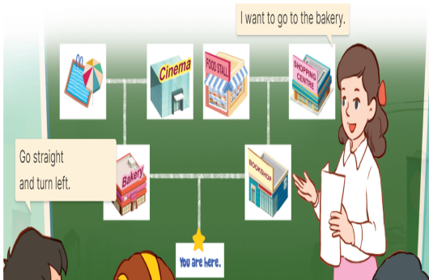

V. Adjustment (if necessary):
………………………………………………………………………………………….…..…………………………………………………………………………
-----------------------------------------------------

Unit 17: In the city
Lesson 3 (1, 2, 3)
I. Objectives:
By the end of the lesson, Ss will be able to:
1. Knowledge:
- correctly pronounce of the words 'bookshop and 'campsite with the stress on the first syllable in isolation and in the sentences How can I get to the 'bookshop? and How can I get to the 'campsite?
- listen to and demonstrate understanding of simple communicative contexts in relation to the topic “In the city”.
- Vocabulary: Review
- Skills: speaking, listening, reading and writing.
2. Competences:
- Co-operation: ready to help friends in pair work/ group work.
- Self-control and independent learning: perform listening tasks.
3. Attitude/ Qualities:
- Kindness: Help partners to complete learning tasks.
- Honesty: tell the truth about feelings and emotions
II. Methods: Communicative approach, group Ss and T's activities, play as a character, teaching methods with game, teaching methods by visual, teaching methods by practising, discussion group, technical present....
III. Teaching aids:
- Teacher: Teacher’s guide Pages 249, 250; audio Tracks 69, 70,71; website hoclieu.vn, posters, laptop, pictures, textbook, lesson plan, TV or projector.
- Students: Pupil’s book Page 50, notebooks, workbooks, school things.
IV. Procedures:
Teacher’s and students’ activities | Contents
1. Warm- up:  Game: memory game  - Invite two or three teams of four pupils to the front of the class.  - Stick four flashcards for turn left, turn right, turn round and go straight on the board.  - Have Ss look at the flashcards to memorise.  + Take a flashcard out quickly.  + Have the Ss at the front of the lines can hand up to say what flashcard is missing.  + If it is correct, the team gets one star.  + The first pupil of each line goes to the end of the line.  + The team gets most stars wins.  - Play the game with other teams in the class  - Say “Open your book page 50” and look at “Unit 17, Lesson 3 (1,2,3)”.  Activity 2. Listen and repeat:  - T gives instruction to the words 'bookshop and 'campsite with the stress on the first syllable in isolation and in the sentences How can I get to the 'bookshop? and How can I get to the 'campsite?  - Play the recording for the words ‘bookshop and ‘campsite.  - Encourage Ss to point at the words sentence while listening.  - Play the recording again and encourage Ss to listen and repeat.  - Do this several times until Ss feel confident.  - T calls some Ss to practice.  - T gives feedbacks.  Activity 3. Listen and circle.  - Elicit the sentences and explain that they have to listen.  - T ask Ss to guess the answers.  + T writes Ss’guessing on the board.  - Listen to the tape:  + Play the recording  + Play the recording again and get Ss to swap books with their partners.  + Play the recording again to check answers together as a class.  + Write the answers on the board for Ss to correct their answers. Then checks Ss’ guessing.  - Play the recording, sentence by sentence, for the class to listen and repeat in chorus.  - Invite one or two Ss to stand up and read the completed sentences.  Activity 4. Let’s chant  - Introduce the title and lyrics of the chant.  - Play the recording for Ss to listen to the whole chant.  + Have them repeat the title and lyrics line by line.  + Ask Ss to attend to the words bookshop and campsite  - Play the recording all the way through for Ss to listen to pronunciation and melody.  - Play the recording line by line for Ss to listen and repeat  - Play the recording for Ss to chant and clap along.  - Ask Ss to practice chant and clap along in pairs or groups.  - Invite groups to the front of the classroom to perform the chant  -T gives feedback.  Activity 5: Consolidation  - T praises some Ss who are hardworking / active/ good…. as well as encourage others to try more.  Homework.  - Practice the chant more.  - Prepare the new lesson: Unit 17, Lesson 3 (4,5,6). | 1. Listen and repeat:  'bookshop - How can I get to the 'bookshop?  'campsite - How can I get to the 'campsite?  2. Listen and circle.  Key: 1.c 2.a  3. Let’s chant  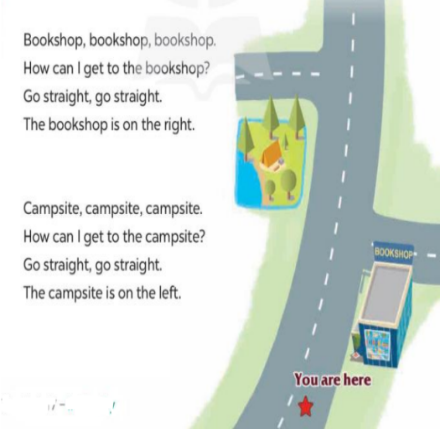
V. Adjustment (if necessary):
………………………………………………………………………………………….…..…………………………………………………………………………
-----------------------------------------------------
Unit 17: In the city
Lesson 3 (4, 5, 6)
I. Objectives:
By the end of the lesson, Ss will be able to:
1. Knowledge:
- read and understand a passage about directions
- write a short paragraph about give directions with the help of the suggested questions, a map and an in complete paragraph..
- draw a map and present it by giving directions in class at Project time.
- Vocabulary: Review
- Skills: speaking, listening, reading and writing.
2. Competences:
- Co-operation: ready to help friends in pair work/ group work.
- Self-control and independent learning: perform reading tasks.
3. Attitude/ Qualities:
- Kindness: Help partners to complete learning tasks.
- Honesty: tell the truth about feelings and emotions.
II. Methods: Communicative approach, group Ss and T's activities, play as a character, teaching methods with game, teaching methods by visual, teaching methods by practising, discussion group, technical present....
III. Teaching aids:
- Teacher: Teacher’s guide Pages 251, 252, website hoclieu.vn, posters, laptop, pictures, textbook, lesson plan, TV or projector.
- Students: Pupil’s book Page 51, notebooks, workbooks, school things.
IV. Procedures:
Teacher’s and students’ activities | Contents
Activity 1. Warm- up:  Game: What’s in the box?  - Divide class into 4 teams.  - Set rules: invite 1 pupil from each team go to the board look at the place  (bookshop,bakery,waterpark,supermarket, cinema, …) then unscramble the words by writing on the board and say aloud what the place is. The fastest will get more points than the rest.  - Encourage Ss join in the game.  - Give points for the teams.  - Say “Open your book page 51” and look at “Unit 17, Lesson 3 (4,5,6)”.  Activity 2. Read and tick True or False:  - Explain that they should read the text and tick if the Sentences 1- 4 are true or false.  - Do Statement 1 as an example.  + First, have Ss read Statement 1 and find what the statement is about (It’s about the bakery) and where it is (in Nguyen Hue Street).  + Then, find the information about the bakery in the text.  + Read carefully to decide if the statement is true or false.  - Ask Ss to do the task independently.  - Get Ss to swap their books with a partner and check their answers before checking as a class.  Activity 3. Let’s write  - Explain that they should read the gapped text and fill in the gaps with their own information.  - Have Ss do the first gapped sentence together as an example.  + Ask Ss to read the first sentence and elicit the words (ex: books, cakes, pencils). Then have them write it in the gap.  - Give Ss time to complete other gaps independently.  - Get Ss to swap their books with a partner and check their answers before checking as a class.  - Invite one or two Ss to read their completed texts in front of the class.  Activity 3. Project.  - Explain again that they are making a map of their neighbourhood to give directions from their house to at least three different places.  - Draw a map, mark the directions from their house to at least three places on the map, and prepare how to present it at home.  - Make a presentation to a group.  - Ask Ss to show their map.  - Use Nam’s map and his presentation as an example.  - Have Ss work in their groups. Each pupil shows his / her map and gives the directions from their house to three places.  - Invite a few Ss to show the map and make a presentation in front of the class.  Activity 5: Consolidation  - T asks ss to answer the following questions:  + What have you learnt from the lesson today?  Homework.  - Prepare the new lesson: Unit 18- Lesson 1 (1,2,3). | Game: What’s in the box?  4. Read and tick True or False:  Key: 1. True 2. False 3. False 4. True  5. Let’s write  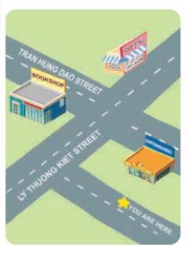  Key: Pupils’ own answers  Example: Today is Sunday. I want to buy some books. The bookshop is on Tran Hung Dao Street. I can go straight and turn right. The bookshop is on the left.  6. Project.  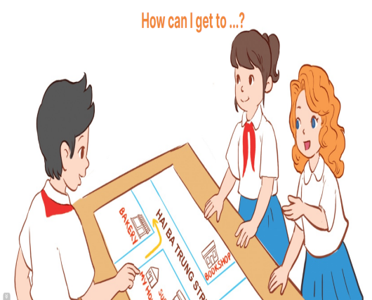
V. Adjustment (if necessary):
………………………………………………………………………………………….…..…………………………………………………………………………
-----------------------------------------------------

