Week 25 Preparing date: February………, 2024
Period 97 Teaching date: February…….., 2024

Unit 15: My family’s weekend
Lesson 1 (1, 2, 3)
A. OBJECTIVES:
By the end of the lesson, Ss will be able to:
1. Knowledge:
- use the words and phrases cinema, shopping centre, sports centre, swimming pool in relation to the topic “My family’s weekends”
– use Where does he / she go on Saturdays? – He / She goes to the ………to ask and answer questions about where someone goes
- Vocabulary: cinema, shopping centre, sports centre, swimming pool
- Model sentences:
A: Where does he / she go on Saturdays?
B: He/ She goes to the gym.
- Skills: speaking and listening
2. Competences:
- Co-operation: ready to help friends in pair work/ group work.
- Sociability: Talk to each other, say good words to others.
3. Attitude/ Qualities:
- Kindness: Help partners to complete learning tasks.
- Honesty: tell the truth about feelings and emotions
B. TEACHING AIDS:
- Teacher: Teacher’s guide Pages 209, 210; audio Tracks 41, 42, website hoclieu.vn, posters, laptop, pictures, textbook, lesson plan, TV or projector.
- Students: Pupil’s book Page 30, notebooks, workbooks, school things.
C. PROCEDURES:
Teacher’s and Students’activities | Contents
1.Warm- up: (3’)  Sing: weekend song  - Ss listen  - Ss sing and dance  *Procedure:  https://www.youtube.com/watch?v=Fz8weSgTBiA  -Show the song on the screen  -Ask Ss sing and dance  - Say “Open your book page 30” and look at “Unit 15, Lesson 1 (1,2,3)”.  - Ss open their books  2. Presentation(16’)  Activity 1. Look, listen and repeat:  *Procedure:  - Have Ss look at Pictures a and b and identify the characters in the pictures.  -Ss Look at the pictures and get to know the characters in the pictures.  - Play the audio twice (sentence by sentence). Correct their pronunciation where necessary.  -Ss listen and repeat in chorus (twice)  - Have Ss to practice the dialogue  - T invites a few pairs to the front of the class to practice.  -Ss work in pairs to practice  - T checks pronunciation for ss.  -T elicits the new words  - T models (3 times).  - Ss listen and repeat  + Choral repetition (3 times).  + Individual repetition (3 ss)  - T writes the words on the board.  - Ss take note  - Ss look, remember and write  - Checking: Rub out and remember  Activity 2 Listen, point and say.  *Procedure:  - T asks Ss look at picture a and helps Ss know the structure from the dialogue.  - T introduces new structure for Ss.  - T explains, models and gives meaning.  -Have Ss repeat the model sentences.  -Ss look at the picture and answer.  -Ss listen  -Ss listen and repeat  *Drill pictures  - Elicit and check comprehension the name of the rooms.  - Run through all the pictures.  - Run through model sentences.  + Run through the questions.  + Run through the answers  - Have Ss to practise:  + T says asks and Ss answer (change role).  - Ss look, listen and answer  + Ss – Ss (change role).  - Ask Ss to work in pairs.  -Ss work in pairs to practice  - T controls and corrects.  - Invite a few pairs to come to the front of the classroom, point at the relevant character in each picture, and act out his/her role.  -Ss work in pairs to practice  - Encourage Ss to practise speaking English.  - T gives feedbacks.  Activity 3. Let’s talk.  *Procedure:  - Ask questions to help them identify the context  -Ss look at the picture and answer  - T fills the gaps and writes the sentences on the board.  - T models  - T asks Ss to work in pairs to ask and answer  - Invite some pupils to the front of the class to present their exchanges.  - Ss say the completed sentences.  -Ss work in pairs  -Ss perform in front of the class.  - Give feedbacks  3.Consolidation  *Procedure:  - T asks ss to answer the following questions:  + What have you learnt from the lesson today?  -Ss answer the questions  - T review the vocabulary and model sentences.  - T praises some Ss who are hardworking / active/ good…. as well as encourage others to try more.  4. Homework. (2’)  - Prepare the new lesson: Unit 15, Lesson 1 (4,5,6). | Sing: weekend song  1.Look, listen and repeat:  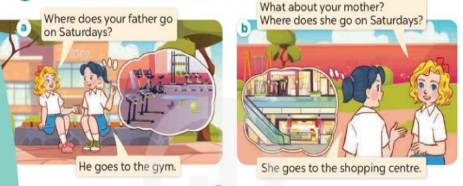  + Picture a:  Mary: Where does your father go on Saturdays?  Mai: He goes to the gym.  + Picture b  Mary: What about your mother? Where does she go on Saturdays?  Mai: She goes to the shopping centre.  *New words:  + sports centre : trung tâm thể thao  (picture)  + shoppping center: trung tâm mua sắm  (situation)  + swimming pool : hồ bơi (picture)  + cinema : rạp chiếu phim (picture)  2. Listen, point and say.  * Model sentences:  A: Where does he / she go on Saturdays?  B: He’ She goes to the gym.  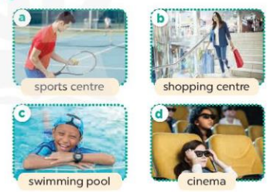  + Picture a: father at the sports centre  + Picture b. a mother at the shopping centre  + Picture c. a brother at the swimming pool  + Picture d. a sister at the cinema  3.Let’s talk.  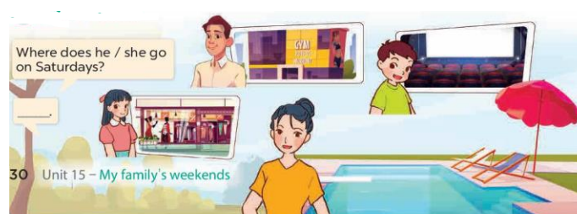  + a father at the gym, a brother at the cinema, a sister at the shopping centre, a mother at the swimming pool.
D. ADJUSTMENTS (if necessary):
………………………………………………………………………………………….…..…………………………………………………………………………
Week 25 Preparing date: February………, 2024
Period 98 Teaching date: February…….., 2024

Unit 15: My family’s weekend
Lesson 1 (4, 5, 6)
A. OBJECTIVES:
By the end of the lesson, Ss will be able to:
1. Knowledge:
- use the words and phrases cinema, shopping centre, sports centre, swimming pool in relation to the topic “My family’s weekends”
- listen to and demonstrate understanding of simple communicative contexts in relation to the topic “My family’s weekends”
- Vocabulary: Review
- Skills: speaking, listening, reading and writing.
2. Competences:
- Co-operation: ready to help friends in pair work/ group work.
- Self-control and independent learning: perform listening tasks.
3. Attitude/ Qualities:
- Kindness: Help partners to complete learning tasks.
- Diligence: complete learning tasks.
B. TEACHING AIDS:
- Teacher: Teacher’s guide Pages 212,213 audio Tracks 43, 44; website hoclieu.vn, posters, laptop, pictures, textbook, lesson plan, TV or projector.
- Students: Pupil’s book Page 31, notebooks, workbooks, school things.
C. PROCEDURES:
Teacher’s and Students’ activities | Contents
1.Warm- up: (5’)  *Procedure:  - Divides class into 2 teams.  - T calls 1 pupil from each team to come to the board.  - T shows clues (picture and some given letters) on the slides, pupils need to slap the board as quickly as possible to choose the missing letters.  - Ss listen  -Ss play the game  - The first pupils slapping at the correct answer will get 1 point for their team.  - Say “Open your book page 31” and look at “Unit 15, Lesson 1 (4,5,6)”.  - Ss open their books  2.Practice: (27’)  Activity 1. Listen and tick:  *Procedure:  - Elicit the name of the food in each picture  - T ask Ss to guess the answers.  + T writes Ss’guessing on the board.-Ss guess the answers  - Listen to the tape:  + Play the recording  + Play the recording again and get Ss to swap books with their partners.  - Ss listen to the tape and tick  + Play the recording again to check answers together as a class.  - Ss listen again, tick and swap books with their partners  + Write the answers on the board for Ss to correct their answers. Then checks Ss’ guessing.  - Play the recording, sentence by sentence, for the class to listen and repeat in chorus.  -Ss listen and repeat.  Activity 2. Look, complete and read.  *Procedure:  - Have Ss look at the pictures and identify the places and characters in the pictures.  - Have Ss look at the four incomplete exchanges and elicits the missing words in the sentences.  -Look at the pictures and say  -Ss look at the picture and say  - T models with sentence 1  + Ask Ss what is missing in the sentence.  + Have Ss look at the picture and complete the gap, then read the completed sentence in chorus.  -Ss look and answer  -Have Ss work in groups and complete the sentences 2,3 and 4.  - Ask a few Ss to stand up and read the completed sentences aloud.  -Ss look, complete and read the completed sentence in chorus.  -Ss complete the sentence  -Ss read aloud  -T gives feedbacks.  Activity 3. Let’s sing.  *Procedure:  - Introduce the title and lyrics of the song: “ Where do they go on Saturdays? ” song.  - Play the recording for Ss to listen to the whole song.  - Ss look and listen.  + Have them repeat the title and lyrics line by line.  + Tell Ss to point at the relevant character while singing his or her name.  - Play the recording all the way through for Ss to listen to pronunciation and melody of the song.  - Play the recording line by line for Ss to listen, repeat and point at the relevant character.  -Ss point to the character while singing  - Ss listen and repeat line by line without the action.  - Play the recording for Ss to sing and do actions.  - Ss sing and do actions.  - Ask Ss to practice singing and doing actions in pairs or groups.  - Invite groups to the front of the classroom to perform the song  - Ss work in groups (two groups) to sing.  -Ss perform in front of the class.  -T gives feedback.  -Ss listen and clap their hands  *Consolidation  *Procedure:  - T asks ss to answer the following questions:  + What have you learnt from the lesson today?  +What are the core values of the lesson? (if the teacher can take from the lesson).  -Ss answer the questions  - T praises some Ss who are hardworking / active/ good…. as well as encourage others to try more.  3. Homework. (3’)  - Learn the sing by heart  - Prepare the new lesson: Unit 15, Lesson 2 (1,2,3). | 4. Listen and tick:    + Picture 1a: a sister at the cinema  + Picture 1b: a sister at the swimming pool  + Picture 2a: a mother at the shopping centre  + Picture 2b: a mother at the gym  Key: 1.b 2.a  5. Look, complete and read.  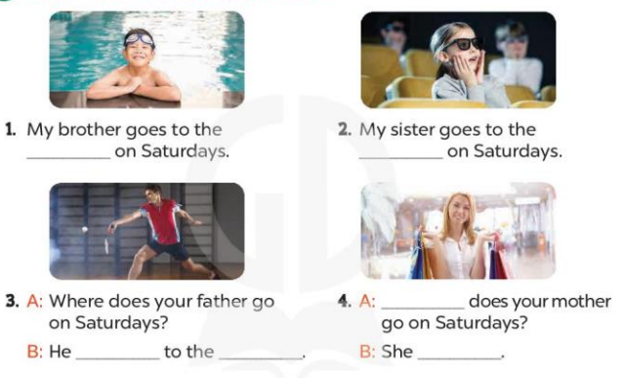  Key:  - : 1. swimming pool  - 2. cinema  - 3. goes; sports centre  4. Where; goes to the shopping centre  6. Let’s sing.  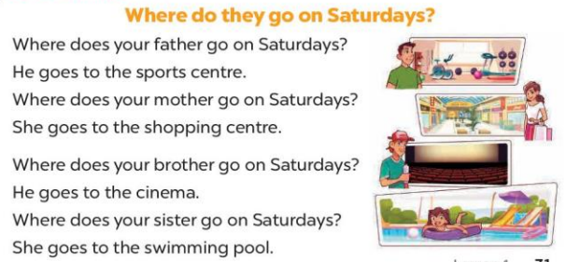

D. ADJUSTMENTS (if necessary):
………………………………………………………………………………………….…..…………………………………………………………………………
Week 25 Preparing date: February………, 2024
Period 99 Teaching date: February…….., 2024

Unit 15: My family’s weekend
Lesson 2 (1, 2, 3)
A. OBJECTIVES:
By the end of the lesson, Ss will be able to:
1. Knowledge:
- Use the words and phrases cook meals, do yoga, play tennis and watch films in relation to the topic “My family’s weekends”
- use What does he / she do on Sundays? – He / She ……. to ask and answer questions about what someone does;
- Vocabulary: cook meals, do yoga, play tennis and watch films
- Model sentences:
A: What does he / she do on Sundays?
B: He/ She plays tennis.
- Skills: speaking and listening
2. Competences:
- Co-operation: ready to help friends in pair work/ group work.
- Oral Communication: speak about someone, ask and answer the questions
3. Attitude/ Qualities:
- Kindness: Help partners to complete learning tasks.
- Honesty: tell the truth about feelings and emotions
B. TEACHING AIDS:
- Teacher: Teacher’s guide Pages 214, 215; audio Tracks 45, 46, website hoclieu.vn, posters, laptop, pictures, textbook, lesson plan, TV or projector.
- Students: Pupil’s book Page 32, notebooks, workbooks, school things.
C. PROCEDURES:
Teacher’s and Students’ activities | Contents
1.Warm- up: (3’)  Game: Lucky Wheel game (ppt)  *Procedure:  - Divide the class into 2 teams.  - Have Ss from each team choose a number, then answer the questions.  - If the Ss answer correctly, T spins the wheel on the slide to get the points for that question.  - After 6 numbers, the team with the most points is the winner.  - Ss listen  - Ss play the game  - Say “Open your book page 32” and look at “Unit 13, Lesson 2 (1,2,3)”.  - Ss open their books  2. Presentation(16’)  Activity 1. Look, listen and repeat:  *Procedure:  - Have Ss look at Pictures a and b and identify the places, characters and their activities in the pictures.  -Look at the pictures and get to know the characters in the pictures.  - Play the audio twice (sentence by sentence). Correct their pronunciation where necessary.  -Ss listen and repeat in chorus (twice)  - Have Ss to practice the diaguage  - T invites a few pairs to the front of the class to practice.  -Ss work in pairs to practice  -Ss practice the diaguage  - T checks pronunciation for ss.  -T elicits the new words  - T models (3 times). - Ss listen and repeat  + Choral repetition (3 times).  + Individual repetition (3 ss)  - T writes the words on the board.  - Checking: Rub out and remember  Activity 2. Listen, point and say.  *Procedure:  - T asks Ss look at picture b and helps Ss know the structure from the dialogue.  A: What does he / she do on Sundays?  B: He/ She plays tennis  -Ss look at the picture and answer.  - T introduces new structure for Ss.  - T explains, models and gives meaning.  - Have Ss repeat the model sentences.  -Ss listen and repeat  Practice: (7’)  *Drill pictures  - Elicit the activities of the people.  - Run through all the pictures.  - Run through model sentences.  +Run through the question sentences  +Run through the answer sentences  - Have Ss to practise:  + T asks, Ss answer picture a  + Ss ask, T answers picture b  + Group A ask, group B answer picture c  + Group B ask, group A answer picture d  - Ask Ss to work in pairs.  - Ss look, listen and answer  - T controls and corrects.  - Invite a few pairs to come to the front of the classroom, point at the relevant character in each picture, and act out his/her role.  -Ss go to the board and role play.  - T gives feedbacks.  3.Production: (7’)  Activity 3. Let’s talk.  *Procedure:  - Ask questions to help them identify the context.  -Ss look at the picture and answer  - Put pupils into pairs and encourage them to ask and answer questions about what a family member does at the weekend.  - Invite a few pairs to practise asking and answering questions about what a family member does at the weekend.  -Ss work in pairs to ask and answer  - Invite a few pairs to the front of the class to perform their conversations.  -Ss ask and answer  -Ss perform in front of the class.  *Consolidation  *Procedure:  - T asks ss to answer the following questions:  +What are the core values of the lesson? (if the teacher can take from the lesson).  -Ss answer the questions  - T review the vocabulary and model sentences.  - T praises some Ss who are hardworking / active/ good…. as well as encourage others to try more.  4. Homework. (2’)  - Learn the vocabulary by heart  - Prepare the new lesson: Unit 15, Lesson 2 (4,5,6). | Game: Lucky Wheel game  1.Look, listen and repeat:  + In picture a:  Ben: Where does your father go on Sundays?  Linh: He goes to the sports centre  + In picture b:  Ben: What does he do there?  Linh: He plays tennis  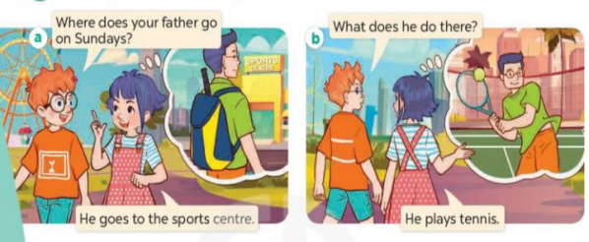  Vocabulary:  + cook meals : nấu các bữa ăn (realia)  + play tennis : chơi quần vợt (realia)  + watch films : xem phim (realia)  + do yoga : tập yoga (visual)  2. Listen, point and say.  * Model sentences:  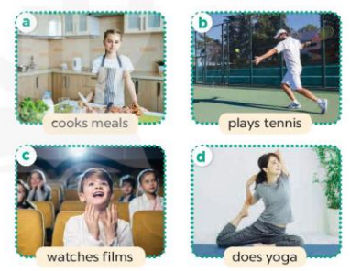  + Picture a: a sister cooking  + Picture b: a father playing tennis  + Picture c: a brother watching a film  + Picture d: a mother doing yoga  3.Let’s talk.  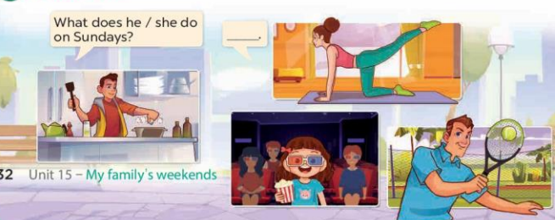  + a mother doing yoga, a brother cooking a meal, a sister watching a film, a father playing tennis
D. ADJUSTMENTS (if necessary):
………………………………………………………………………………………….…..…………………………………………………………………………
Week 25 Preparing date: February………, 2024
Period 100 Teaching date: February…….., 2024

Unit 15: My family’s weekend
Lesson 2 (4, 5, 6)
A. OBJECTIVES:
By the end of the lesson, Ss will be able to:
1. Knowledge:
- use the words and phrases cinema, shopping centre, sports centre, swimming pool in relation to the topic “My family’s weekends”
-listen to and demonstrate understanding of simple communicative contexts in relation to the topic “My family’s weekends”
- Vocabulary: Review
- Skills: speaking, listening, reading and writing.
2. Competences:
- Co-operation: ready to help friends in pair work/ group work.
- Self-control and independent learning: perform listening tasks.
3. Attitude/ Qualities:
- Kindness: Help partners to complete learning tasks.
- Honesty: tell the truth about feelings and emotions.
B. TEACHING AIDS:
- Teacher: Teacher’s guide Pages 216, 217; audio Tracks 47; website hoclieu.vn, posters, laptop, pictures, textbook, lesson plan, TV or projector.
- Students: Pupil’s book Page 33, notebooks, workbooks, school things.
C. PROCEDURES:
Teacher’s and Students’ activities | Contents
1.Warm- up: (5’)  Game: “Lucky wheel”  *Procedure:  - Teacher divides the class into 2 teams (boys and girls).  - Each team takes turns to choose the flag and answer the question.  - The team that has more points is the winner.  - Say “Open your book page 33” and look at “Unit 15, Lesson 2 (4,5,6)”.  - Ss open their books  2.Practice: (27’)  Activity 1. Listen and match:  *Procedure:  - Ask questions to help Ss identify the people in the pictures and the icons.  - Ss Look at the pictures and say:  - T ask Ss to guess the answers.-Ss guess the answers  + T writes Ss’guessing on the board.  - Listen to the tape:  + Play the recording  + Play the recording again and get Ss to swap books with their partners.  + Play the recording again to check answers together as a class.  - Ss listen to the tape and match  - Ss listen again, match and swap books with their partners.  + Write the answers on the board for Ss to correct their answers. Then checks Ss’ guessing.  - Play the recording, sentence by sentence, for the class to listen and repeat in chorus.  -Ss listen and repeat.  Activity 2. Look, complete and read.  *Procedure:  - Have Ss look at the pictures and identify the people and their activities in the pictures  -Ss look at the pictures and say  - Have Ss look at the two gapped exchanges. Draw their attention to the missing words.  -Ss look at the gap and pay attention  - Have Ss look at the first gap. Ask them what word is missing (sports centre). Then have them complete the sentence (He goes to the sports centre.).  -Ss answer and complete the sentence  +Get them to guess the missing words in the following sentences (do; tennis).  - Repeat the same procedure with Exchange 2.  -Ss do the task with exchange 2  - Get Ss to swap books with a partner and check their answers before checking as a class.  -Ss swap books and check answer  - Ask a few pairs to read the completed exchanges aloud  -Ss read the completed  -T gives feedbacks.  Activity 3. Let’s play.  *Procedure:  - Tell Ss that they are going to play Matching game in pairs.  - Ss listen  - The player turns over a pair of cards.  +If the cards show an activity and a place that matches, the player scores a point, ex: the card play tennis matches the card sports centre.  - The player continues to turn over pairs of cards.  + If the cards do not match, the other player has a turn.  + The player who gets more points is the winner.  - Have Ss work in pairs. Invite one or two pairs to the front of the class to play the game.  -Ss play the game  - Ask Ss to make sentences with the words on the cards they have, ex: My father goes to the sports centre on Sundays. He plays tennis.  -Ss listen and answer  *Consolidation  *Procedure:  - T asks ss to answer the following questions:  + What have you learnt from the lesson today?  +What are the core values of the lesson? (if the teacher can take from the lesson).  - T praises some Ss who are hardworking / active/ good…. as well as encourage others to try more.  -Ss listen and take note  3. Homework. (3’)  - Prepare the new lesson: Unit 15, Lesson 3 (1,2,3). | 4.Listen and match:    + Picture a: cinema icon  + Picture b: yoga icon  + Picture c: tennis icon  + Picture d: cooking icon  Key: 1.c 2. d 3. a 4. b  5.Look, complete and read.  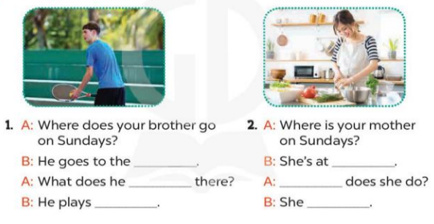  Key: 1. sports center; do; tennis  2. home; What; cooks meals  6.Let’s play.  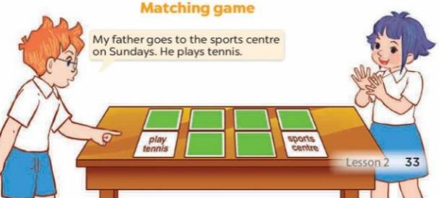

D. ADJUSTMENTS (if necessary):
………………………………………………………………………………………….…..…………………………………………………………………………
Week 26 Preparing date: March ……., 2024
Period 101 Teaching date: March …………, 2024

Unit 15: My family’s weekend
Lesson 3 (1, 2, 3)
A. OBJECTIVES:
By the end of the lesson, Ss will be able to:
1. Knowledge:
- correctly repeat the sounds of the letters g and s in isolation, in the words go and television, and in the sentences I go to the cinema on Saturdays. and We watch television on Sundays
- identify the target words go and television while listening.
- say the chant with the correct rhythm and pronunciation.
- Vocabulary: Review
- Skills: speaking, listening, reading and writing.
2. Competences:
- Co-operation: ready to help friends in pair work/ group work.
- Self-control and independent learning: perform listening tasks.
3. Attitude/ Qualities:
- Kindness: Help partners to complete learning tasks.
- Honesty: tell the truth about feelings and emotions
B. TEACHING AIDS:
- Teacher: Teacher’s guide Pages 218, 219; audio Tracks 48, 49, 50; website hoclieu.vn, posters, laptop, pictures, textbook, lesson plan, TV or projector.
- Students: Pupil’s book Page 34, notebooks, workbooks, school things.
C. PROCEDURES:
Teacher’s and Students’ activities | Contents
1.Warm- up: (5’)  Game: play the Build the city game (PPT)  *Procedure:  - Divide the class into 2 teams, Ss choose any number, the teacher clicks on the NUMBER to go to the question, after pupils answer correctly, the teacher clicks on the key next to it to unlock  - Ss listen  - Teacher clicks on start to build to go to the city building slide.  - Teacher clicks on the corresponding picture to put the object in the right place.  - The game ends when the city is built.  - Teachers can also add points for students to have more fun  -Ss play game  - Say “Open your book page 34” and look at “Unit 15, Lesson 3 (1,2,3)”.  - Ss open their books  2. Presentation(9’)  Activity 1. Listen and repeat:  *Procedure:  - T gives instruction to the letters g and s in isolation, in the words go and television, and in the sentences I go to the cinema on Saturdays. and We watch television on Sundays  - Ss recognize the differences about color of letter  - Play the recording for the letter ea.  - Ss listen and point  - Encourage Ss to point at the letter/ word/ sentence while listening.  - Play the recording again and encourage Ss to listen and repeat.  - Ss listen again and repeat  - Do this several times until Ss feel confident.  - T calls some Ss to practice.  -Ss practice  - T gives feedbacks.  3.Practice: (19’)  Activity 2. Listen and circle.  *Procedure:  - Elicit the sentences and explain that they have to listen.  - T ask Ss to guess the answers.  -Ss listen and say  -Ss guess the answers  + T writes Ss’guessing on the board.  - Listen to the tape:  + Play the recording  - Ss listen to the tape and circle  + Play the recording again and get Ss to swap books with their partners.  - Ss listen again, circle and swap books with their partners.  + Play the recording again to check answers together as a class.  + Write the answers on the board for Ss to correct their answers. Then checks Ss’ guessing.  - Ss check their answers and guessing  -Ss write the answer  - Play the recording, sentence by sentence, for the class to listen and repeat in chorus.  - Invite one or two Ss to stand up and read the completed sentences.  Activity 3. Let’s chant  *Procedure:  - Introduce the title and lyrics of the chant.  - Play the recording for Ss to listen to the whole chant.  -Ss listen to the chant  + Have them repeat the title and lyrics line by line.  + Ask Ss to attend to the sounds of the letters g and s and the words go and television  - Play the recording all the way through for Ss to listen to pronunciation and melody.  - Play the recording line by line for Ss to listen and repeat  - Play the recording for Ss to chant and clap along.  - Ss listen and repeat line by line without clap their hands  - Ask Ss to practice chant and clap along in pairs or groups.  - Ss chant and clap along.  - Invite groups to the front of the classroom to perform the chant  - Ss work in groups (two groups) to chant  -Ss perform in front of the class.  -T gives feedback.  *Consolidation  *Procedure:  - T asks ss to answer the following questions:  + What have you learnt from the lesson today?  +What are the core values of the lesson? (if the teacher can take from the lesson).  -Ss answer the questions  - T praises some Ss who are hardworking / active/ good…. as well as encourage others to try more.  -Ss listen and clap their hands  4. Homework. (2’)  - Practice the chant more.  - Prepare the new lesson: Unit 15, Lesson 3 (4,5,6). | 1.Listen and repeat:  -  2.Listen and circle.  Key: 1.c 2.d  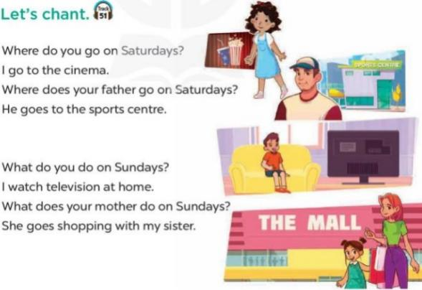  3.Let’s chant

D. ADJUSTMENTS (if necessary):
………………………………………………………………………………………….…..…………………………………………………………………………

Week 26 Preparing date: March ……., 2024
Period 102 Teaching date: March …………, 2024

Unit 15: My family’s weekend
Lesson 3 (4, 5, 6)
A. OBJECTIVES:
By the end of the lesson, Ss will be able to:
1. Knowledge:
- read and write about where someone goes and what someone does at the weekend;
- make notes about where their family members go and what they do at the weekend, and present the results to the class at Project time
- Vocabulary: Review
- Skills: speaking, listening, reading and writing.
2. Competences:
- Co-operation: ready to help friends in pair work/ group work.
- Self-control and independent learning: perform reading tasks.
3. Attitude/ Qualities:
- Honesty: tell the truth about feelings and emotions.
- Diligence: complete learning tasks.
B. TEACHING AIDS:
- Teacher: Teacher’s guide Pages 220, 221, website hoclieu.vn, posters, laptop, pictures, textbook, lesson plan, TV or projector.
- Students: Pupil’s book Page 35, notebooks, workbooks, school things.
C. PROCEDURES:
Teacher’s and Students’ activities | Contents
1.Warm- up: (5’)  Game: Catch the sentence (PPT)  *Procedure:  - Divide the class into 2 or 3 teams  - T calls one pupil from each team to come up to the front.  - T explains the rules:  - Letters or words will appear then disappear.  - Ss listen  -Ss play game  - Read them quickly, the quicker one gets points for their team.  - Say “Open your book page 35” and look at “Unit 15, Lesson 3 (4, 5, 6)”.  - Ss open their books  2.Practice: (8’)  Activity 1. Read and tick True or False:  *Procedure:  - Draw pupils’ attention to the four statements, focusing on the activities of each member of Ben’s family on Sunday.  - Ask Ss to read the text individually first, then in pairs to decide if the statements are true or false.  - Ss read and answer  - Have Ss to do the task.  -Ss read and choose the correct answer  - Select a few pupils to read their answers in front of the class.  -Ss read the answer in front of the class  - Check answers as a class and give explanations where necessary.  -Ss check the correct their answers  3.Production: (19’)  Activity 2. Let’s write  *Procedure:  - Explain to the class the goal of this activity.  - Ask Ss to read each gapped sentence, look at the picture and fill in the gap.  -Ss listen  -Ss read and answer  - Give Ss time to write their answers  - Ask Ss to swap and correct their answers in pairs.  -Ss write  -Ss swap books and check their answers  - Check the answers as a class.  Activity 3. Project.  *Procedure:  - Explain that they have to look at the notes they have prepared at home and present the results to the class.  -Ss listen  - Have pupils work in groups of five.  -Ss work in groups  + Each pupil looks at his / her notes and tells the group about where each member of his / her family goes at the weekend and what each of them does there.  - Invite a few pupils to look at their notes and tell the class about them,  -Ss perform in front of the class.  *Consolidation  *Procedure:  - T asks ss to answer the following questions:  + What have you learnt from the lesson today?  -Ss answer the questions  - T praises some Ss who are hardworking / active/ good…. as well as encourage others to try more.  -Ss listen and clap their hands  4. Homework. (3’)  - Prepare the new lesson: Review 3. | Game: Catch the sentence  4,Read and tick True or False:  Key: 1. T 2. F 3. T 4. T  5,Let’s write  Key: Pupils’ own answers  Example: Mai and her family do a lot of things at the weekend. On Saturdays, her father goes to the sports centre. Her mother goes to the supermarket. Her brother goes to the zoo. Mai does her homework at home. On Sundays, her family has dinner together.  6, Project.  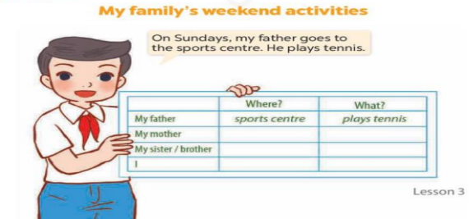  ex: On Sundays, my father goes to the sports centre. He plays tennis.
D. ADJUSTMENTS (if necessary):
………………………………………………………………………………………….…..………………………………………………………………………

