Unit 14: Daily activities

Lesson 1 (1, 2, 3)
A. OBJECTIVES:
By the end of the lesson, Ss will be able to:
1. Knowledge:
- use the phrases in the morning, at noon, in the afternoon, in the evening in relation to the topic “Daily activities”
- use When do you watch TV? – I watch TV ………. to ask and answer questions about when someone watches TV;
- Vocabulary: in the morning, in the afternoon, in the evening, at noon
- Model sentences:
A: When do you watch TV?
B: I watch TV in the evening.
- Skills: speaking and listening
2. Competences:
- Co-operation: ready to help friends in pair work/ group work.
- Sociability: Talk to each other, say good words to others.
3. Attitude/ Qualities:
- Kindness: Help partners to complete learning tasks.
- Honesty: tell the truth about feelings and emotions
B. TEACHING AIDS:
- Teacher: audio Tracks 31, 32, website hoclieu.vn, posters, laptop, pictures, textbook, lesson plan, TV or projector.
- Students: Pupil’s book , notebooks, workbooks, school things.
- PROCEDURES:
Teacher’s and students’ activities | Contents
1.Warm- up:  - Sing a song  - Show the song on the screen.  https://www.youtube.com/watch?v=XqZsoesa55w  - Ask Ss to listen, sing and dance the song.  - Ss sing and dance the song  - Say “Open your book page 24” and look at “Unit 14, Lesson 1 (1,2,3)”.  2.New lesson:  Activity 1. Look, listen and repeat:  - Have Ss look at Pictures a and b and identify the time of the day in the pictures.  - Play the audio twice (sentence by sentence). Correct their pronunciation where necessary.  - Have Ss to practice the dialogue  - T invites a few pairs to the front of the class to practice.  - T checks pronunciation for ss.  Activity 2. Listen, point and say.  -T elicits the new words:  - T models (3 times).  - T writes the words on the board.  - T asks Ss look at picture b and helps Ss know the structure from the dialogue.  - T introduces new structure for Ss.  - T explains, models and gives meaning.  -Have Ss repeat the model sentences.  - Elicit the time of the day from pupils (looking at the clock and the sun in the pictures).  - Run through all the pictures.  - Run through model sentences.  - Have Ss to practise  - Ask Ss to work in pairs.  - T controls and corrects.  - Invite a few pairs to come to the front of the classroom, point at the relevant character in each picture, and act out his/her role.  - Encourage Ss to practise speaking English.  - T gives feedbacks.  Activity 3. Let’s talk.  - Draw Ss’ attention to the clocks and the sun for the answers I watch TV in the morning / at noon / in the afternoon / in the evening.  - Get pupils to repeat the questions and answers several times.  - Have Ss to work in pairs, point at the diﬀerent pictures in this section, ask and answer the question When do you watch TV?  - Invite some pairs to take turns asking and answering questions about when someone watches TV in front of the class.  3.Consolidation  *Aims: Ss will be able consolidate and wrap up the content of the lesson.  *Procedure:  - T asks ss to answer the following questions:  + What have you learnt from the lesson today?  - T review the vocabulary and model sentences.  - T praises some Ss who are hardworking / active/ good…. as well as encourage others to try more  4. Homework.  - Prepare the new lesson: Unit 14, Lesson 1 (4,5,6). | - Look, listen and repeat:  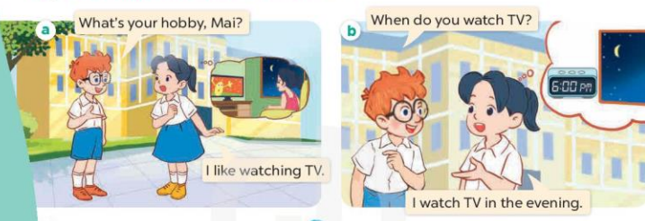  2. Listen, point and say.  * New words  + in the morning : vào buổi sáng  + in the afternoon: vào buổi chiều  + in the evening: vào buổi tối  + at noon : vào buổi trưa  * Model sentences:  A: When do you watch TV?  B: I watch TV in the evening.  *Drill pictures  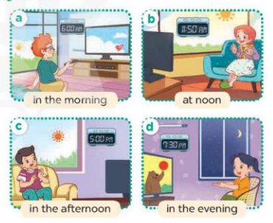  3.Let’s talk.  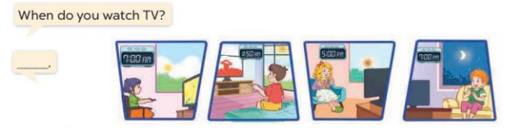
D. ADJUSTMENTS (if necessary):
………………………………………………………………………………………….…..……………………………………………………………………………...………………………………………….…..…………………………………………………

Unit 14: Daily activities
Lesson 1 (4, 5, 6)
A. OBJECTIVES:
By the end of the lesson, Ss will be able to:
1. Knowledge:
- use the phrases in the morning, at noon, in the afternoon, in the evening in relation to the topic “Daily activities”.
- listen to and demonstrate understanding of simple communicative contexts in relation to the topic “Daily activities”.
- Vocabulary: Review
- Skills: speaking, listening, reading and writing.
2. Competences:
- Co-operation: ready to help friends in pair work/ group work.
- Self-control and independent learning: perform listening tasks.
3. Attitude/ Qualities:
- Kindness: Help partners to complete learning tasks.
- Honesty: tell the truth about feelings and emotions.
B. TEACHING AIDS:
- Teacher: audio Tracks 33, 34; website hoclieu.vn, posters, laptop, pictures, textbook, lesson plan, TV or projector.
- Students: Pupil’s book , notebooks, workbooks, school things.
- PROCEDURES
Teacher’s and students’ activities | Contents
1. Warm- up:  Game: “pass the ball”  - T gives Ss a ball.  - T asks Ss to listen to music and transfer a ball around the class.  - When the music stops, Ss who keep a ball have to answer the question using: When do you watch TV? and I watch TV…….  - Say “Open your book ” and look at “Unit 14, Lesson 1 (4,5,6)”.  - New lesson:  Activity 1. Listen and tick or cross:  - Elicit and identify the activities and the time of the day by looking at the clocks and the sun or moon.  - T ask Ss to guess the answers.  + T writes Ss’guessing on the board.  - Listen to the tape:  + Play the recording  + Play the recording again and get Ss to swap books with their partners.  +Play the recording again to check answers together as a class.  + Write the answers on the board for Ss to correct their answers. Then checks Ss’ guessing.  -Play the recording, sentence by sentence, for the class to listen and repeat in chorus.  Activity 2. Look, complete and read.  - Ask Ss to look at the pictures and identify the activities and time of the day.  - Have Ss look at the four incomplete sentnces and elicits the missing words in the sentences.  - T models with sentence 1  + Ask Ss what is missing in the sentence.  + Have Ss look at the picture and complete the gap, then read the completed sentence in chorus.  -Have Ss work in groups and complete the sentences 2,3 and 4.  - Ask a few Ss to stand up and read the completed sentences aloud.  -T gives feedbacks.  Activity 3. Let’s sing  - Have pupils read the lyrics to familiarise themselves with the questions and answers.  - Encourage them to identify two activities (watch TV; read books) and time of the day in the pictures.  - Have Ss listen to the whole song, drawing their attention to the pronunciation and tune.  - Play the recording of the song once or twice for pupils to listen and repeat, line after line, and do related actions.  - Ask Ss to sing the whole song while doing actions or clapping hands.  - Invite a few groups to the front of the class to sing the song.  3.Consolidation  *Aims: Ss will be able consolidate and wrap up the content of the lesson.  *Procedure:  - T asks ss to answer the following questions:  + What have you learnt from the lesson today?  +What are the core values of the lesson? (if the teacher can take from the lesson).  - T praises some Ss who are hardworking / active/ good…. as well as encourage others to try more.  4. Homework.  - Prepare the new lesson: Unit 14, Lesson 2 (1,2,3). | 4. Listen and tick or cross:  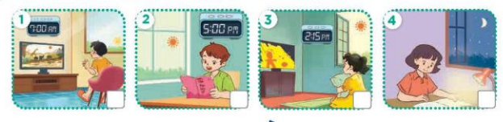  Key: 1.x 2.v 3.x 4.x  - Look, complete and read.  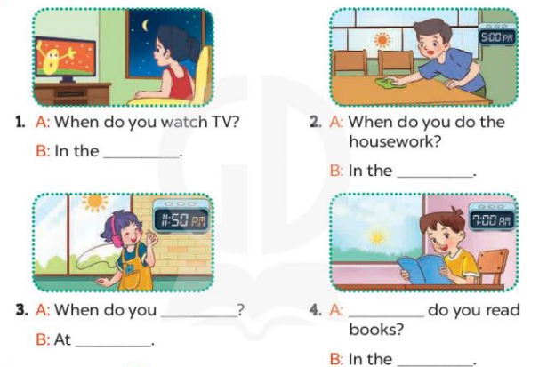  Key:  1. evening 2. afternoon  3. listen to music; room  4. When; morning  - Let’s sing  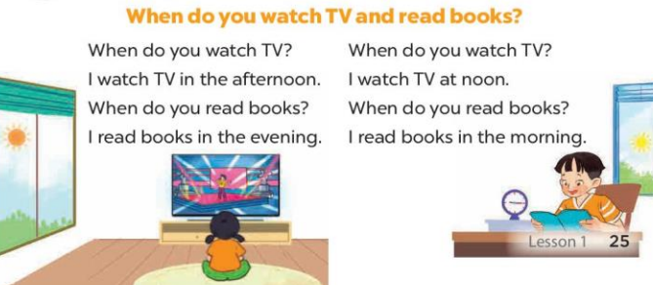
D. ADJUSTMENTS (if necessary):
………………………………………………………………………………………….…..……………………………………………………………………………...………………………………………….…..……………………………………………………………………………….……………………………………………………………

Unit 14: Daily activities
Lesson 2 (1, 2, 3)
A. OBJECTIVES:
By the end of the lesson, Ss will be able to:
1. Knowledge:
- use the phrases wash the clothes, clean the ﬂoor, help with the cooking and wash the dishes in relation to the topic “Daily activities”.
- use What do you do in the morning? – I …..to ask and answer questions about what daily activities someone does in the morning;
- Vocabulary: wash the clothes, clean the floor, help with the cooking, wash the dishes
- Model sentences:
A: What do you do in the morning?
B: I clean the floor.
- Skills: speaking and listening
2. Competences:
- Co-operation: ready to help friends in pair work/ group work.
- Oral Communication: speak about someone, ask and answer the questions
3. Attitude/ Qualities:
- Kindness: Help partners to complete learning tasks.
- Honesty: tell the truth about feelings and emotions
B. TEACHING AIDS:
- Teacher: website hoclieu.vn, posters, laptop, pictures, textbook, lesson plan, TV or projector.
- Students: Pupil’s book , notebooks, workbooks, school things.
- PROCEDURES:
Teacher’s and students’ activities | Contents
1.Warm- up:  - Sing a song.  - Say “Open your book ” and look at “Unit 14, Lesson 2 (1,2,3)”.  2.New lesson:  Activity 1. Look, listen and repeat:  - Have Ss look at Pictures a and b and identify what activities Linh does on Sundays.  - Play the audio twice (sentence by sentence). Correct their pronunciation where necessary.  - Have Ss to practice the diaguage  - T invites a few pairs to the front of the class to practice.  - T checks pronunciation for ss.  Activity 2. Listen, point and say.  * Vocabulary.  -T elicits the new words  - T models (3 times).  - T writes the words on the board.  * Model sentences:  - T asks Ss look at picture b and helps Ss know the structure from the dialogue.  - T introduces new structure for Ss.  - T explains, models and gives meaning.  - Have Ss repeat the model sentences.  - Have Ss look at the pictures and elicit what activity each child is doing.  - Run through all the pictures.  - Run through model sentences.  - Have Ss to practise:  - Ask Ss to work in pairs.  - T controls and corrects.  - Invite a few pairs to come to the front of the classroom, point at the relevant character in each picture, and act out his/her role.  - T gives feedbacks.  Activity 3. Let’s talk.  - Explain that each picture shows the members of a family doing the housework together  - Ask Ss to repeat the question a few times: What do you do in the morning / afternoon / evening?  - Point at the boy who is cleaning the floor to elicit the answer (I clean the floor.).  - Have Ss repeat it a few times.  - Split the class into two groups to take turns pointing at each activity that a character is doing, asking and answering in chorus.  - Ask S to practise asking and answering What do you do in the morning / afternoon / evening? – I ……..  - Invite some pairs of pupils to the front of the class to take turns asking and answering  3.Consolidation  - T asks ss to answer the following questions:  +What are the core values of the lesson? (if the teacher can take from the lesson).  - T review the vocabulary and model sentences.  - T praises some Ss who are hardworking / active/ good…. as well as encourage others to try more.  4. Homework.  - Prepare the new lesson: Unit 14, Lesson 2 (4,5,6). | - Look, listen and repeat:  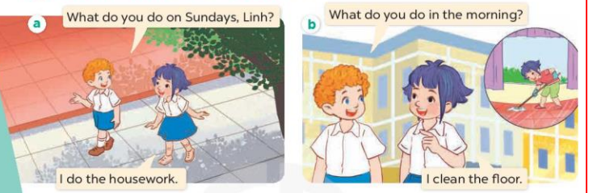  - Listen, point and say.  * Vocabulary.  + clean the floor : lau sàn nhà  + wash the clothes: giặt quần áo  + wash the dishes : rửa chén bát  + help with the cooking : giúp đỡ việc nấu ăn  * Model sentences:  A: What do you do in the morning? B: I clean the floor.  *Drill pictures  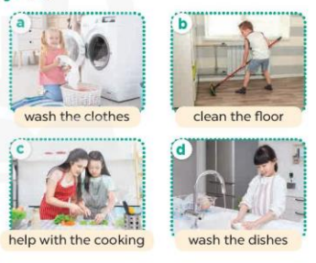  - Let’s talk.  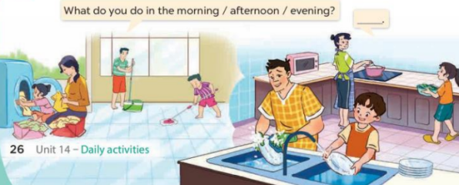
D. ADJUSTMENTS (if necessary):
………………………………………………………………………………………….…..……………………………………………………………………………...………

Unit 14: Daily activities
Lesson 2 (4, 5, 6)
A. OBJECTIVES:
By the end of the lesson, Ss will be able to:
1. Knowledge:
- use the phrases wash the clothes, clean the ﬂoor, help with the cooking and wash the dishes in relation to the topic “Daily activities”
- listen to and demonstrate understanding of simple communicative contexts in relation to the topic “Daily activities”
- Vocabulary: Review
- Skills: speaking, listening, reading and writing.
2. Competences:
- Co-operation: ready to help friends in pair work/ group work.
- Self-control and independent learning: perform listening tasks.
3. Attitude/ Qualities:
- Kindness: Help partners to complete learning tasks.
- Diligence: complete learning tasks.
B. TEACHING AIDS:
- Teacher: website hoclieu.vn, posters, laptop, pictures, textbook, lesson plan, TV or projector.
- Students: Pupil’s book , notebooks, workbooks, school things.
- PROCEDURES:
Teacher’s and students’ activities | Contents
1.Warm- up:  Sing: Baby shark  - Show the song on the screen.  https://www.youtube.com/watch?v=XqZsoesa55w  - Ask Ss to listen, sing and dance the song.  - Ss sing and dance the song  - Say “Open your book” and look at “Unit 14, Lesson 2 (4,5,6)”.  - New lesson:  Activity 1. Listen and number:  - Elicit the activity that the girl is doing in each picture.  - T ask Ss to guess the answers.  + T writes Ss’guessing on the board.  - Listen to the tape:  + Play the recording  + Play the recording again and get Ss to swap books with their partners.  + Play the recording again to check answers together as a class.  + Write the answers on the board for Ss to correct their answers. Then checks Ss’ guessing.  - Play the recording, sentence by sentence, for the class to listen and repeat in chorus.  Activity 2. Look, complete and read.  *Aims: Ss will be able to complete two gapped exchanges with the help of picture cues and sentences  *Procedure:  - Elicit the missing words in the question and answer from the picture cue and sentence.  - T models with sentence 1.  + Have Ss look at the sentence.  + Ask them what is missing in the answer ( clothes).  + Have Ss complete the gap.  + Have Ss read the completed sentence in chorus.  -Have Ss work in pairs and complete the sentences 2.  - Invite pairs of pupils to stand up and read aloud the sentences.  -T gives feedbacks.  Activity 3. Let’s play- Miming game  - Explain how the game is played.  + Write the question on the board What do you do in the ...?  +Ask one player from each team to come to the front of the class and whisper the answer to the question he / she wants to revise to the two players.  +They take turns miming the sentences they are told for their team to guess.  +The team gets one point if their guess is correct.  +The game continues until the time is up. + The team with the most points at the end of the game wins.  - Write all correct answers on the board, under the question What do you do in the …?  - When the game is over, get pairs of pupils to take turns asking and answering the question What do you do in the morning / afternoon / evening? using the answers on the board.  3.Consolidation  - T asks ss to answer the following questions:  + What have you learnt from the lesson today?  +What are the core values of the lesson? (if the teacher can take from the lesson).  - T praises some Ss who are hardworking / active/ good…. as well as encourage others to try more.  4. Homework.  - Prepare the new lesson: Unit 14, Lesson 3 (1,2,3). | 4.Listen and number:  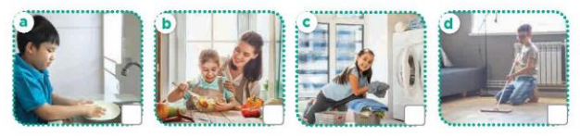  Key: 1.c 2. a 3. d 4. b  5.Look, complete and read.  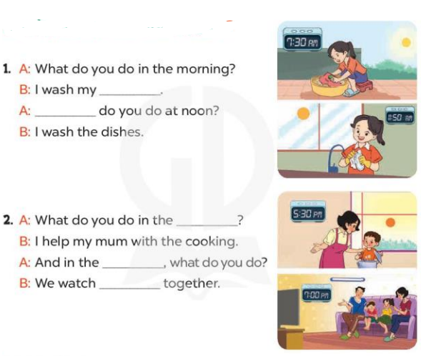  Key: 1. Clothes; What  2. afternoon; evening; TV  6.Let’s play- Miming game

D. ADJUSTMENTS (if necessary):
………………………………………………………………………………………….…..……………………………………………………………………………...………………………………………….…..……………………………………………………………………………….……………………………………………………………

Unit 14: Daily activities
Lesson 3 (1, 2, 3)
A. OBJECTIVES:
By the end of the lesson, Ss will be able to:
1. Knowledge:
- correctly repeat the sounds of the letters tch and sh in isolation, the words watch and wash and the sentences When do you watch TV? and I wash my clothes in the evening. with the correct pronunciation and intonation.
- identify the target words watch and wash while listening.
- say the chant with the correct rhythm and pronunciation.
- Vocabulary: Review
- Skills: speaking, listening, reading and writing.
2. Competences:
- Co-operation: ready to help friends in pair work/ group work.
- Self-control and independent learning: perform listening tasks.
3. Attitude/ Qualities:
- Kindness: Help partners to complete learning tasks.
- Honesty: tell the truth about feelings and emotions
B. TEACHING AIDS:
- Teacher: Teacher’s guide Pages 206, 207; audio Tracks 38, 39, 40; website hoclieu.vn, posters, laptop, pictures, textbook, lesson plan, TV or projector.
- Students: Pupil’s book Page 28, notebooks, workbooks, school things.
- PROCEDURES:
Teacher’s and Students’ activities | Contents
1.Warm- up:  Game: Brainstorming  - Hold a activity card, then reveal it slowly.  - Ask What’s activity?  - Ask the Ss guess the answer as fast as possible.  - Then have Ss do the same with the rest.  - This can be played in groups to make it more interesting.  - Say “Open your book ” and look at “Unit 14, Lesson 3 (4, 5, 6)”.  - Ss open their books  2.New lesson:  Activity 1. Listen and repeat:  - T gives instruction to the letters tch and sh in isolation, in the words watch and wash, and in the sentencesWhen do you watch TV? and I wash my clothes in the evening.  - Play the recording for the letter tch, sh  - Encourage Ss to point at the letter/ word/ sentence while listening.  - Play the recording again and encourage Ss to listen and repeat.  - Do this several times until Ss feel confident.  - T calls some Ss to practice.  - T gives feedbacks.  Activity 2. Listen and circle.  - Elicit the sentences and explain that they have to listen.  - T ask Ss to guess the answers.  + T writes Ss’guessing on the board.  - Listen to the tape:  + Play the recording  + Play the recording again and get Ss to swap books with their partners.  + Play the recording again to check answers together as a class.  + Write the answers on the board for Ss to correct their answers. Then checks Ss’ guessing.  - Play the recording, sentence by sentence, for the class to listen and repeat in chorus.  - Invite one or two Ss to stand up and read the completed sentences.  Activity 3. Let’s chant  - Introduce the title and lyrics of the chant.  - Play the recording for Ss to listen to the whole chant.  + Have them repeat the title and lyrics line by line.  + Ask Ss to attend to the sounds of the letters tch and sh and the words watch and wash.  - Play the recording all the way through for Ss to listen to pronunciation and melody.  - Play the recording line by line for Ss to listen and repeat  - Play the recording for Ss to chant and clap along.  - Ask Ss to practice chant and clap along in pairs or groups.  - Invite groups to the front of the classroom to perform the chant  -T gives feedback.  3.Consolidation  - T asks ss to answer the following questions:  + What have you learnt from the lesson today?  -Ss answer the questions  - T praises some Ss who are hardworking / active/ good…. as well as encourage others to try more.  -Ss listen and clap their hands  4. Homework.  - Practice the chant more.  - Prepare a poster about their school in order to introduce school to a new pupil.  - Prepare the new lesson: Unit 11, Lesson 3 (4,5,6). | 1.Listen and repeat:  tch watch When do you watch TV?  sh wash I wash my clothes in the evening.  2. Listen and circle.  Key: 1.c 2.b  3. Let’s chant  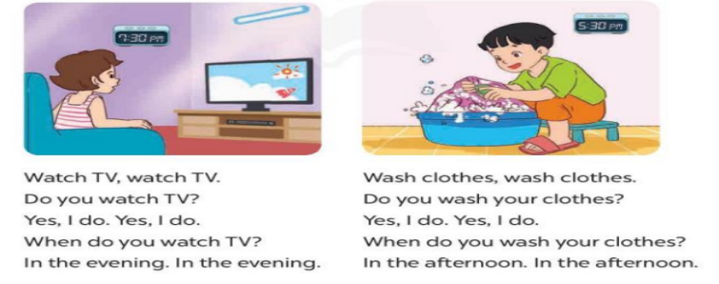
D. ADJUSTMENTS (if necessary):
………………………………………………………………………………………….…..……………………………………………………………………………...………………………………………….…..…………………………………………………

Unit 14: Daily activities
Lesson 3 (4, 5, 6)
A. OBJECTIVES:
By the end of the lesson, Ss will be able to:
1. Knowledge:
- use the phrases wash the clothes, clean the ﬂoor, help with the cooking and wash the dishes in relation to the topic “Daily activities”
- read and write about someone’s daily activities.
- draw pictures or take notes of what daily activities pupils do at home and present the results to the class at Project time.
- Vocabulary: Review
- Skills: speaking, listening, reading and writing.
2. Competences:
- Co-operation: ready to help friends in pair work/ group work.
- Self-control and independent learning: perform reading tasks.
3. Attitude/ Qualities:
- Kindness: Help partners to complete learning tasks.
- Diligence: complete learning tasks.
B. TEACHING AIDS:
- Teacher: website hoclieu.vn, posters, laptop, pictures, textbook, lesson plan, TV or projector.
- Students: Pupil’s book, notebooks, workbooks, school things.
- PROCEDURES:
Teacher’s and Students’ activities | Contents
1.Warm- up: Chant  *Procedure:  - Ask Ss chant and do the actions in Lesson 3 Unit 14 in groups.  - Ss listen and chant  - Give point for the groups and encourage them.  - Say “Open your book” and look at “Unit 14, Lesson 3 (4, 5, 6)”.  - Ss open their books  2. New lesson  Activity 1. Read and match:  - Have Ss read all the phrases under the paragraph. Tell them to read Phrase 1: in the morning.  - Ask Ss scan the paragraph for the appropriate activity related to the phrase.  -Have Ss to do the activity independently.  - Get Ss to swap books with their partners and check their answers before checking as a class.  - Invite some Ss to stand up and read the paragraph aloud.  Activity 2. Let’s write  - Explain to the class the goal of this activity.  - Ask Ss to read each gapped sentence, look at the picture and fill in the gap.  - Give Ss time to write their answers  - Ask Ss to swap and correct their answers in pairs.  - Check the answers as a class.  Activity 3. Project.  - Explain that they have to look at the pictures or notes they have prepared at home and present the results to the class.  - Have Ss work in groups of five.  + Each pupil looks at their pictures or notes and tells the group about what daily activities he / she does on Sundays.  - Invite a few Ss to look at their pictures or notes and tell the class about them  - Have the rest of class applaud if pupils perform well  3.Consolidation  *Procedure:  - T asks ss to answer the following questions:  + What have you learnt from the lesson today?  - T praises some Ss who are hardworking / active/ good…. as well as encourage others to try more.  - Ss listen and clap their hands  4. Homework.  - Prepare the new lesson: Unit 12, Lesson 1 (1, 2, 3).  -Ss listen and take note | Game: Chant  4. Read and match:  Key: 1.a 2. a, d 3. b  5. Let’s write  Example:  I do a lot of housework on Sundays. In the morning, I wake up and have breakfast. In the afternoon, I watch TV and play games. In the evening, I have dinner with my family.  6.Project.  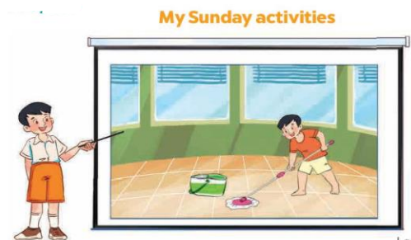  Example: Hello, everyone. My name’s Linh. I’m nine years old. This is my picture. I do housework on Sundays. In the morning, I wake up and have breakfast. In the afternoon, I watch TV and play games. In the evening, I have dinner with my family.

D. ADJUSTMENTS (if necessary):
………………………………………………………………………………………….…..……………………………………………………………………………...………

