Week 19 – Grade 4
Unit 11: My home
Lesson 1 (1, 2, 3)
I. Objectives:
By the end of the lesson, Ss will be able to:
1. Knowledge:
- understand and correctly repeat the sentences in two communicative contexts (pictures) in which characters ask and answer the question about where Mary lives.
- correctly say the phrases and use Where do you live? – I live _____. to ask and answer questions about where someone lives.
- enhance the correct use of Where do you live? – I live _____. to ask and answer questions about where someone lives in a freer context.
- Vocabulary: live, street, road
2. Skills: speaking, listening, reading and writing.
3. Competences:
- Communication and collaboration: work in pairs and groups to complete the learning tasks.
- Self-control & independent learning: perform learning tasks.
4. Attitude/ Qualities:
- Kindness: Help partners to complete learning tasks.
- Honesty: tell the truth about feelings and emotions
II. Methods: Communicative approach, group Ss and T's activities, play as a character, teaching methods with game, teaching methods by visual, teaching methods by practising, discussion group, technical present....
III. Teaching aids:
1. Teacher’s preparation: Projector/ TV
- Speaker
- Website hoclieu.vn
2. Student’s preparation: books, notebooks.
IV. Procedures:
Teacher’s and students’ activities | Contents
Activity 1.Warm- up:  Watch a chant video about house in Tieng Anh 3 (https://www.youtube.com/watch?v=L08bVyhfKpg&list=PL8_ETpRL2xNY6ptJqBTgFUP3I654rZ9bv&index=21)  Activity 2. Look, listen and repeat:  - Have Ss look at Pictures a and b and identify the characters in the pictures.  + Who are they ?  + Where are they ?  - Play the audio twice (sentence by sentence). Correct their pronunciation where necessary.  - Have Ss to practice the dialogue.  - Draw pupils’ attention to the question Where do you live? and the answer I live in Tran Hung Dao Street. Tell them that they are used to asking and answering about where Mary lives.  - T invites a few pairs to the front of the class to practice.  - T checks pronunciation for ss.  Activity 3 Listen, point and say.  - Ask pupils to look at Pictures a and b and tell what the words and numbers on the places are about (e.g. the street name, the street / road number).  -T elicits the new words:  - T models (3 times).  - T writes the words on the board.  - Checking: Rub out and remember  - T asks Ss look at picture a and helps Ss know the structure from the dialogue.  - T introduces new structure for Ss.  - T explains, models and gives meaning.  - Have Ss repeat the model sentences.  - Elicit and check comprehension the name of each character and countries.  - Run through all the pictures.  - Run through model sentences.  - Have Ss to practise:  + T asks the first picture, Ss answer  + Ss asks the second picture, T answers  + Group A asks the third picture, group B  answers  + Group B asks the last picture, group A  - Ask Ss to work in pairs.  - T controls and corrects.  - Invite a few pairs to come to the front of the classroom, point at the relevant character in each picture, and act out his/her role.  - Encourage Ss to practise speaking English.  - T gives feedbacks.  Activity 4. Let’s talk.  - Have Ss look at the picture and say the names of the months in the picture.  - Have pupils look at the bubbles to understand how the sentence pattern is used. - Have pupils role-play to practise asking the questions and giving their answers in pairs, using picture cues.  - Invite some pupils to practise asking and answering questions in front of the class.  - Have pupils ask and answer questions about where their friend(s) live using the structure learnt.  Activity 4. Consolidation  - T asks ss to answer the following questions:  + What have you learnt from the lesson today?  +What are the core values of the lesson? (if the teacher can take from the lesson).  - T review the vocabulary and model sentences.  - T praises some Ss who are hardworking / active/ good…. as well as encourage others to try more.  Homework.  - Learn the vocabulary and model sentences by heart  - Prepare the new lesson | 1. Look, listen and repeat:  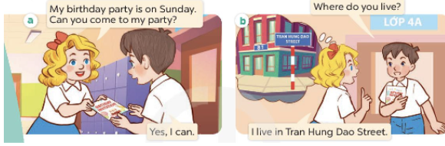  2. Listen, point and say.  Vocabulary.  + live : sống  + street : đường phố  + road :đường  A: Where do you live?  B: I live in + name of street  at + home’s number + name of street  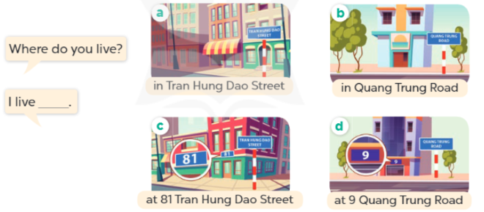  3. Let’s talk.  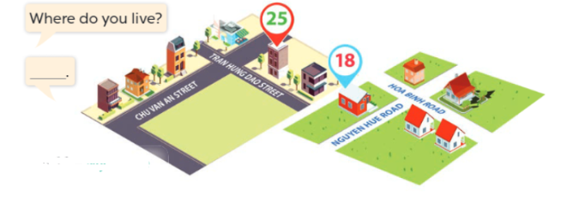
V. Adjustments (if necessary):
………………………………………………………………………………………….…..……………………………………………………………………………...………………………………………….…..………………………………...
--------------------------------------------------------------
Week 19 – Grade 4

Unit 11: My home
Lesson 1 (4,5,6)
I. Objectives:
By the end of the lesson, Ss will be able to:
1. Knowledge:
- listen to and understand four communicative contexts in which the characters talk about where they live and tick or cross the correct pictures.
- complete four gapped exchanges with the help of picture cues.
- practise the target vocabulary and sentence patterns by playing the game Whispering.
- Vocabulary: Review
2. Skills: listening, reading and writing.
3. Competences:
- Communication and collaboration: work in pairs and groups to complete the learning tasks.
- Self-control & independent learning: perform listening tasks.
4. Attitude/ Qualities:
- Kindness: Help partners to complete learning tasks.
- Honesty: tell the truth about feelings and emotions
II. Methods: Communicative approach, group Ss and T's activities, play as a character, teaching methods with game, teaching methods by visual, teaching methods by practising, discussion group, technical present....
III. Teaching aids:
1. Teacher’s preparation: Projector/ TV
- Speaker
- Website hoclieu.vn
2. Student’s preparation: books, notebooks.
IV. Procedures:
Teacher’s and students’ activities | Contents
Activity 1. Warm- up: Play the game Slap the board. (powerpoint)  Activity 2. Listen and tick or cross  - Draw pupils’ attention to the pictures and elicit the names of the streets or roads, and the house numbers. Remind them to look at the street or road names, the house numbers and tick or cross in the boxes while they listen.  - Play the recording all the way through for pupils to listen. Play the recording again for them to do the task by ticking or crossing the correct pictures.  - Play the recording a third time to give pupils another listening opportunity if needed.  - Get pupils to swap books with a partner, then check answers together as a class.  - Write the correct answers on the board.  - Play the recording again for pupils to listen and double-check their answers.  - Play the recording, sentence by sentence, for the class to listen and repeat individually and in chorus.  Activity 3. Look, complete and read  - Have pupils look at the pictures and identify the home’s number/ name of street/ road.  - Have Ss look at the four incomplete dialogue. Elicit and model with picture 1  + Ask Ss to read the sentence 1 in chorus.  + Ask Ss what word is missing in the gap. Then have them complete the sentence  -Have Ss work in pairs and complete the sentences 2, 3, 4.  - Ask a few Ss to stand up and read the sentences aloud.  -T gives feedbacks.  Activity 4. Let’s play.  - Invite two or three teams of four pupils to the front. Each team makes a line.  - Show a sentence to the last pupil of each team. Ask them to whisper the sentence to the next pupil. The pupil continues whispering until the one at the front of the line gets the sentence. The pupil at the front of the line shouts out the sentence or writes the sentence on the board. If it is correct, the team gets one star.  - Play the game with other teams in the class.  Activity 5. Consolidation  - T asks ss to answer the following questions:  + What have you learnt from the lesson today?  +What are the core values of the lesson? (if the teacher can take from the lesson).  - T praises some Ss who are hardworking / active/ good…. as well as encourage others to try more.  Homework.  - Practice part 5 again.  - Prepare the new lesson | 4. Listen and tick or cross  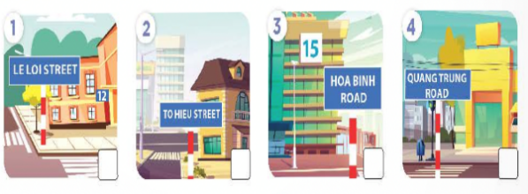  Key: 1. ✓ 2. X 3.X 4. ✓  5. Look, complete and read  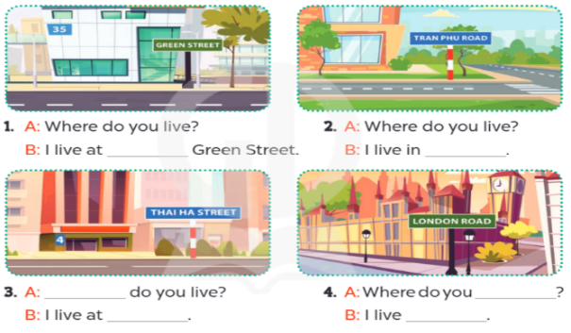  1. 35  2. Tran Phu Road  3. Where; 4 Thai Ha Street.  4. live; in London Road  6. Let’s play.  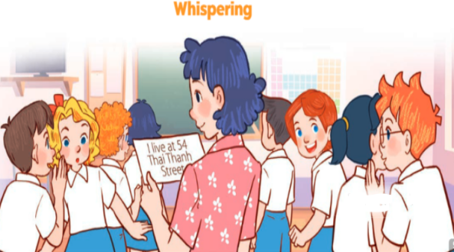
V. Adjustments (if necessary):
………………………………………………………………………………………….…..……………………………………………………………………………...………………………………………….…..………………………………
-------------------------------------------------
Week 19 – Grade 4

Unit 11: My home
Lesson 2 (1,2,3)
I. Objectives:
By the end of the lesson, Ss will be able to:
1. Knowledge:
- understand and correctly repeat the sentences in two communicative contexts (pictures) in which characters ask and answer the question about what a place is like.
- correctly say the phrases and use What’s the _____ like? – It’s _____. to ask and answer questions about what a place is like.
- enhance the correct use of What’s the _____ like? – It’s _____. to ask and answer questions about what a place is like in a freer context.
- Vocabulary: busy, big, quiet, noisy
2. Skills: speaking, listening, reading and writing.
3. Competences:
- Self-control and independent learning: perform listening tasks.
- Communication and collaboration: work in pairs or groups.
4. Attitude/ Qualities:
- Kindness: Help partners to complete learning tasks.
- Honesty: tell the truth about feelings and emotions
II. Methods: Communicative approach, group Ss and T's activities, play as a character, teaching methods with game, teaching methods by visual, teaching methods by practising, discussion group, technical present....
III. Teaching aids:
1. Teacher’s preparation: Projector/ TV
- Speaker
- Website hoclieu.vn
2. Student’s preparation: books, notebooks.
IV. Procedures:
Teacher’s and students’ activities | Contents
Activity 1.Warm- up:  Game: Buzz!  - Arrange pupils into a circle and ask pupils to count from 1 in sequence from pupil to pupil.  - Set a goal from one to twenty for pupils.  - Each pupil shouts out one number in their turn.  If a number is a multiple of 5, or a number with a 5 in it, the player has to shout out "buzz!" instead of saying that number.  - The game is meant to be fast paced, so if a pupil takes too long or buzzes at the wrong time, they are eliminated.  – Get pupils to open their books at page 8 and look at Unit 11, Lesson 2, Activity 1. Tell pupils what they will learn in this lesson.  Activity 2. Look, listen and repeat:  - Ask pupils to look at Pictures a and b and identify the characters and predict what they are talking about (e.g. Bill’s house, Minh’s house, the street, the road).  - Ask pupils to look at Picture a. Play the recording for them to listen and check the prediction. Play the recording again, sentence by sentence, for pupils to listen and repeat after each character. Correct their pronunciation where necessary. Repeat the same procedure with Picture b.  - Invite a few pairs to the front of the class to listen to and act out the exchanges.  - Draw pupils’ attention to the question What’s the street like? and the answer It’s a busy street. Explain that they are used to ask and answer about what a place is like.  Activity 3 Listen, point and say.  - Ask pupils to look at Pictures a, b, c and d and identify the places in the pictures. Have pupils describe what they can see in each picture.  - T introduces new structure for Ss.  - T explains, models and gives meaning.  - Have Ss repeat the model sentences.  - Play the recording for pupils to listen to and repeat the phrases in chorus and individually until they feel confident. Use the flash cards for a busy street, a quiet village, a noisy road and a big city to practise the phrases.  - Draw pupils’ attention to the speech bubbles and elicit the missing words and phrases in the question and answer by pointing at Picture a.  - Ask Ss to work in pairs.  - T controls and corrects.  - T gives feedbacks  Activity 4. Let’s talk.  - Have Ss look at the picture and elicit the question and the answer in context.  - Elicit the missing words in the second speech bubble and write them on the board.  - Get pupils to say the completed sentences.  - Have pupils look at the bubbles to understand how the sentence pattern is used.  - Have pupils role-play to practise asking the questions and giving their answers in pairs, using picture cues.  - Invite a few pupils to stand up, point at each month in the picture and say the sentence aloud.  Activity 5. Consolidation  - T asks ss to answer the following questions:  + What have you learnt from the lesson today?  +What are the core values of the lesson? (if the teacher can take from the lesson).  - T review the vocabulary and model sentences.  - T praises some Ss who are hardworking / active/ good…. as well as encourage others to try more.  Homework.  - Learn the vocabulary and model sentences by heart  - Prepare the new lesson | 1. Look, listen and repeat:  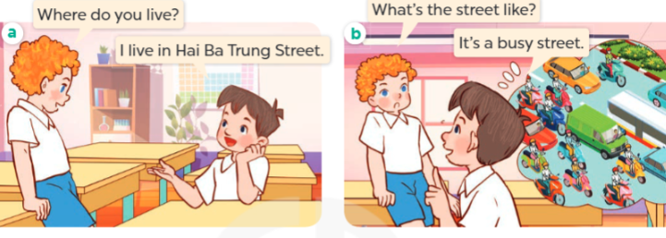  + busy : náo nhiệt/ đông đúc  2. Listen, point and say.  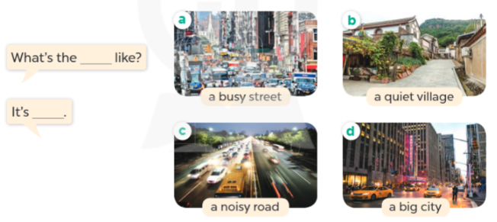  + quiet : yên tĩnh  + noisy: ồn ào  + big: lớn  A:What’s the + name of place?  B:It's……….  3. Let’s talk.  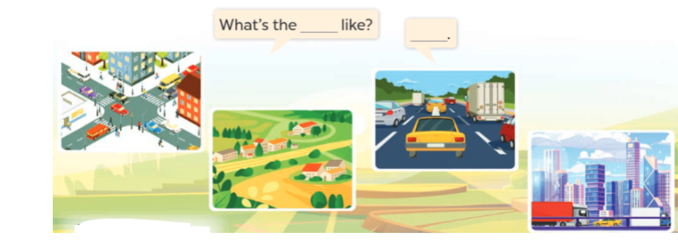
V. Adjustments (if necessary):
………………………………………………………………………………………….…..……………………………………………………………………………...………………………………………….…..………………………………
-------------------------------------------------
Week 19 – Grade 4

Unit 11: My home
Lesson 2 (4,5,6)
I. Objectives:
By the end of the lesson, Ss will be able to:
1. Knowledge:
- Listen to and understand two communicative contexts in which characters ask and answer questions about what a place is like and tick the correct pictures.
- Complete two gapped exchanges with the help of picture cues.
- Sing the song My house with the correct pronunciation, rhythm and melody.
- Vocabulary: Review
2. Skills: listening, reading and writing.
3. Competences:
- Self-control and independent learning: perform listening tasks.
- Communication and collaboration: work in pairs or groups.
4. Attitude/ Qualities:
- Kindness: Help partners to complete learning tasks.
- Honesty: tell the truth about feelings and emotions
II. Methods: Communicative approach, group Ss and T's activities, play as a character, teaching methods with game, teaching methods by visual, teaching methods by practising, discussion group, technical present....
III. Teaching aids:
1. Teacher’s preparation: Projector/ TV
- Speaker
- Website hoclieu.vn
2. Student’s preparation: books, notebooks.
IV. Procedures:
Teacher’s and students’ activities | Contents
Activity 1.Warm- up:  - Greet the class, then use the flash cards to revise the words and phrases in Activities 2 on pages 6 and 8.  – Get pupils to open their books at page 9 and look at Unit 11, Lesson 2, Activity 4.  Activity 2. Listen and tick:  - Elicit the month in each picture.  - T ask Ss to guess the answers.  + T writes Ss’guessing on the board.  - Listen to the tape:  + Play the recording  + Play the recording again and get Ss to swap books with their partners.  + Play the recording again to check answers together as a class.  + Write the answers on the board for Ss to correct their answers. Then checks Ss’ guessing.  - Play the recording, sentence by sentence, for the class to listen and repeat in chorus.  Activity 3. Look, complete and read  - Have pupils look at the pictures and identify the contents in each picture.  - Model the first gapped sentence. Have pupils read the sentence and guess the missing words. Then draw pupils’ attention to the picture and elicit the house number to complete the answer.  - Give pupils a time limit to read the gapped sentences, look at the pictures and fill in the gaps independently. Go around the classroom and give further support to pupils who find it difficult to do the task.  - Get pupils to swap books with a partner and check their answers before checking as a class. Invite one pupil to write the answers on the board.  Activity 3. Let’s sing  - Draw pupils’ attention to the title and the lyrics of the song. Encourage them to point at the places in the pictures to reinforce their understanding.  - Have pupils read the first verse of the lyrics. Explain that the first verse is about a house in a town. Have pupils listen to the first verse, drawing their attention to the pronunciation, rhythm and melody. Then let them listen to and practise singing it, line by line, while making gestures for small, quiet and big  - Ask pupils to listen to and sing the whole song while making gestures. Go around the classroom and offer help if necessary.  - Invite a few groups to the front of the class to sing the song. The class may sing along and clap to reinforce the activity.  Activity 4. Consolidation  - T asks ss to answer the following questions:  + What have you learnt from the lesson today?  +What are the core values of the lesson? (if the teacher can take from the lesson).  - T praises some Ss who are hardworking / active/ good…. as well as encourage others to try more.  Homework.  - Practice part 5 again.  - Prepare the new lesson | 4. Listen and tick:  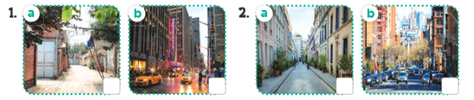  Key: 1. b 2.a  5. Look, complete and read.  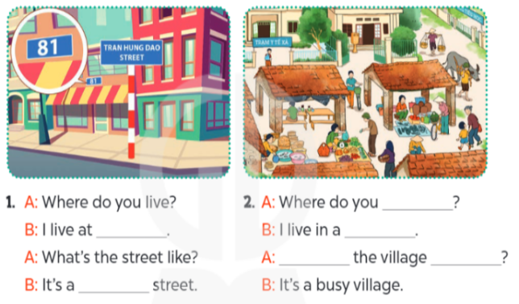  Key:  1. 81 Tran Hung Dao Street; quiet 2. live; village; What’s; like  6. Let’s play  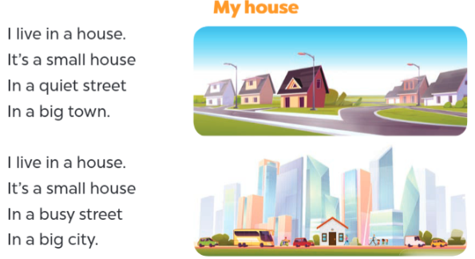
V. Adjustments (if necessary):
………………………………………………………………………………………….…..……………………………………………………………………………...………………………………………….…..………………………………
---------------------------------------------------------------------
Week 20 – Grade 4

Unit 11: My home
Lesson 3 (1,2,3)
I. Objectives:
By the end of the lesson, Ss will be able to:
1. Knowledge:
- correctly pronounce the sounds of the letters i and ee in isolation, in the words big and street, and in the sentences They live in a big village., and They live in Green Street.;
- Identify the specific information by listening 2 sentences to identify the target word;
- Perform the chant in interesting ways, using appropriate and meaningful gestures.
- Vocabulary: Review
2. Skills: speaking, listening, reading.
3. Competences:
- Self-control and independent learning: perform listening tasks.
- Communication and collaboration: work in pairs or groups.
4. Attitude/ Qualities:
- Kindness: Help partners to complete learning tasks.
- Honesty: tell the truth about feelings and emotions
II. Methods: Communicative approach, group Ss and T's activities, play as a character, teaching methods with game, teaching methods by visual, teaching methods by practising, discussion group, technical present....
III. Teaching aids:
1. Teacher’s preparation: Projector/ TV
- Speaker
- Website hoclieu.vn
2. Student’s preparation: books, notebooks.
IV. Procedures:
Teacher’s and students’ activities | Contents
Activity 1.Warm- up:  - Greet the class, then sing the song My house on page 9.  – Get pupils to open their books at page 10 and look at Unit 11, Lesson 3, Activity 1. Tell them what they will learn in this lesson  Activity 2. Listen and repeat:  - Have pupils point at the letter i, the word big, and the sentence They live in a big village. Play the recording for them to listen and repeat in chorus and individually until they feel confident. Correct their pronunciation when necessary.  - Invite a few pupils to listen to and repeat the sound, the word and the sentence in front of the class. Praise them when their pronunciation is good.  - Repeat Steps 1 and 2 for the letters, the word and the sentence in the second line. Go around the classroom and correct their pronunciation if necessary.  - Let pupils work in pairs or groups, pronouncing the sounds, saying the words, and reading the sentences until they feel confident.  Activity 3. Listen and circle.  - Elicit the sentences and the gap-fill options.  - T ask Ss to guess the answers.  + T writes Ss’guessing on the board.  - Listen to the tape:  + Play the recording  + Play the recording again and get Ss to swap books with their partners.  + Play the recording again to check answers together as a class.  + Write the answers on the board for Ss to correct their answers. Then checks Ss’ guessing.  - Play the recording, sentence by sentence, for the class to listen and repeat in chorus.  - Invite one or two Ss to stand up and read the completed sentences.  Activity 4. Let’s chant  - Introduce the title and lyrics of the chant.  - Play the recording for Ss to listen to the whole chant.  + Have them repeat the title and lyrics line by line.  - Play the recording all the way through for Ss to listen to pronunciation and melody.  - Play the recording line by line for Ss to listen and repeat  - Play the recording for Ss to chant and clap along.  - Ask Ss to practice chant and clap along in pairs or groups.  - Invite groups to the front of the classroom to perform the chant  -T gives feedback.  Activity 5. Consolidation  - T asks ss to answer the following questions:  + What have you learnt from the lesson today?  +What are the core values of the lesson? (if the teacher can take from the lesson).  - T praises some Ss who are hardworking / active/ good…. as well as encourage others to try more.  Homework.  - Practice the chant more.  - Collect three school things  - Prepare the new lesson | 1. Listen and repeat:    2. Listen and circle.  Key: 1.a 2.b  3. Let’s chant.  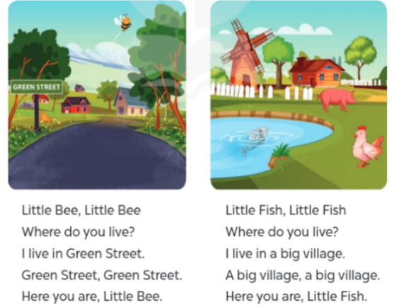
V. Adjustments (if necessary):
………………………………………………………………………………………….…..…………………………………………………………………………
------------------------------------------------
Week 20 – Grade 4

Unit 11: My home
Lesson 3 (4,5,6)
I. Objectives:
By the end of the lesson, Ss will be able to:
1. Knowledge:
- Identify the specific information by scanning the text and circle the correct answers;
- Write about their home;
- Present pictures to the class at the Project time.
- Vocabulary: Review
2. Skills: speaking, listening, reading and writing.
3. Competences:
- Self-control and independent learning: perform listening tasks.
- Communication and collaboration: work in pairs or groups.
4. Attitude/ Qualities:
- Kindness: Help partners to complete learning tasks.
- Honesty: tell the truth about feelings and emotions
II. Methods: Communicative approach, group Ss and T's activities, play as a character, teaching methods with game, teaching methods by visual, teaching methods by practising, discussion group, technical present....
III. Teaching aids:
1. Teacher’s preparation: Projector/ TV
- Speaker
- Website hoclieu.vn
2. Student’s preparation: books, notebooks.
IV. Procedures:
Teacher’s and students’ activities | Contents
Activity 1 .Warm- up:  Chant and do activities (Unit 11, Lesson 3).  - Ask pupils to chant and do the actions in Unit 11, Lesson 3 in groups.  - Give points for the groups and encourage them.  – Ask pupils to open their books at page 11 and look at Unit 11, Lesson 3, Activity 4.Activity 2. Read and circle.  - Tell pupils the goal of the activity and explain that they should read the text and circle the correct options to complete the gapped sentences. Check comprehension.  - Do Sentence 1 as an example. First, have pupils read Sentence 1 and decide what information they need to find in the text. Then, have them read the text carefully and find the information about the flat where the writer lives to decide if option a or b is correct. Circle the correct option.  - Set a time limit for pupils to do the task independently. Go around the classroom and offer help if necessary.  - Get pupils to swap their books with a partner and check their answers before checking as a class. Correct the answers where necessary.  Extension: Invite one or two pupils to read the text in front of the class. Correct their pronunciation where necessary  Activity 3. Let’s write  - Tell the class the goal of the activity and explain that they should read the gapped text and fill in the gaps with their own information. Explain that the gaps in the text focus on the place pupils live in. Check comprehension.  - Have pupils do the first gapped sentence together as an example. Ask them to read the first sentence and elicit the words (e.g. house, flat). Then have them write it in the gap.  - Give pupils time to complete the text independently. Go around the classroom and offer help if necessary.  - Get pupils to swap their books with a partner, check and read their friend’s writing.  Activity 4. Project.  - Tell pupils the goal of the activity. Explain the project again that pupils are introducing their home. Pupils draw a picture of the place (street, road, village, etc.) where they live and prepare how to present it at home.  - Have pupils work in their groups. Each pupil shows his or her picture and talks about it. Go around the classroom and offer help if necessary.  - Invite a few pupils to show the pictures and make a presentation about their beautiful homes. Praise pupils when they do the task well.  Activity 5. Consolidation  - T asks ss to answer the following questions:  + What have you learnt from the lesson today?  +What are the core values of the lesson? (if the teacher can take from the lesson).  - T praises some Ss who are hardworking / active/ good…. as well as encourage others to try more.  Homework.  - Prepare the new lesson | 4. Read and circle.  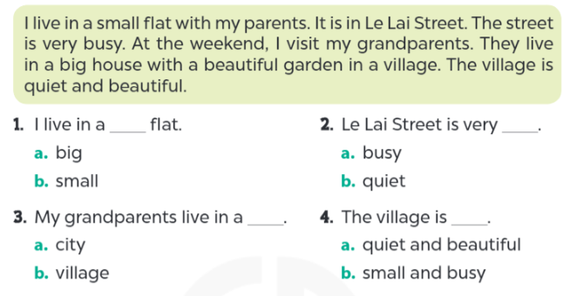  + flat: căn hộ  Key:  1. b 2. a 3. b 4. a  5. Let’s write  Key: Pupils’ answer  Ex: I live in a big house with my parents. It is in Thai Ha road. It is beautiful. There are not many trees there, but there is a park. I love my house.  6. Project.  