Week
Preparing date:
Teaching date:
UNIT 10: OUR SUMMER HOLIDAYS
Lesson 1: 1,2,3
A. OBJECTIVES:
By the end of the lesson, Ss will be able to:
1. Knowledge:
- Understand and correctly repeat the sentences in two communicative contexts in which pupils ask and answer questions about if someone was somewhere in the past.
- Correctly say the phrases and use Were you _____ last weekend? – Yes, I was. / No, I wasn’t. to ask and answer questions about if someone was somewhere in the past.
- enhance the correct use of Were you _____ last weekend? – Yes, I was. / No, I wasn’t. to ask and answer questions about if someone was somewhere in the past in a freer context.
- Vocabulary: at the zoo, on the baech, at the campsite, in the countryside
- Skills: speaking and listening
2. Competences:
- Critical Thinking: self-introduce
- Co-operation: ready to help friends in pair work/ group work.
- Sociability: Talk to each other, say good words to others.
3. Attitude/ Qualities:
- Kindness: Help partners to complete learning tasks.
- Show pride in what they can do and great respect for other people’s abilities by using appropriate gestures and intonation when asking and answering about abilities.
B. TEACHING AIDS:
- Teacher: Teacher’s guide Pages 68,69,70, audio Tracks 46,47, website hoclieu.vn, posters, laptop, pictures, textbook, lesson plan, TV or projector.
- Students: Pupil’s book Page 34, notebooks, workbooks, school things.
C. PROCEDURES:
Teacher’s and Students’ activities | Contents
1.Warm- up: (3’)  - Spend a few minutes revising the previous lesson by saying the chant on page 66.  - Ask pupils to open their books at page 68 and look at Unit 10, Lesson 1, Activity 1.  2. Presentation (16’)  Activity 1. Look, listen and repeat:  *Aims: Ss will be able to understand and correctly repeat the sentences in two communicative contexts in which pupils ask and answer questions about if someone was somewhere in the past  *Procedure:  - Have Ss look at Pictures a and b and identify the characters (Bill and Mai) in the pictures.  - Play the audio twice (sentence by sentence). Correct their pronunciation where necessary.  - Have Ss to practice the dialogue  - T invites a few pairs to the front of the class to practice.  - T checks pronunciation for ss.  Activity 2 Listen, point and say.  *Aims: Ss will be able to correctly say the words and phrases and use Were you ….. last weekend? – Yes, I was. / No, I wasn’t. to ask and answer questions about if someone was somewhere in the past.  *Procedure:  T elicits the new words  - T models (3 times).  -Ss listen and repeat in chorus ( 3 times)  + Individual repetition (3 ss)  - T writes the words on the board.  - Checking: Rub out and remember  - Ss take note  - Ss look, remember and match  * Model sentences:  - T asks Ss look at picture a and helps Ss know the structure from the dialogue.  -Ss look at the picture and answer.  - T introduces new structure for Ss.  -Ss listen  - T explains, models and gives meaning.  - Have Ss repeat the model sentences.  -Ss repeat to the the sentences  3.Practice: (7’)  *Drill pictures  - Have pupils look at pictures a, b, c and d and identify the characters and the locations.  - Run through all the pictures.  - Run through model sentences.  +Run through question sentence  +Run through answer sentence  - Have Ss to practise:  + T asks, Ss answer picture a  + Ss asks, T answers picture b  + Group A ask, group B answer picture c  + Group B ask, group A answer picture d  - Ask Ss to work in pairs.  - T controls and corrects.  - Invite a few pupils to stand up, point at each school thing in the picture and say the sentence aloud.  - T gives feedbacks.  4.Production: (7’)  Activity 4. Let’s talk.  *Aims: Ss will be able to enhance the correct use of Were you ……..last weekend? – Yes, I was. / No, I wasn’t. to ask and answer questions about if someone was somewhere in the past in a freer context.  *Procedure:  - Ask questions to help them identify the places  - Have Ss look at the picture and say the activities  - Have Ss look at the first speech bubble and read Were you at the zoo last weekend?  - Then have them point to the pupils at the campsite and complete the gapped answer in the second bubble (Ex: Yes, I was/ No, I wasn’t)  - After that, let them say aloud.  - Give Ss time to practise say the sentence Were you…last weekend?  - Invite some Ss to practise talking about school break time activities in front of the class.  *Consolidation  *Aims: Ss will be able consolidate and wrap up the content of the lesson.  *Procedure:  - T asks ss to answer the following questions:  + What have you learnt from the lesson today?  +What are the core values of the lesson? (if the teacher can take from the lesson).  - T review the vocabulary and model sentences.  - T praises some Ss who are hardworking / active/ good…. as well as encourage others to try more.  5. Homework. (2’)  - Learn the vocabulary and model sentences by heart  - Prepare the new lesson: Unit 10, Lesson 1 (4,5,6). | 1.Look, listen and repeat:  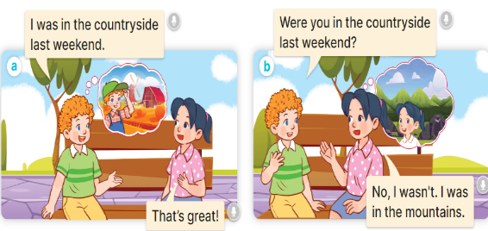  + In picture a:  Bill: I was in the countryside last weekend.  Mai: That’s great!  + In picture b:  Bill: Were you in the countryside last weekend? Mai: No, I wasn’t. I was in the mountains.  2. Listen, point and say  New words:  + at the zoo : ở sở thú (situation)  + on the beach : trên bãi biển (picture)  + at the campsite :ở điểm cắm trại (picture)  + in the countryside : ở miền quê (picture)  + yesterday : ngày hôm qua (translation)  * Model sentences:  A: Were you in the countryside last weekend?  B: Yes, I was. / No, I wasn’t  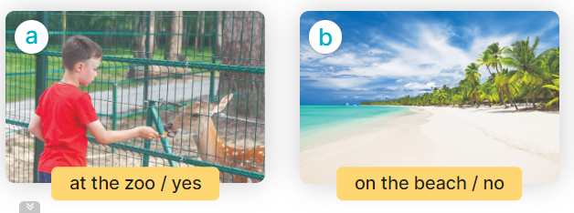  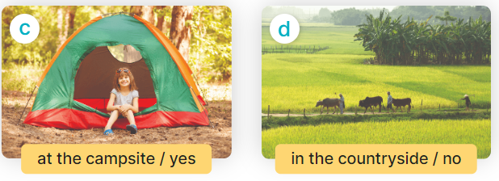  + Picture a: a boy at the zoo / yes  + Picture b: a boy on the beach / no  + Picture c: a girl at the campsite / yes  + Picture d: a boy in the countryside / no  3. Let’s talk.  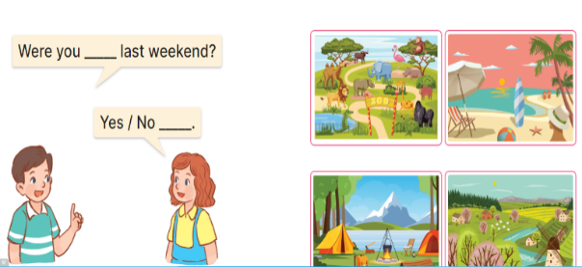
D. ADJUSTMENTS (if necessary):
………………………………………………………………………………………….…..………………………………………………………………………

----------------------------------------------------------
Preparing date:
Teaching date:
Unit 10: Our summer holiday
Lesson 1 (4, 5, 6)
A. OBJECTIVES:
By the end of the lesson, Ss will be able to:
1. Knowledge:
- use the phrases at the campsite, at the zoo, in the countryside, on the beach in relation to the topic “Our summer holidays”
- listen to and demonstrate understanding of simple communicative contexts in relation to the topic “Our summer holidays”.
- Vocabulary: Review
- Skills: speaking, listening, reading and writing.
2. Competences:
- Written Communication: complete the sentences.
- Self-control and independent learning: perform listening tasks.
- Communication and collaboration: work in pairs or groups.
3. Attitude/ Qualities:
- Show pride in where they were to and what they did in their summer holidays
B. TEACHING AIDS:
- Teacher: Teacher’s guide Pages 140, 141, 142; audio Tracks 99, 100, website sachmem.vn, posters, laptop, pictures, textbook, lesson plan, TV or projector.
- Students: Pupil’s book Page 69, notebooks, workbooks, school things.
C. PROCEDURES:
Teacher’s and Students’ activities | Contents
1.Warm- up: (5’)  Slap the board  *Aims: to create a friendly and active atmosphere in the class to beginning the lesson.  *Procedure:  - Divide class into 2 groups: Tom and Jerry.  - How to play:  + Each group chooses five Ss to play.  + Class will read aloud.  + Look at the picture, listen and slap the picture you heard.  + Who faster will get 1 mark.  + Which group with higher mark is the winner.  - T gives feedback.  - Say “Open your book page 69” and look at “Unit 10, Lesson 1 (4,5,6)”.  2.Practice: (27’)  Activity 1. Listen and tick:  *Aims: Ss will be able to listen to and understand two communicative contexts about if someone was somewhere in the past and tick the correct pictures.  *Procedure:  - Elicit the name of the character and their activities in each picture.  - T ask Ss to guess the answers.  + T writes Ss’guessing on the board.  - Listen to the tape:  + Play the recording  + Play the recording again and get Ss to swap books with their partners.  + Play the recording again to check answers together as a class.  + Write the answers on the board for Ss to correct their answers. Then checks Ss’ guessing.  - Play the recording, sentence by sentence, for the class to listen and repeat in chorus.  Activity 2. Look, complete and read  *Aims: Ss will be able to complete two gapped sentences and two gapped exchanges with the help of picture cues.  *Procedure:  - Have Ss look at the pictures and identify the the characters and places in the picture  - Have Ss look at the four incomplete sentences. Elicit and model with picture 1  + Ask Ss to read the sentence 1 in chorus.  + Ask Ss what word is missing in the gap (the campsite). Then have them complete the sentence (I was at the campsite yesterday.)  -Have Ss work in pairs and complete the sentences 2, 3, 4.  - Ask a few Ss to stand up and read the sentences aloud.  -T gives feedbacks.  Activity 3. Let’s sing  *Aims: Ss will be able to sing the song Were you on the beach yesterday? with the correct pronunciation, rhythm and melody.  *Procedure:  - Introduce the title and lyrics of the song and check comprehension.  + What is the song about?  + What are they doing?  - Play the recording for Ss to listen to the whole song.  + Have them repeat the title and lyrics line by line.  + Tell Ss to point at the pictures while singing.  - Play the recording all the way through for Ss to listen to pronunciation and melody of the song.  - Play the recording line by line for Ss to listen, repeat and point to the pictures  - Play the recording for Ss to sing and do actions.  - Ask Ss to practice singing and doing actions in pairs or groups.  - Invite groups to the front of the classroom to perform the song  -T gives feedback.  *Consolidation  *Aims: Ss will be able consolidate and wrap up the content of the lesson.  *Procedure:  - T asks ss to answer the following questions:  + What have you learnt from the lesson today?  +What are the core values of the lesson? (if the teacher can take from the lesson).  - T praises some Ss who are hardworking / active/ good…. as well as encourage others to try more.  3. Homework. (3’)  - Practice part 5 again.  - Prepare the new lesson: Unit 10, Lesson 2 (1,2,3). | 4.Listen and tick:  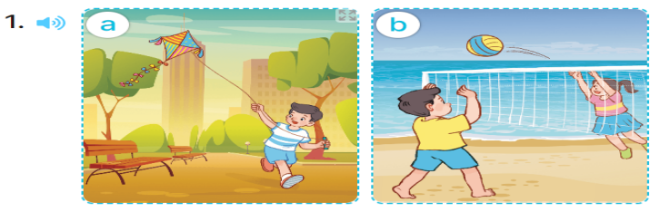  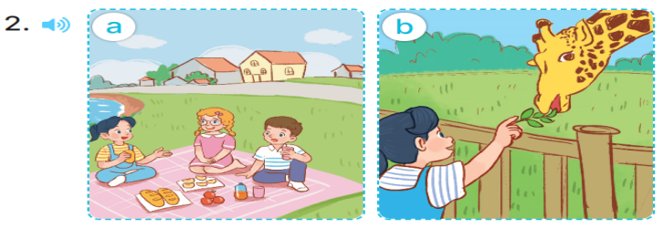  + Picture 1a. Nam at the park  + Picture 1b. Nam on the beach  + Picture 2a. Mai in the countryside  + Picture 2b. Mai at the zoo.  Key: 1. b 2. b  5.Look, complete and read  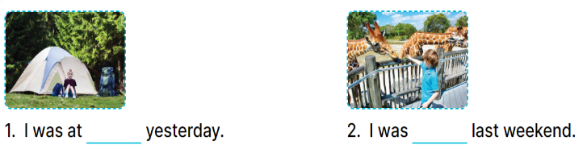  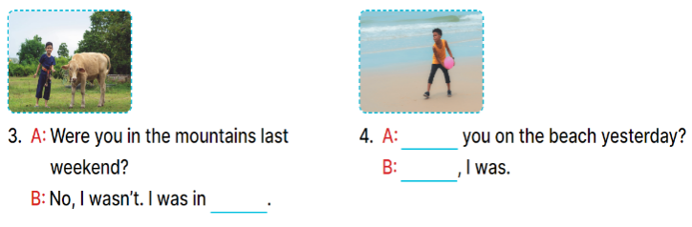  Key:  1.the campsite  2. at the zoo  3. the countryside  4. Were/ yes  6. Let’s sing  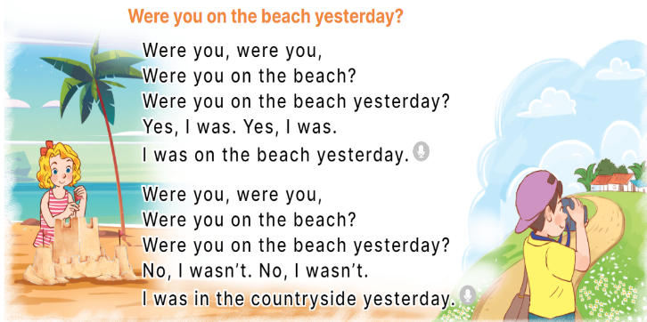
D. ADJUSTMENTS (if necessary):
………………………………………………………………………………………….…..………………………………………………………………………….
---------------------------------------------------
Preparing date:
Teaching date:
Unit 10: Our summer holiday
Lesson 2 (1, 2, 3)
A. OBJECTIVES:
By the end of the lesson, Ss will be able to:
1. Knowledge:
- use the phrases Bangkok, London, Sydney and Tokyo in relation to the topic “Our summer holidays”
- use Where were you last summer? – I was in …. to ask and answer questions about where
- someone was in the past; listen to and demonstrate understanding of simple communicative contexts in relation to the topic “Our summer holidays”.
- Vocabulary: Bangkok, London, Sydney, Tokyo
- Skills: speaking and listening
2. Competences:
- Self-control and independent learning: perform listening tasks.
- Communication and collaboration: work in pairs or groups.
- Sociability: talk to each other, say good words to others.
3. Attitude/ Qualities:
- Kindness: Help partners to complete learning tasks.
- Honesty: tell the truth about feelings and emotions
B. TEACHING AIDS:
- Teacher: Teacher’s guide Pages 142, 143, 144; audio Tracks 101, 102, website hoclieu.vn, posters, laptop, pictures, textbook, lesson plan, TV or projector.
- Students: Pupil’s book Page 70, notebooks, workbooks, school things.
C. PROCEDURES:
Teacher’s and Students’ activities | Contents
1.Warm- up: (3’)  Game: Play Game (ppt)  *Aims: to create a friendly and active atmosphere in the class to beginning the lesson.  *Procedure:  - Divide the class into 3 teams.  - Pupils from each team take turns choose a letter and answer a question  - Pupils answer correctly get some points  - Say “Open your book page 70” and look at “Unit 10, Lesson 2 (1, 2, 3)”.  Activity 1. Look, listen and repeat:  *Aims: Ss will be able to understand and correctly repeat the sentences in two communicative contexts focusing on asking and answering questions about where someone was in the past.  *Procedure:  - Have Ss look at Pictures a and b and identify the characters, places and activities..  - Play the audio twice (sentence by sentence). Correct their pronunciation where necessary.  - Have Ss to practice the dialogue  - T invites a few pairs to the front of the class to practice.  - T checks pronunciation for ss.  Activity 3 Listen, point and say.  *Aims: Ss will be able to correctly say the words and use Where were you last summer? – I was in….. to ask and answer questions about where someone was in the past.  *Procedure:  * Model sentences:  - T asks Ss look at picture b and helps Ss know the structure from the dialogue.  - T introduces new structure for Ss.  - T explains, models and gives meaning.  - Have Ss repeat the model sentences.  - Run through all the pictures.  - Run through model sentences.  +Run through question sentence  +Run through answer sentence  - Have Ss to practise:  + T asks, Ss answer picture a  + Ss asks, T answers picture b  + Group A ask, group B answer picture c  + Group B ask, group A answer picture d  - Ask Ss to work in pairs.  - T controls and corrects.  - Invite a few pupils to stand up, point at each school thing in the picture and say the sentence aloud.  - T gives feedbacks  4.Production: (7’)  Activity 4. Let’s talk.  *Aims: Ss will be able to enhance the correct use of Where were you last summer? – I was in…... to ask and answer questions about where someone was in the past in a freer context.  *Procedure:  - Have Ss look at the picture and elicit the question and the answer in context.  + Who are they?  + Where are they?  + How many places are there?  - Have Ss look at the picture and say the break time activites.  - Have Ss look at the first speech bubble and read Where were you last summer?  - Have Ss point the activities, ask and answer the questions about break time activities  - Give Ss time to practise asking and answering the question Where were you last summer? – I was……. in pairs.  - Invite a few pairs to practise asking and answering questions about break time activites in front of the class.  *Consolidation  *Aims: Ss will be able consolidate and wrap up the content of the lesson.  *Procedure:  - T asks ss to answer the following questions:  + What have you learnt from the lesson today?  +What are the core values of the lesson? (if the teacher can take from the lesson).  - T review the vocabulary and model sentences.  - T praises some Ss who are hardworking / active/ good…. as well as encourage others to try more.  5. Homework. (2’)  - Learn the vocabulary and model sentences by heart  - Prepare the new lesson: Unit 10, Lesson 2 (4,5,6). | 1.Look, listen and repeat:  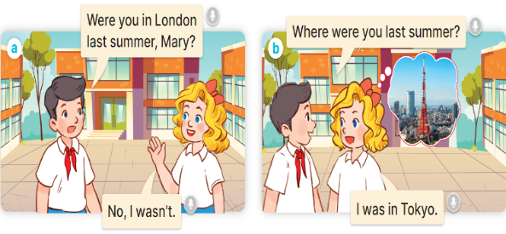  + In picture a:  Nam: Were you in London last summer, Mary?  Mary: No, I wasn’t.  + In picture b:  Nam: Where were you last summer?  Mary: I was in Tokyo.  2. Listen, point and say:  * Model sentences:  A Where were you last summer  B: I was in Tokyo      + Picture a: Mai standing by Big Ben  + Picture b: Nam standing by Opera House  + Picture c: Mary standing by Tokyo Tower  + Picture d: Bill standing by Temple of the Golden Buddha  3. Let’s talk.  
D. ADJUSTMENTS (if necessary):
………………………………………………………………………………………….…..……………………………………………………………………………...………………………………………….…..………………………………

Preparing date:
Teaching date:

Unit 10: Our summer holidays
Lesson 2 (4, 5, 6)
A. OBJECTIVES:
By the end of the lesson, Ss will be able to:
1. Knowledge:
- use the phrases Bangkok, London, Sydney and Tokyo in relation to the topic “Our summer holidays”
- someone was in the past; listen to and demonstrate understanding of simple communicative contexts in relation to the topic “Our summer holidays”.
- Vocabulary: Review
- Skills: speaking, listening, reading and writing.
2. Competences:
- Critical Thinking: look, complete and read
- Co-operation: ready to help friends in pair work/ group work.
- Self-control and independent learning: perform listening tasks.
3. Attitude/ Qualities:
- Honesty: tell the truth about feelings and emotions.
- Diligence: complete learning tasks.
B. TEACHING AIDS:
- Teacher: Teacher’s guide Pages 145, 146; audio Tracks 103; website hoclieu.vn, posters, laptop, pictures, textbook, lesson plan, TV or projector.
- Students: Pupil’s book Page 71, notebooks, workbooks, school things.
C. PROCEDURES:
Teacher’s and Students’ activities | Contents
1.Warm- up: (5’)  Game: Who says fast?  *Aims: to create a friendly and active atmosphere in the class to beginning the lesson.  *Procedure:  - Hold a places card, then reveal it slowly.  - Ask Where was you last summer?  - Ask the Ss guess the answer as fast as possible.  - Then have Ss do the same with the rest.  - This can be played in groups to make it more interesting.  - Say “Open your book page 71” and look at “Unit 10, Lesson 2 (4,5,6)”.  2.Practice: (27’)  Activity 1. Listen and match:  *Aims: Ss will be able to listen to and understand four communicative contexts about where someone was in the past and match the correct pictures.  *Procedure:  - Elicit the action of the character in each picture.  + Who are they?  + Which places are they?  - T ask Ss to guess the answers.  + T writes Ss’guessing on the board.  - Listen to the tape:  + Play the recording  + Play the recording again and get Ss to swap books with their partners.  + Play the recording again to check answers together as a class.  + Write the answers on the board for Ss to correct their answers. Then checks Ss’ guessing.  - Play the recording, sentence by sentence, for the class to listen and repeat in chorus.  Activity 2. Look, complete and read  *Aims: Ss will be able to complete two gapped dialogues with the help of picture cues.  *Procedure:  - Get Ss to look at the pictures and identify the characters and the places in the pictures.  - Have Ss look at the first sentence and the pictures. Elicit and model with number 1: I was in London.  + Ask Ss read and complete the sentence.  -Have Ss work in pairs and complete the other gaps  - Ask a few Ss to stand up and read the sentences aloud.  -T gives feedbacks.  Activity 3. Let’s play  *Aims: Ss will be able to review target words to make sentences about where someone was in the past by playing the game Making sentences.  *Procedure:  - Tell pupils that they are going to play the game Making sentences in groups of four or five.  - Nominate one pupil in each group as a leader.  + The leader says a sentence and the other group members have to stand in a line, holding the word cards to make a sentence. Example: Where were you last summer?  - Have pupil work in groups to play the game.  - Invite two groups to the front of the class to play the game.  - Have the class give comments and announce the winner.  - The group that makes most correct sentences will win.  *Consolidation  *Aims: Ss will be able consolidate and wrap up the content of the lesson.  *Procedure:  - T asks ss to answer the following questions:  + What have you learnt from the lesson today?  +What are the core values of the lesson? (if the teacher can take from the lesson).  - T praises some Ss who are hardworking / active/ good…. as well as encourage others to try more.  3. Homework. (3’)  - Practice part 5 again.  - Prepare the new lesson: Unit 10, Lesson 3 (1,2,3). | 4.Listen and match:  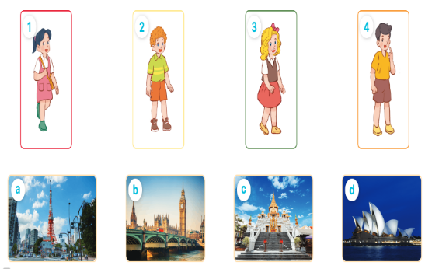  1. Mai 2. Bill 3. Mary 4. Nam  + Picture a. Tokyo Tower  + Picture b. Big Ben  + Picture c. Temple of the Golden Buddha  + Picture d. Opera House  Key: 1. d 2. c 3. a 4. b  5. Look, complete and read  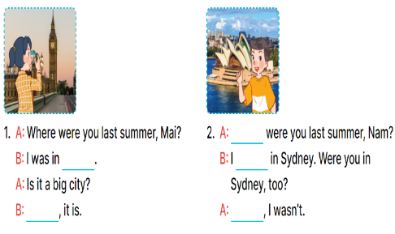  Key:  1. London, Yes 2. Where, was, No  6. Let’s play  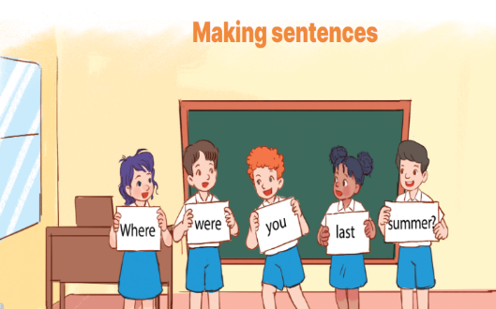
D. ADJUSTMENTS (if necessary):
………………………………………………………………………………………….…..…………………………………………………………………………
--------------------------------------------
Preparing date:
Teaching date:

Unit 10: Our summer holidays
Lesson 3 (1, 2, 3)
A. OBJECTIVES:
By the end of the lesson, Ss will be able to:
1. Knowledge:
- correctly repeat the sounds of the letter ere in isolation, in the words were and where, and in the sentences Were you on the beach last summer? and Where were you last weekend? with correct pronunciation and intonation.
- identify the target words were and where while listening.
- listen to and demonstrate understanding of simple communicative contexts in relation to the topic “Our summer holidays”
- say the chant with the correct rhythm and pronunciation.
- Vocabulary: Review
- Skills: speaking, listening, reading and writing.
2. Competences:
- Co-operation: ready to help friends in pair work/ group work.
- Sociability: Talk to each other, say good words to others.
3. Attitude/ Qualities:
- Kindness: Help partners to complete learning tasks.
- Honesty: tell the truth about feelings and emotions
B. TEACHING AIDS:
- Teacher: Teacher’s guide Pages 147, 148; audio Tracks 104, 105, 106; website hoclieu.vn, posters, laptop, pictures, textbook, lesson plan, TV or projector.
- Students: Pupil’s book Page 72, notebooks, workbooks, school things.
C. PROCEDURES:
Teacher’s and Students’ activities | Contents
1.Warm- up: (5’)  Sing a song: If you’re happy and you know it  *Aims: to create a friendly and active atmosphere in the class to beginning the lesson.  *Procedure:  - Show the song in the screen  https://www.youtube.com/watch?v=zyMWcWqmhRc  - Have pupils to sing and dance together  - Say “Open your book page 72” and look at “Unit 10, Lesson 3 (1,2,3)”.  2. Presentation (9’)  Activity 1. Listen and repeat:  *Aims: Ss will be able to correctly repeat the sounds of the letter ere in isolation, in the words were and where, and in the sentences Were you on the beach last summer? and Where were you last weekend? with correct pronunciation and intonation.  *Procedure:  - T gives instruction to the letter ere, the words were and where, and in the sentences Were you on the beach last summer? and Where were you last weekend?  - Play the recording for the letter ere.  - Encourage Ss to point at the letter/ word/ sentence while listening.  - Play the recording again and encourage Ss to listen and repeat.  - Do this several times until Ss feel confident.  - T calls some Ss to practice.  - T gives feedbacks.  .Practice: (19’)  Activity 2. Listen and circle.  *Aims: Ss will be able to identify the target words were and where while listening.  *Procedure:  - Explain that they have to listen to the recording and circle the correct options.  - Play the recording for pupils to listen.  - Play the recording again for them to listen and circle the correct options.  - Tell pupils to swap books with a partner, then check the answers together as a class. - Write the correct answers on the board.  - Play the recording again for pupils to double-check their answers.  - Invite one or two pupils to stand up, listen to and repeat the sentences.  Activity 3. Let’s chant  *Aims: Ss will be able to say the chant with the correct rhythm and pronunciation  *Procedure:  - Introduce the title and lyrics of the chant  - Play the recording for Ss to listen to the whole chant.  + Have them repeat the title and lyrics line by line.  + Ask Ss to attend to the sounds of the letters ere and the words were and where.  - Play the recording all the way through for Ss to listen to pronunciation and melody.  - Play the recording line by line for Ss to listen and repeat  - Play the recording for Ss to chant and clap along.  - Ask Ss to practice chant and clap along in pairs or groups.  - Invite groups to the front of the classroom to perform the chant  -T gives feedback.  *Consolidation  *Aims: Ss will be able consolidate and wrap up the content of the lesson.  *Procedure:  - T asks ss to answer the following questions:  + What have you learnt from the lesson today?  +What are the core values of the lesson? (if the teacher can take from the lesson).  - T praises some Ss who are hardworking / active/ good…. as well as encourage others to try more.  4. Homework. (2’)  - Practice the chant more.  - Prepare the new lesson: Unit 10, Lesson 3 (4, 5, 6). | 1.Listen and repeat:  ere-were ere- where  Were you on the beach last summer?  Where were you last weekend?  2. Listen and circle..  Key: 1.b 2.c  3. Let’s chant  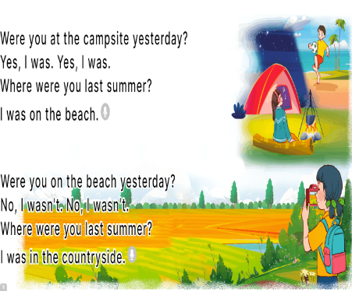
. ADJUSTMENTS (if necessary):
………………………………………………………………………………………….…..…………………………………………………………………………
---------------------------------------------------
Preparing date:
Teaching date:
Unit 10: Our summer holidays
Lesson 3 (4, 5, 6)
A. OBJECTIVES:
By the end of the lesson, Ss will be able to:
1. Knowledge:
- read and write about if someone was somewhere and where someone was in the past.
- make a mind map of where pupils were on holiday in the previous summer and present the results to the class at Project time.
- Vocabulary: Review
- Skills: speaking, listening, reading and writing.
2. Competences:
- Critical thinking: complete a task in reading a text.
- Co-operation: ready to help friends in pair work/ group work.
- Self-control and independent learning: perform listening tasks.
3. Attitude/ Qualities:
- Show pride in the travelling experience in their summer holidays.
B. TEACHING AIDS:
- Teacher: Teacher’s guide Pages 149, 150; website hoclieu.vn, posters, laptop, pictures, textbook, lesson plan, TV or projector.
- Students: Pupil’s book Page 73, notebooks, workbooks, school things.
C. PROCEDURES:
Teacher’s and Students’ activities | Contents
1.Warm- up: (5’)  Game: “Chant”  *Aims: to review the vocabulary and structure about greet and respond to greetings.  *Procedure:  - Ask Ss chant and do the actions in Unit 10, Lesson 3 page 66 in groups.  - Give point for the groups and encourage them.  - Say “Open your book page 73” and look at “Unit 10, Lesson 3 (4, 5, 6)”.  2.Practice: (8’)  Activity 1. Read and complete:  *Aims: Ss will be able to read two texts and complete the sentences about Mai’s and Tony’s summer holiday.  *Procedure:  - Elicit Sentence 1 about the location, Sentence 2 about the description of Ha Long Bay, Sentence 3 about the people in London, and Sentence 4 about Mai’s and Tony’s feelings of their summer holidays.  - Have pupils read the texts to find the information and complete four sentences.  - Have pupils work in pairs and do the task  - Get pupils to swap their answers with a partner.  - Check answers together as a class.  Activity 2. Let’s write  *Aims: Ss will be able to read and complete a gapped paragraph about where someone was on holiday in the previous summer *Procedure:  - Check comprehension and elicit to Ss read the gapped text and fill in the gaps.  - Let Ss read the gapped text and fill in the gaps.  - Have Ss complete the first gap together as an example: I am Huong.  - Ask Ss to look at the gap and ask them what is missing. Then let them identify the the name. After that, let them write down the suitable word in the gap.  - Give Ss time to complete the text independently.  - In pairs or groups, ask Ss to swap their complete texts before checking as a class.  - Invite some Ss to come to the board and read the answer.  Activity 3. Project.  *Aims: Ss will be able to make a mind map of where pupils were on holiday in the previous summer, and use the notes to make a presentation to the class  *Procedure:  - Explain that they have to look at the notes in their mind maps and present the results to the class.  - Have pupils work in groups of five.  + Each pupil looks at the notes in his / her mind map and tells the group about where he / she was on holiday in the previous summer, and describe the place.  - Invite a few pupils to look at the notes in their mind maps and tell the class about them, ex: Last summer, I was on holiday in Nha Trang. The beach was beautiful ...  - Have the rest of the class give comments and praise pupils if they perform well.  *Consolidation  *Aims: Ss will be able consolidate and wrap up the content of the lesson.  *Procedure:  - T asks ss to answer the following questions:  + What have you learnt from the lesson today?  +What are the core values of the lesson? (if the teacher can take from the lesson).  - T praises some Ss who are hardworking / active/ good…. as well as encourage others to try more.  4. Homework. (3’)  - Prepare the new lesson: Review 2 (1, 2). | 4.Read and complete:  Key: 1. Ha Long Bay. 2. beautiful.  3. helpful 4. great.  5. Let’s write  Key: Pupils’ answer  Example: I am Huong. Last summer, I was on holiday in London with my family. The city was busy. The food was good. The people were friendly. My holiday was great!  6. Project  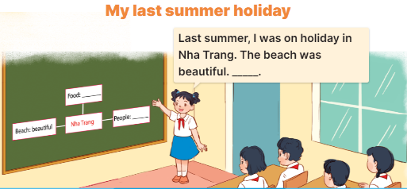
D. ADJUSTMENTS (if necessary):
………………………………………………………………………………………….…..……………………………………………………………………………...………………………………………………………………………………

