Week 14 Preparing date: December ….., 2023
Period 56 Teaching date: December ….., 2023

Unit 9: Our sports day
Lesson 1 (1, 2, 3)
I. Objectives:
By the end of the lesson, Ss will be able to:
1. Knowledge:
- use the words and phrase December, July, June, November, October, September, sports day in relation to the topic "Our sports day"
- use Is your sports day in ……..? – Yes, it is. / No, it isn’t. It’s in ……. to ask and answer questions about sports days;
- listen to and demonstrate understanding of simple exchanges in relation to the topic "Our sports day"
- Vocabulary: June, July, August.
2. Skills: speaking, listening, reading and writing.
3. Competences:
- Self-control and independent learning: perform listening tasks.
- Communication and collaboration: work in pairs or groups.
4. Attitude/ Qualities:
- Kindness: Help partners to complete learning tasks.
- Honesty: tell the truth about feelings and emotions
II. Methods: Communicative approach, group Ss and T's activities, play as a character, teaching methods with game, teaching methods by visual, teaching methods by practising, discussion group, technical present....
III. Teaching aids:
- Teacher: Teacher’s guide Pages 125,126,127, audio Tracks 87, 88, website hoclieu.vn, posters, laptop, pictures, textbook, lesson plan, TV or projector.
- Students: Pupil’s book Page 62, notebooks, workbooks, school things.
IV. Procedures:
Teacher’s and students’ activities | Contents
Activity 1.Warm- up:  Sing a song  https://www.youtube.com/watch?v=Fe9bnYRzFvk  - Have pupils listen and sing the song “Months of the Year”  - Say “Open your book page 62” and look at “Unit 9, Lesson 1 (1,2,3)”.  Activity 2. Look, listen and repeat:  - Have Ss look at Pictures a and b and identify the characters in the pictures.  + Who are they ?  + Where are they ?  - Play the audio twice (sentence by sentence). Correct their pronunciation where necessary.  - Have Ss to practice the dialogue  - T invites a few pairs to the front of the class to practice.  - T checks pronunciation for ss.  Activity 3 Listen, point and say.  -T elicits the new words:  - T models (3 times).  - T writes the words on the board.  - Checking: Rub out and remember  - T asks Ss look at picture a and helps Ss know the structure from the dialogue.  - T introduces new structure for Ss.  - T explains, models and gives meaning.  - Have Ss repeat the model sentences.  - Elicit and check comprehension the name of each character and countries.  - Run through all the pictures.  - Run through model sentences.  - Have Ss to practise:  + T asks the first picture, Ss answer  + Ss asks the second picture, T answers  + Group A asks the third picture, group B  answers  + Group B asks the last picture, group A  - Ask Ss to work in pairs.  - T controls and corrects.  - Invite a few pairs to come to the front of the classroom, point at the relevant character in each picture, and act out his/her role.  - Encourage Ss to practise speaking English.  - T gives feedbacks.  Activity 4. Let’s talk.  - Have Ss look at the picture and say the names of the months in the picture.  - Have pupils look at the bubbles to understand how the sentence pattern is used. - Have pupils role-play to practise asking the questions and giving their answers in pairs, using picture cues.  - Invite some pupils to practise asking and answering questions in front of the class.  - Have pupils ask and answer questions about what their friend(s) do on school sports day, using the structure learnt.  ex: What do you do on sports day? – I ……..  Activity 4. Consolidation  - T asks ss to answer the following questions:  + What have you learnt from the lesson today?  +What are the core values of the lesson? (if the teacher can take from the lesson).  - T review the vocabulary and model sentences.  - T praises some Ss who are hardworking / active/ good…. as well as encourage others to try more.  Homework.  - Learn the vocabulary and model sentences by heart  - Prepare the new lesson: Unit 9, Lesson 1 (4,5,6). | 1. Look, listen and repeat:  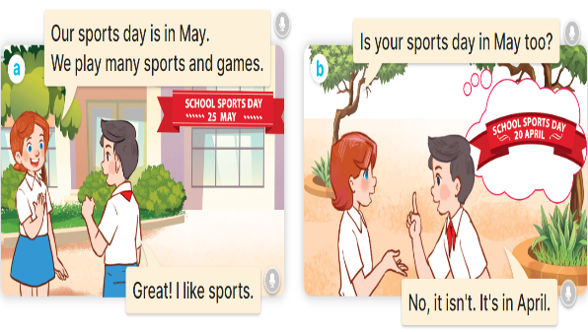  2. Listen, point and say.  Vocabulary.  + June : tháng 6  + July : tháng 7  + August :tháng  A: Is your sports day in May?  B: Yes, it is. / No, it isn’t. It’s in June  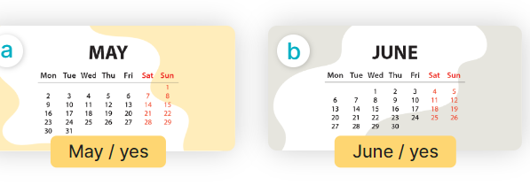  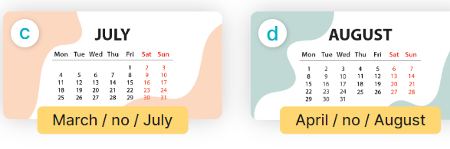  3. Let’s talk. 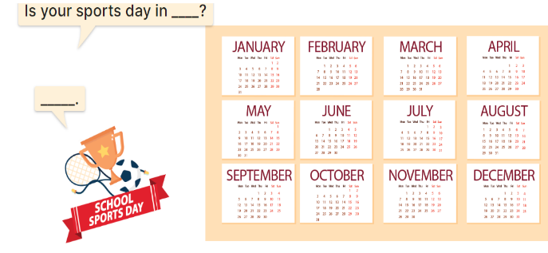
V. Adjustments (if necessary):
………………………………………………………………………………………….…..……………………………………………………………………………...………………………………………….…..………………………………...
Week 14 Preparing date: December ….., 2023
Period 57 Teaching date: December ….., 2023

Unit 9: Our sports day
Lesson 1 (4,5,6)
I. Objectives:
By the end of the lesson, Ss will be able to:
1. Knowledge:
- use the words and phrase December, July, June, November, October, September, sports day in relation to the topic "Our sports day".
- listen to and demonstrate understanding of simple exchanges in relation to the topic "Our sports day".
- Vocabulary: Review
2. Skills: speaking, listening, reading and writing.
3. Competences:
- Self-control and independent learning: perform listening tasks.
- Communication and collaboration: work in pairs or groups.
4. Attitude/ Qualities:
- Kindness: Help partners to complete learning tasks.
- Honesty: tell the truth about feelings and emotions
II. Methods: Communicative approach, group Ss and T's activities, play as a character, teaching methods with game, teaching methods by visual, teaching methods by practising, discussion group, technical present....
III. Teaching aids:
- Teacher: Teacher’s guide Pages 128, 129, 130; audio Tracks 89, 90; website hoclieu.vn, posters, laptop, pictures, textbook, lesson plan, TV or projector.
- Students: Pupil’s book Page 63, notebooks, workbooks, school things.
IV. Procedures:
Teacher’s and students’ activities | Contents
Activity 1. Warm- up: Slap the board  - Divide class into 2 groups: Tom and Jerry.  - How to play:  + Each group chooses five Ss to play.  + Class will read aloud.  + Look at the picture, listen and slap the picture you heard.  + Who faster will get 1 mark.  + Which group with higher mark is the winner.  - T gives feedback.  - Say “Open your book page 63” and look at “Unit 9, Lesson 1 (4,5,6)”.  Activity 2. Listen and match:  - Draw pupils’ attention to the pictures of the characters and the months.  - Play the recording and ask pupils to listen and draw a line to match the character.  Ex: (Mary) with the month (Picture b).  - Play the recording again for pupils to do the task.  - Play the recording a third time to give pupils another listening opportunity if needed.  - Get pupils to swap books with a partner, then check answers together as a class.  - Write the correct answers on the board.  - Play the recording again for pupils to listen and double-check their answers.  - Play the recording, sentence by sentence, for the class to listen and repeat individually and in chorus.  Activity 3. Look, complete and read  - Have pupils look at the pictures and identify the months.  - Have Ss look at the four incomplete dialogue. Elicit and model with picture 1  + Ask Ss to read the sentence 1 in chorus.  + Ask Ss what word is missing in the gap (it is). Then have them complete the sentence (Yes, it is).  -Have Ss work in pairs and complete the sentences 2, 3, 4.  - Ask a few Ss to stand up and read the sentences aloud.  -T gives feedbacks.  Activity 4. Let’s sing  - Draw pupils’ attention to the title and lyrics of the song.  - Play the recording all the way through.  - Play the recording, line by line, for pupils to listen and repeat.  - Introduce actions for pupils to do while they sing along with the recording.  - Play the recording all the way through for pupils to sing along.  - Put pupils into groups to make up their own actions for the song.  - Invite groups to the front of the class to perform, while the rest of the class sings and / or claps along.  Activity 5. Consolidation  - T asks ss to answer the following questions:  + What have you learnt from the lesson today?  +What are the core values of the lesson? (if the teacher can take from the lesson).  - T praises some Ss who are hardworking / active/ good…. as well as encourage others to try more.  Homework.  - Practice part 5 again.  - Prepare the new lesson: Unit 9, Lesson 2 (1,2,3). | 4. Listen and match:  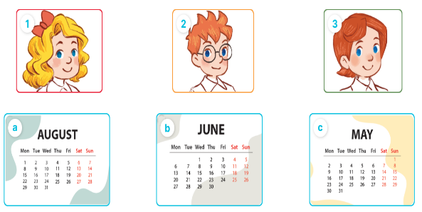  Key: 1. b 2. c 3.a  5. Look, complete and read  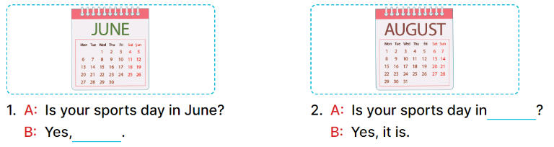  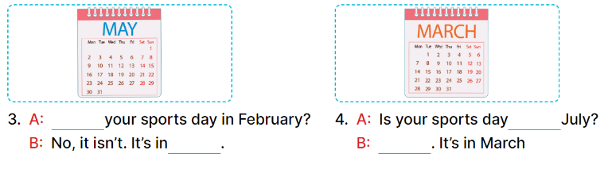  Key:  1. it is 2. April  3. Is; May 4. in; No, it isn’t  6. Let’s sing.  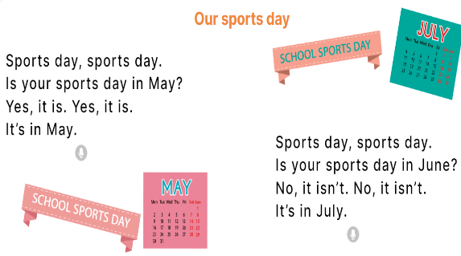
V. Adjustments (if necessary):
………………………………………………………………………………………….…..……………………………………………………………………………...………………………………………….…..………………………………
Week 14 Preparing date: December ….., 2023
Period 58 Teaching date: December ….., 2023

Unit 9: Our sports day
Lesson 2 (1,2,3)
I. Objectives:
By the end of the lesson, Ss will be able to:
1. Knowledge:
- use the words and phrase December, July, June, November, October, September, sports day in relation to the topic "Our sports day".
- use When's your sports day? – It's in ……... to ask and answer questions about when a sport day is;
- listen to and demonstrate understanding of simple exchanges in relation to the topic "Our sports day"
- Vocabulary: December, November, October, September
2. Skills: speaking, listening, reading and writing.
3. Competences:
- Self-control and independent learning: perform listening tasks.
- Communication and collaboration: work in pairs or groups.
4. Attitude/ Qualities:
- Kindness: Help partners to complete learning tasks.
- Honesty: tell the truth about feelings and emotions
II. Methods: Communicative approach, group Ss and T's activities, play as a character, teaching methods with game, teaching methods by visual, teaching methods by practising, discussion group, technical present....
III. Teaching aids:
- Teacher: Teacher’s guide Pages 130, 131, audio Tracks 91, 92, website hoclieu.vn, posters, laptop, pictures, textbook, lesson plan, TV or projector.
- Students: Pupil’s book Page 64, notebooks, workbooks, school things.
IV. Procedures:
Teacher’s and students’ activities | Contents
Activity 1.Warm- up:  Lucky number  - Divide the class into 2 teams (boys and girls).  - Each team takes turns to choose a number.  - They need to ask and answer with the picture corresponding to that number to get points.  - The group with more points at the end of the game will be the winner.  - Praise the winner, encourage the other team.  - Say “Open your book page 64” and look at “Unit 9, Lesson 2 (1, 2, 3)”.  Activity 2. Look, listen and repeat:  - Have Ss look at Pictures a and b and identify the characters (Minh and Lucy) in the pictures.  - Play the audio twice (sentence by sentence). Correct their pronunciation where necessary.  - Have Ss to practice the dialogue  - T invites a few pairs to the front of the class to practice.  - T checks pronunciation for ss.  Activity 3 Listen, point and say.  - T asks Ss look at picture b and helps Ss know the structure from the dialogue.  - T introduces new structure for Ss.  - T explains, models and gives meaning.  - Have Ss repeat the model sentences.  - Have pupils look at the pictures and elicit the name of each month.  - Run through all the pictures.  - Run through model sentences.  +Run through question sentence  +Run through answer sentence  - Have Ss to practise:  + T asks, Ss answer picture a  + Ss asks, T answers picture b  + Group A ask, group B answer picture c  + Group B ask, group A answer picture d  - Ask Ss to work in pairs.  - T controls and corrects.  - Invite a few pupils to stand up, point at each school thing in the picture and say the sentence aloud.  - T gives feedbacks  Activity 4. Let’s talk.  - Have Ss look at the picture and elicit the question and the answer in context.  - Elicit the missing words in the second speech bubble and write them on the board.  - Get pupils to say the completed sentences.  - Have pupils look at the bubbles to understand how the sentence pattern is used.  - Have pupils role-play to practise asking the questions and giving their answers in pairs, using picture cues.  - Invite a few pupils to stand up, point at each month in the picture and say the sentence aloud.  Activity 5. Consolidation  - T asks ss to answer the following questions:  + What have you learnt from the lesson today?  +What are the core values of the lesson? (if the teacher can take from the lesson).  - T review the vocabulary and model sentences.  - T praises some Ss who are hardworking / active/ good…. as well as encourage others to try more.  Homework.  - Learn the vocabulary and model sentences by heart  - Prepare the new lesson: Unit 9, Lesson 2 (4,5,6). | 1. Look, listen and repeat:  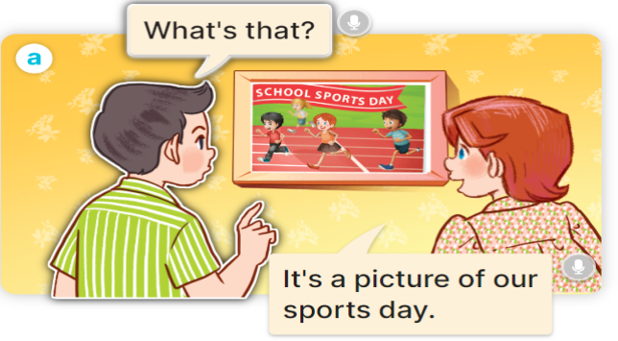  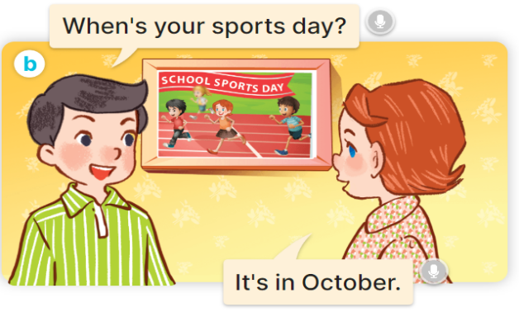  + October : tháng 10  2. Listen, point and say.      + September : tháng 9  + November: tháng 11  + December: tháng 12  A:When's your sports day?  B:It's in October.  3. Let’s talk.
V. Adjustments (if necessary):
………………………………………………………………………………………….…..……………………………………………………………………………...………………………………………….…..………………………………
Week 14 Preparing date: December ….., 2023
Period 59 Teaching date: December ….., 2023

Unit 9: Our sports day
Lesson 2 (4,5,6)
I. Objectives:
By the end of the lesson, Ss will be able to:
1. Knowledge:
- use When's your sports day? – It's in _____. to ask and answer questions about when a sport day is;
- listen to and demonstrate understanding of simple exchanges in relation to the topic "Our sports day".
- Vocabulary: Review
2. Skills: speaking, listening, reading and writing.
3. Competences:
- Self-control and independent learning: perform listening tasks.
- Communication and collaboration: work in pairs or groups.
4. Attitude/ Qualities:
- Kindness: Help partners to complete learning tasks.
- Honesty: tell the truth about feelings and emotions
II. Methods: Communicative approach, group Ss and T's activities, play as a character, teaching methods with game, teaching methods by visual, teaching methods by practising, discussion group, technical present....
III. Teaching aids:
- Teacher: Teacher’s guide Pages 132,133; audio Tracks 93; website hoclieu.vn, posters, laptop, pictures, textbook, lesson plan, TV or projector.
- Students: Pupil’s book Page 65, notebooks, workbooks, school things.
IV. Procedures:
Teacher’s and students’ activities | Contents
Activity 1.Warm- up:  Game: The football game  - Give each pair some Blue-Tak or something to stick the cards on the wall with.  - Ask pupils to randomly stick their cards all over the walls around the room.  - Then bring everyone into the middle of the room.  - Shout out "January" and everyone has to race over to a January card and touch it.  - Then “February” and so on (in the correct order) until you make it through all the months.  - Play another round, this time faster.  - Say “Open your book page 65” and look at “Unit 9, Lesson 2 (4,5,6)”.  Activity 2. Listen and tick:  - Elicit the month in each picture.  - T ask Ss to guess the answers.  + T writes Ss’guessing on the board.  - Listen to the tape:  + Play the recording  + Play the recording again and get Ss to swap books with their partners.  + Play the recording again to check answers together as a class.  + Write the answers on the board for Ss to correct their answers. Then checks Ss’ guessing.  - Play the recording, sentence by sentence, for the class to listen and repeat in chorus.  Activity 3. Look, complete and read  - Have pupils look at the pictures and identify the event and the month in each picture.  - Have Ss look at the four dialogues and the pictures. Elicit and model with number 1  + Get Ss to read number 1 in chorus.  + Ask them what A and B are talking about.  + Write the word notebook on the board.  + Tell Ss to identify the picture of a notebook (Yes, November).  + Then write number 1 with Yes, November.  -Have Ss work in pairs and complete the sentences 2.  - Ask a few Ss to stand up and read the sentences aloud.  -T gives feedbacks.  Activity 3. Let’s play  - Tell pupils that they are going to play the game Who’s faster? in groups.  - Explain how to play the game:  + Each group makes sentences using month words and reads them aloud to the class.  - Model, write three month words on the board and a sentence.  Ex: March, May, July.  Our sports day in in May.  - Divide the class into grooups of five.  - Ask groups to look at the words and the example on the board.  - Have groups make two sentences with the two words January and August, then read the sentences aloud to the class.  -The group that makes correct sentences faster wins.  Activity 4. Consolidation  - T asks ss to answer the following questions:  + What have you learnt from the lesson today?  +What are the core values of the lesson? (if the teacher can take from the lesson).  - T praises some Ss who are hardworking / active/ good…. as well as encourage others to try more.  Homework.  - Practice part 5 again.  - Prepare the new lesson: Unit 9, Lesson 3 (1,2,3). | 4. Listen and tick:  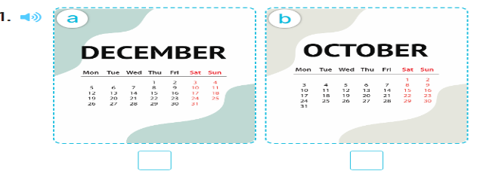  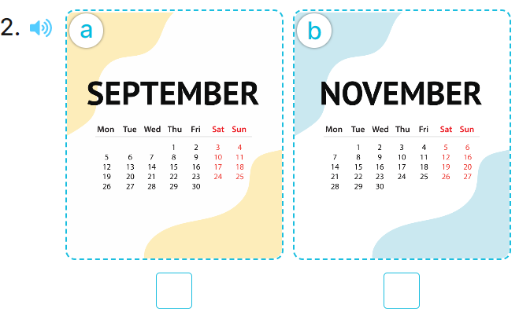  Key: 1. b 2.a  5. Look, complete and read.  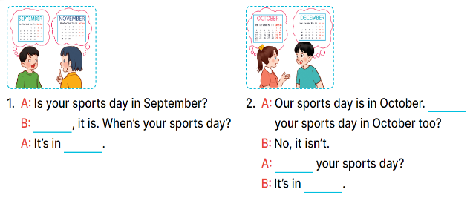  Key:  1. Yes; November  2. Is; When’s; December  6. Let’s play  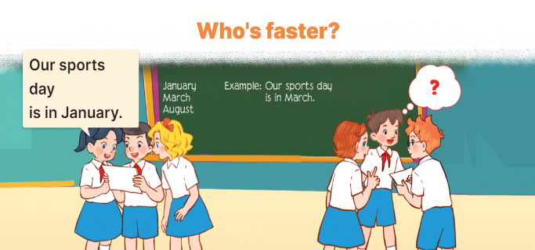
V. Adjustments (if necessary):
………………………………………………………………………………………….…..……………………………………………………………………………...………………………………………….…..………………………………
Week 15 Preparing date: December ….., 2023
Period 60 Teaching date: December ….., 2023

Unit 9: Our sports day
Lesson 3 (1,2,3)
I. Objectives:
By the end of the lesson, Ss will be able to:
1. Knowledge:
- correctly pronounce the sounds of the letter y in isolation, in the words February and July, and in the sentences Our sports day is in February. and My birthday is in July.
- use Is your sports day in ……. – Yes, it is. / No, it isn’t. It’s in ……. to ask and answer questions about sports days
- use When's your sports day? – It's in ……. to ask and answer questions about when a sport day is
- Vocabulary: Review
2. Skills: speaking, listening, reading and writing.
3. Competences:
- Self-control and independent learning: perform listening tasks.
- Communication and collaboration: work in pairs or groups.
4. Attitude/ Qualities:
- Kindness: Help partners to complete learning tasks.
- Honesty: tell the truth about feelings and emotions
II. Methods: Communicative approach, group Ss and T's activities, play as a character, teaching methods with game, teaching methods by visual, teaching methods by practising, discussion group, technical present....
III. Teaching aids:
- Teacher: Teacher’s guide Pages 134, 135; audio Tracks 94, 95, 96; website hoclieu.vn, posters, laptop, pictures, textbook, lesson plan, TV or projector.
- Students: Pupil’s book Page 66, notebooks, workbooks, school things.
IV. Procedures:
Teacher’s and students’ activities | Contents
Activity 1.Warm- up:  Game: Find and circle the words  J M V K E P S C B J  U C T H N E K C L A  L L U A A V Y O U N  Y E L N N N A S U U  A B R K A K L E S A  S C D K O K K I Y R  S R F E B R U A R Y  L C Y C L I N G A Y  D T S S R S O T S M  A C E B F Z Z Y W  - Divide class into 2 groups  - Ask Ss to find and circle the words that they learnt.  - Which groups find the best correct words is winner.  - Give Ss time to play the game.  Rows: February, cycling.  Columns: July, sky, January  -T checks who’s winner?  - Say “Open your book page 66” and look at “Unit 9, Lesson 3 (1,2,3)”.  Activity 2. Listen and repeat:  - T gives instruction to the letter y, the words February and July, and in the sentences Our sports day is in February. and My birthday is in July.  - Play the recording for the letter y.  - Encourage Ss to point at the letter/ word/ sentence while listening.  - Play the recording again and encourage Ss to listen and repeat.  - Do this several times until Ss feel confident.  - T calls some Ss to practice.  - T gives feedbacks.  Activity 3. Listen and circle.  - Elicit the sentences and the gap-fill options.  - T ask Ss to guess the answers.  + T writes Ss’guessing on the board.  - Listen to the tape:  + Play the recording  + Play the recording again and get Ss to swap books with their partners.  + Play the recording again to check answers together as a class.  + Write the answers on the board for Ss to correct their answers. Then checks Ss’ guessing.  - Play the recording, sentence by sentence, for the class to listen and repeat in chorus.  - Invite one or two Ss to stand up and read the completed sentences.  Activity 4. Let’s chant  - Introduce the title and lyrics of the chant.  - Play the recording for Ss to listen to the whole chant.  + Have them repeat the title and lyrics line by line.  + Ask Ss to attend to the sounds of the letters y and the words February and July.  - Play the recording all the way through for Ss to listen to pronunciation and melody.  - Play the recording line by line for Ss to listen and repeat  - Play the recording for Ss to chant and clap along.  - Ask Ss to practice chant and clap along in pairs or groups.  - Invite groups to the front of the classroom to perform the chant  -T gives feedback.  Activity 5. Consolidation  - T asks ss to answer the following questions:  + What have you learnt from the lesson today?  +What are the core values of the lesson? (if the teacher can take from the lesson).  - T praises some Ss who are hardworking / active/ good…. as well as encourage others to try more.  Homework.  - Practice the chant more.  - Collect three school things  - Prepare the new lesson: Unit 9, Lesson 3 (4, 5, 6). | 1. Listen and repeat:  y February  y July  2. Listen and circle.  Key: 1.a 2.b  3. Let’s chant.  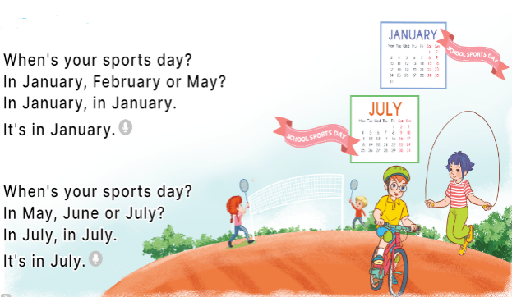
V. Adjustments (if necessary):
………………………………………………………………………………………….…..…………………………………………………………………………
Week 15 Preparing date: December ….., 2023
Period 61 Teaching date: December ….., 2023

Unit 9: Our sports day
Lesson 3 (4,5,6)
I. Objectives:
By the end of the lesson, Ss will be able to:
1. Knowledge:
- listen to and demonstrate understanding of simple exchanges in relation to the topic "Our sports day";
- read and write about sports days;
- make a sports day poster and present it to the class at Project time.
- Vocabulary: Review
2. Skills: speaking, listening, reading and writing.
3. Competences:
- Self-control and independent learning: perform listening tasks.
- Communication and collaboration: work in pairs or groups.
4. Attitude/ Qualities:
- Kindness: Help partners to complete learning tasks.
- Honesty: tell the truth about feelings and emotions
II. Methods: Communicative approach, group Ss and T's activities, play as a character, teaching methods with game, teaching methods by visual, teaching methods by practising, discussion group, technical present....
III. Teaching aids:
- Teacher: Teacher’s guide Pages 136, 137; website hoclieu.vn, posters, laptop, pictures, textbook, lesson plan, TV or projector.
- Students: Pupil’s book Page 67, notebooks, workbooks, school things.
IV. Procedures:
Teacher’s and students’ activities | Contents
Activity 1 .Warm- up:  Game: “Chant”  - Ask Ss chant and do the actions in Unit 9, Lesson 3 page 66 in groups.  - Give point for the groups and encourage them.  - Say “Open your book page 67” and look at “Unit 9, Lesson 3 (4, 5, 6)”.  Activity 2. Read and tick True or False:  - Have pupil look at the text, the four statements and read it together as a class.  - Have pupils pay attention to the sentences about sports day and what the boys, the girls do on sports day in the text. - Give pupils time to tick the correct boxes.  - Tell pupils to swap books with a partner, then check answers together as a class.  -Write the correct answers on the board.  - Ask the pupils to read the text aloud in front of the class.  Activity 3. Let’s write  - Tell the class the goal of this activity: Pupils are to read the gapped text and fill in the gaps.  - Write the first gapped sentence on the board: Our school sports day is in… .  - Read the sentence, point at it and encourage pupils to say the answer.  - Give pupils time to write the answer.  - Invite a few pupils to read the sentences they have completed in front of the class.  Activity 4. Project.  - Explain that they are going to show sports day posters that they have made at home and tell the class about their sports day.  - Have pupils work in groups of five. Each pupil shows his / her poster and tells the group about sports day, ex: Our sports day is in October. I cycle. My friends play badminton.  - Invite some pupils to show their work and talk about their sports days.  - Have pupils stick their posters on the walls of the classroom as a display.  Activity 5. Consolidation  - T asks ss to answer the following questions:  + What have you learnt from the lesson today?  +What are the core values of the lesson? (if the teacher can take from the lesson).  - T praises some Ss who are hardworking / active/ good…. as well as encourage others to try more.  Homework.  - Prepare the new lesson: Unit 10, Lesson 1 (1, 2, 3). | 4. Read and tick True or False.  Key:  1. T 2. F 3. T 4. F  5. Let’s write  Key: Pupils’ answer  Ex: Our sports day is in November. We play sports and games in the school playground. The boys play badminton. The girls play football. The teachers play basketball. We all love our sports day.  6. Project.  

